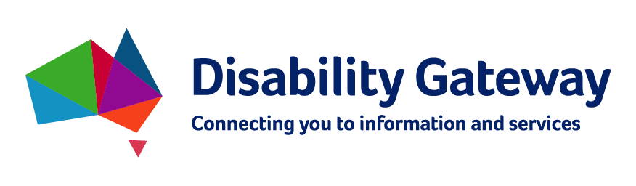

Disability Gateway

Stakeholder Kit
Updated by the Department of Social Services, February 2021.

What’s in the pack?
Introduction 3
Disability Information Helpline 3
Help us spread the message 3
Social Media 4
Social media graphics 5
Key messages 7
Q&As 7

Introduction
Australians living with disability, and their families and carers identified accessing information about policies, programs and support as a key barrier to their independence and community participation.
The Department of Social Services has developed a way to improve access to this information by creating the National Disability Information Gateway.
The Disability Gateway includes a website, a dedicated phone number (1800 643 787) and social media channels, to assist people with disability, their families and carers, to find and access trusted information and services.
The Disability Gateway is for all Australians with disability, whether they are a National Disability Insurance Scheme (NDIS) participant or not.
Please visit the Disability Gateway website here www.disabilitygateway.gov.au

Disability Information Helpline
The Disability Information Helpline has now transitioned to the Disability Gateway.
People with disability can contact the Disability Gateway to get free, fact-checked and private information and advice about COVID-19. They can also be referred to other support services if needed, including counselling and advocacy. The Disability Gateway can help families, carers and support workers, too.
The Disability Gateway number (1800 643 787) is the same as the Disability Information helpline number, so there will be no disruption of service or inconvenience for people with disability.
If you need information in a language other than English, you can call the Translating and Interpreting Service on 131 450. If you are deaf, or have a hearing or speech impairment, you can call the National Relay Service on 133 677.

Help us spread the message
We encourage you to share information about the Disability Gateway service with your networks.
In this kit, there are key messages to help you communicate what the Disability Gateway offers and to encourage people to use it and provide feedback (it is still being developed and open to suggestions).
Help us ensure all people with disability and their families and carers have access to up-to-date, relevant information.

Social Media
Facebook
Key Messages | Image
The Disability Gateway is now available.  The Disability Gateway is your first step in finding information and services for people with disability, their families and carers.  Visit: www.disabilitygateway.gov.au or call the dedicated Disability Gateway phone line on 1800 643 787. | 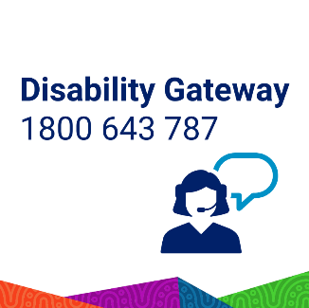
Do you care for, or have a friend with a disability?  The Disability Gateway is a new government website that leads you to trusted information on disability services – and can help find resources local to you.  Visit www.disabilitygateway.gov.au or call the dedicated Disability Gateway phone line on 1800 643 787. | 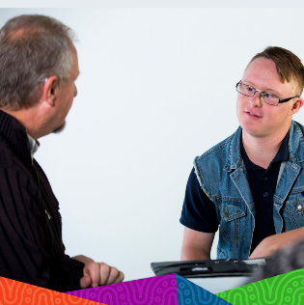
Do you have a question about COVID-19? Do you need help because things have changed?
The Disability Gateway can give you free, clear and fact-checked information and can transfer you to other support services if needed, like counselling or advocacy.
Call 1800 643 787 or visit www.disabilitygateway.gov.au for more information.
The Disability Gateway is your first step in finding information and services for people with disability, their families and carers.  If you are looking for easy to understand, accessible information and advice about COVID-19, visit www.disabilitygateway.gov.au or call 1800 643 787.  The Disability Gateway is available Monday to Friday 8am to 8pm. It is not available on weekends or national public holidays. | 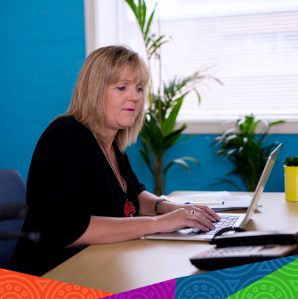
Are you looking for easy to understand information about COVID-19 for a friend or family member with disability?  Visit the Disability Gateway at www.disabilitygateway.gov.au or call 1800 643 787 for free, fact-checked and accessible information and advice about COVID-19.  The Disability Gateway is available Monday to Friday 8am to 8pm. It is not available on weekends or national public holidays. | 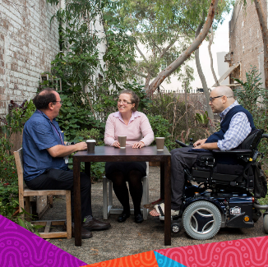

Twitter
Key Messages | Image
The Disability Gateway is live. Launch your search for trusted disability services and information at www.disabilitygateway.gov.au or call the dedicated Disability Gateway phone line on 1800 643 787 | 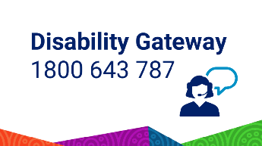
Looking for disability services relevant to you? Find information on local offerings at the Disability Gateway www.disabilitygateway.gov.au or call the dedicated Disability Gateway phone line on 1800 643 787 | 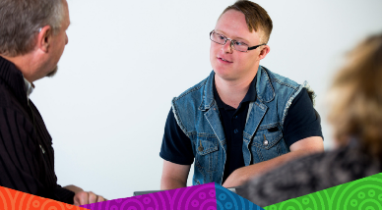
Are you looking for disability information and advice about COVID-19? The Disability Gateway can give you free, fact-checked and accessible information and advice.  Call 1800 643 787 or visit www.disabilitygateway.gov.au for more information. | 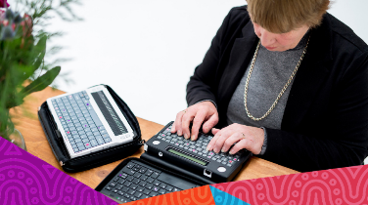
The Disability Gateway is for people with disability and their families and carers.  If you need COVID-19 support and advice in another language, you can contact the Disability Gateway on 1800 643 787 and ask for an interpreter. You can also call Translating and Interpreting Services on 131 450 and ask for the Disability Gateway.  Visit www.disabilitygateway.gov.au for more info. | 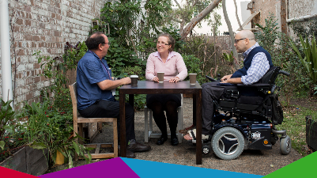
Do you care for or live with someone with disability? Do you have concerns about COVID-19?

The Disability Gateway is available for people with disability and their families, carers and support workers.

Call 1800 643 787 or visit www.disabilitygateway.gov.au for more info.

Social media graphics
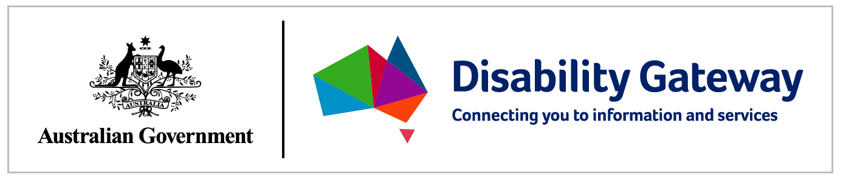
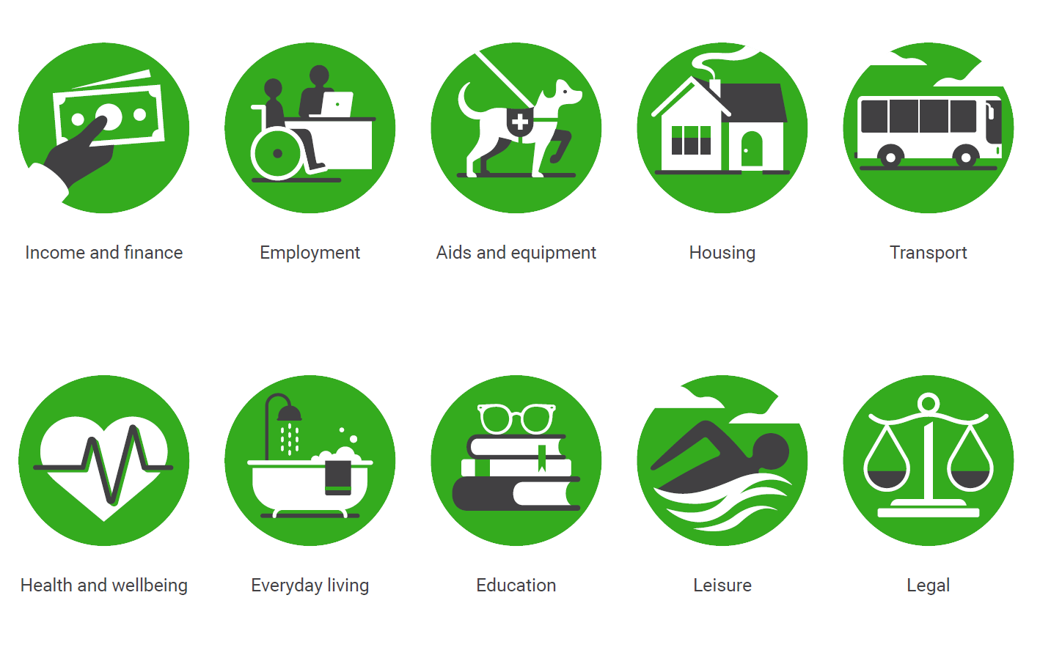
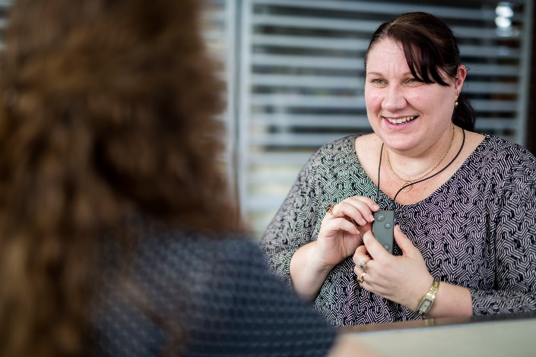
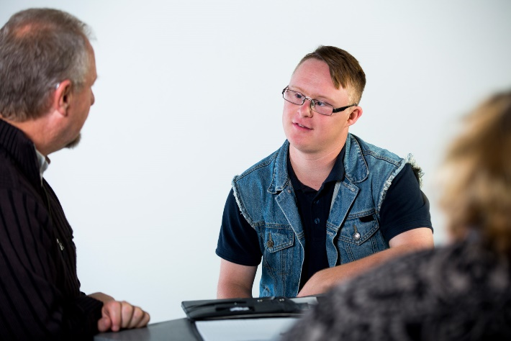 | 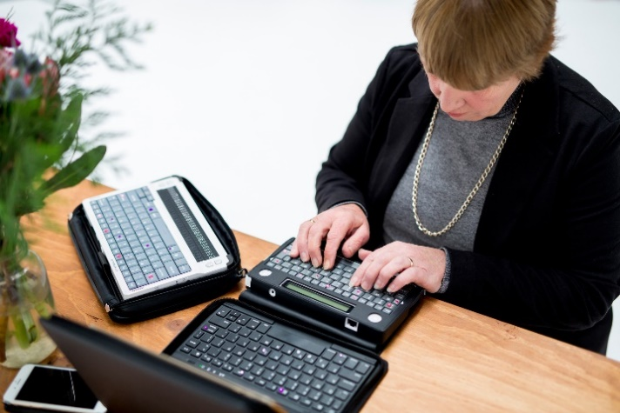
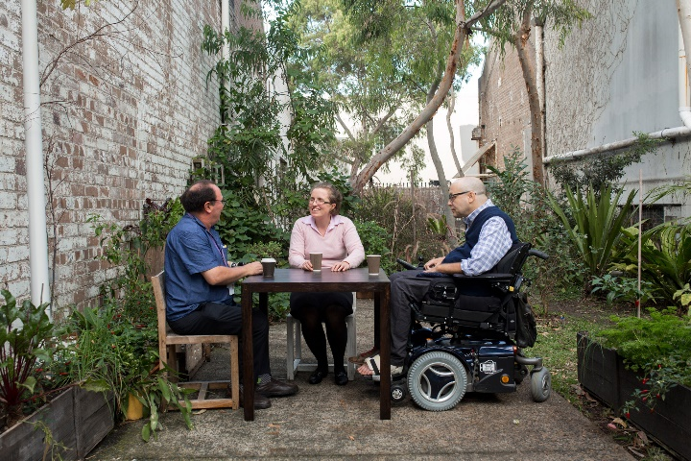 | 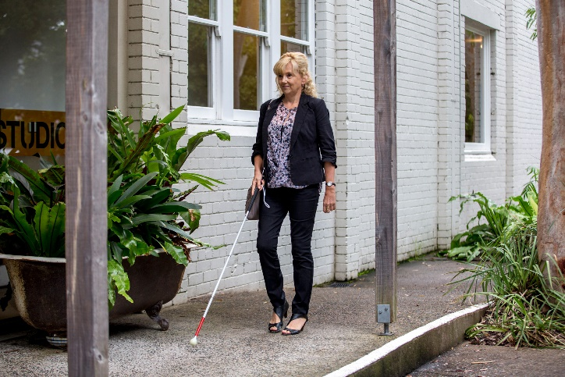

Key messages
- During the 2019 election campaign, the Australian Government committed to develop the National Disability Information Gateway (the Disability Gateway), to help improve the lives of people with disability, their families and carers.
- The Disability Gateway includes a website, a dedicated 1800-phone number and social media channels, to assist people with disability, their families and carers, to find and access trusted information and services.
- The Disability Gateway is for all Australians with disability, whether they are a National Disability Insurance Scheme (NDIS) participant or not.
- The Disability Gateway is available at www.disabilitygateway.gov.au and the dedicated Disability Gateway phone line is 1800 643 787.

Q&As

Who is eligible to call the 1800-phone number?
Anyone can call the Disability Gateway. The Disability Gateway service has been created for people with disability, their families and carers to use to have direct access to information and other services. The Disability Gateway is for all Australians with disability, whether they are a National Disability Insurance Scheme (NDIS) participant or not.
If you need information in a language other than English, you can call the Translating and Interpreting Service on 131 450. If you are deaf, or have a hearing or speech impairment, you can call the National Relay Service on 133 677.

Why should people use this website?
The Disability Gateway seeks to improve access to information about disability services and supports that is currently difficult to navigate using several search methods. For example, the Disability Gateway will assist people with disability to find a local advocacy service, disability related events and disability service providers.
Who was involved in the consulting process?
The Department of Social Services has and will continue to consult with people with lived experience of disability and the broader disability sector, to ensure their needs and expectations are considered in the design of the Disability Gateway.
How will the Government ensure that the Disability Gateway services are accessible and appropriate?
The Department of Social Services has consulted with people with lived experience of disability and the broader disability sector, to ensure their accessibility needs and expectations were considered in the design of the Disability Gateway.
Experts in Web Content Accessibility Guidelines (WCAG) and user experience were also engaged during the website design process, to ensure the site is accessible and fit for purpose and to ensure that the website complies with Digital Transformation Agency guidelines.
Is the Disability Gateway website finished?
The Disability Gateway site is still being developed and refined ahead of the Ministerial launch scheduled for May 2021 when a national television and press campaign will also commence.

