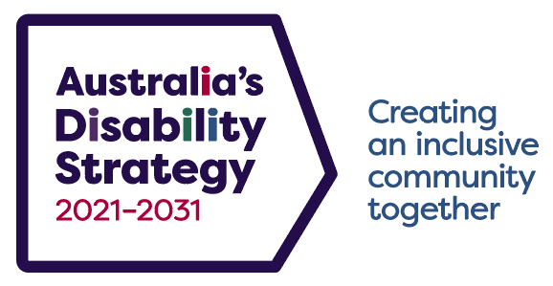

Australia’s Disability Strategy 2021–2031

What is Australia’s Disability Strategy 2021–2031?
Australia’s Disability Strategy 2021–2031 (the Strategy) is a national framework that all governments in Australia have signed up to. It sets out a plan for continuing to improve the lives of people with disability in Australia over the next ten years. The Strategy replaces and builds on the first National Disability Strategy 2010–2020.
The Strategy supports Australia’s commitment under the United Nations Convention on the Rights of Persons with Disabilities.
What will the Strategy do?
The Strategy’s vision is for an inclusive Australian society that ensures people with disability can fulfil their potential as equal members of the community.
The Strategy will drive change in seven outcomes areas:
- Employment and financial security:
Providing jobs and career opportunities for people with disability and making sure they have enough income to meet their needs.
- Inclusive homes and communities:
Increasing the number of accessible, affordable and well-designed homes and creating a community that is inclusive and accessible.
- Safety, rights and justice:
Ensuring the rights of people with disability are promoted, upheld and protected, and people with disability feel safe and enjoy equality before the law.
- Personal and community support:
Providing people with disability access to supports so they can live independently
and engage in their communities.
- Education and learning:
Supporting people with disability to access education and learning throughout their lives
so they reach their full potential.
- Health and wellbeing:
Increasing support and capability in the healthcare sector to meet the needs of people with disability, and ensuring disaster preparedness and emergency responses include the needs of people with disability.
- Community attitudes:
Recognising the positive contribution people with disability make to society, and building confidence in the community to work and engage with people with disability.
How will the Strategy achieve improvements for people with disability?
To help the Strategy improve the lives of people with disability there will be:
- Activities governments will undertake to deliver against the Policy Priorities that sit under each Outcome Area.
- A series of Targeted Action Plans that commit governments to specific actions. The first five Targeted Action Plans are on employment, community attitudes, early childhood, safety and emergency management.
- Public reports each year that will measure progress and show where more effort is needed.
- Ways for people with disability to tell governments what they think the Strategy needs to do. This includes an Advisory Council comprising of people with disability and regular public consultations and forums involving people with disability.
Who did governments consult about the Strategy?
As part of developing the Strategy, governments consulted with more than 3,000 people with disability and their families, carers and representatives.
Feedback from consultations was a major influence on the Strategy.
Where can I find more information?
You can read Australia’s Disability Strategy 2021 – 2031 and find more information at www.disabilitygateway.gov.au/ads.
The Strategy and its supporting documents are available in Easy Read, Auslan
and language translations.
If you have any questions about the Strategy, please email australia’sdisabilitystrategy@dss.gov.au
You can find more information on the United Nations Convention on the Rights of Persons with Disabilities at www.un.org/development/desa/disabilities/convention-on-the-rights-of-persons-with-disabilities.html

