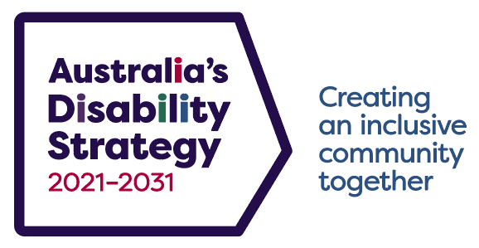

Engagement Plan
Australia’s Disability Strategy Engagement Plan (the Engagement Plan) outlines the ways people with disability will be involved in the implementation of Australia’s Disability Strategy (the Strategy) over its term. This includes having a role in monitoring and reporting on its progress. The features of the Engagement Plan will give people with disability ways to influence the future direction of the policies and services that impact on their lives.
For the Strategy to be implemented effectively, the views of people with disability, disability sector stakeholders, and diverse groups within the sector must be heard and considered. Engagement with groups such as Aboriginal and Torres Strait Islander people with disability and people with disability from culturally and linguistically diverse communities will ensure inclusion and consideration of a broad range of views.
1. The Strategy Advisory Council (the Council)
The establishment of the Council coincided with the commencement of the Strategy in 2021.
The Council’s role is to advise Australian, state and territory disability ministers and governments (including local governments) on the main elements of the Strategy, including:
- Targeted Action Plans
- Associated Plans
- Outcomes Framework
- periodic progress/implementation reports.
The Council’s advice on these matters will:
- align with the Strategy’s reporting framework and be included in reporting to ministers
and the public
- provide advice on other issues falling within scope of the Strategy’s Outcome Areas,
if agreed by jurisdictions.
The Council’s core membership will be streamlined and drawn from key stakeholder groups. At least half of the members will be people with disability. Priority groups to consider for membership of the Council include:
- Aboriginal and Torres Strait Islander people
- people from culturally and linguistically diverse communities
- women
- young people
- people with lived experience of rural and remote communities.
The Chair of the Council will attend one meeting of disability ministers each year to provide advice to disability ministers.
The Council will be closely connected with state and territory disability advisory bodies.
The Council may be supported by time-limited sub-groups as required, to bring together people with disability and their representatives, experts, and organisations to advise on topics that are a high priority for action under the Strategy.
2. Public forums and consultations to support implementation of the Strategy
At least one public forum or consultation will be held to support the implementation of the Strategy every year from 2022 to 2031 (see timeline in the Roadmap on the Strategy’s website) consisting of:
- three Strategy National Public Forums (the National Public Forum) over the term
of the Strategy, with the first to be held in 2022
- at least four state and territory Strategy Forums over the term of the Strategy, in the years
the National Public Forum is not held
- three public consultations over the term of the Strategy, to align with major reviews
of the Strategy, including one in the year before the end of the Strategy.
People with disability and organisations such as the Australian Human Rights Commission, Disabled People’s Organisations, and Disability Representative Organisations will be involved in designing, arranging, and conducting the public forums and consultations.
3. The Strategy’s website
A dedicated website (www.disabilitygateway.gov.au/ads) has been created to make it easier to locate the latest information on the Strategy. This includes:
- an information gateway to provide an accessible one-stop shop for information on the Strategy, including the Outcomes Framework and Targeted Action Plans, to raise awareness and allow users to easily find what they are looking for
- an events and ‘what’s new’ feature to provide up-to-date information on upcoming Engagement Plan events such as public forums and consultations, as well as the release of key information and policies
- an online feedback service to allow for continuous consultation for the whole community
that will be active over the life of the Strategy.
4. Good Practice Guidelines for the Engagement of People with Disability
The Australian Government is funding the development of Good Practice Guidelines for the Engagement of People with Disability. People with disability who provided advice on developing the Strategy told us a good practice engagement guide would be a valuable resource. This guide will help remove barriers to participation for people with disability and uphold the rights of people with disability to access the same opportunities in the community as everyone else.
The Guidelines will be developed by one or more non-government organisations with expertise in lived experience of disability and in engaging and communicating with people with disability. People with disability themselves will be centrally involved in, and advise on, the Guidelines as they are developed.
5. Revisions to the Engagement Plan
Throughout the life of the Strategy, the Australian Government will continue to review the effectiveness of engagement activities and explore new engagement forums. The Engagement Plan will be updated as required.

Endnote

Key stakeholder groups include people with disability, family members and carers of people with disability; organisations representing people with disability, family members, carers or service providers; technical experts and academics; organisations or individuals representing the mainstream sectors aligned with the Strategy’s Outcome Areas.

