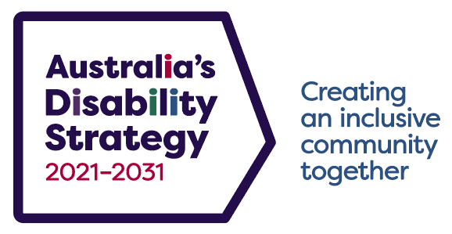

Evaluation Good Practice Guide Checklist

Protocol | Detail |  | Yes/No
The Strategy’s Guiding Principles | Evaluation aim and implementation adhere to the Strategy’s Guiding Principles. | ◻
Outcomes | Evaluation outcomes link to the Strategy’s Outcome Areas and Policy Priorities, and the Strategy’s Outcomes Framework or an appropriate proxy measure/s will  be used. | ◻
Measuring impact | Differences in outcomes across cohorts of people with disability are measured (e.g. disability type, age, gender, Aboriginal and Torres Strait Islander peoples, cultural and linguistic background, geographic location, etc.). | ◻
Conduct | People with disability are actively involved in the evaluation design, implementation and analysis, and in action flowing from recommendations/findings.  The evaluation process is culturally sensitive to people with disability from diverse backgrounds (e.g. Aboriginal and Torres Strait Islander peoples, or culturally and linguistically diverse backgrounds).  The evaluation process ensures appropriate protections for the treatment of sensitive information, privacy and confidentiality are in place. | ◻  ◻  ◻
Evaluation scope | The evaluation tests whether:  - the policy/program is meeting its objectives for people with disability, including across different cohorts  - there is equal access to the policy/program for different cohorts of people with disability  - the policy/program complements other responses under the Strategy to improve outcomes for people with disability  - the policy/program is the most effective and cost-efficient intervention for people with disability  - the intervention remains relevant to people with disability across economic, environmental, political, and social change  - the benefits for people with disability are enduring or short-term. | ◻  ◻  ◻  ◻  ◻  ◻
Findings | Key evaluation findings are provided for inclusion in two-yearly reports. | ◻
Report | Reports will be published in accessible formats.  When evaluations are published, they will be linked to the Strategy’s website. | ◻  ◻

