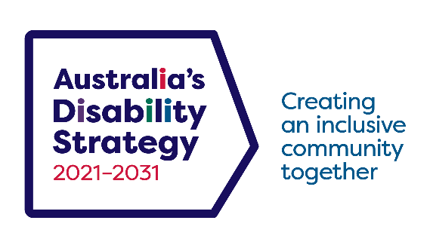

Australia’s Disability Strategy 2021 – 2031
Stakeholder Toolkit
Last updated: 29 November 2021

Introduction
Australia’s Disability Strategy 2021 – 2031 is a transformative new strategy developed by all levels of government, together with people with disability and their representatives, to change the lives of people with disability across the country.
The Strategy sets out where practical changes will be made to improve the lives of people with disability in Australia in the following areas:
- Employment and Financial Security
- Inclusive Homes and Communities
- Safety, Rights and Justice
- Personal and Community Support
- Education and Learning
- Health and Wellbeing
- Community Attitudes
For more than two years we worked closely with more than 3,000 people with disability, their families, carers and representatives to develop this strategy. The Strategy includes a strong focus on taking action in the areas people with disability said were most important in their lives. The Strategy launched on 3 December 2021 on International Day of People with Disability (IDPwD). It builds and expands on the original National Disability Strategy 2010 – 2020, adding new key features to drive more action and accountability.

Help us spread the message
The Department of Social Services (the department) encourages you to share information about the Strategy with your own networks and communities so that people with disability, their families, carers and support workers:
- know the Strategy has been finalised after years of public consultation
- understand the plans set at all levels of government to improve the lives of people with disability over the next ten years
- can find out more about opportunities to be involved in implementing the Strategy.
We have developed this Stakeholder Toolkit to provide you with a suite of materials to help you spread the word.
This is also a great opportunity to promote any ongoing and/or planned disability initiatives by your organisation that fall under or align with the Strategy.
By working together, we can create a more inclusive Australia.

Resources
A range of products are available to help you learn about and promote the Strategy.
Electronic copies of the Strategy documents are available for download at disabilitygateway.gov.au/ads-hub/strategy

Australia’s Disability Strategy Fact Sheet
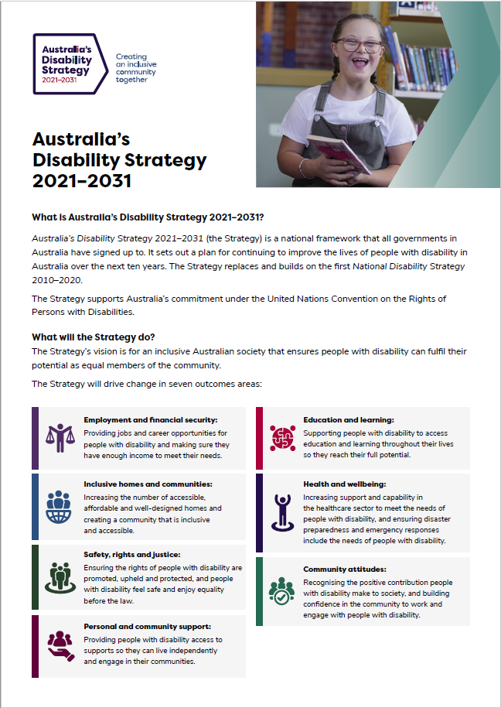

Australia’s Disability Strategy Summary Document
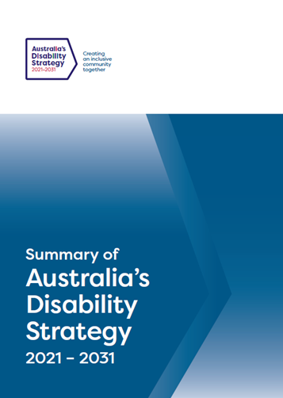
This document is also available in other accessible formats including Easy Read, Auslan and 13 language translations.

Products to help you promote the Strategy and to show your support are available at disabilitygateway.gov.au/ads-hub/keep-informed-strategy

Social Media Tiles
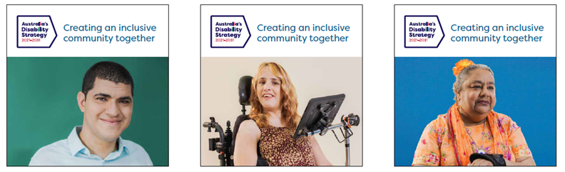
If you have any questions about these resources please email Australia’sDisabilityStrategy@dss.gov.au

Social media
You are welcome to use or adapt the content below for your own social media channels to help spread the word about the Strategy.
Facebook
Post # | Facebook message
Post # 1 | Australia’s Disability Strategy 2021 – 2031 is here.  The Strategy will drive change over the next decade so people with disability can participate in all areas of Australian life and feel included, respected and equal.  It was created alongside people with disability and their representatives, and addresses key areas such as employment, housing, education and health and wellbeing.  To find out more, visit disabilitygateway.gov.au/ads
Post # 2 | Australia’s Disability Strategy 2021 – 2031 is now here!  The Strategy is a new government plan that will drive more inclusive and accessible services to improve the lives of people with disability.  [Organisation] will be doing its part by [information about relevant work/initiatives].  By working together, we can create a more inclusive Australia.  To find out more, visit disabilitygateway.gov.au/ads

Twitter
Post # | Twitter message
Post # 1 | Australia’s Disability Strategy 2021 – 2031 is a new national plan to improve the lives of people with disability.  Let’s work together to create a more inclusive Australia where people with disability are included, respected and equal. Go to disabilitygateway.gov.au/ads
Post # 2 | [Organisation] supports Australia’s Disability Strategy 2021 – 2031 by [information about relevant work/initiatives].  To find out more, visit disabilitygateway.gov.au/ads

Newsletter or Website Content
You can use the text below on your own websites or newsletters to help spread the word about the Strategy.

Australia’s Disability Strategy launches
Australia’s Disability Strategy 2021 – 2031 (the Strategy) will advance the inclusion of Australia’s more than 4.4 million people with disability.
Over the next decade, the Strategy will drive initiatives to ensure greater inclusion and participation of people with disability in all areas of Australian life including employment, housing, education and health and wellbeing.
It sets out a plan out where governments at all levels, working with the community, business, and people with disability will focus on delivering the best possible life outcomes for people with disability through effective policy and service delivery.
[Organisation name] supports the Strategy through [We recommend adding further info about your program/initiative here].
Through the Strategy, we can create an inclusive community together.
To find out more information on Australia’s Disability Strategy 2021 – 2031 visit disabilitygateway.gov.au/ads

Frequently Asked Questions

What’s the purpose of Australia’s Disability Strategy?
The Strategy sets out where practical changes will be made to improve the lives of people with disability in Australia.
- The Strategy will:
  - provide national leadership towards greater inclusion of people with disability
  - guide activity across all areas of public policy to be inclusive and responsive to people with disability
  - drive mainstream services and systems to improve outcomes for people with disability
  - engage, inform and involve the whole community to achieve a more inclusive society.

How is this Strategy different to the National Disability Strategy 2010 – 2020?
- Australia’s Disability Strategy retains a number of policy priorities from the 2010-2020 Strategy as people with disability told us these are still relevant.
- The new Strategy has a stronger focus on employment than its predecessor.
- Community attitudes and safety are also seen as key issues for people with disability and have been given a stronger focus in this new Strategy.
- This Strategy also has a much stronger focus on accountability and transparency..
- Under the Strategy, governments have made a commitment to do implementation better.
- This includes an intensive focus to drive practical changes through the development of Targeted Action Plans, under which all governments have committed to specific actions.

What are the Outcome Areas of the Strategy?
- The Outcome Areas in the Strategy set out where governments at all levels, working with the community and business, will focus on driving improvements for people with disability.
- Collectively, the Outcome Areas represent the areas people with disability have said are important to them and need to be improved to achieve an inclusive Australian society.
- The seven Outcome Areas are:
  - Employment and Financial Security: Providing jobs and career opportunities for people with disability and making sure they have enough income to meet their needs.
  - Inclusive Homes and Communities: Increasing the number of accessible, affordable and well-designed homes and creating a community that is inclusive and accessible.
  - Safety, Rights and Justice: Ensuring the rights of people with disability are promoted, upheld and protected, and people with disability feel safe and enjoy equality before the law.
  - Personal and Community Support: Providing people with disability access to supports so they can live independently and engage in their communities.
  - Education and Learning: Supporting people with disability access to education and learning throughout their lives so they reach their full potential.
  - Health and Wellbeing: Increasing support and capability in the healthcare sector to meet the needs of people with disability, and ensuring disaster preparedness and emergency responses include the needs of people with disability.
  - Community Attitudes: Recognising the positive contribution people with disability make to society, and building confidence in the community to work and engage with people with disability.
Did people with disability have a say in the Strategy?
- The Strategy was developed in close consultation with people with disability and the disability sector over a three-year period, with more than 3,000 people and organisations providing input into the consultation process.
- An initial review was held in 2018, while Stage One consultations were held in 2019 and Stage Two consultations were held in 2020.
- These consultations included a public submission process, community workshops, a public survey, an online forum, and a range of targeted consultations including with, and led by, Aboriginal and Torres Strait Islander people with disability.
- We will continue to engage and work closely with people with disability, families and carers, advocacy organisations, peak bodies and service providers throughout the implementation of the new strategy.
- The new Strategy has an Engagement Plan and its central feature is the Strategy’s Advisory Council, which gives people with disability a new, direct voice to ministers and governments.
- The Council is made up entirely of people with disability, who will give governments direct, independent advice on the Strategy’s implementation and progress.
- The Engagement Plan also commits to holding at least one Australia’s Disability Strategy public forum or consultation every year over the life of the Strategy.
- It makes the commitment that people with disability must be closely involved in designing, arranging and delivering the forums and consultations.
How do Australia’s Disability Strategy and the NDIS work together?
- Australia’s Disability Strategy is about improving the lives of all the 4.4 million Australians with disability, of which around 480,000 are NDIS participants.
- This Strategy presents the overarching framework for inclusive policies, programs and infrastructure that will support all people with disability to participate fully in every aspect of Australian life over the next decade.
- It’s about making sure all Australians with disability can use and benefit from the broad range of supports and services available such as schools, health services, sporting venues and public transport.
- The NDIS is covered under the Strategy’s outcome areas, but the Strategy also covers many other vital services and supports used by people with disability throughout their lives.
- The NDIS is delivered under the Strategy’s Outcome 4 - Personal and Community Support.

How will we know if the Strategy is working?
- The new Strategy is focused on driving action for people with disability and reporting on the progress made. This will be publicly done through:
  - an annual data report on the outcomes achieved against the Strategy’s priorities, produced by the Australian Institute of Health and Welfare
  - an annual Targeted Action Plan Report which will track progress against individual actions that each government has committed to deliver
  - a two yearly implementation report that will document what action has been taken and what progress has been made.
  - State, territory and local government reports under jurisdictional disability inclusion plans.
- There will also be two major independent reviews of the Strategy in 2025 and 2029, as well as a review following the final report of the Disability Royal Commission in 2023.

More information
If you want further information, please visit Australia’s Disability Strategy Hub at disabilitygateway.gov.au/ads

