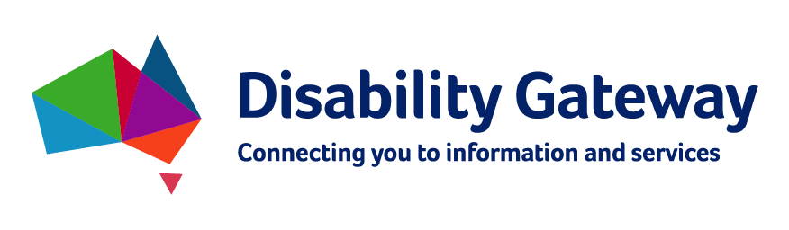

Disability Gateway

Stakeholder Kit
Updated by the Department of Social Services, 10 February 2022.

What’s in the pack?
Introduction 3
COVID-19 support 3
Help us spread the message 3
Resources 4
Social Media 5
Newsletter / eDM 8
FAQ 9
How does the Disability Gateway provide COVID-19 support 10

Introduction
Australians living with disability, their families and carers identified accessing information about policies, programs and support as a key barrier to their independence and community participation.
The Department of Social Services (DSS) has developed a way to improve access to this information by creating the Disability Gateway
The Disability Gateway includes a website, a dedicated phone line (1800 643 787) and social media channels, to assist people with disability, their families and carers, to find and access trusted information and services.
The Disability Gateway is for all Australians with disability, regardless of whether they are a National Disability Insurance Scheme (NDIS) participant or not.
Please visit the Disability Gateway website here www.disabilitygateway.gov.au

COVID-19 support
The Disability Gateway can assist people with disability, their families, carers and support workers to find trusted COVID-19 information, support and services.
Disability Gateway phone operators are trained to help people with disability to find COVID-19 information in their area, assist with booking vaccination appointments and a range of other supports.

Help us spread the message
We encourage you to share information about the Disability Gateway service with your networks.
In this kit there are key messages to help you communicate the information and services the Disability Gateway offers and to encourage people to use it and provide feedback.
Help us ensure all people with disability, their families and carers have access to up to-date, relevant information.

Resources
A range of resources are available to download from our website.
Specialist resources are also available for Aboriginal and Torres Strait Islander communities and culturally and linguistically diverse communities.

Factsheet available for download
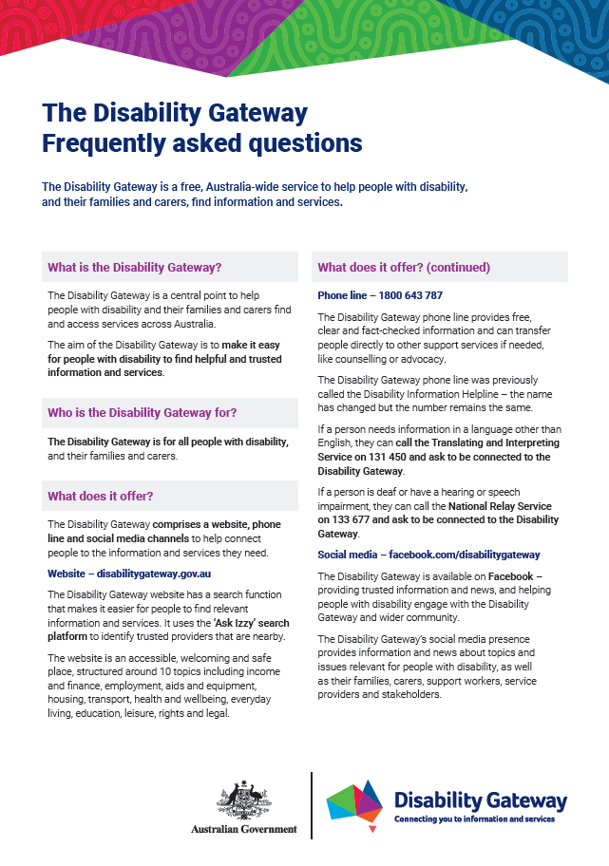
Poster available for download
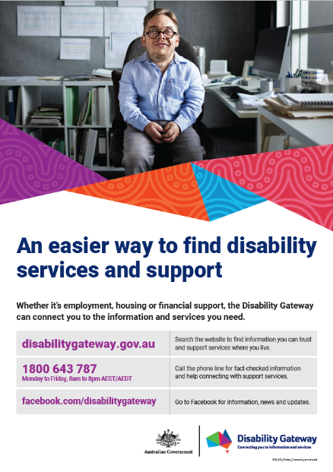

Animation
Post copy | Image
The Disability Gateway provides free, nation-wide information and services to help people living with disability, their families, friends and carers, in key areas of life including but not limited to finance, employment, health and equipment.  To access these or more services provided by the Disability Gateway visit www.disabilitygateway.gov.au or call 1800 643 787. The Disability Gateway phone line is available Monday to Friday, 8am to 8pm AEDT. | Animation available for download  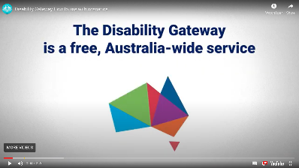

Social Media

Facebook
Post copy | Image
The Disability Gateway is your first step in finding information and services for people with disability, their families and carers.  Visit: www.disabilitygateway.gov.au or call the dedicated Disability Gateway phone line on 1800 643 787. | 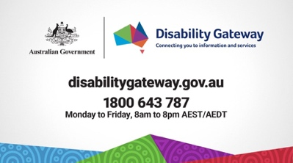
Do you care for, or have a friend with a disability?  The Disability Gateway can lead you to trusted information on disability support – and can help find services local to you.  Visit www.disabilitygateway.gov.au or call the dedicated Disability Gateway phone line on 1800 643 787. | 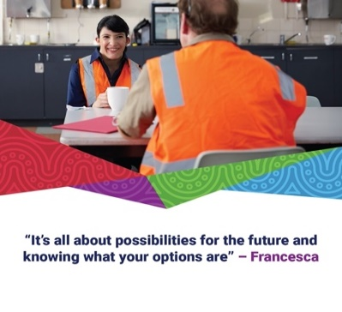
The Disability Gateway is your first step in finding information and services for people with disability, their families and carers.  If you are looking for easy to understand, accessible information and advice about COVID-19, visit www.disabilitygateway.gov.au or call 1800 643 787.  The Disability Gateway is available Monday to Friday 8am to 8pm. It is not available on weekends or national public holidays. | 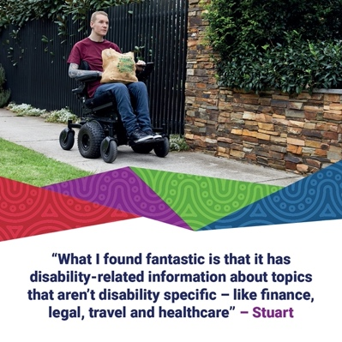
Are you looking for easy to understand information about COVID-19 for a friend or family member with disability?  Visit the Disability Gateway at www.disabilitygateway.gov.au or call 1800 643 787 for free, fact-checked and accessible information and advice about COVID-19.  The Disability Gateway is available Monday to Friday 8am to 8pm. It is not available on weekends or national public holidays. | 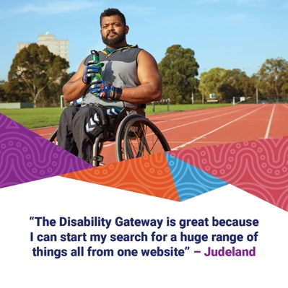

Twitter
Post copy | Image
The Disability Gateway can help you search for trusted disability services and information. Visit www.disabilitygateway.gov.au or call the dedicated Disability Gateway phone line on 1800 643 787.
Looking for disability services relevant to you? Find information on local offerings at the Disability Gateway www.disabilitygateway.gov.au or call the dedicated Disability Gateway phone line on 1800 643 787. | 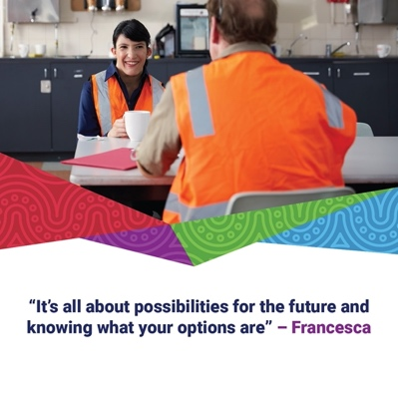
The Disability Gateway is for people with disability, their families and carers.
If you need COVID-19 support and advice in another language, you can contact the Disability Gateway on 1800 643 787 and ask for an interpreter.
Visit www.disabilitygateway.gov.au for more info.
Do you care for or live with someone with disability? Do you have concerns about COVID-19?
The Disability Gateway is available for people with disability and their families, carers and support workers.
Call 1800 643 787 or visit www.disabilitygateway.gov.au for more info.

Social media graphics

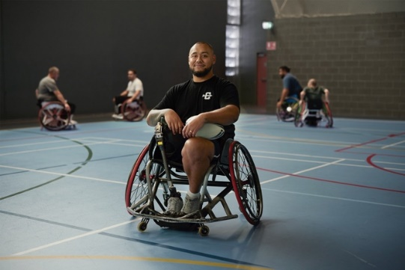
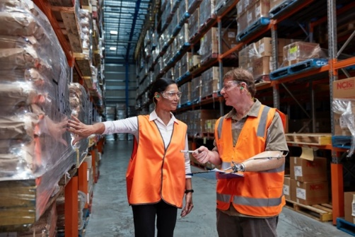

Newsletter / eDM
Around 4.4 million Australians are living with disability and there are a wide range of services and supports available. However, searching for information and services can sometimes be difficult and complex.
The Australian Government’s Disability Gateway is a free, Australia-wide service dedicated to helping people living with disability, their families and carers find trusted information and connects them to services in their area.
It includes:
- a website
- phone line and
- social media channels to help connect people to the right disability information and services.
The Disability Gateway aims to improve access to information and services and make searching less stressful. It is a central starting point, providing information people can trust that is accessible, easy and safe to use.
Information on the website is structured around 10 topic areas that provide useful categories for searching for and finding services, including income and finance, employment, aids and equipment, housing, transport, health and wellbeing, everyday living, education, leisure, and rights and legal.
The Disability Gateway phone line provides free, fact-checked information and can transfer people directly to other support services if needed, such as counselling or advocacy.
For more information go to www.disabilitygateway.gov.au or call 1800 643 787. The Disability Gateway phone line is available Monday to Friday, 8am to 8pm AEDT.

Key messages
- The Disability Gateway includes a website, a dedicated 1800-phone number and social media channels, to assist people with disability, their families and carers, to find and access trusted information and services.
- The Disability Gateway is for all Australians with disability, whether they are a National Disability Insurance Scheme (NDIS) participant or not.
- The Disability Gateway is available at www.disabilitygateway.gov.au and the dedicated Disability Gateway phone line is 1800 643 787.

FAQ
The Disability Gateway is a free, Australia-wide service to help people with disability, their families and carers, find information and services.

What is the Disability Gateway?
The Disability Gateway is a central point to help people with disability, their families and carers find and access services across Australia. The aim of the Disability Gateway is to make it easy for people with disability to find helpful and trusted information and services.

Who is the Disability Gateway for?
The Disability Gateway is for all people with disability, their families and carers.

What does it offer?
The Disability Gateway comprises a website, phone line and social media channels to help connect people to the information and services they need.

Website – disabilitygateway.gov.au
The Disability Gateway website has a search function that makes it easier for people to find relevant information and services. It uses the ‘Ask Izzy’ search platform to identify trusted providers that are nearby.
The website is an accessible, welcoming and safe place, structured around 10 topics including income and finance, employment, aids and equipment, housing, transport, health and wellbeing, everyday living, education, leisure, rights and legal.

Phone line – 1800 643 787
The Disability Gateway phone line provides free, clear and fact-checked information and can transfer people directly to other support services if needed, like counselling or advocacy.
The Disability Gateway phone line was previously called the Disability Information Helpline – the name has changed but the number remains the same.
If a person needs information in a language other than English, they can call the Translating and Interpreting Service on 131 450 and ask to be connected to the Disability Gateway.
If a person is deaf or has a hearing or speech impairment, they can call the National Relay Service on 133 677 and ask to be connected to the Disability Gateway.

Social media – facebook.com/disabilitygateway
The Disability Gateway is available on Facebook – providing trusted information and news, and helping people with disability engage with the Disability Gateway and wider community.
The Disability Gateway’s social media presence provides information and news about topics and issues relevant for people with disability, as well as their families, carers, support workers, service providers and stakeholders.

How does the Disability Gateway provide COVID-19 support?
People with disability can also contact the Disability Gateway on 1800 643 787 for free COVID-19 information and support including:
  - help with booking your vaccination appointment
  - information and support on getting tested
  - applying for COVID-19 financial support
  - COVID-19 Information in accessible formats such as Easy Read or Auslan.

If you need information in a language other than English, call the Translating and Interpreting Service on 131 450 and ask to be connected to the Disability Gateway.
If you are deaf or have a hearing or speech impairment, call the National Relay Service on 133 677 and ask to be connected to the Disability Gateway.
When you call the Disability Gateway, you will talk to a real person who will give you clear and fact-checked information and connect you to helpful supports and services.
The Disability Gateway website also has a dedicated COVID-19 page that provides access for people with disability, their families, carers and support workers to trusted COVID-19 information, support and services.

Social Media (COVID-19)
Facebook
Post copy | Image
People with disability can find trusted COVID-19 information and support by calling the Disability Gateway on 1800 643 787 or visiting disabilitygateway.gov.au.  When you call the Disability Gateway, you will talk to a real person who will give you clear and fact-checked information and connect you to helpful supports and services.  If you need information in a language other than English, call the Translating and Interpreting Service on 131 450 and ask to be connected to the Disability Gateway.  If you are deaf or have a hearing or speech impairment, call the National Relay Service on 133 677 and ask to be connected to the Disability Gateway. | 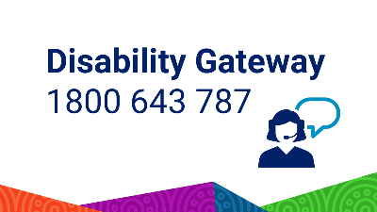
Are you living with disability and need support to book your COVID-19 vaccination or booster? We can help.
Call the Disability Gateway on 1800 643 787 or visit disabilitygateway.gov.au for more information.
Do you have a question about COVID-19? Do you need help because things have changed?
The Disability Gateway can give you, clear and fact-checked information and can transfer you to other support services if needed, like counselling or advocacy.
Call 1800 643 787 or visit www.disabilitygateway.gov.au for more information.
Did you know there is a dedicated phone line to assist people with disability to make a COVID-19 vaccination appointment?

It’s also available for families and carers too.
For more information or assistance, call the Disability Gateway on: 1800 643 787 Monday to Friday from 8am-8pm AEST or visit www.disabilitygateway.gov.au.
Twitter
Post copy | Image
People with disability can find trusted COVID-19 information and support by calling the Disability Gateway on 1800 643 787 or visiting disabilitygateway.gov.au.
Are you a person with disability looking for support to book your COVID-19 vaccination or booster? We can help. Call the Disability Gateway on 1800 643 787 or visit disabilitygateway.gov.au.

