# Australia’s Disability Strategy 2021–2031

## Targeted Action Plans What have we done so far?

### 3 December 2021 to 30 June 2022

### A text-only Easy Read report

## How to use this report

The Australian Government Department of Social Services (DSS) wrote this report. When you see the word ‘we’, it means DSS.

We wrote this report in an easy to read way.

We wrote some words in **bold**.

This means the letters are thicker and darker.

We explain what these bold words mean.

There is a list of these words on page 16.

This Easy Read report is a summary of another report.

This means it only includes the most important ideas.

You can find the other report on our website.

Website – [www.disabilitygateway.gov.au/ads](http://www.disabilitygateway.gov.au/ads)

You can ask for help to read this report. A friend, family member or support person may be able to help you.

If you speak a language other than English, you can call Translating and Interpreting Services (TIS).

Phone – **1800 131 450**

## What’s in this report?

What is this report about? 3

What’s happened already? 5

Working and earning money 7

Community attitudes 8

Early childhood 10

Safety 12

Managing emergencies 14

Word list 16

## What is this report about?

Australia’s Disability Strategy 2021–2031 is a plan to support people with disability in all areas of their life.

In this report we call it the Strategy.

**The Strategy will last for 10 years.**

**It will finish in 2031.**

The Strategy is for:

* people with disability
* the Australian community.

The Strategy is also for all levels of government in Australia, including:

* the Australian Government
* state and territory governments
* local governments.

The Strategy includes **outcomes**.

**These are the important results we want to get for people with disability.**

**The Strategy** has ideas about how to make different areas of life better for people with disability.

**We call these** outcome areas**.**

### What are the Targeted Action Plans?

Our Targeted Action Plans talk about what we will do to help get the outcomes.

We call them action plans.

**This includes what:**

* the Australian Government will do
* state and territory governments will do.

**We talked to people with disability about what should be in our action plans.**

**And we used their ideas to write our action plans.**

**There are 5 action plans:**

1. Working and earning money

2. Community attitudes

3. Early childhood

4. Safety

5. Managing emergencies

**In this report, we explain each action plan.**

**We also explain what governments did between 3 December 2021 to 30 June 2022.**

**This includes how many actions they:**

* **have finished**
* **are still working on.**

**We also use the images to show this.**

**For example, 10% of actions.**

## What’s happened already?

There are 417 actions that all levels of government need to do by June 2024.

So far, governments:

* have finished 10% of actions
* are working on 74% of actions.

12% of actions have been delayed.

But governments are still working on them.

2% of actions were paused.

But governments:

* are still working on these actions
* will finish these actions before June 2024.

Governments will start working on the last 2% of actions after 30 June 2022.

In each action plan, governments have started working on at least 90% of the activities.

This includes finished activities.

Western Australia is on track to finish 100% of their activities.

And South Australia has the most finished activities.

The Managing emergencies action plan has 95% of actions that:

* are finished

or

* governments are still working on.

This is the highest amount for any action plan.

The Safety action plan has the most finished actions.

But it also has the most actions that are:

* delayed
* paused.

## Working and earning money

We want people with disability to have the chance to have a job and enough money so they can:

* live well
* plan for their future
* have choice and control of their own lives.

**Our Working and earning money action plan** has 2 **goals.**

1. Support people with disability to find

and keep jobs.

2. Make it better for young people with disability

when they leave school to get ready to work.

**This plan also** has 83 a**ctions that all governments need to do.**

### What have governments done so far?

**So far, governments have** finished 10 out of the 83 actions**.**

**They are still working** on 72 out of the 83 actions**.**

**This** includes 10 out of the 83 ac**tions that are delayed or paused.**

**Governments will** start the last **action in the future.**

**The Australian** Government has finished 3 out of their 12 actions.

**The Northern Territory (NT) Government has done a lot to support students with disability to move from school or learning to work.**

**So far, the NT Government has given plans to** 78 students**.**

**And they gave grants** to 8 schools **far away from cities or towns.**

**A grant is money from the government to pay for important projects to help others.**

## Community attitudes

Your **attitudes** are what you think, feel and believe.

We want the community to have positive attitudes towards people with disability.

We want community attitudes to support treating people with disability as equals.

And we want community attitudes to be **inclusive**.

When the community is inclusive, everyone can:

* take part
* feel like they belong.

Our Community attitudes action plan has 4 goals.

1. **Employers** understand that people with

disability are good workers.

An employer is a person who hires other people to work for them.

2. The services and businesses people use

the most know the right ways to support people with disability.

3. More people with disability can be leaders

where they work.

4. The whole community has positive attitudes

towards people with disability.

This action plan also has 68 actions that all governments need to do.

### What have governments done so far?

**So far, governments have** finished 5 out of the 68 actions**.**

**They are still working** on 63 out of the 68 actions**.**

**This** includes 9 out of the 68 actions **that are delayed or paused.**

**The ACT Government has started writing plans for how to be more** **accessible and inclusive.**

**When the community is accessible, it is easy to:**

* **find and use things**
* **travel around.**

**The ACT Government worked with people with disability between March to July 2022.**

**People with disability ran all of the meetings.**

**And people could choose how they shared their ideas.**

**For example, answering questions online or in person.**

**The ACT Government will write a report about what people shared.**

**And they will publish it in December 2022.**

**The Australian Government worked with a group of researchers called the Australian Council of Learned Academies (ACOLA).**

**ACOLA checked the type of training and learning workers get about disability to see what:**

* **worked well**
* **needs to be better.**

**They wrote a guide about what:**

* **they found out**
* **needs to happen in the future.**

## Early childhood

**We want people with disability to get what they need from:**

* **school**
* **learning**
* **training.**

**We want people with disability to:**

* **learn**
* **develop their skills.**

**This will help them:**

* **be who they want to be**
* **live the life they want to live.**

**Our Early childhood action plan** has 3 **goals.**

1. **Help young children with disability get the**

**support they need during early childhood.**

2. **Support services to help parents and**

**carers make choices about young children with disability.**

3. **Give parents, carers and young children**

**with disability more chances to connect with others.**

**This action plan** also has 76 actions that all governments need to do.

### What have governments done so far?

**So far, governments have** finished 2 out of the 76 actions**.**

**They are still working** on 71 out of the 76 actions.

**This** includes 12 out of the 76 actions **that are delayed or paused.**

**Governments will** start 3 out of the 76 actions **in the future.**

**The TAS Government is** building 6 new**buildings to support:**

* **parents and carers**
* **children with disability.**

**All of these buildings will be open by 2024.**

**The NSW Government is creating one place where people can find and use information about school and learning.**

**You can find out more on their website.**

Website – <https://education.nsw.gov.au/parents-and-carers/inclusive-learning-support>

## Safety

We want people with disability to:

* feel safe
* be treated the same as other people in the community.

We also want people with disability to have their **rights** protected.

Rights are rules about how everybody should be treated fairly and equally.

Our Safety action plan has 5 goals.

1. We will get better at knowing if a person with

disability is at risk of harm.

2. The services in our community know how to

keep people with disability safe, including:

* community services
* services everyone can use
* services for people with disability.

3. Government services are made better to

support people with disability at risk of harm.

4. Government services:

* use **restrictive practices** less
* stop using restrictive practices.

Restrictive practices are actions that stop people from moving and doing what they want.

5. We will help people with disability get better

at knowing:

* when they are at risk of harm
* who they can tell
* what **safeguards** they have.

Safeguards are things we can do to:

* keep someone safe
* make sure they still have choice and control.

**This action plan** also has 132 actions that all governments need to do.

### What have governments done so far?

**So far, governments have** finished 15 out of the 132 actions**.**

**They are still working on** 112 out of the 132 actions**.**

**This** includes 24 out of the 132 actions **that are delayed or paused.**

**Governments will** start 5 out of the 132 actions **in the future.**

**The Victorian (VIC) Government is supporting children and young people with disability in court.**

**And they are helping prisons understand how to work with people with disability.**

**The VIC Government is** running 2 tr**aining programs in-person.**

**The SA Government is making sure new social housing is accessible.**

**Social housing provides homes that cost less to live in.**

**Between December 2021 and June 2022, they focused on accessibility** in 46 projects**.**

## Managing emergencies

**We want people with disability to:**

* **be healthy**
* **enjoy the life they live.**

**Our Managing emergencies action plan** has 2**goals.**

1. **Include more people with disability when we:**

* **plan for emergencies**
* **look at risks.**

**An emergency is something dangerous that:**

* **we don’t expect to happen**
* **can put your health at risk.**

2. **Support the health of people with disability when emergencies happen.**

**This includes before, during and after an emergency.**

**This action plan** also has 58 actions that all governments need to do.

### What have governments done so far?

**So far, governments have** finished 11 out of the 58 **actions.**

**They are still working** on 47 out of the 58 actions**.**

**This** includes 3 out of the 58 actions **that are delayed or paused.**

**The Western Australian (WA) Government is working with the community to better support people with disability in an emergency.**

**For example, after the Wooroloo bushfires they talked to people who work with people with disability.**

**The WA Government also created a Disability Taskforce.**

**The Taskforce supported people with disability who were affected by COVID-19.**

**They also made a list of accessible places for people with disability to stay when they must self-isolate.**

**If you self-isolate, you don’t:**

* **leave your house**

**or**

* **see other people.**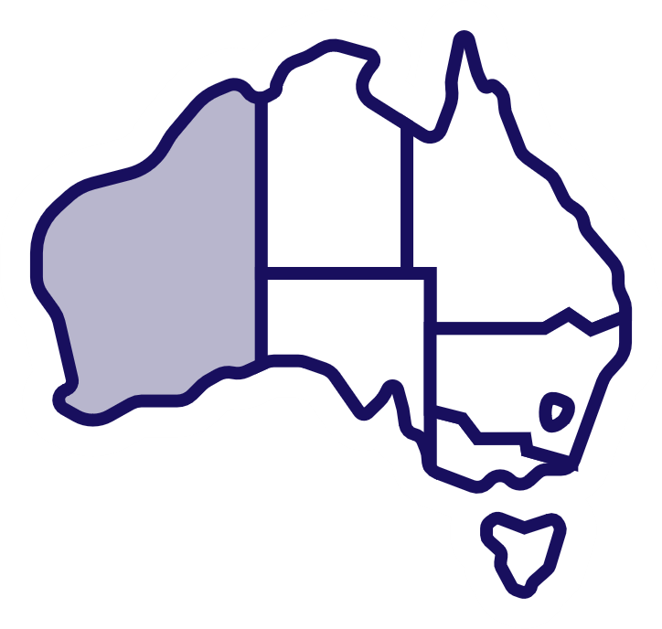

**The QLD Government is working with people with disability when they plan for life after an emergency.**

**For example, after a flood.**

**The QLD Government made** sure 100% of **the District Human and Social Recovery groups worked with a person who:**

* **has a disability**

**or**

* **supports a person with disability.**

**These groups support people after an emergency.**

## Word list

This list explains what the **bold** words in this document mean.

**Accessible**

**When the community is accessible, it is easy to:**

* **find and use things**
* **travel around.**

**Attitudes**

Your attitudes are what you think, feel and believe.

**Emergencies**

**An emergency is something dangerous that:**

* **we don’t expect to happen**
* **can put your health at risk.**

**Employers**

An employer is a person who hires other people to work for them.

**Grants**

**A grant is money from the government to pay for important projects to help others.**

**Inclusive**

When the community is inclusive, everyone can:

* take part
* feel like they belong.

**Outcomes**

**These are the important results we want to get for people with disability.**

**Restrictive practices**

Restrictive practices are actions that stop people from moving and doing what they want.

**Rights**

Rights are rules about how everybody should be treated fairly and equally.

**Safeguards**

Safeguards are things we can do to:

* keep someone safe
* make sure they still have choice and control.

**Self-isolate**

**If you self-isolate, you don’t:**

* **leave your house**

**or**

* **see other people.**

**Social housing**

**Social housing provides homes that cost less to live in.**

This text-only Easy Read document was created by the Information Access Group. For any enquiries, please visit [www.informationaccessgroup.com](http://www.informationaccessgroup.com)  
Quote job number 5007.