Lipoti mo Fuafuaga Faatino

3 Tesema 2021 ia Iuni 30 2022

*Fuafuaga Faataatia o Aafiaga Tumau i le Soifua i Ausetalia 2021-2031*

This document, Summary Targeted Action Plans Report, is licensed under the Creative Commons Attribution 4.0 International License, with the exception of:

• The Australia’s Disability Strategy 2021-2031 logo and branding

• Any third-party material

• All images and/or photographs.

More information on this CC By license is set out at the Creative Commons

website: <https://creativecommons.org/licenses/by/4.0/legalcode>

Tagavai o le Creative Commons

Attribution

Use of all or part of this document must include the following attribution:

© Commonwealth of Australia (Department of Social Services) 2022

Enquiries about copyright arrangements and any use of this information can be sent to the Department of Social Services:

By email: copyright@dss.gov.au

By post:

Communications and Media

Department of Social Services, GPO Box 9820, Canberra ACT 2601

Design: Dreamtime Creative

Anotusi

Faatomuaga 4

Alualu i luma o le Atunuu 5

Fuafuaga o Faatinoga Tulimata’i o Galuega 8

Fuafuaga Faatino i Uiga o Nuu 11

Fuafuaga Faatino mo A'oga Amata 13

Fuafuaga Faatino mo le Saogalemu 15

Fuafuaga Faatino mo Pulega o Faalavelave Faafuase'i 17

Gaioiga o loo Faatino 19

# Faatomuaga

*Fuafuaga Faataatia o Aafiaga Tumau i le Soifua a Ausetalia 2021-2031* (Fuafuaga Faataatia) e amata ai se fuafuaga e suia ai olaga o tagata e iai aafiaga tumau i le soifua mo le sili atu i le 10 tausaga.

I lalo o le Fuafuaga Faataatia, o Fuafuaga Faatino (TAPs) e faaaoga le taula'i malosi i le sili atu i le tasi i le 3 tausaga ina ia ausia tulaga mana'omia e faaleleia ai taunuuga mo tagata e iai aafiaga tumau i le soifua.

O TAP ta'itasi e tofia ma faamaonia e minisita uma o aafiaga tumau i le soifua a Ausetalia ma e aofia ai fuafuaga faatino ma faamaopopo mai i malō. O faatinoga e faavae i molimau o loo maua ma o tagata e iai aafiaga tumau i le soifua e aofia ai i le faatinoina o gaioiga.

O Fuafuaga Faatino e 5 na faalauiloa ma le Fuafuaga Faataatia i le aso 3 o Tesema 2021, o:

* [Fuafuaga o Faatinoga Tulimata’i o Galuega](https://www.disabilitygateway.gov.au/document/3151)
* [Fuafuaga Faatino i Uiga o Nuu](https://www.disabilitygateway.gov.au/document/3141)
* [Fuafuaga Faatino mo A'oga Amata](https://www.disabilitygateway.gov.au/document/3146)
* [Fuafuaga Faatino mo le Saogalemu](https://www.disabilitygateway.gov.au/document/3176)
* [Fuafuaga Faatino mo Pulega o Faalavelave Faafuase'i](https://www.disabilitygateway.gov.au/document/3181)

O TAPs ia e 5 ua otooto ai faatinoga ua tuuto ai malō e faia mai ia Tesema 3 2021 ia Iuni 30 2024. I le faasologa o le Fuafuaga Faataatia, o le a tofia ai ni TAPs fou. O le taula'i a TAPs o le a faailoaina e ala i le galulue ma tagata e iai aafiaga tumau i le soifua. O TAPs uma o le a tuuina i luga o le upega tafa'ilagi a le Fuafuaga Faataatia.

O le lipoti faaletausaga muamua lea i TAPs ma e aofia ai le piriota mai ia Tesema 3 2021 ia Iuni 30 2022.

O loo faaalia ai le aotelega o le alualu i luma na iai i faatinoga ta'itasi e 417 mo TAPs e 5.

O lenei Lipoti e aofia ai se Faaopopoga lea e aumai ai se aotelega o faamatalaga i le alualu i luma na iai i le taimi e faia ai lipoti mo faatinoga ta'itasi e 417. O le alulau i luma na lipotia e faasaga i faatinoga ta'itasi e aofia ai fo'i lona tulaga atoa:

* Mae'a O lenei gaioiga na faamae'aina ia Iuni 30 2022.
* Gasolo lelei O loo sologa lelei gaioiga e fetaui ma fuafuaga.
* Nai faatuai A'o faagasolo gaioiga, ua tuai le faatamo’eina mai le taimi sa'o faatulagaina.
* Taofia O gaioiga a le'i amata pe na tuu e amata, ae ua taofia.
* Amata i se taimi o i luma Na tuu e amata gaioiga pe a uma Iuni 30 2022.

O malō a setete ma teritori a Ausetalia na fai o latou sao i le Lipoti a le TAPs.

Mo nisi faamatalaga i le Fuafuaga Faatatau, e aofia ai TAPS, e maua i le [www.disabilitygateway.gov.au/ads](http://www.disabilitygateway.gov.au/ads)

# Alualu i luma o le Atunuu

O gaioiga faasaga i faatinoga a TAP sa gasolo lelei i le 7 masina na fai ai lipoti.

I le tuuaofa'i, o TAPs e 5 e aofia ai faatinoga e 417 i Ausetalia atoa, malō a setete ma teritori. Mo TAPs uma e 5, o le tele o gaioiga na faailoa e pei ona amata i totonu o le piriota na fai ai lipoti, ma:

* 350 (84%) na lipotia ua ma'ea poo loo sologa lelei
* 58 (14%) ma'ea ni nai gaioiga ae o loo iai ni nai faatuai poo loo taofia
* 9 (2%) lona aso amata ina ua uma le piliota na fai ai lipoti

O mafuaaga mo le tuai poo le taofia o gaioiga a TAP sa eseese, ae peita'i o nisi faatuai poo taofiga na aafia i gaioiga i totonu poo malō uma:

* 3 na soota'i i le faamaopoopo o gaioiga i malō uma
* 7 na faalagolago i gaioiga poo faai'uga i totonu o le latou malō poo se isi

I le ma le isi, a'o faaauau ona aafia a tatou galuega ma ola i le KOVITI-19, e na o le 15 (4%) gaioiga na lipoti faapitoa le aafiaga i le alulau i luma ona o le KOVITI-19, e ala i le tuai poo aafiaga o le taula'i i a latou gaioiga. Tasi (0.2%) gaioiga i Niusauelese (NSW) na taofia ona o le tali atu i gaioiga o lologa.

O TAP ta'itasi na lipotia o le 90% o gaioiga ua ma'ea, sologa lelei poo loo tuai. O le TAP mo le Puleaina o Faalavelave Faafuase'i e sili le maualuga o vaega ua ma'ea ma o loo sologa lelei gaioiga (95%) mo piriota na fai ai lipoti. E ui ina avea le TAP o le Saogalemu ma pito sili ona tele gaioiga ua mae'a (15), o loo avea fo'i ma sili i le numera o gaioiga na iai ni faatuai poo le taofia (24).

Laulau 1: Alualu i luma o gaioiga a TAPs e ala le TAP ma le tulaga

|  |  |  |  |  |  |  |
| --- | --- | --- | --- | --- | --- | --- |
| **TAP** | **Mae'a** | **Gasolo lelei** | **Nai faatuai** | **Taofia** | **Amata i se taimi o i luma** | **Aofa'i** |
| **Galuega** | 10 | 62 | 9 | 1 | 1 | 83 |
| **Amioga a le Nuu** | 5 | 54 | 6 | 3 | 0 | 68 |
| **A'oga Amata** | 2 | 59 | 10 | 2 | 3 | 76 |
| **Saogalemu** | 15 | 88 | 21 | 3 | 5 | 132 |
| **Puleaina o Faalavelave Faafuase'i** | 11 | 44 | 2 | 1 | 0 | 58 |
| **Aofa'i** | 43 | 307 | 48 | 10 | 9 | 417 |
| **Pasene** | 10% | 74% | 12% | 2% | 2% |  |

Siata 1: Alualu i luma o gaioiga a TAPs e ala i le TAP ma le tulaga

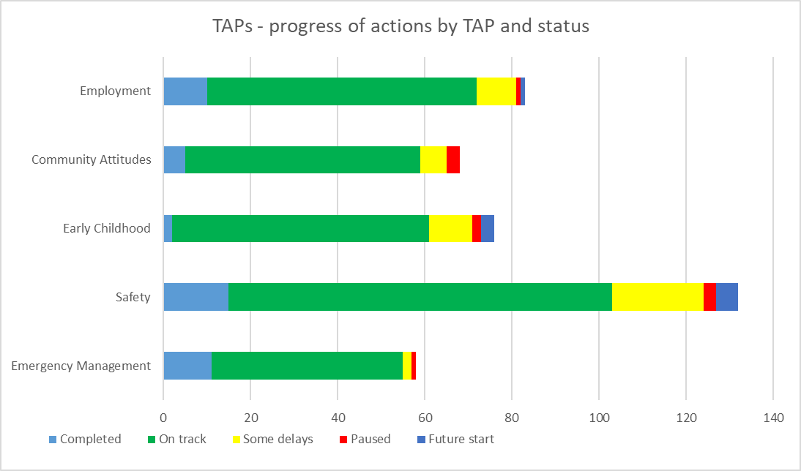

Alualu i luma o gaioiga a TAPs e ala i le TAP ma le tulaga

Mae'a

Nai faatuai

Taofia

Galuega

Amata i se taimi o i luma

Gasolo lelei

Puleaina o Faalavelave Faafuase'i

Saogalemu

A'oga Amata

Amioga a le Nuu

I malō uma, e sili atu ma le 90 pasene o gaioiga na lipotia ua ma'ea, sologa lelei poo faatuai. O Ausetalia i Sisifo e sili le maualuga o vaega o gaioiga o loo sologa lelei (100%) mo le piriota na fai ai lipoti. O Ausetalia i Saute e sili le maualuga o gaioiga ua mae'a (15) mo le piriota na fai ai lipoti.

Laulau 2: Tulaga o le alualu i luma o gaioiga a TAPs a le malō

|  |  |  |  |  |  |  |
| --- | --- | --- | --- | --- | --- | --- |
| **Malō** | **Mae'a** | **Gasolo lelei** | **Nai faatuai** | **Taofia** | **Amata i se taimi o i luma** | **Aofa'i** |
| Aus Gov | 5 | 31 | 16 | 1 | 6 | 59 |
| NSW | 3 | 31 | 9 | 3 | 0 | 46 |
| VIC | 0 | 46 | 2 | 2 | 0 | 50 |
| QLD | 9 | 37 | 8 | 0 | 1 | 55 |
| WA | 0 | 31 | 0 | 0 | 0 | 31 |
| SA | 15 | 47 | 3 | 2 | 2 | 69 |
| TAS | 3 | 21 | 5 | 0 | 0 | 29 |
| ACT | 4 | 35 | 1 | 0 | 0 | 40 |
| NT | 4 | 28 | 4 | 2 | 0 | 38 |
| **Aofa'i o le Atunuu** | **43** | **307** | **48** | **10** | **9** | **417** |

Siata 2: Tulaga o le alualu i luma o gaioiga a TAPs a le malō

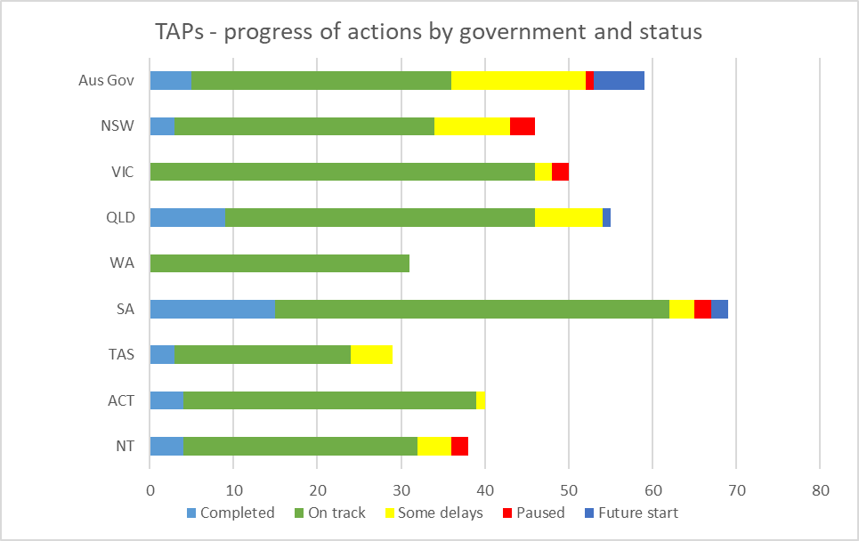

Gasolo lelei

Amata i se taimi o i luma

TAPs - progress of acta Tulaga o le alualu i luma o gaioiga a TAPs a le malō ions by government and status

Mae'a

NT

ACT

TAS

SA

WA

QLD

VIC

NSW

Aus Gov

Taofia

Nai faatuai

# Fuafuaga o Faatinoga Tulimata’i o Galuega

**Faatomuaga**

Ua faia lea Fuafuaga Taula'i o Galuega Faatino (TAP) ina ia una'i le aga'i i luma i lalo o le Vaega o Taunuuga o Galuega ma Puipuiga tau Tupe o le Fuafuaga. O lenei Vaega o Taunuuga e vaai aga'i i le faamautinoa le iai o puipuiga tau tamaoaiga o tagata e iai aafiaga tumau, ia mafai ai e latou ona fuafua mo le lumana'i, ma faata'ita'i filifiliga ma pulega i latou lava olaga. O le vaega autū o le puipuiga tau tamaoaiga o galuega ma o lenei TAP o se saofaga autū lea i lenei vaega o taunuuga.

I lalo o le TAP o Galuega e iai faatinoga e 83 i Ausetalia, setete ma malō teritori. E aofia ai faatinoga o le a avatu galuega faata'ita'i e fesoota'i ai tagata e iai aafiaga tumau i nofoaga e utiuti ai le agavaa, galue ina ia faateleina galuega i totonu o 'auaunaga lautele ma una'i faaleleiga i polokalame tau galuega.

**Sini**

1. Faatele galuega o tagata e iai aafiaga tumau i le soifua.

2. Faalelei le suiga mai o tupulaga talavou e iai aafiaga tumau i le soifua mai a'oa'oga i galuega.

Laulau 3: TAP o Galuega - faatinoga alualu i luma a le malo

|  |  |  |  |  |  |  |
| --- | --- | --- | --- | --- | --- | --- |
| **Malō** | **Mae'a** | **Gasolo lelei** | **Nai faatuai** | **Taofia** | **Amata i se taimi o i luma** | **Aofa'i** |
| Aus Gov | 3 | 6 | 3 | 0 | 0 | 12 |
| NSW | 1 | 5 | 1 | 0 | 0 | 7 |
| VIC | 0 | 17 | 0 | 1 | 0 | 18 |
| QLD | 2 | 9 | 0 | 0 | 0 | 11 |
| WA | 0 | 7 | 0 | 0 | 0 | 7 |
| SA | 1 | 9 | 0 | 0 | 1 | 11 |
| TAS | 1 | 0 | 4 | 0 | 0 | 5 |
| ACT | 2 | 5 | 0 | 0 | 0 | 7 |
| NT | 0 | 4 | 1 | 0 | 0 | 5 |
| **Aofa'i o le Atunuu** | **10** | **62** | **9** | **1** | **1** | **83** |

Siata 3: TAP o Galuega- faatinoga alualu i luma a le malo

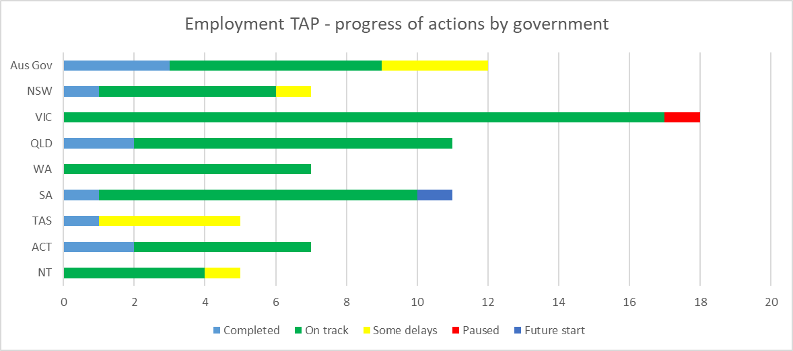

Amata i se taimi o i luma

Gasolo lelei

Nai faatuai

Mae'a

Taofia

NT

ACT

TAS

SA

WA

QLD

VIC

NSW

Aus Gov

TAP o Galuega- faatinoga alualu i luma a le malo

Laulau 4: TAP o Galuega - faatinoga alualu i luma e ala i sini

|  |  |  |  |  |  |  |
| --- | --- | --- | --- | --- | --- | --- |
| **Sini** | **Mae'a** | **Gasolo lelei** | **Nai faatuai** | **Taofia** | **Amata i se taimi o i luma** | **Aofa'i** |
| Sini 1 | 5 | 41 | 6 | 1 | 0 | 53 |
| Sini 2 | 5 | 21 | 3 | 0 | 1 | 30 |
| **Aotelega** | **10** | **62** | **9** | **1** | **1** | **83** |

Siata 4: TAP o Galuega - faatinoga alualu i luma e ala i sini

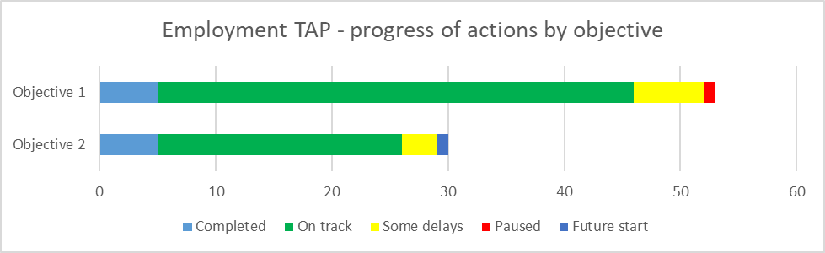

Amata i se taimi o i luma

Gasolo lelei

TAP o Galuega - faatinoga alualu i luma e ala i sini

Nai faatuai

Mae'a

Sini 1

Sini 2

Taofia

# Fuafuaga Faatino i Uiga o Nuu

**Faatomuaga**

Ua faia lea TAP o Amioga o Nuu ina ia una'i le aga'i i luma i lalo o le Vaega o Taunuuga i Uiga o Nuu o le Fuafuaga. O lenei Vaega o Taunuuga e faamoemoe ina ia faamautinoa le faaleleia o uiga o nuu ma ia mafai e tagata e iai aafiaga tumau i le soifua ona laugatasia, aofiaga ma le auai faatasi i totonu o sosaiete.

I lalo o le TAP o Amioga o Nuu e iai faatinoga e 68 i Ausetalia, setete ma malo o teritori. E aofia ai faatinoga o le a atina'e ai le mautinoa o aafiaga tumau i le soifua i totonu o tulaga faapitoa, faatino faiganuu ma gaioiga tau a'oa'oga, ma faia puna'oa tau a'oa'oga mo tagata faigaluega o loo galulue i luma ina ia faaleleia ai lo latou malamalamaga i aafiaga tumau o le soifua.

**Sini**

1. E faatauaina e falefaigaluega le sao o tagata e iai aafiaga tumau i le soifua i le galuega, ma iloa faamanuiaga maua i le faafaigaluegaina o i latou.

2. O galuega faapolofesa taua ua mafai ona tali ma le mautinoa ma le lelei i tagata e iai aafiaga tumau i le soifua.

3. Faatele sui o tagata e iai aafiaga tumau i le soifua i tulaga tau ta'ita'i.

4. Faalelei amioga a nuu ina ia lelei lona aafiaga i luga o Faavae Faamuamua i lalo o le Fuafuaga.

Laulau 5: TAP o Amioga a Nuu - faatinoga alualu i luma a le malo

|  |  |  |  |  |  |  |
| --- | --- | --- | --- | --- | --- | --- |
| **Malō** | **Mae'a** | **Gasolo lelei** | **Nai faatuai** | **Taofia** | **Amata i se taimi o i luma** | **Aofa'i** |
| Aus Gov | 0 | 2 | 1 | 0 | 0 | 3 |
| NSW | 1 | 7 | 2 | 1 | 0 | 11 |
| VIC | 0 | 9 | 0 | 1 | 0 | 10 |
| QLD | 1 | 10 | 2 | 0 | 0 | 13 |
| WA | 0 | 3 | 0 | 0 | 0 | 3 |
| SA | 3 | 5 | 0 | 0 | 0 | 8 |
| TAS | 0 | 5 | 0 | 0 | 0 | 5 |
| ACT | 0 | 10 | 0 | 0 | 0 | 10 |
| NT | 0 | 3 | 1 | 1 | 0 | 5 |
| **Aofa'i o le Atunuu** | **5** | **54** | **6** | **3** | **0** | **68** |

Siata 5: TAP o Amioga a Nuu - faatinoga alualu i luma a le malo

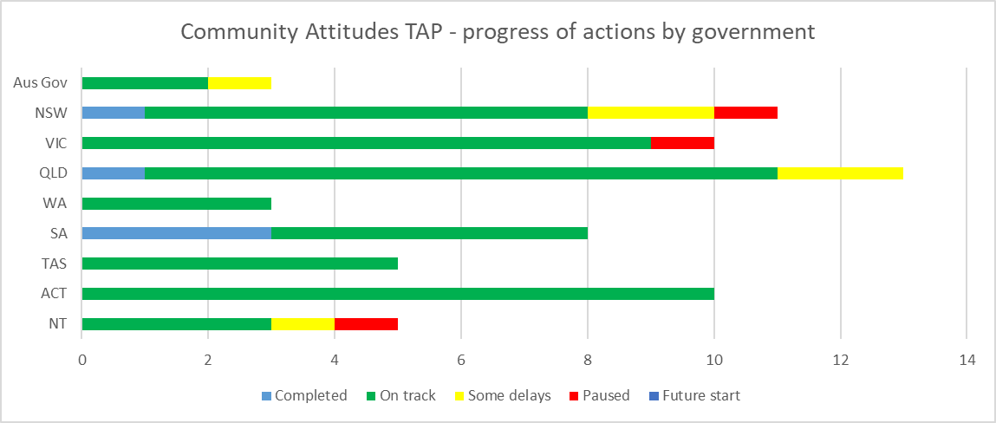

Amata i se taimi o i luma

Gasolo lelei

TAP o Amioga a Nuu - faatinoga alualu i luma a le malo

Aus Gov

NSW

VIC

QLD

WA

SA

TAS

ACT

NT

Taofia

Nai faatuai

Mae'a

Laulau 6: TAP o Amioga a Nuu - faatinoga alualu i luma e ala i le sini

|  |  |  |  |  |  |  |
| --- | --- | --- | --- | --- | --- | --- |
| **Sini** | **Mae'a** | **Gasolo lelei** | **Nai faatuai** | **Taofia** | **Amata i se taimi o i luma** | **Aofa'i** |
| Sini 1 | 1 | 6 | 1 | 0 | 0 | 8 |
| Sini 2 | 0 | 16 | 2 | 0 | 0 | 18 |
| Sini 3 | 1 | 7 | 0 | 0 | 0 | 8 |
| Sini 4 | 3 | 25 | 3 | 3 | 0 | 34 |
| **Aotelega** | **5** | **54** | **6** | **3** | **0** | **68** |

Siata 6: TAP o Amioga a Nuu - faatinoga alualu i luma e ala i le sini

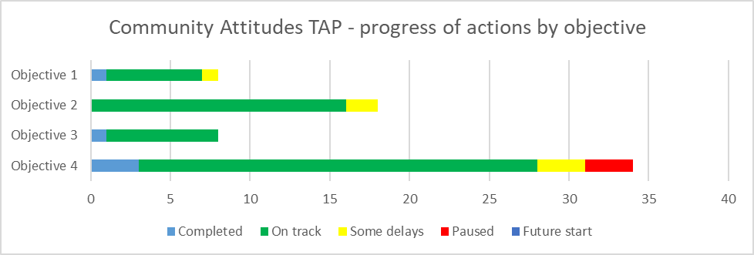

Amata i se taimi o i luma

Gasolo lelei

Sini 4

Sini 3

Sini 1

Sini 2

TAP o Amioga a Nuu - faatinoga alualu i luma e ala i le sini

Nai faatuai

Taofia

Mae'a

# Fuafuaga Faatino mo A'oga Amata

**Faatomuaga**

Ua faia TAP o Aoga Amata ina ia una'i le aga'i i luma i lalo o Soifua Maloloina ma le Soifua Manuia; A'oga ma A'oa'oga; Aiga ma Nuu e aofia uma ai; ma Lagolago Faaletagata ma Faalenuu i Vaega o Taunuuga o le Fuafuaga. I tulaga ta'itasi, o nei Vaega o Taunuuga e faamoemoe ia faamautinoa tagata e iai aafiaga tumau e maua taunuuga maualuga i le soifua maloloina ma le manuia i latou olaga; 'ausia lo latou mafai atoatoa e ala i aoga ma a'oa'oga; nonofo i aiga ma nuu e maua ai avanoa, aofia ai ma le lelei lona fausiaina, ma maua le tele o lagolago e fesoasoani ai iai latou ina ia nonofo tuto'atasi ma galulue i totonu o latou nuu.

I lalo o le TAP o Aoga Amata e iai faatinoga e 76 i Ausetalia, setete ma malo o teritori. E aofia ai faatinoga o le a atina'e ai puna'oa, fausia ai kulupu lagolago, matua ma tagata e avatu tausiga lagolago, ma siitia faatinoga o le aofia ai o tagata i totonu o aoga faata'ita'i ma aoga amata.

**Sini**

1. Ia mafai ona faailoa vave aafiaga tumau o le soifua poo popolega i le tuputupu a'e ma atina'e ala manino ma avanoa talafeagai i lagolago fetaui.

2. Faamalosia le agavaa ma le gafatia o auaunaga ma polokalame autū e lagolago mātua ma tagata e tausia ina ia faia filifiliga ua logoina e faatatau i le latou tamaititi.

3. Faamalosia se lagona malosi i le aofia ai ma saunia avanoa mo matua, tagata e vaaia ma fanau ina ia fausia fesoota'iga, e aofia ai mo Tagata Apoliki ma Atumotu o Torres Strait ma matua ma tagata o tausia e eseese aganuu ma gagana.

Laulau 7: TAP o Aoga Amata - faatinoga alualu i luma a le malo

|  |  |  |  |  |  |  |
| --- | --- | --- | --- | --- | --- | --- |
| **Malō** | **Mae'a** | **Gasolo lelei** | **Nai faatuai** | **Taofia** | **Amata i se taimi o i luma** | **Aofa'i** |
| Aus Gov | 0 | 4 | 5 | 0 | 2 | 11 |
| NSW | 0 | 4 | 0 | 1 | 0 | 5 |
| VIC | 0 | 4 | 0 | 0 | 0 | 4 |
| QLD | 0 | 9 | 0 | 0 | 0 | 9 |
| WA | 0 | 5 | 0 | 0 | 0 | 5 |
| SA | 2 | 12 | 2 | 0 | 1 | 17 |
| TAS | 0 | 5 | 1 | 0 | 0 | 6 |
| ACT | 0 | 5 | 0 | 0 | 0 | 5 |
| NT | 0 | 11 | 2 | 1 | 0 | 14 |
| **Aofa'i o le Atunuu** | **2** | **59** | **10** | **2** | **3** | **76** |

Siata 7: TAP o Aoga Amata - faatinoga alualu i luma a le malo

Amata i se taimi o i luma

Gasolo lelei

Aus Gov

NSW

VIC

QLD

WA

SA

TAS

ACT

NT

TAP o Aoga Amata - faatinoga alualu i luma a le malo

Mae'a

Nai faatuai

Taofia

Laulau 8: TAP o Aoga Amata - faatinoga alualu i luma e ala i le sini

|  |  |  |  |  |  |  |
| --- | --- | --- | --- | --- | --- | --- |
| **Sini** | **Mae'a** | **Gasolo lelei** | **Nai faatuai** | **Taofia** | **Amata i se taimi o i luma** | **Aofa'i** |
| Sini 1 | 1 | 26 | 4 | 0 | 1 | 32 |
| Sini 2 | 1 | 22 | 5 | 1 | 1 | 30 |
| Sini 3 | 0 | 11 | 1 | 1 | 1 | 14 |
| **Aotelega** | **2** | **59** | **10** | **2** | **3** | **76** |

Siata 8: TAP o Aoga Amata - faatinoga alualu i luma e ala i le sini

Amata i se taimi o i luma

Gasolo lelei

Sini 3

TAP o Aoga Amata - faatinoga alualu i luma e ala i le sini

Sini 2

Sini 1

Taofia

Mae'a

Nai faatuai

# Fuafuaga Faatino mo le Saogalemu

**Faatomuaga**

Ua faia le TAP mo le Saogalemu ina ia una'i le aga'i i luma i lalo o le Vaega o Taunuuga o le Saogalemu, Aiā Tatau ma Faamasinoga o le Fuafuaga. O lenei Vaega o Taunuuga e faamoemoe e faamautinoa aiā tatau o tagata e iai aafiaga tumau i le soifua e faalauiloa, taofimau ma puipuia, ma lagona ai e tagata e iai aafiaga tumau i le soifua le saogalemu ma fiafia i le tutusa o tagata uma i luma o le tulafono.

I lalo o le TAP o le Saogalemu e iai faatinoga e 132 i Ausetalia, setete ma malo o teritori. E aofia ai faatinoga e lagolago ai le faailoina o tagata e iai aafiaga tumau i le soifua o loo iai lamatiaga o le faaleaga, mafaufau pe faapefea ona faafetaui lelei tulafono ma faavae a le atunuu, ma faaleleia auaunaga ma puna'oa e lagolago ai tagata ua lamatia.

**Sini**

1. Fausia le mafai e faailoa ma tali i lamatiaga ma puipuiga mai tulaga e ono aafia ai le tagata e iai aafiaga tumau i le soifua, pe ni tulaga e lamatia ai ma afaina.

2. Faamautinoa o auaunaga masani ma faapitoa e saunia puipuiga talafaegai ma tatau mo tagata e iai aafiaga tumau i le soifua o loo aafia pe ono lamatia ma afaina.

3. Faamalosia le fuafuaga o faiga o auaunaga uma o le malo ma lagolago latou te avatu mo tagata e iai aafiaga tumau i le soifua o loo lamatia ma afaina.

4. Faaitiitia ma soloia le faaaogaina o faatinoga faatapulaa i totonu o faiga o auaunaga uma a le malo.

5. Fausia le mafai ta'ito'atasi ma puipuiga faanatura aogā (i.e. lagolago ma puipuiga lē aloaia e pei o le fesoota'iga ma aiga ma nuu) o tagata e iai aafiaga tumau i le soifua.

Laulau 9: TAP o le Saogalemu - faatinoga alualu i luma a le malo

|  |  |  |  |  |  |  |
| --- | --- | --- | --- | --- | --- | --- |
| **Malō** | **Mae'a** | **Gasolo lelei** | **Nai faatuai** | **Taofia** | **Amata i se taimi o i luma** | **Aofa'i** |
| Aus Gov | 1 | 8 | 6 | 1 | 4 | 20 |
| NSW | 1 | 12 | 6 | 0 | 0 | 19 |
| VIC | 0 | 13 | 1 | 0 | 0 | 14 |
| QLD | 3 | 6 | 6 | 0 | 1 | 16 |
| WA | 0 | 11 | 0 | 0 | 0 | 11 |
| SA | 8 | 12 | 1 | 2 | 0 | 23 |
| TAS | 1 | 7 | 0 | 0 | 0 | 8 |
| ACT | 0 | 13 | 1 | 0 | 0 | 14 |
| NT | 1 | 6 | 0 | 0 | 0 | 7 |
| **Aofa'i o le Atunuu** | **15** | **88** | **21** | **3** | **5** | **132** |

Siata 9: TAP o le Saogalemu - faatinoga alualu i luma a le malo

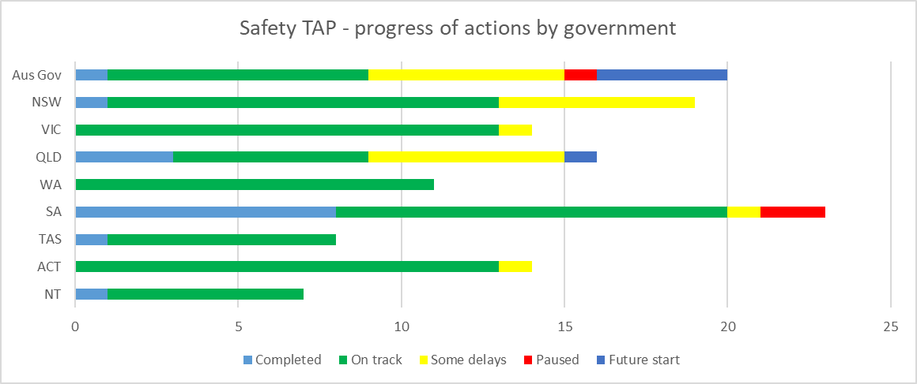

Amata i se taimi o i luma

Gasolo lelei

TAP o le Saogalemu - faatinoga alualu i luma a le malo

VIC

QLD

WA

SA

TAS

ACT

NT

NSW

Aus Gov

Taofia

Nai faatuai

Mae'a

Laulau 10: TAP o le Saogalemu - faatinoga alualu i luma a le sini

|  |  |  |  |  |  |  |
| --- | --- | --- | --- | --- | --- | --- |
| **Sini** | **Mae'a** | **Gasolo lelei** | **Nai faatuai** | **Taofia** | **Amata i se taimi o i luma** | **Aofa'i** |
| Sini 1 | 3 | 13 | 1 | 0 | 3 | 20 |
| Sini 2 | 1 | 19 | 5 | 0 | 1 | 26 |
| Sini 3 | 5 | 36 | 10 | 1 | 1 | 53 |
| Sini 4 | 3 | 17 | 3 | 1 | 0 | 24 |
| Sini 5 | 3 | 3 | 2 | 1 | 0 | 9 |
| **Aotelega** | **15** | **88** | **21** | **3** | **5** | **132** |

Siata 10: TAP o le Saogalemu - faatinoga alualu i luma a le sini

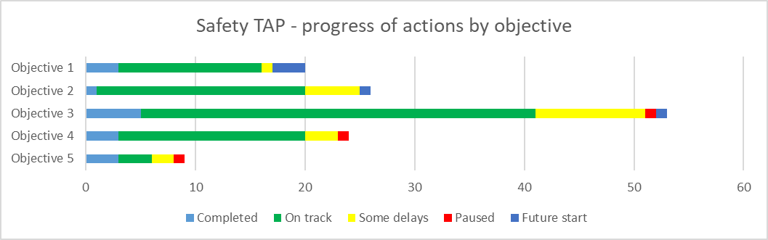

Amata i se taimi o i luma

Gasolo lelei

Sini 5

Sini 4

Sini 3

Sini 2

Sini 1

TAP o le Saogalemu - faatinoga alualu i luma a le sini

Taofia

Nai faatuai

Mae'a

# Fuafuaga Faatino mo Pulega o Faalavelave Faafuase'i

**Faatomuaga**

Ua faia le TAP mo le Pulega o Faalavelave Faafuase'i ina ia una'i le aga'i i luma i lalo o le Vaega o Taunuuga o le Soifua Maloloina ma Soifua manuia o le Fuafuaga. O lenei Vaega o Taunuuga e faamoemoe e faamautinoa tagata e iai aafiaga tumau i le soifua ona maua le taunuuga maualuga o le soifua maloloina ma le laulelei i o latou olaga atoa.

I lalo o le TAP o Pulega o Faalavelave Faafuase'i e iai faatinoga e 58 i Ausetalia, setete ma malo o teritori. E aofia ai faatinoga aogā e sailia manatu faaalia mai tagata e iai aafiaga tumau i le soifua ma le ofisa, iloilo ma faaleleia fuafuaga i le tali atu ai i faalavelave faafuase'i ma sauniuniga e faaaofia ai tagata e iai aafiaga tumau i le soifua, ma faaleleia fesoota'iga saunia i taimi o faalavelave faafuase'i.

**Sini**

1. Faamautinoa o faagasologa o fuafuaga tau mala/faalavelave faafuase'i mo le faatinoga o iloiloga o lamatiaga o mala, ma atina'e sosoo a'i ma le tausiga o fuafuaga i le pulega o mala/faalavelave faafuase'i, e aofia ai tagata e iai aafiaga tumau i le soifua.
2. Faamautinoa le aofia ai i le faatautaia o mala/faalavelave faafuase'i, faagasologa o fuafuaga i le sauniuniga ma le toe faaleleia, lagolago le soifua maloloina ma le manuia o tagata e iai aafiaga tumau i le soifua ae le i tupu, i le taimi ua tupu ma le taimi ua mae'a ona tupu ai faalavelave faafuase'i.

Laulau 11: TAP o Pulega o Faalavelave Faafuase'i - faatinoga alualu i luma a le malo

|  |  |  |  |  |  |  |
| --- | --- | --- | --- | --- | --- | --- |
| **Malō** | **Mae'a** | **Gasolo lelei** | **Nai faatuai** | **Taofia** | **Amata i se taimi o i luma** | **Aofa'i** |
| Aus Gov | 1 | 11 | 1 | 0 | 0 | 13 |
| NSW | 0 | 3 | 0 | 1 | 0 | 4 |
| VIC | 0 | 3 | 1 | 0 | 0 | 4 |
| QLD | 3 | 3 | 0 | 0 | 0 | 6 |
| WA | 0 | 5 | 0 | 0 | 0 | 5 |
| SA | 1 | 9 | 0 | 0 | 0 | 10 |
| TAS | 1 | 4 | 0 | 0 | 0 | 5 |
| ACT | 2 | 2 | 0 | 0 | 0 | 4 |
| NT | 3 | 4 | 0 | 0 | 0 | 7 |
| **Aofa'i o le Atunuu** | **11** | **44** | **2** | **1** | **0** | **58** |

Siata 11: TAP o Pulega o Faalavelave Faafuase'i - faatinoga alualu i luma a le malo

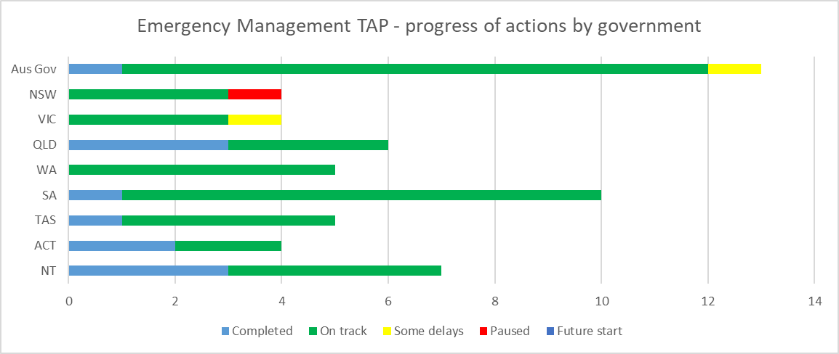

Amata i se taimi o i luma

Gasolo lelei

Aus Gov

NSW

VIC

QLD

WA

SA

TAS

ACT

NT

TAP o Pulega o Faalavelave Faafuase'i - faatinoga alualu i luma a le malo

Nai faatuai

Taofia

Mae'a

Laulau 12: TAP o Galuega - faatinoga alualu i luma e ala i sini

|  |  |  |  |  |  |  |
| --- | --- | --- | --- | --- | --- | --- |
| **Sini** | **Mae'a** | **Gasolo lelei** | **Nai faatuai** | **Taofia** | **Amata i se taimi o i luma** | **Aofa'i** |
| Sini 1 | 5 | 22 | 2 | 0 | 0 | 29 |
| Sini 2 | 6 | 22 | 0 | 1 | 0 | 29 |
| **Aotelega** | **11** | **44** | **2** | **1** | **0** | **58** |

Siata 12: TAP o Galuega - faatinoga alualu i luma e ala i sini

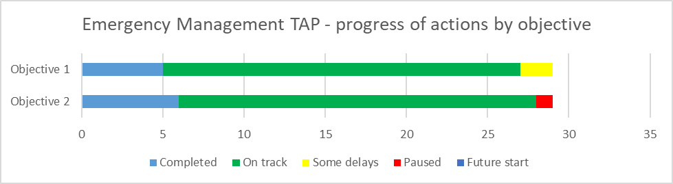

Amata i se taimi o i luma

Gasolo lelei

TAP o Galuega - faatinoga alualu i luma e ala i sini

Sini 1

Sini 2

Mae'a

Nai faatuai

Taofia

# Gaioiga o loo Faatino

Ua ta'utino tulaga uma o le malo i le faatinoga o gaioiga i lalo o TAP nei e 5 ma ua lelei le alualu i luma ma le tele o faatinoga i le vaitaimi o le faiga o lipoti.

O le vaega mulimuli mai e saunia faataitaiga filifilia mai TAP ta'itasi, ma mai malo ta'itasi, i luga o gaioiga ua 'ausia ma faapefea ona avatu nei faatinoga e faaleleia ai taunuuga mo tagata e iai aafiaga tumau o le soifua.

Fuafuaga o Faatinoga Tulimata’i o Galuega

|  |  |
| --- | --- |
|  | **Lagolagoina o le Suiga mo Tamaiti A'oga** |
| **Pule'aga/Faapotopotoga** | Teritori i Matu  Matagaluega o A'oga |
| **TAP** | Galuega |
| **Sini o le TAP** | Sini 2: Faalelei le suiga mai o tupulaga talavou e iai aafiaga tumau i le soifua mai a'oa'oga i galuega. |
| **Gaioiga** | 2.3: Lagolago le suiga o tamaiti a’oga  Faaleleia lagolago i suiga mo tamaiti ma tamaiti aoga e iai aafiaga tumau i le soifua, aofia ai le suiga mai fafo o aoga, faipaaga ma faalapotopotoga i nuu ma ala manuia. |
| **Faailoga** | Numera o tamaiti aoga e iai aafiaga tumau i le soifua ua iai Fuafuaga i Suiga Ta'ito'atasi. |
| **Tulaga: Sologa Lelei** | O loo faalauiloa e le matagaluega le numera o fuafuaga e faaleleia ai le suiga i galuega mo tamaiti aoga e iai aafiaga tumau i le soifua.  • E 78 tamaiti aoga ua iai fuafuaga i Suiga Ta'ito'atasi.  • Sa ave fesoasoani tau tupe i a'oga e 8 e mamao i tua ina ia lagolago gaioiga mai fuafuaga o suiga mo tamaiti a'oga e iai aafiaga tumau i le soifua.  • E 28 Tamaiti Aoga mai Darwin ma le 10 mai Alice Springs na auai i le Lagolago o faatulagaina o Galuega Faamasani. O nei faatulagaga e avatu galuega-ua saunia ma agavaa tuto'atasi ma le mafai i totonu o le fale faigaluega.  • 16 tamaiti a’oga na auai i faiga paaga ma le YouthWorX. E resitala tamaiti a'oga i le Tusi Pasi 1 i le Atina'eina o le Tuto'atasi ma o le a faamae'a le faailoga e faapena foi le iai o se auala lagolago aga'i i galuega. |

Fuafuaga Faatino i Uiga o Nuu

|  |  |
| --- | --- |
|  | **Fuafuaga Faata'atia o Aafiaga Tumau i le Soifua a le ACT** |
| **Pule'aga/Faapotopotoga** | Malo o le ACT  Faatonu o Auaunaga i Nuu |
| **TAP** | Amioga a le Nuu |
| **Sini o le TAP** | Sini 4: Faalauiloa le aofia ai o tagata e iai aafiaga tumau i le soifua i totonu o le sosaiete, e aofia ai galuega, e ala i le fai tele o faalauiloa ma malamalamaaga o aafiaga tumau i le soifua. |
| **Gaioiga** | 4.5: Fuafuaga Faata'atia o Aafiaga Tumau i le Soifua a le ACT  O le a atina'e e le ACT se ta'utinoga faafou i le Fuafuaga fou o Aafiaga Tumau i le Soifua a Ausetalia (ADS) 2021-2031. O le Tautinoga fou o le ACT o le a aofia uma ai tulaga-maualuga o le tautinoga a le malo i le faagasoloina o avanoa maua ma le aofia ai o aafiaga tumau i le soifua i totonu o le ACT.  O le Ta'utinoga fou o le ACT o le a fuafuaina faatasi ma tagata e iai aafiaga tumau i le soifua. |
| **Faailoga** | Ua faataatia le Ta'utinoga Fou o le ACT i le Fuafuaga o Aafiaga Tumau i le Soifua a Ausetalia i totonu o Tesema 2022. |
| **Tulaga: Sologa Lelei** | Sa faatino faatalanoga o le Fuafuaga i le Aafiaga Tumau i le Soifua a le ACT i le va o Mati ma Iulai 2022. Sa fuafua faatasi le faatalanoaga ma le Vaega Faatatau Agai iai Aafiaga Tumau i le Soifua o le ACT, ma i se auala ese fo'i mo malo, talanoaga uma na faafoeina e tagata e iai aafiaga tumau i le soifua. E avatu e faatalanoaga auala eseese mo tagata e fai ai o latou manatu i le auala e sili atu ia latou, e aofia ai le faatumuina o ni fesili i luga o le upega tafailagi pe lafo mai, auai i se tasi o faatalanoaga e 32 fesaga'i pe online, e aofia ai se vaega faalautele o le vaai aga'i avanoa o talanoaga, poo le auai ai i talanoaga i le Laulau o le Umukuka, lagolagoina i le atina'e ai o se Pusa o se Faatalanoaga o Laulau Umukuka. Sa taulimaina tulaga tuu mai e ala i tusitusiga, faamatalaga pu'e, ma le tele o isi auala. Sa saili le faatalanoaga ina ia maua manatu o le lautele, poto masani ma manatu mo suiga, o le a tuufatasi i totonu o se Lipoti Faalogologo, lea o le a tuuina atu i se taimi mulimuli ane o le 2022. |

|  |  |
| --- | --- |
|  | **Atia'eina o le mautinoa i aafiaga tumau i le soifua i galuega autū** |
| **Pule'aga/Faapotopotoga** | Malo o Ausetalia  Department of Social Services |
| **TAP** | Amioga a le Nuu |
| **Sini o le TAP** | Sini 2: O galuega faapolofesa taua ua mafai on tali ma le mautinoa ma le lelei i tagata e iai aafiaga tumau i le soifua. |
| **Gaioiga** | 2.1: Atia'eina o le mautinoa i aafiaga tumau i le soifua i galuega autū  Inivesi le $2.5 miliona i le fausiaina o faiga faaaofia ai aafiaga tumau i le soifua i totonu o a'oga ma a'oa'oga i faailoga muamua ma faailoga maualuga ma atina'e puna'oa e mafai ona faaaogaina i aoga maualuga ma le atina'eina o tomai. |
| **Faailoga** | Numera o tagata e iai le tomai autū o loo iai le poto ma le lagolago e fesoasoani ai i tagata e iai aafiaga tumau i le soifua. |
| **Tulaga: Sologa Lelei** | Ina ia alualu i luma le atina'eina o le mautinoa o aafiaga tumau i le soifua i faatinoga o galuega autū, na fesoota'i le Matagaluega o Auaunaga o Agafesoota'iga ma le ACOLA (Fono o A'oga A'oa'oina a Ausetalia) e iloilo ma avatu fautuaga i le, agavaa ai mo a'oa'oga i faailoga muamua ma faailoga maualuga i aafiaga tumau i le soifua i totonu o Ausetalia. E faapito lava, le vaavaai aga'i i le iai o le mautinoa tau aafiaga tumau i le soifua i aoga, faamasinoga, soifua maloloina ma vaega tau agafesoota'i ma nuu. O nei vaega o vaega o tagata e iai aafiaga tumau i le soifua na faamatala i le malo le tele ai i o latou aafiaga leaga.  O le vaega muamua o galuega e avatu aga'i i nei gaioiga ua fua mai ta'iala ma le tele o gaioiga e mafai ona faatino e vaega uma o le malo, aoga maualuluga, faapotopotoga o ofisa ma falefaigaluega ina ia fausia ai faiga e faaaofia ai aafiaga tumau i le soifua. |

Fuafuaga Faatino mo A'oga Amata

|  |  |
| --- | --- |
|  | **Nofoaga Tutotonu mo A'oa'oga o Fanau ma Aiga** |
| **Pule'aga/Faapotopotoga** | Tasemania  Matagaluega o A'oga |
| **TAP** | A'oga Amata |
| **Sini o le TAP** | Sini 3: Faamalosia se lagona malosi i le aofia ai ma saunia avanoa mo matua, tagata e vaaia ma fanau ina ia fausia fesoota'iga, e aofia ai mo Tagata Apoliki ma Atumotu o Torres Strait ma matua ma tagata o tausia e eseese aganuu ma gagana. |
| **Gaioiga** | 3.2 Fausia nofoaga tutotonu fou e 6 e faalautele ai fesoota'iga a le tamaititi ma nofoaga mo aiga o loo lagolagoina a'oga tau soifua maloloina ma soifua manuia ma tausiga o tamaiti laiti Tasemania e matua lagolago ma le faaleleiina o le mauaina o auaunaga i totonu o nuu i le lotoifale. |
| **Faailoga** | Faatele le mafai e fausia ai fesoota'iga lagolago. |
| **Tulaga: Sologa Lelei** | E faaauau pea ona inivesi le Malo o Tasemania i matou tupulaga laiti o a'ooga ma o latou aiga e ala i sauniuniga o tausaga amata lelei o a'oa'oga ma suiga i totonu o a'oga. O matou nofoaga-faavae o Nofoaga Tutotonu o A'oa'oga o Tamaiti ma Aiga (CFLC) e saogalemu ma o siosiomaga e aofia uma ai e faia tulaga sa'o mo a'oa'oga ma soifua manuia, e mafai ai e aiga e iai tamaiti 5 tausaga ma lalo ifo ona maua 'auaunaga 'aloa'ia ma lagolago e tali atu i mana'oga o nuu i le lotoifale. E ono nofoaga tutotonu fou ua eseese laasaga ua oo iai le fausiaina ma e faaaogaina faatasi i le 2024. O nei nofoaga o le a fesoasoani i le faateleina o avanoa maua, auai ma iai e lagolago le tele o aiga i le Setete atoa ina ia manuia. O le vaega muamua o le CFLC fou o le a tatala i totonu o East Tamar ia Novema 2022, mulimuli ane ai ma le larapi i totonu o Waratah Wynyard ia Fepuari 2023. O Nofoaga Tutotonu o Kingborough, Glenorchy ma West Ulverstone o le a tatala i le faai’uga o le 2023 ma Sorell i le faai’uga o le 2024. |

|  |  |
| --- | --- |
|  | **O se punaoa e tasi i luga o le initaneti e faatautaia lelei A'oga** |
| **Pule'aga/Faapotopotoga** | Niu Saute Uelese  Matagaluega o A'oga |
| **TAP** | A'oga Amata |
| **Sini o le TAP** | Sini 2: Faamalosia le agavaa ma le gafatia o auaunaga ma polokalame autū e lagolago mātua ma tagata e tausia ina ia faia filifiliga ua logoina e faatatau i le latou tamaititi. |
| **Gaioiga** | 2.2: O le a faia e le Matagaluega o Aoga a NSW se alaga'oa online taofi-tasi e iai faamatalaga mo aiga ma tagata tausi fanau ina ia feagai ma ni tulaga sili atu ona lelei ma faigofie pe a latou faaaogaina o fautuaga o tatou faiga ma avanoa maua. |
| **Faailoga** | Numera e maua ai nofoaga. |
| **Tulaga: Sologa Lelei** | O le a faia e le Matagaluega o Aoga a NSW se alaga'oa online taofi-tasi e iai faamatalaga mo aiga ma tagata tausi fanau ina ia feagai ma ni tulaga sili atu ona lelei ma faigofie pe a latou faaaogaina o fautuaga o tatou faiga ma avanoa maua. E aofia ai le faiga ma le atina'ega o nofoaga o matua/tagata tausia ae maise lava mo aiga e iai se tamaititi e mana’omia se a'oa'oga faaopoopo ma se lagolago - https://education.nsw.gov.au/parents-and-carers/inclusive-learning-support. |

Fuafuaga Faatino mo le Saogalemu

|  |  |
| --- | --- |
|  | **Fausiaina o Fale mo le Lautele** |
| **Pule'aga/Faapotopotoga** | Ausetalia i Saute  Pulega o Fale SA |
| **TAP** | Saogalemu |
| **Sini o le TAP** | Sini 3: Faamalosia le fuafuaga o faiga o auaunaga uma o le malo ma lagolago latou te avatu mo tagata e iai aafiaga tumau i le soifua o loo lamatia ma afaina. |
| **Gaioiga** | 3.1: Faaleleia le ola lelei o tatou fale i le faamautinoaina lea e apalai le SAHT Taiala o Fuafuaga i le Lalolagi i le lē itiiti ifo ma le 75% o le fausiaina o fale fou mo le lautele. |
| **Faailoga** | Aofa'iga o meatotino fou sa atina'eina i le ta'iala o fuafuaga o Fale i le Lalolagi i tausaga ta'itasi. |
| **Tulaga: Sologa Lelei** | I le taimi o lenei piriota fai lipoti, o meatotino fou uma na fausiaina sa fausia i ta'iala o fuafuaga o Fale i le Lalolagi SAHT, e aofia ai:  12 Polokalame o Fale Gafatia le Tau  12 Polokalame o Aiga Tuaoi Lelei  22 Polokalame Toe Atina'e & Fausaga Fou Fale o iai nei mo le lautele ua amata ona tuai ma i nisi tulaga ua le talafeagai mo tagata e iai aafiaga tumau e tusa pe toe faalelei. O le fausaga o fale fou i le Ta'iala o Fuafuaga i le Lalolagi e faamautinoa o fale fou mo le lautele e maua ma talafeagai ina ia lagolago ai le puipuiga o fale mo le taimi umi ma tutoatasi, e faapena foi le faaali o taunuuga o le saogalemu i le faaitiitia lea o pa puipui e avatu lamatiaga e ono afaina ai i le tagata nofo mautotogi ma/poo lona aiga. E tutusa lea, o le fauga o Fale Gafatia le tau i Taiala o Fuafuaga i le Lalolagi e lagolago avanoa maua e pulea ai mo tagata e iai aafiaga tumau, e ala uma mea ia e lua e faaleleia avanoa maua ma faaavanoa meatotino i le tau masani o fale e gafatia. |

|  |  |
| --- | --- |
|  | **A'oa'oga mo le Aufaigaluega a le Faamasinoga mo Tupulaga** |
| **Pule'aga/Faapotopotoga** | Vitoria  Matagaluega o Faamasinoga ma Saogalemu o Nuu (DJCS) |
| **TAP** | Saogalemu |
| **Sini o le TAP** | Sini 3: Faamalosia le fuafuaga o faiga o auaunaga uma o le malo ma lagolago latou te avatu mo tagata e iai aafiaga tumau i le soifua o loo lamatia ma afaina. |
| **Gaioiga** | 3.6: O Faufautua Sinia ma Faapitoa o Aafiaga Tumau i le Soifua e saunia faatalanoaga lona lua ma fautuaga poto i tausiga o faamasinoga o tupulaga talavou ma tagata faigaluega i nuu ma vaega e avatu tausiga. O lenei galuega ua fuafuaina e faaleleia ai vaavaaiga o faamasinoga o tupulaga talavou ma fesoota'i nei tupulaga i 'auaunaga, e aofia ai le NDIS. |
| **Faailoga** | * E lagolagoina tagata faigaluega mo faamasinoga o tupulaga talavou ina ia faaaogā fuafuaga aogā e lagolago ai tupulaga e iai aafiaga tumau i le soifua. |
| * O tupulaga talavou e iai aafiaga tumau i le soifua ua maua avanoa faaleleia i faatinoga o 'auaunaga ma lona faaaogaina. |
| **Tulaga: Sologa Lelei** | E avatu e Faufautua Sinia ma Faapitoa o Aafiaga Tumau i le Soifua i le Faamasinoga o Tupulaga Talavou ia a'oa'oga fesaga'i, aofia ai polokalame faalauiloa mo tagata faigaluega fou, e aofia ai a'oa'oga e fesoota'i i le malamalama ai o aafiaga o le iai o aafiaga tumau i le soifua ma le faaaogaina o metotia aogā e lagolago ai tamaiti ma tupulaga talavou e iai aafiaga tumau i le soifua i totonu o faiga faamasinoga. O le a'oa'oga e aofia ai polokalame faalauiloa eseese e lua, ta'itasi puipuiga ma nuu e faavae i tagata faigaluega. |

Puleaina o Faalavelave Faafuase'i

|  |  |
| --- | --- |
|  | **Tagata ma Kulupu Toe Faafo'isia ai le Malosi** |
| **Pule'aga/Faapotopotoga** | Kuiniselani  Matagaluega o Nuu, Fale ma Tamaoaiga tau Tekinolosi |
| **TAP** | Puleaina o Faalavelave Faafuase'i |
| **Sini o le TAP** | Sini 2: Faamautinoa le aofia ai i le faatautaia o mala/faalavelave faafuase'i, faagasologa o fuafuaga i le sauniuniga ma le toe faaleleia, lagolago le soifua maloloina ma le manuia o tagata e iai aafiaga tumau i le soifua ae le i tupu, i le taimi ua tupu ma le taimi ua mae'a ona tupu ai faalavelave faafuase'i. |
| **Gaioiga** | 2.3: Vaega Toe Faaleleia Tagata ma Agafesoota'iga e aofia ai sui poo le iai o masini e auai ai sui o tagata e iai aafiaga tumau i le soifua i le faagasologa o fuafuaga e toe faaleleia tagata ma agafesoota'iga. |
| **Faailoga** | Pasene o Matagaluega o Nuu, Fale ma Tamaoaiga Tekinolosi o Tagata ma Vaega Toe Faaleleia e aofia ai sui ma/poo masini e auai ai sui o tagata e iai aafiaga tumau i le soifua i le faagasologa o fuafuaga i le toe faaleleia o tagata ma agafesoota'iga. |
| **Tulaga: Mae'a** | A’o iai i le vaitau o mala 2021-22, 100 pasene o Vaega Toe Faaleleia o Tagata ma Agafesoota'iga a le Itumalo e aofia ai se tagata e iai aafiaga tumau i le soifua, o se sui o tagata e iai aafiaga tumau i le soifua poo masini e auai ai sui o tagata e iai aafiaga tumau i le soifua. O lenei fesoota'iga ma le faaaofiaga o tagata e iai aafiaga tumau i le soifua poo sui o tagata e iai aafiaga tumau e faamautinoaina le amanaiaina ma faaaofiaina mana'oga o tagata e iai aafiaga tumau i le soifua i totonu o faagasologa o fuafuaga o le toe faaleleia o tagata a agafesoota'iga. O le tele o taimi ua faagalo mana'oga faapitoa o tagata ma’ale’ale i totonu o nuu ma o lenei fuafuaga fai faatasi ua amata o le a fai se sao i le faaleleia o taunuuga o tagata e iai aafiaga tumau i le soifua ina ia toe manuia mai ai i se mala na tupu. |

|  |  |
| --- | --- |
|  | **Fuafuaga o le Puleaina o Faalavelave Faafuase'i** |
| **Pule'aga/Faapotopotoga** | Ausetalia i Sisifo  Matagaluega o Nuu |
| **TAP** | Puleaina o Faalavelave Faafuase'i |
| **Sini o le TAP** | Sini 1: Faamautinoa o faagasologa o fuafuaga tau mala/faalavelave faafuase'i mo le faatinoga o iloiloga o lamatiaga o mala, ma atina'e sosoo a'i ma le tausiga o fuafuaga i le pulega o mala/faalavelave faafuase'i, e aofia ai tagata e iai aafiaga tumau i le soifua. |
| **Gaioiga** | 1.1: Iloiloga o Fuafuaga o Sauniuniga ma le Matagaluega o Aafiaga Tumau i le Soifua Faamautinoa e manaomia e tagata e iai aafiaga tumau i le soifua ona faailoa pe a tupu se faalavelave faafuase'i. |
| **Faailoga** | • Tausia Vaega Faigaluega e iai Aafiaga Tumau i le Soifua i le taimi o Faalavelave Faafuase'i. • Faatinoga o fautuaga o A'oa'oga Faaauau ma Tuufaatasi. Pulega: Lipoti Mulimuli o le Fuafuaga o le Faama'i o le KOVITI-19 mo le Ola Potopoto mo Tagata e iai Aafiaga Tumau i le Soifua - Tesema 2021. • Faafou Ta'iala o Faatinoga.  • Iloiloina Faatulagaga o Faalavelave Faafuase'i o le Lotoifale ma le Itumalo. |
| **Tulaga: Sologa Lelei** | I le mulimuli ai i le Vaomū a Wooroloo, ua galulue faatasi nuu ma le ofisa o aafiaga tumau i le soifua ia lagolago lelei tagata e iai aafiaga tumau i le soifua na afaina i ni mea na tutupu faafuase'i.   Na faatuina e nuu le Vaega faigaluega o Aafiaga Tumau i le Soifua o le KOVITI-19 ina ia sauni ai ma tali atu i mana'oga o tagata e iai aafiaga tumau i le soifua ua afaina i le KOVITI-19. Na faia e nuu se resitala e mafai ona su'e e maua ai filifiliga o fale nonofo e lagolago ai tagata e iai aafiaga tumau i le soifua ina ia faanofoesea. Sa faia le Ta'iala Faasino i Vaega Ma’ale’ale o le KOVITI-19 ina ia faafaigofie ai ona maua auaunaga lagolago talafeagai mo le soifua manuia o tagata e iai aafiaga tumau i le soifua e lē o mafai ona faaaogaina auaunaga ma lagolago o loo iai nei a'o faanofoesea ai latou. Ina ia lagolago le ofisa o aafiaga tumau i le soifua, o loo faamaopoopoina e Nuu le tufatufaina o le 2.25 miliona RAT a le Malo WA i le faipaaga ai ma le WA Health ma le Foodbank WA.   O loo faasolo nuu i le faatautaia o se iloiloga o lesona na a’oa’o mai le KOVITI-19. O le a logoina ai le atina'eina o se fuafuaga e faaleleia a taunuuga mo tagata ma’ale’ale i se faalavelave faafuase'i. |

DSS 2803.10.22