Australia’s Disability Strategy National Forum

 | The Australian Government is releasing a plan to make life better for people with disability.
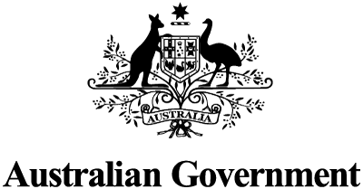 | When you see “we” in this document, it means the Australian Government.
The event
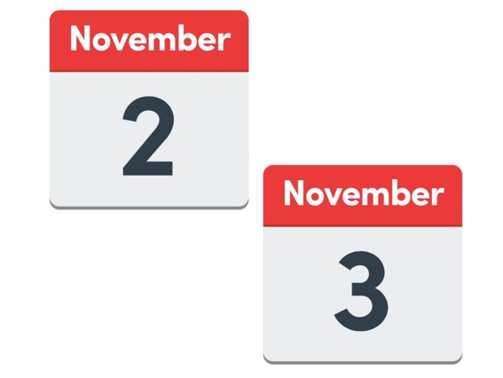 | On 2 and 3 November 2022, we are having an event.
 | At the event we will be talking about our strategy for people with disability.
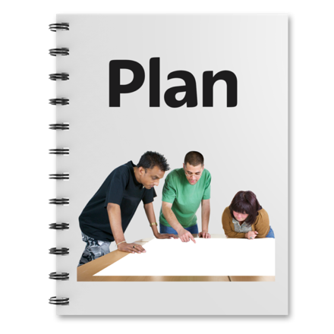 | A strategy is a plan for how we will make things better.
 | This strategy has our plan for how we will improve the lives of people with disability over ten years.
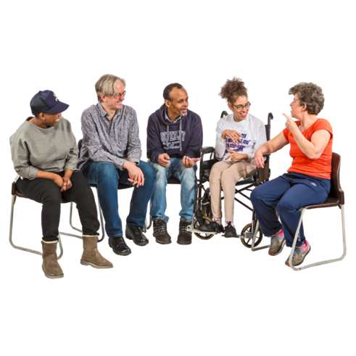 | At the event, you will hear from lots of people about what is in the strategy.
 | You can watch the event online.
 | There will be Auslan interpreters.
 | You will be able to ask any questions you have at the event.
 | The event is on 2 and 3 November.
 | On 2 November the event starts at 9:15 in the morning.
 | It finishes at 5 in the afternoon.
 | On 3 November the event starts at 9 in the morning.
 | It finishes at 12:15 in the afternoon.
Where to find more information
If you have any questions or need help coming to the event, email:

disabilityreform@dss.gov.au
You can find more about the strategy at:

www.disabilitygateway.gov.au/ads

