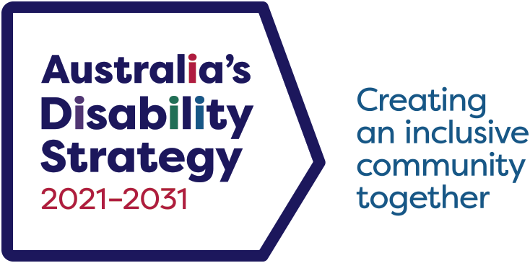

Australia’s Disability Strategy 2021 – 2031
  - Data Improvement Plan Summary
Contents
Contents 1
Introduction 1
Alignment 2
Data 2
Diversity and Intersectionality 2
Future Measures in the Outcomes Framework 3
Launch Measures in the Outcomes Framework 5
Way forward 5

Introduction
The purpose of the Australia’s Disability Strategy (the Strategy) Data Improvement Plan (DIP) is to improve the data needed to track progress against the Strategy Outcomes Framework (Outcomes Framework). The Outcomes Framework consists of 85 measures across 7 Outcome Areas. Forty-one are systems measures, 40 are population measures and 4 are community attitudes measures. These comprise launch measures which already have data to report against them and future measures which require data to be developed or linked in order to report against them.
The Department of Social Services (DSS) has developed the DIP in consultation with people with disability and Australian, state and territory government agencies. Multi-jurisdictional arrangements are needed to deliver data for the Outcomes Framework. Final decisions regarding data improvement will sit with Disability Reform Ministers.
All governments have agreed to work closely with people with disability over the life of the Strategy. The views of people with disability, disability sector stakeholders and diverse groups within the sector will be heard and considered. Engagement will continue with people with disability and intersectional groups such as First Nations people with disability, people with disability from culturally and linguistically diverse communities, and women with disability to ensure a broad range of views are considered and included.

Alignment
The DIP aligns with the following documents:
- Australia’s Disability Strategy 2021–2031
- the National Agreement on Closing the Gap.

Data
Data for the Outcomes Framework will come from various sources, including:
- survey data, including from the Survey of Disability, Ageing and Carers (SDAC), other ABS surveys, and Australia’s Disability Strategy Survey (Strategy Survey) on community attitudes towards people with disability
- administrative data, including from the National Disability Insurance Scheme (NDIS), and state and territory health and education departments
- linking datasets together to improve data quality and comparability to create a wide range of new insights through mechanisms including the National Disability Data Asset (NDDA).
High-quality data governance will improve decision-making and enable collaboration across Australian, state and territory governments. It will help governments measure the impact of the services they deliver for people with disability.

Diversity and Intersectionality
The Strategy and DIP recognise the importance of understanding, acknowledging and celebrating the diversity of the disability community. This includes an understanding of intersectionality, meaning the potential for people to experience disadvantage due to the intersection of their sex, age, race, culture, gender identity, sexual orientation, impairment, disability status, socioeconomic status, religion and other dimensions. These dimensions are connected; each informs the other and they have overlapping and compounding effects.
When developing new data sources for future measures or improving data for launch measures, the ability to disaggregate the data in as many ways as possible is a priority.

Future Measures in the Outcomes Framework
The Outcomes Framework includes future measures as part of the commitment to improve measures and to refine the Outcomes Framework over the life of the Strategy.
There are 38 future measures. Data for some have become available since the launch of the Strategy. Others will require further work before it is possible to report against them.
Two measures are now available and will be published on the Outcomes Framework webpages at the first update in mid-2023. These measures relate to employment among NDIS participants, and public sector employees with disability.
Four measures will be derived from the Strategy Survey addressing the Community Attitudes Outcome Area. Data collection for the Strategy Survey commenced in September 2022 and will conclude in January 2023. Data will be compiled from the start of 2023, followed by analysis from March to June 2023 and published on the Outcomes Framework webpages by September 2023.
A further 4 measures will be available in late 2023 or 2024. These 4 measures may be reported through linkage with the Multi-Agency Data Integration Project (MADIP). These measures relate to length of time and re-substantiations in the child protection system, avoidable deaths in hospital and involuntary hospital admissions.
One measure will use NDIS data and relates to the success of linkages of NDIS participants to mainstream and community services and systems. Reporting on this measure will likely be available from 2026.
Data for a further 7 measures will require complex data linkage through the NDDA or similar cross-jurisdictional data assets. It is expected that this data will become available between 2024 and 2025.
Data from new survey questions will be required to report on and track 12 measures. This data will be collected by adding questions to an existing survey, such as the SDAC or the Strategy Survey, or through a new survey.
Collaboration on definitions, methodology and administration is needed to address the remaining 8 future measures. Working groups will be convened by DSS in partnership with relevant Australian Government agencies and state and territory governments. Planning for the working groups has commenced. The working groups are expected to conclude by the end of 2023. This will be followed by a period of data collection and reporting.

Launch Measures in the Outcomes Framework
Data linkage should improve some launch measures by:
- improving the quality of data used in analysis of the measures
- offering new insights that were not previously available
- increasing the frequency for reporting on the measures
- allowing the population to access measure results more relevant to them – for example, based upon their geography, type of disability or use of disability supports.
Other launch measures will be improved through collaboration between Australian, state and territory governments. This includes agreeing on standard definitions and collection practices that would allow comparisons across the nation.

Way forward
All governments, working closely with people with disability, will continue to develop data for future measures and improve the quality and usability of data about people with disability over the life of the Strategy.
The DIP will be updated in line with the review points of the Strategy. The first review will follow the final report of the Royal Commission into Violence, Abuse, Neglect and Exploitation of People with Disability at the end of 2023. Further reviews will follow in 2025 and 2029.

