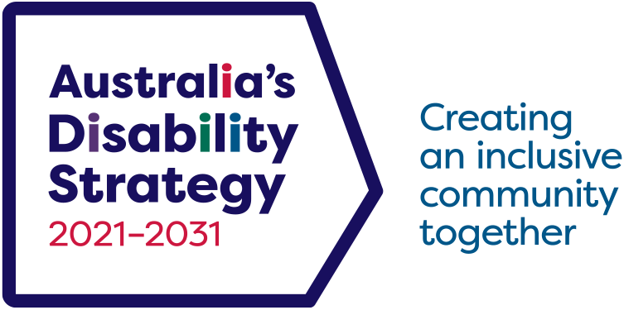

Quick guide for facilitating with people with disability

The following pages are a mock-up of information provided to facilitators to keep in mind and remember on the day of an activity. While this example is fictious, it is based on real information provided to facilitators.

In this scenario, 15 facilitators (10 in-person and 5 online) are delivering an all-day hybrid community park design symposium with around 95 participants. This information is for both the online and in-person facilitators. A total of 30 participants are people with disability, while the others are their carers, landscape artists, urban designers, government officials and more. The content for the day is delivered via a mix of large group presentations, speeches and small group activities.

## Example facilitation guide

Thank you so much for expressing interest in facilitating small group activities during the Better Parks Symposium next Thursday. See our website for more information.

This symposium will be led by people with disability and will launch a conversation with the community about what the park should have and what it should look like. We will talk about the key principles used to design the park as well as ways to make the park safe and fun.

There will be over 50 people online (as well as around 40 in person), so we are very grateful for the facilitators’ help with the online group activities. The current times for the breakout rooms will be 10:45 and 12:25 (running 20 minutes each). If you are available, it might be best to be on standby (online with cameras off) from 10:15–13:00.

We will use a Microsoft Teams channel. For online facilitators, we will use this to notify you if the event is running behind and advise you to hop online when breakout rooms are due to start.

## Appropriate and respectful language

Throughout the symposium, it is integral that we use appropriate and respectful language. Keep this handout somewhere where you can easily access it.

* Introduce yourself and start your contributions with your name. Speak clearly and ensure that you are standing where the people you are speaking to can see you. Encourage others to start their contributions with their names as well. This will help people in the room be aware of who is speaking, familiarise themselves with the people around them, and follow the conversation in the best way for them.
  + In-person: We will have an Auslan interpreter for all main stage speakers and in the group activities where participants have indicated that they require this service. Facilitators of these groups will be individually briefed to ensure they do not begin before the Auslan interpreter is present.
  + Online: We will have a live-captioning service for all main stage speakers for the online group to access. For group activities where participants have indicated that they require Auslan, we will have an Auslan interpreter join. Facilitators of these groups will be individually briefed to ensure they do not begin before the Auslan interpreter is present.
* Do not assume whether someone does or does not have a disability. Not all disabilities are visible and not all participants here today are people with disability.
* If you feel compelled to help someone, ask them if they need help first. If they say no, please respect that.
  + Only once they say yes, ask them how.
  + Follow through and communicate the support you can provide.
  + Avoid doing things that they have not requested.
* Call people by their name, not their disability. Only refer to the person’s disability if it is relevant for the specific context or activity.
* People’s preferred language for their disability is personal. Listen to how people refer to themselves, their disability and the community they are a part of.
  + If required to name their disability, use the language they have been using for themselves.
  + If you are unsure, default to their name and ask for their preference. You could say, “How would you like me to refer to you in relation to your disability?” “Do you prefer person-first or identity-first language?”
* Allow people to contribute in multiple ways and find alternative ways to communicate. Give people options to use the pens and paper provided for writing or drawing. It may also be helpful to act scenarios out.

## Information on disclosures

During the symposium, some people may talk about poor experiences they have had. For more information, read our trauma-informed facilitation resources available on our intranet.

While we do not expect that you are the experts in responding to disclosures, we all have a role to ensure all the participants’ safety and to refer them to an appropriate service if they would like.

In the event a participant discloses anything troubling, please engage with the participant from a space of being supportive, compassionate and non-judgmental.

Some key messages for you to please remember and possibly say:

* Thank the participant for sharing and being vulnerable with the group.
* Anyone’s experience of abuse or violence is not their own fault.
* Everyone here matters and their contributions matter.
* Include content and trigger warnings to start or when you see that the conversation may include experiences with domestic, physical and sexual violence and image-based abuse.
* Offer reminders of some support services to guide people to as needed.
* Please give everyone the opportunity to take the time and space that they need. In the in-person sessions there is a sensory space. Please allow remote participants to switch off their cameras and mute themselves if they become uncomfortable.

If any participant wants counselling, please ask them for their first name and email or phone number and let the project lead know. We will arrange for the counsellor to contact them.

Any questions please feel free to contact the project lead on [#] and via email at [email].

DSS3062.09.23