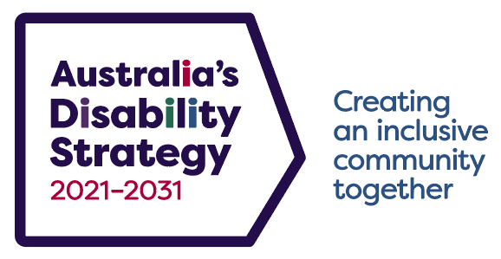

Roadmap – Australia’s Disability Strategy
2021–2031
Working together
Everyone has a role to play. We will work across governments and communities towards our shared vision.

Taking action
We will have an action-orientated approach to achieving clear goals. We will guide action and reform across Australia.

Connecting
We will listen to people with disability, their families and supporters, and respect what they have to say.

Accountability
We are responsible for our actions. We will regularly report on progress, and recognise where more work is needed.
Vision
An inclusive Australian society that ensures people with disability can fulfil their potential, as equal members of the community.

Strategy milestones
2021
- Launch of the Strategy - complete
- 1st Targeted Action Plans - complete
- 2021 Review of Disability (Access to Premises – Buildings) Standards - complete
- Establishment of the Strategy’s Advisory Council - complete

2022
- 1st Strategy National Public Forum - complete
- Survey of Disability, Ageing and Carers undertaken – complete
- 2022 Review of the Disability Standards for Accessible Public Transport – in progress

2023
- 1st Implementation Report – complete
- 1st State and Territory Forum – complete
- Review Strategy following final report from Royal Commission into Violence, Abuse, Neglect and Exploitation of People with Disability – in progress

2024
- 1st set of Targeted Action Plans finished and evaluated
- Public Consultation on the Strategy

2025
- 1st Major Evaluation Review
- 2nd Implementation Report
- 2nd Strategy National Public Forum
- 2025 Review of the Disability Standards for Education

2026
- 1st Major Evaluation Report
- 2nd State and Territory Forum
- 2026 Review of the Disability (Access to Premises – Building) Standards

2027
- 3rd Implementation Report
- Public Consultation on the Strategy
- 2027 Review of the Disability Standards for Accessible Public Transport

2028
- 3rd Strategy National Public Forum
- Survey of Disability, Ageing and Carers undertaken

2029
- 2nd Major Evaluation
- 3rd State and Territory Forum
- 4th Implementation Report

2030
- 2nd Major Evaluation
- 2030 Review of the Disability Standards for Education
- Public Consultation on the Strategy

2031
- 4th State and Territory Forum

Outcome Areas
Employment and Financial Security
Inclusive Homes and Communities
Safety, Rights and Justice
Personal and Community Support
Education and Learning
Health and Wellbeing
Community Attitudes

Regular reporting
- Annual Outcomes Dashboard
- Annual Targeted Action Plan Reports
- Two-yearly Implementation Reports
- Major Evaluation Reports
Strategy actions
- Targeted Action Plans, focusing on priority areas for change:
- Community attitudes, employment, early childhood, safety,
and emergency management
- Strategy Engagement Plan – listening to people with disability
- Guiding Principles for policy development and program design
- State and Territory disability plans align with the Strategy
- Collaboration across governments to implement the Strategy
Better accountability
- Outcomes Framework
- Reporting Strategy
- Data Improvement Strategy
- Evaluation Framework
- Governance model

