
Community attitudes
towards people with
disability

Marian Esler*, Matthew Gray*, Anna Lethborg^ and Dinith Marasinghe*

*ANU Centre for Social Research and Methods ^Social Research Centre

DSS3259.02.24
Acknowledgements
The authors thank the Australian Government Department of Social Services for funding this important research project and for their support throughout. This research was undertaken to report on data under the Community Attitudes Outcome Area under Australia’s Disability Strategy 2021-2031. We also acknowledge the input from Disability Representative Organisations (DROs) particularly their valuable feedback on the final report, and people with disability.
The Social Research Centre supported the development of the survey, undertook the data collection and processing and technical reporting.
JFA Purple Orange played an important role in facilitating the co-design groups that informed the design of the survey and conducting the focus groups for the nested study with people living with intellectual disability.

We know that current community attitudes towards people with disability are not good. We know from the studies that… people with disabilities are viewed as sometimes not having a meaningful role in society.
Dr Ben Gauntlett, former Disability Discrimination Commissioner

Table of Contents

Tables 4
Figures 4
Appendix Tables 6
Acronyms 7
Executive summary 8
1 Introduction 10
2 Background 11
2.1 Australia’s Disability Strategy 2021–2031 11
2.2 Prior research on attitudes of society towards people with disability 12
3 Methodology 12
3.1 Overview 12
3.2 Accessibility of the survey 15
3.3 Respondent profiles 15
3.3.1 Unweighted sample 15
3.3.2 Weighted sample 16
4 Community attitudes and perceptions of disability 17
4.1 Understanding of disability 17
4.2 Attitudes towards people with disability 18
4.2.1 Attitudes to disability by disability status 22
4.2.2 Attitudes to disability by sector and hiring responsibilities 23
4.2.3 Attitudes to disability by experience with disability 25
5 Attitudes to disability in context: The vignettes 26
5.1 Vignette – Relationship 27
5.2 Vignette – General practitioner 28
5.3 Vignette – Boss 28
5.4 Vignettes – Health sector 29
5.5 Vignettes – Justice and legal sector 30
5.6 Vignettes – Personal and community support sector 31
5.7 Vignettes – Education sector 32
5.8 Vignettes – Hiring responsibilities 33
6 Experiences of people living with disability 34
6.1 Experience with workers in the key sectors 34
6.2 Experience in the broader community 36
6.3 Disability and paid employment 42
6.3.1 Employers’ perspectives 42
6.3.2 Impact of community attitudes on the employment of people with disability 46
7 Conclusion 47
References 50
Appendix 51

Tables
Table 1 Numbers of respondents (Unweighted) 14
Table 2 Australians’ perceptions of what is a disability 18
Table 3 Attitudes to people with disability, Power scale individual items, Australia, 2022 (%) 21
Table 4 Imagine a close relative is in a relationship with a person with a […] disability. How comfortable or uncomfortable would you feel? Australian population aged
18 years plus 27
Table 5 Imagine your doctor (GP) has a […] disability. Do you agree or disagree that they would give you the same quality of treatment as a doctor without these conditions? Australian population aged 18 years plus 28
Table 6 Imagine your boss has a […] disability. How comfortable would this make you feel? Australian population aged 18 years plus 29
Table 7 Imagine a patient has a […] disability. Do you agree or disagree they should be able to make their own decisions about treatment? Health sector workers 29
Table 8 Imagine a patient has a […] disability. Do you agree or disagree they should be able to access the same range of fertility or family planning services as people without disability? Health sector workers 30
Table 9 Imagine a person has a […] disability. Do you agree or disagree they are likely to be believed if they report abuse? Justice sector workers 30
Table 10 Imagine a person has a […] disability stole something from a shop. How comfortable or uncomfortable would you be dealing with this? Justice sector workers 31
Table 11 Imagine a person has a […] disability. Do you agree or disagree they should be able to access the services your organisation provides if they are eligible? Community sector workers 31
Table 12 Imagine a person has a […] disability. Do you agree or disagree they should be able to communicate directly with a service provider, rather than through someone else? Personal and community support sector workers 32
Table 13 Imagine a teenager has a […] disability, Do you agree or disagree they should attend sex education classes with their peers? Education sector workers 32
Table 14 Imagine a young person has a […] disability. Do you agree or disagree they should be excluded from activities such as basketball? Education sector workers 33
Table 15 Imagine a person has a […] disability. Do you agree or disagree that a business should employ them if they have the experience and can physically do the job? 33
Table 16 Imagine a person has a […] disability. Do you agree or disagree that a business should provide the support and training required to help them get promoted? 34
Table 17 In general, how often do you feel included and welcomed by your community?, by severity of disability (%) 41
Table 18 People with hiring responsibilities: Barriers experienced by people with disability in the workplace (%) 45

Figures
Figure 1 Attitudes to people with disability, Australian adult population, 2022, mean scores 22
Figure 2 Attitudes to people with disability by whether respondent has a disability, Australian adult population, 2022, mean scores 23
Figure 3 Attitudes to people with disability by sector, Australia, 2022, mean scores 24
Figure 4 Attitudes to people with disability by whether respondent has hiring responsibilities, Australia, 2022, mean scores 25
Figure 5 Attitudes to people with disability by whether respondent has experience with disability, Australia, 2022, mean scores 26
Figure 6 Treated with respect by workers in key sectors, people living with disability (%) 35
Figure 7 Things were explained to me clearly by workers in key sectors, people living with disability (%) 35
Figure 8 I would have been treated better if I did not have a disability by workers in key
sectors, people living with disability (%) 36
Figure 9 Have other people’s attitudes prevented you from …, people living with disability (%) 37
Figure 10 Have other people’s attitudes prevented you from attending community events, by severity of disability (%) 37
Figure 11 Have other people’s attitudes prevented you from travelling, by severity of
disability (%) 38
Figure 12 Have other people’s attitudes prevented you from accessing education, by severity of disability (%) 38
Figure 13 Have other people’s attitudes prevented you from attending community events, by nature of disability (%) 39
Figure 14 Have other people’s attitudes prevented you from travelling, by nature
of disability (%)…….………………………………………………………………………………………………………40
Figure 15 Have other people’s attitudes prevented you from accessing education, by nature
of disability (%) 40
Figure 16 Thinking about your life in general, do you feel valued and respected in your community? People living with disability (%) 42
Figure 17 People with hiring responsibilities: Views about ‘value’ of employees living with disability (%) 43
Figure 18 Have other people’s attitudes prevented you from trying to get a job, by severity of disability (%) 46

Appendix Tables
Appendix Table 1A: Respondent profiles, by disability status (unweighted) 51
Appendix Table 2A: Respondent profiles, by disability status (weighted) 53
Appendix Table 3A: Think a person with this condition has a disability, by disability status (%) 54
Appendix Table 4A: Think a person with this condition has a disability, by experience with disability (%) 55
Appendix Table 5A: Vignettes: Relationship, by disability status (%) 55
Appendix Table 6A: Vignettes: Relationship, by experience with disability (%) 56
Appendix Table 7A: Vignettes: Relationship, by hiring responsibilities (%) 56
Appendix Table 8A: Vignettes: Relationship, by key sectors (%) 57
Appendix Table 9A: Vignettes: GP, by disability status (%) 58
Appendix Table 10A: Vignettes: GP, by experience with disability (%) 58
Appendix Table 11A: Vignettes: GP, by hiring responsibilities (%) 59
Appendix Table 12A: Vignettes: GP, by key sectors (%) 59
Appendix Table 13A: Vignettes: Boss, by disability status (%) 60
Appendix Table 14A: Vignettes: Boss, by hiring responsibilities (%) 60
Appendix Table 15A: Vignettes: Boss, by experience with disability (%) 61
Appendix Table 16A: Vignettes: Boss, by key sectors (%) 61
Appendix Table 17A: Have other people's attitudes prevented you from telling people you have a disability 62
Appendix Table 18A: Do you feel that people with disability are well represented?, by disability type (%) 62
Appendix Table 19A: People with hiring responsibilities: Hiring people with disability benefits your workplace (%) – by sector 63
Appendix Table 20A: People with hiring responsibilities: People with disability would make a valuable contribution to your workplace (%) – by sector) 63
Appendix Table 21A: Have other people’s attitudes prevented you from trying to get a promotion or keeping a job 63
Appendix Table 22A: Have other people’s attitudes prevented you from trying to get a promotion, by disability severity (%) 62
Appendix Table 23A: Have other people’s attitudes prevented you from keeping a job, by disability severity (%) 62

Acronyms
ABS | Australian Bureau of Statistics
A-BS | address-based sample
ADHD | attention deficit hyperactivity disorder
ADS | Australia’s Disability Strategy 2021–31
ANU | Australian National University
ANZSIC | Australia and New Zealand Standard Industrial Classification (system)
DRO | Disability Representative Organisation
DSS | Australian Government Department of Social Services
G-NAF | Geo-coded National Address File
GP | general practitioner
LGBTIQ+ | lesbian, gay, bisexual, transgender, intersex, or questioning
NHS | National Health Survey
CRPD | United Nations Convention on the Rights of Persons with Disabilities
WHO | World Health Organization

Executive summary
It has long been understood that the attitudes of society towards people with disability have a major impact on their wellbeing. In recognition of this, Australia’s Disability Strategy 2021–2031 (ADS) includes, as one of seven outcome areas, Community Attitudes. To provide data on community attitudes towards people with disability, the Australian Government has funded the ADS Survey – Share with us, a longitudinal survey on attitudes towards people with disability.
The survey collects information on attitudes in the general community, from workers in four key sectors (health, justice and legal, education and personal and community support) and from people with hiring responsibilities. The four sectors were chosen because they were identified during widespread consultations as key sectors with whom people with disability interact. The survey also explores how people with disability are affected by the attitudes and behaviours of others and the extent to which attitudes can be both enablers and barriers to inclusion. That is, some attitudes and behaviours can make inclusion possible or even stronger, while others can prevent or limit inclusion.
This report provides some of the key findings from the first wave of the ADS Survey conducted in 2022. It showed that, overall, most Australians report having fairly positive attitudes to people with disability. However, a closer look at the data showed that attitudes varied significantly between types of disability. Also, the extent to which people with disability were affected by other people’s attitudes varied significantly by both the type and the severity of their disability.
People who have experience with people with disability generally had more positive attitudes than people without that experience. This was supported by the findings related to workers in the four key sectors and their levels of confidence in their ability to advise, assist or treat people with different types of disability. Those with experience with people with disability most frequently had the highest levels of confidence.
Most respondents with hiring responsibilities reported that hiring people with disability benefits their workplace and that hiring people with disability would make a valuable contribution to their workplace. However, only a minority had hired someone with disability in the last 12 months and the majority had never employed anyone with disability. This discrepancy highlights the challenges with collecting data on people’s attitudes towards disability, as their responses may be impacted by social desirability bias. Social desirability bias occurs where respondents give answers to questions that they believe will make them look good to others, concealing their true opinions or experiences. The employment experience of people with disability demonstrates that there is room for significant improvement.
People living with disability were asked if other people’s attitudes or behaviours ever stopped them from accessing or undertaking various activities. While the majority reported ‘hardly ever’ or ‘never’ across all of the activities, the severity and type of the disability both had a significant impact on access. For example, more than 20% responded that they had been stopped from accessing education always, often or sometimes. This ranged from 1 in 10 people with mild disability to almost 2 in 5 with severe disability. The disability types affected by the attitudes of others always or often were speech, intellectual and learning impairments and brain injury.
Other people’s attitudes and behaviours had a greater impact on respondents attending community events. Overall, almost a third reported feeling deterred always, often or sometimes. Again, this ranged from about 1 in 5 people with mild disability to more than half of respondents with severe disability. Well over half of respondents with disability felt valued, respected and welcomed by and included in their community. However, this reduced significantly with the level of severity of disability.
Finally, respondents with disability were asked if people with disability are well represented in various spheres of life such as in leadership roles, the workplace, among community and in the media. Positive responses ranged from almost half feeling well represented in the community, down to less than 1 in 5 feeling represented in leadership roles.

Introduction
It has long been understood that the attitudes of society towards people with disability have a major impact on their wellbeing (Thompson et al. 2011). In recognition of this, Australia’s Disability Strategy 2021–2031 (ADS) includes community attitudes as one of seven outcome areas. The community attitudes outcome area is important in improving the lives of people with disability, as it influences a range of other outcomes such as employment prospects, educational attainment and health. ADS promotes and realises the human rights of people with disability, in line with Australia’s commitment under the United Nations Convention on the Rights of Persons with Disabilities (UNCRPD). The UNCRPD is based on the social model of disability, recognising that attitudes, practices and structures can be disabling and act as barriers preventing people from full and effective participation in society on an equal basis with others.
Extensive consultation with the disability sector during the development of ADS suggested that changing attitudes across society will lead to better support, improved treatment and more respect for people with disability. Increased awareness and understanding can not only improve lives of people with disability, but also improve outcomes for the community.
The Royal Commission into Violence, Abuse, Neglect and Exploitation of People with Disability (the Disability Royal Commission) notes in its final report in ‘Our vision for an inclusive Australia’, that people with disability encounter negative attitudes and discriminatory behaviours throughout their lives. ‘Ableism’ is the word most commonly used to describe the attitudes that motivate harmful behaviours directed at people with disability. It refers to the expectations about typical body and cognitive abilities, and the disadvantage people experience when their bodies and functioning capabilities are seen as ‘abnormal’. The word ‘ableism’ pinpoints attitudes that perpetuate the idea that people with disability are different from, less than and inferior to people without disability, incapable of exercising choice and control, and a burden on society. Ableism leads to low expectations of people with disability. In the context of education for example, the attitudes of teachers and principals towards students with disability are key determinants of students’ success in the education system.
This makes it important to gain a more nuanced understanding of attitudes, the reasons people hold these attitudes, and any structural factors that prevent (or constrain) positive change. The ADS Survey – Share with us 2022–24 has been commissioned and funded by the Australian Government Department of Social Services (DSS) as a longitudinal survey to measure changes in community attitudes over time.
The ADS Survey explores the attitudes of the general community, people working in particular sectors (health, justice and legal, education and personal and community support) and people who make hiring decisions. It also describes how people with disability are affected by the attitudes and behaviours of others and the extent to which attitudes can be both enablers and barriers to inclusion. The longitudinal design of the survey, going back to as many of the same respondents as possible in each wave, will enable identification of the factors associated with changes over time in attitudes at the individual person level. A total of four waves will be conducted, collecting and releasing data on community attitudes, over the life of ADS.
To inform the development of the ADS Survey, the ANU Centre for Social Research and Methods was commissioned to develop a methodology and survey instrument, which was required to:
- provide robust data on the attitudes of workers from the four key sectors (personal and community support, education, justice and legal, and health), among people with responsibility for making hiring decisions and the general community
- provide robust data on the experiences of people with disability in engaging with workers in these sectors
- be able to be repeated on a regular basis in order to provide reliable estimates of changes in attitudes of workers and employers and of changes in the experiences of people with disability
- allow statistically reliable estimates of differences in attitudes and changes in attitudes for each state and territory
- ensure inclusion in the survey of people with disability from rural, remote, and urban communities and intersectionality cohorts such as Aboriginal and Torres Strait Islander people, Culturally and Linguistically Diverse and LGBTIQ+.
This report provides early findings from the baseline (Wave 1) data. Further analysis will be conducted to explore different aspects of the data.

Background

Australia’s Disability Strategy 2021–2031
ADS is the overarching policy framework that is designed to provide national leadership towards greater inclusion of people with disability across all areas of public policy.
ADS includes seven Outcome Areas:
- employment and financial security
- inclusive homes and communities
- safety, rights and justice
- personal and community support
- education and learning
- health and wellbeing
- community attitudes.
As part of the development of ADS, DSS conducted consultations across Australia. As a result of those consultations, it was decided to add a seventh Outcome Area, community attitudes, in addition to those in the National Disability Strategy 2010–2020. An Outcomes Framework, designed to measure, track and report on how things are changing for people with disability across the life of the ADS, has been established. The main source of data for the community attitudes Outcomes Area is the ADS Survey.

Prior research on attitudes of society towards people with disability
Thompson et al. (2011:9) identified three types of attitudes held by people without disability towards people with disability. The first attitude is inclusive. That is, people without disability have an awareness of, and a willingness to engage with, people with disability. The second attitude is characterised by a lack of awareness of people with disability, the difficulties they face, their personal support requirements and life ambitions. The third attitude is one of discomfort with the ‘otherness’ of people with disability.
Discomfort associated with ‘otherness’ (psychosocial disabilities) and perceived lack of competence (intellectual or developmental disabilities) can be overcome through personal contact, particularly when the person with disability is perceived as credible, relatable and of equal or higher status (Randle & Reis 2020:6). The effects of having experience with people with disability are explored in this report.
The Survey of Community Attitudes toward People with Disability (DHHS 2018) (Survey of Community Attitudes) presented the findings of a survey designed to provide a baseline understanding of attitudes for Victoria’s State Disability Plan (2017–2020). In Phase 1, the survey included 1,000 participants from greater Melbourne and the rest of Victoria and explored dimensions of attitudes relating to beliefs and stereotypes, rights and entitlements, discrimination and social exclusion and attitudes at work and at school. In Phase 2, the survey included respondents from all over Australia.
The DHHS survey and subsequent work has identified that attitudes can differ according to both the nature and the severity of the disability. In 2020, Randle and Reis (2020:13) noted that, while community attitudes toward the inclusion of people with disability are generally positive, levels of discomfort or anxiety are more likely to emerge when a disability is perceived to be more severe.
People living with physical disability experience the least stigma (Randle & Reis 2020:6, 17; DHHS 2018:28). For example, in an ACT Disability Advisory Council study, ‘the overwhelming response was that people with a physical disability or sensory impairments were more able to make a valuable contribution than people with intellectual or psychiatric disability’ (Thompson et al. 2011:12).

Methodology
This section provides a summary of the methodology used for the ADS Survey. The underlying data used in this report and supporting documentation will be available to approved users for download via the Australian Data Archive.

Overview
The ADS Survey was designed to produce nationally representative data for the population aged 18 years or older living in private dwellings. The ADS Survey was required to provide data for the Australian population as a whole as well as for a number of groups, including: people with disability, people with responsibility for making employment/hiring decisions, and people working in the four key sectors: education, health, personal and community support and justice and legal.
The Australia and New Zealand Standard Industrial Classification (ANZSIC) system classifies entities based on their main business activity and is used to collect and analyse data across industries. We used several items from this system to identify if respondents who were working were from one of the four key sectors. Section E (Screening) included:
Do you work in any of these industries?
Please select one only. If you work in more than one industry, please select the main one.
1. Health care – e.g., hospitals, doctors and dentists, pathology, medical imaging, optometrists, allied and other health services (such as physiotherapy, homeopathy, psychology), ambulances
2. Residential care – e.g., aged care, hospices, crisis care, group homes
3. Social or community services – e.g., adult day care, disability assistance services, youth welfare, family support and counselling
4. Legal services – e.g., barristers and solicitors, conveyancing, legal aid, courts
5. Public order and safety – e.g., police, jails, correctional centres, juvenile detention, remand centres
6. Education – e.g., child care, preschools, primary, secondary and special schools, technical and vocational education, universities and other higher education institutions, adult education, community education
We then combined Residential care and Social or community services to identify the Personal and Community Support Sector workers and we combined legal services with public order and safety to identify the Justice and Legal Sector workers. Results are reported based on those four key sectors throughout the report, except where we identify exactly which service categories were used by people with disability.
The target number of respondents to the survey was approximately 21,500. While this was recognised as more than would typically be required for a general population survey, this size was recommended to achieve sufficient numbers for analysis in the specific key groups. Based on the estimated yield of 20%, the selected sample size was 107,500 addresses.
Estimates associated with the yield within each of the key groups assumed the sample would fall out exactly in proportion to population with respect to disability (National Health Survey disability items), sector and hiring responsibilities. It was acknowledged that actual response rates from each of these groups would likely vary, and responses to Wave 1 were closely monitored for this reason.
The survey was designed as an address-based sampling (A-BS) push-to-web, offering online and hard copy completion modes. The response rate from this approach was lower than initially expected and, once survey yields were analysed, it was evident targets would not be met.
Accordingly, the decision was made to supplement the sample by running the survey on the January 2023 wave of Life in Australia™, a probability-based online panel of Australians. All online panellists were approached to achieve up to 5,000 additional survey responses. As well as boosting the overall sample size using a robust methodology, conducting the Survey on Life in Australia™ allowed us to obtain results from respondents without the potential influence of topic salience, to allow for a comparison of national estimates achieved from each frame.
Table 1 shows the total number of respondents to the survey as well as from the A-BS and from the Life in Australia™ sample. Table 1 also shows the numbers of respondents in each of the key industry groups and those with hiring responsibilities. The total number of respondents is 18,188, with 13,459 from the address-based sample and 4,729 from the Life in Australia™ panel.
Table 1 Numbers of respondents (Unweighted)
 |  | Total |  | Address-based sample |  |  | Life in Australia
 |  |  |  | Online | Hard-copy
Total (no.) |  | 18,188 |  | 9,664 | 3,795 |  | 4,729
Industry
Health | No. | 1,552 |  | 897 | 286 |  | 369
 | % of total | 8.5 |  | 9.3 | 7.5 |  | 7.8
Personal and Community Support | No. | 867 |  | 529 | 145 |  | 194
 | % of total | 4.8 |  | 5.5 | 3.8 |  | 4.1
Justice and Legal | No. | 352 |  | 192 | 51 |  | 109
 | % of total | 1.9 |  | 2.0 | 1.3 |  | 2.3
Education | No. | 1,646 |  | 998 | 248 |  | 402
 | % of total | 9.0 |  | 10.3 | 6.5 |  | 8.5
Involved in hiring employees in past 12 months | No. | 2,474 |  | 1,459 | 421 |  | 586
 | % of total | 13.6 |  | 15.1 | 11.1 |  | 12.4
Source: Australia’s Disability Strategy Survey – Share with us, 2022.
The initial survey response rate achieved through A-BS was 15.2% of households that were eligible to participate in the survey. The survey over-represents people living with disability due to the response rate for people with disability being higher than the overall response rate. While we are not able to determine exactly why this is the case, our judgement is that, because the approach letter specifically mentioned that the survey was about disability, those with disability may have seen the survey as more relevant to themselves than those without disability.

Accessibility of the survey
While the ADS Survey was a population-based survey, we endeavoured to make it accessible to people with disability and people from culturally and linguistically diverse backgrounds. Some of the key elements of accessibility included an online platform that adheres to the Web Content Accessibility Guidelines version 2.0 AAA, the availability of Computer Assisted Telephone surveying, Easy English version of the questionnaire and translations into five other languages. Publishing the questionnaire in an Easy English format made it accessible to a wider audience, including people with disability, First Nations people, culturally and linguistically diverse people, and people of all ages with low levels of literacy. Overall, 404 respondents (3.0% of participants in the main survey) completed the survey online using the Easy English version of the survey.
To improve the representation of people from a non-English speaking background, the online survey and supporting information were translated into five languages other than English: Arabic, Korean, Simplified Chinese, Traditional Chinese and Vietnamese. Overall, 1.3% of respondents participated in the survey using a translated version of the online survey. This comprised: 89 who completed in Simplified Chinese; 42 who completed in Traditional Chinese; 24 who completed in Korean; 11 who completed in Vietnamese; and 4 who completed in Arabic.
With accessibility a priority for the ADS Survey, an interviewer-assisted completion mode was also offered, whereby respondents could call in to the helpdesk and interviewers would complete the online survey on their behalf. Overall, 42 respondents took up the option of completing the survey using the telephone-assisted approach.
The ADS Survey was designed to provide a high-quality sample of the general population, of sufficient size to allow for analysis within the key groups. It was adapted for the Life in Australia™ infrastructure and data was readily combined.

Respondent profiles
The data are weighted to adjust for differences in the likelihood of being selected to participate in the survey due to the sampling and design and difference in the response rates amongst different population groups. The weighted data are used throughout this report to give population-level estimates of results, however, both the unweighted and weighted versions of the respondent profiles have been provided here.

Unweighted sample
In the unweighted sample, the total number of respondents was 18,188. The proportion of women was 62.2% (11,287) and the proportion of men was 37.2% (6,746). The highest proportions of respondents were in the age brackets 65-74 (21.7%), 55-64 (19.5%) and 45-54 (14.8%). Further information on respondent profiles is available at Appendix Tables 1A and 2A.
The five largest states had sufficient respondents for interstate comparisons, ranging from 4,420 (24.3%) from New South Wales to 1,847 (10.2%) from South Australia. However, the smaller jurisdictions, Tasmania and the two territories, had samples between 1,056 (5.8%) from Tasmania and 725 (3.9%) from the Northern Territory, which were not sufficient for comparisons to be made.
In terms of the key sectors, 4,417 employed respondents identified as working in one of the four key sectors (42.7%). More specifically, there were 1,646 in education, 1,552 in health care, 867 in personal and community support (259 in residential care and 608 in social or community services) and 352 in justice and legal (214 in legal services and 138 in public order and safety). Furthermore, of those employed, 2,470 (24%) had hiring responsibilities.
The sample consisted of 9,590 people with disability (53.2%) and 8,432 people without disability (46.8%) and there were some differences in the demographic characteristics of the two groups. The proportion of females with disability was 60.87% and the proportion of males with disability was 38.1%. In terms of age, those with a disability were older than those without a disability. More specifically, the average age of a respondent with disability was 58 and the average age of a respondent without disability was 49.
Furthermore, people without disability were more likely to have bachelor degrees or higher (58.3%) compared to those with disability (44.4%) and have higher levels of income relative to those with disability. In terms of sectors, the highest proportion of those with disability worked in the education sector (37.0%) and the lowest proportion worked in the justice and legal sector (8.3%). The highest proportion of those without disability worked in the health care sector (37.3%) and lowest proportion worked in justice and legal sector (7.7%). A complete respondent profile of the unweighted sample is presented in Appendix Table 1A.

Weighted sample
The weighted number of respondents was 18,188 with fairly equal numbers of men and women and all states and territories represented. The highest weighted proportions of respondents were in the age brackets 25–34 (18.4%), 35–44 (17.7%) and 45–54 (16.2%).
The five largest states had sufficient respondents for interstate comparisons, ranging from 5,712 (31.4%) from New South Wales to 1,297 (7.1%) from South Australia. However, comparisons were not possible for small jurisdictions including Tasmania and the two territories, which had samples between 409, (2.3%) from Tasmania and 169 (0.9%) from the Northern Territory.
In terms of the key groups, 4,153 of those employed (34.7%) identified as working in one of the four key sectors, ranging from 1,458 in education, to 1,356 in health care, 952 in personal and community support (318 in residential care and 633 in social or community services) and 388 in justice and legal (236 in legal services and 152 in public order and safety). Of 11,954 employed respondents, 21.7% had hiring responsibilities.
The weighted sample consisted of 6,553 people with disability (36.3%) and 11,503 people without disability (63.7%). In terms of demographic differences, more men (51.6%) than woman (46.5%) with disability responded and respondents with disability were generally older than those without disability. The mean age of those with and without disability was 51 and 44, respectively.
Almost twice as many people without disability (39.9%) had bachelor degrees or higher than people with disability (21.0%) and, generally, people without disability had higher incomes than people with disability. In 2018, the median gross income for a person with disability aged 15 to 64 years was $505 per week, less than half of the $1,016 per week median gross income of a person without disability (ABS 2018).
Of those who work in the key sectors, people with disability were more likely to work in the personal and community support sector, and less likely to work in the health sector. A complete respondent profile of the weighted sample is presented in the Appendix Table 2A.
The weighted sample is used for the remainder of the report. The underlying data used in this report will be available to approved users for download via the Australian Data Archive.

Community attitudes and perceptions of disability
The ADS Survey explored both what people regard as disability and their attitudes towards people with disability. It is challenging to measure people’s attitudes towards people with disability because there are different dimensions of attitudes and because people may give answers that they think will make them look better (which introduces social desirability bias). Disability is a multidimensional concept and is considered as an interaction between health conditions and personal and environmental factors. For further detail on the definition of disability, please see the Outcomes Framework website (Australia’s Disability Strategy 2021–2031 Outcomes Framework: First annual report, Technical notes - Australian Institute of Health and Welfare (aihw.gov.au)). Therefore, the ADS Survey included several sections about attitudes towards people living with disability. In addition to the Power scale described in detail in Section 4.2, there were also a number of vignettes designed to elicit a more nuanced understanding of attitudes targeted at different groups within the sample. These were developed in close consultation with people with disability through co-design.
In addition, there were modules specifically for people with disability about their experiences of other people’s attitudes, and for people with hiring responsibilities. Overall, responses to the Power scale were more positive than those elicited in other ways, which may reflect social desirability bias among respondents. It is also clear that the experience of people living with disability, and the impact on them of other people’s attitudes, is even less positive.

Understanding of disability
The United Nations Convention on the Rights of Persons with Disabilities (UNCRPD) defines disability as ‘long-term physical, mental, intellectual or sensory impairments which in interaction with various barriers may hinder their full and effective participation in society on an equal basis with others’ (United Nations 2006).
The National Health Survey (NHS) is conducted by the Australian Bureau of Statistics (ABS) every three years and assesses disability according to type of condition, duration (has lasted or is likely to last more than six months) and whether/how often people need help or supervision with key tasks (self-care, mobility and communication). The questions in the ADS Survey about whether the respondent has a disability and, if so, the nature of disability, are based on the NHS questions. However, it appears from responses to the perception questions that many people have a less strict understanding of what constitutes a disability.
In the ADS Survey, respondents were asked which of a number of conditions they see as a disability. The list of conditions that respondents were asked about included conditions that would be classified as a disability (such as blindness or Down syndrome) and conditions that would not generally be classified as a disability under the UNCRPD definition or by the ABS NHS definition (such as a broken leg).
Table 2 shows that the conditions which the highest proportion of the Australian population see as a disability were: Blindness (89.7%), Down syndrome (84.6%) and severe arthritis (80.7%). These are all conditions which would generally be classified as being a disability. HIV/AIDS was seen as a disability by the lowest proportion of the Australians (37.7%). One of the more surprising findings was that over one-half the respondents (51%) classed a broken leg as a disability, in spite of it being temporary. This indicates some lack of clarity in Australians’ understanding of what conditions would generally be classified as a disability.
Across most of the conditions listed, more people with disability regarded the conditions as a disability, but significantly more people with disability saw chronic pain and extreme fatigue as a disability (Appendix Table 3A). Similarly, more people with experience with people with disability regarded all the conditions as disability than those without experience (Appendix Table 4A).

Table 2 Australians’ perceptions of what is a disability
Condition | Think a person with this condition has a disability (%)
Has HIV/AIDS | 31.7
Has severe arthritis | 80.7
Is blind | 89.7
Has a broken leg and uses crutches while it heals | 51.1
Has cancer | 46.5
Has a diagnosis of depression | 57.3
Has Down syndrome | 84.6
Has a severe facial disfigurement | 51.0
Has extreme fatigue or tiredness | 59.5
Has chronic pain | 75.6
Source: Australia’s Disability Strategy Survey – Share with us, 2022

Attitudes towards people with disability
The Attitudes to Disability Scale developed by the World Health Organization (WHO) Quality of Life Group (the Power scale) is widely used in surveys and was included in the ADS Survey (Power et al. 2010). The scale asks respondents to indicate whether they strongly agree, agree, neither agree nor disagree, disagree or strongly disagree with 20 statements related to the perception of the functioning of people with disability in society. The 20 statements relate to five domains:
- Inclusion – Relationships, involvement, burden to society, burden to family
- Discrimination – Ridicule, exploitation, irritation, ignorance
- Gains – Emotional strength, maturity, achievement, determination
- Prospects – Sexuality, underestimation, optimism, future prospects
- Work – Company image, willingness to work, efficiency, support at work.
The Power scale (with slightly simplified language) as it appeared in the ADS Survey is shown in Box 1.
Box 1. Power scale questions
Please indicate how much you agree or disagree with the following statements.
Please select an answer for each.
Inclusion
a) People with disability find it harder than others to make new friends
b) People with disability have a hard time getting involved in society
c) People with disability are a burden on society
d) People with disability are a burden on their family
Discrimination
e) People often make fun of disability
f) People with disability are easier to take advantage of (exploit or treat badly) compared with other people
g) People tend to become impatient with those with disability
h) People tend to treat those with disability as if they have no feelings
Gains
i) Having a disability can make someone a stronger person
j) Having a disability can make someone a wiser person
k) Some people achieve more because of their disability (e.g., they are more successful)
l) People with disability are more determined to reach their goals
Prospects
m) Sex should not be discussed with people with disability
n) People should not expect too much from those with disability
o) People with disability should not be optimistic (hopeful) about their future
p) People with disability have less to look forward to than others
Work
q) Employing people with disability improves a company’s image
r) People with disability do not want to work, they do not look for a job
s) People with disability work less efficiently than people without any disability
t) It is easier for people with disability to do their job if they have the right support and equipment at work
(RESPONSE CATEGORIES)
1. Strongly agree
2. Agree
3. Neither agree nor disagree
4. Disagree
5. Strongly disagree

The statements vary, with some worded positively and some negatively. This means that for positively worded statements, agreement indicates a more positive attitude towards people with disability and for negatively worded statements, agreement indicates a less positive attitude. The statements are combined into five domains by reversing the coding on negatively framed items so that, for all domains, agreement indicates a more positive attitude toward people with disability. The mean attitude for each domain was then calculated based on a 1–5 scale. Number 1 represents strongly negative attitudes and number 5 represents strongly positive attitudes.
While the Power scale statements are designed to be combined into the five domains and the overall scale to provide robust measures of attitudes toward people with disability, the responses to the individual items provide some interesting insights into Australians’ attitudes towards people with disability. Table 3 (below) shows the extent of agreement or disagreement with each statement.
Key observations include:
- More than half of respondents agreed that people with disability find it harder than others to make new friends and have a hard time getting involved in society.
- Only 6% agreed that people with disability are a burden on society, but 17% agreed that they are a burden on their families.
- In terms of people with disability receiving poor treatment from other people, 56% agreed that people often make fun of disability, 62% agreed that people with disability are easier to take advantage of or exploit than other people. 60% agreed that people tend to get impatient with people with disability, while 40% agreed that people with disability are treated as if they have no feelings.
- 61% agreed that having a disability can make someone a stronger person, and 43% agreed that it can make someone wiser. 49% agreed that some people achieve more because of their disability and 41% agreed that people with disability are more determined to reach their goals.
- Only 5% of respondents agreed that sex should not be discussed with people with disability. In terms of the prospects for the future for people with disability, 14% agreed that people should not expect too much from people with disability, 6% agreed that people with disability should not be optimistic about the future and 13% agreed that people with disability have less to look forward to than people without disability.
- Attitudes to employment were fairly positive, with 60% agreeing that employing people with disability improves a company’s image. Only 3% agreed that people with disability do not want to work and 14% agreed with the statement that people with disability work less efficiently than people without disability. A large majority of respondents (89%) agreed that it’s easier for people with disability to do their job if they have the right support and equipment at work.

Table 3 Attitudes to people with disability, Power scale individual items, Australia, 2022 (%)
 | Strongly agree (%) | Agree (%) | Neither agree nor disagree (%) | Disagree (%) | Strongly disagree  (%)
Inclusion
People with disability find it harder than others to make new friends | 9.0 | 43.8 | 33.3 | 11.8 | 2.1
People with disability have a hard time getting involved in society | 8.6 | 49.6 | 28.6 | 11.4 | 1.9
People with disability are burden on society | 1.0 | 5.1 | 16.4 | 37.7 | 39.8
People with disability are a burden on their family | 1.6 | 14.9 | 31.7 | 30.7 | 21.1
Discrimination
People often make fun of disability | 10.2 | 45.8 | 25.1 | 15.6 | 3.3
People with disability are easier to take advantage of | 12.6 | 48.6 | 27.2 | 8.9 | 2.7
People tend to become impatient with those with disability | 9.5 | 51.1 | 26.5 | 11.2 | 1.7
People tend to treat those with disability as if they have no feelings | 6.8 | 33.5 | 30.3 | 24.7 | 4.8
Gains
Having a disability can make someone a stronger person | 12.4 | 48.7 | 31.6 | 6.0 | 1.3
Having a disability can make someone a wiser person | 8.0 | 34.8 | 44.5 | 10.1 | 2.6
Some people achieve more because of their disability | 8.7 | 39.8 | 38.7 | 10.5 | 2.4
People with disability are more determined to reach their goals | 8.1 | 33.4 | 52.2 | 5.3 | 1.0
Prospects
Sex should not be discussed with people with disability | 1.9 | 3.4 | 21.5 | 41.4 | 31.9
People should not expect too much from those with disability | 1.9 | 12.1 | 30.3 | 40.0 | 15.7
People with disability should not be optimistic (hopeful) about their future | 1.8 | 4.2 | 10.8 | 40.5 | 42.7
People with disability have less to look forward to than others | 1.6 | 11.3 | 24.4 | 40.7 | 22.0
Work
Employing people with disability improves a company’s image | 12.0 | 47.7 | 33.5 | 5.3 | 1.4
People with disability do not want to work, they do not look for a job | 1.1 | 2.0 | 16.9 | 44.3 | 35.7
People with disability work less efficiently than people without any disability | 1.7 | 12.5 | 33.5 | 37.8 | 14.5
It is easier for people with disability to do their job if they have the right support | 46.0 | 42.8 | 7.5 | 2.3 | 1.5
Source: Australia’s Disability Strategy Survey – Share with us, 2022.

Australians have the most positive attitudes towards people with disability in the domains of prospects and work and the least positive attitudes in the domains of discrimination and gains (Figure 1). The statements in the discrimination domain are different from the others because they are not specifically asking about the respondents’ own attitudes, but rather their perceptions of other people’s attitudes. This could explain why, overall, these responses are less positive than the others. It could be that people think their own attitudes are fairly positive but are aware that other people might discriminate against people with disability.
The differences between the five domains are all statistically significant at the 95% confidence level. For each domain, the mean score on the 1–5 scale is above 3, meaning that, overall, attitudes towards people with disability are more positive than negative.
Figure 1 Attitudes to people with disability, Australian adult population, 2022, mean scores
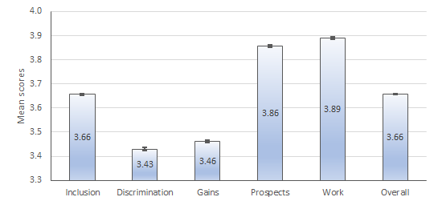
Notes: The ‘error bars’ on each bar indicate the 95% confidence intervals for the estimate.
Source: Australia’s Disability Strategy Survey – Share with us, 2022.

Attitudes to disability by disability status
People with a disability themselves have more positive attitudes about disability than people who do not have a disability in relation to inclusion, discrimination, gains and work. However, those with disability had more negative views about the prospects for people with disability. In other words, people with disability reported lower optimism and future prospects and believed that people underestimate them (Figure 2).
These results are different from the data from the vignettes (Section 5) and the modules for people with disability and people with hiring responsibilities (Section 6), which highlighted more of the poor treatment of people with disability in the workplace and the barriers to work.

Figure 2 Attitudes to people with disability by whether respondent has a disability, Australian adult population, 2022, mean scores
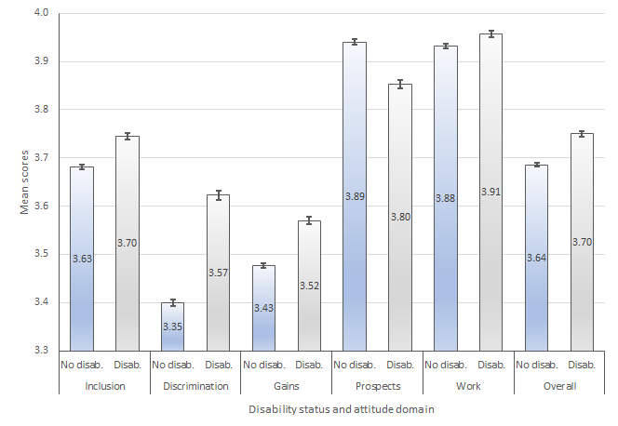
Notes: The ‘error bars’ on each bar indicate the 95% confidence intervals for the estimate.
Source: Australia’s Disability Strategy Survey – Share with us, 2022.

Attitudes to disability by sector and hiring responsibilities

This section presents some of the attitudes of workers in the key sectors and people with hiring responsibilities towards people with disability relating to the five domains - Inclusion, Discrimination, Gains, Prospects and Work (Figures 3 and 4). Some of the key findings are:
- Under the Inclusion domain, there were a number of differences in responses between groups. For example:
  - More people in personal and community support agreed that people with disability find it harder than others to make new friends (58%) and have a hard time getting involved in society (65%) relative to other key sectors.
  - In terms of being a burden, there was little difference in attitudes between sectors, with very few agreeing that people with disability are a burden on society (although the rate for health workers was slightly higher than the others). There was more variation in the rates of agreeing that people with disability are a burden on their families (health 16%, justice and legal 14%, education 13% and personal and community support 11%).
- The attitudes across the four Discrimination statements show similar variations between sectors, with the lowest levels of agreement or strong agreement with the statement that people tend to treat people with disability as if they have no feelings.
- Similarly, there are only very small differences between sectors across all the remaining attitude domains (Gains, Prospects and Work).
- There are almost no differences between respondents with or without hiring responsibilities across the whole Power scale.

Figure 3 Attitudes to people with disability by sector, Australia, 2022, mean scores
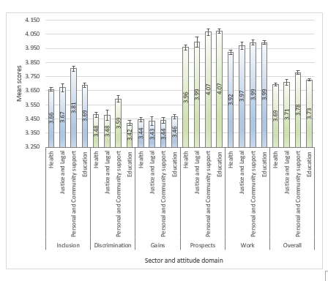
Notes: The ‘error bars’ on each bar indicate the 95% confidence intervals for the estimate.
Source: Australia’s Disability Strategy Survey – Share with us, 2022.
Figure 4 Attitudes to people with disability by whether respondent has hiring responsibilities, Australia, 2022, mean scores
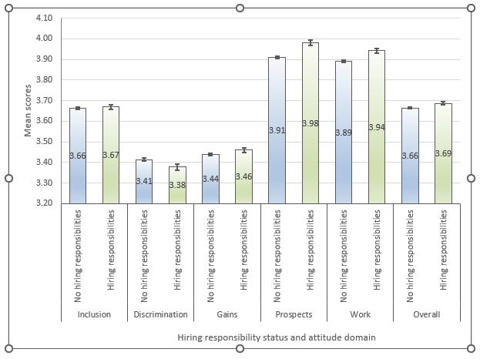
Notes: The ‘error bars’ on each bar indicate the 95% confidence intervals for the estimate.
Source: Australia’s Disability Strategy Survey – Share with us, 2022.

Attitudes to disability by experience with disability
Section D of the ADS Survey, ‘Own experience with people with disability’, was designed to identify those who had engaged with people with disability in a number of ways. These included providing paid care, providing unpaid care, help or assistance, having ever lived with someone with disability and having ever had one of the following:
a) Close family member with disability (such as a parent, child or sibling)
b) Partner with disability
c) Close friend with disability
d) Work colleague with disability
e) Boss or work supervisor with disability
f) Teacher or lecturer with disability
g) Classmate with disability.
Respondents who answered yes to any of these were categorised in the analysis as having experience with people with disability.
Those who had experience with people with disability had more positive attitudes relative to those who did not have experience in all five domains: Inclusion, Discrimination, Gains, Prospects and Work (Figure 5). This is consistent across all the survey data, including the vignettes (see Section 5).
Figure 5 Attitudes to people with disability by whether respondent has experience with disability, Australia, 2022, mean scores
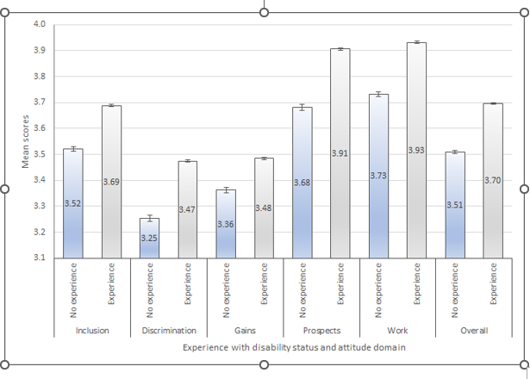
Notes: The ‘error bars’ on each bar indicate the 95% confidence intervals for the estimate.
Source: Australia’s Disability Strategy Survey – Share with us, 2022.

Attitudes to disability in context: The vignettes
An alternative way to assess attitudes to disability is the use of vignettes. A vignette is a short description of a situation or scenario to which respondents are asked to respond. To understand how attitudes might differ according to the type of disability, the type of disability is varied randomly across survey respondents. This randomisation provides insights into how attitudes towards disability vary according to the type of disability. This approach is sometimes described as a survey experiment. For example:

Imagine a close relative is in a relationship with a person with a physical disability, such as reduced mobility or movement.

How comfortable or uncomfortable would you feel?
1 Very comfortable
2 Fairly comfortable
3 Fairly uncomfortable
4 Very uncomfortable

The types of disabilities, how they are described, and the relative allocations are:
- a sensory or communication impairment, such as being partially or fully blind or deaf [25% of the sample]
- a physical disability, such as reduced mobility or movement [25% of the sample]
- a psychosocial condition, such as severe anxiety or depression [25% of the sample]
- a neurological disability, such as autism or ADHD [12.5% of the sample]
- an intellectual disability, such as Down syndrome [12.5% of the sample].
In total there were 13 vignettes. The first three were presented to all respondents. Respondents from the four key sectors and people with hiring responsibilities were presented with an additional two vignettes. This means that a person could be presented with anywhere between three and seven vignettes. Respondents were randomly allocated to one of the five disability categories.
Some of the responses to the vignettes are quite surprising and are likely to be due to mixed levels of understanding of the nature and effects of different types of disability.

Vignette – Relationship
All respondents were asked how comfortable they would feel about a close family member being in a relationship with someone with a disability. Across the whole sample, most people were fairly comfortable or very comfortable with a close family member being in a relationship with someone with disability (ranging from 76% to 91%), and very few people were very uncomfortable (between 1% and 3%). There are substantial differences between categories of disability, with 22% being fairly or very uncomfortable with respect to intellectual disability and 24% with respect to psychosocial disability. Slightly more people with disability were fairly comfortable or very comfortable across all disability categories.
Table 4 Imagine a close relative is in a relationship with a person with a […] disability. How comfortable or uncomfortable would you feel? All respondents
 | Nature of disability
 | Sensory | Physical | Psychosocial | Neurological | Intellectual
Very comfortable (%) | 44.2 | 47.1 | 23.3 | 38.6 | 24.4
Fairly comfortable (%) | 46.1 | 43.9 | 52.9 | 48.4 | 53.6
Fairly uncomfortable (%) | 8.7 | 7.6 | 21.7 | 11.7 | 18.8
Very uncomfortable (%) | 1.0 | 1.5 | 2.2 | 1.3 | 3.2
Source: Australia’s Disability Strategy Australia – Share with us, 2022.

People with experience of disability were more comfortable than those without experience across all disability categories (Appendix Table 6A), while there were only minimal differences between respondents with or without hiring responsibilities (Appendix Table 7A).
Responses from the four key sectors were very similar to the sample-wide results, except for justice and legal, where more were uncomfortable with physical disability (16.3%) and fewer were uncomfortable with psychosocial disability (9%) (Appendix Table 8A).

Vignette – General practitioner
When participants were asked if they agreed or disagreed that they would get the same quality of treatment from a doctor/general practitioner (GP) with disability as from a doctor without disability, responses were quite different, depending on the category of disability (Table 5). For physical disability, 94.0% agreed that they would get the same level of treatment. This compares to 81.9% for neurological disability, 72.6% for psychosocial and 69.2% for sensory, down to 60.4% who agreed that they would get the same quality of treatment from a GP with intellectual disability. The fact that 6 in 10 people think that they would get the same quality of treatment from a doctor with an intellectual disability is quite surprising and perhaps reflects a lack of understanding of either what having an intellectual disability means or what is required to provide high quality medical care.
Responses from those with and without disability are very similar, with those with disability slightly more likely to disagree that they would get the same quality of treatment (Appendix Table 9A). The same pattern is evident for those both with and without experience of disability and with or without hiring responsibilities (Appendix Tables 10A and 11A).
Table 5 Imagine your doctor (GP) has a […] disability. Do you agree or disagree that they would give you the same quality of treatment as a doctor without these conditions? All respondents
 | Nature of disability
 | Sensory | Physical | Psychosocial | Neurological | Intellectual
Strongly agree (%) | 27.1 | 66.7 | 31.3 | 38.9 | 23.4
Somewhat agree (%) | 42.1 | 27.3 | 41.3 | 43.0 | 37.0
Somewhat disagree (%) | 24.0 | 5.0 | 21.5 | 14.1 | 28.6
Strongly disagree (%) | 6.8 | 1.0 | 5.9 | 4.0 | 10.9
Source: Australia’s Disability Strategy Survey – Share with us, 2022.

There were some interesting differences between the attitudes of workers in the key sectors. Only 54% of health workers agreed that they would get the same quality of treatment from a GP with intellectual disability, compared to 72% in justice and legal, 66% in personal and community support and 64% in education. More workers in justice and legal than other sectors thought that a physical disability would affect the quality of treatment. Otherwise, the patterns are similar across sectors (Appendix Table 12A).

Vignette – Boss
All respondents were asked about how comfortable or uncomfortable they would feel working for a boss with […] disability. Only 5% said they would be fairly or very uncomfortable having a boss with physical disability, but this went up to 12% for sensory, 21% for neurological, 29% for intellectual and 32% for psychosocial disability (Table 6).
Table 6 Imagine your boss has a […] disability. How comfortable would this make you feel? All respondents
 | Nature of disability
 | Sensory | Physical | Psychosocial | Neurological | Intellectual
Very comfortable (%) | 35.7 | 60.3 | 19.3 | 28.1 | 22.0
Fairly comfortable (%) | 51.6 | 35.5 | 48.8 | 50.8 | 49.4
Fairly uncomfortable (%) | 11.4 | 3.5 | 28.7 | 18.9 | 24.8
Very uncomfortable (%) | 1.3 | 0.7 | 3.2 | 2.2 | 3.8
Notes: The question included the additional instruction ‘If you are currently not working, think about how you would feel in this situation’.
Source: Australia’s Disability Strategy Survey – Share with us, 2022.

Responses did not vary much between respondents with or without disability (Appendix Table 13A) or those with or without hiring responsibilities (Appendix Table 14A). However, those with experience of people with disability were less likely to be uncomfortable than those without experience (Appendix Table 15A).
Responses were similar across the four key sectors, except that in the justice and legal sector, workers were more likely to feel uncomfortable (30%) about a boss with intellectual disability relative to other key sectors. More specifically, 25% in personal and community support, 23% in education and 22.3% in health care (Appendix Table 16A).

Vignettes – Health sector
Workers in the health sector were asked if they agreed or disagreed that a patient should be able to make their own decisions about treatment. The vast majority agreed that people with disability should be able to make their own decisions about treatment (Table 7). The breakdown by disability type was: sensory – 95.9%, physical – 98.7%, psychosocial – 84.4%, neurological – 86.4% and intellectual – 91.8%.
The major differences were in the numbers who disagreed that people with particular disabilities should be able to make treatment decisions. While the numbers were very small for sensory and physical disability, rates of disagreement were higher for people with intellectual disability (8.2%), neurological disability (13.6%) and psychosocial (15.6%) disability. This may partly explain why many people with certain types of disability report that they feel excluded from decision-making.
Table 7 Imagine a patient has a […] disability. Do you agree or disagree they should be able to make their own decisions about treatment? Health sector workers
 | Nature of disability
 | Sensory | Physical | Psychosocial | Neurological | Intellectual
Strongly agree (%) | 81.2 | 82.3 | 34.2 | 49.7 | 33.1
Somewhat agree (%) | 14.7 | 16.4 | 50.1 | 36.8 | 58.7
Somewhat disagree (%) | 3.1 | 1.4 | 13.3 | 12.1 | 8.1
Strongly disagree (%) | 1.0 | 0.0 | 2.4 | 1.5 | 0.1
Source: Australia’s Disability Strategy Survey – Share with us, 2022.
Workers in the health sector were also asked if they agreed or disagreed that a person with a disability should be able to access the same range of fertility or family planning services as people without disability. They overwhelmingly agreed that people with disability, particularly sensory or physical disability, should be able to access the same range of fertility or family planning services as people without disability (Table 8). However, there was more disagreement about access to these services for people in the other disability categories, psychological (12.8%), neurological (8.8%) and intellectual (10.1%).

Table 8 Imagine a patient has a […] disability. Do you agree or disagree they should be able to access the same range of fertility or family planning services as people without disability? Health sector workers
 | Nature of disability
 | Sensory | Physical | Psychosocial | Neurological | Intellectual
Strongly agree (%) | 83.2 | 72.5 | 54.0 | 56.1 | 33.5
Somewhat agree (%) | 14.5 | 24.1 | 33.2 | 35.2 | 56.4
Somewhat disagree (%) | 1.4 | 3.3 | 10.8 | 5.7 | 6.5
Strongly disagree (%) | 0.9 | 0.1 | 2.0 | 3.0 | 3.6
Source: Australia’s Disability Strategy Survey – Share with us, 2022.

Vignettes – Justice and legal sector
Workers in the justice and legal sector were asked if they agreed or disagreed that a person with a disability is likely to be believed if they report abuse. While the majority of workers in this sector agreed that people with disability are likely to be believed if they report abuse, there were variations depending on the category of disability (Table 9). The responses were generally more positive when it came to believing people with physical (89%) and sensory (81%) disabilities reporting abuse, than for those with intellectual (77%), neurological (75%) and psychosocial (70%) disabilities. It is interesting that the lowest rates of agreement and the highest rates of disagreement (at 30.2%) related to people with a psychosocial condition, such as severe anxiety or depression.
Table 9 Imagine a person has a […] disability. Do you agree or disagree they are likely to be believed if they report abuse? Justice sector workers
 | Nature of disability
 | Sensory | Physical | Psychosocial | Neurological | Intellectual
Strongly agree (%) | 25.1 | 48.5 | 22.3 | 28.7 | 28.2
Somewhat agree (%) | 55.6 | 40.0 | 47.5 | 45.9 | 48.7
Somewhat disagree (%) | 14.4 | 11.6 | 28.5 | 24.8 | 18.4
Strongly disagree (%) | 4.8 | 0.0 | 1.6 | 0.6 | 4.8
Source: Australia’s Disability Strategy Survey – Share with us, 2022.
The majority of justice and legal sector workers felt comfortable engaging with a person with disability who had stolen something from a shop (Table 10). Once again, there were differences between disability types, with more workers comfortable engaging with people with physical disability (70.9%) compared to engaging with people with psychosocial disability (56.9%). This is much more positive than the responses from people with disability describing their experiences with the justice and legal sector would suggest (See Section 6.1).
Table 10 Imagine a person has a […] disability stole something from a shop. How comfortable or uncomfortable would you be dealing with this? Justice and legal sector workers
 | Nature of disability
 | Sensory | Physical | Psychosocial | Neurological | Intellectual
Very comfortable (%) | 19.9 | 30.8 | 9.3 | 35.0 | 24.4
Fairly comfortable (%) | 47.6 | 40.1 | 47.6 | 28.6 | 37.9
Fairly uncomfortable (%) | 23.0 | 29.1 | 35.5 | 33.2 | 36.4
Very uncomfortable (%) | 9.6 | 0.0 | 7.7 | 3.2 | 1.2
Source: Australia’s Disability Strategy Survey – Share with us, 2022.

Vignettes – Personal and community support sector
Workers in the personal and community support sector were asked if they agreed or disagreed that a person with disability should be able to access the services their organisation provides if they are eligible (Table 11). The vast majority of workers in the sector agreed, with the highest level of agreement related to people with sensory disability (99.1%) and the highest level of disagreement related to people with intellectual disability (6.1%).
Table 11 Imagine a person has a […] disability. Do you agree or disagree they should be able to access the services your organisation provides if they are eligible? Personal and community support sector workers
 | Nature of disability
 | Sensory | Physical | Psychosocial | Neurological | Intellectual
Strongly agree (%) | 86.2 | 90.8 | 76.5 | 83.3 | 91.3
Somewhat agree (%) | 12.9 | 5.0 | 20.9 | 14.3 | 2.6
Somewhat disagree (%) | 0.9 | 4.2 | 2.5 | 2.4 | 5.4
Strongly disagree (%) | 0.0 | 0.0 | 0.0 | 0.0 | 0.8
Source: Australia’s Disability Strategy Survey – Share with us, 2022.
Similarly, most personal and community support sector workers agreed that people with disability should be able to communicate directly with a service provider rather than through someone else (Table 12). In this case, the highest levels of agreement related to people with neurological disability (100%) and physical disability (96.8%) and the highest levels of disagreement related to people with psychosocial disability (11.3%).
Table 12 Imagine a person has a […] disability. Do you agree or disagree they should be able to communicate directly with a service provider, rather than through someone else? Personal and community support sector workers

 | Nature of disability
 | Sensory | Physical | Psychosocial | Neurological | Intellectual
Strongly agree (%) | 71.9 | 87.6 | 65.1 | 72.8 | 69.9
Somewhat agree (%) | 19.4 | 9.2 | 23.6 | 27.2 | 24.9
Somewhat disagree (%) | 7.8 | 2.5 | 11.3 | 0.0 | 5.2
Strongly disagree (%) | 0.9 | 0.7 | 0.0 | 0.0 | 0.0
Source: Australia’s Disability Strategy Survey – Share with us, 2022.

Vignettes – Education sector
When asked if students with disability should attend sex education classes with their peers, most education sector workers agreed across all the disability categories (Table 13). The lowest rates of agreement related to people with psychosocial disability (90.4%).

Table 13 Imagine a teenager has a […] disability, Do you agree or disagree they
should attend sex education classes with their peers? Education sector workers
 | Nature of disability
 | Sensory | Physical | Psychosocial | Neurological | Intellectual
Strongly agree (%) | 80.1 | 81.5 | 61.0 | 67.6 | 66.1
Somewhat agree (%) | 16.4 | 15.3 | 29.4 | 28.3 | 30.5
Somewhat disagree (%) | 2.5 | 1.9 | 7.6 | 4.0 | 3.1
Strongly disagree (%) | 1.0 | 1.3 | 2.0 | 0.0 | 0.4

Source: Australia’s Disability Strategy Survey – Share with us, 2022.

In addition, most education sector workers disagreed that students with disability should be excluded from activities like basketball (Table 14). Of those who agreed they should be excluded, the highest rate was for sensory disability (14.5%). Interestingly, the lowest rates of agreement that students with disability should be excluded related to people with psychosocial (7.4%) and intellectual disability (6.9%).

Table 14 Imagine a young person has a […] disability. Do you agree or disagree they should be excluded from activities such as basketball? Education sector workers
 | Nature of disability
 | Sensory | Physical | Psychosocial | Neurological | Intellectual
Strongly agree (%) | 4.3 | 3.2 | 1.9 | 4.1 | 2.6
Somewhat agree (%) | 10.2 | 5.6 | 5.5 | 5.6 | 4.3
Somewhat disagree (%) | 30.7 | 25.7 | 13.4 | 12.7 | 10.8
Strongly disagree (%) | 54.9 | 65.5 | 79.2 | 77.7 | 82.3
Source: Australia’s Disability Strategy Survey – Share with us, 2022.

Vignettes – Hiring responsibilities
Workers with hiring responsibilities were asked if a business should hire people with disability if they have experience and can physically do the job. The vast majority, more than 90%, agreed with this across all disability categories (Table 15). Again, this is much more positive than the experience of people with disability would suggest.

Table 15 Imagine a person has a […] disability. Do you agree or disagree that a business should employ them if they have the experience and can physically do the job?
 | Nature of disability
 | Sensory | Physical | Psychosocial | Neurological | Intellectual
Strongly agree (%) | 73.2 | 83.7 | 56.9 | 72.6 | 69.3
Somewhat agree (%) | 23.0 | 14.8 | 36.2 | 24.4 | 26.4
Somewhat disagree (%) | 2.8 | 1.4 | 5.7 | 1.7 | 2.2
Strongly disagree (%) | 1.1 | 0.1 | 1.2 | 1.4 | 2.2
Source: Australia’s Disability Strategy Survey – Share with us, 2022.
There were equally strong levels of agreement that a business should provide the support and training required to help people with disability to get promoted (Table 16). This aligns with the high rate of agreement to item (t) in the power scale (see Section 4.2, page 22) about providing support and equipment.
Table 16 Imagine a person has a […] disability. Do you agree or disagree that a business should provide the support and training required to help them get promoted?
 | Nature of disability
 | Sensory | Physical | Psychosocial | Neurological | Intellectual
Strongly agree (%) | 62.1 | 62.2 | 60.5 | 63.6 | 63.6
Somewhat agree (%) | 29.8 | 32.7 | 33.7 | 29.9 | 32.8
Somewhat disagree (%) | 5.5 | 4.3 | 4.4 | 5.9 | 3.6
Strongly disagree (%) | 2.6 | 0.8 | 1.5 | 0.7 | 0.0
Source: Australia’s Disability Strategy Survey – Share with us, 2022.

Experiences of people living with disability
In addition to surveying attitudes towards disability, it is also important to understand the experiences of people with disability. This can help to shape sound policy and service responses. The ADS Survey included a number of questions for people living with disability about their experiences and the extent to which attitudes of others create barriers to their full social and economic participation.

Experience with workers in the key sectors
The ADS Survey first asked people with disability whether they had contact with the health care, residential care, social or community, legal services, public order and safety and education sectors in the last 12 months. Those who reported having had contact with workers in these sectors in the last 12 months were then asked about their experience. If they had contact with more than one sector over the previous 12 months, they were then asked about their experience with workers in the sector that they had the most recent contact.
Most people with disability reported using health services in the last 12 months (87.4%), followed by education (25.7%), social and personal and community support (20.7%), legal services (12.7%), and residential care (7.6%). Just 4.9% reported contact with workers in public order and safety in last 12 months. To maintain consistency throughout the report, these six groups were collapsed into the four key sectors using the method outlined in Section 3.
The vast majority of people with disability agreed that they were treated with respect by workers in the key sectors. The proportion of respondents reporting that they strongly agree they were treated with respect was around two-thirds for all sectors, except for the justice and legal sector, for which 54.6% strongly agreed that they were treated with respect (Figure 6). The proportion who disagreed that they were treated with respect was relatively low (around 6%) except for experiences with workers in justice and legal sector, with 13.7% disagreeing that they were treated with respect.

Figure 6 Treated with respect by workers in key sectors, people with disability (%)
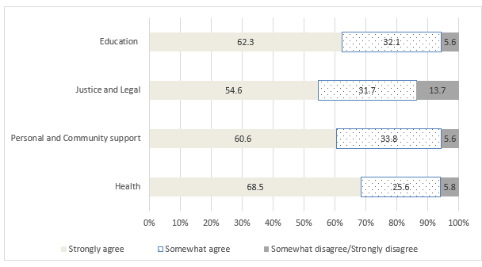
Source: Australia’s Disability Strategy Survey – Share with us, 2022.
In terms of receiving clear explanations, the proportion who agreed was again high (between 88% and 92%), except for workers in the justice and legal sector (74.8%) (Figure 7).
Figure 7 Things were explained to me clearly by workers in key sectors, people with disability (%)
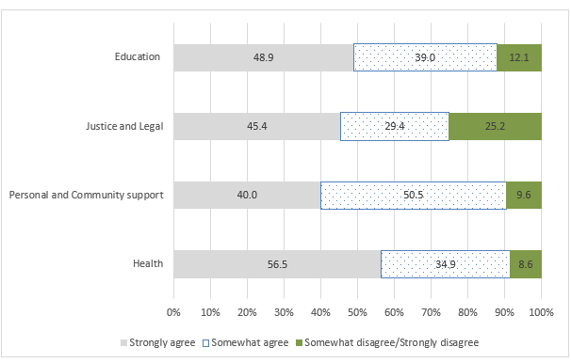
Source: Australia’s Disability Strategy Survey – Share with us, 2022.

While the majority of people with disability did not think that they would have been treated better if they did not have a disability, a substantial minority agreed that they would have been treated better (Figure 8). This ranged from 15.6% in relation to health services to 25.6% in the justice and legal sector.
Figure 8 I would have been treated better if I did not have a disability by workers in key sectors, people living with disability (%)
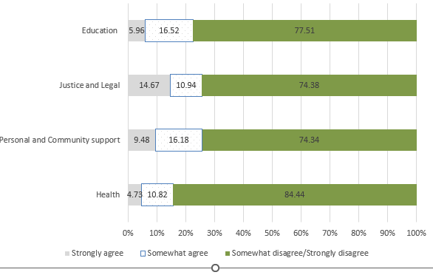
Source: Australia’s Disability Strategy Survey – Share with us, 2022.

Experience in the broader community
Restricted by other people’s attitudes
In the context of people with disability or long-term health conditions experiencing unfair treatment, bullying or discrimination, respondents with disability were asked if other people’s attitudes or behaviours ever stopped them from accessing or undertaking various activities, including attending community activities, travelling and accessing education.
While the majority of people with disability said that other people’s attitudes hardly ever or never limited their ability to attend community activities, travelling or accessing education, a substantial minority said they were limited by other people’s attitudes (Figure 9). This varied from 32.7% for attending community activities, 26.3% for travelling and 21.6% for accessing education.
Figure 9 Have other people’s attitudes prevented you from…, people with disability (%)
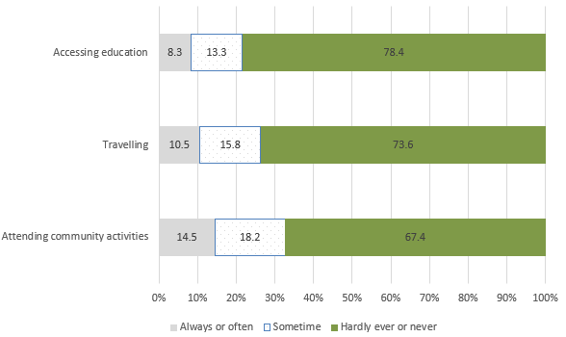
Source: Australia’s Disability Strategy Survey – Share with us, 2022.
In this analysis, disability severity is self-reported by respondents who identified as having a disability or long-term condition. There is clear evidence that people with more severe disabilities are more restricted in participation by the attitudes of others. The proportion who are always or often prevented from attending community events by others’ attitudes is 5% for people with a mild disability, 13% for those with a moderate disability and 31% of those with a severe disability (Figure 10). There are also similar relationships between severity of disability and being restricted by other people’s attitudes from travelling and accessing education (Figures 11 and 12).
Figure 10 Have other people’s attitudes prevented you from attending community events, by severity of disability (%)
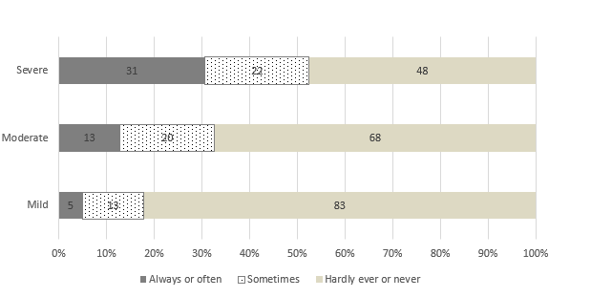
Source: Australia’s Disability Strategy Survey – Share with us, 2022.

Figure 11 Have other people’s attitudes prevented you from travelling, by severity of disability (%)
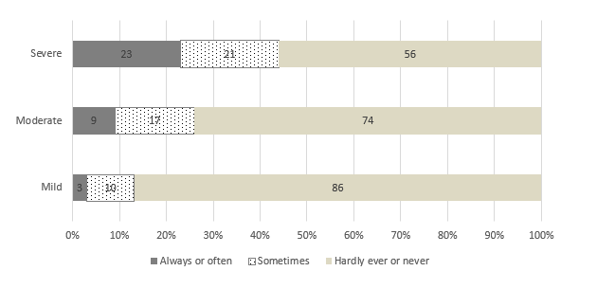
Source: Australia’s Disability Strategy Survey – Share with us, 2022.

Figure 12 Have other people’s attitudes prevented you from accessing education, by severity of disability (%)
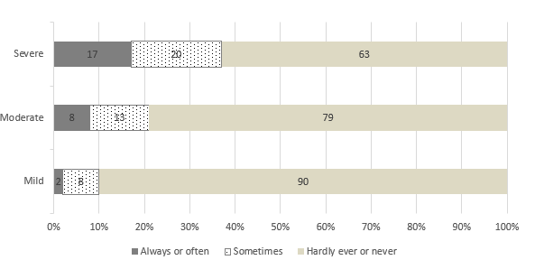
Source: Australia’s Disability Strategy Survey – Share with us, 2022.

There is also evidence that the impact of other people’s attitudes on the ability of people with disability to participate in community events, travelling and accessing education varies with the nature of disability. In this analysis, the nature of disability is based on the type(s) of disability reported by respondents who self-identified as having a disability or long-term condition.
The attitudes of others have a smaller impact on participation by people with a sensory disability (hearing or sight) or a physical disability, and a larger impact on those with speech, intellectual, learning, and neurological disabilities (Figures 13, 14 and 15).

Figure 13 Have other people’s attitudes prevented you from attending community events, by nature of disability (%)
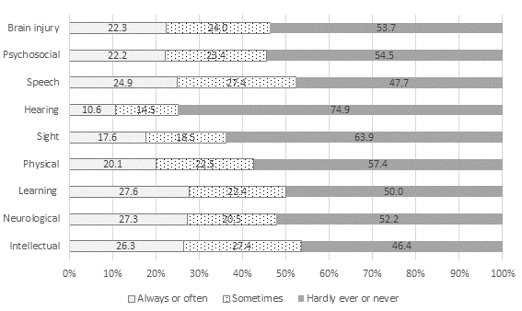
Notes: The numbers of respondents with each type of disability are 145 intellectual, 1,061 neurological, 554 learning, 1,609 physical, 778 sight, 1,507 hearing, 269 speech, 2,335 psychosocial and 331 brain injury.
Source: Australia’s Disability Strategy Survey – Share with us, 2022.

Figure 14 Have other people’s attitudes prevented you from travelling, by nature of disability (%)
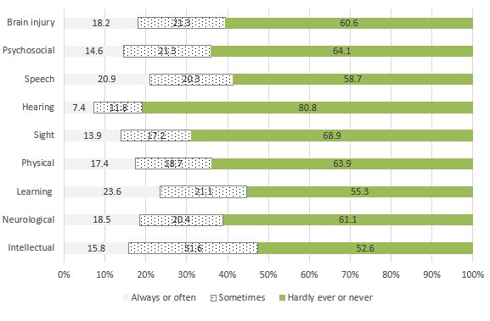
Source: Australia’s Disability Strategy Survey – Share with us, 2022.

Figure 15 Have other people’s attitudes prevented you from accessing education, by nature of disability (%)
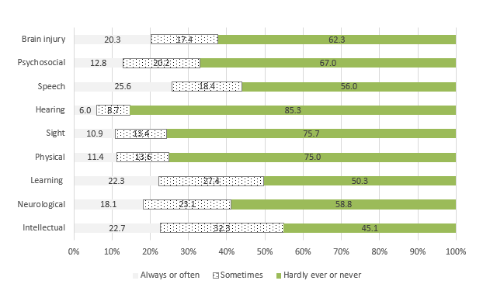
Source: Australia’s Disability Strategy Survey – Share with us, 2022.

Telling people you have a disability
The issue of ‘invisible disability’ was partly addressed by the question about whether other people’s attitudes or behaviours stopped respondents from telling people they have a disability. Overall, only 58% of people with disability reported that they were never or hardly ever affected, with 10% of people with mild disability, 22% with moderate disability and 35% with severe disability reporting people’s attitudes or behaviours always or often stopped them from disclosing their disability (Appendix Table 17A).
Whether valued and respected in community
The survey included a question about the extent to which people living with disability feel valued and respected in their community. This is a good measure of inclusion. Overall, just over one-half (54%) of people with disability reported feeling valued and respected in their community always or often, 32% sometimes feel valued and respected in their community and 13% hardly ever or never felt valued and respected in their community.
The extent to which people with disability feel valued and respected in their community decreases as severity of disability increases. For those with a mild disability, 67% always or often feel valued and respected in their community. This decreases to 54% for those with moderate disability and 38% for those with severe disability (see Figure 16).
The survey also included a question on how often people feel included in and welcomed by their community. The pattern of responses was very similar to the question on feeling valued and respected. Again, just over half of respondents (56%) always or often felt included in and welcomed by their community (Table 17). For those with mild disability, 69% always or often feel included and welcomed. This decreased to 55% for those with moderate disability and 41% for those with severe disability.
Table 17 In general, how often do you feel included in and welcomed by your community? By severity of disability (%)
 | Mild | Moderate | Severe | Total
Always (%) | 28.0 | 21.7 | 15.7 | 22.3
Often (%) | 40.7 | 33.6 | 25.5 | 33.8
Some of the time (%) | 23.8 | 35.2 | 36.4 | 32.0
Hardly ever (%) | 5.1 | 7.5 | 16.3 | 8.8
Never (%) | 2.5 | 2.0 | 6.2 | 3.1
Source: Australia’s Disability Strategy Survey – Share with us, 2022.
Finally, respondents were asked if people with disability are well represented in various spheres of life and, in this case, there were minimal differences related to the severity of the respondent’s disability. The levels of agreement varied: 45% agreed that people with disability are well represented in the community, 35% agreed that people with disability are well represented in the media, 32% agreed that people with disability are well represented in the workplace and only 19% agreed that people with disability are well represented in leadership roles. Across all disability types, more people felt well represented in the workplace and the community, but fewer in the media and in leadership roles, down to 13.7% of those with neurological and 16.1% psychosocial disorders (Appendix Table 18A).

Figure 16 Thinking about your life in general, do you feel valued and respected in your community? People living with disability (%)
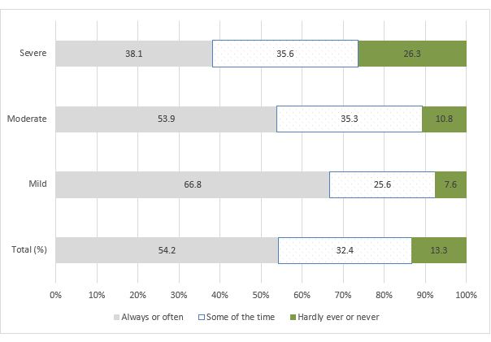
Source: Australia’s Disability Strategy Survey – Share with us, 2022.

Disability and paid employment
There is a very large gap in the rate of paid employment of people with disability compared to people without disability. In 2018, just over half of people with disability aged 15 to 64 were in the labour force (53.4%), compared with 84.1% of people without disability (ABS 2018: Table 8.3). People with disability experience systematic barriers to obtaining and retaining open employment. Open employment refers to work settings where people with disability and without disability are employed. This is different from segregated employment settings, such as Australian Disability Enterprises, which are focused exclusively on employing people with disability.
Increasing employment of people with disability is a high priority. There is clear evidence that the behaviours and attitudes of employers affect whether people with disability are able to find and sustain employment. The survey included specific questions for people who have hiring responsibilities and questions for people with disability about whether other people’s behaviours and attitudes had affected their labour market participation.

Employers’ perspectives
Respondents with hiring responsibilities were asked a series of questions about employing people with disability. Overall, 86.6% agreed that hiring people with disability benefits their workplace and 92.5% agreed that hiring people with disability would make a valuable contribution to their workplace. There was little variation between the key sectors, although the personal and community support sector had the highest agreement rates for both questions (Figure 17 and Appendix Tables 19A – 20A).

Figure 17 People with hiring responsibilities: Views about ‘value’ of employees living with disability (%)
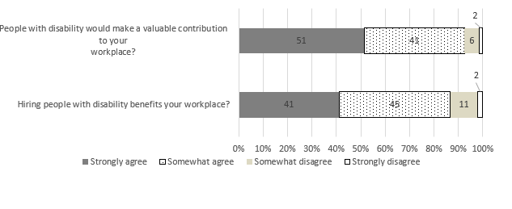
Source: Australia’s Disability Strategy Survey – Share with us, 2022.

Those with hiring responsibilities were then asked if they had ever been involved in hiring a person with disability. Overall, 14.6% had done so in the last year, 15.0% had done so more than a year ago, and 70.3% had never been involved in hiring someone with a disability. In the personal and community support sector, 43.9% had never hired someone with disability, but this rose to 68.1% in justice and legal, 73.5% in health, and 73.7% in education.
Respondents with hiring responsibilities were also asked if certain things would be a major challenge, a minor challenge, or not a challenge to their workplace employing someone with disability. Lack of knowledge about people with disability was seen as a major challenge by 20.6%, a minor challenge by 50.3% and not a challenge by 29.0% (Table 18). Broken down by sector, in the justice and legal sector it was seen as a major challenge by 20.8%, a minor challenge by 56.7% and not a challenge by 22.5%. In contrast, only 12.2% of personal and community support workers saw it as a major challenge, 33.1% a minor challenge and 54.8% did not see it as a challenge.
Attitudes of co-workers were seen as a challenge by over half (52.7%) of respondents with hiring responsibilities, with 11.5% seeing it as a major challenge and 41.2% a minor challenge, whilst 47.4% did not see it as a challenge at all. There was little variation by sector, although slightly more respondents in personal and community support (53.8%) and education (55.3%) said it was not a challenge. Attitudes of managers were also not seen as a challenge by almost half of respondents with hiring responsibilities (48.9%), with roughly the same breakdown by sector.
Attitudes of clients (also includes patients, students) were seen as a major challenge by 16.0% of respondents with hiring responsibilities, a minor challenge by 41.3% and not a challenge by 42.7%. Justice and legal sector workers were almost twice as likely (20.4%) than workers from the other sectors to see the attitudes of clients a major challenge, but were also the most likely not to see them as a challenge at all.
Confidence engaging with people with disability was seen as a major challenge by 12.9%, a minor challenge by almost one-half (49.5%) and not a challenge by 37.7%. Only 27.1% of justice and legal sector workers with hiring responsibilities did not see confidence as a challenge to employing people with disability. It was not seen as a challenge by 36.6% in education, 41.6% in health and 51.3% in the personal and community support sector.
The unknown cost to set up the workplace for people with disability and actual cost to set up the workplace for people with disability yielded very similar responses, with 23.0% seeing not knowing the cost as a major challenge, 43.4% a minor challenge and 33.5% not seeing it as a challenge. For the actual cost, 24.0% saw it as a major challenge, 43.2% a minor challenge and 33.0% did not see it as a challenge. The results were fairly consistent across sectors, with the major difference being in the justice and legal sector, where only 35.1% said not knowing the cost was not a challenge, but the actual cost was not a challenge for 36.7%. This is interesting when compared with Item t in the Power scale (see Section 4.2, page 22): ‘A massive 89% of respondents agreed that it’s easier for them to do their job if they have the right support and equipment at work.’
You cannot find qualified people with disability was not seen as a challenge by only 23.8% of respondents with hiring responsibilities, with 34.4% seeing it as a major challenge and 41.8% as a minor challenge. In the justice and legal sector, only 13.1% did not see that as a challenge, lowest among the key sectors.
The nature of the work is such that it cannot be done by people with disability was seen as a major challenge by a quarter (25.8%) of respondents and as a minor challenge by 39.9%. Just over a third (34.3%) did not see it as a challenge. However, there were differences between sectors. The nature of work was seen as a major challenge by 33.4% of health workers, but only by 16.9% in education, 12.1% in personal and community support and 10.7% in justice and legal.

Table 18 People with hiring responsibilities: Barriers experienced by people with disability in the workplace (%)
 |  | Sector |  |  |  | Total
 |  | Health | Justice  and legal | Personal and Community  support | Education
Lack of knowledge about people with disability (%)
Major challenge |  | 15.9 | 20.8 | 12.2 | 18.6 | 20.6
Minor challenge |  | 47.2 | 56.7 | 33.1 | 46.3 | 50.3
Not a challenge |  | 36.9 | 22.5 | 54.8 | 35.2 | 29.0
Attitudes of co-workers (%)
Major challenge |  | 11.8 | 11.8 | 9.0 | 7.3 | 11.5
Minor challenge |  | 42.7 | 41.0 | 37.2 | 37.4 | 41.2
Not a challenge |  | 45.5 | 47.1 | 53.8 | 55.3 | 47.4
Attitudes of managers (%)
Major challenge |  | 12.7 | 9.4 | 8.8 | 12.9 | 14.4
Minor challenge |  | 42.2 | 52.1 | 37.6 | 33.7 | 36.8
Not a challenge |  | 45.2 | 38.6 | 53.6 | 53.4 | 48.9
Attitudes of clients (%)
Major challenge |  | 13.6 | 20.4 | 13.8 | 13.6 | 16.0
Minor challenge |  | 53.6 | 30.2 | 49.7 | 41.8 | 41.3
Not a challenge |  | 32.8 | 49.4 | 36.5 | 44.6 | 42.7
Confidence engaging with people with disability (%)
Major challenge |  | 9.6 | 8.2 | 9.3 | 7.7 | 12.9
Minor challenge |  | 48.9 | 64.7 | 39.4 | 55.8 | 49.5
Not a challenge |  | 41.6 | 27.1 | 51.3 | 36.6 | 37.7
Not knowing how much it will cost to set up the workplace for people with disability (%)
Major challenge |  | 21.3 | 29.3 | 15.9 | 17.5 | 23.0
Minor challenge |  | 51.3 | 35.6 | 44.7 | 39.3 | 43.4
Not a challenge |  | 27.5 | 35.1 | 39.4 | 43.2 | 33.5
The cost to set up the workplace (%)
Major challenge |  | 18.2 | 23.4 | 15.3 | 17.3 | 23.9
Minor challenge |  | 52.0 | 39.8 | 45.9 | 45.8 | 43.2
Not a challenge |  | 29.7 | 36.8 | 38.8 | 36.9 | 33.0
You cannot find qualified people with disability (%)
Major challenge |  | 32.8 | 33.9 | 29.5 | 29.1 | 34.4
Minor challenge |  | 48.4 | 52.9 | 47.6 | 42.9 | 41.8
Not a challenge |  | 18.8 | 13.2 | 23.0 | 28.0 | 23.8
The nature of the work is such that it cannot be done by people with disability (%)
Major challenge |  | 33.4 | 10.6 | 12.1 | 16.9 | 25.8
Minor challenge |  | 41.9 | 45.1 | 48.0 | 43.7 | 39.9
Not a challenge |  | 24.7 | 44.2 | 40.0 | 39.4 | 34.3
Source: Australia’s Disability Strategy Survey – Share with us, 2022.

Impact of community attitudes on the employment of people with disability

People with disability were asked whether other people’s attitudes or behaviours have ever stopped them from trying to get a job, get a promotion, get a better job or keep a job. Due to the response patterns being similar across all three employment outcomes, the data presented here only relates to the impact of attitudes and behaviours on trying to get a job. Results for trying to get a promotion and keeping a job are presented in the Appendix (Tables 21A-23A).

Overall, 67.2% of people with a disability said that other people’s attitudes or behaviours never or hardly ever stopped them from trying to get a job, 16.1% said that other people’s attitudes or behaviours sometimes stopped them from trying to get a job and 16.8% said that other people’s attitudes or behaviours always or often. Looking at how the severity of disability influenced the results, 82.1% of people with mild disability, 66.6% with moderate disability and 48.2% with severe disability said other people’s attitudes had hardly ever or never prevented them from trying to get a job (Figure 18). This indicates that more than half of people with severe disability were put off trying to get a job because of the attitudes or behaviours of others.
Figure 18 Have other people’s attitudes prevented you from trying to get a job, by severity of disability (%)
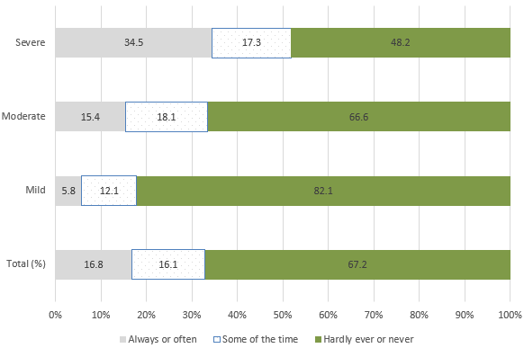
Source: Australia’s Disability Strategy Survey – Share with us, 2022.

Conclusion
This report describes key findings from the first wave of the ADS Survey – Share with us conducted in 2022. The survey looks at attitudes in the general community (including people with disability), the attitudes of workers in the four sectors identified as key during the widespread consultations people with disability to support the development of the ADS and employed people with hiring responsibilities. The key sectors identified were: health, justice and legal, education and personal and community support. Additional results and data on the ADS Outcomes Framework are published on Community attitudes - Australian Institute of Health and Welfare (aihw.gov.au).
The survey also collected detailed information on the experiences of people with disability and how they are affected by the attitudes and related behaviours of others. The ADS Survey was designed to collect data on attitudes towards people with disability, however, measuring people’s attitudes was challenging as responses may be affected by the social desirability bias. Subsequently, people may give answers that they think will make them look better.
Overall, most Australians report having fairly positive attitudes towards people with disability.
Based on the responses to a series of questions about attitudes towards people living with disability (the Power scale), Australians have the most positive attitudes towards people with disability in the domains of Prospects and work and the least positive attitudes in the domains of discrimination and Gains. A key finding is that people with experience of people with disability had more positive attitudes towards, and were more confident engaging with, people with disability. People who themselves have disability also had more positive attitudes towards people with disability than did other Australians.
Attitudes of workers in the four key sectors were compared using the data from the Power scale. There were minimal differences between the sectors, apart from agreement with the statement that people with disability are a burden on their families (health 16%, justice and legal 14%, education 13% and personal and community support 11%). There are almost no differences between respondents with or without hiring responsibilities across the whole Power scale.
The findings from the vignettes were less positive overall and attitudes varied significantly between types of disability. Some of the responses to the vignettes are quite surprising and are likely to be due to mixed levels of understanding of the nature and effects of different types of disability. For example, when asked how comfortable the respondent felt with a close relative being in a relationship with someone with disability, respondents who were very comfortable ranged from 47.1% for physical disability down to 23.3% for psychosocial disability.
Vignettes for respondents from the four key sectors showed slightly less positive attitudes than the Power scale responses. Once again there were differences by disability type. For example, when asked if people with disability should be able to access the same range of fertility or family planning services as people without disability, health sector workers who strongly agreed ranged from 83.2% for physical disability down to 33.5% for intellectual disability.
Workers in the key sectors were asked about their ‘confidence in their ability to advise, assist or treat people with…’ different categories of disability. A majority of respondents felt quite confident or very confident in their ability to advise, assist or treat people with different categories of disability, although there were variations between sectors and types of disability. Once again, experience with disability is very important. Those who engaged with people with disability most frequently had the highest levels of confidence. Overall, 92.5% of key sector workers reported feeling very confident or quite confident that they respond in a positive way to people living with disability, ranging from 87.1% in the justice sector up to 98.0% in the personal and community support sector.
In terms of employment, 86.6% of those with hiring responsibilities reported that hiring people with disability benefits their workplace and 92.5% agreed that hiring people with disability would make a valuable contribution to their workplace. However, it is interesting to note that only 14.6% had hired someone with a disability in the last 12 months, 15.0% had done so more than a year ago and 70.3% had never been involved in hiring someone with disability. The proportion who had never hired someone with disability varied from 43.9% in the personal and community support sector, 68.1% in the justice and legal sector, 73.5% in the health sector, to 73.7% in the education sector. Potential barriers to hiring people with disability were seen as a major challenge by a minority of respondents, however, this varied between sectors and the type of barrier.
As expected, the experience of people with disability is much more complex and is affected by a range of factors, particularly the type and severity of disability, so the survey explored that experience from a number of perspectives. Firstly, people with disability were asked about their experience with workers from the four key sectors. The proportion of respondents reporting they agree that they were treated with respect was very high – over 94% for all sectors, except the justice and legal sector (86.3%). Similarly, in terms of having things clearly explained, the proportion of people with disability who agreed was between 88% and 92%, with a lower rate for the justice and legal sector (74.8%).
People with disability were then asked if other people’s attitudes or behaviours ever stopped them from accessing or undertaking various activities. While the majority reported ‘hardly ever’ or ‘never’ across all of the activities, both the severity and the type of the disability had a significant impact on access. For example, accessing education was least affected by other peoples’ attitudes or behaviours, with 21.6% responding that they had been stopped from accessing education always, often or sometimes. However, when broken down by severity, the results showed that 10% of people with mild disability, 21% with moderate disability and 37% with severe disability had been stopped by other peoples’ attitudes (always, often or sometimes) from accessing education. The disability types always or often affected by the attitudes of others were speech (25.6%), intellectual impairments (22.7%), learning impairments (22.3%) and brain injury (20.3%).
Other people’s attitudes and behaviours had a greater impact on respondents attending community events. Overall, almost a third (32.5%) of respondents reported feeling deterred always, often or sometimes from attending community events. For those with mild disability, it was 18%, rising to 33% for those with moderate disability and to 53% for respondents with severe disability. People with neurological (37.6%), learning (36.3%) and psychosocial (33.7%) disorders were stopped from attending community events by the attitudes of others always or often.
In terms of feeling valued and respected by their community, just over half of people with disability (54.5%) reported feeling valued and respected always or often, however, there were variations by disability type. The results showed that 67% of those with mild disability, 54% of those with moderate disability and just 38% of those with severe disability felt valued and respected always or often. Similarly, just over half of respondents (56.5%) with disability always, or often, felt included in, and welcomed by, their community, including 69% of respondents with mild disability, 56% of respondents with moderate disability and only 41% of respondents with severe disability.
Finally, respondents with disability were asked if people with disability are well represented in various spheres of life. In this case, there were minimal differences related to the severity of the respondent’s disability. The levels of agreement varied, with 45.4% agreeing that people with disability are well represented in the community, 35.4% agreeing that people with disability are well represented in the media, 31.6% agreeing that people with disability are well represented in the workplace and only 19.2% agreeing that people with disability are well represented in leadership roles.
Further analysis is required to identify the demographic and other drivers of different kinds of attitudes, and what can be done to change attitudes. This baseline data and the three subsequent waves will enable monitoring of changes in community attitudes over the life of ADS and support the development of initiatives and responses designed to change attitudes and, ultimately improve outcomes for people with disability across all ADS outcome areas.

References
Australian Bureau of Statistics (ABS) (2018). Survey of Disability, Ageing and Carers, Australia, Catalogue 4430.0. <https://www.abs.gov.au/ausstats/abs@.nsf/mf/4430.0>
Department of Health and Human Services (DHHS) (2018). Survey of Community Attitudes toward People with Disability, Victorian Government Department of Health and Human Services, Melbourne. https://apo.org.au/node/313845 [accessed 3 September 2023]
Power, M., Green, A and THE WHOQOL-DIS Group (2010). ‘The Attitudes to Disability Scale (ADS): development and psychometric properties’. Journal of Intellectual Disability Research, 54(9): 860-874.
Randle, M. and S. Reis (2020), Changing community attitudes toward greater inclusion of people with disabilities: A rapid literature review, NSW Government Family and Community Services https://apo.org.au/sites/default/files/resource-files/2019-09/apo-nid313462.pdf [accessed 3 September 2023]
Royal Commission into Violence, Abuse, Neglect and Exploitation of People with Disability (2023) Final Report: Our vision for an Inclusive Australia Final Report | Royal Commission into Violence, Abuse, Neglect and Exploitation of People with Disability (accessed 22 December 2023)
The Social Research Centre (2023). Australia’s Disability Strategy Survey – Technical Report. Social Research Centre, Melbourne.
Thompson, D., K. Fisher, C. Purcal, C. Deeming and P. Sawrikar (2011). ‘Community Attitudes to people with disability: Scoping project’. SPRC Occasional Paper No. 39, University of New South Wales, Sydney.
United Nations (2006). Convention on the Rights of Persons with Disabilities. Treaty Series, 2515, 3.

Appendix
Appendix Table 1A: Respondent profiles, by disability status (unweighted)
 | Disability |  | No disability
 | Frequency | % | Frequency | %
Gender
Female | 5,825 | 61.5 | 5,344 | 63.6
Male | 3,646 | 38.5 | 3,057 | 36.4
Age Groups
18-24 | 329 | 3.4 | 411 | 4.9
25-34 | 821 | 8.6 | 1,425 | 16.9
35-44 | 978 | 10.2 | 1,615 | 19.2
45-54 | 1,260 | 13.2 | 1,414 | 16.8
55-64 | 1,900 | 19.9 | 1,605 | 19.1
65-74 | 2,465 | 25.8 | 1,436 | 17.1
More than 75 | 1,807 | 18.9 | 517 | 6.1
Indigenous Status
Non-indigenous | 9,379 | 98.0 | 8,338 | 99.0
Indigenous | 192 | 2.0 | 85 | 1.0
Born in Australia
No | 2,442 | 25.5 | 2,683 | 31.9
Yes | 7,131 | 74.5 | 5,728 | 68.1
Household composition
Person living alone | 2,726 | 28.6 | 1,492 | 17.8
Couple living alone | 3,132 | 32.8 | 2,577 | 30.7
Couple w non-dep children | 938 | 9.8 | 885 | 10.5
Couple w dep children | 1,143 | 12.0 | 2,116 | 25.2
Couple w dep and non-dep | 254 | 2.7 | 295 | 3.5
Single Person w non-dep | 305 | 3.2 | 195 | 2.3
Single Person w dep | 298 | 3.1 | 264 | 3.2
Single Person w dep and non-dep | 69 | 0.7 | 58 | 0.7
Adults sharing | 327 | 3.4 | 291 | 3.5
Others | 355 | 3.7 | 221 | 2.6
Highest qualification
Postgrad | 1,302 | 13.8 | 1,664 | 19.8
Graduate diploma | 1,066 | 11.3 | 876 | 10.5
Bachelor degree | 1,829 | 19.3 | 2,349 | 28.0
Advance diploma | 848 | 9.0 | 757 | 9.0
Certificate III/IV | 1,470 | 15.5 | 1,016 | 12.1
Certificate I/II | 299 | 3.2 | 180 | 2.2
Year 10 and above | 1,944 | 20.5 | 1,316 | 15.7
Year 9 and below | 399 | 4.2 | 99 | 1.2
Other | 307 | 3.2 | 128 | 1.5
Annual income ($)
1−7,799 | 178 | 2.0 | 92 | 1.2
7,800−15,599 | 264 | 3.0 | 112 | 1.5
15,600−20,799 | 530 | 6.0 | 160 | 2.1
20,800−25,999 | 868 | 9.9 | 266 | 3.4
26,000−33,799 | 792 | 9.0 | 335 | 4.3
33,800−41,599 | 668 | 7.6 | 334 | 4.3
33,800−41,599 | 672 | 7.6 | 411 | 5.3
52,000−64,999 | 772 | 8.8 | 580 | 7.5
65,000−77,999 | 609 | 6.9 | 526 | 6.8
78,000−90,999 | 617 | 7.0 | 690 | 8.9
91,000−103,999 | 511 | 5.8 | 603 | 7.8
104,000−155,999 | 941 | 10.7 | 1,420 | 18.3
156,000−181,999 | 411 | 4.7 | 688 | 8.9
182,000−207,999 | 229 | 2.6 | 417 | 5.4
More than $208,000 | 503 | 5.7 | 979 | 12.6
Nil income | 206 | 2.3 | 109 | 1.4
Negative income | 20 | 0.2 | 23 | 0.3
Experience with disability
No | 1,233 | 12.9 | 1,613 | 19.2
Yes | 8,296 | 87.1 | 6,781 | 80.8
Hiring responsibilities
No | 3,284 | 76.9 | 4,496 | 75.4
Yes | 986 | 23.1 | 1,471 | 24.7
Sectors
Health care | 584 | 32.1 | 956 | 37.3
Justice and legal | 151 | 8.3 | 198 | 7.7
Personal and community support | 400 | 22.0 | 461 | 18.0
Education | 686 | 37.7 | 949 | 37.0
Appendix Table 2A: Respondent profiles, by disability status (weighted)
 | Disability |  | No disability
 | Frequency | % | Frequency | %
Gender
Female | 3,045 | 47.4 | 5,970 | 52.1
Male | 3,376 | 52.6 | 5,491 | 47.9
Age Groups
18-24 | 684 | 10.5 | 1,302 | 11.3
25-34 | 934 | 14.3 | 2,397 | 20.9
35-44 | 852 | 13.0 | 2,348 | 20.4
45-54 | 926 | 14.2 | 1,982 | 17.3
55-64 | 1,015 | 15.5 | 1,670 | 14.5
65-74 | 1,206 | 18.5 | 1,296 | 11.3
More than 75 | 914 | 14.0 | 500 | 4.4
Indigenous Status
Non-indigenous | 6,357 | 97.1 | 11,345 | 98.8
Indigenous | 187 | 2.9 | 142 | 1.2
Born in Australia
No | 1,836 | 28.1 | 4,285 | 37.4
Yes | 4,709 | 71.9 | 7,186 | 62.7
Household composition
Person living alone | 1,133 | 17.4 | 1,200 | 10.5
Couple living alone | 1,990 | 30.5 | 3,078 | 26.9
Couple w non-dep children | 859 | 13.2 | 166 | 14.6
Couple w dep children | 102 | 15.7 | 327 | 28.7
Couple w dep and non-dep | 283 | 4.3 | 565 | 4.9
Single Person w non-dep | 236 | 3.6 | 275 | 2.4
Single Person w dep | 196 | 3.0 | 280 | 2.5
Single Person w dep and non-dep | 79 | 1.2 | 98 | 0.9
Adults sharing | 406 | 6.2 | 617 | 5.4
Others | 318 | 4.9 | 367 | 3.2
Highest qualification
Postgrad | 403 | 6.3 | 1,557 | 13.6
Graduate diploma | 281 | 4.4 | 654 | 5.7
Bachelor degree | 670 | 10.4 | 2,345 | 20.5
Advance diploma | 847 | 13.2 | 1,510 | 13.2
Certificate III/IV | 1,552 | 24.1 | 2,060 | 18.0
Certificate I/II | 285 | 4.4 | 348 | 3.1
Year 10 and above | 1,896 | 29.4 | 2,624 | 23.0
Year 9 and below | 295 | 4.6 | 141 | 1.2
Other | 210 | 3.3 | 180 | 1.6
Annual income ($)
1−7,799 | 141 | 2.4 | 159 | 1.5
7,800−15,599 | 208 | 3.5 | 173 | 1.6
15,600−20,799 | 363 | 6.0 | 226 | 2.2
20,800−25,999 | 463 | 7.7 | 309 | 2.9
26,000−33,799 | 487 | 8.1 | 364 | 3.5
33,800−41,599 | 420 | 7.0 | 430 | 4.1
33,800−41,599 | 478 | 7.9 | 553 | 5.3
52,000−64,999 | 539 | 9.0 | 793 | 7.5
65,000−77,999 | 431 | 7.2 | 712 | 6.8
78,000−90,999 | 439 | 7.3 | 935 | 8.9
91,000−103,999 | 368 | 6.1 | 829 | 7.9
104,000−155,999 | 685 | 11.4 | 1,983 | 18.9
156 000−181,999 | 280 | 4.7 | 964 | 9.2
182,000−207,999 | 177 | 2.9 | 545 | 5.2
More than $208,000 | 350 | 5.8 | 1,317 | 12.5
Nil income | 168 | 2.8 | 178 | 1.7
Negative income | 18 | 0.3 | 44 | 0.4
Experience with disability
No | 953 | 14.7 | 2,662 | 23.3
Yes | 5,542 | 85.3 | 8,779 | 76.7
Hiring responsibilities
No | 2,571 | 79.4 | 6,720 | 77.9
Yes | 665 | 20.6 | 1,908 | 22.1
Sectors
Health care | 326 | 31.5 | 1,018 | 34.6
Justice and legal | 56 | 5.4 | 178 | 6.0
Personal and community support | 287 | 27.7 | 661 | 22.5
Education | 367 | 35.4 | 1,089 | 37.0

Appendix Table 3A: Think a person with this condition has a disability, by disability status (%)

 | Not disabled (%) | Disabled (%)
Has HIV/AIDS | 28.3 | 37.9
Has severe arthritis | 78.2 | 85.5
Is blind | 89.7 | 89.7
Has a broken leg and uses crutches while  it heals | 50.1 | 52.9
Has cancer | 42.2 | 54.3
Has a diagnosis of depression | 52.5 | 66.0
Has Down syndrome | 84.9 | 84.0
Has a severe facial disfigurement | 50.1 | 53.1
Has extreme fatigue or tiredness | 55.1 | 67.5
Has chronic pain | 71.7 | 82.7

Appendix Table 4A: Think a person with this condition has a disability, by experience with disability (%)
 | No experience with disability (%) | Has experience with disability (%)
Has HIV/AIDS | 22.2 | 34.2
Has severe arthritis | 69.8 | 83.6
Is blind | 82.9 | 91.5
Has a broken leg and uses crutches  while it heals | 46.0 | 52.4
Has cancer | 37.3 | 48.9
Has a diagnosis of depression | 43.5 | 60.9
Has Down syndrome | 74.8 | 87.1
Has a severe facial disfigurement | 39.9 | 53.9
Has extreme fatigue or tiredness | 43.4 | 63.7
Has chronic pain | 61.8 | 79.3

Appendix Table 5A: Vignettes: Relationship, by disability status (%)
 | Type of disability
 | Sensory | Physical | Psychosocial | Neurological | Intellectual
 | Not Disabled (%)
Very comfortable | 42.6 | 44.3 | 19.5 | 37.6 | 21.7
Fairly comfortable | 47.6 | 46.1 | 55.9 | 48.8 | 55.9
Fairly uncomfortable | 9.0 | 8.2 | 23.0 | 12.3 | 19.6
Very uncomfortable | 0.8 | 1.3 | 1.6 | 1.3 | 2.8
Sample size | 2,943 | 2,977 | 2,917 | 1,256 | 1,339
 |  | Disabled (%)
Very comfortable | 46.9 | 52.6 | 30.5 | 41.1 | 27.7
Fairly comfortable | 43.5 | 39.3 | 47.2 | 46.9 | 50.9
Fairly uncomfortable | 8.3 | 6.4 | 19.2 | 10.7 | 17.7
Very uncomfortable | 1.3 | 1.7 | 3.1 | 1.3 | 3.7
Sample size | 1,566 | 1,578 | 1,556 | 648 | 1,152

Appendix Table 6A: Vignettes: Relationship, by experience with disability (%)
 | Type of disability
 | Sensory | Physical | Psychosocial | Neurological | Intellectual
 | No experience with disability (%)
Very comfortable | 32.7 | 31.6 | 14.7 | 23.5 | 16.6
Fairly comfortable | 51.2 | 51.5 | 54.2 | 58.5 | 53.0
Fairly uncomfortable | 14.0 | 14.9 | 29.5 | 15.6 | 24.5
Very uncomfortable | 2.1 | 2.1 | 1.7 | 2.5 | 6.0
Sample size | 893 | 912 | 372 | 503 | 2,276
 | Has experience with disability (%)
Very comfortable | 47.2 | 51.1 | 25.5 | 42.3 | 26.7
Fairly comfortable | 44.8 | 41.9 | 52.6 | 46.1 | 53.9
Fairly uncomfortable | 7.2 | 5.7 | 19.7 | 10.5 | 17.2
Very uncomfortable | 0.7 | 1.2 | 2.3 | 1.1 | 2.2
Sample size | 3,653 | 3,563 | 1,534 | 1,982 | 682

Appendix Table 7A: Vignettes: Relationship, by hiring responsibilities (%)
 | Type of disability
 | Sensory | Physical | Psychosocial | Neurological | Intellectual
 | Has hiring responsibilities (%)
Very comfortable | 44.6 | 46.3 | 24.8 | 40.1 | 25.3
Fairly comfortable | 46.0 | 43.6 | 52.3 | 47.2 | 53.9
Fairly uncomfortable | 8.8 | 9.2 | 21.3 | 12.0 | 18.0
Very uncomfortable | 0.6 | 0.8 | 1.6 | 0.8 | 2.8
Sample size | 2,276 | 2,347 | 2,333 | 1,035 | 1,314
No hiring responsibilities (%)
Very comfortable | 50.0 | 50.0 | 25.9 | 37.1 | 21.6
Fairly comfortable | 42.5 | 44.0 | 51.9 | 49.4 | 61.8
Fairly uncomfortable | 7.2 | 3.7 | 21.3 | 10.8 | 14.5
Very uncomfortable | 0.3 | 2.4 | 1.0 | 2.7 | 2.1
Sample size | 682 | 677 | 594 | 315 | 312

Appendix Table 8A: Vignettes: Relationship, by key sectors (%)
 | Type of disability
 | Sensory | Physical | Psychosocial | Neurological | Intellectual
Health care (%)
Very comfortable | 45.6 | 48.5 | 25.9 | 33.7 | 26.2
Fairly comfortable | 45.9 | 43.0 | 58.2 | 52.5 | 54.5
Fairly uncomfortable | 8.4 | 8.5 | 15.8 | 13.4 | 17.5
Very uncomfortable | 0.1 | 0.0 | 0.1 | 0.4 | 1.8
Sample size | 369 | 333 | 312 | 161 | 177
Justice and legal (%)
Very comfortable | 43.5 | 34.9 | 33.7 | 29.7 | 15.8
Fairly comfortable | 41.2 | 48.8 | 57.2 | 59.3 | 58.0
Fairly uncomfortable | 14.6 | 15.9 | 9.1 | 11.0 | 24.6
Very uncomfortable | 0.8 | 0.4 | 0.0 | 0.0 | 1.5
Sample size | 118 | 84 | 92 | 48 | 46
Personal and community support (%)
Very comfortable | 56.4 | 67.5 | 39.7 | 62.1 | 43.2
Fairly comfortable | 36.8 | 29.7 | 48.4 | 34.7 | 46.3
Fairly uncomfortable | 6.7 | 2.5 | 9.5 | 2.8 | 10.5
Very uncomfortable | 0.1 | 0.3 | 2.4 | 0.5 | 0.0
Sample size | 253 | 252 | 200 | 107 | 139
Education (%)
Very comfortable | 45.7 | 55.7 | 23.2 | 52.4 | 26.5
Fairly comfortable | 43.3 | 37.5 | 56.5 | 38.0 | 59.1
Fairly uncomfortable | 10.9 | 3.7 | 19.3 | 8.8 | 12.3
Very uncomfortable | 0.1 | 3.1 | 1.1 | 0.8 | 2.1
Sample size | 362 | 359 | 372 | 158 | 205

Appendix Table 9A: Vignettes: GP, by disability status (%)
 | Type of disability
 | Sensory | Physical | Psychosocial | Neurological | Intellectual
 | Not Disabled (%)
Strongly agree | 24.9 | 64.8 | 30.3 | 38.4 | 19.2
Somewhat agree | 41.2 | 29.4 | 41.9 | 44.6 | 38.9
Somewhat disagree | 27.4 | 5.3 | 22.3 | 13.2 | 30.9
Strongly disagree | 6.5 | 0.4 | 5.5 | 3.8 | 11.0
Sample size | 2,453 | 3,008 | 2,976 | 1,629 | 1,331
 | Disabled (%)
Very comfortable | 30.0 | 70.7 | 33.4 | 40.5 | 32.3
Fairly comfortable | 43.3 | 23.0 | 39.9 | 39.5 | 33.4
Fairly uncomfortable | 19.6 | 4.3 | 19.8 | 15.8 | 23.6
Very uncomfortable | 7.2 | 2.0 | 6.8 | 4.3 | 10.6
Sample size | 1,810 | 1,539 | 1,528 | 939 | 642

Appendix Table 10A: Vignettes: GP, by experience with disability (%)
 |  | Type of disability
 | Sensory | Physical | Psychosocial | Neurological | Intellectual
 | No experience with disability (%)
Strongly agree | 23.1 | 53.5 | 21.6 | 24.7 | 13.4
Somewhat agree | 42.4 | 36.6 | 41.6 | 53.1 | 38.5
Somewhat disagree | 26.0 | 8.6 | 28.2 | 16.4 | 33.5
Strongly disagree | 8.6 | 1.4 | 8.7 | 5.8 | 14.7
Sample size | 838 | 976 | 839 | 514 | 428
 | Has experience with disability (%)
Strongly agree | 28.2 | 70.7 | 33.6 | 42.3 | 26.2
Somewhat agree | 42.0 | 24.5 | 41.3 | 40.7 | 36.4
Somewhat disagree | 23.4 | 3.9 | 20.1 | 13.4 | 27.4
Strongly disagree | 6.4 | 0.9 | 5.1 | 3.6 | 10.0
Sample size | 3,415 | 3,567 | 3,674 | 2,068 | 1,541

Appendix Table 11A: Vignettes: GP, by hiring responsibilities (%)
 | Type of disability
 | Sensory | Physical | Psychosocial | Neurological | Intellectual
 | Has hiring responsibilities (%)
Strongly agree | 26.2 | 66.0 | 32.1 | 40.2 | 22.6
Somewhat agree | 41.0 | 28.8 | 40.7 | 43.9 | 37.8
Somewhat disagree | 26.1 | 4.5 | 21.5 | 12.1 | 29.7
Strongly disagree | 6.7 | 0.7 | 5.7 | 3.9 | 9.9
Sample size | 2,167 | 2,312 | 2,398 | 1,267 | 1,120
No hiring responsibilities (%)
Strongly agree | 23.0 | 69.1 | 37.1 | 41.9 | 18.7
Somewhat agree | 43.3 | 24.7 | 40.4 | 40.8 | 35.7
Somewhat disagree | 27.8 | 5.6 | 17.3 | 12.6 | 33.4
Strongly disagree | 5.9 | 0.6 | 5.3 | 4.7 | 12.2
Sample size | 592 | 659 | 654 | 377 | 293

Appendix Table 12A: Vignettes: GP, by key sectors (%)
 |  | Type of disability
 | Sensory | Physical | Psychosocial | Neurological | Intellectual
 | Health care (%)
Strongly agree | 28.7 | 67.1 | 33.1 | 51.9 | 20.2
Somewhat agree | 39.8 | 27.5 | 44.5 | 32.5 | 34.1
Somewhat disagree | 25.2 | 5.4 | 17.0 | 12.3 | 33.4
Strongly disagree | 6.3 | 0.0 | 5.4 | 3.4 | 12.4
Sample size | 316 | 336 | 351 | 220 | 129
 |  | Justice and legal (%)
Strongly agree | 19.6 | 53.9 | 34.4 | 37.9 | 34.2
Somewhat agree | 44.8 | 35.6 | 42.1 | 49.6 | 37.5
Somewhat disagree | 29.6 | 10.5 | 17.8 | 12.5 | 24.8
Strongly disagree | 6.0 | 0.0 | 5.8 | 0.0 | 3.6
Sample size | 109 | 67 | 107 | 55 | 50
 |  | Personal and community support (%)
Strongly agree | 40.0 | 79.2 | 38.5 | 57.4 | 18.9
Somewhat agree | 43.8 | 18.9 | 41.3 | 33.5 | 46.9
Somewhat disagree | 13.6 | 1.9 | 17.9 | 8.8 | 22.5
Strongly disagree | 2.6 | 0.1 | 2.4 | 0.3 | 11.7
Sample size | 203 | 250 | 257 | 122 | 111
 |  | Education (%)
Strongly agree | 29.7 | 74.7 | 36.2 | 47.8 | 12.5
Somewhat agree | 42.1 | 22.1 | 42.5 | 38.3 | 43.8
Somewhat disagree | 21.2 | 2.3 | 17.9 | 11.7 | 29.6
Strongly disagree | 7.0 | 0.9 | 3.4 | 2.2 | 14.1
Sample size | 327 | 339 | 400 | 204 | 183

Appendix Table 13A: Vignettes: Boss, by disability status (%)
 | Type of disability
 | Sensory | Physical | Psychosocial | Neurological | Intellectual
 | Not Disabled (%)
Very comfortable | 33.6 | 58.7 | 16.5 | 28.9 | 20.6
Fairly comfortable | 53.8 | 37.3 | 50.9 | 49.7 | 49.4
Fairly uncomfortable | 11.5 | 3.6 | 29.6 | 19.8 | 25.6
Very uncomfortable | 1.0 | 0.4 | 3.0 | 1.6 | 4.4
Sample size | 2,960 | 2,598 | 3,029 | 1,584 | 1,237
 |  | Disabled (%)
Very comfortable | 39.7 | 62.6 | 25.4 | 27.6 | 24.8
Fairly comfortable | 47.4 | 33.0 | 44.0 | 51.8 | 49.5
Fairly uncomfortable | 11.3 | 3.4 | 27.1 | 17.4 | 23.0
Very uncomfortable | 1.6 | 1.1 | 3.6 | 3.2 | 2.7
Sample size | 1,641 | 1,825 | 1,460 | 911 | 638

Appendix Table 14A: Vignettes: Boss, by hiring responsibilities (%)
 |  | Type of disability
 | Sensory | Physical | Psychosocial | Neurological | Intellectual
 | Has hiring responsibilities (%)
Very comfortable | 35.8 | 59.7 | 21.4 | 30.8 | 25.2
Fairly comfortable | 52.6 | 36.5 | 48.4 | 49.5 | 50.7
Fairly uncomfortable | 10.4 | 3.3 | 27.9 | 17.4 | 21.9
Very uncomfortable | 1.2 | 0.5 | 2.3 | 2.3 | 2.3
Sample size | 2,357 | 2,307 | 2,367 | 1,185 | 1,064
No hiring responsibilities (%)
Very comfortable | 42.4 | 66.3 | 22.2 | 33.4 | 14.4
Fairly comfortable | 48.7 | 30.1 | 51.1 | 48.3 | 50.1
Fairly uncomfortable | 8.1 | 2.5 | 24.4 | 17.6 | 29.7
Very uncomfortable | 0.8 | 1.2 | 2.3 | 0.8 | 5.9
Sample size | 635 | 614 | 642 | 396 | 276

Appendix Table 15A: Vignettes: Boss, by experience with disability (%)
 | Type of disability
 | Sensory | Physical | Psychosocial | Neurological | Intellectual
Very comfortable | 24.9 | 44.8 | 12.3 | 15.6 | 15.8
Fairly comfortable | 56.6 | 47.1 | 46.8 | 53.1 | 46.1
Fairly uncomfortable | 16.0 | 6.7 | 36.0 | 27.9 | 34.0
Very uncomfortable | 2.5 | 1.4 | 5.0 | 3.4 | 4.1
Sample size | 939 | 902 | 902 | 453 | 399
 |  | Has experience with disability (%)
Very comfortable | 38.5 | 64.6 | 21.2 | 30.9 | 23.6
Fairly comfortable | 50.4 | 32.4 | 49.2 | 50.3 | 50.3
Fairly uncomfortable | 10.2 | 2.7 | 26.8 | 16.8 | 22.4
Very uncomfortable | 0.9 | 0.4 | 2.8 | 2.0 | 3.8
Sample size | 3,672 | 3,501 | 3,594 | 2,055 | 1,476

Appendix Table 16A: Vignettes: Boss, by key sectors (%)
 | Type of disability
 | Sensory | Physical | Psychosocial | Neurological | Intellectual
 | Health care (%)
Very comfortable | 37.9 | 59.8 | 23.6 | 28.3 | 18.0
Fairly comfortable | 52.9 | 36.0 | 55.2 | 54.3 | 59.7
Fairly uncomfortable | 9.1 | 3.2 | 19.5 | 16.1 | 17.1
Very uncomfortable | 0.0 | 1.0 | 1.8 | 1.4 | 5.3
Sample size | 362 | 319 | 356 | 182 | 131
Justice and legal (%)
Very comfortable | 33.6 | 63.6 | 26.5 | 18.9 | 23.6
Fairly comfortable | 56.9 | 32.9 | 51.6 | 71.4 | 46.4
Fairly uncomfortable | 8.8 | 3.5 | 21.2 | 8.6 | 28.4
Very uncomfortable | 0.8 | 0.0 | 0.8 | 1.0 | 1.6
Sample size | 110 | 91 | 85 | 37 | 64
Personal and community support (%)
Very comfortable | 44.5 | 79.1 | 26.9 | 49.5 | 37.1
Fairly comfortable | 46.2 | 19.6 | 45.8 | 32.3 | 37.8
Fairly uncomfortable | 7.5 | 1.3 | 26.6 | 16.9 | 22.8
Very uncomfortable | 1.9 | 0.0 | 0.7 | 1.3 | 2.3
Sample size | 207 | 254 | 244 | 131 | 111
Education (%)
Very comfortable | 45.6 | 71.8 | 21.2 | 38.2 | 19.5
Fairly comfortable | 48.6 | 25.8 | 49.4 | 49.0 | 57.4
Fairly uncomfortable | 5.3 | 1.7 | 27.3 | 12.5 | 21.4
Very uncomfortable | 0.6 | 0.7 | 2.2 | 0.3 | 1.7
Sample size | 336 | 358 | 360 | 228 | 172

Appendix Table 17A: Have other people's attitudes prevented you from telling people you have a disability
 | Mild (%) | Moderate(%) | Severe(%) | Total (%)
Always | 3.6 | 7.8 | 16.0 | 8.44
Often | 6.6 | 13.9 | 18.6 | 12.69
Sometimes | 15.1 | 23.7 | 24.1 | 21.15
Hardly | 12.1 | 13.3 | 12.1 | 12.61
Never | 62.6 | 41.3 | 29.2 | 45.11
Total | 100 | 100 | 100 | 100.00

Appendix Table 18A: Do you feel that people with disability are well represented?, by disability type (%)
 | In leadership roles | In the workplace | In the community | In the media
 | %
Intellectual | 22.5 | 39.7 | 44.0 | 27
Neurological | 13.7 | 24.8 | 36.6 | 23.9
Learning | 19.1 | 31.3 | 37 | 28.6
Physical | 20.4 | 32.1 | 45.6 | 35.5
Sight | 22.2 | 33.2 | 43.9 | 38.4
Hearing | 24.7 | 36.6 | 50.2 | 40.2
Speech | 22.1 | 34 | 41.7 | 29.2
Psychosocial | 16.1 | 27.6 | 41.4 | 30.6
Brain injury | 23.2 | 35.9 | 43.1 | 35.3

Appendix Table 19A: People with hiring responsibilities: Hiring people with disability benefits your workplace (%) – by sector
 | Health | Justice and legal | Personal and community support | Education
Strongly agree | 46.81 | 42.03 | 62.42 | 46.7
Somewhat agree | 42.12 | 47.40 | 36.55 | 44.5
Somewhat disagree | 10.74 | 9.34 | 0.94 | 8.6
Strongly disagree | 0.33 | 1.23 | 0.09 | 0.2
Appendix Table 20A: People with hiring responsibilities: People with disability would make a valuable contribution to your workplace (%) – by sector
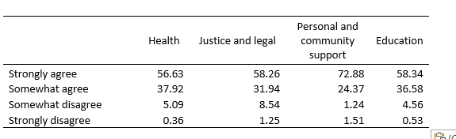 Appendix Table 21A: Have other people’s attitudes prevented you from trying to get a promotion or keeping a job
 | Trying to get a  promotion (%) | Keeping a job (%)
Always | 5.8 | 5.6
Often | 10.4 | 9.0
Sometime | 16.7 | 16.8
Hardly | 10.4 | 10.8
Never | 56.8 | 57.8

Appendix Table 22A: Have other people’s attitudes prevented you from trying to get a promotion, by disability severity (%)
 | Severity of disability
 | Mild (%) | Moderate (%) | Severe (%)
Always | 1.7 | 5.2 | 12.7
Often | 5.1 | 10.6 | 17.1
Some of the time | 11.8 | 18.2 | 19.9
Hardly ever | 9.9 | 11.7 | 8.7
Never | 71.5 | 54.3 | 41.6

Appendix Table 23A: Have other people’s attitudes prevented you from keeping a job, by disability severity (%)
 | Severity of disability
 | Mild (%) | Moderate (%) | Severe (%)
Always | 1.7 | 4.5 | 13.4
Often | 3.0 | 9.3 | 16.3
Some of the time | 11.5 | 18.5 | 20.2
Hardly ever | 8.0 | 11.5 | 13.4
Never | 75.8 | 56.3 | 36.6

https://humanrights.gov.au/about/news/speeches/critical-task-changing-community-attitudes-towards-disability
Transcript, Ronald Sackville (Chair), Public hearing 28, 10 October 2022, P-4 [30–40]; Transcript, Natalie Wade, Public hearing 18, 8 November 2021, P-45 [16–18]; Shane Clifton, Hierarchies of power: Disability theories and models and their implications for violence against, and abuse, neglect, and exploitation of, people with disability, Report prepared for the Royal Commission into Violence, Abuse, Neglect and Exploitation of People with Disability, October 2020, pp 15–16.
Royal Commission into Violence, Abuse, Neglect and Exploitation of People with Disability, Issue Paper: Rights and attitudes, April 2022 Issues paper - Rights and attitudes (royalcommission.gov.au)
Submissions of Counsel Assisting the Royal Commission following Public hearing 31, 3 February 2023, pp 7–8 [5]; Shane Clifton, Hierarchies of power: Disability theories and models and their implications for violence against, and abuse, neglect, and exploitation of people with disability, Report prepared for the Royal Commission into Violence, Abuse, Neglect and Exploitation of People with Disability, October 2020, pp 15–16.
Submissions of Counsel Assisting the Royal Commission following Public hearing 24, 21 October 2022, p 142 [385].
The sampling frame for the address-based sample is the Geo-coded National Address File (G-NAF). The ‘square root allocation’ sample selection method was preferred to an equal or probability-proportionate to size selection approach as a means of increasing the achieved sample sizes in smaller states, improving the bases for state-level reporting. Using this approach, States and Territories which normally achieve fewer completions (either due to smaller populations and / or lower sample yields) were over-sampled to reflect more of the final number of completes than they would otherwise.
Our design is informed by the online inclusive design and legibility considerations available through Vision Australia.
The weighting is complicated because the total survey respondents are drawn from two probability samples. The approach taken is to construct weights for each sample with weights within each sample adding to the total Australian population aged 18 years and older. When combining the two samples, weights are scaled to sample sizes before files are combined. This gives weight to each sample based on its size, thus combining the two without over-representation of respondents from one sample. This approach is justified by the probability-based frames of both samples, along with the existence of quantifiable base weights and an assumed small overlap in samples (Social Research Centre 2023).
Those with hiring responsibilities indicated marginally better attitudes by about 0.6%. Even though this difference is marginal, the difference is statistically significant at 5% confidence interval.
These are self-identified disability types (based on variables DIS_TYP*)
Royal Commission into Violence, Abuse, Neglect and Exploitation of People with Disability, Final Report: Volume 7, Inclusive education, employment and housing – Part B Inclusive employment; September 2023;

