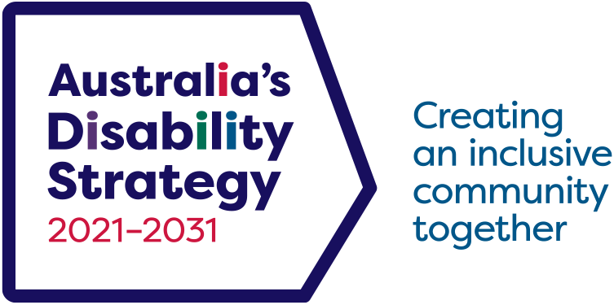

3rd Targeted Action Plans Report

1 July 2023 to 30 June 2024

*Australia’s Disability Strategy 2021 – 2031*

© Commonwealth of Australia (Department of Social Services) 2024

Creative Commons.
BY graphic.
Copyright symbol.

This document is licensed under the Creative Commons Attribution 4.0 International License (<https://creativecommons.org/licenses/by/4.0>), except for:

* the Commonwealth Coat of Arms
* any images and photographs unless marked as being included under CC BY
* any protected names, symbols and registered trademarks
* content identified as being provided by third parties.

Please credit the department using the following words:

Commonwealth of Australia (Department of Social Services) 2024 For any copyright enquiries, email [Copyright@dss.gov.au](mailto:Copyright%40dss.gov.au?subject=) or phone 1300 653 227.

All website links provided in this document are correct at time of publication.

Contents

Introduction 4

National Progress of Targeted Action Plans 8

Employment Targeted Action Plan 12

Community Attitudes Targeted Action Plan 16

Early Childhood Targeted Action Plan 20

Safety Targeted Action Plan 24

Emergency Management Targeted Action Plan 28

Overall achievements and review since 3 December 2021 32

Overview 32

Final status of all actions since 3 December 2021 34

Review of TAPs 35

Stakeholder feedback 38

Australian Government and state and territory TAPs overviews 39

Australian Government – Employment TAP 44

Northern Territory – Employment TAP 46

Australian Capital Territory – Community Attitudes TAP 48

Queensland – Community Attitudes TAP 50

Western Australia – Early Childhood TAP 52

South Australia – Safety TAP 54

New South Wales – Safety TAP 56

Tasmania – Emergency Management TAP 58

Victoria – Emergency Management TAP 60

The next Targeted Action Plans 63

# Introduction

Australia’s Disability Strategy 2021–2031 (ADS) sets out a plan to change the lives of people with disability over 10 years.

Under ADS, Targeted Action Plans (TAPs) apply an intensive focus over 1 to 3-years to achieve specific deliverables which aim to improve outcomes for people with disability.

Each TAP is commissioned and endorsed by all Australian disability ministers and includes a series of targeted and coordinated actions from governments.

The first set of TAPs, which commenced at the time of launch of ADS in December 2021, have now ceased. This is the 3rd and final report for those TAPs and provides a final status on actions during the reporting period, along with an overview of all actions since 3 December 2021. Actions that remain open after 30 June 2024, will continue as ongoing business‑as‑usual activities.

A high-level overview of the first set of TAPs is included towards the end of the report.

New TAPs have been developed in line with what we heard from people with disability. A high-level description is included at the end of the report.

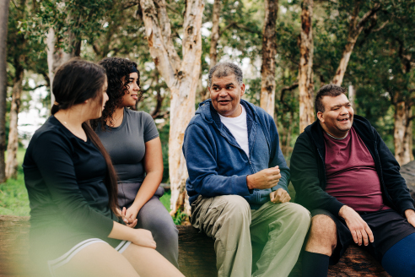

Targeted Action Plans are one of the key mechanisms introduced during the development of Australia’s Disability Strategy 2021–2031 to focus the effort of governments on applying intensive action on key areas over 1 to 3-years.

Throughout the life of ADS, disability ministers will commission new Targeted Action Plans to drive and focus action of all governments on improving outcomes in specific areas for people with disability. Governments focussed the first five TAPs on the following areas:

* [Employment](https://www.disabilitygateway.gov.au/document/3151)
* [Community Attitudes](https://www.disabilitygateway.gov.au/document/3141)
* [Early Childhood](https://www.disabilitygateway.gov.au/document/3146)
* [Safety](https://www.disabilitygateway.gov.au/document/3176)
* [Emergency Management](https://www.disabilitygateway.gov.au/document/3181)

These are the areas people with disability told us needed immediate action, and the areas where achieving improved outcomes would make the most difference to their lives. New TAPs will be implemented to replace these.

Reporting on TAPs

Under ADS, all governments committed to deliver more comprehensive and visible reporting to ensure greater transparency and accountability in improving the lives of people with disability.

The annual TAPs report provides a progress update on what governments are doing to implement and progress TAP actions and the successes. TAPs reports are published annually on a financial year basis, in line with improved reporting requirements under ADS.

The Report

The Report includes updates from across Australian and state and territory governments and includes the final status of actions.

The 3rd TAPs Report consists of two documents:

* **The Report:**
  + The report provides an overview of progress on all actions and includes data and charts. The report also includes a brief overview on progress since the launch of ADS (December 2021 – June 2023 period). Since this is the final report, it includes a section covering stakeholder feedback and reviews of TAPs from each state and territory government, and the Australian Government.
* **The Appendix:** 
  + Provides a progress and status update of TAP actions for the reporting period. All actions have been linked to the relevant Policy Priority in ADS.

The status indicators for the final report have been revised to the following:

* **Completed in period**: Action was completed between 1 July 2023 and 30 June 2024.
* **Ongoing**: Activities under the action are still being progressed and will be absorbed into business‑as‑usual functions. Reporting on these activities will become part of normal annual report requirements as per Australian Government and state/territory government legislated reporting requirements.
* **Discontinued**: Action was not progressed. Activities under the action were either superseded by other reform or actions or a decision was made to withdraw the action. The progress update will provide details of why the action was discontinued.
* **Completed in past period**: Action was completed in either 2021–2022 or 2022–2023.

Further information on ADS, including the TAPs, is available at [www.disabilitygateway.gov.au/ads](http://www.disabilitygateway.gov.au/ads)



# National Progress of Targeted Action Plans

This final report covers the period 1 July 2023 to 30 June 2024 (the reporting period).

Progress and status updates cover the 273 actions remaining (not completed) from the 2022–2023 reporting period.

National progress across all 5 TAPs comprising of 273 remaining actions in the 2023–2024 reporting period show:

* **138 (50%)** actions were completed in period
* **127 (47%)** actions are ongoing
* **8 (3%)** actions are discontinued.

For the period 1 July 2023 to 30 June 2024, most TAPs had 45% or over of their actions reported as completed. The Community Attitudes TAP had the highest proportion of completed actions with 60%. The Safety TAP had the lowest proportion of completed with 45%.

The government with the highest proportion of completed actions overall was the Northern Territory with 86% of actions completed in the reporting period. New South Wales had the second highest number of actions completed overall, in the reporting period with 80%.

The tables and graphs on the following page provide a breakdown of the final status of actions under each government and then by TAPs.



1. TAPs status for the reporting period 2023–2024 by government

|  |  |  |  |  |
| --- | --- | --- | --- | --- |
| Government | Completed in period | Ongoing | Discontinued | Total |
| Australian Government | 6 | 32 | 4 | 42 |
| New South Wales | 32 | 7 | 1 | 40 |
| Victoria | 18 | 14 | 0 | 32 |
| Queensland | 21 | 11 | 0 | 32 |
| Western Australia | 2 | 18 | 1 | 21 |
| South Australia | 18 | 21 | 2 | 41 |
| Tasmania | 5 | 16 | 0 | 21 |
| Australian Capital Territory | 11 | 4 | 0 | 15 |
| Northern Territory | 25 | 4 | 0 | 29 |
| **National total** | **138** | **127** | **8** | **273** |
| **Percentage** | **51%** | **47%** | **3%** |  |

Note: Percentages may not total 100 due to rounding

1. Status for the reporting period 2023–2024 by TAPs

|  |  |  |  |  |
| --- | --- | --- | --- | --- |
| TAP | Completed in period | Ongoing | Discontinued | Total |
| Employment | 27 | 28 | 1 | 56 |
| Community Attitudes | 26 | 17 | 0 | 43 |
| Early Childhood | 30 | 19 | 5 | 54 |
| Safety | 37 | 44 | 2 | 83 |
| Emergency Management | 18 | 19 | 0 | 37 |
| **National total** | **138** | **127** | **8** | **273** |
| **Percentage** | **51%** | **47%** | **3%** |  |

Note: Percentages may not total 100 due to rounding

1. TAPs status for the reporting period 2023–2024 by government

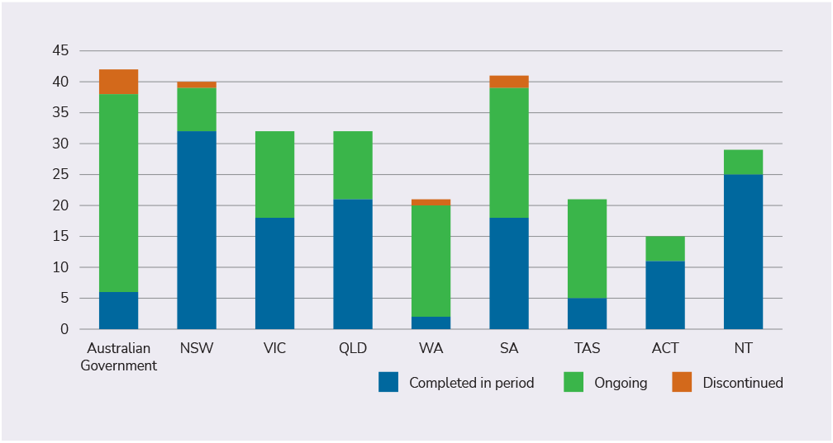

1. Status for the reporting period 2023–2024 by TAP

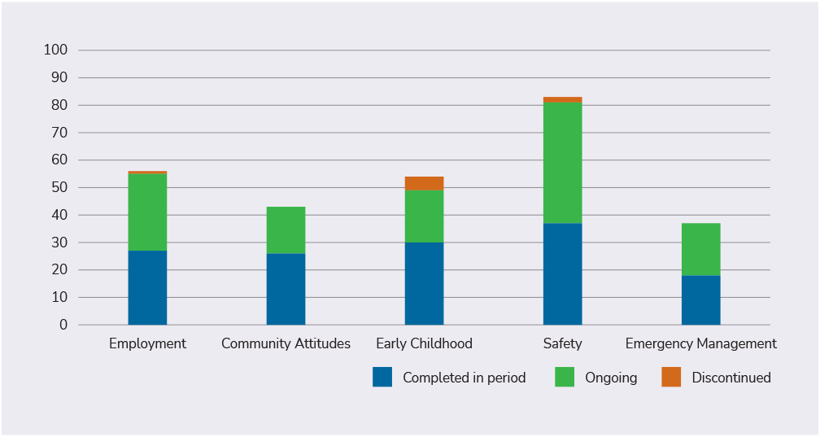

# Employment Targeted Action Plan

Introduction

The Employment TAP is designed to drive progress under the Employment and Financial Security Outcome Area of ADS.

This Outcome Area aims to ensure people with disability have economic security, enabling them to plan for the future, and exercise choice and control over their lives.

Under the Employment TAP there are 56 actions across Australian, state and territory governments being reported on for the 2023–2024 period.

This includes actions that will deliver employment pilots to connect people with disability to areas of skills shortage, work to boost disability employment in public services and drive improvements to employment programs.

### Objectives

1. **Increase employment of people with disability.**
2. **Improve the transition of young people with disability from education to employment.**



1. Employment TAP – status of actions in 2023–2024 by government

|  |  |  |  |  |
| --- | --- | --- | --- | --- |
| Government | Completed in period | Ongoing | Discontinued | Total |
| **Australian Government** | 0 | 7 | 0 | 7 |
| **New South Wales** | 4 | 2 | 0 | 6 |
| **Victoria** | 3 | 10 | 0 | 13 |
| **Queensland** | 5 | 1 | 0 | 6 |
| **Western Australia** | 0 | 5 | 1 | 6 |
| **South Australia** | 7 | 2 | 0 | 9 |
| **Tasmania** | 2 | 0 | 0 | 2 |
| **Australian Capital Territory** | 1 | 1 | 0 | 2 |
| **Northern Territory** | 5 | 0 | 0 | 5 |
| **National total** | **27** | **28** | **1** | **56** |

1. Employment TAP – status of actions in 2023–2024 by objective

|  |  |  |  |  |
| --- | --- | --- | --- | --- |
| TAP | Completed in period | Ongoing | Discontinued | Total |
| **Objective 1** | 17 | 18 | 1 | 36 |
| **Objective 2** | 10 | 10 | 0 | 20 |
| **Overall** | **27** | **28** | **1** | **56** |

1. Employment TAP in 2023–2024 by government

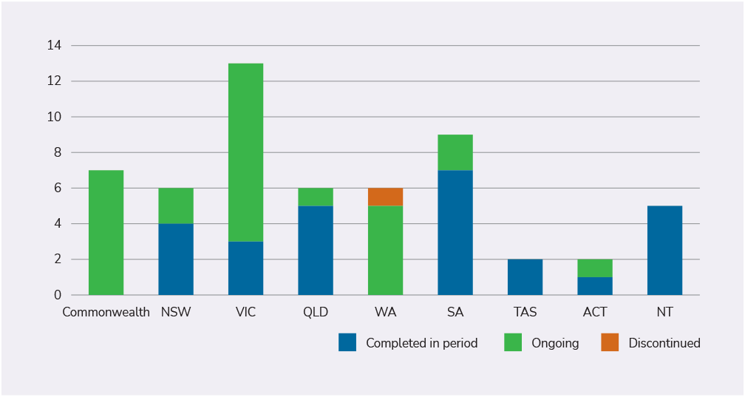

1. Employment TAP in 2023–2024 by objective

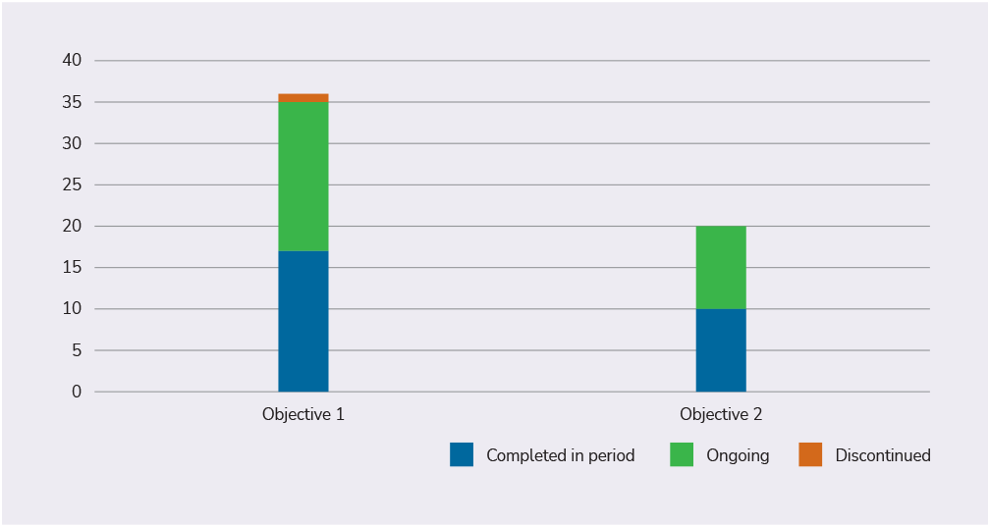

# Community Attitudes Targeted Action Plan

Introduction

The Community Attitudes TAP is designed to drive progress under the Community Attitudes Outcome Area of ADS.

This Outcome Area aims to ensure that community attitudes are improved and enable people with disability to have full equality, inclusion and participation in society.

Under the Community Attitudes TAP there are 43 actions across Australian, state and territory governments being reported on for the 2023–2024 period.

This includes actions that will develop disability confidence in key professionals, deliver community engagement and education activities, and produce training resources for frontline staff to improve their understanding of disability.

### Objectives

1. **Employers value the contribution people with disability make to the workforce and recognise the benefits of employing people with disability.**
2. **Key professional workforces are able to confidently and positively respond to people with disability.**
3. **Increase representation of people with disability in leadership roles.**
4. **Improving community attitudes to positively impact on Policy Priorities under the Strategy.**



1. Community Attitudes TAP – status of actions in 2023–2024 by government

|  |  |  |  |  |
| --- | --- | --- | --- | --- |
| Government | Completed in period | Ongoing | Discontinued | Total |
| **Australian Government** | 0 | 1 | 0 | 1 |
| **New South Wales** | 10 | 0 | 0 | 10 |
| **Victoria** | 4 | 3 | 0 | 7 |
| **Queensland** | 4 | 2 | 0 | 6 |
| **Western Australia** | 1 | 1 | 0 | 2 |
| **South Australia** | 0 | 4 | 0 | 4 |
| **Tasmania** | 0 | 4 | 0 | 4 |
| **Australian Capital Territory** | 3 | 2 | 0 | 5 |
| **Northern Territory** | 4 | 0 | 0 | 4 |
| **National total** | **26** | **17** | **0** | **43** |

1. Community Attitudes TAP – status of actions in 2023–2024 by objective

|  |  |  |  |  |
| --- | --- | --- | --- | --- |
| TAP | Completed in period | Ongoing | Discontinued | Total |
| **Objective 1** | 3 | 2 | 0 | 5 |
| **Objective 2** | 9 | 5 | 0 | 14 |
| **Objective 3** | 2 | 1 | 0 | 3 |
| **Objective 4** | 12 | 9 | 0 | 21 |
| **Overall** | **26** | **17** | **0** | **43** |

1. Community Attitudes TAP in 2023–2024 by government

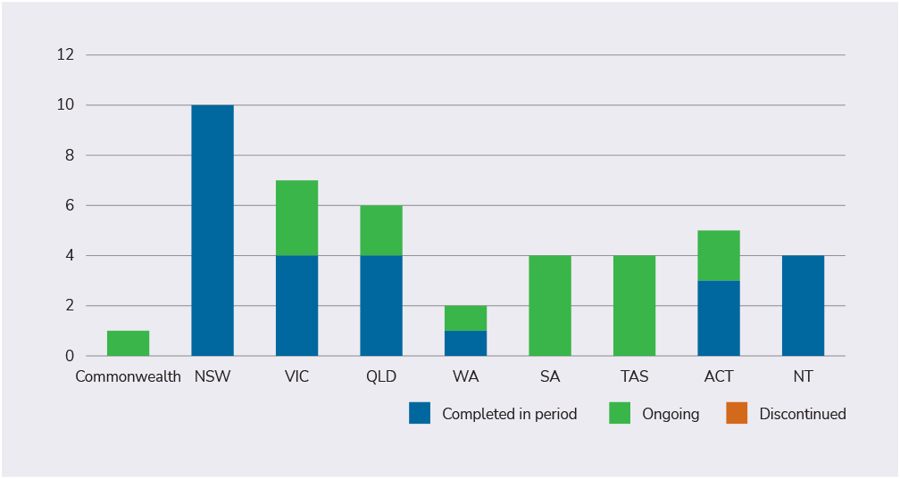

1. Community Attitudes TAP in 2023–2024 by objective

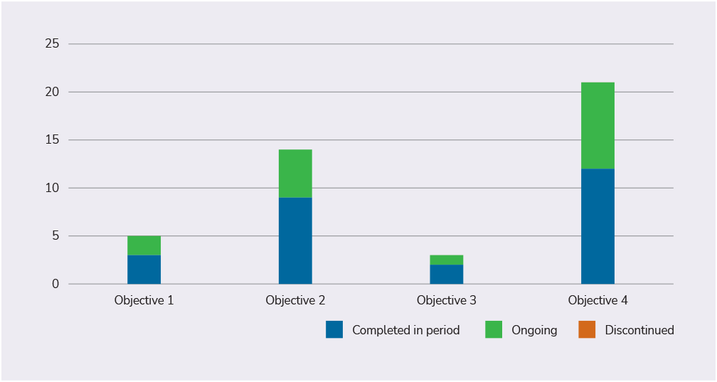

# Early Childhood Targeted Action Plan

Introduction

The Early Childhood TAP is designed to drive progress under the Health and Wellbeing; Education and Learning; Inclusive Homes and Communities; and Personal and Community Support Outcome Areas of ADS.

Respectively, these Outcome Areas aim to ensure people with disability attain the highest possible health and wellbeing outcomes throughout their lives; achieve their full potential through education and learning; live in inclusive, accessible and well-designed homes and communities; and have access to a range of supports to assist them to live independently and engage in their communities.

Under the Early Childhood TAP there are 54 actions across Australian, state and territory governments being reported on for the 2023–2024 period.

This includes actions that will develop information resources to support educators and families/caregivers, establish peer support groups, and promote inclusive practices in kindergarten and early childhood education and care.

### Objectives

1. **Enable early identification of disability or developmental concerns and develop clearer pathways and timely access to appropriate supports.**
2. **Strengthen the capability and capacity of key services and systems to support parents and carers to make informed choices about their child.**
3. **Encourage a stronger sense of inclusion and provide opportunities for parents, carers and children to build peer networks, including for Aboriginal and Torres Strait Islander and culturally and linguistically diverse parents and carers.**



1. Early Childhood TAP – status of actions in 2023–2024 by government

|  |  |  |  |  |
| --- | --- | --- | --- | --- |
| Government | Completed in period | Ongoing | Discontinued | Total |
| **Australian Government** | 2 | 3 | 3 | 8 |
| **New South Wales** | 1 | 2 | 1 | 4 |
| **Victoria** | 1 | 1 | 0 | 2 |
| **Queensland** | 6 | 1 | 0 | 7 |
| **Western Australia** | 0 | 4 | 0 | 4 |
| **South Australia** | 4 | 3 | 1 | 8 |
| **Tasmania** | 0 | 5 | 0 | 5 |
| **Australian Capital Territory** | 3 | 0 | 0 | 3 |
| **Northern Territory** | 13 | 0 | 0 | 13 |
| **National total** | **30** | **19** | **5** | **54** |

1. Early Childhood TAP – status of actions in 2023–2024 by objective

|  |  |  |  |  |
| --- | --- | --- | --- | --- |
| TAP | Completed in period | Ongoing | Discontinued | Total |
| **Objective 1** | 13 | 7 | 2 | 22 |
| **Objective 2** | 11 | 8 | 1 | 20 |
| **Objective 3** | 6 | 4 | 2 | 12 |
| **Overall** | **30** | **19** | **5** | **54** |

1. Early Childhood TAP in 2023–2024 by government

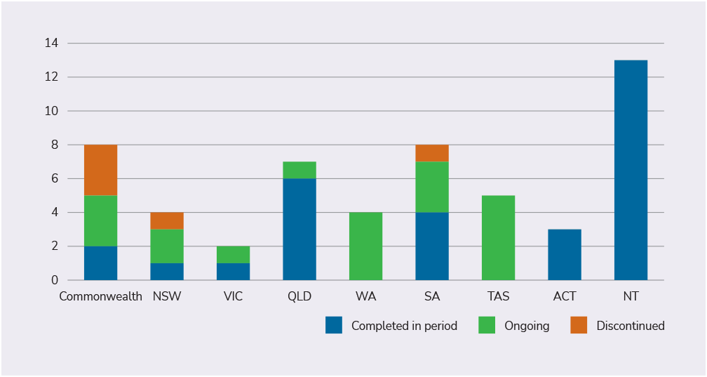

1. Early Childhood TAP in 2023–2024 by objective

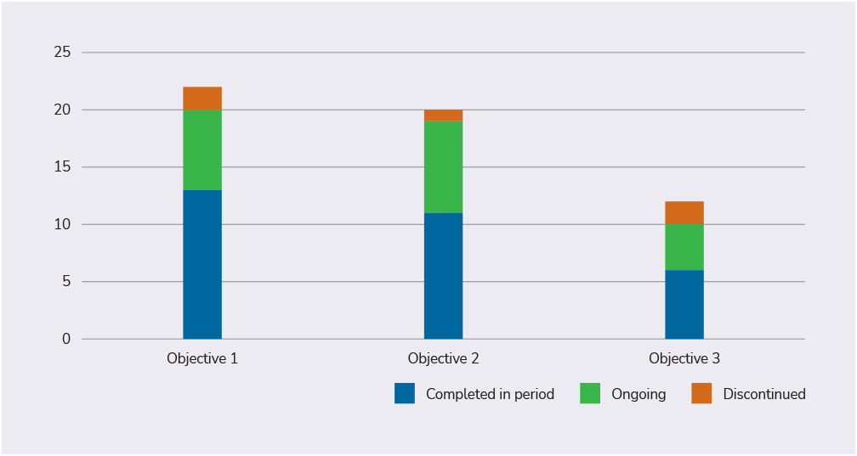

# Safety Targeted Action Plan

Introduction

The Safety TAP is designed to drive progress under the Safety, Rights and Justice Outcome Area of ADS.

This Outcome Area aims to ensure the rights of people with disability are promoted, upheld and protected, and people with disability feel safe and enjoy equality before the law.

Under the Safety TAP there are 83 actions across Australian, state and territory governments being reported on for the 2023–2024 period.

This includes actions that support the identification of people with disability at risk of harm, consider how to better align national legislation and policy, and improve services and resources that support people with disability at risk.

### Objectives

1. **Build capability to identify and respond to risk and protective factors resulting in a person with disability experiencing, or possibly being at risk of, harm.**
2. **Ensure mainstream and specialist disability services provide appropriate and proportionate protections for people with disability who experience or may be at risk of harm.**
3. **Strengthen the design of all government service systems and the supports they provide for people with disability at risk of harm.**
4. **Reduce and eliminate the use of restrictive practices in all government service systems.**
5. **Build individual capacity and effective natural safeguards (i.e. informal supports and protections such as connection with family and community) of people with disability.**



1. Safety TAP – status of actions in 2023–2024 by government

|  |  |  |  |  |
| --- | --- | --- | --- | --- |
| Government | Completed in period | Ongoing | Discontinued | Total |
| **Australian Government** | 1 | 12 | 1 | 14 |
| **New South Wales** | 14 | 3 | 0 | 17 |
| **Victoria** | 8 | 0 | 0 | 8 |
| **Queensland** | 4 | 6 | 0 | 10 |
| **Western Australia** | 1 | 5 | 0 | 6 |
| **South Australia** | 5 | 6 | 1 | 12 |
| **Tasmania** | 0 | 7 | 0 | 7 |
| **Australian Capital Territory** | 4 | 1 | 0 | 5 |
| **Northern Territory** | 0 | 4 | 0 | 4 |
| **National total** | **37** | **44** | **2** | **83** |

1. Safety TAP – status of actions in 2023–2024 by objective

|  |  |  |  |  |
| --- | --- | --- | --- | --- |
| TAP | Completed in period | Ongoing | Discontinued | Total |
| **Objective 1** | 3 | 9 | 0 | 12 |
| **Objective 2** | 4 | 11 | 0 | 15 |
| **Objective 3** | 21 | 13 | 2 | 36 |
| **Objective 4** | 7 | 10 | 0 | 17 |
| **Objective 5** | 2 | 1 | 0 | 3 |
| **Overall** | **37** | **44** | **2** | **83** |

1. Safety TAP in 2023–2024 by government

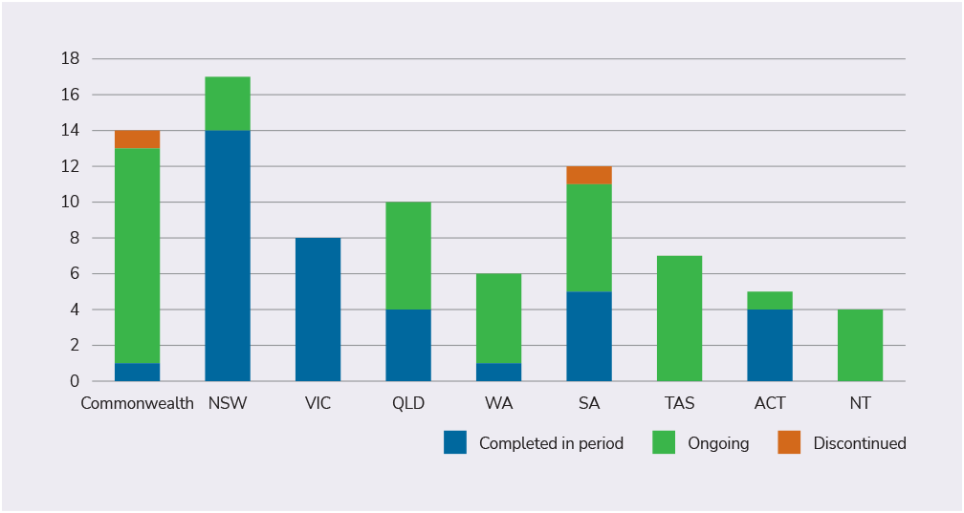

1. Safety TAP in 2023–2024 by objective

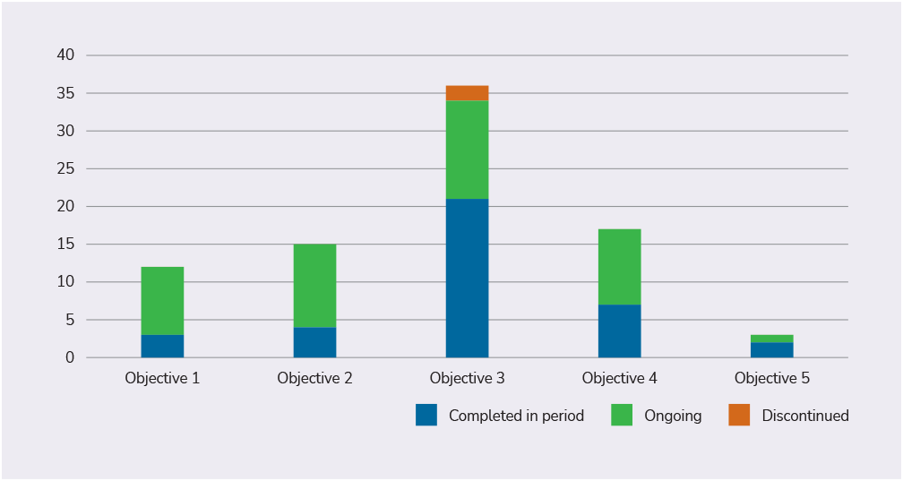

# Emergency Management Targeted Action Plan

Introduction

The Emergency Management TAP is designed to drive progress under the Health and Wellbeing Outcome Area of ADS.

This Outcome Area aims to ensure people with disability attain the highest possible health and wellbeing outcomes throughout their lives.

Under the Emergency Management TAP there are 37 actions across Australian, state and territory governments being reported on for the 2023–2024 period.

This includes actions that actively seek feedback from people with disability and the sector, review and improve emergency response plans and preparations to better include people with disability, and improve communications provided during emergencies.

### Objectives

1. **Ensure disaster/emergency planning processes for conducting disaster risk assessments, and subsequent development and maintenance of disaster/emergency management plans, are inclusive of people with disability.**
2. **Ensure inclusive disaster/emergency management, preparedness and recovery planning processes support the health and wellbeing of people with disability before, during and after emergencies.**



1. Emergency Management TAP–status of actions in 2023–2024 by government

|  |  |  |  |  |
| --- | --- | --- | --- | --- |
| Government | Completed in period | Ongoing | Discontinued | Total |
| **Australian Government** | 3 | 9 | 0 | 12 |
| **New South Wales** | 3 | 0 | 0 | 3 |
| **Victoria** | 2 | 0 | 0 | 2 |
| **Queensland** | 2 | 1 | 0 | 3 |
| **Western Australia** | 0 | 3 | 0 | 3 |
| **South Australia** | 2 | 6 | 0 | 8 |
| **Tasmania** | 3 | 0 | 0 | 3 |
| **Australian Capital Territory** | 0 | 0 | 0 | 0 |
| **Northern Territory** | 3 | 0 | 0 | 3 |
| **National total** | **18** | **19** | **0** | **37** |

1. Emergency Management TAP – status of actions in 2023–2024 by objective

|  |  |  |  |  |
| --- | --- | --- | --- | --- |
| TAP | Completed in period | Ongoing | Discontinued | Total |
| **Objective 1** | 10 | 8 | 0 | 18 |
| **Objective 2** | 8 | 11 | 0 | 19 |
| **Overall** | **18** | **19** | **0** | **37** |

1. Emergency Management TAP in 2023–2024 by government

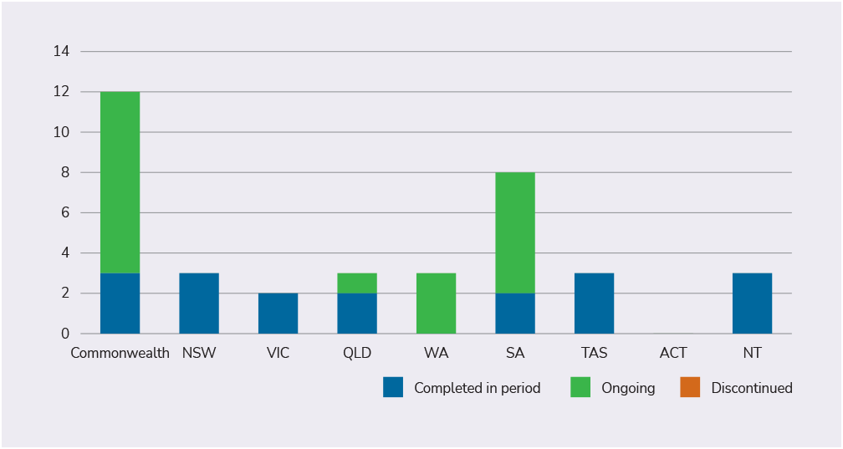

1. Emergency Management TAP in 2023–2024 by objective

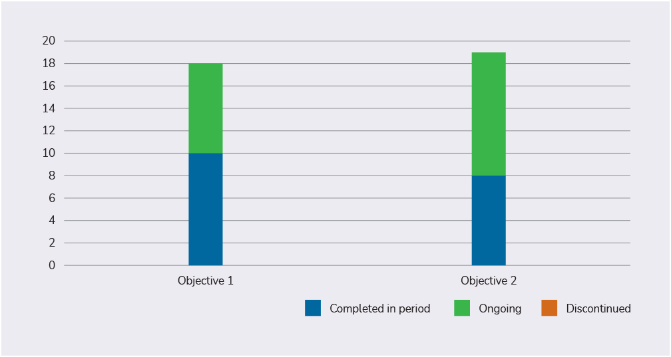

# Overall achievements and review since 3 December 2021

## Overview

This section includes a high-level overview of the first set of TAPs, including the final status of all 417 actions and a themed based view of the type of actions in each TAP. It also includes consolidated stakeholder feedback received on the TAPs since the launch of ADS on 3 December 2021.

ADS Roadmap stipulates the completion and evaluation of the first set of TAPs for 2024.

In 2025, under ADS Roadmap, the Australian Government will commission the 1st Major Independent Evaluation Review of ADS. The major evaluation will consider the effectiveness of the TAPs and their implementation in more depth.

In the interim, the Australian Government and each state and territory government has prepared an overview of one specific TAP each to highlight how actions were implemented, including successes and barriers.

In addition to the overviews, stakeholder feedback has been collected from the response to the Royal Commission into Violence, Abuse, Neglect and Exploitation of People with Disability (Disability Royal Commission) and the NDIS Review, Disability Representative Organisations (DROs), ADS Advisory Council along with feedback received as part of ADS Review in 2024. A consolidated overview of feedback received is included.



## Final status of all actions since 3 December 2021

The overall progress made on all 417 TAPs over the period 3 December 2021 to 30 June 2024, shows that:

* **282 (67%)** actions were completed since the TAPs were launched.
* **127** **(31%)** actions will continue as ongoing, business-as-usual activities.
* **8 (2%)** actions were discontinued.

1. Final status of all actions for the period 3 December 2021 to 30 June 2024, by government

|  |  |  |  |  |
| --- | --- | --- | --- | --- |
| Government | Completed | Ongoing | Discontinued | Total |
| **Australian Government** | 23 | 32 | 4 | 59 |
| **New South Wales** | 38 | 7 | 1 | 46 |
| **Victoria** | 36 | 14 | 0 | 50 |
| **Queensland** | 44 | 11 | 0 | 55 |
| **Western Australia** | 12 | 18 | 1 | 31 |
| **South Australia** | 46 | 21 | 2 | 69 |
| **Tasmania** | 13 | 16 | 0 | 29 |
| **Australian Capital Territory** | 36 | 4 | 0 | 40 |
| **Northern Territory** | 34 | 4 | 0 | 38 |
| **National total** | **282** | **127** | **8** | **417** |
| **Percentage** | **67%** | **31%** | **2%** |  |

Note: Percentages may not total 100 due to rounding

1. Final status of actions for the period 3 December 2021 to 30 June 2024, by TAPs

|  |  |  |  |  |
| --- | --- | --- | --- | --- |
| TAP | Completed | Ongoing | Discontinued | Total |
| **Employment** | 54 | 28 | 1 | 83 |
| **Community Attitudes** | 51 | 17 | 0 | 68 |
| **Early Childhood** | 52 | 19 | 5 | 76 |
| **Safety** | 86 | 44 | 2 | 132 |
| **Emergency Management** | 39 | 19 | 0 | 58 |
| **National total** | **282** | **127** | **8** | **417** |
| **Percentage** | **67%** | **31%** | **2%** |  |

Note: Percentages may not total 100 due to rounding

## Review of TAPs

A high-level scan of TAP actions was undertaken to see whether actions linked to TAPs objectives and what kind of themes or categories they fell into.

The majority of actions appear to directly relate to TAP objectives with 406 (97%) actions having a direct correlation to a TAP objective. The actions that did not directly relate to a TAP objective were in the Community Attitudes (7) and Safety (4) TAPs.

1. Actions linked to objectives

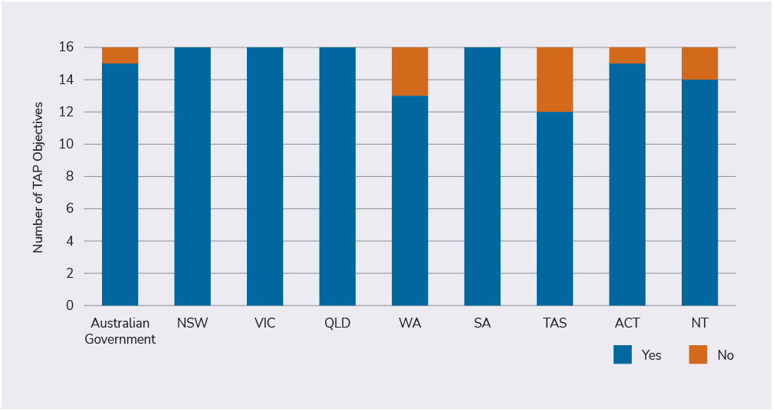

The 417 actions were then grouped into themes based on certain activities. Seven themes were identified throughout, including:

|  |  |
| --- | --- |
| Theme | Definition |
| **Programs and projects** | measures or activities that provide supports to achieve particular outcomes or goals. |
| **Strategies and plans** | development and/or implementation of a strategy or plan to achieve particular outcomes or goals. |
| **Education,** **material and resources** | fact sheets / material providing information and/or education material |
| **Strategy and framework review** | review of existing strategies / frameworks / plans and/or other activities. |
| **Policy and legislation** | changes to, development or implementation of policies or legislation. |
| **Data collection, reporting and research** | activities that gather data, analysis, and/or findings to inform reporting and/or building evidence on relevant issues. |
| **Communication and stakeholder engagement** | activities that bring together or seek input/feedback/insights from stakeholders on issues, programs or strategies. This also includes public information such as advertising/media releases/publishing on social media. |

Of the 417 actions, 195 (47%) of the actions were grouped into the Program and project theme. The remaining 222 actions fell under the following themes:

* Strategy and plan (61 actions or 15%)
* Education, material and resources (47 actions or 11%)
* Strategy and framework review (34 actions or 8%)
* Policy and legislation (33 actions or 8%)
* Data collection, reporting and research (23 actions or 5%)
* Communication and stakeholder engagement (24 actions or 6%).

The table below shows the breakdown of actions by main themes for each TAP.

1. Table of themes

|  |  |  |  |  |  |  |
| --- | --- | --- | --- | --- | --- | --- |
| TAP | Employment | Community Attitudes | Early Childhood | Safety | Emergency Management | Total* |
| **Program / projects** | 57 | 20 | 42 | 55 | 21 | **195 (47%)** |
| **Strategy / plan** | 13 | 14 | 5 | 21 | 8 | **61 (15%)** |
| **Education / material / resources** | 3 | 16 | 19 | 6 | 3 | **47 (11%)** |
| **Strategy / framework reviews** | 5 | 5 | 3 | 12 | 9 | **34 (8%)** |
| **Policy / legislation** | 1 | 1 | 0 | 27 | 4 | **33 (8%)** |
| **Data collection / reporting / research** | 4 | 2 | 4 | 8 | 5 | **23 (5%)** |
| **Communication / engagement** | 0 | 10 | 3 | 3 | 8 | **24 (6%)** |
| **Total** | **83** | **68** | **76** | **132** | **58** | **417** |

*Percentages may be affected by rounding

There were a number of actions across the 5 TAPs where the main focus of the action directly related to one theme while some activities under the action related to a secondary theme. There were 48 actions (12%) that included activities of a secondary theme.

## Stakeholder feedback

Stakeholder feedback on the first set of TAPs was collected and collated from the response to the Disability Royal Commission and the NDIS Review, Disability Representative Organisations (DROs), ADS Advisory Council along with feedback received as part of ADS Review in 2024. These observations and recommendations have helped to inform the development of the new TAPs.

Overall, feedback from stakeholders indicated that TAPs included too many actions, there was not enough national coordination and actions did not, in some cases, directly relate to better outcomes for people with disability.

It was specifically identified that TAPs did not reflect the priorities, needs and experiences of First Nations people with disability. Stakeholders also noted a lack of data to measure progress of TAPs.

Some stakeholders called for reporting on the progress of actions to be improved. This included the frequency and quality of progress updates. Feedback notes, that if reporting on TAPs was clearer and more frequent, TAPs would be able to identify and respond to delayed and undelivered actions quickly. Stakeholders also viewed that governments needed to do more to avoid delayed and undelivered actions.

Stakeholders also made several observations and recommendations on the implementation of future TAPs. Overall, stakeholders advocated for future TAPs to be more ambitious, directly linked to enabling and embedding system-wide change and supporting a national alignment of actions across governments. Some DROs advocated for future TAPs to have more detailed activities and clear commitments from government. Future TAPs could be strengthened by harmonising efforts across state, territory and the Australian Government, including significant TAP actions and disability inclusion plans, including robust mechanisms that ensure engagement of people with disability in the design and implementation of TAPs activities.

## Australian Government and state and territory TAPs overviews

The following overviews by the Australian Government and each state and territory government provides a high-level view of the successes and in some cases the barriers to implementing actions under each of the TAPs.

All governments have demonstrated their commitment towards progressing and implementing actions under the ADS over the 3-year period across the five TAPs.

Over the 3-year period, there has been significant progress made on both the delivery of programs and new initiatives across the 5 TAPs. A number of reviews have been undertaken across all governments and new strategies, legislation and processes implemented. Some examples include:

* The Australian Government – Review of Australia’s COVID–19 response
* The New South Wales (NSW) Ageing and Disability Commissioner (ADC) report
* Building on the commitments in Inclusive Victoria: State Disability Plan (2022–2026)
* Queensland’s Disability Plan 2022–2027: Together, a better Queensland
* Western Australia (WA) for Everyone State Disability Strategy 2020–2030
* South Australian Police (SAPOL) Disability Access and Inclusion Plan 2020–2024
* The Tasmanian Royal Commission into National Natural Disaster Arrangements (RCNNDA)
* Australian Capital Territory (ACT) Disability Health Strategy 2024–2033
* The next iteration of the Northern Territory (NT) Public Service (NTPS) Employability Strategy 2024–2027.

Some of the challenges and lessons learned encountered by governments in implementing actions included:

* Working with stakeholders: Where employers had limited capacity and experience in working with people with disability.
* Workforce shortage: The lack of trained professionals, including allied health workers, educators, and support staff, significantly impacts the delivery of quality services
* Workload of teachers: The ongoing shortage of teachers combined with administrative responsibilities, increases workloads, affecting teaching and learning in schools.
* Funding and resources: Limited funding and resources restrict the ability to provide comprehensive services and support.
* Common logistical issues: engaging with stakeholders and dealing with challenges of rural and regional population and ensuring a diverse representation of people with disability in processes
* Progress of some actions was affected by waiting on outcomes from the Disability Royal Commission and the NDIS Review.
* Other key lessons include the importance of ongoing stakeholder engagement, the value of tailored guidance for service providers, and the need for adaptable legislative frameworks to accommodate evolving disaster scenarios.

All governments noted a number of successes in implementing and delivery actions. Some of the key deliverables include:

### Employment

* The Australian Government implemented the New Employment Services Model (NESM) nationally as Workforce Australia in 2022.
* The Australian Government released a new Strategy covering 2024–2026 to provide ongoing focus on supporting NDIS participants to find and keep a job.
* The Northern Territory launched a Disability Confident Recruiter online learning program for all government recruitment panel members.
* The Northern Territory implemented supports for students with disability to complete the NT Certificate of Education and Training (NTCET) and to transition between stages of schooling and out of school.

### Community Attitudes

* The Australian Capital Territory (ACT) implemented a Diversity Register to elevate the voice of people with diverse and intersectional backgrounds on ACT Government and non-Government boards.
* ACT delivered its Disability Justice Strategy 2019–2029 and First Action Plan 2019–2023 to improve the attitudes and capability of the justice sector to respond to and improve outcomes for people with disability in the justice system.
* The implementation of the Queensland Accessible Transport Advisory Council (QATAC) has provided a mechanism for meaningful consultation between disability-sector representatives and government.
* The Queensland Child Safety and Youth Justice portfolios delivered targeted training to staff to recognise disability in young people

### Early Childhood

* Western Australia delivered an Autism program to 12 schools in the Pilbara and Wheatbelt regions.
* The Western Australian government allocated $4.58 million over 3 years to the Department of Education to provide more assistance to children with disability achieve better learning outcomes.
* The Western Australia KidSport program provided sporting vouchers to children with a disability from low socio-economic backgrounds. Over 4,000 children with disability have accessed 5,000 vouchers increasing participation of children with disability and their families in their local communities.

### Safety

* South Australia established a Restrictive Practices Authorisation Scheme, which included the education of NDIS providers; the monitoring, reporting and integration of an ICT system and website and the promotion of reduction of restrictive practices.
* The South Australian Police (SAPOL) worked with Spectrum Australia to launch an online training program ‘Autism: An interactive module for Australian Police’.
* The New South Wales Ageing and Disability Commissioner (ADC) has built capabilities across services systems and community to better identify and respond to factors contributing to increased risk of harm for people with disability.
* The New South Wales government delivered campaigns in print, radio and social media to increase awareness of the NSW Ageing and Disability Abuse Helpline and recognise the signs of abuse, neglect and exploitation of adults with disability.



### Emergency Management

* Tasmania has enhanced community resilience and better integration of disability inclusive packages in emergency responses through the development and distribution of guides and the conduct of pilot exercises.
* Tasmania engaged extensively with people with disability in the development of inclusive emergency management strategies and guidelines.
* The Victorian Department of Health implemented the Disability Liaison Officer (DLO) program supporting people with disability to access healthcare.
* Emergency Recovery Victoria (ERV) is working to embed co-design approach across emergency response, relief and recovery planning for people with disability.

### Links below to each government overview:

* Australian Government – Employment TAP
* Northern Territory – Employment TAP
* Australian Capital Territory – Community Attitudes TAP
* Queensland – Community Attitudes TAP
* Western Australia – Early Childhood TAP
* South Australia – Safety TAP
* New South Wales – Safety TAP
* Tasmania – Emergency Management TAP
* Victoria – Emergency Management TAP

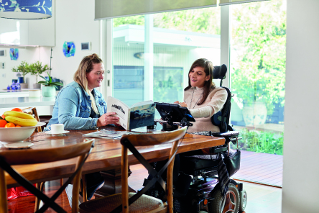

## Australian Government – Employment TAP

**Number of actions: 12**

**Actions completed: 5**

**Actions ongoing: 7**

**Actions discontinued: 0**



### Introduction

The Employment Targeted Action Plan (TAP) includes 12 Australian Government actions with the objectives of increasing employment of people with disability and improving the transition of young people with disability from education to employment. The three-year period has seen significant progress on reforms to Australian government employment services.

### Actions implemented as planned

1. **The New Employment Services Model (NESM) (action 1.6) was implemented nationally as Workforce Australia in 2022**

It continues to support people with disability to exercise choice and access services tailored to assist them to address their specific barriers, improve their employability and move into work.

1. **The Disability Employment Services (DES) reforms (action 1.2) are being undertaken through a phased approach**

The first phase focused on quality with the new Quality Framework announced in July 2023 and the new Performance Framework and Scorecards announced in July 2024. A new specialist disability employment program will commence on 1 July 2025 that will help more people with disability access flexible and tailored supports from quality providers to help them prepare for and find and sustainable quality employment. Information on these reforms can be found on the Department of Social Services’ website at [Employment services for people with disability | Department of Social Services, Australian Government (dss.gov.au)](https://www.dss.gov.au/disability-and-carers-programs-services/employment-services-for-people-with-disability)

1. **The NDIS Participant Employment Strategy (action 1.9) was developed in consultation with people with disability and was implemented from 2019–2022.**
2. **A new Strategy has been released for 2024–2026 to provide ongoing focus on supporting NDIS participants to find and keep a job.**
3. **The national Post School Destinations Survey (PSDS) (now referred to as the GENERATION survey of post-school destinations) was also successfully implemented in 2022**

A second wave of interviews took place in 2023, and data will become available later in 2024.

### Actions ongoing

Actions 1.4 and 2.1 relating to the Individual Placement and Support program are ongoing and continue to support people with mental ill health who are seeking employment. Action 1.3 is in the implementation phase and aims to improve the motivation and capability of employers to attract, recruit and retain employers with disability.

### Achievement of Short/Medium Outcomes

Progress has been made against action 1.7 regarding employment targets of people with disability in the public service. Whilst the 7 per cent target in the TAP has not yet been achieved, as of December 2023, the APS Employment Database indicated 5.2 per cent of employees identify having a disability, which is an increase on previous reporting.

### Challenges and Enablers to Implementation

The disability employment pilots, and the RecruitAble pilot have progressed. These pilots have demonstrated the challenges that can arise when working with mainstream employers who are managing various priorities and have, at times, limited capacity for engagement on disability employment. The lessons learnt through these pilots will inform future employment engagement initiatives.

### Stakeholder engagement

Implementation and development of several of the actions involved stakeholders with disability. The DES Reforms process includes ongoing consultation on various aspects of the implementation of the new program through [engage.dss.gov.au](https://engage.dss.gov.au/). Implementation of the PSDS involved stakeholders from state and territory education departments and from the Catholic and independent school sectors. Consultation was also undertaken on the design of the current Transition to Work program (action 2.3) with disability stakeholders, whose views informed policy and implementation decisions.

Stakeholder engagement has been used as part of the user testing for the redesign of the JobAccess website, partnerships with employers continue to increase and the employment assistance fund caps have increased for Auslan and building modifications.

### Alignment with Government and Agency Priorities under ADS

Implemented actions align with the government priorities under Australia’s Disability Strategy to increase the employment of people with disability and to assist with the transition from school to work through programs, pilots, and support services available. This includes the Transition to Work program, which has successfully increased the share of young people with a disability participating in the service and being placed into jobs.

## Northern Territory – Employment TAP

**Number of actions: 5**

**Actions completed: 5**

**Actions ongoing: 0**

**Actions discontinued: 0**

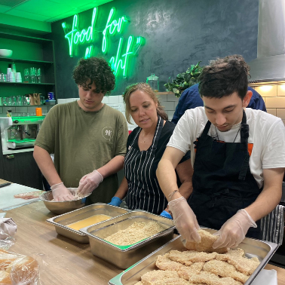

### Introduction

The Northern Territory has a range of strategies to improve access to necessary education, training and appropriate adjustments within the workplace for Territorians with disability. The Employment Targeted Action Plan (TAP) lists 5 Northern Territory Government actions with the objectives of increasing employment of people with disability and improving the transition of young people with disability from education to employment.

As the largest employer in the Northern Territory, the Northern Territory Public Service (NTPS) is responsible for leading the way in promoting and reinforcing the benefits of inclusive and accessible employment. The employment of people with disability is a key component to creating a diverse and inclusive NTPS.

The NTPS works proactively to ensure that people with disability have access to equitable employment opportunities through employment programs aimed at strengthening the diversity and adaptability of the public service and in building staff awareness and addressing unconscious bias.

### Achievement of Short/Medium Outcomes

Across the Northern Territory, successful employment opportunities in the open market continue to be achieved by young people with disability, through initiatives supported by local businesses, including Bunnings, McDonalds and a local office of IT provider, NEC Australia.

From 1 July 2023, a total of 76 students completed ‘transition from school’ plans for Years 9 to 12, with a further 21 students scheduled to have their transition plans completed by late June 2024.

In 2024, 34 students from Darwin and Alice Springs were part of the supported work experience program provided to build capacity of students with disability in the workplace. As a result, one student received a school-based apprenticeship, and 3 students obtained employment within their host workplace at the time of finishing their placement.

Students continued to be provided with opportunities to achieve credits towards their NTCET when supported in transitional work experience programs. A total of 41 students received a modified NTCET, including 15 Aboriginal students and 26 non-Aboriginal students, showing a 10% growth from 2022 figures.

### Activities implemented:

1. **The NTPS EmployAbility Strategy 2024–2027 (the Strategy) was released on 20 June 2024**

The Strategy acknowledges recommendations from the Disability Royal Commission and the review results of the previous strategy, conducted in 2023 (Action 1.2). The Strategy is focused on:

* + improving workplace environment and accessibility to create an inclusive and accessible workplace environment; and
  + improving attraction, recruitment and retention of people with disability to increase the number of NTPS employees with disability from 5% to 8% by 2027.

1. **The NTPS offers a Disability Confident Recruiter online learning program**

This program is set to become essential training for all recruitment panel members. NTPS staff are encouraged to commence discussions during the recruitment process to identify and implement any adjustments before an employee commences, including enabling flexible work arrangements. Through this proactive approach and by fostering a culture of inclusion and diversity, accessibility for all employees is regarded as ‘business as usual’.

1. **The NTPS offers a Disability Employment Program traineeship targeted at school-leavers with disability**

In 2023–24, one person with disability participated in the program (Action 2.1).

1. **McDonalds implemented use of different coloured food trays to identify the different food types (meat burgers versus chicken burgers or fish burgers) to support a young person with disability, who is deaf**

This clear identification process has permitted them to easily distinguish different menu items, allowing them to work independently in their food preparation role.

1. **Students continue to be supported to complete the NT Certificate of Education and Training (NTCET) and to transition between stages of schooling and out of school (Action 2.2 and 2.3).**

### Alignment with Government and Agency Priorities under ADS

Opportunities to improve the employability and financial security of people with disability is a key component of Australia’s Disability Strategy (ADS).

### Challenges and Enablers to Implementation

Some challenges to implementing the actions:

* Workforce shortage: The lack of trained professionals, including allied health workers, educators, and support staff in the Northern Territory, significantly impacts the delivery of quality services.
* Workload of teachers: The ongoing shortage of teachers combined with administrative responsibilities, increases workloads, affecting teaching and learning in schools.
* Funding and resources: Limited funding and resources restrict the ability to provide comprehensive services and support.

Some enablers supporting implementation of actions:

* Implementing Disability Royal Commission recommendations and NDIS Review Final Report recommendations related to education as appropriate.
* Implementing a needs-based, equitable, effective, simple and transparent resourcing model for students with disabilities under the Framework for Inclusion 2019–2029 of the Department of Education.
* Investing in workforce development including enhancing training and recruitment initiatives to build a larger, more skilled workforce, including allied health professionals, educators, and support workers.
* Leveraging technology to improve access to services and utilising innovative approaches to deliver allied health services within school settings.
* Fostering partnerships with relevant sectors to create a more integrated and holistic approach to service delivery.

## Australian Capital Territory – Community Attitudes TAP

**Number of actions: 10**

**Actions completed: 8**

**Actions ongoing: 2**

**Actions discontinued: 0**



### Introduction

Community attitudes matter and significantly impact the experiences of people with disability. Negative attitudes and low expectations towards people with disability result in people with disability experiencing discrimination and disadvantage and having fewer opportunities to participate in and enjoy all areas of life.

The Community Attitudes Targeted Action Plan includes 10 Australian Capital Territory (ACT) Government actions which work to improve community attitudes toward people with disability. The ACT Government has worked in partnership with people with disability to develop and deliver a suite of initiatives and activities.

Each of these activities align with outcome areas under Australia’s Disability Strategy as well as through the Community Attitudes outcome priority.

### Actions being implemented

1. **Health and Wellbeing**

Over the three-year period, the ACT Government has developed and commenced the implementation of the ACT Disability Health Strategy 2024–2033 and the First Action Plan 2024–2026 (Action 2.1). The strategy, launched in December 2023, aims to influence the understanding and capability of key health professionals in responding confidently and positively to people with disability, ensuring people with disability achieve equitable and appropriate access to healthcare. The development was supported by the ACT Disability Health Strategy Steering Committee, membership of which included people with disability.

1. **Education and Learning**

The ACT Inclusive Education Strategy 2024–2034 was also launched in December 2023 to expand on the initiatives in ACT public schools and to foster and promote inclusive attitudes in school communities (Action 4.4).

1. **Safety Rights and Justice**

The ACT Disability Justice Strategy 2019–2029 and its First Action Plan 2019–2023 are being implemented (Action 2.2) and creating changes in improving the attitudes and capability of the justice sector to respond to and improve outcomes for people with people with disability in the justice system. Key actions that have already contributed to improved outcomes for people with disability in justice settings include:

* + the establishment of a network of Disability Liaison Officers across the justice system.
  + disability awareness training across justice and other agencies.
  + the introduction of tools to support identification and provision of reasonable adjustments; and
  + the development of best practice guides for child and youth protection workers and police on how to support people with disability.

In addition, Disability Action and Inclusion Plans (DAIPs) (Action 4.3) have continued to be developed and implemented to support proactive action and removal of barriers in service areas and systems. Key DAIPS have been delivered by Canberra Health Services and ACT Corrections.

1. **Community Attitudes**

Increasing the representation of people with disability in leadership roles is an integral element in ensuring the voice of people with disability is heard. The ACT Government has continued to support and elevate the voice of the ACT Disability Reference Group, and other advisory bodies (Action 3.1). The ACT’s Diversity Register (Action 3.2) has ensured the voices of people with diverse and intersectional backgrounds are considered for and represented on ACT Government and non-Government boards. Numbers of people with disability on boards and governance committees across government is reported in the [Community Services Directorate Annual Report](https://www.act.gov.au/open/community-services-directorate-annual-reports) each year.

1. **Inclusive homes and communities, Health and Wellbeing, Community Attitudes**

In April 2024, ACT Government launched the ACT Disability Strategy 2024–2033 and the First Action Plan 2024–2026 (Action 4.5). Comprehensive consultation was undertaken, co-designed and led by the ACT Disability Reference Group. Every conversation was led by a person with disability, with policy makers and other key community influencers included in these conversations. This approach embodied the principle of ‘nothing about us without us’ and ensured the ACT Government heard the views and experiences of diverse groups of people with disability, including families and carers.

During this period the ACT Government also delivered grant programs and events to support activities that improve community attitudes towards people with disability. The Disability Inclusion Grants (Action 4.1) and International Day of People with Disability (I-Day) Grants (Action 4.2) continued supporting a range of projects and initiatives to remove barriers, including attitudinal barriers, and promote increased awareness of the benefits of inclusion of people with disability in all areas of life.

The Chief Minister’s Inclusion Awards (CMIAs) (Action 1.1), continue to be held annually around the International Day of People with Disability. These awards acknowledge the outstanding achievements of businesses, organisations and individuals who demonstrate their commitment to include, welcome and support people with disability in their workplace, business and community. The CMIAs is contemporising the award categories to better reflect the changing attitudes and awareness of disability rights and disability pride.

### Challenges and Enablers to Implementation

* The ACT Disability Strategy 2024–2033 and other key strategies and plans developed by the ACT Government embodied the principles of ‘nothing about us without us’.
* The ACT Disability Reference Group led the approach to public consultation on the ACT Disability Strategy to ensure the voices of people with disability were at the forefront of all planning and activities.
* ACT Government recognises maintaining strong and trusting relationships with people with disability, their representative organisations and the wider ACT disability community is central to delivering improved outcomes.

## Queensland – Community Attitudes TAP

**Number of actions: 13**

**Actions completed: 11**

**Actions ongoing: 2**

**Actions discontinued: 0**



### Introduction

Under the Community Attitudes Targeted Action Plan (TAP), the Queensland Government committed to delivering 13 key actions to improve community attitudes and enable people with disability to have full equality, inclusion and participation in society. Over the three-year reporting period significant progress has been made implementing initiatives that drive outcomes under the Community Attitudes TAP objectives.

### Actions Implemented as planned

1. **Ensuring people with disability are valued and respected in the workforce**

The Queensland Government recognises the importance of ensuring people with disability are at the centre of decision making in the Queensland public sector.

People with disability were an integral part of a review of Queensland’s Disability Awareness Training for the Queensland public sector (action 2.4), completed in December 2023. The review considered whether training addressed a contemporary understanding of inclusion issues and aligns with the Queensland’s Disability Plan 2022–27: Together, a better Queensland.

Through an extensive co-design and consultation process, people with disability were involved at all stages of the project including its review, scoping, content development, and user-testing.

The Queensland Government is focussed on building disability awareness in the Queensland public sector. Staff from the Child Safety and Youth Justice portfolios completed targeted training in relation to recognising disability in young people (action 2.2).

Delivery of actions is also contributing to improvements in the way workforces communicate and engage with people with disability. Collaboration between the Queensland Government and the National Disability Insurance Agency’s (NDIA) Community Engagement Team has seen targeted information sessions delivered each month to frontline child protection workers to build confidence in positively responding to people with disability (action 2.1).

1. **Increasing representation of people with disability in leadership roles**

Improving representation of people with disability in leadership roles in the Queensland public sector is a key focus for the Queensland Government (action 3.2). The Queensland Government set a target of 8% representation of people with disability at the Senior Officer and Senior Executive Service (and equivalent) levels by 30 June 2024.

While public sector payroll data indicates that representation of this leadership cohort sits at 4.8% (as at March 2024), the anonymous ‘Working for Queensland’ employee survey data indicates representation is at 9%.

Progress towards achieving this target has been driven through new requirements under the Public Sector Act 2022 (Qld) that focus on equity, respect and inclusion.

### Improving community attitudes to drive outcomes under the Australia’s Disability Strategy 2021–31

Australia’s Disability Strategy 2021–31 is broad reaching, and it is important that initiatives to improve community attitudes are targeted across all of its domains, such as transport. In June 2022, Queensland’s Move Together social media campaign (phase 1) was released with an overwhelmingly positive response from the community (action 4.2).

The campaigns aim was to educate general public transport users on the need for accommodations, such as priority seating, to meet the diversity needs of people with disability. Since its launch, there have been 791,046 impressions, 4,028 reactions, 317 comments, and 685 shares across social media platforms. Phase 2 is scheduled for release later in 2024 and phase 3 scheduled for release in 2025.

### Stakeholder engagement

The Queensland Accessible Transport Advisory Council (QATAC) was also an example of authentic consultation between disability-sector representatives and government. Through its three-year term, QATAC was a key mechanism for engagement, collaboration and codesign between the disability sector and the Queensland Government on all major transport projects (action 4.4).

There are now multiple accessible reference groups established which focus on passenger transport. Membership includes people with lived experience and these formal groups facilitate engagement, collaboration and codesign early in the design of a range of transport projects.

### Challenges and Enablers to Implementation

A challenge in relation to implementation to improve community attitudes includes continuing to build the capability of selection panels in implementing the new recruitment and selection requirements (merit and diversity) of the Public Sector Act 2022.

In addition, finding appropriate channels for the ongoing promotion of resources and information can be challenging.

An enabler which has assisted with efficient, effective authentic consultation on major infrastructure projects has been the Accessibility Reference Groups. However, it is important to ensure that more people with lived experience are skilled in co-design, rather than the same people spread across multiple groups. A challenge is that currently there are limited people with the required skills and experience to fully participate in co-design and consultation activities relating to passenger transport services.

An enabler which has assisted with implementation is that the Queensland Public Sector Act 2022 includes a positive duty to progress equity and diversity and to promote respect and inclusion. The legislative requirement for agencies to complete an annual equity and diversity audit has strengthened agency awareness of underrepresentation as an issue.

In addition, ongoing communication and collaboration with established and existing networks is valuable and helps to ensure a range of diverse voices contribute to the development of work to impact community attitudes.

## Western Australia – Early Childhood TAP

**Number of actions: 5**

**Actions completed: 1**

**Actions ongoing: 4**

**Actions discontinued: 0**

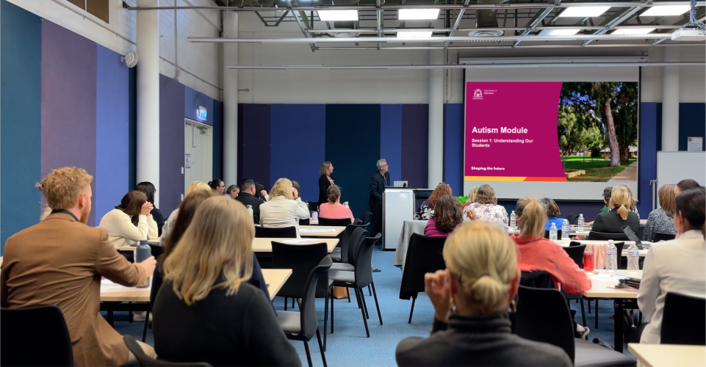

### Introduction

The Early Childhood Targeted Action Plan (TAP) lists 5 Western Australian (WA) actions that aim for children with disability or developmental delay to thrive across, and between, life stages. The three-year period has seen significant progress across WA in improving the learning outcomes of children with disability, building the capability of parents and carers to make informed choices about their child and building stronger participation in cultural, linguistic and diverse community networks.

### Actions implemented as planned

1. **In 2022, the State Government allocated $4.58 million over 3 years to the Department of Education in recognition that learning outcomes for children with disability can be adversely impacted in all settings including regional and remote.**

This funding is used to support a range of initiatives to meet the teaching and learning needs of students with disability, and complex behaviour with a focus on:

* + Developing staff capacity to support students with disability and complex behaviour
  + Using research to inform streamlined access to resources and support for students with disability.

1. **In 2023, the School of Special Education Needs Disability (SSEN:D) and the Key Support Teacher (KST): Autism program was delivered to 12 schools in the Pilbara region. In 2024, the program delivered this essential support to an additional 12 schools in the Wheatbelt region.**

To build staff capability to support students with disability, public schools have access to professional support and a range of professional learning and resources through the SSEN:D. SSEN:D builds the capacity of public schools to ensure students with disability (diagnosed or imputed) can access the curriculum on the same basis as their peers. This included the KST: Autism program, that delivered a targeted coaching program to teachers in regional areas of WA about strategies to effectively address the diverse needs of autistic children. All SSEN:D professional learning is developed through a collaborative consultation process to include student voice, subject matter experts and community feedback.

1. **KidSport provided sporting vouchers to children with a disability from low socio-economic backgrounds.**

Strengthening the capability of parents and carers to make informed choices about which sports and sporting club best suits the needs of their child. Since 2022 over 4,000 children with disability have accessed 5,000 vouchers, representing an investment of almost $800,000 to increase participation of children with disability and their families in their local communities.

1. **The Department of Communities (Communities) provided funding to the Aboriginal Heath Council WA (AHCWA) to enhance their** [**MAPPA**](https://mappa.com.au/) **System, lifting the capability of Aboriginal and Torres Strait Islander and culturally and linguistically diverse parents and carers to access culturally appropriate disability services that best meet the needs of their families.**

The free-to-use online mapping tool provides information about culturally secure NDIS registered service providers across Western Australia. Information parents can access includes where the service provider operates, what services they provide and how to make contact.

1. **Launched in November 2022, the ACCO Strategy focuses on the delivery of culturally informed and led procurement of services where Aboriginal people and families are the primary recipients.**

Communities continues to work with Aboriginal Advisory Groups and Aboriginal Community Controlled Organisations (ACCOs) to implement the [ACCO Strategy 2022–2032](https://www.wa.gov.au/government/publications/aboriginal-community-controlled-organisation-strategy-2022-2032) (action 3.2).

### Alignment with Government and Agency Priorities under ADS

Implementation of WA actions align with both the [Australia’s Disability Strategy](https://www.disabilitygateway.gov.au/sites/default/files/documents/2021-11/1786-australias-disability.pdf) and the [WA for Everyone State Disability Strategy 2020 – 2030](https://www.wa.gov.au/government/document-collections/state-disability-strategy-2020-2030), where children with disability have access to a range of high-quality supports to achieve their full potential and thrive in their community. Avenues for children to be engaged and develop alongside their peers and key to their thriving in the community will continue to underpin the design and implementation of early years pathways in the changing disability landscape.

## South Australia – Safety TAP

**Number of actions: 23**

**Actions completed: 16**

**Actions ongoing: 6**

**Actions discontinued: 1**

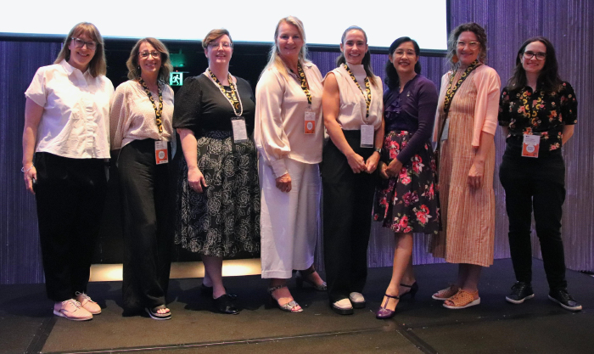

### Introduction

The Safety Targeted Action Plan (TAP) includes 23 South Australian actions, aimed at supporting people with disability to engage safely across mainstream services, exercise their rights and make decisions. Over the reporting period, the South Australian Government continued to make progress to achieve safeguarding outcomes for people with disability across the State.

Key achievements include authorising and reducing restrictive practices, supporting Aboriginal people with culturally safe supported decision-making, ensuring access to accessible and livable public housing, engaging in safer and informed interactions between police and people with autism, and supporting women with disability in correctional environments and in the community.

### Actions implemented as planned

1. **Restrictive Practices**

Since the commencement of the Safety TAP, the South Australian Department of Human Services (SA DHS) established a [Restrictive Practices Authorisation Scheme](https://www.sa.gov.au/topics/care-and-support/disability/restrictive-practices) (action 4.2–4.3), which has established:

* + a two-tier approach to the definitions of regulated restrictive practices, with authorisation decisions made by appropriately trained staff depending on the level of complexity.
  + a unit within SA DHS to make authorising decisions, educate NDIS providers, and monitor, report and promote the reduction of restrictive practices.
  + an ICT system and website which provides information, resources and links to key authorities.

1. **Culturally safe supported decision-making**

From 1 April 2023 to 30 June 2024, the South Australian Office of the Public Advocate (SA OPA) conducted a [Culturally Safe Supported Decision-making (SDM) pilot](https://www.opa.sa.gov.au/guardianship/supported-decision-making/culturally-safe-supported-decision-making#:~:text=In%20December%202022%2C%20the%20OPA,Culturally%20Safe%20Supported%20Decision%2Dmaking.&text=The%20project%20began%20on%201,run%20until%2030%20June%202024) (action 3.2–3.3). The pilot has assisted SA OPA staff to understand the needs, wishes and preferences of Aboriginal clients, using culturally appropriate SDM tools and practices.

As part of the project, SA OPA successfully engaged an Aboriginal ‘cultural broker,’ interviewed Aboriginal clients, trialled and refined supported decision-making tools through a co-design process, and produced a guideline and training video on culturally safe SDM.

SA OPA is now working to implement SDM tools and consider longer-term actions, such as embedding the role of the cultural broker.

1. **Accessible housing**

The South Australian Housing Trust (SAHT) continues to support people with disability to remain in their homes by undertaking disability modifications (action 3.2) to public housing properties in South Australia. Within the 1 July 2023 to 30 June 2024 reporting period, modifications have been completed for 2,418 SAHT properties, with a South Australian Government investment of more than $6.5 million.

To support improved liveability for new homes, Silver Level of the Livable Housing Australia Design guidelines are being used for SAHT’s new builds (action 3.1). This includes 437 new builds to be delivered through the Public Housing Improvement Program – with the commitment continuing for all future public housing homes.

1. **Autism in police**

During the development of the South Australian Police (SAPOL) [Disability Access and Inclusion Plan 2020–2024](https://www.police.sa.gov.au/about-us/disability-plan-2020), autism awareness training was identified through consultation as something that would enable greater understanding and better communication and response when engaging with people with autism. In response, SAPOL worked with Autism Spectrum Australia to launch an online training program; ‘Autism: An interactive module for Australian Police’ (action 2.1, action 3.9). SAPOL continues to broaden its disability awareness through face-to-face training and is trialling a workshop on autism and neurodivergence.

1. **Women in the community**

Over the reporting period, the South Australian Department for Correctional Services (SA DCS) has been undertaking research to drive approaches that specifically respond to women with complex needs, including those with disability, in both custody and the community (action 1.1).

SA DCS continues to analyse options and work closely with mental health and health providers, migrant services and disability providers to support the safe transition of women with disability to the community.

### Challenges and Enablers to Implementation

In delivering the ‘Women in the community’ project, some challenges experienced were due to navigating and coordinating roles and responsibilities across governments in supporting people across the justice interface, particularly when a person is also a NDIS participant. A central agency lead is an important consideration for future work.

Engagement with people with disability and the disability community was an important enabler throughout the implementation of actions in the Safety TAP. Specifically, an Easy English Guide for Tenants was developed and released by SAHT in May 2022. Feedback from focus groups comprising people with lived experience of disability refined the guide and ensured it appropriately met their needs.

In OPA’s culturally safe supported decision-making pilot, input from guardians and the cultural broker enabled effective implementation.

## New South Wales – Safety TAP

**Number of actions: 19**

**Actions completed: 16**

**Actions ongoing: 3**

**Actions discontinued: 0**



### Introduction

The Safety Targeted Action Plan aims to reduce the risk of harm to people with disability, improve supports for those at risk of harm, and provide appropriate and accessible pathways for action if things go wrong.

The NSW Targeted Action Plans (TAPs) were derived from the agreed priorities and resourced action included in the Disability Inclusion Action Plans of NSW agencies and statutory Authorities. NSW agencies contributed to 19 actions to the Safety TAP:

* Health (8 actions: 3.2, 3.3, 3.4, 3.5, 3.6, 3.7, 4.3, 4.4)
* Ageing and Disability Commissioner (4 actions:1.1, 2.1, 2.3, 5.1)
* Department of Communities and Justice (5 actions: 3.8, 3.9, 3.10, 4.2, 4.5)
* Department of Education (1 action: 4.1)
* Whole of NSW Government (1 action: 2.2)

### Actions implemented as planned

All except 3 actions have been implemented as planned. These 3 actions (4.1, 4.5 and 5.1) relate to the refinement of restrictive practices policy in NSW and will be impacted by the NSW and Commonwealth agreed responses to the Disability Royal Commission. All actions in the TAPs were clearly defined strategies with approved budget and resources and were developed in response to local issues identified through consultation with impacted groups.

### Resources and achievements

NSW Health: Actions included a focus on mental health, intellectual disability and sexual assault and sexual health. Resources developed include the Children First strategy [children-first.pdf (nsw.gov.au)](https://www.health.nsw.gov.au/parvan/hsb/Documents/children-first.pdf) and Easy Read mental health information [Easy read and accessible mental health information – Consumers (nsw.gov.au)](https://www.health.nsw.gov.au/mentalhealth/services/consumers/Pages/easy-read-mental-health-info.aspx).

NSW Ageing and Disability Commissioner (ADC): The ADC has built capabilities across service systems and community to better identify and respond to factors contributing to increased risk of harm for people with disability. This has included:

* handling reports received by the NSW Ageing and Disability Abuse Helpline about alleged abuse of adults with disability and investigating where appropriate
* operating the Official Community Visitor scheme to people with disability living in supported accommodation and assisted boarding houses
* delivering engagement and training activities to increase awareness and build agency, provider and community capabilities to better prevent and respond to harm of adults with disability.

### Achievement of Short/Medium Outcomes

Over the three years, the ADC has:

* handled over 43,000 calls and over 12,000 reports, including approximately 3,000 reports about adults with disability in NSW subject to, or at risk of, abuse, neglect and exploitation.
* participated in approximately 200 training and engagement sessions.
* developed three online training modules for frontline staff and management of service providers, and NSW Police.
* facilitated approximately 6,000 visits to adults with disability living in supported accommodation and assisted boarding houses.
* produced resources including Easy Read materials, targeted resources for First Nations communities, and resources in diverse community languages.
* employed print, radio and social media campaigns to increase awareness of the NSW Ageing and Disability Abuse Helpline and signs of abuse, neglect and exploitation of adults with disability.
* Following input from the disability sector NSW adult safeguarding legislation [Ageing and Disability Commissioner Act 2019 No 7 – NSW Legislation](https://legislation.nsw.gov.au/view/whole/html/inforce/current/act-2019-007) has been amended to strengthen information sharing arrangements to improve responses to abuse, neglect and exploitation, and reduce risk of harm.

### Stakeholder engagement

NSW had established a well-defined governance structure for disability which involved disability stakeholders (for example through the NSW Disability Council) and NSW Government officials from all key human services agencies meeting regularly to discuss emerging disability inclusion issues and conducting workshops to target specific challenges.

Information sharing and referral arrangements with NSW and Commonwealth government agencies now make it easier and faster for people with disability at risk of harm to get to the support they need from the right agency.

### Challenges and Enablers to Implementation

Increasing numbers of helpline calls reporting abuse, neglect and exploitation have occurred over the period of the TAP. The challenge is attributing this to a real increase or the likely success of the program in raising awareness of issues and providing a forum for reaching out.

The legislative foundations of the Disability Inclusion Act (2015) and the Ageing and Disability Commissioner Act (2019) have provided a basis on which to build the above initiatives.

## Tasmania – Emergency Management TAP

**Number of actions: 5**

**Actions completed: 5**

**Actions ongoing: 0**

**Actions discontinued: 0**

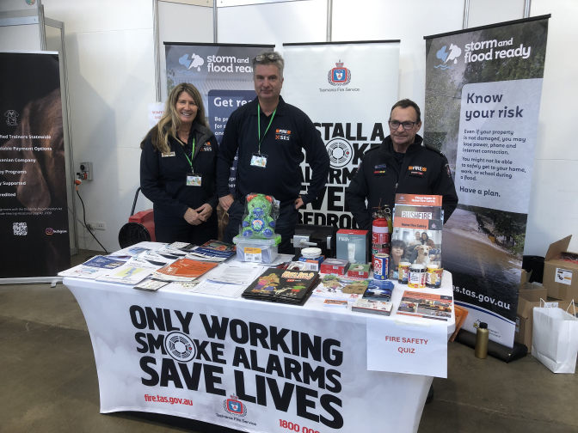

### Introduction

The Emergency Management Action Plan (TAP) includes 5 Tasmanian actions with an aim to enhance disaster preparedness and management, particularly focusing on inclusivity for people with disabilities across Tasmania before, during and after emergencies. Key initiatives included completing the Tasmanian State Disaster Risk Assessment (TASDRA), modernising key parts of emergency legislation, planning and implementing disability inclusion focused projects, and aligning with the Royal Commission’s disaster preparedness recommendations.

Tasmania’s Emergency Management TAP has made significant strides in enhancing disaster preparedness and management for people with disabilities. While challenges exist, proactive engagement, legislative reforms, and community partnerships have enabled meaningful progress. Ongoing efforts are crucial to sustaining these gains and further advancing inclusive emergency management practices across the region.

### Actions implemented as planned.

1. **Completion of TASDRA**

This assessment aimed to provide practical insights for all levels of government and communities. It was successfully completed.

1. **Review of Tasmania’s Emergency Management Act 2006**

Terms of Reference were released for public consultation on February 25, 2022, as a part of a review of legislation post-COVID–19.

1. **Engagement of Disability Service Providers**

Various actions were undertaken, including resilience forums and a pilot exercise in Hobart on June 17, 2023, for disability service providers.

1. **Royal Commission into National Natural Disaster Arrangements (RCNNDA) Recommendations**

Actions have commenced to integrate inclusive practices into disaster preparedness and recovery planning.

1. **TasALERT Accessibility Enhancements**

TasALERT platform underwent accessibility testing, supports Auslan videos on Get Ready section, and an accessible TasALERT App is in development, focusing on vulnerable communities.

1. **People at Increased Risk in an Emergency Guide**

A guide for Tasmanian Government and Non‑Government Community Service Providers was published and distributed.

### Challenges and Enablers to Implementation

Challenges included timeframes, resourcing, capacity, logistical issues engaging with stakeholders due to the challenges of Tasmania’s rural and regional population and ensuring a diverse representation of people with disability in processes. Enablers included strong community engagement, supportive legislative reform processes, and collaborative efforts between emergency management, government at all levels and disability service providers.

### Involvement of People with Disability

People with disability were actively involved through engagement in planning exercises, forums, and governance/advisory groups. Their input contributed to the development of inclusive emergency management strategies and guidelines.

### Achievement of Short/Medium Outcomes

Actions have led to enhanced community resilience and better integration of disability-inclusive practices in emergency responses. The development and distribution of guides and the conduct of pilot exercises signify progress towards achieving these outcomes.

### Addressing Identified Needs

Implemented actions directly address the identified need for inclusive emergency preparedness and response frameworks, aligning with broader government priorities under Policy Priority 4 of Australian Disaster Strategy.

### Alignment with Government and Agency Priorities under ADS

The actions align well with ADS priorities, focusing on resilience, inclusivity, and community-based disaster management strategies.

### Lessons Learned

Key lessons include the importance of ongoing stakeholder engagement, the value of tailored guidance for service providers, and the need for adaptable legislative frameworks to accommodate evolving disaster scenarios.

### Stakeholder Feedback

Stakeholders, including local councils and community service providers, have generally responded positively to the initiatives. Feedback highlights the usefulness of guidance materials and the value of collaborative forums in improving emergency preparedness and management for people with disabilities.

## Victoria – Emergency Management TAP

**Number of actions: 4**

**Actions completed: 4**

**Actions ongoing: 0**

**Actions discontinued: 0**

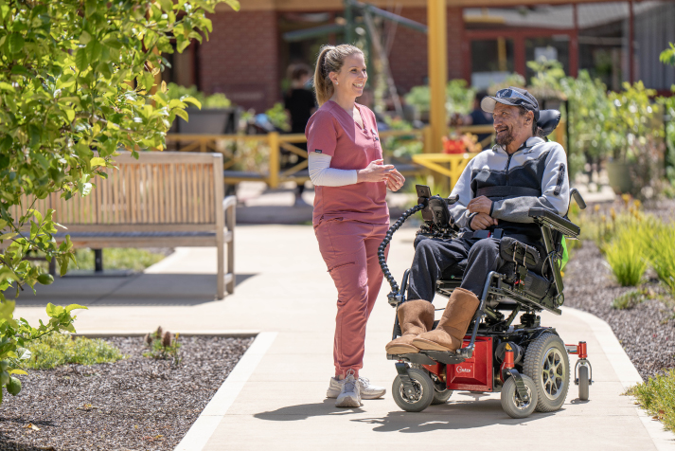

### Introduction

The Emergency Management Targeted Action Plan (TAP) (2021–22 to 2023–24) includes 4 Victorian actions to enhance outcomes for individuals with disability affected by national emergencies.

The 2019–20 bushfires and the COVID–19 pandemic highlighted the need for inclusive emergency responses that consider the physical and mental health needs of people with disability.

The aim of this TAP was to develop emergency response strategies that better support individuals with disabilities, fostering their inclusion and participation, along with that of their families, carers, and representatives, in the planning process.

### Actions implemented / being implemented

Building on the commitments in **Inclusive Victoria: State Disability Plan (2022–2026)**, the Victorian government continues to integrate co-design approaches across emergency response, relief, and recovery planning. This involves various government agencies working together on the following initiatives.

### Action 1.1 – Readiness, Response and Emergency Management

The Vulnerable Persons Register supports the planning and response to emergencies for Victorian who are most at risk in emergencies, the VPR guidelines support agencies and local government to plan with individuals and ensure effective supports are in place.

The 4 mandatory eligibility criteria for someone living in the community to be listed on a VPR are as follows:

1. frail and/or physically or cognitively impaired; and
2. unable to comprehend warnings and directions, and/or respond in an emergency situation; and
3. cannot identify personal or community support networks to help them in an emergency; and
4. consents to be on the VPR.

Note: A person must meet all 4 of the above‑mentioned criteria to be listed (and remain) on a VPR.

In addition to the VPR the department has developed the Victorian Emergency Management Planning Toolkit for People Most at Risk, this is published on the Emergency Management Victoria website [Victorian Emergency Management Planning Toolkit for People Most at Risk | Emergency Management Victoria (emv.vic.gov.au)](https://www.emv.vic.gov.au/responsibilities/emergency-management-planning/emergency-management-planning-resource-library-0/victorian-emergency-management-planning-toolkit-for-people-most-at-risk).

The Victorian Emergency Management Planning Toolkit for People Most at Risk (the Planning Toolkit) is a key deliverable of a State Crisis and Resilience Council emergency management priority project. It aims to support shifting Victoria’s emergency management planning to be more dynamic and situation-based, with a focus on people who are most at risk in specific circumstances.

This Planning Toolkit has been co-designed with a range of stakeholders and emergency management experts to be used flexibly, taking an ‘all hazards, all emergencies’ approach to emergency planning.

### Action 1.2 – Accessible communication during emergencies

An Accessible Communications Project commenced in 2021–2022. It involved the establishment of two senior advisory roles for accessible communications. One role is at Emergency Management Victoria (EMV) and the other in the Department of Premier and Cabinet.

The project’s aim is to improve access to public emergency management communications in Victoria for people with disability.

#### Achievements

* improving workforce capabilities to deliver accessible communications through training
* developing technologies to improve the capacity to deliver accessible communications quickly
* liaising with disability stakeholders to identify priority areas to improve emergency management communications to all communities.

The project will continue to work together to develop whole of government strategies and policies to improve access to information for people with disability with a particular focus on accessible communications during emergencies.

#### Enablers

A recent change in structure at Department of Justice and Community Safety (DJCS) Emergency Management means this role is better connected to supporting communities from preparedness to recovery.

#### Challenges

Implementing accessible communications across key government agencies and whole of government involves changing organisational culture, which will take time.

### Action 1.3 – Community safety

Victoria Police is committed to enhancing its emergency response capabilities by increasing the number of Sergeants and Senior Sergeants trained in Evacuation Management.

#### Achievements

To date, 1,172 sergeants and senior sergeants have received this specialised training, which includes sessions on the Vulnerable Persons Register (VPR) and strategies for supporting vulnerable individuals during emergencies.

Additionally, 1,078 Victoria Police staff have access to the VPR, ensuring a coordinated response. The recent updates to the ANZPAA Education and Training Guidelines have highlighted the importance of distinguishing between individuals who are vulnerable to harm and those who may require special consideration during an emergency. This clarification has led to the inclusion of ‘vulnerable members of the community’ and ‘persons at risk during an emergency’ on the VPR, further enhancing Victoria Police’s ability to respond effectively to diverse community needs.

### Action 2.1 – Health sector

The Victorian Department of Health continues to deliver the Disability Liaison Officer (DLO) program. This program supports people with disability to access essential healthcare, such as COVID–19 vaccination, or an outpatient appointment or inpatient admission at a public hospital.

#### Achievements

From July 2021 to the end of April 2024, the DLO program has responded to around 37,500 referrals, including supporting people with disability to access to around 17,500 COVID–19 vaccinations.

DLOs also drive longer-term health service and system improvements codesigned with people with disability and in line with Inclusive Victoria: state disability plan 2022–2026. DLOs also support delivery of Disability Action Plans and foster disability competency within health services.

DLOs are based in more than 20 health services across metropolitan and regional Victoria. The 2023–24 Victorian State Budget has provided $6.5 million over 3 years to continue the DLO program.

#### Challenges

People with disability supported through the DLO program report experiencing a range of barriers accessing healthcare addressed by the program, including barriers related to booking services, communication needs, psychosocial support, and mobility/physical support.

# The next Targeted Action Plans

The Australian Government began working with state and territory governments in early 2024 to develop a new set of TAPs for the period 2024 to 2027.

The new TAPs have been informed from stakeholder and disability community feedback, received since the launch of ADS and from the review of ADS during 2024. Workshops were held with ADS Advisory Council to test the areas of focus of the new TAPs.

The number of TAPs has been reduced from 5 to 3, with less actions. Included are actions with a nationally consistent approach, designed with the aim that actions are high impact with positive outcomes realised within the 1 to 3-year period. Reporting progress against actions will continue to be on an annual cycle. The next set of TAPs and objectives are:

* **Community Attitudes**
  + Increase representation of people with disability in leadership roles.
  + Employers value the contribution people with disability make to the workforce, and recognise the benefits of employing people with disability
  + Key professionals are disability confident and respond positively to people with disability.
  + Improve community attitudes to positively impact on Policy Priorities under ADS.
* **Inclusive Homes and Communities**
  + People with disability are able to participate in social, recreational, sporting, religious and cultural life as equal members in the community.
  + The built and natural environment is accessible.
  + Housing is accessible and people with disability have choice about where they live, who they live with, and who comes into their home.
  + Transport systems are accessible for the whole community.
* **Safety, Rights, and Justice**
  + The criminal justice system responds effectively to the complex needs and vulnerabilities of people with disability.
  + Policies, processes and programs for people with disability promote gender equality and prevent violence against groups of heightened risk, including women and children.
  + Policies, processes and programs provide better responses to people with disability who have experienced trauma.