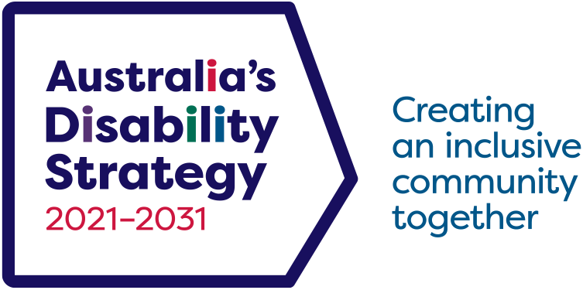

Australia’s Disability Strategy

2024 Review

Consultation Report Summary

Contents

ADS Review Consultation 3

Executive summary 3

Preparing for consultation 3

Taking part 4

What we heard 4

Our draft findings and actions 4

Implementation mechanisms 5

Outcome Areas 6

Taking part in ADS 6

What’s next? 7

# ADS Review Consultation

## Executive summary

We have heard ongoing feedback from the disability community since the launch of *Australia’s Disability Strategy 2021–2031* (ADS) in 2021.

This Report provides an overview of the engagement process undertaken, including targeted engagement with Disability Representative Organisations (DROs) and ADS Advisory Council members, as well as a public engagement period.

The [public engagement for Review of ADS](https://engage.dss.gov.au/ads-review/) offered an opportunity for people with disability, and their supporters, to tell us what they think about ADS and how it could work better.

What we heard has informed our ADS Review findings and actions and will support the development of the framework for the 2025–26 Independent Evaluation of ADS.

## Preparing for consultation

Consultation provided an opportunity to test out our ideas about ADS

We started preparing for consultation by identifying preliminary findings and draft actions. These identified where we could make practical changes to ADS, and included:

* improving how governments work together on ADS
* new ADS Targeted Action Plans
* improving information and communications accessibility
* strengthening ADS data and reporting
* enhancing how people with disability take part in ADS.

We also identified a set of topics related to ADS Outcome Areas that people with disability told us that government should prioritise. We consulted on these topics further to know what is most important to people with disability.

## Taking part

We have a commitment to involve people with disability in matters that affect them

In preparing for public engagement, we met with ADS Advisory Council and DROs in June 2024. We held a series of 4 targeted workshops with ADS Advisory Council members and an additional 5 workshops with DROs.

The public engagement was open from 8 August to 6 September 2024 via the [Department of Social Services Engage](https://engage.dss.gov.au/ads-review/) (DSS Engage) platform.

Public engagement participants could answer a short questionnaire on DSS Engage with a discussion paper to support them making a submission, or people could email, phone or mail us their submission. We received 146 submissions, including 66 from individuals and 80 from organisations.

## What we heard

People told us what they think about ADS and how it could work better

This section outlines what we heard during the engagement period. The most common feedback was around people wanting more opportunities, and different ways, to participate in or engage with ADS. There was also strong support for improving how governments work together on ADS and increasing disability awareness in the broader community. Accessible information and communication, and lifting community awareness of ADS, were also consistently raised across engagement.

### Our draft findings and actions

64% agreed with the draft findings and proposed actions

People told us they wanted to see practical actions attached to the draft findings. They wanted to see an increased focus on accessible information and communications, and more opportunities to participate and engage with ADS. They also highlighted the importance of ADS compliance mechanisms, accountability, and ensuring transparency to the community.

Almost half of all organisations that took part told us that they want to see governments working together better. Organisations also supported improving ADS reporting, increasing accountability and compliance, and governments committing to genuine co-design processes.

ADS Advisory Council members also wanted actions to include practical activities. They supported the development of new TAPs, but also advocated for re-designing the development process for new TAPs and proposed development of new TAPs for Housing and Justice.

DROs supported the development of new TAPs but said TAPs need improved consistency, resourcing, and accountability. DROs also proposed action on data.

In response to the draft findings the 5 most popular topics raised were:

1. Improve coordination across all levels of government.
2. Improve ADS data and reporting.
3. Increase accessible information and communications, including addressing digital accessibility and inclusion.
4. Strengthen compliance mechanisms, accountability, and transparency.
5. Increase opportunities for participation and engagement.

### Implementation mechanisms

Only 23% believed implementation of ADS is effective

ADS implementation mechanisms are the activities that support the delivery of ADS. This includes things like ADS Targeted Action Plans and the Outcomes Framework.

People wanted to see more opportunities to participate and engage with ADS, as well as lifting awareness and visibility of ADS throughout the community. There was strong support for improving how governments work together on ADS, enhancing accountability and streamlining ADS activities.

Organisations said that they want to see improvements in mainstream systems such as healthcare or education, and that ADS implementation mechanisms also need improvement, including in coordination, data, reporting, and communications.

ADS Advisory Council members said that human rights and community attitudes should be included across all ADS implementation mechanisms. They questioned government collaboration on ADS and the role of local government in implementation of the ADS.

Many organisations proposed topics for new TAPs, such as education, housing and addressing violence against women. Similarly, ADS Advisory Council members were broadly in support of new TAPs dedicated to housing and criminal justice.

Both organisations and ADS Advisory Council members supported a re-design of the TAPs based on what was learned from the first TAPs. They want to see a smaller number of TAPS actions that focus on key priorities, as current actions lack cohesion across jurisdictions.

In response to ADS implementation, the 5 most popular topics raised were:

1. Improve coordination across all levels of government.
2. Improve mainstream systems, for example the health or education systems.
3. Increase disability awareness, including disability rights.
4. Reduce barriers to employment.
5. Improve ADS data and reporting.

### Outcome Areas

80% agreed the current 7 Outcome Areas still represent what is most important

Across engagement, there was strong support for improving how governments work together on ADS, improving community attitudes, and increasing disability awareness in the broader community.

People and organisations suggested some service systems were priorities for increasing disability awareness, including education and health. We also heard strong support for a Human Rights Act, as well as disability training in key professions, including teaching and policing.

A consistent theme across engagement was strong support for action on housing and homelessness. Feedback proposed government action on housing affordability and accessibility, as well as including homelessness as an ADS Policy Priority.

We also heard about the need to reduce employment barriers and improve the transition from school to work. ADS Advisory Council members wanted a focus on building employer confidence and creating incentives for the private sector to employ people with disability.

In response to ADS Outcome Areas, the 5 most popular topics raised were:

1. Improve mainstream systems, like the health and education systems.
2. Improve coordination across all levels of government.
3. Reduce barriers to employment.
4. Increase disability awareness, including disability rights.
5. Take action on housing, including homelessness.

### Taking part in ADS

People want more and different ways to participate and engage with ADS

Consistent feedback pointed towards offering participation and engagement opportunities that meet people where they are, and offering a range of opportunities to meet the needs and interests of people with disability.

People said that the current ADS engagements were not frequent enough and they want easier ways to provide feedback or advice on ADS. They also proposed targeting ADS participation and engagement opportunities to specific cohorts of people, such as older people with disability or First Nations people with disability.

Both people and organisations raised the need for genuine co-design as a meaningful process and genuine intent to work together. Organisations advocated for an ADS commitment to co-design throughout engagement activities for the review.

There was consistent feedback advocating for accessible communications across government, and not restricted to ‘disability-specific’ areas. ADS Advisory Council members supported development of an ADS Community Engagement Plan, acknowledging more needs to be done to engage and involve people with disability in ADS.

In response to how people with disability could be more involved in ADS, the 5 most popular responses were:

1. Increase opportunities for participation and engagement.
2. Increase accessible information and communications, including addressing digital accessibility and inclusion.
3. Improve coordination across all levels of government.
4. Improve ADS data and reporting.
5. Improve mainstream systems, for example the health or education systems.

## What’s next?

What we heard has informed our ADS Review findings and actions

We have analysed what we heard during the engagement activities for ADS, along with evidence from the Review’s research and literature review. The consolidated summary of this work is found in the Report on the 2024 Review of ADS.

This engagement process has provided critical feedback to inform how we work under ADS, how we engage with the community and seek to understand perspectives and experiences. What we heard will inform our ADS Review findings and actions and support the development of the framework for the 2025–26 Independent Evaluation of ADS, and inform a refreshed ADS for publication in December 2024.

The full ADS Review Report and Consultation Report are available online, in multiple accessible formats. For further information, go to [ADS Hub on Disability Gateway](https://www.disabilitygateway.gov.au/ads).

DSS3523.11.24