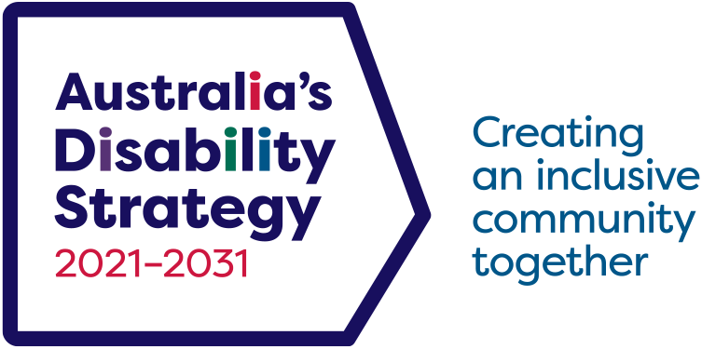 A man holding a rugby ball and wearing a blue t-shirt  is together with three of his friends. They put their hands together in a huddle on a grassy field.

Australia’s Disability Strategy 2021–2031

2024: Building a more inclusive Australia

## What is changing in Australia’s Disability Strategy 2021–2031?

[*Australia’s Disability Strategy 2021–2031* (the Strategy)](https://www.disabilitygateway.gov.au/document/3101) is a national framework that all governments in Australia have signed up to. It sets out a plan for continuing to improve the lives of people with disability in Australia.

To achieve an inclusive Australian community, we need to make sure the Strategy is working as planned. In 2024, we reviewed the Strategy and talked to the disability community about what we could do better.

We heard we need to improve how governments work together on the Strategy, we need more accessible information and communication, and people with disability want more opportunities to participate in and engage with the Strategy.

We have used what we have heard to refresh the Strategy. We have updated the Strategy’s documents and made new commitments to take action. These changes reflect where we are now, and what is important to people with disability.

## Connecting

People with disability are at the heart of the Strategy.

* We’ve heard that people want more diverse ways to participate and engage with the Strategy.
* In 2025, a new Community Engagement Plan will be developed in partnership with people with disability to encourage broader participation.
* There is a need to increase awareness of the Strategy, the refreshed Strategy includes an action to enhance community recognition of the Strategy.
* The ADS Advisory Council has created a video explaining the Strategy, its updates, and their implications for the community.
* The Strategy’s supporting documents have been refreshed to reflect the changes.



## Taking action

We are committed to improving the lives of people with disability. In the Review, people told us about the need for enhanced collaboration and improved coordination among governments on implementing the Strategy.

As a result, governments have committed to:

* Implementing three new targeted action plans over the next three years.
* The new targeted action plans will focus on:
  + Building more inclusive homes and communities.
  + Improving safety, rights, and justice.
  + Changing community attitudes.
* Developing a new Associated Plan for increasing accessible information and communication.
* We recognise there needs to be improved access to secure housing that meets the needs of people with disability and action to reduce homelessness.
* The refreshed Strategy now includes a new Policy Priority focused on addressing homelessness in the outcome area of Inclusive Homes and Communities.

## Impact

We are responsible for our actions and their impact.

* In the refreshed Strategy, we have committed to improving the Strategy’s data and reporting. We will continue to publish reports each year measuring our progress and acknowledge where we need to put in more work.
* In the review, we heard the Strategy’s reporting should support better government accountability and recognise the different intersectional experiences of people with disability in everything that we do.

## What is next?

The updates to the Strategy have focused on practical changes we can make now. In late 2025, the Strategy will start its first Independent Evaluation. The evaluation will focus on progress made against Policy Priorities and Vision and include in-depth engagement with the disability community by an independent evaluator. This will give people with disability opportunities to take part in the development and implementation of future reforms.

Visit [Disability Gateway news](https://www.disabilitygateway.gov.au/news) to keep up to date with latest news about the Strategy, including opportunities to take part in the evaluation.

## Where can I find more information?

You can read Australia’s Disability Strategy 2021 – 2031 and find more information at [www.disabilitygateway.gov.au/ads](http://www.disabilitygateway.gov.au/ads).

The Strategy and its supporting documents are available in Easy Read, Auslan and language translations.

For questions about the Strategy, please email [australia’sdisabilitystrategy@dss.gov.au](mailto:australia%E2%80%99sdisabilitystrategy%40dss.gov.au?subject=)

DSS3532.11.24