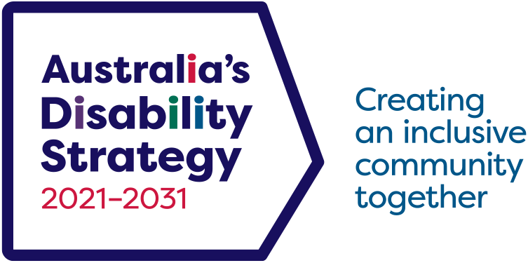

Summary of Australia’s Disability Strategy 2021 – 2031

2024 update:   
Building a more inclusive Australia



This document, Summary of Australia’s Disability Strategy 2021–2031, is licensed under the [Creative Commons Attribution 4.0 International License](https://creativecommons.org/licenses/by/4.0/), with the exception of:

The Australia’s Disability Strategy 2021–2031 logo and branding

Any third-party material

All images and/or photographs.

More information on this CC By license is set out at the Creative Commons website:   
<https://creativecommons.org/licenses/by/4.0/legalcode>

Attribution

Use of all or part of this document must include the following attribution:

© Commonwealth of Australia ([Department of Social Services](https://www.dss.gov.au/)) 2024

Enquiries about copyright arrangements and any use of this information can be sent to the Department of Social Services:

By email:   
[copyright@dss.gov.au](mailto:copyright%40dss.gov.au?subject=)

By post:  
Communications and Media  
Department of Social Services  
GPO Box 9820  
Canberra ACT 2601

DSS2672_Dec2024

Contents

Foreword 4

Australia’s Disability Strategy 2021–2031 5

Vision and Purpose 6

Vision 6

Outcome Areas 7

Employment and Financial Security 7

Inclusive Homes and Communities 8

Safety, Rights and Justice 9

Personal and Community Support 10

Education and Learning 11

Health and Wellbeing 12

Community Attitudes 13

Implementation — Delivering on the Outcome Areas 15

Intersectionality and Diversity 15

Roles and Responsibilities 16

Guiding Principles 17

Targeted Action Plans 18

Associated Plans 19

Outcomes Framework 19

Improving the Data 20

Reporting under the Strategy 20

Evaluating what we do 21

Building the Evidence Base 21

The Governance Model 21

Engaging People with Disability 21

The Strategy’s Roadmap 22

The Strategy’s Website 22

Review of the Strategy 22

Disability Reform Environment 2024 22

Development of the Strategy 23

Role of the Australian Human Rights Commission and Advocacy 23

# Foreword

A message from Jane Spring, Chair of Australia’s Disability Strategy Advisory Council



Australia’s Disability Strategy Advisory Council continues to work with all governments, providing independent advice to guide the implementation of Australia’s Disability Strategy so that it drives tangible improvements in the lives of people with disability.

This year has marked a number of milestones in our collective journey toward an inclusive, accessible and equitable society for the 5.5 million Australians with disability.

Australia’s Disability Strategy has evaluated the first set of Targeted Action Plans, that concluded in June 2024, continued to update quarterly the Outcomes Framework reporting, released the Good Practice Guidelines for Engaging with People with Disability, the Guide to Applying the Australia’s Disability Strategy, and the new Data Improvement Plan, and progressed the design and build of the National Disability Data Asset.

In refreshing Australia’s Disability Strategy, governments engaged with the Advisory Council, representative organisations and the disability community, to identify practical ways the Strategy could be improved as governments work to implement reform and change to the policies, programs and services that most impact people with disability. Governments also considered the findings and recommendations from the Final Report of the Royal Commission into Violence, Abuse, Neglect, and Exploitation of People with Disability.

We are excited that collectively we are continuing to lift the profile of Australia’s Disability Strategy and are pleased to see governments taking a more nationally coordinated approach to the next set of Targeted Action Plans that will focus on Inclusive Homes and Communities, Safety, Rights and Justice and Community Attitudes.

It was an honour to travel as part of the Australian delegation to the United Nations Conference of States Parties to the Convention on the Rights of Persons with Disabilities, in New York showcasing to the world the steps being taken in Australia to become a more inclusive and accessible nation.

As the Chair of Australia’s Disability Strategy Advisory Council, I am proud of the work we are continuing to do to ensure the Strategy is brought to life, resulting in our rights being upheld, and our access to services and the community improved so we can participate on an equal basis. The outcomes under Australia’s Disability Strategy will only be realised if governments continue to focus on breaking down the structural barriers that hold people back, working with people with disability in all matters that affect them.

Together we can shape a more inclusive future – one where every Australian regardless of ability, is valued, supported and given the opportunity to achieve their full potential.

**Jane Spring AM**  
Chair  
Australia’s Disability Strategy Advisory Council

## Australia’s Disability Strategy 2021–2031

Australia’s Disability Strategy 2021–2031 calls on all Australians to ensure people with disability can participate as equal members of society.

This Strategy reflects a collective commitment by all levels of government, Australian, state, territory and local to build an Australia where people with disability are valued, included and empowered to thrive.

It represents a vision for a more inclusive and accessible Australia, where barriers are removed, opportunities are expanded, and the rights of people with disability are upheld.

Throughout the development of the Strategy the voices of people with disability, their families, friends, carers, disability representative organisations and disability service providers have been central and will continue to inform and build the evidence base for informed decision making.

Outcome Areas, policy priorities and targeted actions in the Strategy provide a roadmap to address the systemic and structural barriers faced by people with disability.

By working together with people with disability and across all sectors – governments, businesses and communities – we can create a nation that celebrates diversity and promotes inclusion and accessibility that will enable a future where everyone can participate fully in all aspects of life.



# Vision and Purpose

Australia’s Disability Strategy 2021–2031 (the Strategy) is Australia’s national disability policy framework. It sets out a plan for continuing to improve the lives of people with disability in Australia over the next ten years.

## Vision

The Strategy’s vision is for an inclusive Australian society that ensures people with disability can fulfil their potential, as equal members of the community.

In line with Australia’s commitments under the United Nations Convention on the Rights of Persons with Disabilities (UN CRPD), this Strategy will play an important role in protecting, promoting and realising the human rights of people with disability.

Purpose

The purpose of the Strategy is to:

* provide national leadership towards greater inclusion of people with disability
* guide activity across all areas of public policy to be inclusive and responsive to people with disability
* drive mainstream services and systems to improve outcomes for people with disability
* engage, inform and involve the whole community in achieving a more inclusive society.

# Outcome Areas

The Outcome Areas in the Strategy set out where governments at all levels, working with the community and business, will focus on driving improvements for people with disability.

Employment and Financial Security

Outcome: People with disability have economic security, enabling them to plan for the future and exercise choice and control over their lives



Employment and financial security are central to improving outcomes for people with disability. This includes providing jobs and career opportunities, and having adequate income for people to meet their needs.

Policy Priorities

1. Increase employment of people with disability.
2. Improve the transition of young people with disability from education to employment.
3. Strengthen financial independence of people with disability.

Inclusive Homes and Communities

Outcome: People with disability live in inclusive, accessible and well-designed homes and communities



Having appropriate housing and a community that is accessible and inclusive is central to how people with disability live, work and socialise.

Policy Priorities

1. Increase the availability of affordable housing.
2. Housing is accessible and people with disability have a choice and control about where they live, who they live with, and who comes into their home.
3. People with disability are able to fully participate in social, recreational, sporting, religious and cultural life.
4. The built and natural environment is accessible.
5. Transport systems are accessible for the whole community.
6. Information and communication systems are accessible, reliable and responsive.
7. People with disability have access to services and supports to prevent and reduce homelessness

Safety, Rights and Justice

Outcome: The rights of people with disability are promoted, upheld and protected, and people with disability feel safe and enjoy equality before the law



People with disability have the same rights as people without disability. Community acceptance of these rights is essential to maximising economic participation, social inclusion, safety and equality. Australia’s Disability Discrimination Act 1992 (DDA) makes discrimination on the basis of disability unlawful. Despite this, people with disability continue to experience discrimination in their daily lives.

Policy Priorities

1. People with disability are safe and feel safe from violence, abuse, neglect and exploitation.
2. Policies, processes and programs provide better responses to people with disability who have experienced trauma.
3. Policies, processes and programs for people with disability promote gender equality and prevent violence against groups at heightened risk, including women and their children.
4. The rights of people with disability are promoted, upheld and protected.
5. People with disability have equal access to justice.
6. The criminal justice system responds effectively to the complex needs and vulnerabilities of people with disability.

Personal and Community Support

Outcome: People with disability have access to a range of supports to assist them to live independently and engage in their communities



Personal and community supports including both specialist disability supports and mainstream services available to the general public, are fundamental to improving overall outcomes for people with disability.

Policy Priorities

1. People with disability are able to access supports that meet their needs.
2. The National Disability Insurance Scheme provides eligible people with permanent and significant disability with access to reasonable and necessary disability supports.
3. The role of informal support is acknowledged and supported.
4. People with disability are supported to access assistive technology.

Education and Learning

Outcome: People with disability achieve their full potential through education and learning

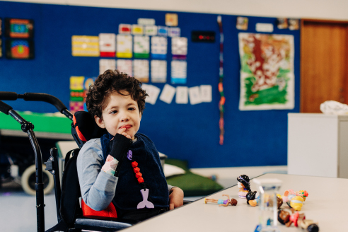

Access to formal and informal education provides pathways to employment, financial independence, and enriched lives. Greater support to prepare children with disability for school, and young people to work or further education, is required to improve attainment of secondary and tertiary qualifications.

Policy Priorities

1. Children with disability can access and participate in high-quality early childhood education and care.
2. Build capability in the delivery of inclusive education to improve educational outcomes   
   for school students with disability.
3. Improve pathways and accessibility to further education and training for people with disability.
4. People with disability have increased opportunities to participate in accessible   
   and inclusive lifelong learning.

Health and Wellbeing

Outcome: People with disability attain the highest possible health and wellbeing outcomes throughout their lives

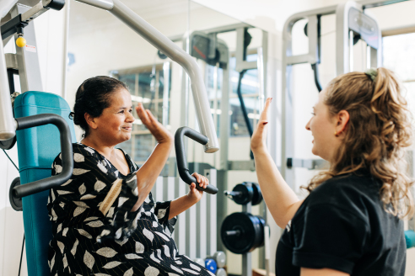

Good health and wellbeing, including mental health, are critical determinants of a person’s quality of life. This is especially the case for people with disability. Greater support is needed to lift the health and wellbeing of people with disability including before, during and after disasters and public emergencies.

Policy Priorities

1. All health service providers have the capabilities to meet the needs of people with disability.
2. Prevention and early intervention health services are timely, comprehensive, appropriate and effective to support better overall health and wellbeing.
3. Mental health supports and services are appropriate, effective and accessible for people with disability.
4. Disaster preparedness, risk management plans and public emergency responses are inclusive of people with disability, and support their physical and mental health, and wellbeing.

Community Attitudes

Outcome: Community attitudes support equality, inclusion and participation in society for people with disability

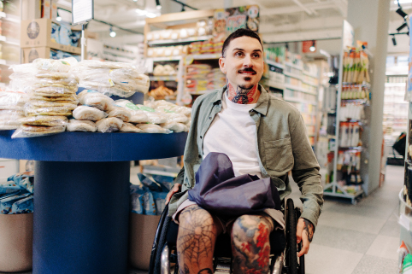

Building positive community attitudes towards people with disability is central to achieving an inclusive society and improving all outcomes for people with disability. Addressing stigma, unconscious bias and lack of understanding of disability will contribute to positive daily experiences and recognition of the contribution that people with disability can make to society.

Policy Priorities

1. Employers value the contribution people with disability make to the workforce, and recognise the benefits of employing people with disability.
2. Key professional workforces are able to confidently and positively respond to people with disability.
3. Increase representation of people with disability in leadership roles.
4. Improved community attitudes to positively impact on Policy Priorities under the Strategy.



# Implementation — Delivering on the Outcome Areas

Governments are committed to working together alongside people with disability, communities, businesses and the non‑government sector, to implement this Strategy and realise its vision, in a coordinated and targeted way to deliver real change. This includes ensuring that over the life of the Strategy, its design and implementation is responsive to changing needs.

## Intersectionality and Diversity

Intersectionality recognises that a person or group of people have different experiences and can be affected by multiple forms of marginalisation, racism, discrimination and disadvantage due to their race, sex, gender identity, sexual orientation, impairment, class, religion, culture and linguistic diversity, age, social origin and other identity markers.

Throughout the life of the Strategy, action taken to deliver on Policy Priorities will be implemented with an intersectional and diversity lens. This will ensure intersectional discrimination is proactively addressed and marginal groups are able to access tailored resources, services and supports.

## Roles and Responsibilities

Australian, state, territory and local governments, along with businesses, the community and non‑government sector, all play a role in inclusion and support of people with disability.

All levels of government continue to play a role in providing mainstream and targeted services, supports and infrastructure systems to people with disability. Listing key government roles and responsibilities helps everyone to understand which level of government is responsible for the systems that may be used by people with disability.

In many cases, more than one level of government has some responsibility for a support or service system. However, in most cases one level of government has primary responsibility for delivery of a system. The table below gives some examples:

|  |  |  |  |
| --- | --- | --- | --- |
| Australian Government | State and territory governments | Local governments | Responsibility is shared |
| * NDIS* (administration) * Income support payments * Employment services | * Public hospitals * Public, social and community housing * Public primary and secondary schools | * Accessible buildings * Municipal services * Local parks and recreational facilities | * NDIS* (funding and shared governance) * Mental health supports * Disability advocacy services * Community infrastructure |

An outline of key government roles and responsibilities is available on the Strategy’s website. People who do not have access to the internet can contact the National Disability Information Gateway telephone helpline on 1800 643 787.

* The NDIS (National Disability Insurance Scheme) is a nationally based scheme jointly governed and funded by the Australian, state and territory governments. Delivery of the NDIS is the responsibility of the National Disability Insurance Agency, a Commonwealth Corporate Entity.

## Guiding Principles

To achieve the Strategy’s vision, governments are committed to the development and implementation of policies, programs, services and systems which reflect the human rights principles of the UN CRPD.

Therefore, the following Guiding Principles are based on Article 3 of the UN CRPD. Governments have agreed to use these Guiding Principles when developing policies, programs, services and systems. It is vital that business, the non-government sector and the broader community also consider how they can apply these principles.

**Principle One** Respect for inherent dignity, individual autonomy including the freedom to make one’s own choices, and independence of persons

**Principle Two** Non-discrimination

**Principle Three** Full and effective participation and inclusion in society

**Principle Four** Respect for difference and acceptance of persons with disabilities as part of human diversity and humanity

**Principle Five** Equality of opportunity

**Principle Six** Accessibility

**Principle Seven** Equality of people

**Principle Eight** Respect for the evolving capacities of children with disabilities and respect for the right of children with disabilities to preserve their identities

## Targeted Action Plans

Targeted Action Plans apply an intensive focus over one to three years to achieve specific deliverables that improve outcomes for people with disability.

The initial five Targeted Action Plans launched with the Strategy focused on improving employment, community attitudes, early childhood, safety, and emergency management.

Working in conjunction with states and territory governments, the Australian Government Department of Social Services undertook an extensive review of the Royal Commission findings, existing advice, and feedback from people with disability, their representative organisations, and the Australia’s Disability Strategy Advisory Council over the life of the Strategy, to inform the new Targeted Action Plans.

There are three Targeted Action Plans for 2025–2027:

* Community Attitudes,
* Inclusive Homes and Communities, and
* Safety, Rights and Justice.

Each one is intended to focus governments on a specific area of the Strategy’s implementation, with clear actions and timeframes, and represent actions that are in line with what was heard from people with disability.



## Associated Plans

Associated Plans provide a more coordinated, long term approach to how governments work to improve outcomes for people with disability. All Associated Plans will clearly identify how they contribute to achieving the outcomes of the Strategy and will be published on the Strategy’s website.

Associated Plans are focused on improving aspects of Australian life (e.g. the arts sector) or for a specific segment of the community (e.g. people with intellectual disability), and generally run for three to ten years.

Associated Plans will include the Strategy brand set out below.

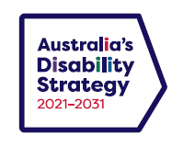

Business and community organisations that want to show their commitment to the Strategy can use the logos below.

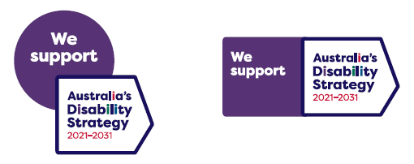

## Outcomes Framework

Australia’s Disability Strategy [Outcomes Framework](https://www.aihw.gov.au/australias-disability-strategy) aims to track, measure and report on outcomes for people with disability. This includes measuring the contribution key systems such as healthcare, housing, education and employment are making to achieve outcomes. It also tracks the changes in outcomes happening over time for people with disability.

The Outcomes Framework includes quarterly data updates and annual report that shows what progress is made against each Outcome Area of the Strategy. Where data is available, information is disaggregated to provide detail on what progress is being made for specific cohorts of people with disability.

The Outcomes Framework is available on the [Strategy’s website](https://www.disabilitygateway.gov.au/ads).

## Improving the Data

Governments are committed to working together and sharing data to support evidence-based change. Improving data will support the Outcomes Framework, evaluations and policy development.

Governments have worked together to develop and update [Australia’s Disability Strategy Data Improvement Plans (DIP).](https://www.disabilitygateway.gov.au/document/8176) This ensures data needed to measure outcomes for people with disability is collected, shared and progressively improved over the life of the Strategy.

The [National Disability Data Asset (NDDA)](https://www.ndda.gov.au/) is being developed to improve insights and outcomes for people with disability. It will bring together a range of Commonwealth and state and territory datasets from disability, health, social security, education, employment, housing, transport and justice to better understand the experiences of people with disability and the programs and services they use. This will help improve outcomes for people with disability and better support people with disability, their families, and carers. The first release of data will be in December 2024.

## Reporting under the Strategy

All governments are committed to deliver comprehensive and visible reporting to improve accountability under the Strategy.

Reporting under the Strategy will complement the reporting under state and territory government and local government disability plans.

The following reports will be produced:

* **Targeted Action Plans Report** – This annual report will cover implementation progress, successes, and overall status. It will be coordinated by the Australian Government.
* **Outcomes Framework** – This annual update will feature high-level data against   
  the outcomes of the Strategy. It will be prepared by a third party data specialist.
* **Implementation Report** – This report produced every two years will include progress against disability initiatives at all levels of government. It will include consultations with people with disability, the Australian Human Rights Commission, and the broader community.
* **Australia’s Disability Strategy Review Report** – The Australian Government committed to review Australia’s Disability Strategy 2021–2031 by the end of 2024. The Review considered existing advice and feedback from people with disability and their representative organisations, in addition to targeted and public consultation activities.
* **Evaluation reports** – The two Major Evaluation Reports will be produced in 2025 and 2029. The reports will be informed by an independent review into how well the Strategy is delivering improvements for people with disability. People with disability, the Australian Human Rights Commission, and key stakeholders will be consulted when preparing the report before it is provided to governments for endorsement.

## Evaluating what we do

Policy, program and system evaluations are critical to understanding what is working well or needs improvement for people with disability. Evaluations will be able to show how policies, services and programs have contributed to the outcomes under the Strategy.

Governments will publicly list planned evaluations, publish evaluation findings, and refer to the Strategy’s [Evaluation Good Practice Guide Checklist](https://www.disabilitygateway.gov.au/document/3131) when running evaluations.

Governments are working together with people with disability to develop a guide on how to involve people with disability in evaluation. This is expected to be completed in 2025 and will be published on the Strategy’s website.

## Building the Evidence Base

Building the evidence base is a key part of the Strategy. The Strategy will support disability research and the translation of findings into actions that support the Strategy outcomes.

The [National Disability Research Partnership (the Partnership)](https://www.ndrp.org.au/) will be instrumental in building the evidence base. The Partnership promotes the use of evidence-informed policy and practice. The Partnership focuses on disability and mainstream services including education, health, housing and justice, and facilitates research.

## The Governance Model

The [Governance Model](https://www.disabilitygateway.gov.au/ads/governance-model) helps governments work together in a coordinated way to achieve the goals of the Strategy. This includes identifying and prioritising where actions should occur and it guides how governments will report on what progress has been made to improve the lives of people with disability. The Governance Model is available on the Strategy’s website.

## Engaging People with Disability

People with disability will play a central and active role in the Strategy over its life.

The Strategy’s [Engagement Plan](https://www.disabilitygateway.gov.au/document/3126) is published on the Strategy’s website. It outlines the ways people with disability will be engaged over the life of the Strategy to inform its implementation, monitoring, reporting, and the future direction of policy.

The development of [Good Practice Guidelines for the Engagement of People with Disability](https://www.disabilitygateway.gov.au/good-practice-guidelines) facilitates improvements in the engagement and inclusion of people with disability in community consultation, policy development and government decision-making.

## The Strategy’s Roadmap

A simple overview of the key deliverables being produced under the Strategy is published in the Strategy’s [Roadmap](https://www.disabilitygateway.gov.au/document/3116) on the Strategy’s website. It shows when reports are due, and when consultations and other major activities will occur.

## The Strategy’s Website

All Strategy documents are available on the dedicated Strategy website, including the latest reports and announcements. The Strategy’s website is at [www.disabilitygateway.gov.au/ads](http://www.disabilitygateway.gov.au/ads).

## Review of the Strategy

The Review of [Australia’s Disability Strategy 2021–2031](https://www.disabilitygateway.gov.au/document/3106) has focused on identifying practical, process improvements that can be made to the Strategy’s implementation mechanisms. The Australian Government has heard what the disability community have said and used this feedback to guide the actions of the Review.

As endorsed by Disability Reform Ministers Council on 1 November 2024, the Strategy Review Report, and summary version, are available on Australia’s Disability Strategy [Hub on Disability Gateway](https://www.disabilitygateway.gov.au/ads).

## Disability Reform Environment 2024

The Royal Commission into Violence, Abuse, Neglect and Exploitation of People with Disability (Royal Commission) was Australia’s largest inquiry into the experiences of people with disability.

The Royal Commission released its [final report](https://disability.royalcommission.gov.au/publications/final-report), which enabled us as a nation to better understand what needs to change to end the unacceptable treatment of people with disability in Australia. The [Australian Government and all States and Territories (except Northern Territory due to being in caretaker) formally responded to the final report.](https://www.dss.gov.au/disability-and-carers-australian-government-response-to-the-disability-royal-commission/joint-government-response)

An Independent Review of the National Disability Insurance Scheme (NDIS Review) began in October 2022 and release its final report on 7 December 2023.

All Governments are committed to achieving lasting change through disability reform. Further information about national disability reform is available on the [Department of Social Services website.](http://www.dss.gov.au/disability-policy-reforms)

## Development of the Strategy

The voices of people with disability, their families, friends, carers, advocacy organisations, peak bodies and service providers were central to developing the Strategy.

Consultations on the Strategy were designed and delivered with people with disability. The consultations were offered in a range of different ways for people with disability to participate. The consultations also had a focus on engaging directly with people who do not typically participate in high numbers in public consultation processes.

## Role of the Australian Human Rights Commission and Advocacy

The Australian Human Rights Commission plays an important role in promoting and protecting the rights of people with disability. Disability advocacy also supports people with disability to safeguard their rights, experience equality and overcome barriers that can affect their ability to participate in the community.

The Australian Government funds the [National Disability Advocacy Program (NDAP)](https://www.dss.gov.au/our-responsibilities/disability-and-carers/program-services/for-people-with-disability/national-disability-advocacy-program-ndap) to provide people with disability access to effective advocacy support. This support works to promote and protect the rights of people with disability by helping to remove barriers to their full and equal participation in the community.

The [National Disability Advocacy Framework 2023–2025 (NDAF)](https://www.dss.gov.au/disability-and-carers-programs-services-for-people-with-disability/national-disability-advocacy-framework-2023-2025), and associated Disability Advocacy Work Plan (Work Plan), commits governments to work together to improve national consistency and access to advocacy services for people with disability across Australia.

