Roadmap – Australia’s Disability Strategy 2021–2031

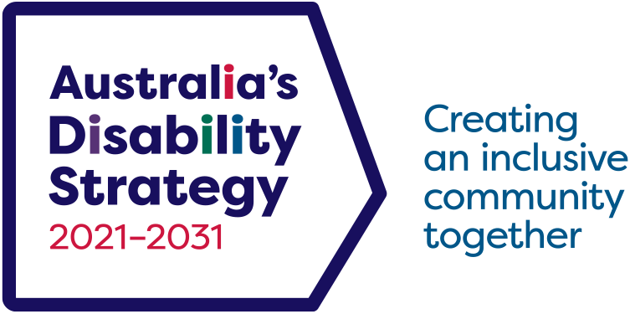

## Working together

**Everyone has a role to play. We will work across governments and communities towards our shared vision.**

## Taking action

**We will have an action-orientated approach to achieving clear goals. We will guide action and reform across Australia.**

## Connecting

**We will listen to people with disability, their families and supporters, and respect what they have to say.**

## Accountability

**We are responsible for our actions. We will regularly report on progress, and recognise where more work is needed.**

## Vision

**An inclusive Australian society that ensures people with disability can fulfil their potential, as equal members of the community.**

# Strategy milestones

Symbol key: Green Circle identifies this item is completed Complete Orange Asterisk identifies this item is in progress In progress

## 2021

* Green Circle identifies this item is completed [Launch of the Strategy](https://www.disabilitygateway.gov.au/ads)
* Green Circle identifies this item is completed [1st Targeted Action Plans](https://www.disabilitygateway.gov.au/ads/key-actions-strategy) started
* Green Circle identifies this item is completed [2021 Review of Disability (Access to Premises – Building) Standards](https://www.industry.gov.au/publications/premises-standards-review-2021)
* Green Circle identifies this item is completed [Establishment of the Strategy’s Advisory Council](https://www.disabilitygateway.gov.au/ads/advisory-council)
* Green Circle identifies this item is completed [Employ My Ability](https://www.dss.gov.au/disability-employment-strategy) started
* Green Circle identifies this item is completed [National Roadmap for Improving the Health of People with Intellectual Disability](https://www.health.gov.au/our-work/national-roadmap-for-improving-the-health-of-people-with-intellectual-disability) started

## 2022

* Green Circle identifies this item is completed [1st Strategy National Public Forum, Canberra ACT](https://www.disabilitygateway.gov.au/document/7481)
* Green Circle identifies this item is completed [Survey of Disability, Ageing and Carers undertaken](https://www.abs.gov.au/statistics/health/disability/disability-ageing-and-carers-australia-summary-findings/latest-release)
* Green Circle identifies this item is completed [Data Improvement Plan](https://www.disabilitygateway.gov.au/document/8176) launch
* Green Circle identifies this item is completed [2022 Review of the Disability Standards for Accessible Public Transport](https://www.infrastructure.gov.au/department/media/publications/summary-report-public-consultations-2022-review-disability-standards-accessible-public-transport)

## 2023

* Green Circle identifies this item is completed [1st Implementation Report](https://www.disabilitygateway.gov.au/document/10146)
* Green Circle identifies this item is completed [1st State and Territory Forum, Brisbane QLD](https://www.disabilitygateway.gov.au/ads-queensland-forum)
* Green Circle identifies this item is completed [National Disability Advocacy Framework start](https://www.dss.gov.au/national-disability-advocacy-framework)
* Green Circle identifies this item is completed [Review](https://www.disabilitygateway.gov.au/document/11126) Strategy following final report from [Royal Commission into Violence, Abuse, Neglect and Exploitation of People with Disability](https://disability.royalcommission.gov.au/publications/final-report)

## 2024

* Green Circle identifies this item is completed 1st Targeted Action Plans end
* Green Circle identifies this item is completed [Public Consultation on the Strategy](https://engage.dss.gov.au/ads-review/)
* Green Circle identifies this item is completed 2nd State and Territory Forum, Hobart TAS
* Green Circle identifies this item is completed [Equity: the Arts and Disability Associated Plan](https://www.arts.gov.au/what-we-do/arts-and-disability) started
* Green Circle identifies this item is completed [The Guide to Applying Australia’s Disability Strategy](https://www.disabilitygateway.gov.au/document/11446)released
* First release of [National Disability Data Asset data](https://www.ndda.gov.au/)



## 2025

* First phase of National Disability Data Asset complete
* 1st Major Independent Evaluation
* Orange Asterisk identifies this item is in progress 2nd Targeted Action Plans start
* 2nd Implementation Report
* 2nd Strategy National Public Forum
* 2025 Review of the Disability Standards for Education
* Orange Asterisk identifies this item is in progress Strategy Community Engagement Plan start
* Orange Asterisk identifies this item is in progress Associated Plan - Communication starts

## 2026

* 1st Major Independent Evaluation Report
* 3rd State and Territory Forum
* 2026 Review of the Disability (Access to Premises – Building) Standards

## 2027

* 2nd Targeted Action Plans end
* 3rd Implementation Report
* 2027 Review of the Disability Standards for Accessible Public Transport
* 4th State and Territory Forum

## 2028

* 3rd Targeted Action Plans start
* 3rd Strategy National Public Forum
* Survey of Disability, Ageing and Carers undertaken

## 2029

* 2nd Major Independent Evaluation
* 5th State and Territory Forum
* 4th Implementation Report

## 2030

* 2nd Major Independent Evaluation Report
* 2030 Review of the Disability Standards for Education
* Public Consultation to support development of the new Disability Strategy
* 4th Strategy National Public Forum

## 2031

* 6th State and Territory Forum
* Launch of new Disability Strategy

# Outcome Areas

**Employment and Financial Security**

**Inclusive Homes and Communities**

**Safety, Rights and Justice**

**Personal and Community Support**

**Education and Learning**

**Health and Wellbeing**

**Community Attitudes**

# Connecting

People with disability are at the heart of the Strategy. You can take part in the Strategy through:

* [Australia’s Disability Strategy Advisory Council](https://www.disabilitygateway.gov.au/ads/advisory-council)
  + The Advisory Council provides advice on how to improve Strategy implementation
* [National Public Forums](https://www.disabilitygateway.gov.au/ads/public-forums-consult)
* [State and Territory Forums](https://www.disabilitygateway.gov.au/ads/public-forums-consult)
* Public consultation to support reviews and new work of the Strategy
* [Australia’s Disability Strategy Engagement Plan](https://www.disabilitygateway.gov.au/document/3126)
  + 2025: Community Engagement Plan will set out more and different ways to take part in the Strategy
* [Good Practice Guidelines for Engaging with People with Disability](https://www.disabilitygateway.gov.au/good-practice-guidelines)

# Taking action

We are committed to improving the lives of people with disability through our actions:

* [Targeted Action Plans](https://www.disabilitygateway.gov.au/ads/key-actions-strategy), focusing on priority areas for change:
  + 2021–24: Community attitudes, employment, early childhood, safety, and emergency management
  + 2025–27: Inclusive homes and communities, community attitudes, and safety, rights and justice
* [The Guide to Applying Australia’s Disability Strategy](https://www.disabilitygateway.gov.au/document/11446) to support policy development and program design across government
* State and Territory disability plans align with the visions and goals of Australia’s Disability Strategy
* Collaboration across governments to implement the Strategy

# Impact

We are responsible for our actions and their impact. We are held accountable by Australia’s Disability Strategy:

* [Outcomes Framework](https://www.aihw.gov.au/australias-disability-strategy)
  + Quarterly updates to the data
  + Outcomes Framework dashboard
  + Outcomes Framework annual report
* [Reporting](https://www.disabilitygateway.gov.au/ads/reporting-ads)
  + Annual Targeted Action Plan Reports
  + Two-yearly Implementation Reports
* [Data Improvement Plan](https://www.disabilitygateway.gov.au/document/10981)
* Independent Evaluations in 2025–26 and 2029–30

<https://www.disabilitygateway.gov.au/ads> Email: [Australia’sDisabilityStrategy@dss.gov.au](mailto:Australia%27sDisabilityStrategy%40dss.gov.au?subject=)

DSS3540_Dec2024