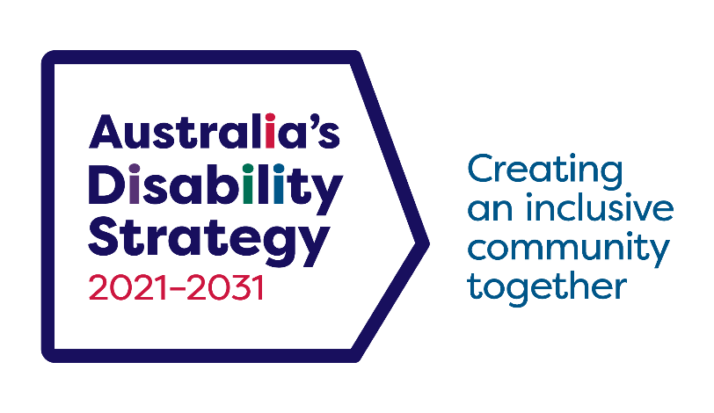

Australia’s Disability Strategy

2024 Building a more inclusive Australia



|  |  |
| --- | --- |
| Australian Government logo with Department of Social Services underneath | The Australian Government Department of Social Services wrote this.  We say **DSS** for short.  When you see the word **we** it means the DSS. |
| A person holding a white book with easy read on the cover | We wrote this in an easy to read way.  We use pictures to explain some ideas. |
| The word bold is in bold and the words not bold are in plain text | We have some words in **bold**.  This means the letters are thicker and darker.  These are important words. |
| An easy read document with pictures and lines for text. | This is an Easy Read summary of another document.  This means it has the most important ideas. |
| red envelope icon | We can answer any questions by email.  Email us  [Australia’sDisabilityStrategy@dss.gov.au](mailto:Australia’sDisabilityStrategy@dss.gov.au?subject=Australia’s%20Disability%20Strategy%20Query) |
| Two people with their arms around each other with thumbs up. | You can ask for help to read this document.  You can ask   * A friend * Family members * A support person. |
| cartoon of Aboriginal and Torres Strait Islander people with the Aboriginal and Torres Strait Islander flags in the background | We recognise Aboriginal and Torres Strait Islander people as the **Traditional Owners** of the land we live on. |
| red map of Australia icon | They were the **first people** to live on and use the   * Land * Waters. |

Contents

|  |  |
| --- | --- |
| Australia’s Disability Strategy | 6 |
| Updating ADS | 8 |
| Connecting | 9 |
| Taking action | 11 |
| Impact | 14 |
| What is next | 16 |
| Contact us | 17 |

Australia’s Disability Strategy

|  |  |
| --- | --- |
| Australia's Disability Strategy 2021-2031, Creating an inclusive community together logo. | The government set up Australia’s Disability Strategy.  We call it ADS for short. |
| group of poeple talking together with speech bubbles above their heads | ADS is the governments way of working together to support people with disability live good lives.  They do this by working with   * People with disability * The community.   This makes the community a more welcoming place for everyone. |
| a person looking through a magnifying glass | We did a **review** of ADS in 2024.  A review is when you check   * What is working * What needs to change. |
| a white folder with plan a next to a white folder with plan b and an arrow pointing from a to b. | This helps us   * **Change** our plans * Make **new plans**. |
| a group of people posing for a photo | We talked to the disability community.  They told us what we could do better.  This is very important. |
| An easy read document with pictures and lines for text. | We wrote a report about what we heard.  There is an Easy Read summary of report. |
| a red icon of a computer mouse clicking | It is on our website.  [www.disabilitygateway.gov.au/ads](http://www.disabilitygateway.gov.au/ads) |

Updating ADS

|  |  |
| --- | --- |
| Simplified network diagram with a central circle connected to four smaller circles. the central circle has ADS. The smaller circles have a picture of a community, scales, a group hugging and easy read document | We updated ADS documents.  We put in new ideas from what we heard. |
| Elderly woman and man with Down syndrome talking with speech bubbles above their heads. | The new ideas say   * How people can take part in ADS * New ADS **actions**   Actions are the things that we will do.   * How we report about ADS.   This will make ADS better. |
| Image of a checklist with one item checked off. | The new ideas mean there are new things for us to work on. |
| 2 people standing next to a board pointing to the words ADS | The updates say   * What we have done so far * What is important for people with disability. |

Connecting

|  |  |
| --- | --- |
| Smiling man in a wheelchair pointing upward with a light bulb illustration. | People said they want more chances to   * Take part in ADS * Give ideas in different ways. |
| Person in a red and white sports jersey shrugging with a nonchalant expression. | People also said they want more people to know about ADS. |
| Three people standing in front of a house and a church, one in a wheelchair, under a tree. | The updates have actions to tell more people in the community about ADS. |
| Person in a rain jacket operating a video camera on a tripod. | To do this the ADS Advisory **Council** made a video talking about   * The updates * What it means for the disability community. |
| A diverse group of people in a meeting, with some in wheelchairs and a guide dog present. | A Council is a group of people that work together to help the government with the ADS. |
| Calendar icon displaying the year 2025 with a green header. | We will write a new plan in 2025.  The new plan is called the Community Engagement Plan. |
| a person talking into a microphone | This will give more chances for the disability community to have a say. |

Taking action

|  |  |
| --- | --- |
| A diverse group of people interacting with speech bubbles overhead. | All governments will work together on ADS.  We will write new plans. |
| Two women standing and interacting, one giving a thumbs-up and holding a blue cup.  a difficult document with a cross and easy read document with a tick | These new plans will be about having more **accessible**   * Information * Communication.   Accessible means everyone can use it.  Like   * Easy Read * **Auslan**   Auslan is Australian sign language. |
| Person in an electric wheelchair on a portable ramp, smiling. | We will help more people with disability   * Have accessible homes * Be able to get around your community. |
| Man and woman shaking hands surrounded by six images of different buildings. | We are working on ways to reduce homelessness for people with disability. |
| Two people having a serious conversation, one explaining and the other listening. | We have listened to what the disability community has told us over the last 3 years.  We have updated ADS with information that has shared with us. |
| A person holding a piece of paper with thumb in the air | In the next 3 years all governments will work together on 3 new **Targeted Action Plans**.  We call them **TAPs** for short.  TAPs are plans to help us do a **good job**. |
| 3 small books with images on the front and the words taps above | They will be about   * **Inclusive** homes and communities * Safety **rights** and **justice** * Community **attitudes** |
| 3 people with thumbs up | Inclusive is when everyone   * Can take part * Feel like they belong. |
| book with the words rules and a tick and cross | Rights are rules about treating everyone   * Fair * Equal. |
| police care  a judge | Justice is   * The law * Police * The courts * Prisons. |
| 3 images of the same person showing different emotions | Attitudes are what people   * Think * Feel * Believe. |

Impact

|  |  |
| --- | --- |
| Two people having a serious conversation, one explaining and the other listening.  Cover of a spiral-bound report with the title 'Report' and an image of a person holding a paper that reads 'easy read.' | We are responsible for what we do.  People want better ways to hear about what we are doing for ADS.  This might be   * More reports on ADS * Having governments share their progress in different ways. |
| Calendar icons for the year 2025, 2026, 2027, 2028, 2029 | We will write reports every year to tell the community how we are going. |
| Person holding a clipboard with a green checkmark giving a thumbs-up. | We will say   * What we have done so far |
| A person in a red shirt holding a clipboard with a large red 'X' and pointing forward. | * Things we can do better. |
| Bar chart with four vertical bars and an upward trending red line graph. | We will also improve   * ADS **data** * How we share data.   Data is   * Facts * Information * Records. |

## What is next

|  |  |
| --- | --- |
| Person in a red dress holding a white sign saying ADS. | We will keep working on ideas that will make good changes for people with disability. |
| Two colleagues discussing a document in a professional setting. | In 2025 we will look at ADS.  This will be done by someone outside the government.  This is called an evaluation. |
| Person holding a clipboard with a completed checklist. | They will look at what we have done so far. |
| a group of people posing for a photo | They will talk to the disability community. |
| A person in a pink shirt speaking through a blue megaphone. | This will give people with disability the chance to have a say about more changes. |

## Contact us

|  |  |
| --- | --- |
| red icon of the information symbol | You can contact us if you **need more information.** |
| red icon of an envelope | You can send us an email.  [Australia’sDisabilityStrategy@dss.gov.au](mailto:australia’sdisabilitystrategy@dss.gov.au?subject=Australia's%20Disability%20Strategy) |
| an icon of a computer mouse clicking | You can look at our website.  [www.disabilitygateway.gov.au/ads](http://www.disabilitygateway.gov.au/ads) |

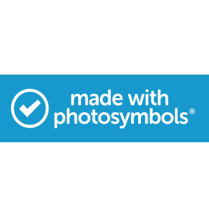  easyread.tech created these original illustrations. Please do not use these illustrations without permission. Visit [easyread.tech](https://easyread.tech) for more information.

**DSS3533**

