Australia’s Disability Strategy 2021 – 2031 Advisory Council

16 October 2024

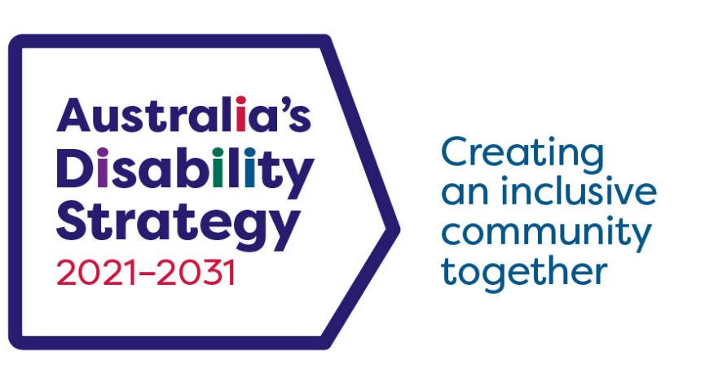

|  |  |
| --- | --- |
| Australian Government Department of Social Services | This Easy Read document was written by the Australian Government Department of Social Services.  We say **DSS** for short.  When you see the word **we** it means DSS. |
|  | We wrote this in an easy to read way.  We use pictures to explain some ideas. |
|  | We have some words in **bold**.  This means the letters are thicker and darker.  These are important words. |
|  | This is an Easy Read summary of what happened in the Advisory Council meeting.  This means it has the most important ideas from the meeting. |
|  | If you need support to read this you can ask   * A friend * Family members * A support person. |
|  | We recognise Aboriginal and Torres Strait Islander people as the **Traditional Owners** of the land we live on. |
|  | They were the **first people** to live on and use the   * Land * Waters. |

Contents

|  |  |
| --- | --- |
| Australia’s Disability Strategy | 5 |
| Australia’s Disability Strategy 2021-2031 Advisory Council | 6 |
| What the Council talked about | 9 |
| What the Council heard about | 14 |

**Australia’s Disability Strategy**

|  |  |
| --- | --- |
|  | **Australia’s Disability Strategy 2021 - 2031** is a plan to make life better for people with disability. |
|  | We call it **ADS**. |
|  | ADS is important for Australia to be more **inclusive**.  **Inclusive** means everyone can take part. |
|  | This makes everyone in our community feel welcome. |

**Australia’s Disability Strategy**

**2021 – 2031 Advisory Council**

|  |  |
| --- | --- |
|  | The Australia’s Disability Strategy2021-2031 **Advisory Council** gives advice about ADS to   * The Australian Government * State and territory governments * Local governments.   We call it **the Council**. |
|  | The Council is **not** part of the government. |
|  | The Council helps governments understand how to   * Use ADS * Share reports about ADS * Work towards the goals of ADS. |
|  | The Council includes people   * With disability * Who understand barriers for people with disability. |
|  | The Council has 4 meetings a year. |
|  | The Council writes **bulletins** about what they did in their meetings.  A bulletin is important news to share with the community. |
|  | This bulletin is about the Council meeting on 16 October 2024. |

What the Council talked about

|  |  |
| --- | --- |
|  | Jane Spring is the Council **Chair**.  This means she leads the Council meetings. |
|  | The Council shared important updates. |
|  | Natalie Wade left the Council in September 2024.  Jane Spring thanked Natalie for her work with the Council. |
|  | The Council talked about emails they got from people with disability about   * Accessible information * Changes to university and TAFE. |
|  | Since the last meeting the Council took part in workshops about |
|  | The **National Disability Reform Agenda** which included the   * Disability Royal Commission recommendations * NDIS review.   These will support people with disability to live a good life. |
|  | **ADS Review** update  The ADS Review is checking   * If ADS is working well * What needs to change * What should be added. |
|  | There was a session about ADS.  It was called **ADS 101.**  This helped new members of the Council understand how ADS works. |
|  | New **Targeted Action Plans**   * Targeted Action Plans are small plans that all work towards ADS.   We call them **TAPs**. |
|  | All governments worked together to write TAPs.  This includes   * Australian Government * State and territory governments * Local governments. |
|  | The Council talked about a draft **Work Plan for 2025**.  The Work Plan will support the Council to |
|  | * Focus on the most important ADS issues * Give formal advice to the **Disability Reform Ministerial Council**.   We call it the **DRMC**. |
|  | The DRMC is a group of Disability **Ministers** from   * The Australian Government * State and territory governments.   Ministers are leaders in an area of the government. |
|  | The DRMC talk about how governments will support people with disability through   * ADS * NDIS. |

**What the Council heard about**

|  |  |
| --- | --- |
|  | People from the **Attorney Generals** **Department** spoke to the Council.  The Attorney Generals Department is the area of government that |
|  | * Gives advice to the government about laws |
|  | * Is reviewing the **Disability Discrimination Act**. |
|  | The **Disability Discrimination Act** is the law that says people with disability must be treated fairly.  We call it the **DDA**. |
|  | The DDA review will check if   * The DDA is working well for people with disability * There is anything that needs to change. |
|  | The Council   * Will get regular updates about the DDA Review * Like being part of the DDA Review process. |
|  | The next Council meeting is on 6 December 2024 |
|  | Go to the Council website if you need more information.  [Australia’s Disability Strategy Advisory Council | Disability Gateway](https://www.disabilitygateway.gov.au/ads/advisory-council) |
|  | You can email us.  [adsadvisorycouncil@dss.gov.au](mailto:adsadvisorycouncil@dss.gov.au) |

.

easyread.tech created these original illustrations. Please do not use these illustrations without permission. Visit [easyread.tech](https://easyread.tech) for more information.