

Stay protected against COVID-19

COVID-19 is still in the community.  
It can make some people with disability very sick.

People with disability share why they are  
vaccinated and how they stay COVID-safe at: [disabilitygateway.gov.au/COVIDstories](http://www.disabilitygateway.gov.au/COVIDstories)

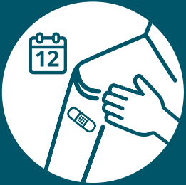

You can protect yourself by  
getting a COVID-19 vaccine.   
Most adults can get a booster  
dose every 12 months.

Two people in medical uniforms


To help you decide if you should  
get another COVID-19 vaccination  
dose, you can talk to your  
healthcare provider.

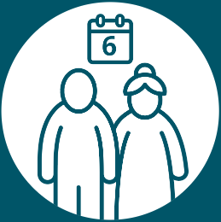

Some adults are recommended  
to get a booster dose every  
6 months. For example, if you are   
over the age of 65 or have severe immunocompromise.



You can also protect yourself by  
being COVID-safe. You can stay at  
home if you’re feeling unwell, wash  
your hands and wear a mask.

For more information you can visit the Disability Gateway at [disabilitygateway.gov.au/covid19-support](http://disabilitygateway.gov.au/covid19-support)