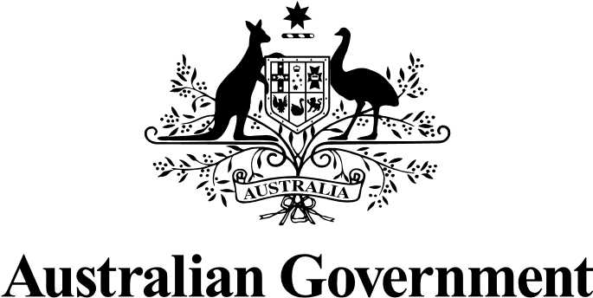

COVID-19 stories
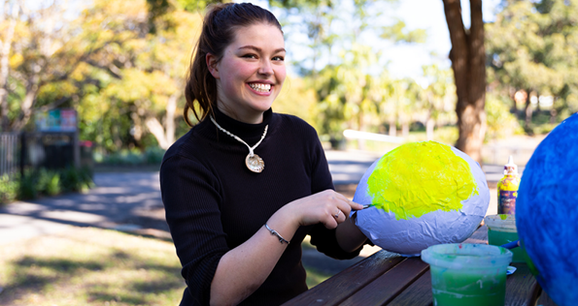
COVID-19 is still in the community.
It can make some people with disability very sick.
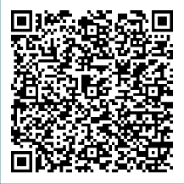
People with disability share why they are
vaccinated and how they stay COVID-safe at: disabilitygateway.gov.au/COVIDstories

For more information you can visit the Disability Gateway at disabilitygateway.gov.au/covid19-support

