Australia’s Disability Strategy Advisory Council
Update
13 March 2025
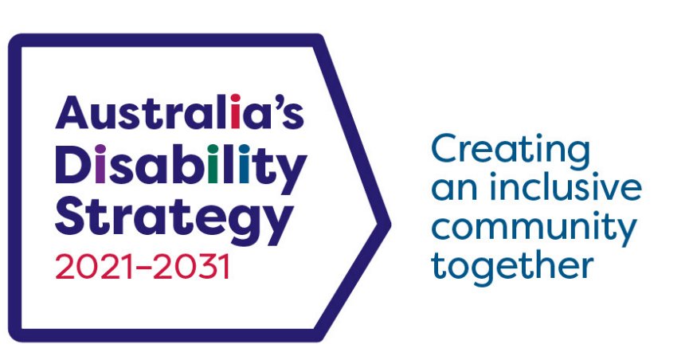
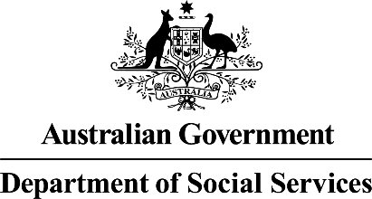 | The Australian Government Department of Social Services wrote this.  We say DSS for short.  When you see the word we it means DSS.
 | We wrote this in an easy to read way.  We use pictures to explain some ideas.
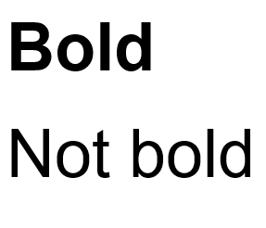 | We have some words in bold.  This means the letters are thicker and darker.  These are important words.
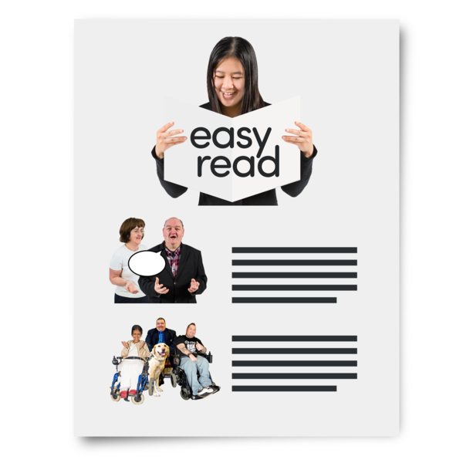 | This is an Easy Read summary of what happened in the Advisory Council meeting.  This means it has the most important ideas from the meeting.
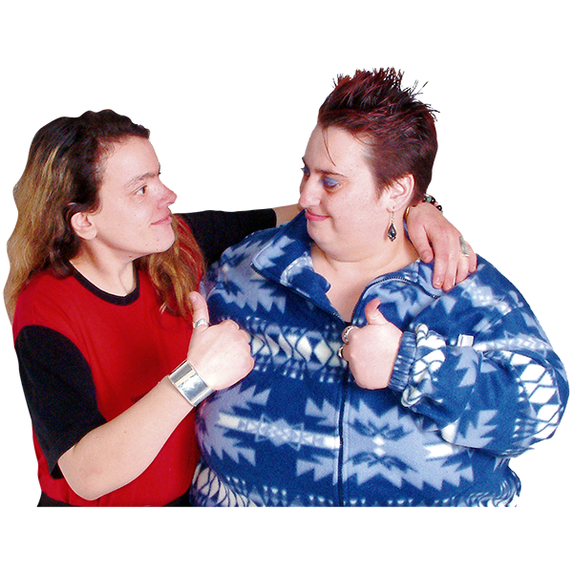 | You can ask for help to read this document.  You can ask  - A friend  - Family members  - A support person.
 | We recognise Aboriginal and Torres Strait Islander people as the Traditional Owners of the land we live on.
 | They were the first people to live on and use the  - Land  - Waters.

Contents

Australia’s Disability Strategy | 5
ADS Advisory Council | 6
What the Chair talked about | 8
What the Council talked about | 10
What the Council heard | 13

Australia’s Disability Strategy

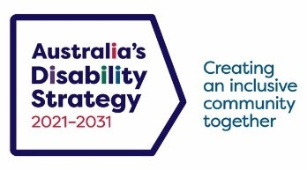 | Australia’s Disability Strategy 2021 to 2031 is a plan to make life better for people with disability.  We call it ADS.
 | ADS is important for Australia to be more inclusive.  Inclusive means everyone can take part.
 | This makes everyone in our community feel welcome.

ADS Advisory Council
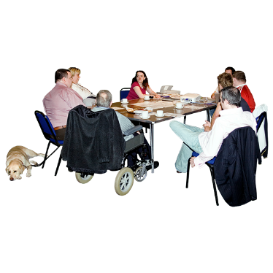 | The ADS Advisory Council gives advice about ADS to  - The Australian Government  - State and territory governments  - Local governments.  We call it the Council.
 | The Council is not part of the government.
The Council helps governments understand how to

- Use ADS
- Share reports about ADS
- Work towards the goals of ADS.

Goals are things you want to do.

 | The Council includes people  - With disability  - Who understand barriers for people with disability.
 | The Council writes information about what they talked about in their meetings.  We share important information with the community.
 | This information is about the Council meeting on 13 March 2025.

What the Chair talked about
 | Jane Spring is the Council Chair.  The Chair is the person who runs the meeting.  Jane gave updates about
 | - Meeting with the Disability Reform Ministerial Council.  We call it DRMC.
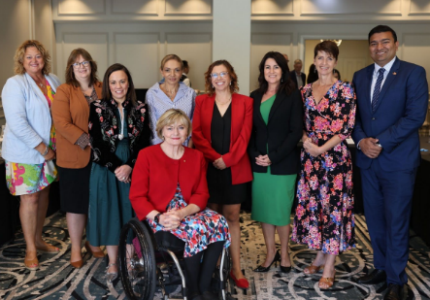 | DRMC is a group of Disability Ministers from  - The Australian Government  - State and territory governments  Ministers are leaders in an area of the government.
 | DRMC agreed to  - ADS 2025 Work Plan  - ADS 2024 Annual Report  - Changes to the ADS Council Terms of Reference.  We call them TOR for short.
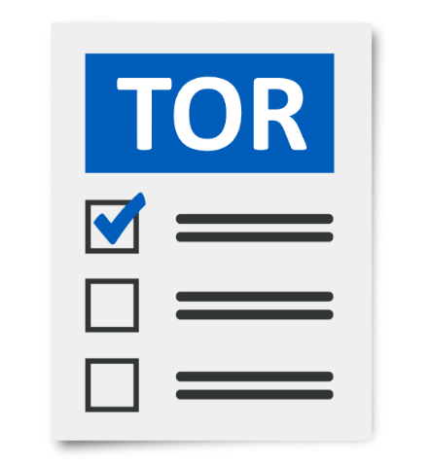 | The TOR are the rules of the Council.  It helps everyone know what is expected.
 | DRMC agreed to put the documents on the website.  You can look at them on the website.  It is not in Easy Read.  www.disabilitygateway.gov.au/ads/strategy

What the Council talked about
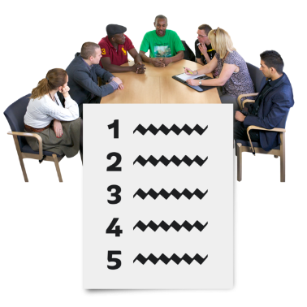 | The Council agreed to giving advice to DSS about
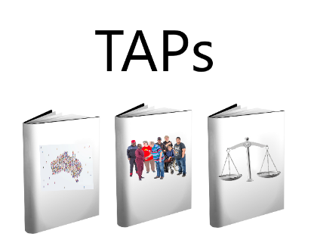 | - Targeted Action Plans  We call them TAPs for short.  TAPs are the small plans working towards ADS.
 | We will focus on what makes a good TAPs report.
 | There was a workshop for the Council members on 17 February 2025.  This helped us give advice about TAPs.
 | The Council put their advice about TAPs in a report for DRMC.
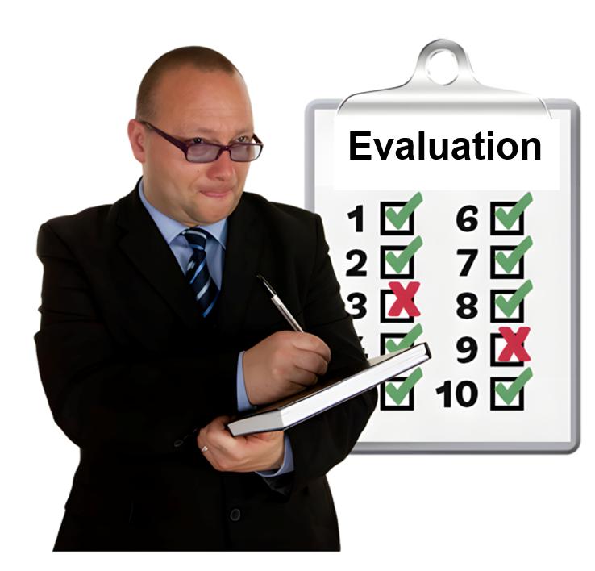 | - The ADS evaluation  Evaluation means you look at what  - Went well  - Could be done better.
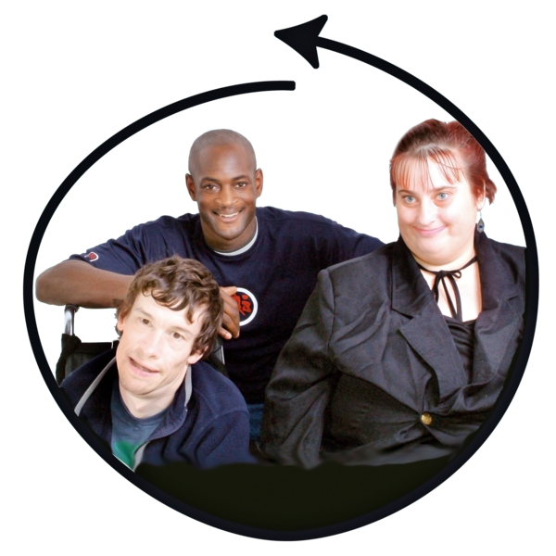 | We want to make sure the evaluation includes people with disability.
 | There was a workshop for the Council members on 18 February 2025.  This helped us give advice about the ADS evaluation.
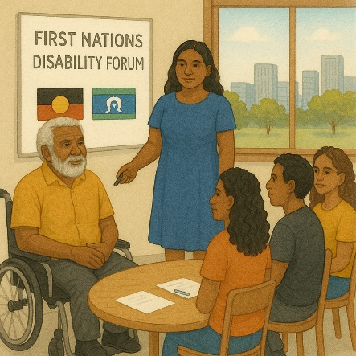 | - The Council also talked about what it might look like if the government set up a First Nations Disability Forum.
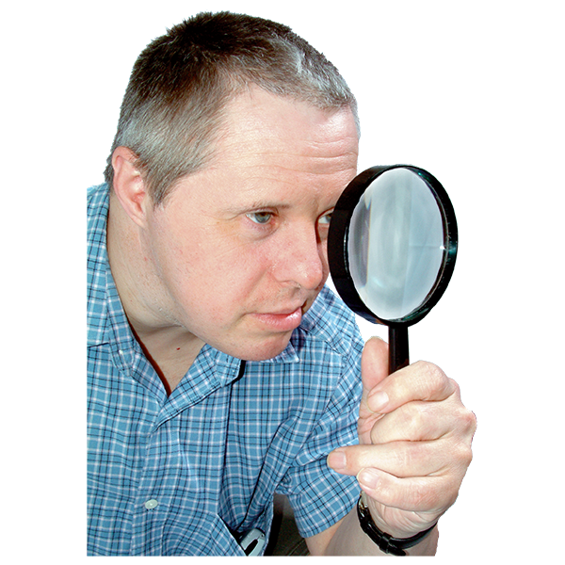 | Setting up the Forum is a recommendation from  - Disability Royal Commission  - NDIS Review.
 | Recommendations are ideas to do things better.

What the Council heard about

 | The Council heard about the work done since the meeting in December 2024 like
 | - The workshops to help give advice
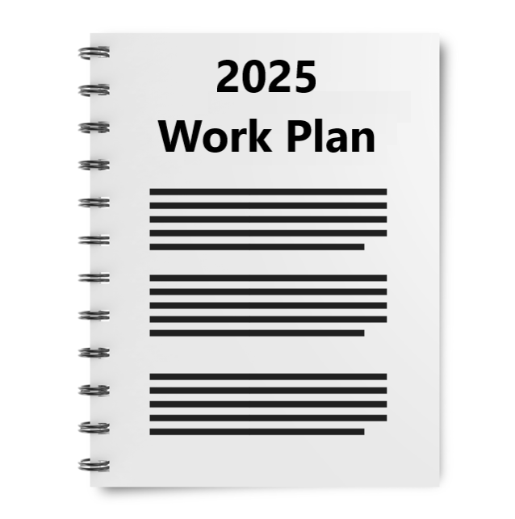 | - ADS 2025 Work Plan
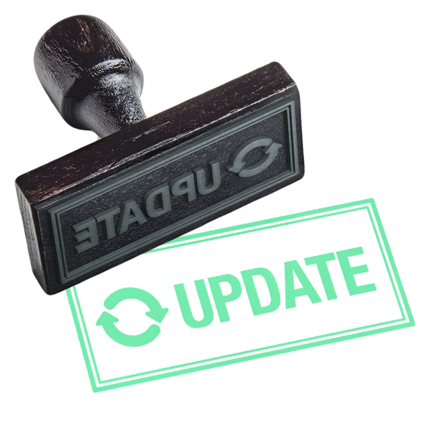 | - Updates on activities done with the states and territories.
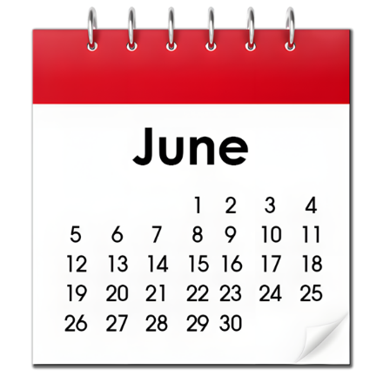 | The next Council meeting will be in June 2025.  It will go for 2 days.  The meeting will be in person.
Go to the Council website if you need more information.
www.disabilitygateway.gov.au/ads/advisory-council
 | You can email us.  adsadvisorycouncil@dss.gov.au

Images in this Easy Read must not be used or copied without permission.

