Australia’s Disability Strategy 2021 – 2031 Advisory Council

Update

6 December 2024

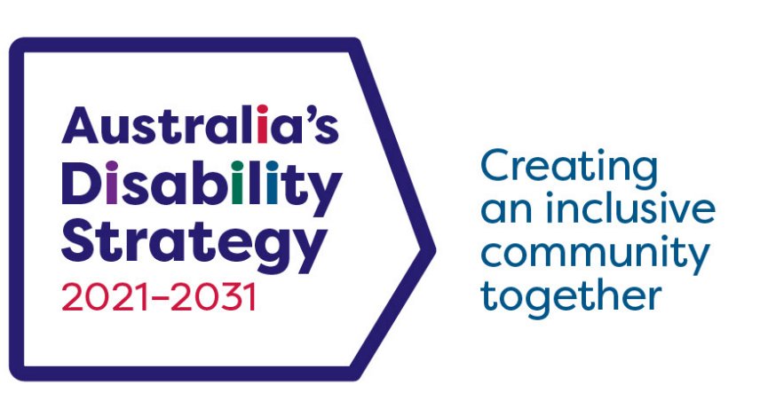

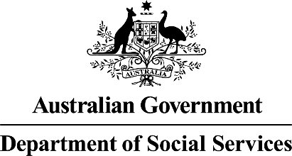 | This Easy Read document was written by the Australian Government Department of Social Services.  We say DSS for short.  When you see the word we it means DSS.
 | We wrote this in an easy to read way.  We use pictures to explain some ideas.
 | We have some words in bold.  This means the letters are thicker and darker.  These are important words.
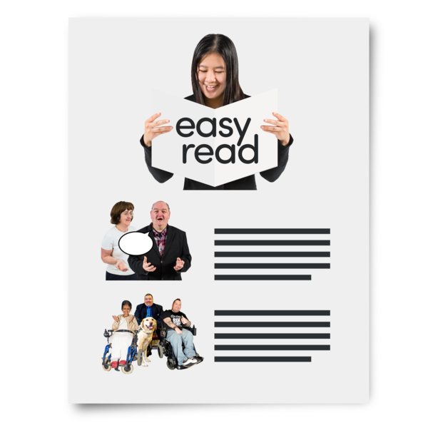 | This is an Easy Read summary of what happened in the Advisory Council meeting.  This means it has the most important ideas from the meeting.
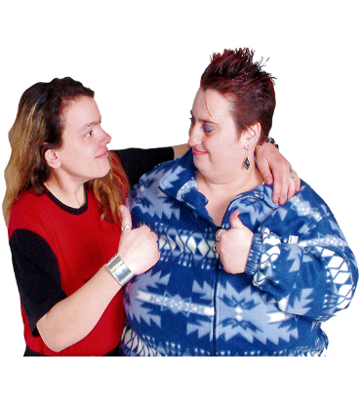 | If you need support to read this you can ask  - A friend  - Family members  - A support person.
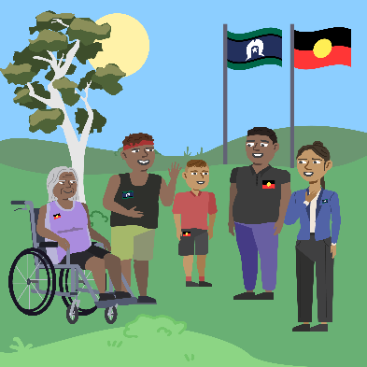 | We recognise Aboriginal and Torres Strait Islander people as the Traditional Owners of the land we live on.
 | They were the first people to live on and use the  - Land  - Waters.

Contents

Australia’s Disability Strategy | 5
Australia’s Disability Strategy 2021-2031 Advisory Council | 6
What the Council talked about | 9
What the Council heard about | 16

Australia’s Disability Strategy

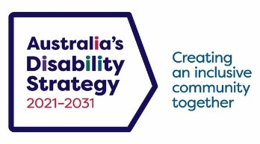 | Australia’s Disability Strategy 2021 - 2031 is a plan to make life better for people with disability.  We call it ADS.
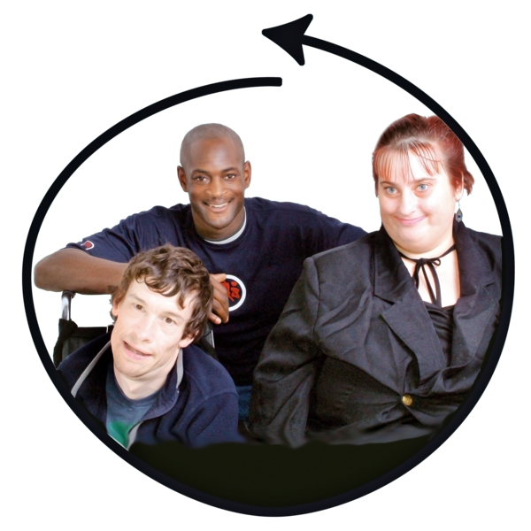 | ADS is important for Australia to be more inclusive.  Inclusive is when everyone  - Can take part  - Feels like they belong.
 | This makes everyone in our community feel welcome.

Australia’s Disability Strategy 2021 – 2031 Advisory Council

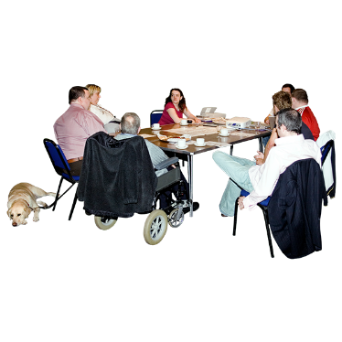 | Australia’s Disability Strategy 2021-2031 Advisory Council gives advice about ADS to  - The Australian Government  - State and territory governments  - Local governments.  We call it the Council.
 | Advice means to tell someone your ideas of how to do something.
 | The Council is not part of the government.
 | The Council helps governments understand how to  - Use ADS  - Share reports about ADS  - Work towards the goals of ADS.
 | The Council includes people  - With disability  - Who understand barriers for people with disability.
 | The Council has 4 meetings a year.
 | The Council writes bulletins about what they did in their meetings.  A bulletin is important news to share with the community.
 | This bulletin is about the Council meeting on 6 December 2024.

What the Council talked about

 | Jane Spring is the Council Chair.  This means she  - Leads the Council meetings  - Shares the Council advice.  Jane welcomed members to the meeting.  The Council talked about
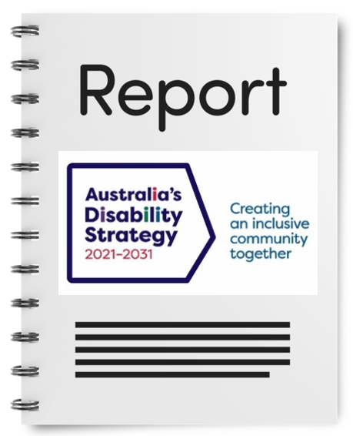 | - The ADS Review Report.
 | The ADS Review report is about  - If ADS is working well  - What needs to change  - What should be added.
- The new Targeted Action Plans

To make it easier to work on ADS they made lots of small plans.

The small plans are all working towards ADS.
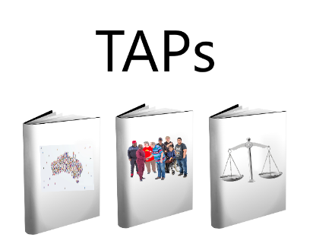 | The small plans are called Targeted Action Plans.  We call them TAPs for short.
 | All governments work together to do TAPs.
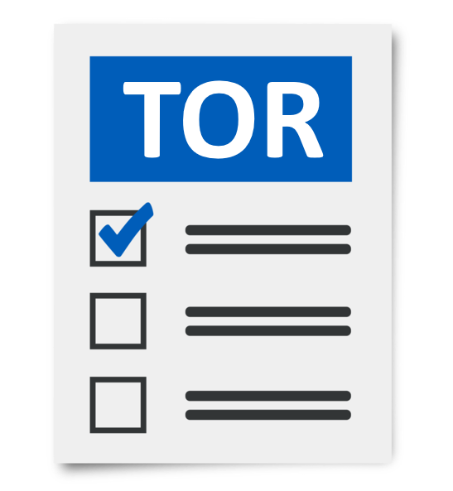 | - The 2024 ADS Council Terms of Reference Review  Terms of Reference are the rules of the Council.  They help everyone know what is expected.  We call it TOR for short.
 | The TOR Review report is about  - If the TOR are working well  - What needs to change  - What should be added.
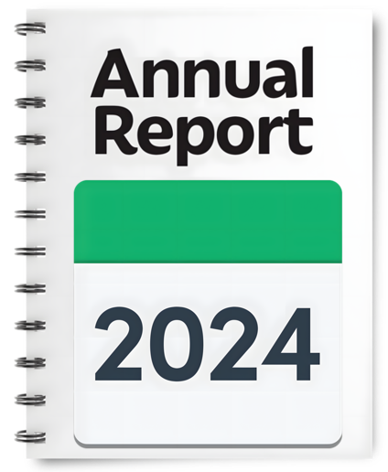 | - Annual Report  The Annual Report is about the work the Council did in 2024.
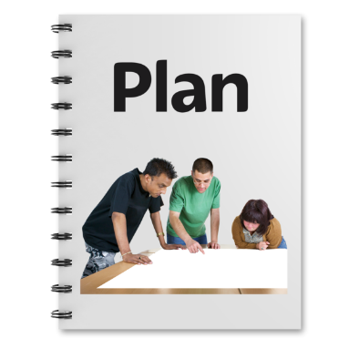 | - The Work Plan for 2025.
 | The Work Plan will support the Council to  - Focus on the most important ADS issues  - Give advice to the Disability Reform Ministerial Council.  We call it the DRMC.
The DRMC is a group of Disability Ministers from

- The Australian Government
- State and territory governments.

Ministers are leaders in an area of the government.
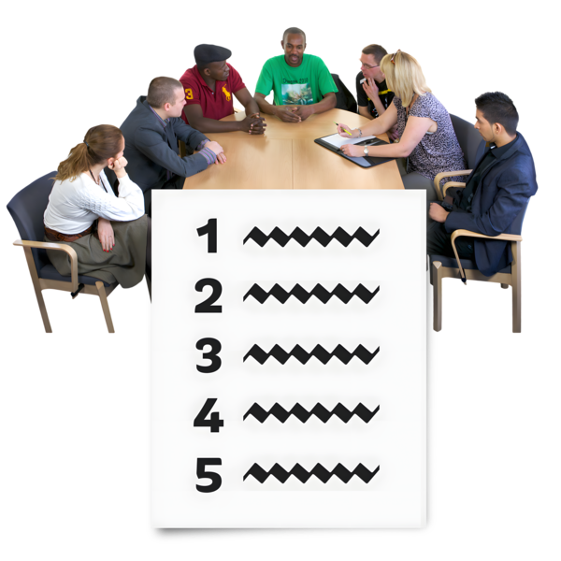 | - What happened at the last DRMC meeting.
 | - The Disability Discrimination Act Review  The Disability Discrimination Act is the law that says people with disability must have their rights met.  We call it the DDA for short.
 | Laws are rules for how we live.  Rights are rules about treating everyone  - Fair  - Equal.
The DDA review will check if

- The DDA is working well for people with disability
- There is anything that needs to change.

 | - How the reviews can make life better for people with disability.
- Australian Human Rights Act idea

A Human Rights Act is an idea for a new law.

It would say how everyone in Australia should have their rights met.

It is an idea people in Australia are talking about.

It is not a law yet.
 | The Council talked about how a Human Rights Act could make sure people with disability  - Have their rights met.
 | - A new guide called Involving People with Disability in Evaluation.  A guide is a group of ideas about how to do something.
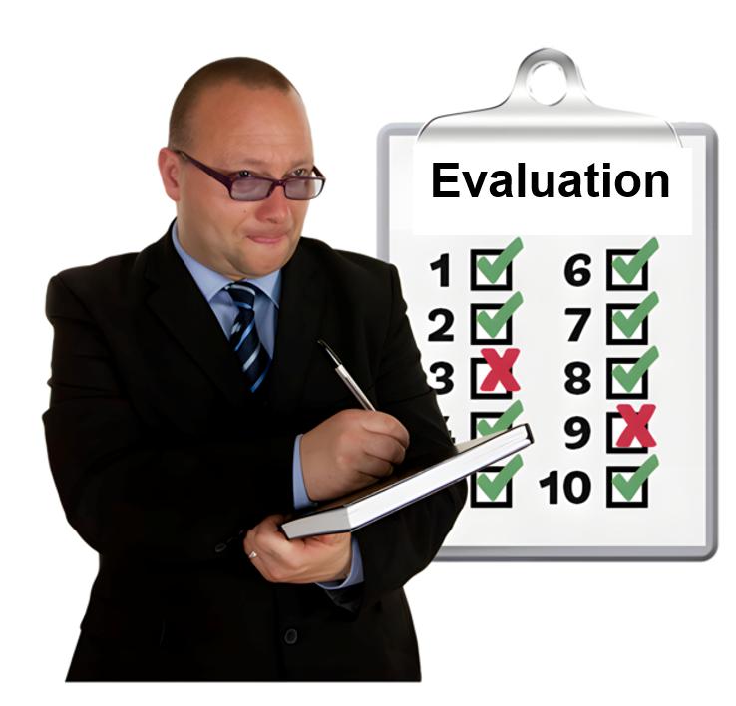 | Evaluation means you look at  - Went well  - Could be done better.  You can do an evaluation of a  - Service  - Program  - Plan.
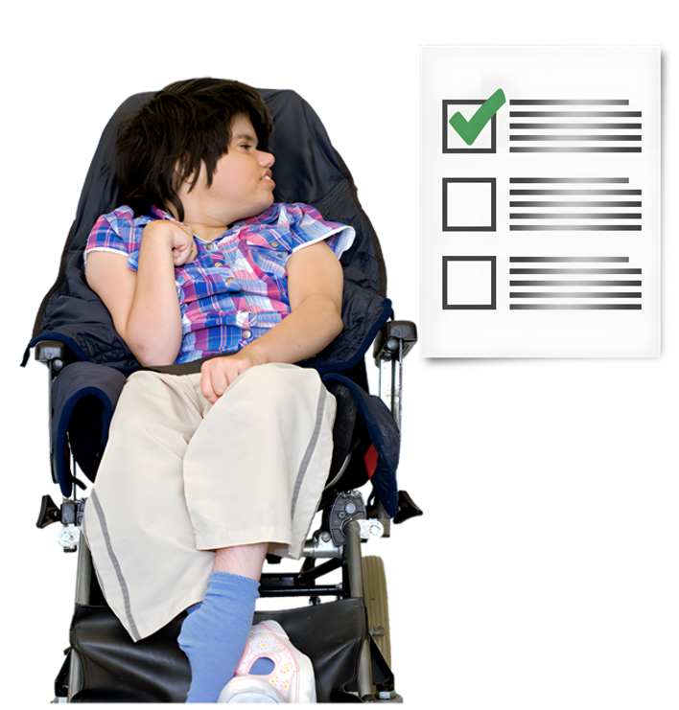 | The guide is about how to include people with disability in an evaluation.
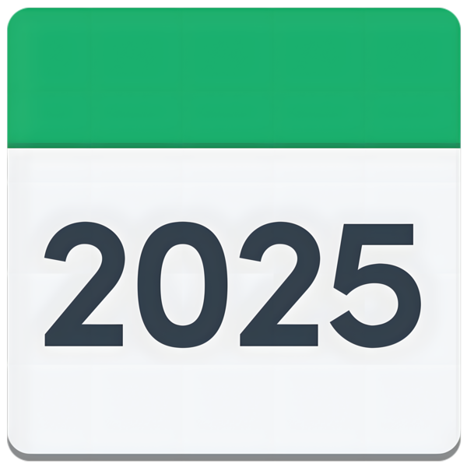 | DSS will write the guide in 2025.

What the Council heard about

 | People on the Council shared work they had done  - Since the October meeting  - For International Day of People with Disability.  This is sometimes called IDPwD for short.
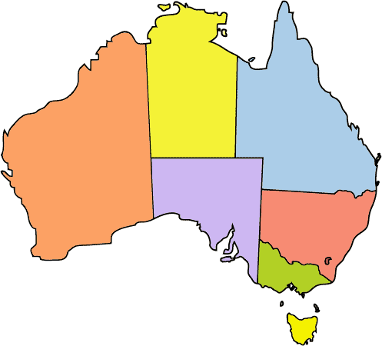 | Members shared updates about what happened in each  - State  - Territory.
 | Jane organised a meeting for the Jurisdictional Disability Advisory Leads.  This was a meeting with Disability Advisory Councils from each  - State  - Territory.  Members shared information and ideas.
 | The next Council meeting is on 13 March 2025.
 | Go to the Council website if you need more information.  www.disabilitygateway.gov.au/ads/advisory-council
 | You can email us.  adsadvisorycouncil@dss.gov.au

Images in this Easy Read must not be used or copied without permission.

