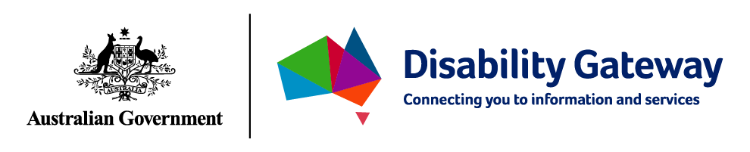

Fay’s Story
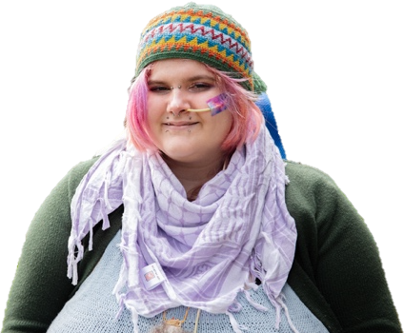

This is a story about Fay.

Fay is a proud Palawa person.

Fay uses they/them pronouns.

They are a person with a disability.

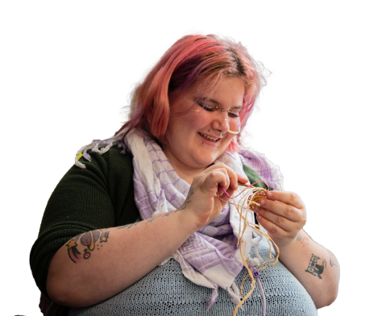

Fay loves to crochet, knit and weave.

Weaving helps them to feel connected to their culture.



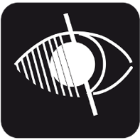
Fay is Deafblind. The language they use is Auslan.

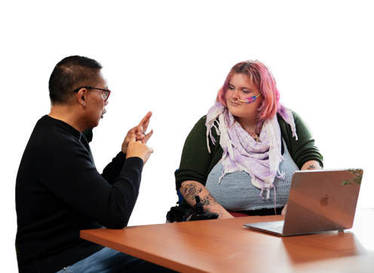

They sign Auslan with an interpreter.

They also use hearing aids or a screen reader to get information.



They say it is important for everyone to have access to the information they need.

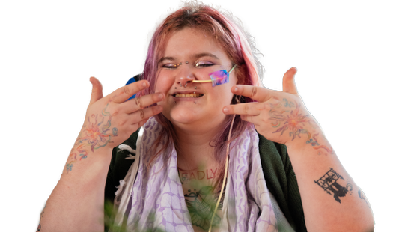

Connecting with their community makes Fay feel very happy.


They say the Disability Gateway can help you find support that understands your culture and your community.

This Easy Read document was produced by Think HQ. If you have any questions or would like an Easy Read document produced, please contact hello@think-hq.com.au.
Images from the Photosymbols Picture Bank, copyright Photosymbols.

