
Australia’s Disability Strategy
2021 - 2031
State and Territory Forum Tasmania
30 August 2024

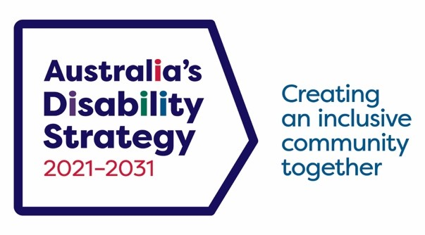
ISBN: 978-1-921975-39-4 (online)

Copyright notice
This document, Australia’s Disability Strategy 2024 Review, is licensed under the Creative Commons Attribution 4.0 International Licence, with the exception of:
Australia’s Disability Strategy 2021–2031 logo and branding
Any third-party material
All images and/or photographs
Australian Commonwealth Coat of Arms: The terms under which the Coat of Arms can be used are detailed on the Department of the Prime Minister and Cabinet website: https://www.pmc.gov.au/honours-and-symbols/commonwealth-coat-arms
More information on this CC By license is set out at the Creative Commons website:
https://creativecommons.org/licenses/by/4.0/legalcode
Notice
If you create a derivative of this document, the Department of Social Services requests the following notice be placed on your derivative: Based on Commonwealth of Australia (Department of Social Services) data.
Inquiries regarding this licence or any other use of this document are welcome. Please contact:
Branch Manager, Campaigns and Strategic Communication Branch, Department of Social Services
Phone: 1300 653 227
Email: communication@dss.gov.au
Accessibility
Access Hub provides information about communication options (including the National Relay Service) for people who are d/Deaf, hard of hearing and/or have speech communication difficulty. For further information, go to https://www.accesshub.gov.au/
This Report is available online, in multiple accessible formats. For further information, go to https://www.disabilitygateway.gov.au/ads
Attribution
Use of all or part of this document must include the following attribution: © Commonwealth of Australia (Department of Social Services) 2024
Web links, telephone numbers, and titles correct at the time of publication. They may have changed after publication.

Acknowledgment of Country
The Department of Social Services and Tasmanian Government acknowledges Aboriginal and Torres Strait Islander peoples throughout Australia and their continuing connection to land, water, culture and community. We pay our respects to the Elders both past and present.



Acknowledgment to People with Disability
The Department of Social Services and Tasmanian Government acknowledges the lived and living experience of people with disability, their families, carers, representative organisations and community.
Table of Contents
Acknowledgments 2
Executive Summary 4
Introduction 6
Part 1: Key Speakers 9
Part 2: Workshop 13
Theme 1: Accessibility and Inclusion 14
Theme 2: Communication and Awareness 15
Theme 3: Defining Roles and Terms of Engagement 15
Theme 4: Leadership and Representation of People with Disability 15
Theme 5: Accessible Physical and Virtual Spaces 15
Theme 6: Recognising and Valuing Contributions 16
Theme 7: Getting the Right People Involved. 16
Theme 8: Structured and Predictable Engagement Opportunities 17
Theme 9: Strategic Partnerships for Effective Engagement 17
Part 3: Good Practise Consultation with People with Disability within the context of Government 18
Appendix A Biographies and Images 22
Appendix B Program 27

Executive Summary
The Tasmanian Government hosted the second Australia’s Disability Strategy 2021-2031 (ADS) State and Territory Forum on Friday, 30 August 2024 in Hobart, Tasmania. Bringing together people with disability to hear about how Tasmania and the Commonwealth governments are implementing ADS and discuss inclusive communication and engagement through a workshop and panel to help guide disability reform.
The Forum included people with disability, government/public servants, disability organisations, service providers and community representatives.
The day began with a Welcome to Country by Cody Summers a Pakana man, traditional owner and connected to Country, whose heritage comes from the Maynard, Mansell and Beeton families. His ancestors are the Trawlwoolway people of Cape Portland in the North-East of Tasmania.
The Forum was co-facilitated by Manisha Amin (in person) CEO of Inclusive Design Collective, and Jane Wardlaw (online) Ministers Disability Consultative Group member and Disability Advocate and Consultant.
The attendees heard from a number of guest speakers including the Hon Amanda Rishworth MP Minister for Social Services and Minister for the National Disability Insurance Scheme, the Hon Jo Palmer MLC Tasmanian Minister for Disability, Kelly Ford Director of Disability and Reform, Department of Premier and Cabinet, Tasmania and Mary Mallet the Tasmanian Interim Disability Commissioner.
Attendees also had the opportunity to participate in person and online in a workshop focused on what best practice engagement for people with disability should be, building on ADS Good Practice Guidelines for Engaging with People with Disability.

Key Theme: Your Say, Your Way’
The theme, ‘Your Say, Your Way’, was inspired by and built on ADS ‘Good Practice Guidelines to Engaging People with Disability’ by applying a place-based lens, specific to Tasmania.
The experiences and information shared and heard in the workshop identified the following themes:
- Accessibility of events
- Finding out about events and consultations
- Be clear about the terms of engagement
- Leadership of people with disability
- Physical spaces
- Getting the right people involved
- Have an engagement calendar
- Communication partners.

Learnings
- The importance of accessibility and inclusivity
- Collaboration and community
- Continuous advocacy and engagement
- Clear communication and the importance of feedback loops
This Inclusive Engagement Workshop (the Workshop) focused on sharing and listening to people with lived experience using an appreciative enquiry, strengths-based approach. The Workshop heard how people found out about consultation, what made it easier to engage and feel welcome, and how everyone with disability has different experiences and needs and what was working well or requires improvement.
The Workshop emphasised the importance of considering local contexts when engaging with people with disability, particularly in different states and territories. Tasmania presents unique challenges compared to other regions of Australia. Limited access to transportation, especially in rural areas, can make it difficult for people with disability to attend consultations. This highlighted the value of state and territory-based forums.
The workshop underscored the need for intentional and well-structured engagement that prioritises inclusion, accessibility, and respect. By incorporating best practice principles into communication and consultation efforts, organisations and government entities can ensure that people with disability are not only heard but also play a significant role in shaping the policies, programs, and decisions that affect their lives.

Next Steps Monitoring and Timelines
The next ADS forum will be the 2025 National Forum, with a focus on engagement with First Nations people, and designed to involve people with disability and support the Independent Evaluation of ADS to continue delivering real outcomes for people with disability. ​
Key objectives will be highlighting achievements of current ADS implementation​, providing insights into how existing services and systems can adjust their approaches to be more accessible and inclusive for people with disability​, and a report capturing insights on priority areas for focus and reflecting where effort needs to be placed to improve ADS.​

Introduction

Australia’s Disability Strategy 2021-2031
At the heart of Australia’s Disability Strategy 2021-2031 (ADS) is a commitment to create inclusive communities that call on all Australians to ensure that people with disability can participate as equal members of society. Consistent with the United Nations Convention of the Rights of Persons with Disabilities (UN CRPD), it commits all Australians to realising the fundamental freedoms and human rights of people with disability.
ADS was developed in collaboration with people with disability, their families, carers and representatives and all levels of governments through more than 2 years of consultations and engagements and reviewed following the Royal Commission into Violence, Abuse, Neglect and Exploitation of People with Disability (Royal Commission) and National Disability Insurance Scheme (NDIS) Review in 2024. An updated ADS: Building a more inclusive Australia and more information is available on the Disability Gateway.
The seven Outcome Areas of ADS set out where governments, working with people with disability, communities and business, will focus on driving improvements for people with disability. The Outcome Areas are the areas people with disability have said need to improve to achieve an inclusive Australian society.
Tasmania’s Disability Strategy is consistent with the vision and outcomes of ADS.
The Tasmanian Government hosted the second ADS State and Territory Forum on 30 August 2024 in Hobart. Bringing together people with disability to hear about how Tasmania and the Commonwealth governments are implementing ADS and discuss inclusive communication and engagement through a workshop and panel to help guide disability reform. The Forum included people with disability, disability organisations, service providers and community representatives.
The Forum was held at RACV Hobart Hotel for proximity and access to parking, public transport and access features of the location and disability confidence of the location. 80 people attended in-person and 45 online. Around 50 percent of attendees identified as people with disability, with many staff from government departments attending also identifying as people with disability.

The event was co-facilitated by people with lived experience, Manisha Amin, CEO Inclusive Design Collective (in person) and Jane Wardlaw, Tasmanian Disability Advocate and Consultant (online), attendees heard from key speakers including:
- Hon Amanda Rishworth MP, Minister for Social Services and Minister for the National Disability Insurance Scheme
- Hon Jo Palmer MLC, Tasmanian Minister for Disability
- Kelly Ford, Director, Disability and Reform, Department of Premier and Cabinet, Tasmania
- Mary Mallet, Tasmanian Interim Disability Commissioner.
Attendees engaged with a panel on ‘Good Practice Consultation with People with Disability within the context of Government’ and had the opportunity to participate in a workshop on ‘Good Practice Inclusive Communication and Engagement’ building on ADS Good Practice Guide to Engaging People with Disability to further inform and improve government practices.

Objectives of the Forum
The objectives of the Forum were:
Engagement: To create opportunities for people to share, listen and gather insights and feedback from people with disability about effective and inclusive consultation methods within the framework of the Tasmanian Government.
Awareness: To raise awareness about engagement opportunities and highlight the barriers faced by the disability community when interacting with Government. This includes suggesting potential solutions and informing people about the efforts of the Tasmanian and Commonwealth Governments implementing ADS, as well as the broader disability reforms such as implementing recommendations from the Royal Commission and NDIS Review.
Collaboration: To foster networking and collaboration among attendees, speakers, and organisations. The focus was on creating a space for capacity-exchange between Community and Government, sharing initiatives, listening and learning from Tasmanians with disability who provided feedback and recommendations on improving engagement processes. Providing space for people with disability to have a voice in shaping engagement practices that affect them, leading to more meaningful and effective engagement.
Accessibility: To discuss engagement and inclusion practices to inform policy and strategies, leading to systemic change and improved accessibility.

Key Learnings
The importance of accessibility and inclusivity: There is no one-size fits all approach. The forum highlighted the need for practices that genuinely consider the diverse experiences of people with disability in urban, regional, and remote communities.
Collaboration and community: Building trust and engaging early is crucial to strengthen relationships between community and to advocate for accessibility and inclusion.
Advocacy and engagement: Ongoing efforts and proper renumeration of people with disability are key to driving systemic changes that support the rights and needs of people with disability.
Clear communication and the importance of feedback loops: Providing timely, clear, and accessible information is essential. Establishing feedback mechanisms helps understand the effectiveness of programs and enable continuous improvement.

Part 1: Key Speakers

The Hon Amanda Rishworth MP, Minister for Social Services and Minister for the National Disability Insurance Scheme
Minister Rishworth spoke about her commitment to transforming ADS from words on a page into life and expressed her gratitude for the Forum participants contributing to the discussion about how we can make ADS vision a reality.
The Forum heard that recent initiatives highlight an increased focus on disability inclusion within national disability policy. Key developments include the integration of disability considerations into the Aviation White Paper, the provision of guidance for emergency management, and the promotion of inclusive early childhood education. Additionally, the establishment of a National Centre for Disability Advocacy (NCDA) and an expansion of accessible infrastructure, such as Changing Places, reflect the government's broader efforts to improve equity and accessibility.
The Forum heard how the Review of ADS built on extensive research, stakeholder engagement, and feedback from disability representative organisations and people with lived experience. The Review aims to identify practical improvements in the implementation of ADS and ensure that policies translate into tangible benefits for the disability community. An independent evaluation of ADS is scheduled for 2025, which will assess key outcome areas, policies, and objectives to guide future improvements.
As a key driver of national disability reform, the Minister shared how ADS will continue to play a central role in shaping government responses to the Royal Commission. ADS is positioned as a foundational framework to support reforms that address systemic challenges and enhance the rights and opportunities of people with disability.
The Forum heard how the Commonwealth Government remains committed to working collaboratively with states and territories to advance the vision set out in the Royal Commission. Financial and legislative commitments are already underway, although further work is required to address complex recommendations that involve multiple considerations and pathways forward.
In closing, the Minister acknowledged and expressed appreciation for the contributions of all those involved in supporting and driving these initiatives, reinforcing the importance of continued collaboration in delivering meaningful change.

The Hon Jo Palmer MLC, Tasmanian Minister for Disability Services
Minister Palmer spoke of the Forum’s focus on enhancing outcomes for Tasmanians with disability, expressing her personal commitment to disability inclusion and rights. She expressed the value in listening to voices and the lived experience of the disability community, and the importance of engaging authentically, listening deeply and acting on feedback.
Clear and inclusive communication was identified as critical in ensuring that the voices of people with disability are heard in discussions. Effective engagement, particularly in political contexts, strengthens dialogue between government and the disability community, fostering more informed and responsive decision-making.
The Forum heard how participation of people with disability, particularly through groups such as the Minister’s Disability Consultative Group, plays a crucial role in shaping policy. These groups provide valuable insights and feedback that inform government legislation, policies, programs and service delivery. Ensuring continued engagement with these advisory groups supports inclusive policymaking and strengthens representation.
The Minister shared how recent discussions at the Disability Reform Ministers Council (DRMC) in Hobart highlighted the ongoing focus on the NDIS Review, the recommendations from the Royal Commission and the importance of maintaining clarity and certainty around NDIS foundational supports. These remain a key priority with efforts directed towards ensuring a more sustainable and effective system for future generations.
The Forum heard that governments have a responsibility to engage with and empower the disability community in shaping future reforms. While ADS provides the framework for achieving positive outcomes, the design, planning, and delivery of reforms must be undertaken in genuine partnership with people with disability. Active listening, continuous learning, and deeper understanding of lived experiences are essential in ensuring policies reflect what works best for the disability community.
Removing barriers to participation in government programs and services was stated as fundamental to upholding the rights of people with disability. The Minister used the example of Tasmania’s Disability Rights, Inclusion and Safeguarding Bill, which was developed through extensive stakeholder consultation, to demonstrate this commitment.
Key components of the Bill include the establishment of a Disability Inclusion Planning and Reporting framework for government agencies, the appointment of a Disability Commissioner, and the creation of a Disability Inclusion Advisory Council with the aim to strengthen accountability and promote inclusive practices across government.
In closing, the Minister thanked participants for the work they were doing and shared that she is looking forward to seeing the outcomes from the session.

Kelly Ford, Director of Disability and Reform, Tasmanian Department of Premier and Cabinet
Kelly welcomed and acknowledged the forum’s high level of interest and participation from the disability community, reflecting the sector’s ongoing commitment to shaping reform despite the amount of consulting occurring across the disability reform landscape. Sharing that people with disability in Tasmania have a strong willingness to participate in decision-making processes that affect their lives, and how this Forum reflects a commitment to valuing and incorporating input from all participants.
The Forum heard more about the advancements made in Tasmanian disability legislation through extensive consultation over recent years with a key focus on engaging people with disability from the outset, ensuring that lived experience informed Tasmania’s Disability Rights, Inclusion and Safeguarding Bill (the Bill) and how this approach contributed to a more inclusive and effective legislative framework.
Unprecedented engagement levels were reported throughout the Bill’s consultation process, reinforcing the government’s commitment to continuous learning and adaptation. Insights from the disability community played a critical role in shaping the Bill that reflected real needs and experiences. Sharing how the Forum aims to build on existing consultation efforts by exploring ways to improve engagement with the disability community with work of the Tasmanian Government moving forward ensuring that reforms are informed by direct feedback, fostering a more collaborative and responsive approach to policy and program delivery.
In closing, Kelly emphasised listening and adapting engagement strategies as central to ensuring that ongoing reforms meet the needs of people with disability, and that this Forum provides an important platform for direct dialogue, enabling government representatives to better understand and address concerns within the community.

Mary Mallet, Tasmanian Interim Disability Commissioner
As Tasmania’s Interim Disability Commissioner Mary spoke about the establishment of the Office for the Disability Commissioner as a key development reflecting Tasmania’s commitment to creating a more inclusive society. Mary shared the consideration given to recruitment of the first Disability Commissioner as someone with lived experience of disability and how the physical office location to ensure the office structure and personnel reflects the priorities of the disability community.
The Forum heard that one of the unique roles of the Tasmanian Disability Commissioner is required by the Tasmania’s Disability Rights, Inclusion and Safeguarding legislation, the position must be filled by a person with disability. This requirement, together with the requirement that the majority of members of the Disability Inclusion Advisory Council have lived experience of disability, is unique to Tasmania and something she felt proud of.
Mary also raised the overwhelming amount of information and change that people with disability are facing, acknowledging the challenge to stay informed and engaged with the pace and complexity of reforms, and highlighted the need for accessible communication and support to ensure meaningful participation.
The Forum heard how the government’s response to the Royal Commission drew mixed reactions both in Tasmania and Nationally. While many recommendations have been accepted in principle; ongoing work is required to ensure implementation. Participants were encouraged to remain actively engaged and hold decision-makers accountable for progressing these reforms.
The Forum also heard how young Tasmanians with disability continue to navigate systemic barriers, despite having been part of the NDIS since its inception. Referring to them as ‘NDIS babies’, she shared many still struggle with complex processes, jargon, and planning requirements of the NDIS. Stating there is a clear need to ensure that these individuals receive the necessary support to access the services they require.
It was raised that inclusion means different things to different people, particularly those responsible for implementing legislative frameworks. Beyond policy, inclusion must also be understood in terms of lived experience. Personal mobility challenges, such as navigating transport and security screening at airports, highlight ongoing barriers that must be addressed to achieve true accessibility.
In closing, Mary conveyed the importance of pushing back against challenges that create additional barriers for people with disability and that there is a collective responsibility to ensure that progress is not hindered and that reforms lead to meaningful improvements in daily life for people with disability.

Part 2: Workshop

Facilitators:
- Manisha Amin, CEO Inclusive Design Collective, (In-person)
- Jane Wardlaw, Member of Tasmania’s Minister’s Disability Consultative Group, Disability Advocate and Consultant, (Virtually).
The objective of the Inclusive Engagement Workshop (the Workshop) was to build on ADS Good Practice Guide to Engaging People with Disability (the Guide), with Tasmanian people with disability, specifically to gather their insights on effective and inclusive consultation methods with a place-based lens.
The Forum talked in groups (groups of 8-10 in-person and 12-16 online) to answer one of three questions per group. The questions were designed with involvement from people with disability and facilitators and inspired by an appreciative enquiry/strengths-based approach by research from the Centre for Universal Design and University of Technology Sydney.
The Workshop heard how people found out about consultation, what made it easier to engage and feel welcome, and how people with disability have different experiences and needs and what was working well or requires improvement.
People were asked to think about a time they were asked to be a part of a consultation process, which could have been face to face, by phone or online, and to think of an opportunity that was easy to find out about, attend and participate in. They were then asked to imagine a future where experiences of finding it easy to engage was the norm and to share two or three things that there could be more of or needs to change to get to this new future reality from where we are today.
The Workshop emphasised the importance of considering local contexts when engaging with people with disability, particularly in different states and territories. Tasmania presents unique challenges such as, limited access to transportation, especially in rural areas, which can make it difficult for people with disability to attend consultations. Additionally, the state's smaller population and geographical isolation can create other barriers to participation in National and other State and Territory Forums. This highlights the value of state and territory-based forums, as they can hear from local communities.

Workshop Key Messages

Theme 1: Accessibility and Inclusion

The discussions underscored the need for accessible and inclusive events to ensure meaningful participation in the future. From user-friendly registration platforms to accessible event materials, these considerations must be integrated at every stage of consultation and event planning. Special attention should be given to assistive technologies and personalised accommodations.

Sub-themes:
- Accessible registration platforms and consultation activity materials are prioritised:
  - Invitations and registration platforms are accessible and user-friendly
  - Activities are advertised inclusively for people with disability widely
  - Registration processes identify additional needs
  - Accessible resources and software are tested with real users before the event
  - Documentation is provided early and in accessible format upon distribution
  - Clearly communicate that assistance animals and support workers are welcome, with space available,
- Technology and assistive tools, such as Easy Read and AI powered tools, are incorporated:
  - Provide Easy Read communication
  - Leverage AI and assistive technology for engagement, such as voice memos or recorded Zoom links for responses.
- Diverse processes and opportunities for involvement are offered:
  - In-person engagement
  - Engagements in regional and remote areas
  - One to one and group conversations
  - Reduction in formal events with casual informal discussions prioritised
  - Personalised approaches rather than ‘special considerations’.
- In-person and online participation are seamlessly integrated:
  - Create events that support full online participation integrated with in-person attendance.

Theme 2: Communication and Awareness
Early communication is essential when it comes to events and consultations. The more notice people receive, the better they can prepare and participate meaningfully. Too often, events that people should or want to be involved in are only discovered at the last minute, leaving little time to engage effectively. Providing clear, upfront information about what to expect in a consultation process whether it’s a discussion, feedback session, or decision-making formula helps manage expectations and encourages engagement.

Sub-themes:
- A variety of communication channels to reach a broader audience
- Early communication to allow people to prepare
- Clear and accessible messaging about event engagement activity expectations is prioritised and what people can expect in an engagement activity.

Theme 3: Defining Roles and Terms of Engagement

Participants felt strongly that the nature of the engagement be clear on the purpose of the engagement. Providing clarity helps people understand their role, manage expectations and see the value of their input. Questions to ask to better understand the nature of the engagement:
- Are people being informed, or is information just being shared?
- Are people being consulted, meaning their feedback will be considered?
- Are people being involved; can they actively shape the outcomes?
- Is the process a partnership, where people have an equal role in decision-making?
- Or is the goal to empower, where the community takes full ownership?

Sub-themes:
- Clear communication of engagement activity objectives and processes will be a priority
- Guidelines, such as the Guide will provide practical steps to ensure good engagement practices.

Theme 4: Leadership and Representation of People with Disability
For engagement to be truly inclusive, people with disability must play a strong leadership role, not just as participants but as presenters, facilitators, and decision-makers. Their lived experience provides invaluable insight, and their leadership helps shape discussions in a way that is authentic and relevant to the community. Events should ensure that people with disability are visible in leadership roles, setting the standard for inclusive participation.

Sub-themes:
- A variety of communication channels are used to reach a broader audience
- Early communication to allow people to prepare properly
- Sometimes people don’t find out about opportunities until the last minute.

Theme 5: Accessible Physical and Virtual Spaces

Discussion on the environment in which an event or engagement activity takes place both in physical and virtual spaces, plays a major role in ensuring accessibility and comfort. Spaces should be well-lit but not glary, have adequate circulation room to avoid obstacles, and be acoustically appropriate. The availability of accessible features, such as hearing loops and sensory rooms, can significantly improve participation.
Health considerations are also important, particularly for people who are medically vulnerable. Since COVID-19, many people need venues with air filtration systems or safe in-person spaces, rather than simply being expected to participate online. Additionally, seating arrangements should allow for choice and control, enabling individuals to position themselves in ways that feel comfortable and not overwhelming. These aspects should not be treated as exceptional accommodations they should be the standard for all events.

Sub-themes:
- Virtual spaces for remote participation are optimised
- Health and Safety measures for all people is ensured
- The accessible features of a venue are important to ensure participation, e.g. sensory room made available.

Theme 6: Recognising and Valuing Contributions
When people contribute their time and insights to a consultation, they deserve to know what happens next. Acknowledging their contributions, providing updates, and ensuring they can review and respond to draft outcomes allows for a more transparent process.

Sub-themes:
- People with disability valued and paid appropriately for their input
- The Guide outlines best practices for ensuring participant input is recognised and meaningfully incorporated into final outcomes.

Theme 7: Getting the Right People Involved.
Meaningful engagement means that people with disability are at the centre of the conversation. It’s crucial to create an environment where they feel welcome, safe, and encouraged to speak freely. Engagement can fail to reach the most vulnerable members of the community, those who are traditionally harder to access. While this may take additional time and resources, it ensures that everyone has a voice. The Workshop added that efforts should also be made to avoid consulting the same voices repeatedly and instead reach those who are often overlooked.

Sub-themes:
- Tailored engagement may also be necessary for diverse groups such as culturally and linguistically diverse (CALD) and LGBTIQA+ communities
- Allow sufficient time – no surprise consultations
- People with disability may have parenting responsibilities during the day or other obligations. So, the timeframe of 10 to 3 p.m. may not work for everyone.

Theme 8: Structured and Predictable Engagement Opportunities
Advice included the need to improve planning and accessibility, and one solution is for government to establish a predictable engagement schedule and coordinate efforts to avoid consultation fatigue and overlapping engagement requests. Providing advance details about key issues and questions would lead to higher quality input, rather than catching participants off guard on the day.

Sub-themes:
- Engagement activities are coordinated across agencies
- Advance notice of key issues and themes are provided.

Theme 9: Strategic Partnerships for Effective Engagement
The discussions shared that effective engagement often relies on partnerships with organisations and individuals who can help interpret, communicate, and reach the right audiences. Working with appropriate and trusted partners ensures that messaging is clear, accessible, and culturally appropriate. These partnerships can also provide valuable insight into the best ways to engage communities that may otherwise be difficult to reach. Resourcing and recognising the value of these relationships strengthens the overall impact of consultation efforts.

Sub-themes:
- Communication is culturally and accessibility appropriate
- Long term relationships with partners fosters greater trust and impact.

Part 3: Panel

Overview of Panel ‘Good Practice Consultation with People with Disability within the context of Government’

Panel members:
- Chris Symonds, Community Chair, Tasmania’s Premier's Disability Advisory Council (PDAC)
- Dr Katherine Elliston, Community Deputy Chair, Tasmania’s Premier's Disability Advisory Council (PDAC)
- Ian Barry, Member, Tasmanian Ministers Disability Consultative Group (MDCG)
- Jodi Cassar PSM, Branch Manager, Australia’s Disability Strategy, Department of Social Services (DSS)
- Maryanne Lewis, Senior Policy Officer, Department of Premier and Cabinet (DPAC).

What’s changed over the last 5 years? Where to next?
Panellists discussed the increased level of engagement that some government departments now have with people with disability.
Chris Symonds, Community Chair of Tasmania’s Premiers Disability Advisory Council (PDAC) talked about the involvement of PDAC in the development of the Northern Suburbs Community Recreation Hub in the north of the state. Noting an increased respect for what disability advisory groups like PDAC have to offer and the impact they can have on positive outcomes.
Ian Barry from the Tasmanian Ministers Disability Consultative Group (MDCG) spoke on the changes bought by the NDIS and Disability Royal Commission, noting they still have a long way to go. Ian is passionate about change and does this through talking, being on boards, committees and consulting on issues, and things like the Disability Rights, Inclusion and Safeguarding Bill.
Dr Katherine Elliston, Community Deputy Chair of PDAC, shared the value of individual stories shared during the Royal Commission and how these highlighted some big issues that need to change.
Katherine noted that now there is a much stronger focus on safeguarding, as well as reporting and monitoring of restrictive practices which will go a long way in protecting the rights of people with disability. This sends a strong message that practices like the use of chemical restraints for the convenience of others is not ok and never has been.

Maryanne Lewis, Senior Policy Officer, Tasmanian Government spoke to the influence that PDAC and MDCG have in Tasmanian Government highlighting a change she has observed that includes planning for accessibility at the beginning of processes rather than as an afterthought. Maryanne spoke to how this approach is starting to spread across government, with the expansion of current resources available for accessible documents such as Easy Read translations.
The Forum heard how the new Disability Rights, Inclusion and Safeguarding Act will help to drive improvement across government and when receiving feedback to think about why people are being critical, while this can be hard to hear, people are providing feedback to make things better.
Jodi Cassar, ADS Branch Manager, Australian Government recognised the bravery and generosity of the people who told their stories over the last five years through the Royal Commission and how the COVID-19 pandemic created an environment that was challenging but also rewarding as it provided an opportunity for people not just in the Department of Social Services (DSS), but across other parts of government to deeply listen to people with disability. This was an opportunity to think not only about how people with disability were directly impacted but also acknowledge the level of care still needed.
The Forum heard from Jodi what a privilege it is to lead the work on Australia’s Disability Strategy, how passionate and innovative the disability community is throughout Australia and how the knowledge and experience of people with disability can take ideas forward in government. With gentle and persistent agitation, encouraging conversations, honesty, awareness of intersectionality and the use of a disability lens across government results in policy areas reaching and supporting more broadly.
Emergency management was used as an example of how applying a disability lens has been essential and currently happening with work such as the Disability Inclusive Emergency Management (DIEM) project, by the National Emergency Management Agency (NEMA).
Jodi concluded by sharing that the NDIS Review and the 130 recommendations that were agreed or agreed in principle in the Royal Commission act as a runway for governments to keep driving change forward.

‘Light bulb’ moments. Panel takeaways from the day.
Manisha Amin opened the discussion highlighting that a “light bulb” moment for her from the days discussions was to remember that when thinking about the consultation process to be more mindful that it is not just about how consultations are run but how they are communicated in advance.
Jodi shared how the day was a reminder about being deliberate in our actions so that engagements are inclusive and accessible.
For Maryanne a light bulb moment was thinking about the pace at which consultation and feedback is required, to better allow sufficient time to meet deadlines required.

From a community representative perspective on government advisory groups Ian spoke to how he wanted to see more people with disability involved and/or employed in governments and organisations at all levels.
The Forum heard from Chris his lightbulb moment of leadership in promoting disability and embedding it in a positive way in our culture; and from Katherine it was a reflection from a comment made earlier in the day about the discrepancy between the CEOs of companies and the people they support being present in conversations.

Creating Psychological Safety
The Forum heard about psychological safety, being brave, standing up and talking in consultation processes – with an audience member asking how we can ensure that it is psychologically safe for those participating, and provide support in the room so that all voices can be heard in their preferred method of communication.
Katherine Elliston spoke as a psychologist and community representative about how people feel safe if it is demonstrated that they are being respected. It is important for people to hear what the outcomes are post consultation - rather than being asked to give and give without ever hearing back. Showing genuine respect for people’s opinions will help put people at ease to have a voice, knowing that it will be heard, trusted and respected.
The Forum heard that preparing and providing information and questions ahead of time is key as it allows people to digest and have adequate time to process information. It also allows people to utilise their preferred method of communication which can add to the psychological safety of the individual.
Jodi Cassar highlighted the importance about learning from others, creating spaces, cultural safety, and disability inclusive facilitation. Sharing that this may mean as a facilitator or leader moving out of one’s comfort zone to sit in locations such as a park, for example. Meeting people where they are at - which could mean that engagement may be a drawing or words on paper rather than speaking out loud as part of some people’s language and communication styles.

Disability Leadership, Allys and Involvement in Decision Making
The Forum heard a question from an audience member around how being involved in government has helped develop leadership and what is the future of disability leadership?
Chris Symonds shared that he felt leadership can be demonstrated more broadly than within the disability community to get out messages. Using his role as a leader in the sailing community with his ‘inclusion hat’ on to get people engaged and spread awareness as many in the broader community are not aware.
Maryanne Lewis acknowledged other leaders around her in the Tasmanian Government, such as Kelly Ford and Minister Palmer, and how supportive and generous they have been in sharing their deep understanding and knowledge helped over a very intense few years to make a difference.

The Forum heard how Maryanne felt leadership was a willingness to being involved, openness to listening to what is heard, and using it to make change – being honest, truthful, and engaged.
Ian Barry shared that leadership is about having the drive, passion and knowledge that you are helping someone and want people with disability to succeed.
The Forum heard Manisha Amin ask about the balance between government and people with disability in engagement and where the boundary lies when it comes to decision making?
Jodi Cassar acknowledged that through the Disability Rights, Inclusion and Safeguarding Bill in Tasmania, NDIS legislation and the Royal Commission there has been a lot of genuine sharing of people’s stories and experiences heard.
The Forum heard how there are government mechanisms and systems within State, Territory and Commonwealth Governments, and how engagement and advice from people with disability guides and influences policy reform and provide the best advice to decision makers. Jodi spoke to seeing partnership models working with communities, such as First Nations communities, and how along with government factors, having all the pieces of information available helps to make decisions and put together the best outcome at the time.
The Panel closed with a comment from Ian Barry who said:
“I think it’s like Rome wasn’t built in a day. Things are going to happen. More changes are going to come. We just need to keep working at it... We just need to push for that change.”
- Ian Barry, Member, Ministers Disability Consultative Group.

Appendix A

Biographies and Images

Dr Manisha Amin, CEO Inclusive Design Collective

Dr Manisha Amin is an innovation leader and cultural and social change champion, focused on helping organisations harness the power of thinking from the edge. She is the founder of Inclusive Design Collective (IDCo), a social enterprise bringing together leaders in inclusive design for greater good. IDCo. specialises in co-design facilitation, systems change and tech for good. Prior to creating Inclusive Design Collective, she was the presenter of podcast ‘With, Not For’ and CEO of the Centre for Inclusive Design (CfID), Australia’s first inclusive design focused charity helping companies to build and design products, services, and policies that are inclusive, valuable, and usable for as many people as possible. Manisha is passionate about social justice and business growth, and believes that when we combine the two, we get gold. Manisha worked in innovation, design, environmental advocacy, and non-profits including Barnardo’s, Cancer Council, and Guide Dogs Australia.
The Hon Amanda Rishworth, MP Federal Minister for Social Services, Minister for NDIS
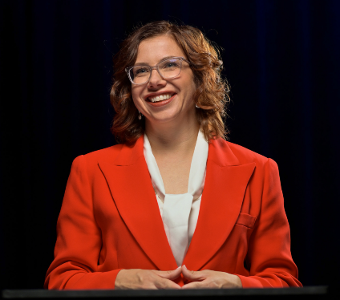
Amanda Rishworth was elected to the Federal Parliament as the Member for Kingston in Adelaide’s southern suburbs in 2007. Prior to becoming Minister for Social Services, she served as a Parliamentary Secretary in the Gillard government focused on disability, carers, environment, and water. In opposition Amanda served as an Assistant Minister in the education portfolio, Shadow Minister for Veterans’ Affairs and Defence Personnel and Shadow Minister for Early Childhood Education and Youth. Raised in Adelaide, Amanda attended local state schools before graduating with a Bachelor of Psychology Honours from Flinders University and a Master’s in Psychology from Adelaide University. Before entering politics, she practiced as a psychologist working with General Practitioners in the delivery of mental health care to the community and served as the Federal President of Young Labor. Her diverse portfolio encompasses issues including women’s safety, social security, delivering an Early Years Strategy, providing support for pensioners, improving the lives of Australians living with disability and tackling the harm caused by online wagering. Amanda is passionate about improving the lives of all people living in Australia and contributing towards a more inclusive and equitable society. She is particularly committed to progressing disability employment outcomes and supporting people with disability to build their careers.
Kelly Ford, A/Director Disability and Reform Department of Premier and Cabinet,
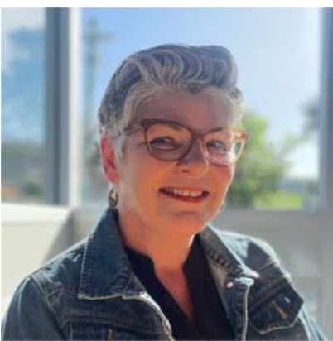
Kelly Ford currently serves as the Acting Director of Disability and Reform at the Department of Premier and Cabinet in Tasmania. Working for over 30 years in human services and 15 years specifically in the disability sector, Kelly has extensive experience in this field. Graduating from University of Tasmania (UTAS) in 1990, Kelly started her career in adult education before transitioning to employment and training. Over the past 15 years, she has held significant roles, including Disability Ministerial Adviser, Director at the National Disability Insurance Agency (NDIA) during its early stages in Tasmania, and Operations Manager for a NDIS provider.
Jane Wardlaw, Tasmanian Disability Advocate and Consultant Member of Tasmania’s Ministers Disability Consultative Group
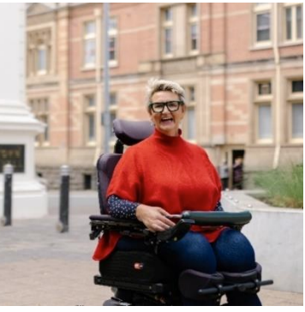
Jane Wardlaw, a Launceston-based advocate, promotes Disabled people's rights to self-determination through systemic advocacy, focusing on embedding human rights in disability practice. She's a board director for a large Tasmanian disability service provider. Jane is undertaking a PhD at the University of Tasmania, researching NDIS policy and support coordination practice, including for people with neuromuscular conditions—a personal cause, as she and her sisters live with this condition. She strives to work collaboratively to influence legislation, policy, and practice that value people with disability and help them flourish.
Ian Barry, Member Tasmanian Ministers Disability Consultative Group
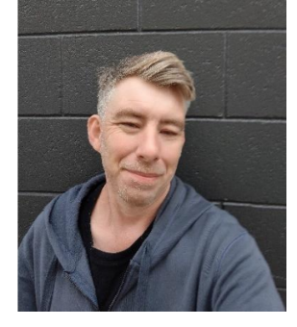
Ian currently resides in Devonport, Tasmania. Ian identifies as a person with disability. Ian believes that knowledge is empowering and strives to make a positive impact through education, advocacy and helping people understand their rights.

The Hon Jo Palmer MLC, Tasmanian Minister for Disability Services
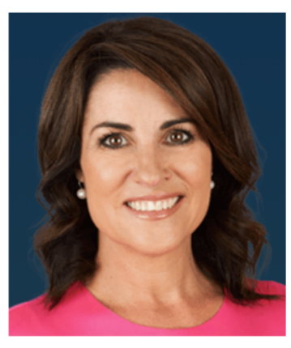
Jo Palmer MLC was born in Christchurch, New Zealand, and moved to Tasmania as a baby after being adopted by an Australian family. Jo served Tasmania for 20 years as a trusted journalist and news reader for Nightly News channel 7 in Tasmania. Originally employed by the station in Hobart as a journalist, she is a former Miss Tasmania and in 1993 she was awarded Miss Australia. Jo presented the hour-long Nightly News for 18 years. Jo was elected to the Legislative Council in August 2020, representing the electorate of Rosevears. Rosevears covers the West Tamar area from Greens Beach and Beauty Point down through to Riverside, as well as the Launceston suburbs of Trevallyn, West Launceston, Summerhill, and Prospect. Jo has supported the community in Ambassador roles for sick or traumatised children, people with disability and medical research. She is a Tasmanian of the Year recipient for her charity work. Jo was appointed to Deputy Leader of the Legislative Council in May 2021 and has served on various committees including a Select Committee on Taswater, Deputy Chair Committee for Disability Services in Tasmania, Road Safety in Tasmania Select Committee and Joint Standing Committee on Integrity. In April 2022 Jo was sworn in as Minister for Women, Minister for Primary Industries and Water and Minister for Disability Services. Since then, she has also held the portfolios of Minister for the Prevention of Family Violence and Minister for Community Services. She now serves as Minister for Education and Minister for Disability Services.
Mary Mallett, Tasmanian Interim Disability Commissioner
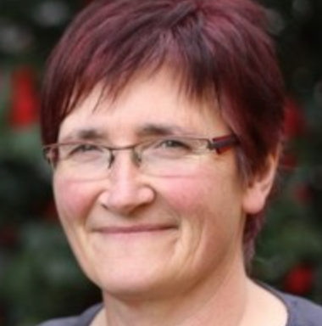
Mary Mallett is the Tasmanian Interim Disability Commissioner, having served in the role since January 2023. She is leading work to establish the new Office of the Disability Commissioner; including scoping the Commissioner’s role and functions, the resources required, legislative framework, and relationship to other statutory offices in Tasmania as well as connections with the disability community and sector. Mary was previously the CEO of Disability Advocacy Network Australia (DANA) based in Canberra, the national peak body for independent disability advocacy in Australia.

Cody Summers, Pakana man
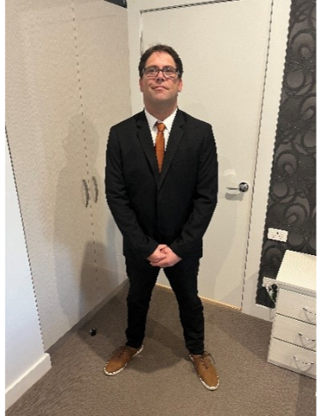
Cody Summers is a Pakana Trawlwoolway man whose heritage comes from the Maynard, Mansell, and Beeton families, from Cape Portland, Tasmania. Cody lives in nipaluna Country/Hobart, working with his Elders to support them in sharing their cultural knowledges through engagement for better health and wellbeing outcomes.

Jodi Cassar, ADS Branch Manager Department of Social Services Australian Government
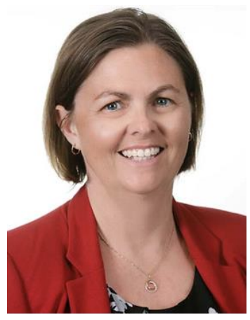
Jodi Cassar is a proud Kamilaroi descendant and a successful leader in the public and private sector for over 25 years. For Jodi, public service is all about coming together and working towards a common goal. She has overseen large scale, user-centred transformation projects and led service delivery programs, including bushfire, flood and cyclone recovery, and cross-government response to COVID-19. In 2023, Jodi became an Australia Day Honours List recipient for her outstanding public service and leadership working across government to deliver advice, information, and support for people with disability, disability workers, and carers during the COVID-19 pandemic. Her taskforce helped deliver 2.5 million vaccine doses and disability support pensions to NDIS participants and support the distribution of 3.3 million rapid antigen tests. Jodi is currently leading the implementation of ADS at DSS.
Chris Symmonds, Chair Tasmanian Premier’s Disability Advisory Council
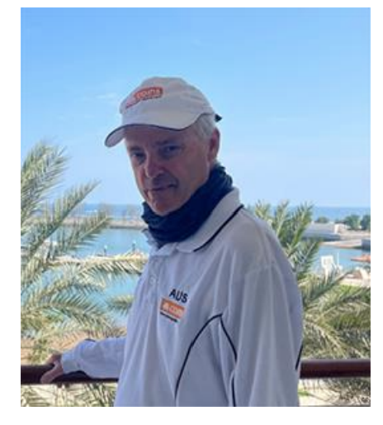
Chris is living with Kennedys Disease, a progressive Motor Neuron Disease without cure or treatment. He has been married to Fayellen for 44 years and has four children Nicole, Michael, Claire and Bronwen. A Boilermaker Welder by trade, Chris left employment in 2010 as a Senior Manager at Caterpillar Underground Mining, based in Burnie Tasmania and now focuses on his health, family, community, sailing, and self-managing his NDIS Plan. Chris volunteers his time to several Boards throughout Tasmania, Chairing Premier’s Disability Advisory Council, Commodore of Wynyard Yacht Club, President of Motor Neuron Disease Tasmania, Vice President of Sailability Tasmania and member of Australian Sailing Tasmania Regional Advisory Committee. Chris has been a sailor since the age of ten, a three-time World Champion who competes successfully at World, European, National, State and club level. Chris is the Current Para Sailor of the Year; an award won a record five times in succession. A high focus on physical and mental health, a positive attitude, combined with high moral values, and respect for others are key attributes.

Maryanne Lewis, Senior Policy Officer Disability and Reform
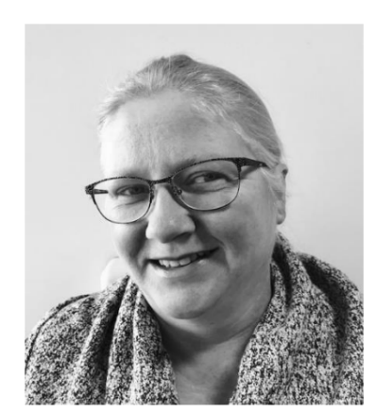
Maryanne is well known as a sensible and practical person, who solves problems and gets stuff done. She is highly regarded as a skilled communicator, using her perceptive and respectful approach to life to create a message that works for her audience. Maryanne has worked in the disability policy area for the Tasmanian Government for more than a decade. She is currently leading work on the Disability Inclusion and Safeguarding Bill and has responsibility for leading work relating to ADS, Tasmania’s Disability Strategy, and the Premier’s Disability Advisory Council. In the past, Maryanne has worked in community services policy, social and public housing policy, and social research. She has a master’s degree in social science (Social Research) and a Graduate Diploma in Counselling. Maryanne lives in Hobart with her husband and teenage daughters. She loves to sing, is learning to play the piano and crochet, and wants to spend more time at the shack when time permits. Maryanne lives with visual impairment and has a fabulous collection of hats.
Dr Katherine Elliston, Deputy Chair Tasmanian Premiers Disability Advisory Council

Katherine is the Deputy Community Chair of the Premier’s Disability Advisory Council Tasmania and is the Tasmanian representative on the Australian Disability Strategy Advisory Council. Katherine volunteers for a governance team running a specialist disability accommodation site and is involved in various mental health and community organisations. Katherine is passionate about ensuring people with disability have opportunities to participate in everyday life. Katherine holds a PhD in Psychology from the University of Tasmania, her research focused on individual and environmental influences on behaviour change. Professionally, Katherine works with children and adolescents as a psychologist, she has worked in Behaviour Support for a number of years. Through her work, she aims to foster collaboration and support among the various systems people with disability encounter. Katherine works to reduce systemic barriers to participation in society and serves to empower people with disability to create meaningful lives. In her personal life, Katherine supports her younger brother, who lives with a cognitive impairment. Growing up around disability has taught her the importance of accessible and inclusive practices and the need to foster independence and choice wherever possible. Katherine believes this is particularly relevant in rural communities where access to formal supports is lacking.

Appendix B

Program
10:00am Morning Tea and Registration
10:30am Welcome to Country
10:35am Acknowledgement of Lived and Living Experience
10:40am Introduction: Manisha Amin and Jane Wardlaw, Co-Facilitators
10:50am Opening Remarks from Kelly Ford, A/Director, Disability and Reform, Department of Premier and Cabinet, Tasmania
11:00am Address by Mary Mallett, Tasmanian Interim Disability Commissioner
11:10am Workshop: ‘Good Practice Inclusive Communication and Engagement’
12:30pm Lunch
1:15pm Morning Overview: Manisha Amin and Jane Wardlaw
1:25pm The Hon Jo Palmer MLC, Tasmanian Minister for Disability Services
1:40pm Panel and Q & A: ‘Good Practice Consultation with People with Disability
within the context of Government’
2:45pm The Hon Amanda Rishworth MP, Minister for Social Services and NDIS
2:55pm Closing Remarks: Manisha Amin and Jane Wardlaw, Co-Facilitators
3:00pm Close of Day.


