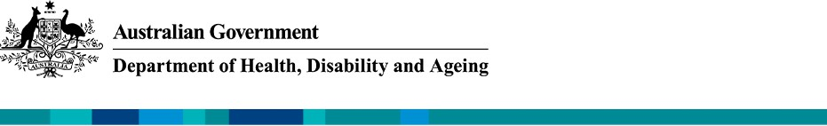

ADS Advisory Council
June 2025 Update

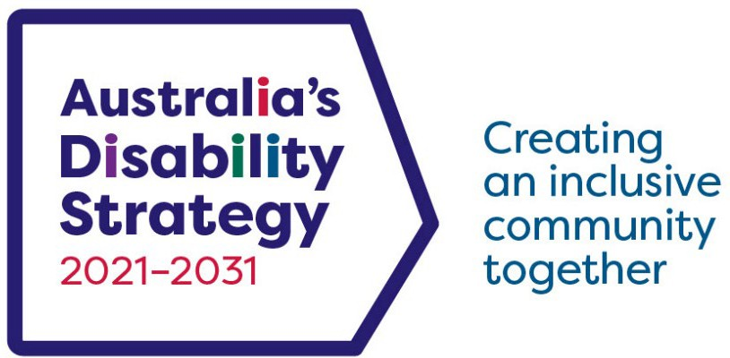

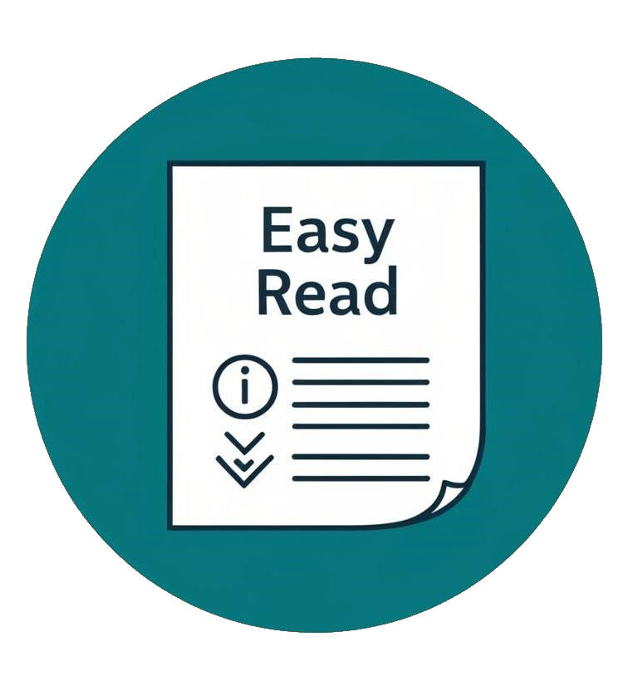

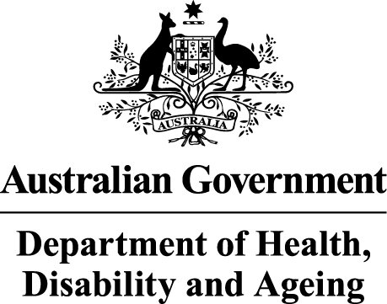
The Australian Government Department of Health Disability and Ageing wrote this.

We say DHDA for short.

When you see the word we it means DHDA.


We wrote this in an easy to read way. We use pictures to explain some ideas.


We have some words in bold.

This means the letters are thicker and darker. These are important words.

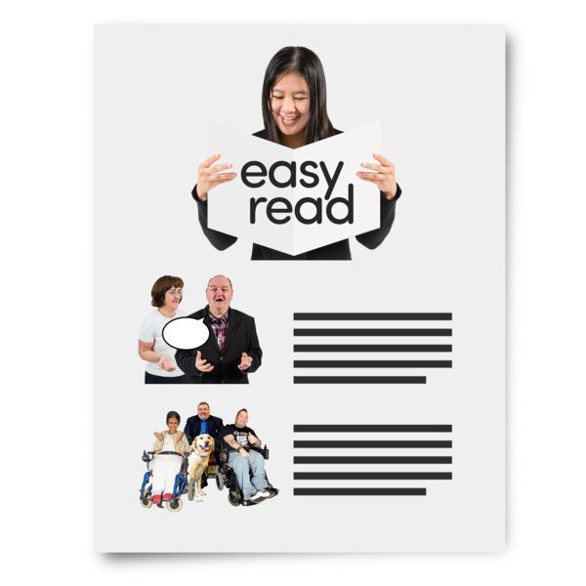
This is an Easy Read summary of another document.

This means it has the most important ideas.


We can answer any questions by email. Email us ADSAdvisoryCouncil@health.gov.au

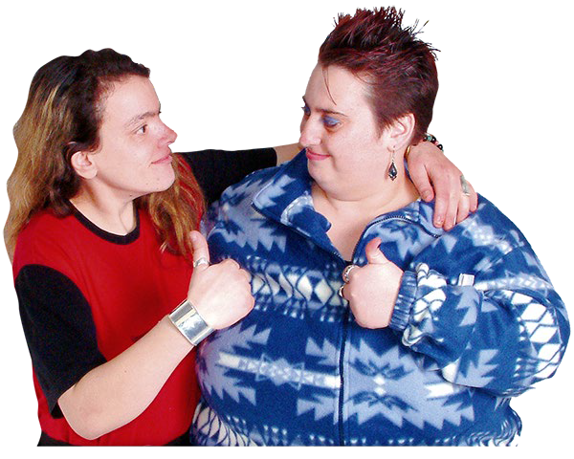
You can ask for help to read this document. You can ask
- A friend
- Family members
- A support person.

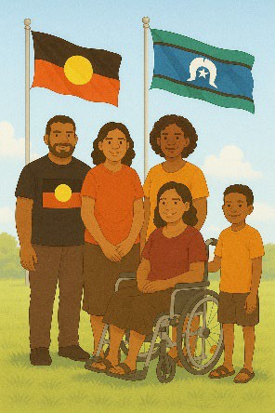
We recognise Aboriginal and Torres Strait Islander people as the Traditional Owners of the land we live on.

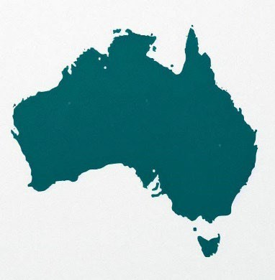
They were the first people to live on and use the

- Land
- Waters.

Contents

Australia’s Disability Strategy | 5
ADS Advisory Council | 6
About the meeting | 8
Machinery of government changes | 13
2025 Workplan | 16
First Nations Disability Forum | 18
ADS Outcomes and Accountability | 23
NDIS RAC | 25
Accessible Information and Communication Plan | 26
AHRC presentation | 28
Toolkit for Engaging with people with disability | 29
Accessible air travel | 30
Disability Minister | 32
The next meeting | 36

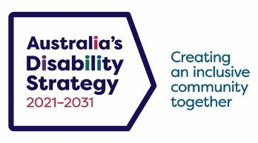
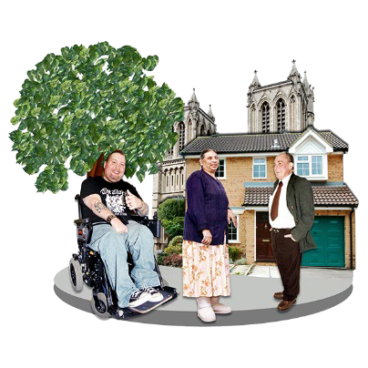

Australia’s Disability Strategy

Australia’s Disability Strategy is a plan to make life better for people with disability.

We call it ADS.
ADS is important for Australia to be more
inclusive.

Inclusive means everyone can take part.
This makes everyone in our community feel welcome.

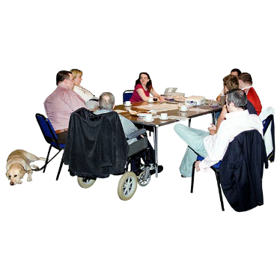
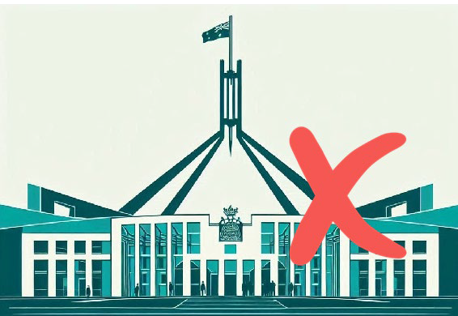
ADS Advisory Council

The ADS Advisory Council gives advice about ADS to

- The Australian Government
- State and territory governments
- Local governments.

We call it the Council.
The Council is not part of the government.
The Council helps governments understand how to

- Use ADS
- Share reports about ADS
- Work towards the goals of ADS.

Goals are things you want to do.

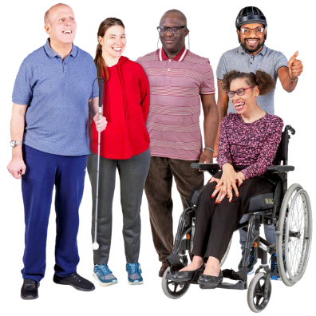
The Council includes people

- With disability
- Who understand barriers for people with disability.


A barrier is something that stops you from doing what you

- Want
- Need.


The Council writes information about what they talked about in their meetings.

We share important information with the community.

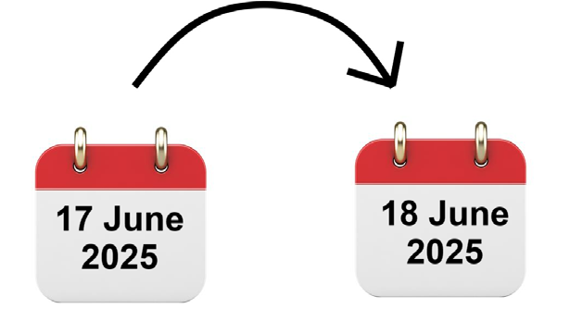
This information is about the Council meeting on

- 17 June 2025
- 18 June 2025.

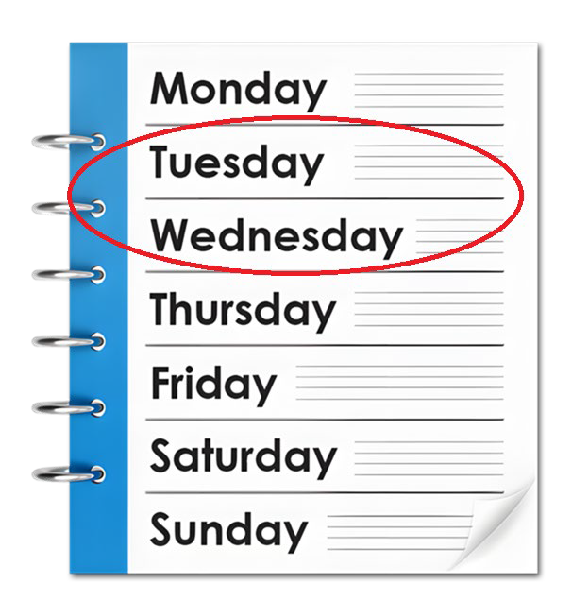

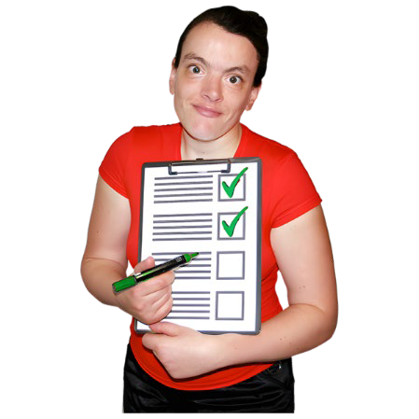

About the meeting

The meeting

- Went for 2 days
- Was in Sydney.
The Council talked about

- Actions and outcomes for the March 2025 meeting

Actions are the things that we will do.
Outcomes are the things we see when our plans are working.

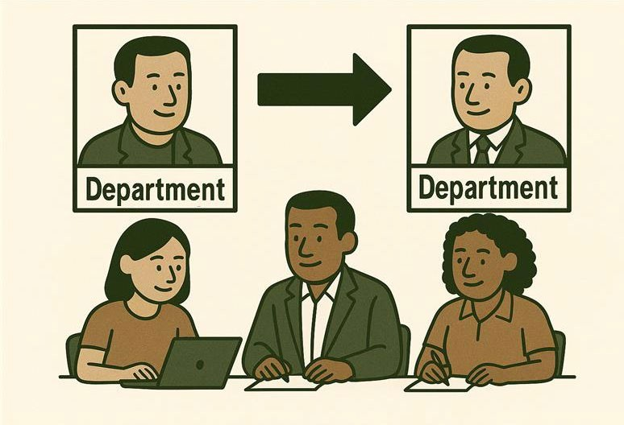
- Machinery of government changes

Machinery of government is when there is a change with who is responsible for the work being done.

It might mean a different minister now needs to do the work.

We call it MoG for short.


Ministers are leaders in an area of the government.

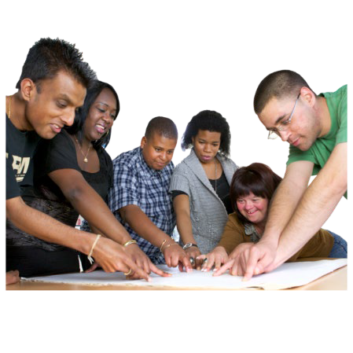
- The Councils Workplan for 2025

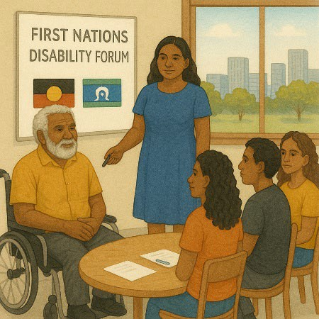
- Making the First Nations Disability Forum

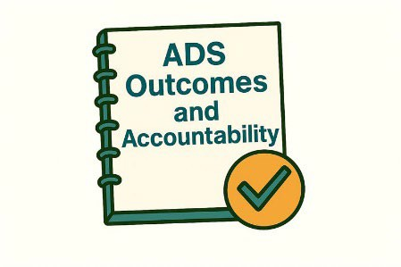
- ADS Outcomes and Accountability

Accountability is taking responsibility for your actions.

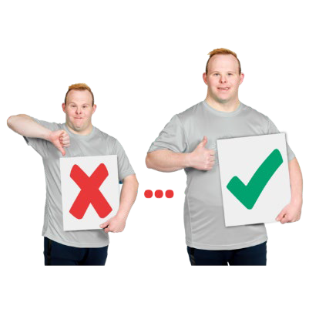
- NDIS Reform Advisory Committee

Reform means making changes to make something better.

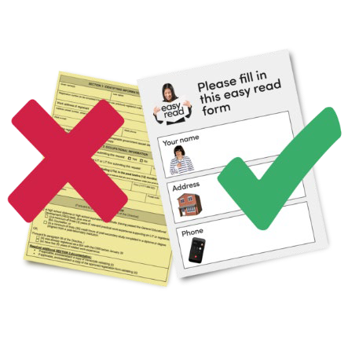
- Accessible Information and Communication Plan

Accessible communication is information that everyone can use.

Like Easy Read.


- Australian Human Rights Commission presentation

We call it AHRC for short.

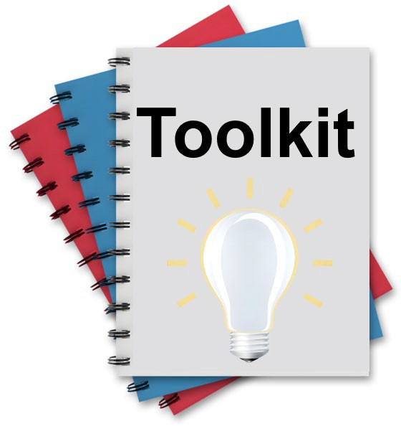
- Toolkit for engaging with people with disability

A toolkit is

- Information
- Strategies
- Ideas.

All of them can be used to make a plan.

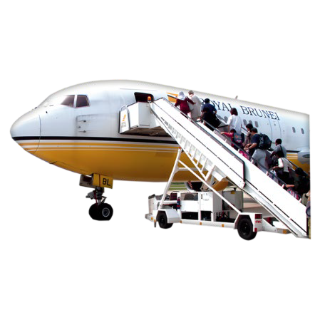
- Accessible air travel

Accessible means everyone can use it.

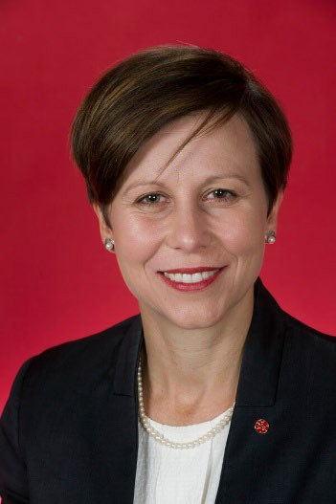
- The Disability Minister.

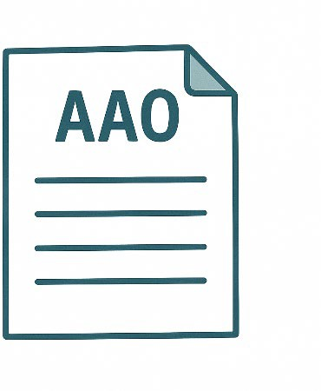
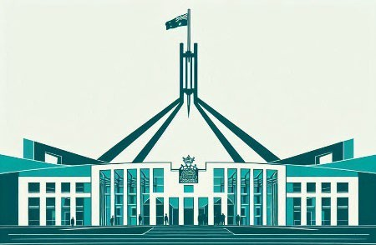
Machinery of government changes

Machinery of government is when there is a change of who is responsible for the work being done.

It might mean a different minister needs to do the work.

We call it MoG for short.
The government makes the changes by putting out new Administrative Arrangement Orders.

We call them AAO for short.
AAOs say which minister is responsible for work done by the government.


The Council talked about the changes for the disability work in the government.

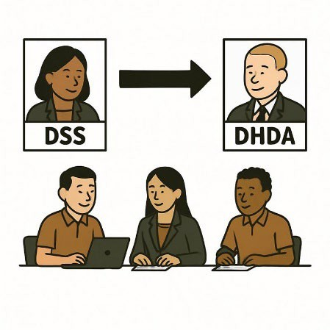
This could be moving the disability work to Department of Health Disability and Ageing.

We call it DHDA for short.

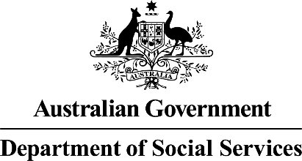
Department of Social Services will still do the work for disability employment.

We call it DSS for short.

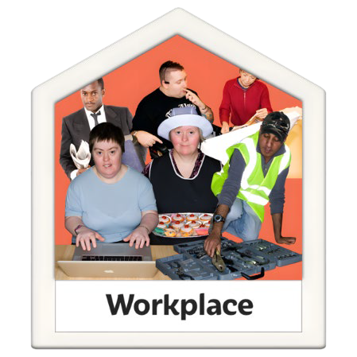
Employment is

- Having a job
- Going to work
- Getting money for the work you do.

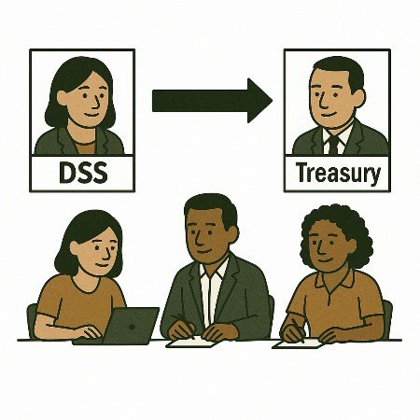
The government work for housing will move to the Department of Treasury.

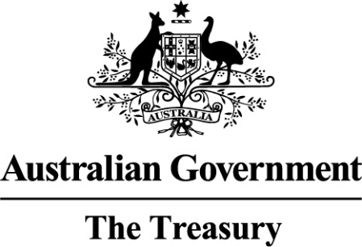


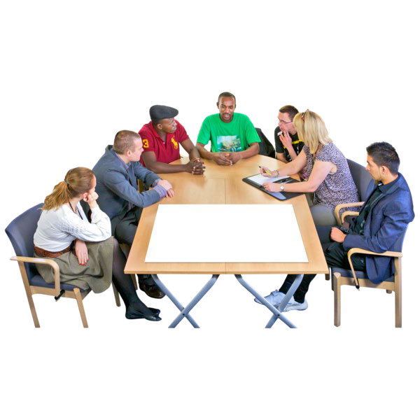
2025 Workplan

The Council has a 2025 Workplan.

It says all the things the Council will do in 2025.
The Disability Reforms Ministerial Council
approved the Workplan.

We call them DRMC for short.
The DRMC is a group of Disability Ministers from

- The Australian Government
- State and territory governments.

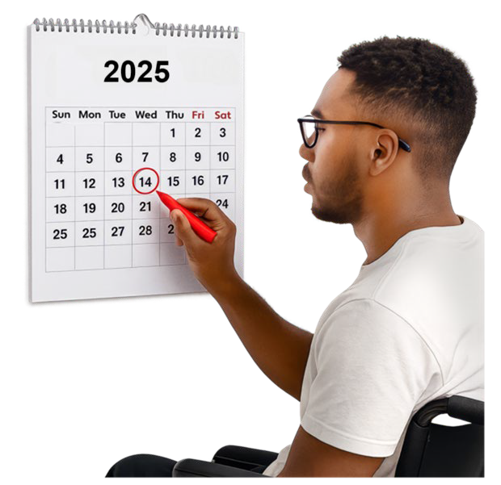
The Council will have 2 more meetings in 2025.

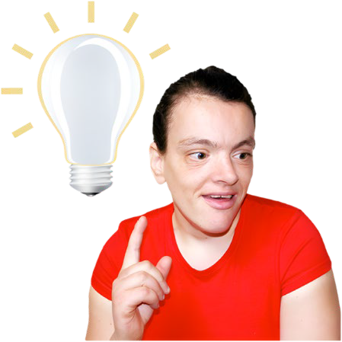
The Council talked about

- Ideas for other Council meetings

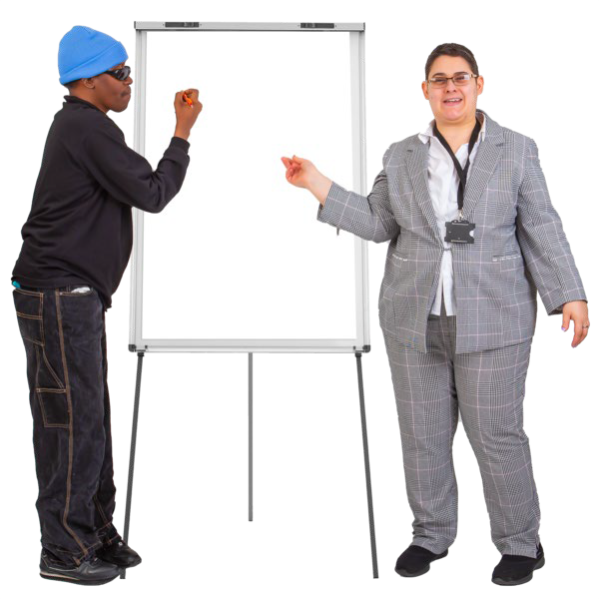
- Ideas for Council workshops

A workshop is when a group of people meet to talk about something.

First Nations Disability Forum

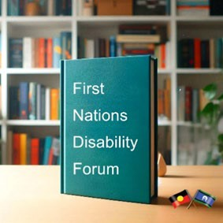
The Council gave informal advice to DSS about the First Nations Disability Forum.

Informal advice is when experts give their ideas.

Experts are people who know a lot about something.


The Council

- Agreed to the advice

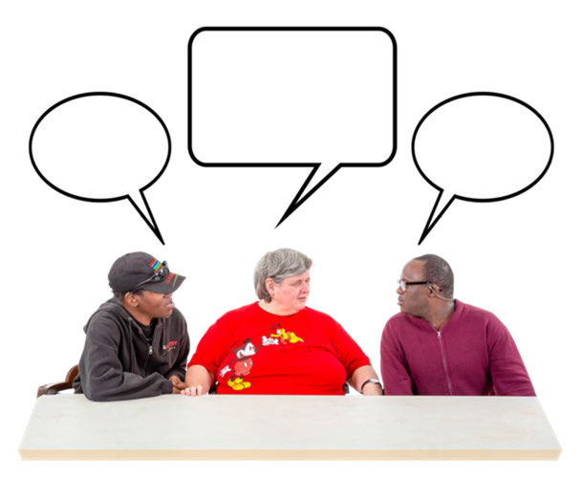
- Added more ideas to the advice.

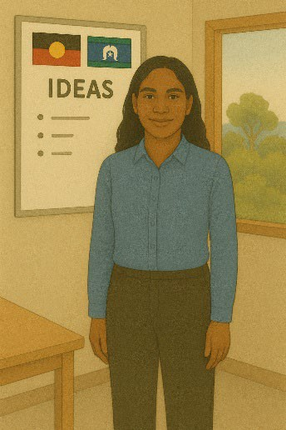
The advice the Council gave is

- The Council needs to support the views of First Nations people with disability with ADS.

The Council can use data to help do this.


Data is

  - Facts
  - Information
  - Records.

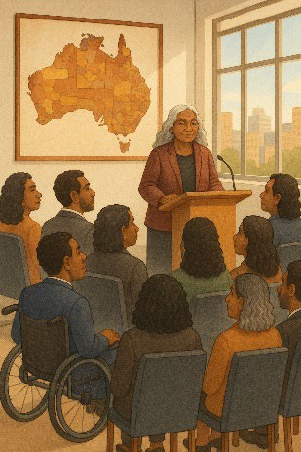
The Council needs to know how First Nations people want their views to be supported.

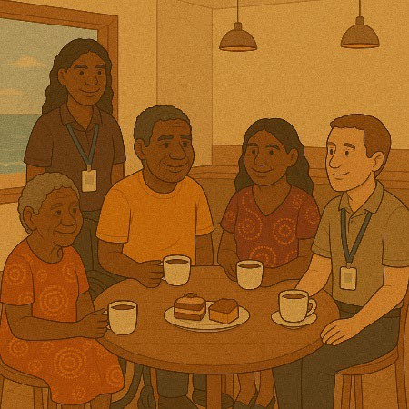
- There needs to be better support for First Nations communities to understand ADS.

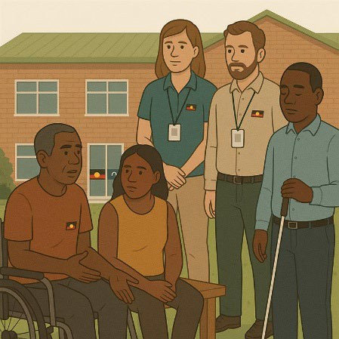
This could be understanding the challenges for Aboriginal and Torres Strait Islander communities.

Challenges are hard things.

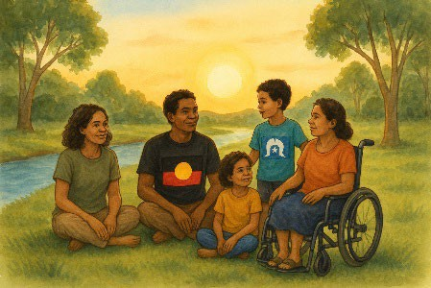
This can look different for people who live in

- Regional areas
- Remote areas.

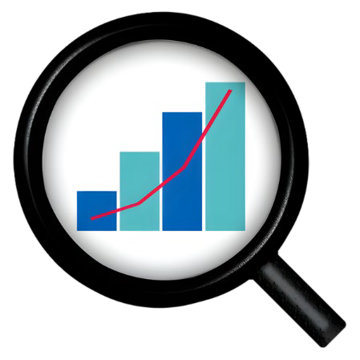
- Understanding different data to check if ADS is working

It is important to break the data down to smaller groups like

- First Nations people
- People with disability.

This helps us know if ADS is working for all people with disability.


The Council can help by sharing indicators
for

- ADS Outcomes Framework

A framework is how we will do something.

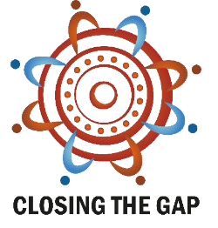
- National Agreement on Closing the Gap.


Indicators are types of information in the data.

This helps us match the same type of information in different data.

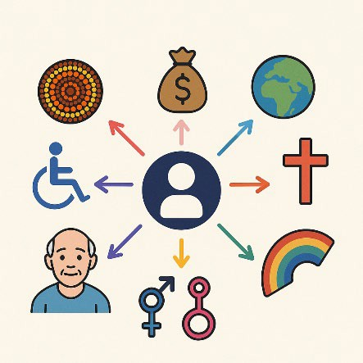
  - Understanding how to support people with disabilities and the different parts of who they are.

This might change what their experience is like.

This is called intersectionality.

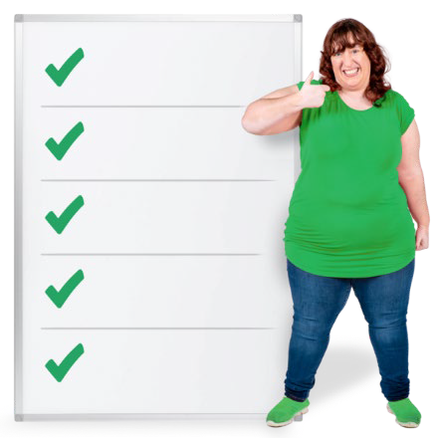
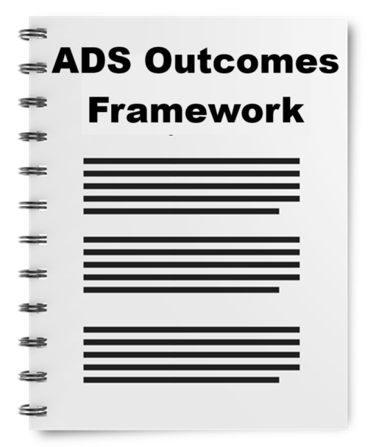
ADS Outcomes and Accountability

The Council got information about

- ADS Outcomes and Accountability.
This says what the Council

- Needs to do for ADS
- Plans to follow.
Different plans help the Council do their work like

- ADS Outcomes Framework

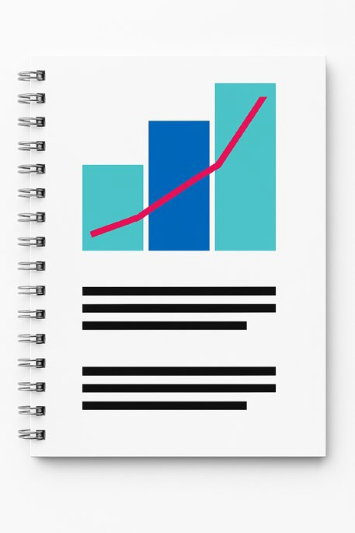
- The Data Improvement Plan.


It also says how ADS need to do their reports.

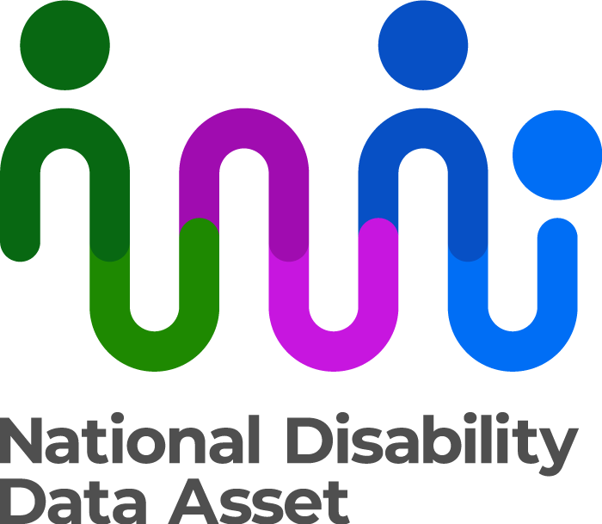
This could be reporting for

National Disability Data Asset

We call it the data asset for short. It can also be called NDDA.

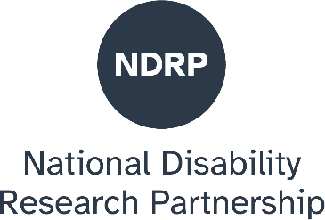
National Disability Research Partnership

We call it NDRP for short.

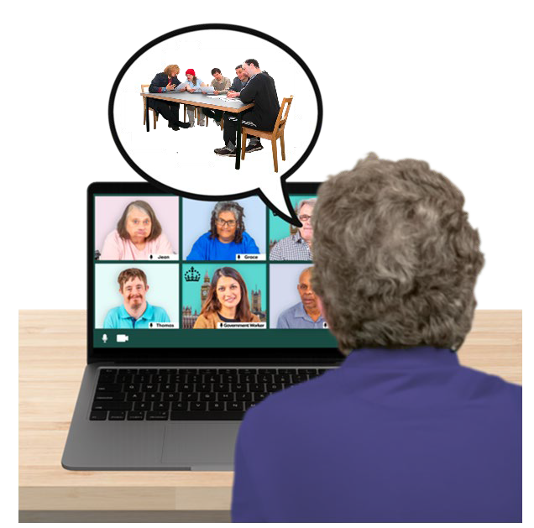
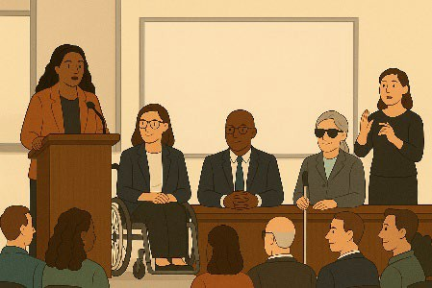
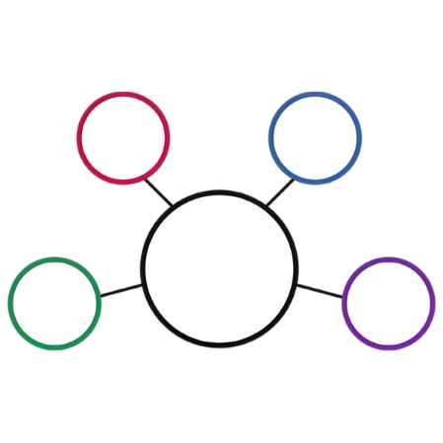
NDIS RAC

- El Gibbs
- Dougie Herd Talked to the Council.
They are the Co Chairs of the NDIS Reform Advisory Committee.

We call it NDIS RAC for short.
The Co Chairs are the leaders of the group.
They talked about the work of

- NDIS RAC
- The Council

That are the same.

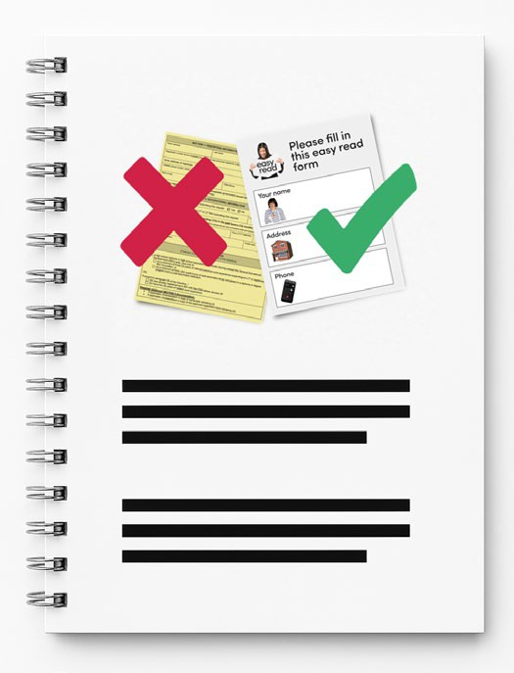
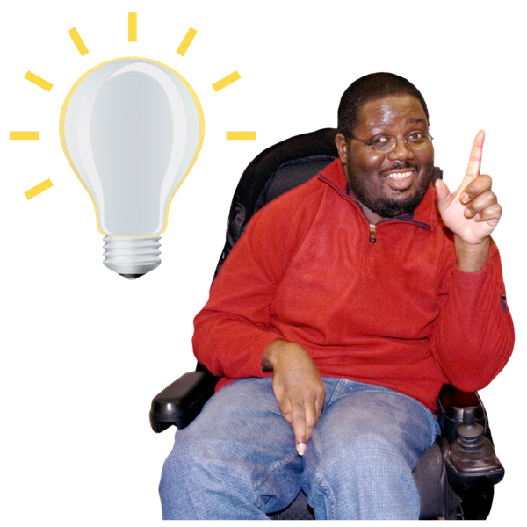
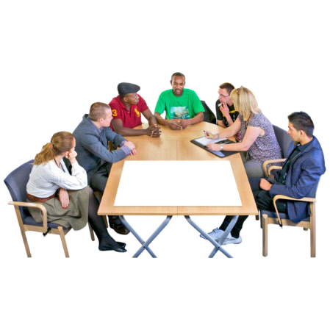
Accessible Information and Communication Plan

The Council got information about

- The Accessible Information and Communications Associated Plan.
This helps do work on the recommendations
of the Disability Royal Commission. We call it DRC for short.
Recommendations are ideas to do things better.
This also had information about

- Disability Communications Working Group

We call it DCOM WG for short.

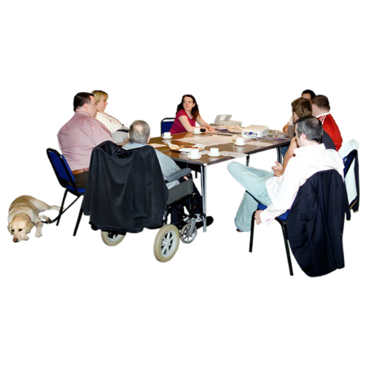
Accessible Communications Technical Advisory Group

We call it AC TAG for short.

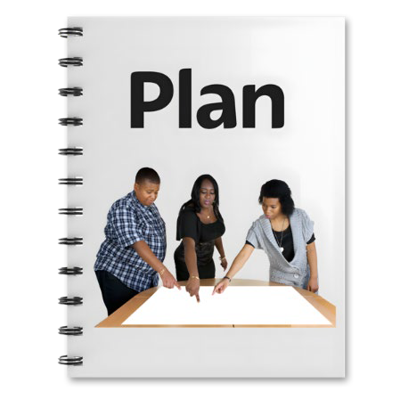
- What work the government is doing on the plan.

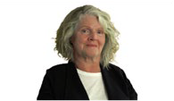
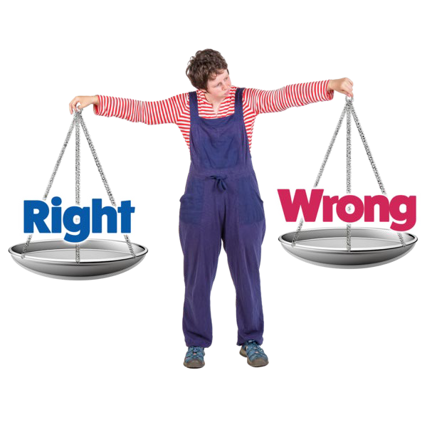
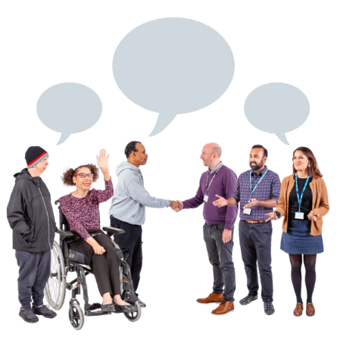
AHRC presentation

Rosemary Kayess gave a presentation.

Rosemary is the AHRC Disability
Discrimination Commissioner.
Discrimination means treating someone unfairly because of something about them they can not change.

Like they have a disability.
A Commissioner is the person in charge in an area of the government.
Rosemary talked about areas to work together for

- The Council
- AHRC.

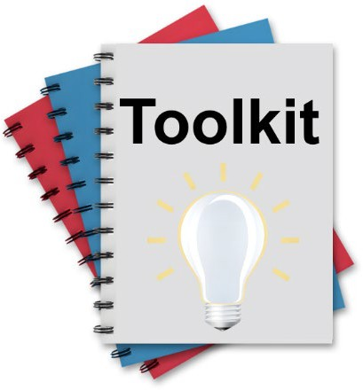
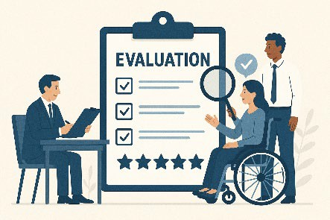
Toolkit for Engaging with people with disability

The Council gave ideas for the

- Toolkit for Engaging with People with Disability in Evaluation.
Evaluation means you look at what

- Went well
- Could be done better.

You can do an evaluation of a

- Service
- Program
- Plan.
There was an update on the first
independent ADS evaluation.

Independent means separate to the government.

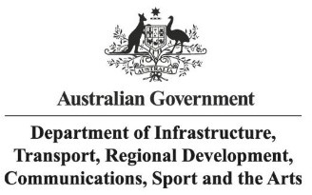
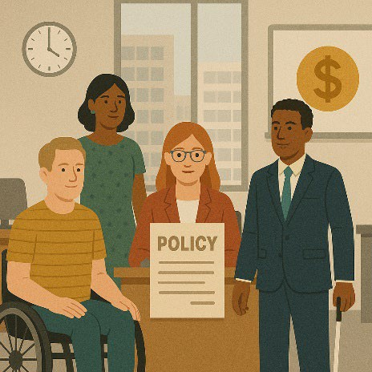
Accessible air travel

The Department of Infrastructure Transport Regional Development Communications Sport and the Arts gave a presentation.

We call it DITRDCSA for short.
The presentation was about

- Accessible air travel

Air travel means going by plane.
- Aviation White Paper

The Aviation White paper talks about the policies for air travel.

Policies are plans for how to do things.

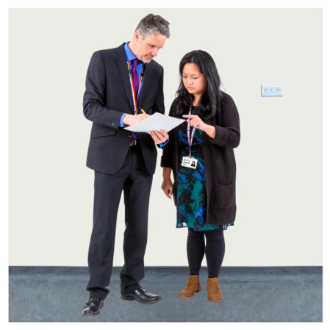
- Making new disability standards for air travel.

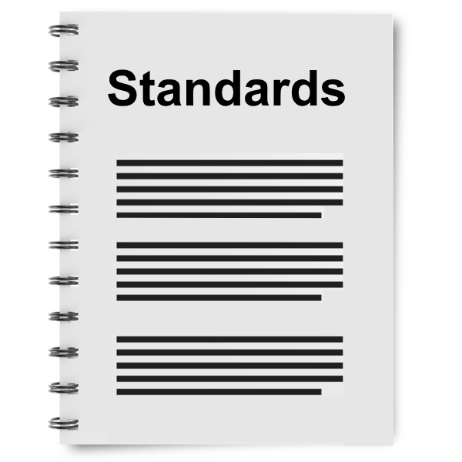
Standards are rules that people need to follow for something.

It makes sure that everyone is doing the same good work.

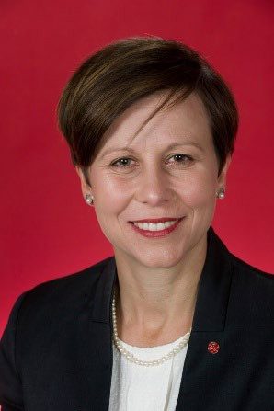

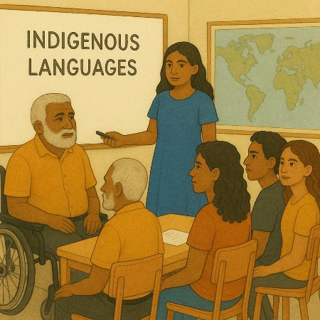
Disability Minister

The Council met with the Disability Minister Jenny McAllister.

Jenny is responsible for the NDIS.
Jenny was interested in the Councils work.

She asked what they thought about the work the government is doing to support people with disability.
The Council gave ideas about

- Challenges for Torres Strait Islander people with disability getting NDIS

It can be hard if information is not in your language.

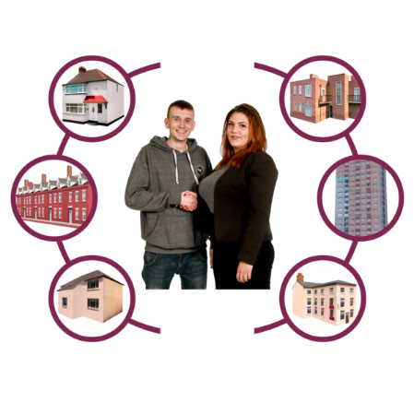
- The government making more accessible housing

It is important to be done by universal design.

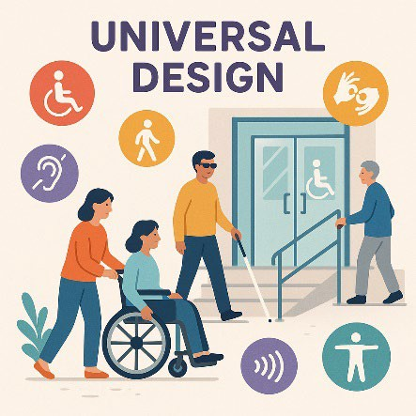
Universal design is making

- Things

Environments

Accessible for everyone.


The environment is everything around us.

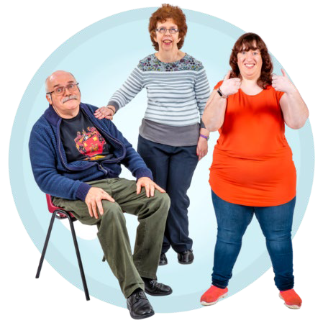
- For the government to give more information about supports that are not part of the NDIS


This is important for

Migrants

Migrants are people who move from 1 place to another.

They do it for a better

- Life
- Job.

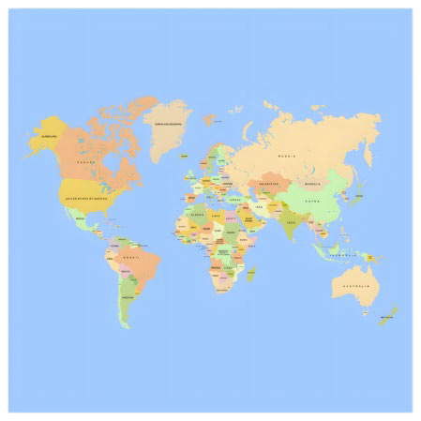
Refugees

Refugees are people who have to leave their country.

They do it because of

- War
- They are treated badly

Natural disasters.

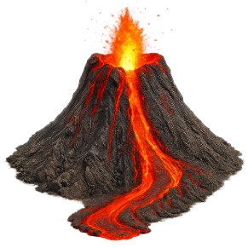
Natural disasters are things like

- Cyclones
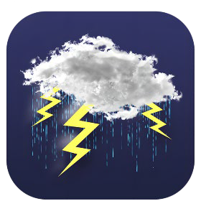
- Earthquakes
- Floods
- Volcanoes.

There are barriers to the government supporting these communities.

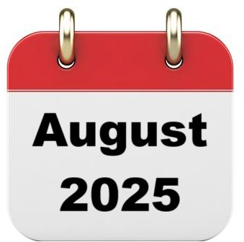


The next meeting

The next Council meeting will be in August 2025.
You can go to the Council website if you need more information.

www.disabilitygateway.gov.au/ads/advisory- council
You can email us. ADSAdvisoryCouncil@health.gov.au

Images in this Easy Read must not be used or copied without permission

