Australia’s Disability Strategy

Evaluation Toolkit
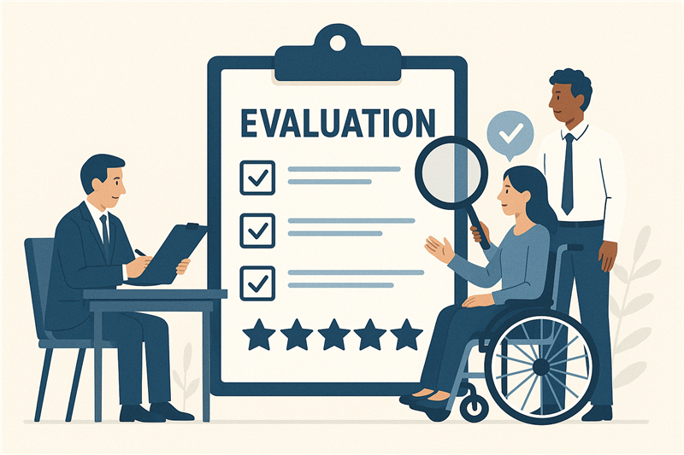

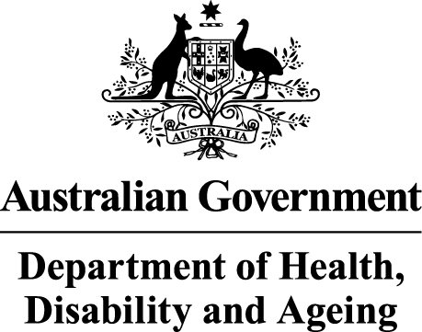 | The Australian Government Department of Health Disability and Ageing wrote this.  We say DHDA for short.  When you see the word we it means DHDA.
 | We wrote this in an easy to read way.  We use pictures to explain some ideas.
 | We have some words in bold.  This means the letters are thicker and darker.  These are important words.
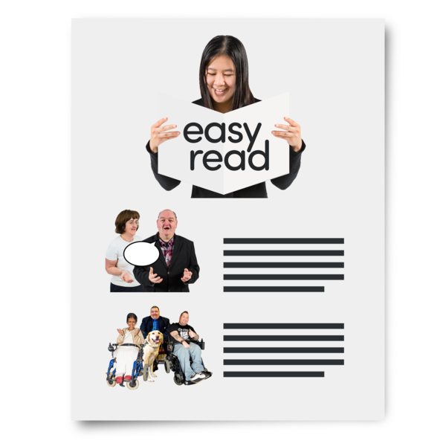 | This is an Easy Read summary of another document.  This means it has the most important ideas.
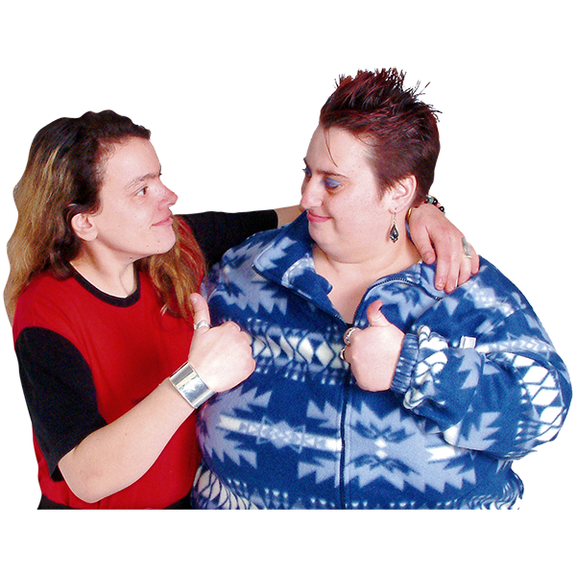 | You can ask for help to read this document.  You can ask  - A friend  - Family members  - A support person.
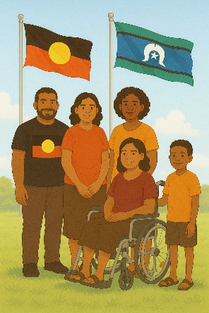 | We recognise Aboriginal and Torres Strait Islander people as the Traditional Owners of the land we live on.
 | They were the first people to live on and use the  - Land  - Waters.

Contents

How we made the toolkit | 5
What is evaluation | 8
Evaluation stages | 9
For people with disability | 11
For evaluators | 13
Fact sheets | 17
Checklists | 20
Contact us | 22

How we made the toolkit

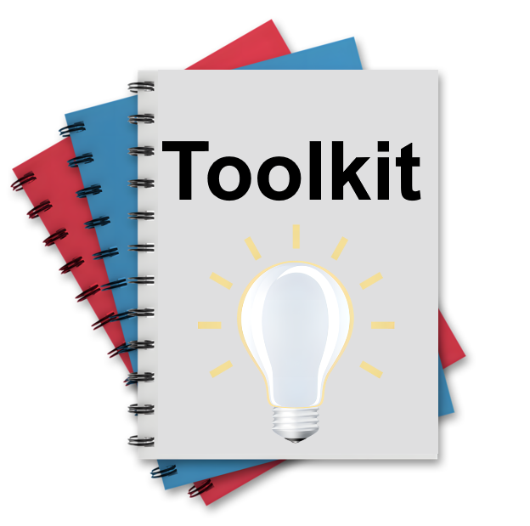 | We made a toolkit.  A toolkit is  - Information  - Strategies  - Ideas.  All of them can be used to make a plan.
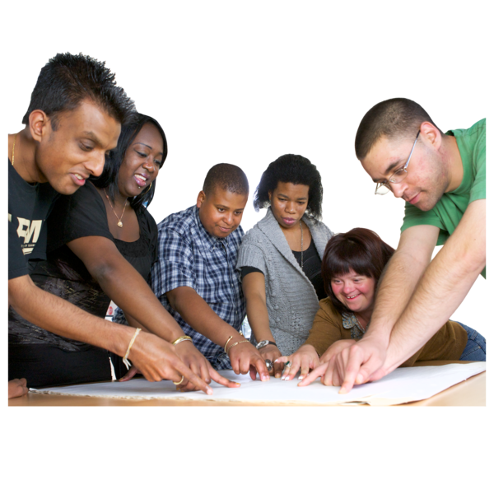 | Lots of people helped us make the toolkit.
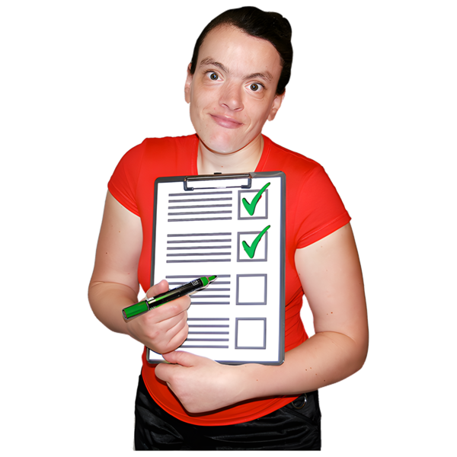 | We wanted to make the toolkit  - Accessible  - Inclusive.
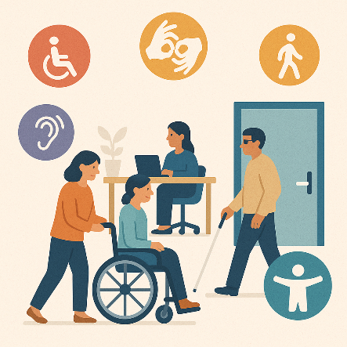 | Accessible means everyone can use it.
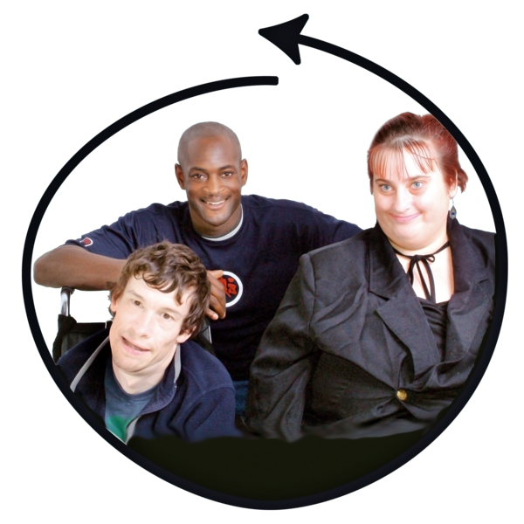 | Inclusive is when everyone  - Can take part  - Feels like they belong.
 | We listened to ideas from  - People with disability
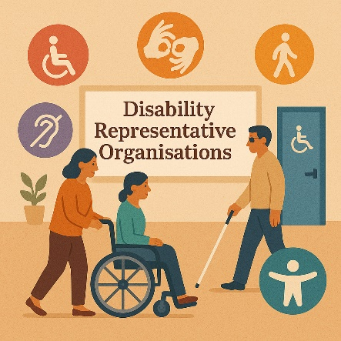 | - Disability Representative Organisations  We call them DRO for short.
 | - People who do research  Research means  - Finding out what people think about things  - Using the information to help others.
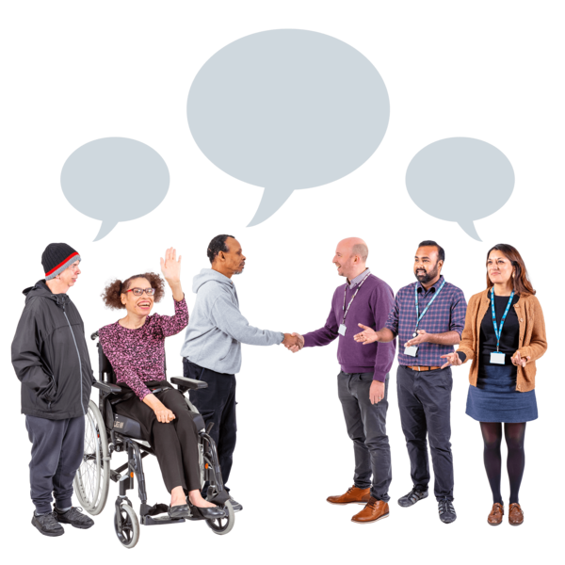 | - The community
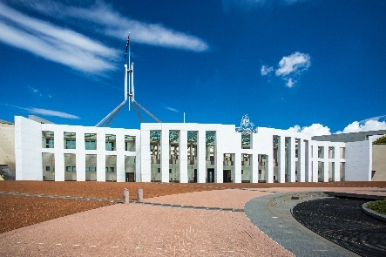 | - People who work for the government.

What is evaluation

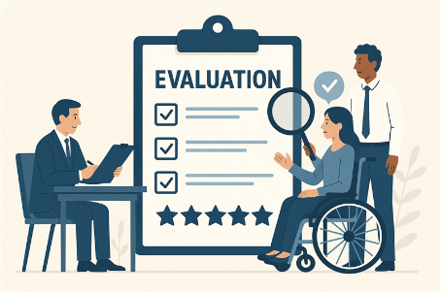 | Evaluation means you look at what  - Went well  - Could be done better.
 | Evaluation helps us know if our plans are working.
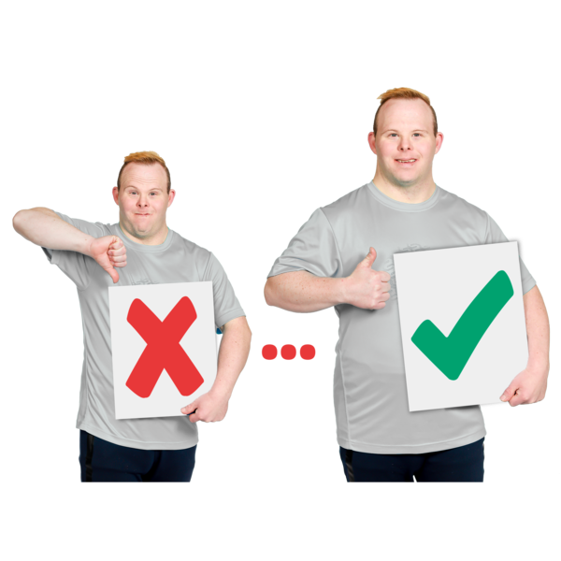 | Evaluation helps us to make things better for people with disability.  This means they get the right support.
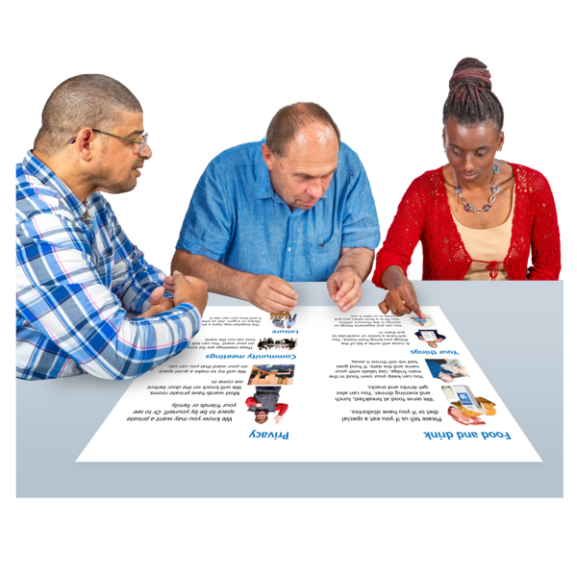 | Good evaluation should be  - Accessible  - Inclusive  For people with disability.

Evaluation stages

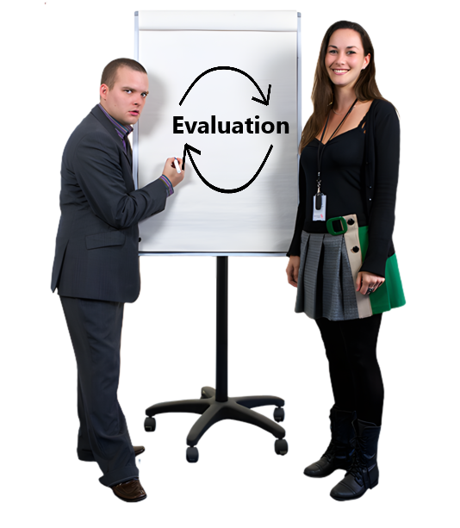 | Evaluation has different stages.  Stages means different steps that need to be done.
 | There are 3 main stages.  - Planning the evaluation
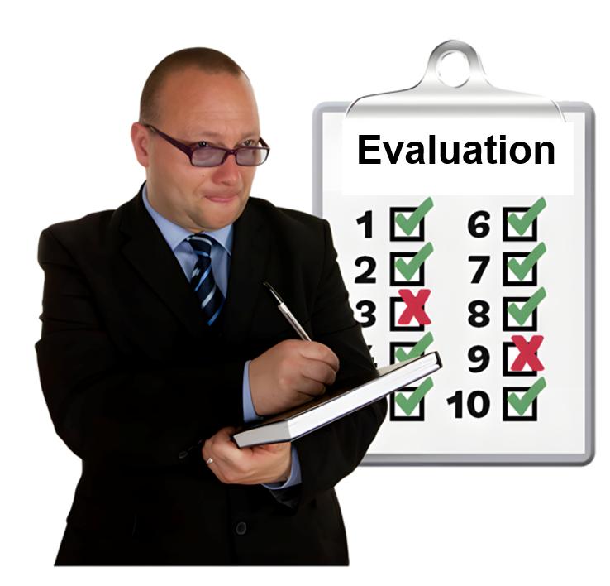 | - Doing the evaluation
 | - Saying what you found in the evaluation.  This is called an evaluation report.
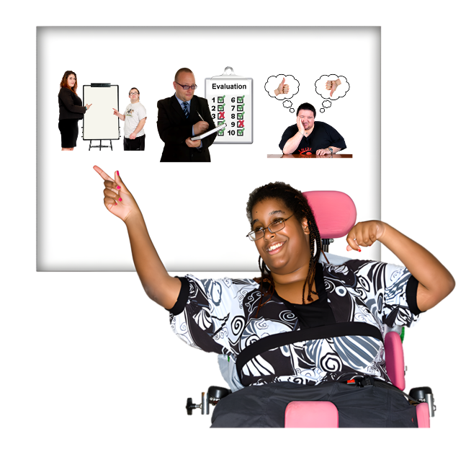 | You might be involved with  - Some parts  - All parts.
 | You might have different ways to take part in evaluation.

For people with disability

 | You know a lot about your  - Life  - Experiences.
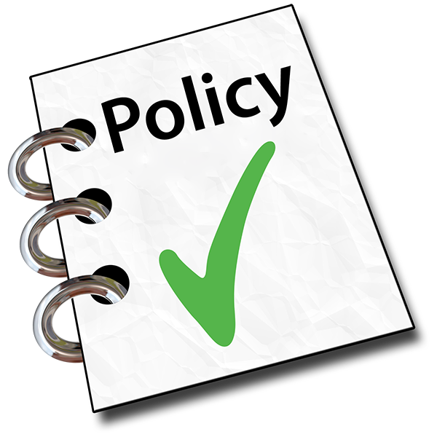 | This helps you give ideas about  - Policies  Policies are plans for how to do things.
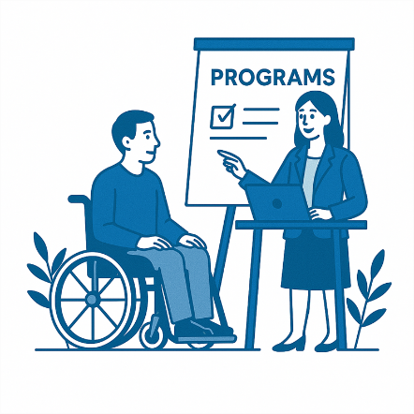 | - Programs  Programs are done to support people in the community.
 | - Services.
Your ideas help make them more

- Accessible
- Inclusive.
Your ideas will help to know if things

- Are working
- Need to change.
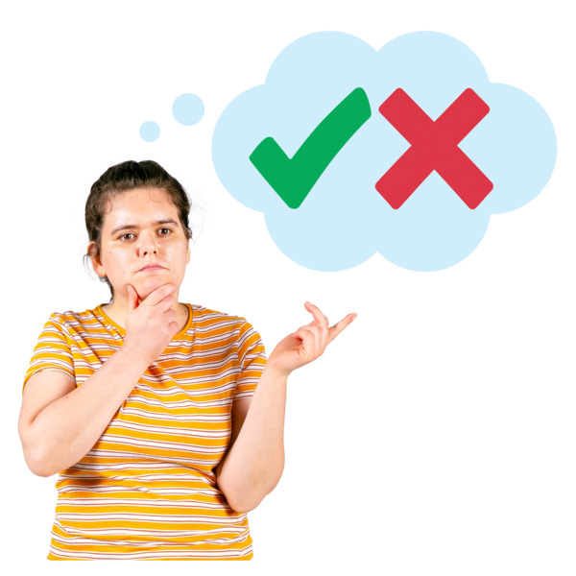 | You can choose to be involved in the evaluation.  You do not have to.

For evaluators

 | The people who do evaluation are called evaluators.
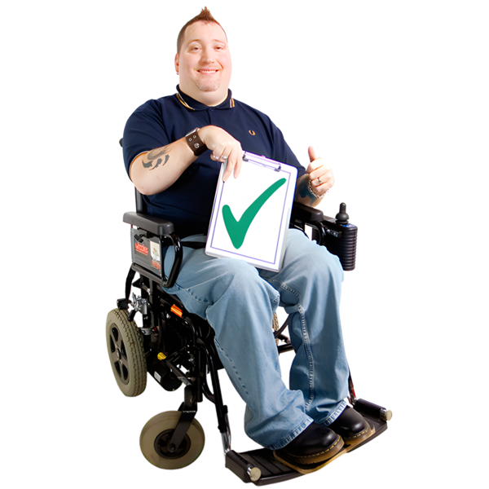 | People with disability have said they want to be involved in evaluation.
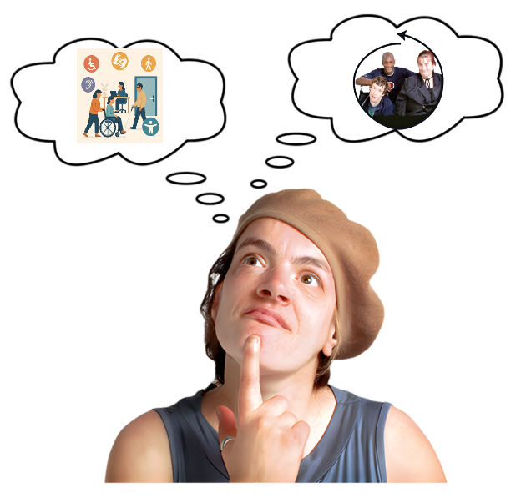 | It is important that from the start evaluators make things  - Accessible  - Inclusive.
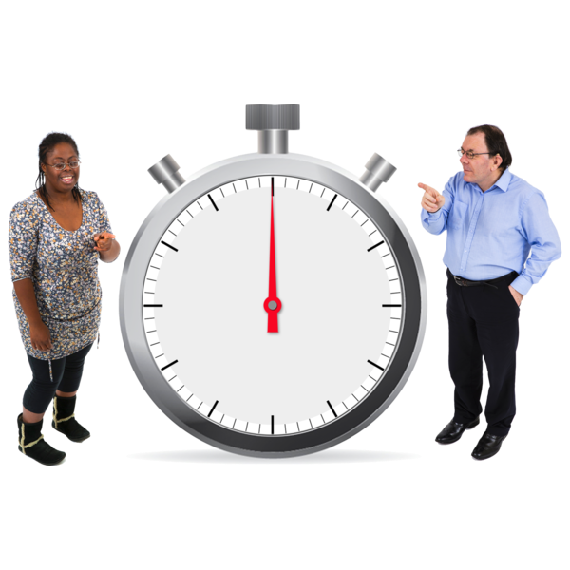 | By doing this it  - Saves time
 | - Costs less money
 | - Means everyone can take part.
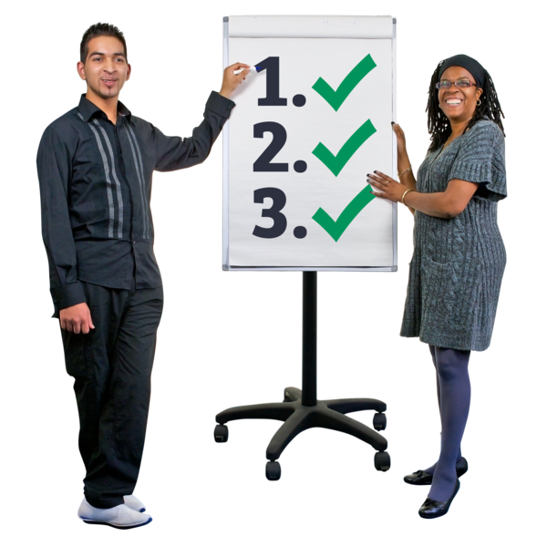 | People with disability should be included in all stages of evaluation.
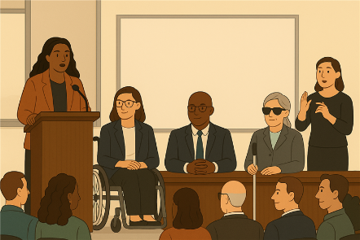 | People with disability should be  - In leadership positions  Leadership positions are when you are in charge of a team or organisation.
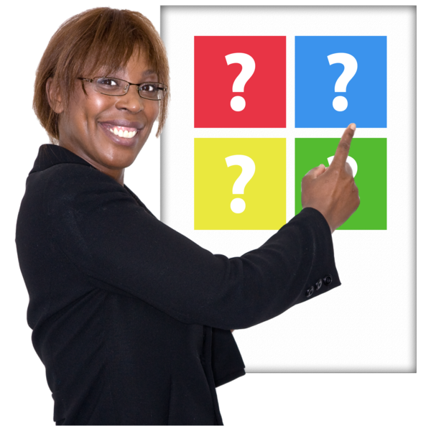 | - Able to make decisions from the start.
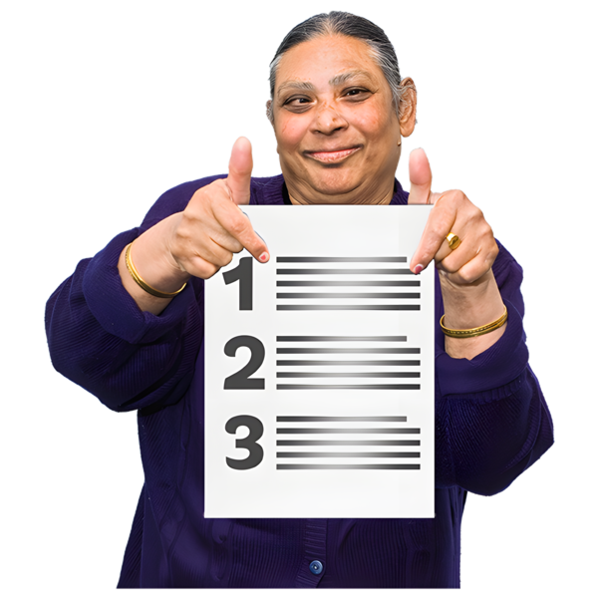 | There are some things that organisations can do to make sure this happens.  They can choose
 | - People with disability as evaluators
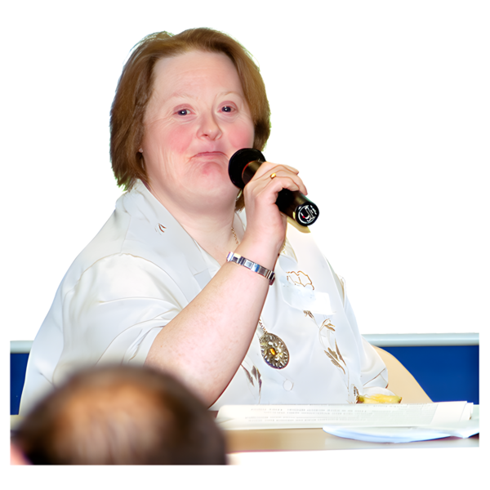 | - A Co Chair that is a person with disability  Co Chairs are the leaders of the group.
 | - People with disability who are experts about what is being evaluated  Experts are people who know a lot about something.
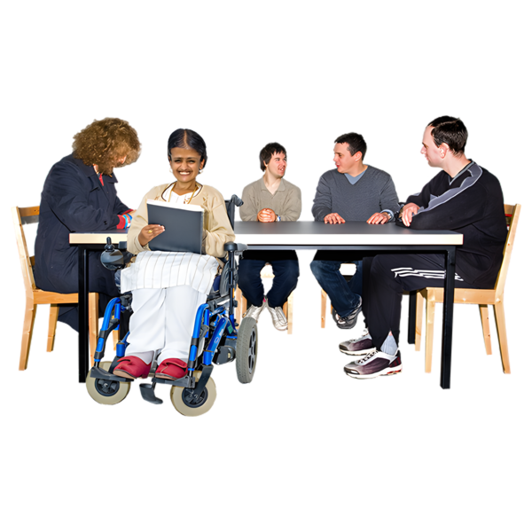 | - People with disability to be in governance groups.
 | Governance groups are people who make sure that a  - Project  - Program  Works well.  It says  - How things will be done  - Makes decisions.

Fact sheets

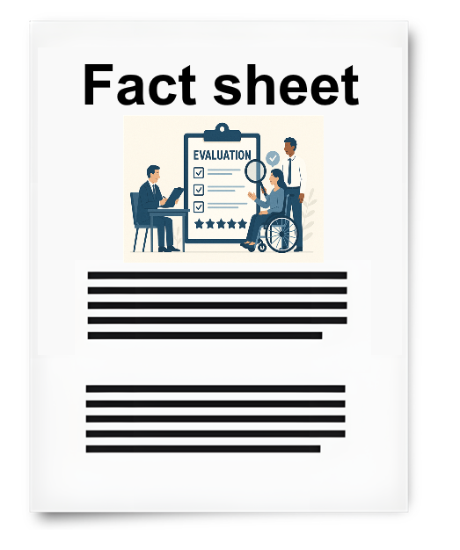 | The toolkit has 7 fact sheets.  Fact sheets have information about an issue.
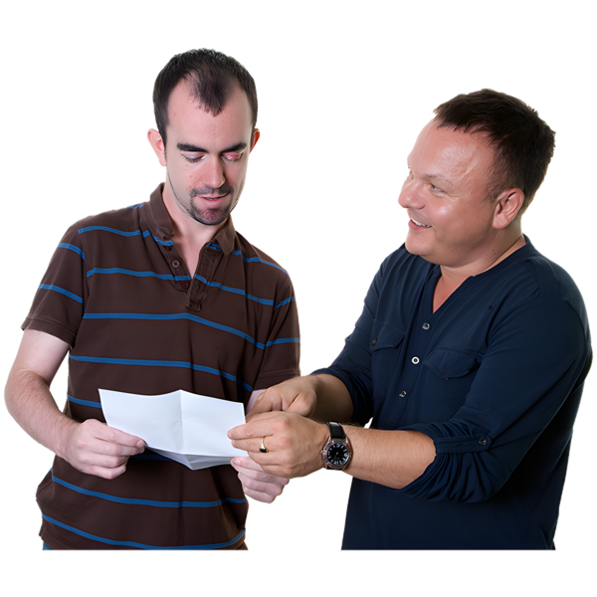 | The fact sheets  - Explain the issue
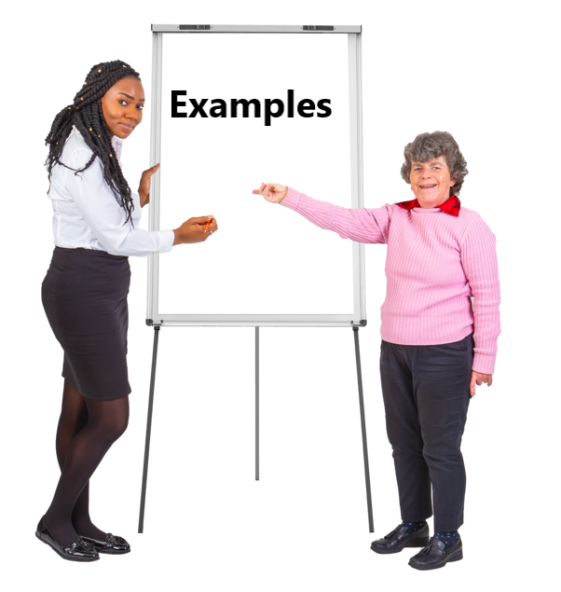 | - Give examples to help you understand better
 | - Have links to websites.
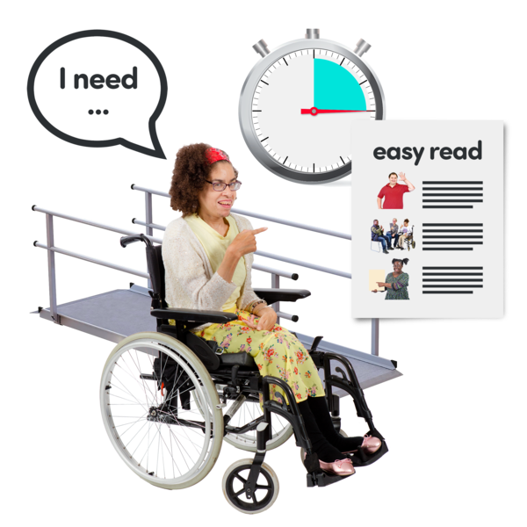 | The fact sheets talk about  - Reasonable adjustments  Reasonable adjustments are things that make it easier for people with disability to take part.
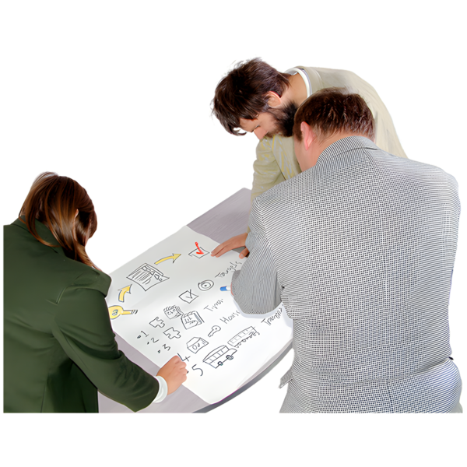 | - Working with people with disability on evaluation  We call this collaborating.
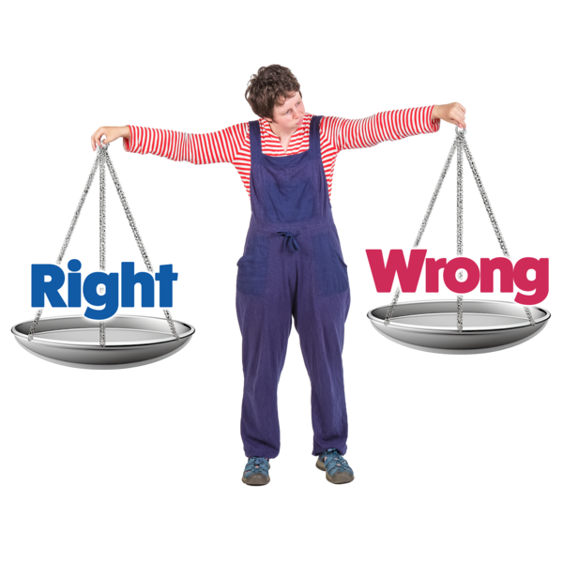 | - Ethical evaluation  Ethical means doing things that  - Are good  - Do not hurt people.
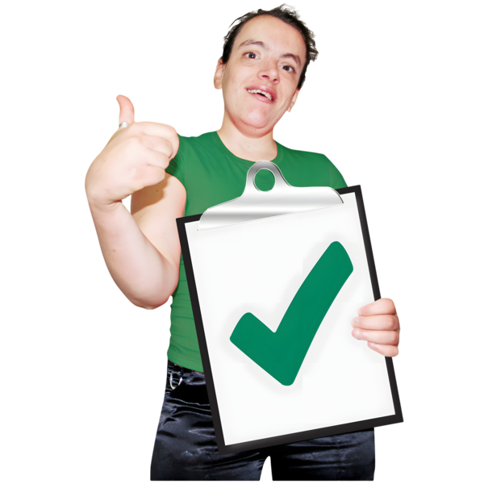 | - Having your time and effort noticed like being paid for your time
 | - Ways to make evaluation inclusive.
 | You can go to the website to read them.  They are not in Easy Read.

Checklists

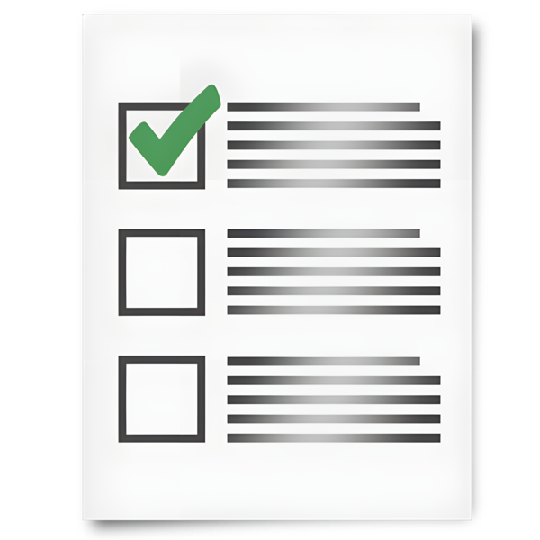 | The toolkit has 2 checklists.
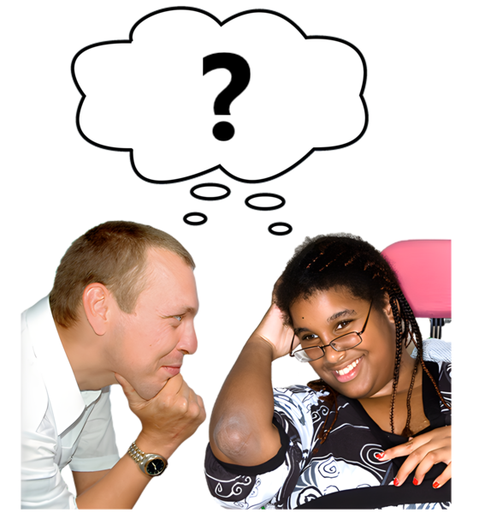 | Checklist 1 is for people with disability.  It has questions to think about if you want to take part in evaluation.
Checklist 2 is for evaluators.

It has questions to think about making evaluation

- Accessible
- Inclusive.
 | This means more people with disability can take part.
You can go to the website to read them.

They are not in Easy Read.

Contact us

 | You can contact us if you need more information.
 | You can send us an email.  Australia’sDisabilityStrategy@health.gov.au
 | You can look at our website.  www.disabilitygateway.gov.au/ads

Images in this Easy Read must not be used or copied without permission

