Australia’s Disability Strategy

Consultation report
Making the Guide and Toolkit
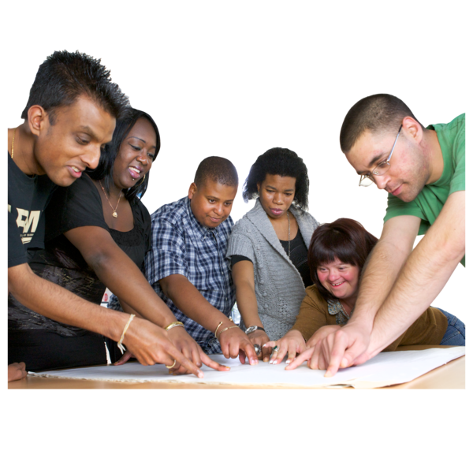
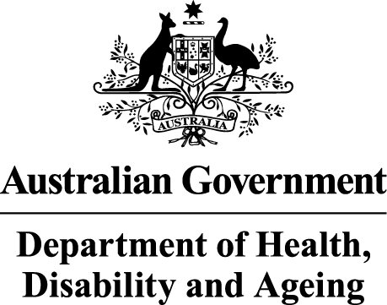 | The Australian Government Department of Health Disability and Ageing wrote this.  We say DHDA for short.  When you see the word we it means DHDA.
 | We wrote this in an easy to read way.  We use pictures to explain some ideas.
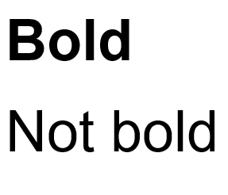 | We have some words in bold.  This means the letters are thicker and darker.  These are important words.
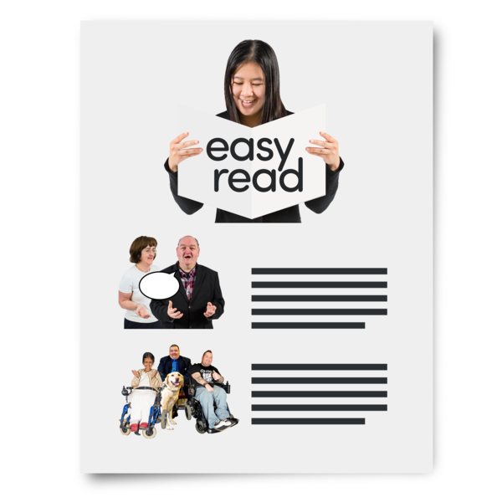 | This is an Easy Read summary of another document.  This means it has the most important ideas.
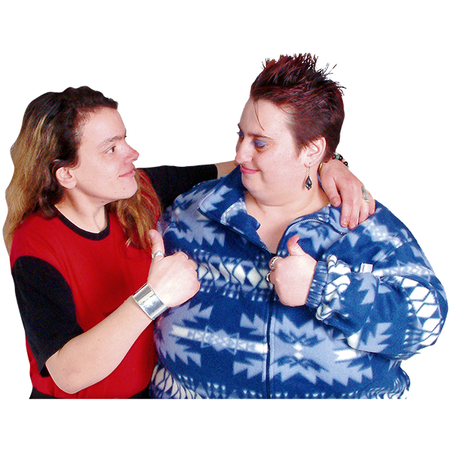 | You can ask for help to read this document.  You can ask  - A friend  - Family members  - A support person.
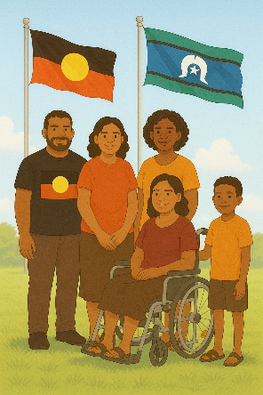 | We recognise Aboriginal and Torres Strait Islander people as the Traditional Owners of the land we live on.
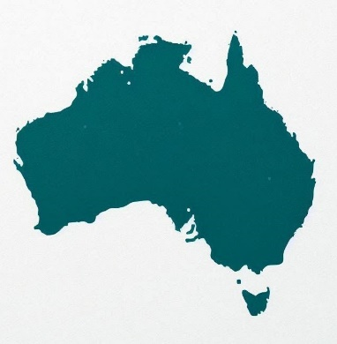 | They were the first people to live on and use the  - Land  - Waters.

Contents

Australia’s Disability Strategy | 5
Who is the Guide for | 9
Writing the Guide | 11
Who is the Toolkit for | 17
Writing the Toolkit | 19
Contact us | 23

Australia’s Disability Strategy

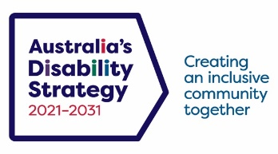 | The government set up Australia’s Disability Strategy.  We call it ADS for short.
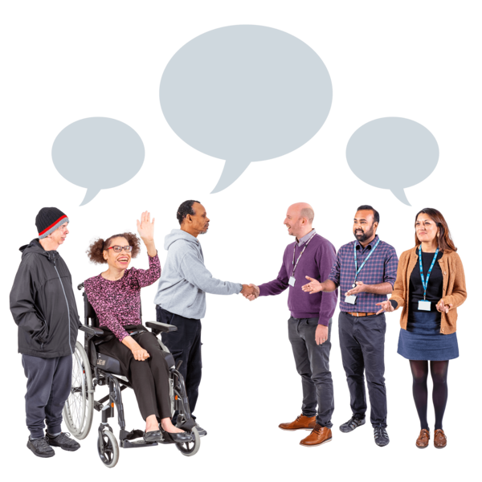 | ADS is the governments way of working together to support people with disability to live good lives.  They do this by working with  - People with disability  - The community.  This makes the community a more welcoming place for everyone.
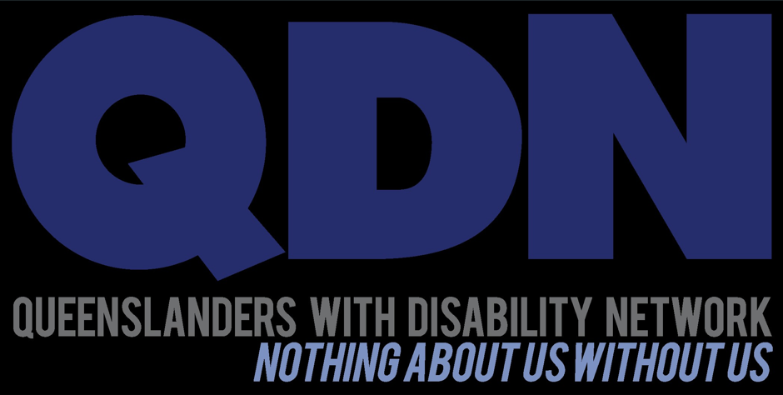 | We did consultations with people with disability and support from groups like  - Queenslanders with Disability Network  We call them QDN for short.
 | - Disability Advocacy Network Australia  We call them DANA for short.
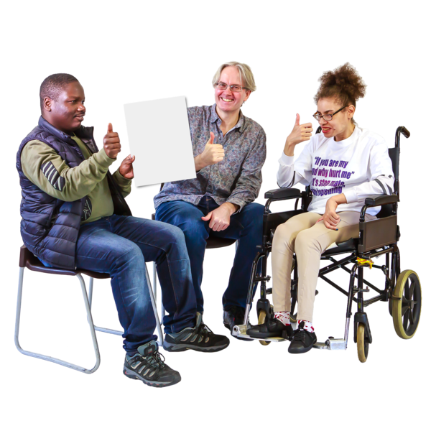 | Consultation is when the government is working with the disability community.  It makes sure that the government is listening to communities.  This helps the government make better plans to support people with disability.
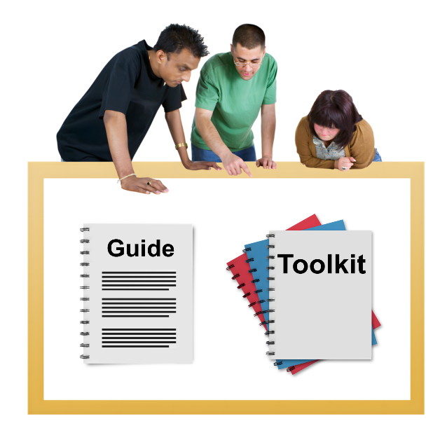 | We used it to help us write the  - Guide  - Toolkit.
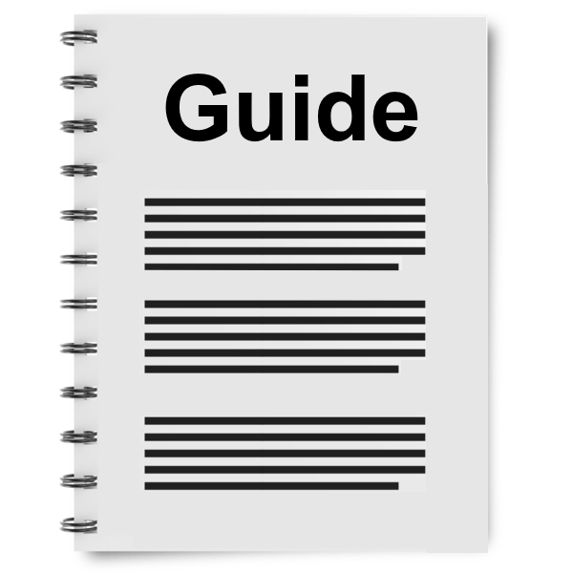 | A guide says  - How things should be done  - Step by step what to do  - Can give recommendations.
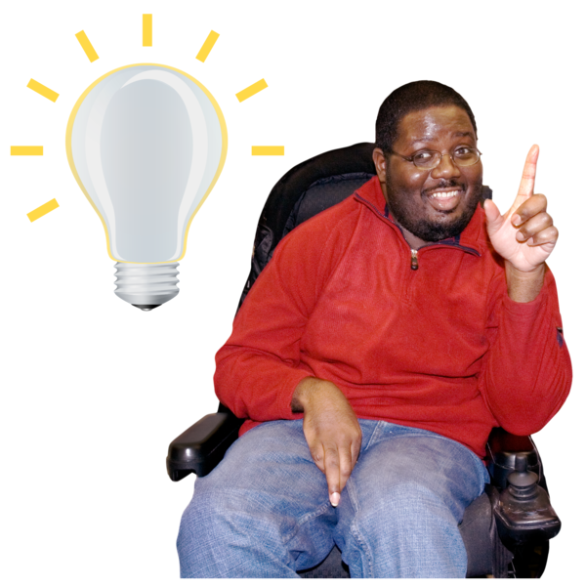 | Recommendations are ideas to do things better.
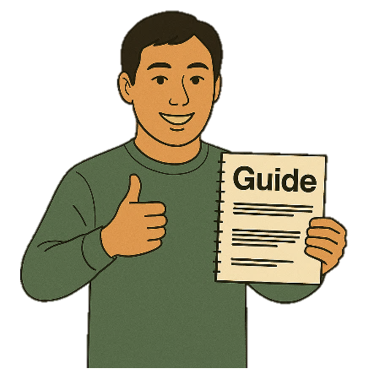 | The Guide will help us know how to use ADS.
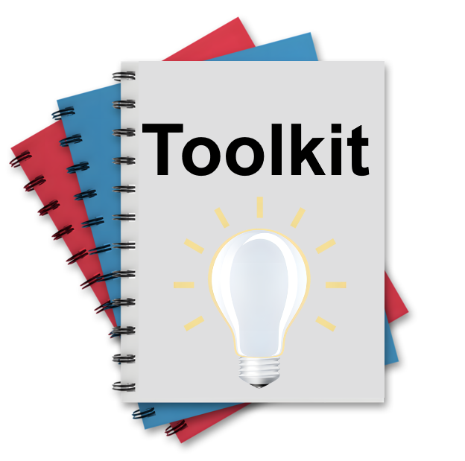 | A toolkit is  - Information  - Strategies  - Ideas.  All of them can be used to make a plan.
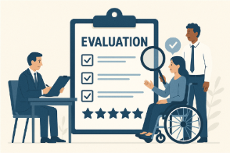 | This Toolkit is about evaluation.  Evaluation means you look at what  - Went well  - Could be done better.

Who is the Guide for

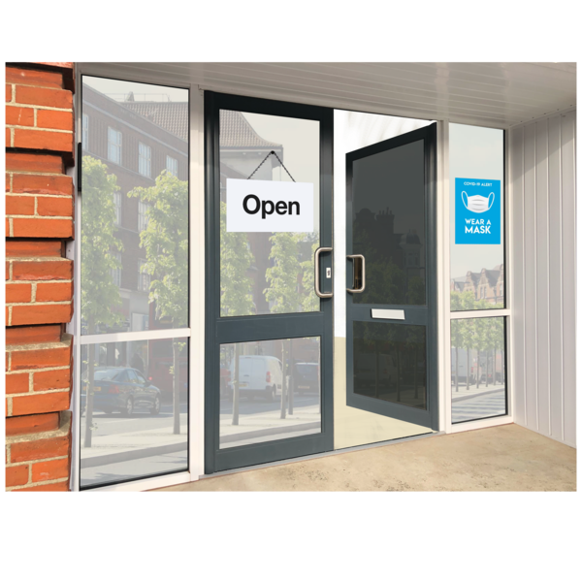 | We made the Guide to give ideas to  - Businesses
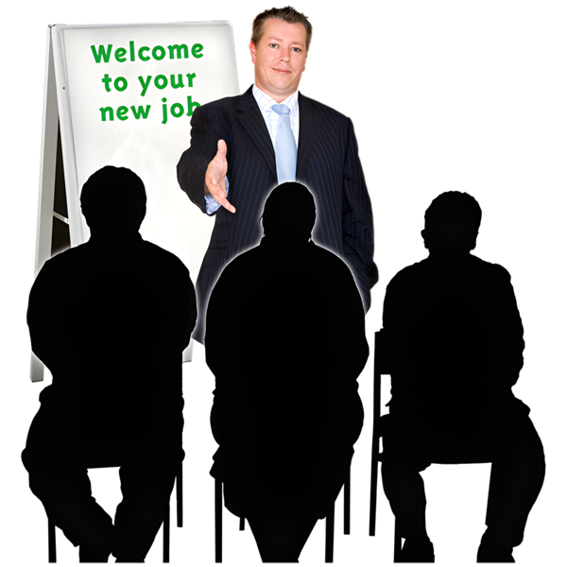 | - Employers  An employer is someone who pays someone to do work for them.
 | - Community organisations
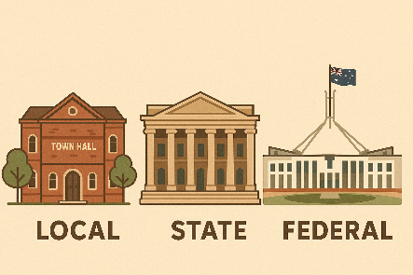 | - People working for the government.  They can be called public servants.  They can work for  - Local government  - State government  - Australian Government.
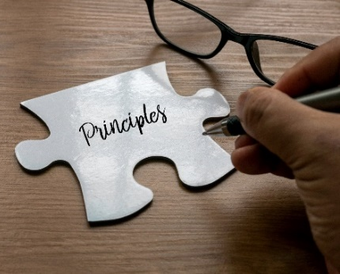 | The Guide will help them to follow ADS Principles.  Principles say how ADS should work

Writing the Guide

 | The community said they want to see 10 things in the Guide.
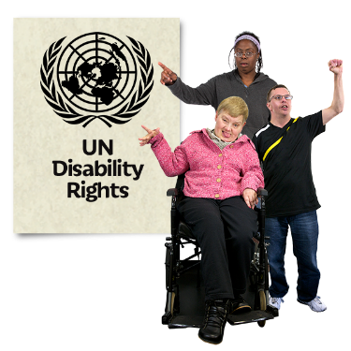 | - The Guide needs to include the United Nations Convention on the Rights of Persons with Disabilities.  We call it CRPD for short.
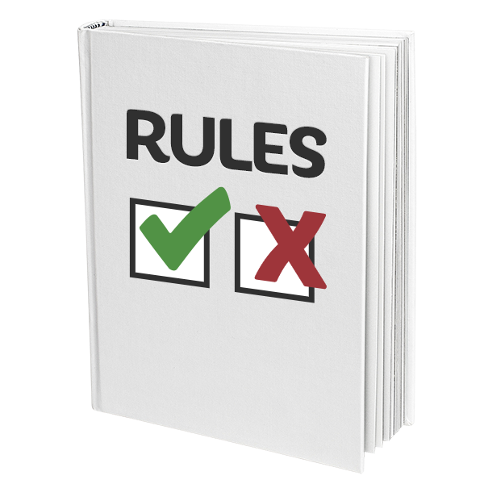 | - The Guide needs to have more about disability laws.  Laws are rules for how we live.
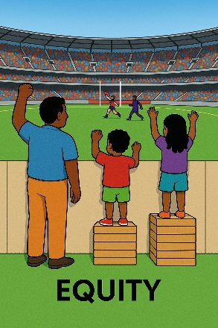 | - The Guide needs more information about equity.  Equity means something is fair for everyone.  Sometimes people will need different things to take part.  This makes it fair.
 | - The Guide needs information about making complaints.  Complaints are when you tell someone they have not done a good job.  Everyone has the right to make a complaint.
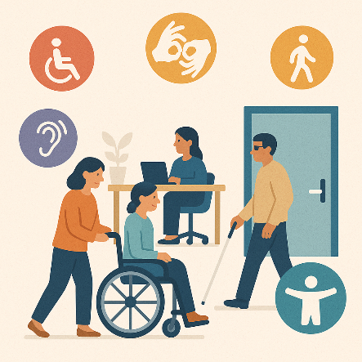 | - The Guide needs to look at making things accessible.  Accessible means everyone can use it.
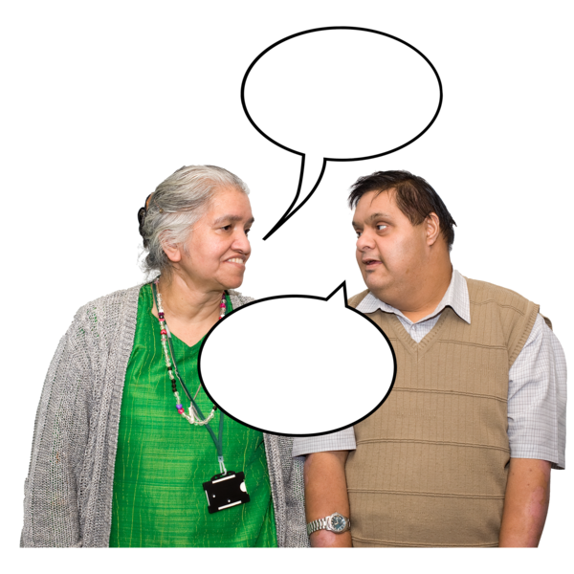 | - The Guide needs to have information about safe communication.  This means that people with disability can talk about their  - Thoughts  - Ideas  - Opinions.
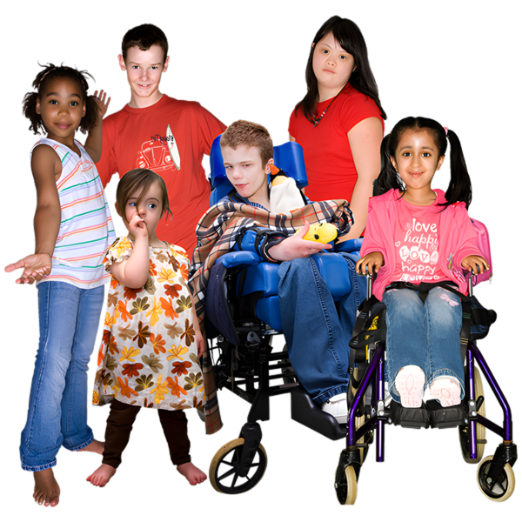 | - The Guide needs to have information about safety for children and young people.
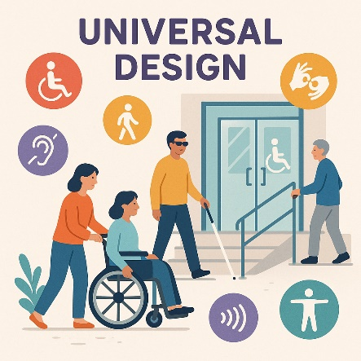 | - The Guide needs to say how to do universal design.  Universal design is making  - Things  - Environments  - Services  Accessible for everyone.
 | The environment is everything around us.  Things like  - Buildings  - People  - Nature  - Technology
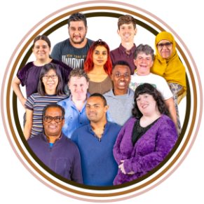 | - The Guide needs to have examples of  - How to support people with disability  - The different parts of who they are.  This might change what their experience is like.  This is called intersectionality.
 | 10. The Guide needs to have training information about disability  - Competency  - Responsiveness  - Awareness
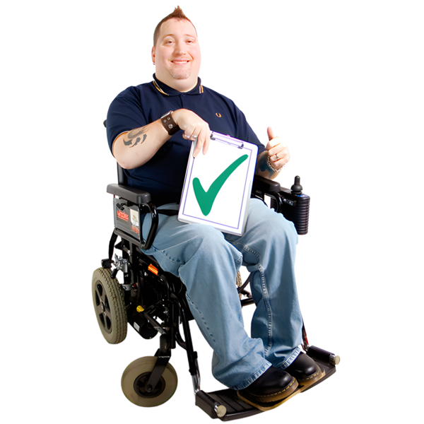 | Disability competency training can help people understand more about people with disability and their rights.
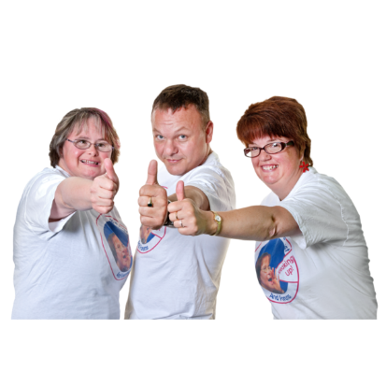 | Rights are rules about treating everyone  - Fair  - Equal.
 | Disability responsiveness training helps to change attitudes about people with disability.
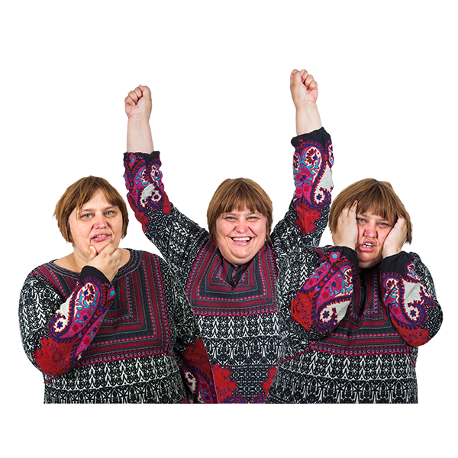 | Attitudes are what people  - Think  - Feel  - Believe.
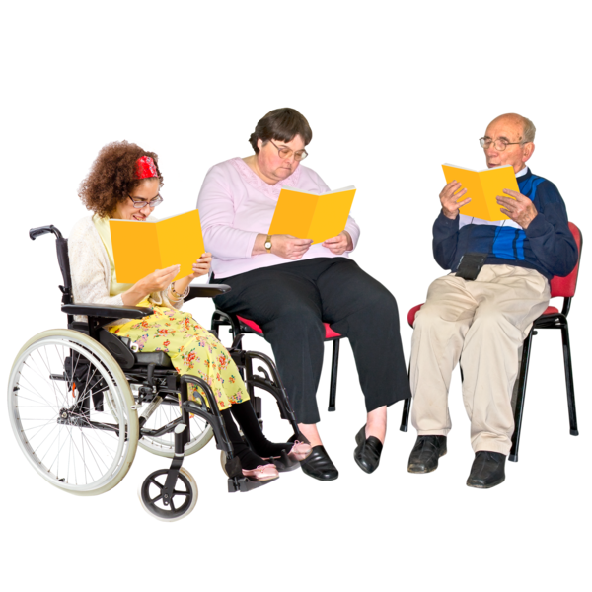 | Disability awareness training helps people know more about  - People with disability  - How to treat people with disability.
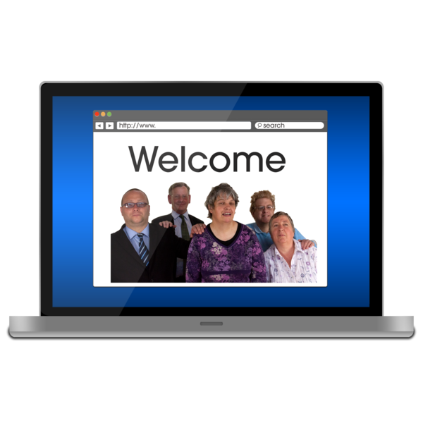 | You can read the Guide on our website.  www.disabilitygateway.gov.au/document/11221  It is in Easy Read.

Who is the Toolkit for

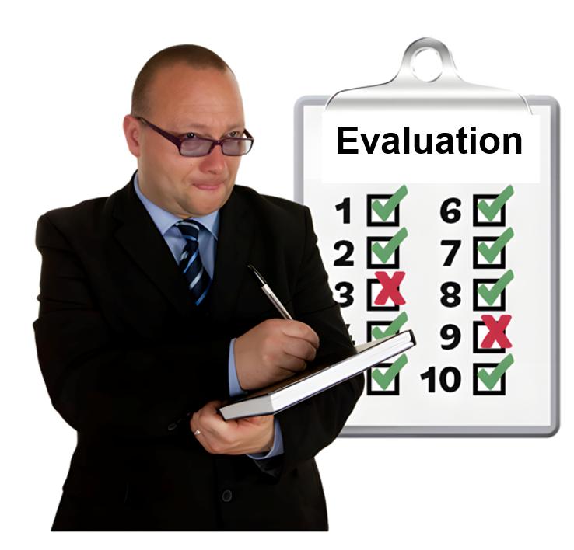 | We made the Toolkit to give ideas to people  - With disability who want take part in evaluation
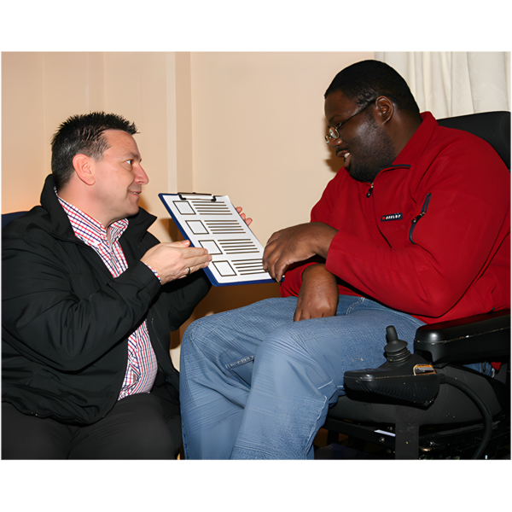 | - Who do evaluations.
 | The Toolkit will support good evaluation that is  - Accessible  - Inclusive  For people with disability.
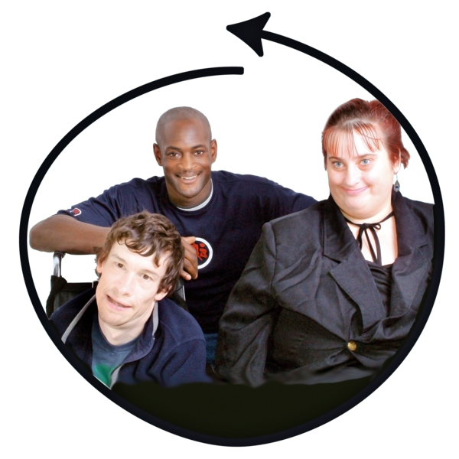 | Inclusive is when everyone  - Can take part  - Feels like they belong.

Writing the Toolkit

The community said they want to see lots of things in the Toolkit.

They said
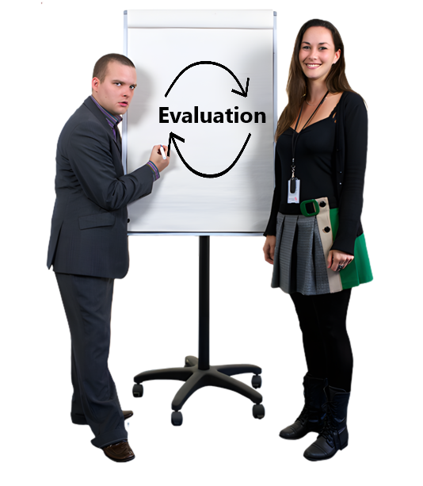 | The Toolkit should include people with disability in all parts of evaluation.  The different parts can be called the evaluation stages.
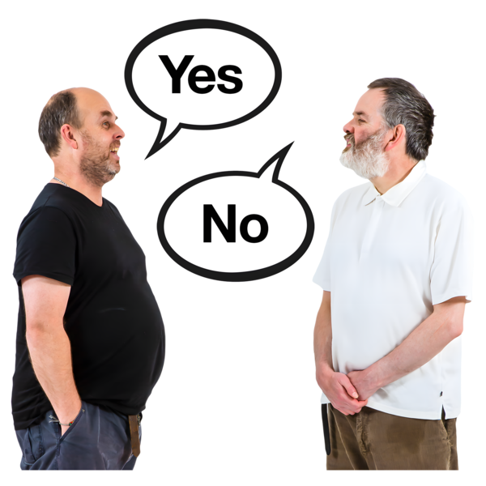 | The Toolkit needs to respect how much people with disability want to be involved.
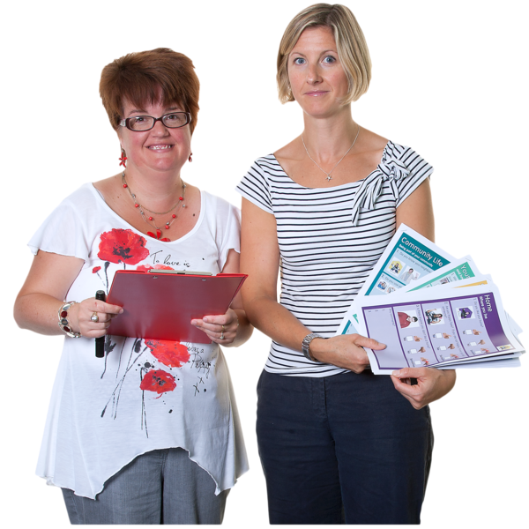 | The Toolkit should have resources for people with disability to take part like  - Supported decision making  - Training.  Supported decision making is when people with disability have support to make decisions about their life.
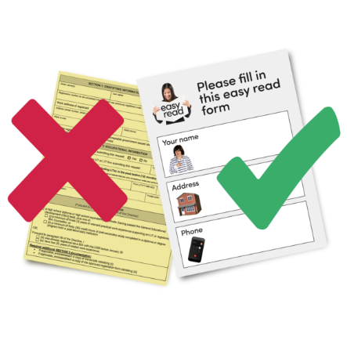 | The Toolkit needs to have information about accessible communication.  Accessible communication is information that everyone can use.  Like Easy Read.
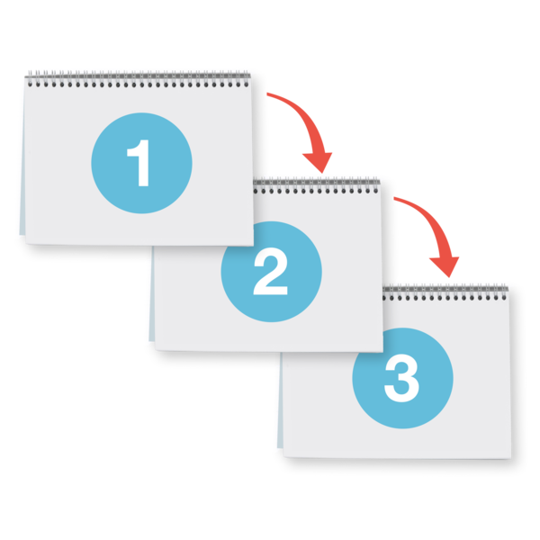 | The Toolkit needs to have ways for people with disability to take part.
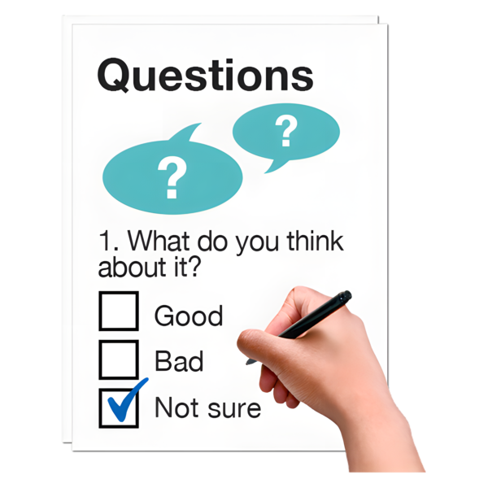 | The Toolkit needs to make sure there are  - Ways to give feedback about how evaluation is done.  Feedback says what you think about something.  It will help  - Find problems  - Make it better in the future.
 | The Toolkit needs to respect that taking part in evaluation uses  - Time  - Effort.  Like being paid for your time.
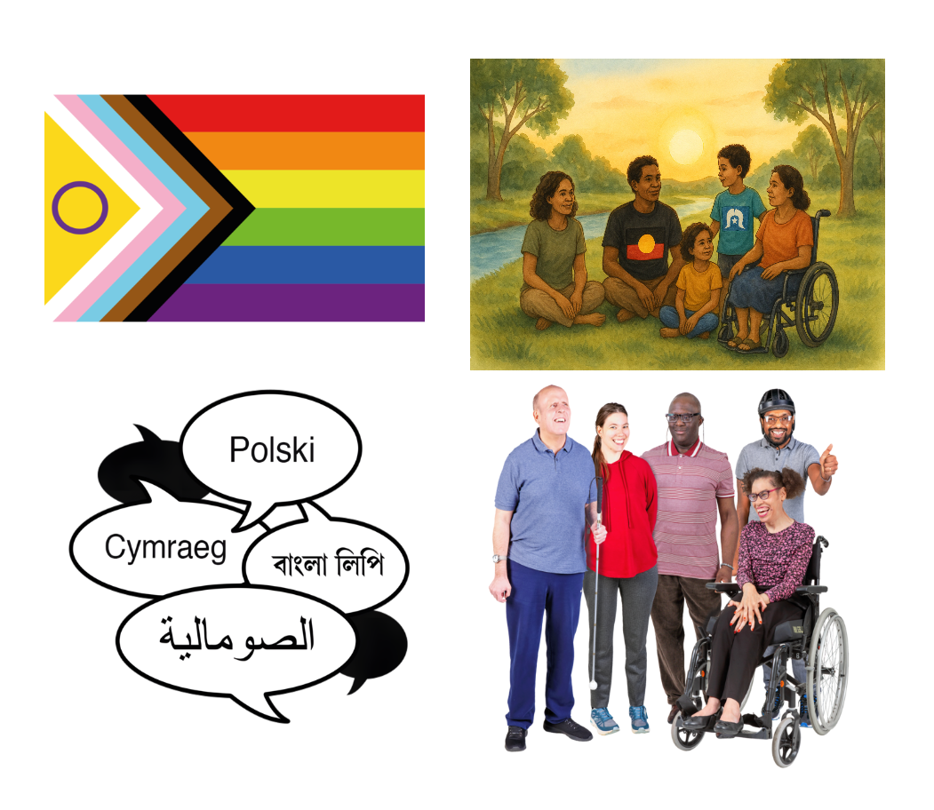 | The Toolkit needs to make sure that  - People from different groups can take part in evaluation.
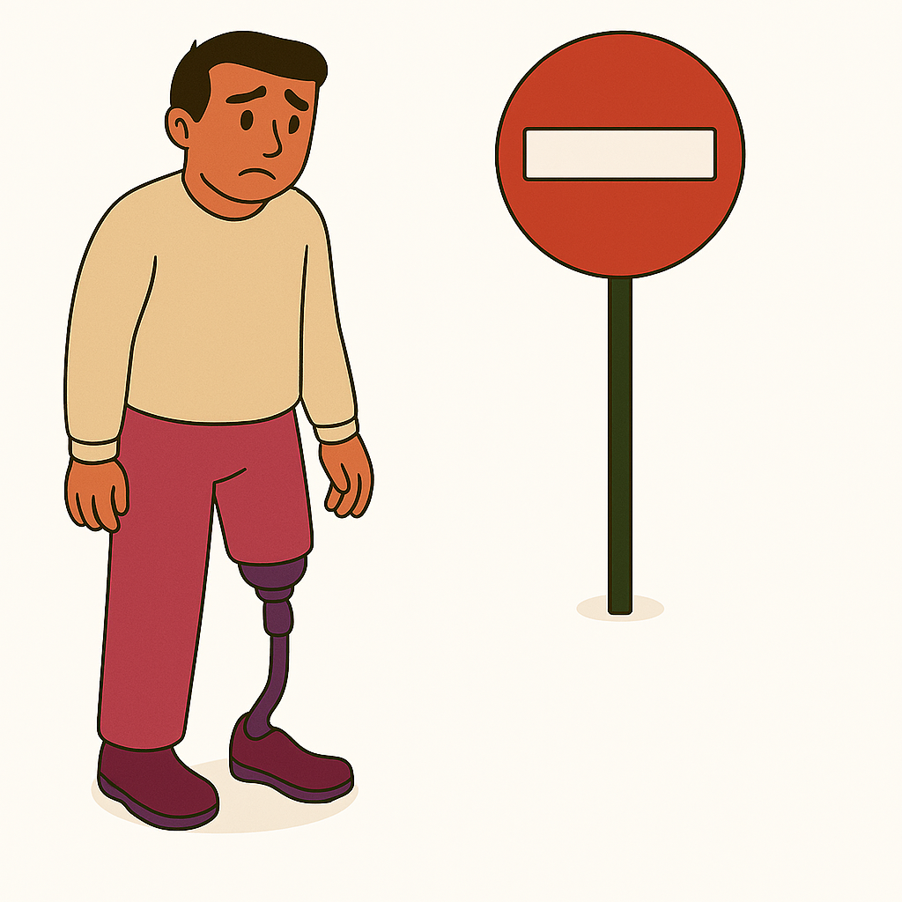 | The Toolkit needs to look at barriers for taking part in evaluation.  A barrier is something that stops you from doing what you  - Want  - Need.
 | You can read about the Toolkit on our website.  It is in Easy Read.

Contact us

 | You can contact us if you need more information.
 | You can send us an email  Australia’sDisabilityStrategy@health.gov.au
 | You can look at our website to read about how the government can work better with people with disability.  www.disabilitygateway.gov.au/good-practice-guidelines  It is not in Easy Read.

Images in this Easy Read must not be used or copied without permission

