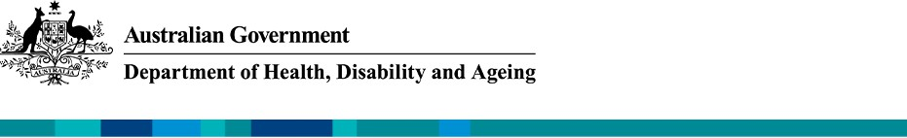

ADS Advisory Council
August 2025 Update

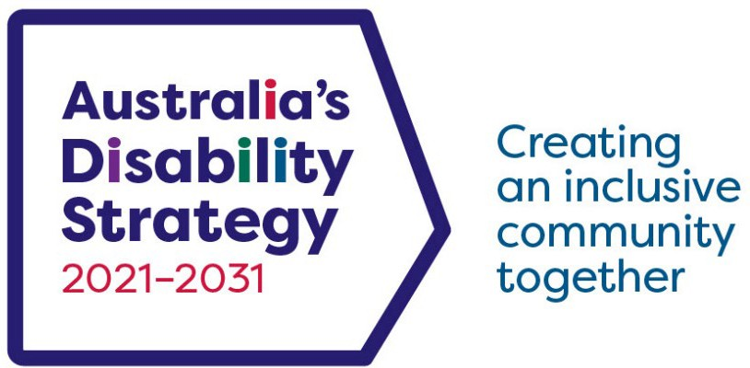

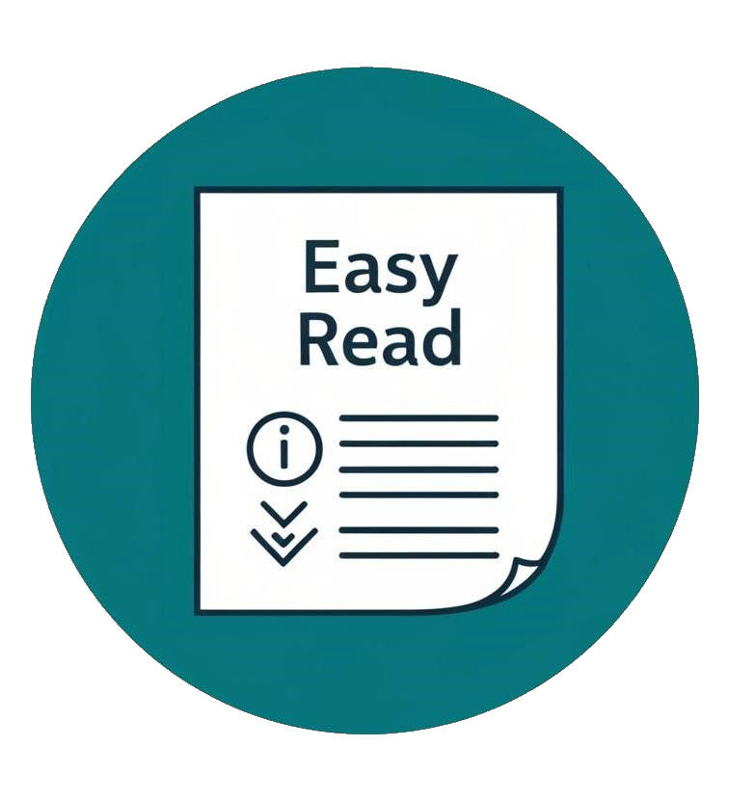

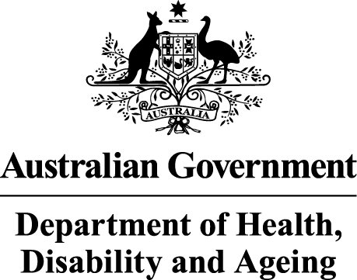
The Australian Government Department of Health Disability and Ageing wrote this.

We say DHDA for short.

When you see the word we it means DHDA.


We wrote this in an easy to read way. We use pictures to explain some ideas.


We have some words in bold.

This means the letters are thicker and darker. These are important words.

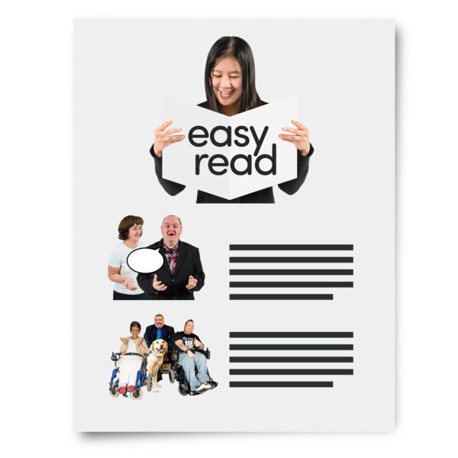
This is an Easy Read summary of another document.

This means it has the most important ideas.


We can answer any questions by email. Email us ADSAdvisoryCouncil@health.gov.au

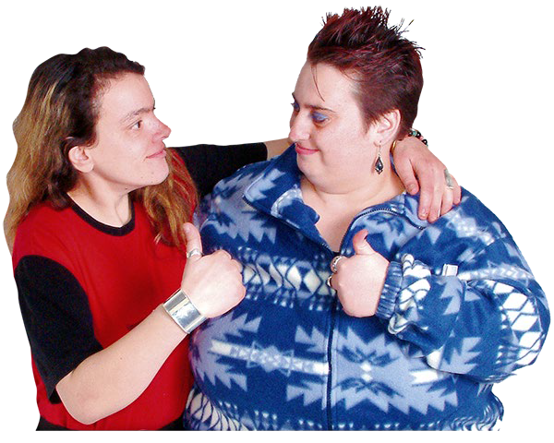
You can ask for help to read this document. You can ask
- A friend
- Family members
- A support person.

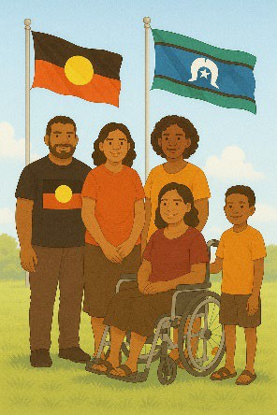
We recognise Aboriginal and Torres Strait Islander people as the Traditional Owners of the land we live on.


They were the first people to live on and use the

- Land
- Waters.

Contents

Australia’s Disability Strategy | 5
ADS Advisory Council | 6
Changes to members | 8
ADS Engagement Plan | 11
Attorney Generals presentation | 13
Updates | 17
The next meeting | 25

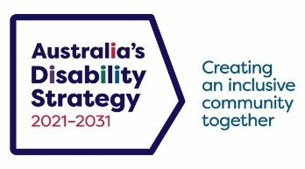
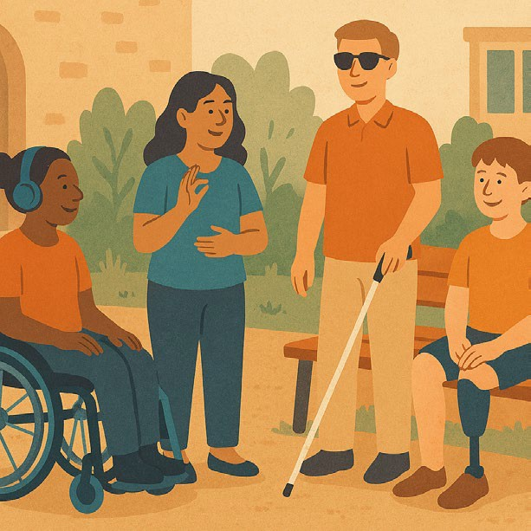

Australia’s Disability Strategy

Australia’s Disability Strategy is a plan to make life better for people with disability.

We call it ADS.
ADS is important for Australia to be more
inclusive.

Inclusive means everyone can take part.
This makes everyone in our community feel welcome.

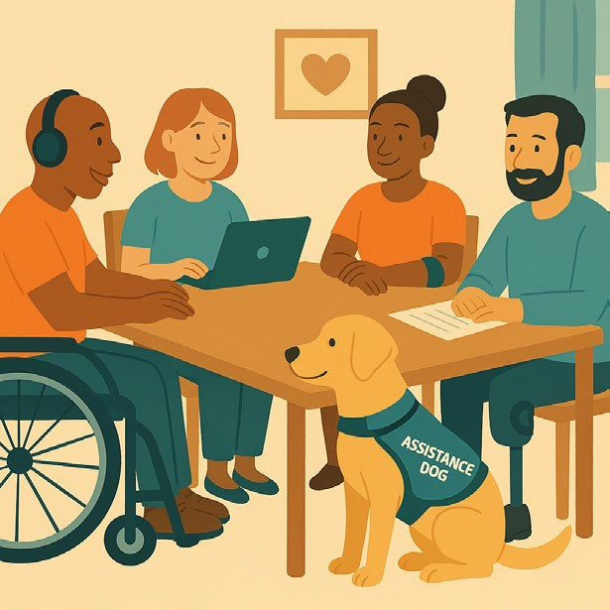

ADS Advisory Council

The ADS Advisory Council gives advice about ADS to

- The Australian Government
- State and territory governments
- Local governments.

We call it the Council.
The Council is not part of the government.
The Council helps governments understand how to

- Use ADS
- Share reports about ADS
- Work towards the goals of ADS.

Goals are things you want to do.

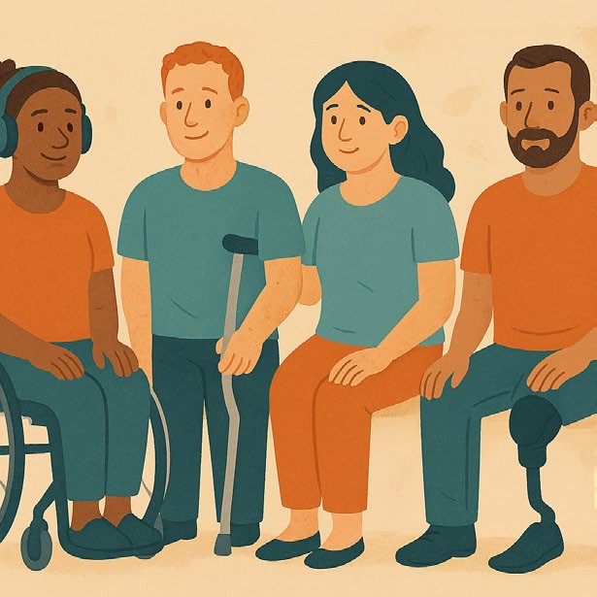
The Council includes people

- With disability
- Who understand barriers for people with disability.

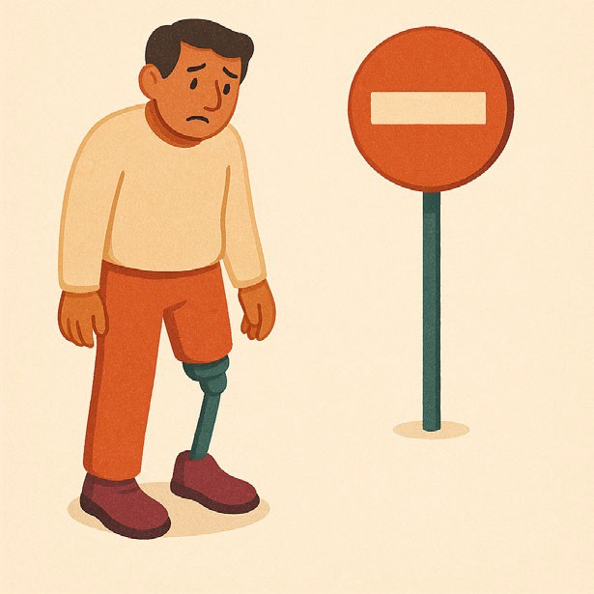
A barrier is something that stops you from doing what you

- Want
- Need.

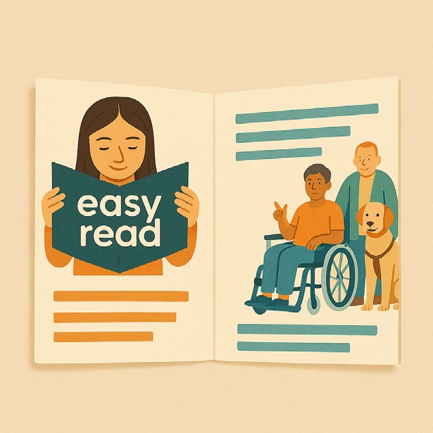
The Council writes information about what they talked about in their meetings.


We share important information with the community.

This information is about the Council meeting on 26 August 2025.

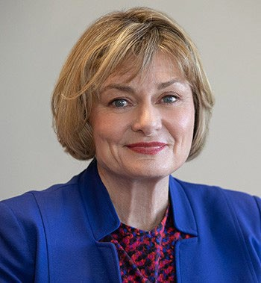
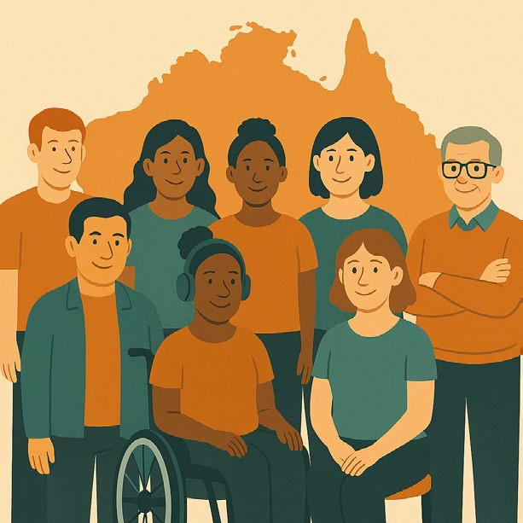
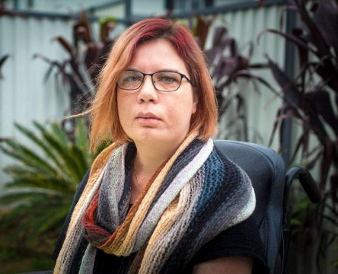
Changes to members

Jane Spring is the Council Chair.

The Chair is the person who runs the meeting.

Jane gave updates about members who have finished being on the Council.
Members are on the Council for a certain amount of time.

Some members represent different states and territories.

Represent means speak up for the people in their state or territory.
The members finishing on 1 September 2025 are

- Kelly Cox

Kelly is the representative for New South Wales.

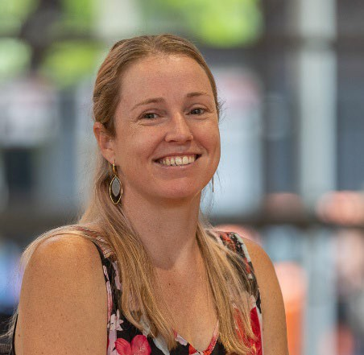
- Sarah Skopellos


Sarah is the representative for Northern Territory.

- Sisaleo Philavong


Sisaleo is the representative for South Australia.

- Chris Varney

Chris is the representative for Victoria.


They were thanked for the good work they did while on the Council.

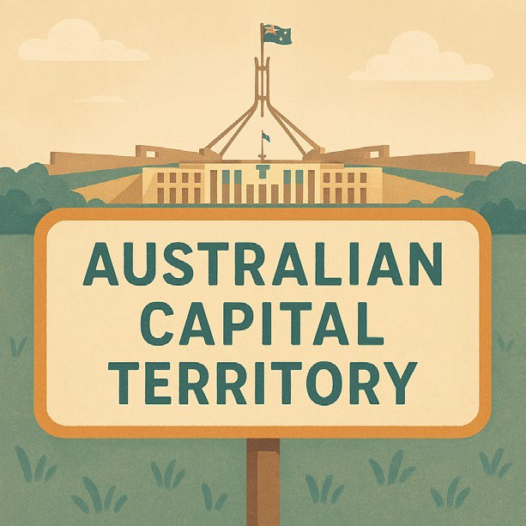
Jane said they would start looking for new state and territory representatives for

- Australian Capital Territory


- Queensland

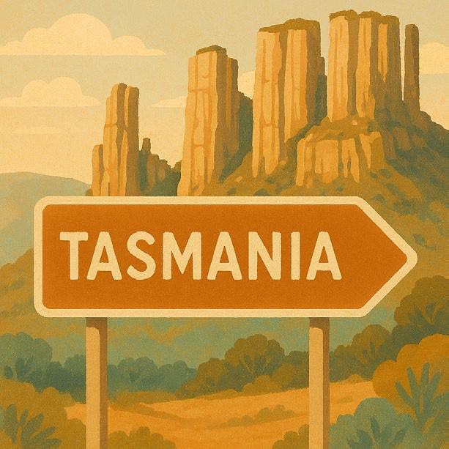
- Tasmania


- Western Australia

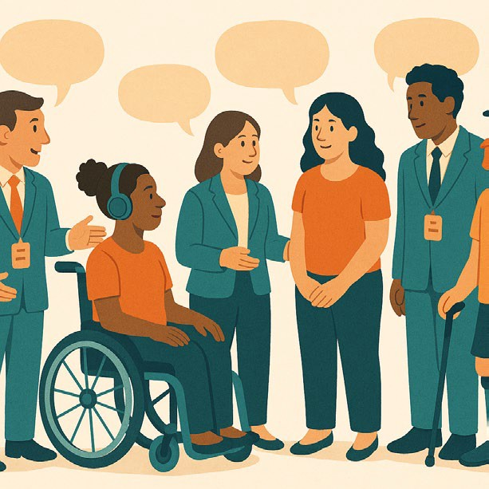
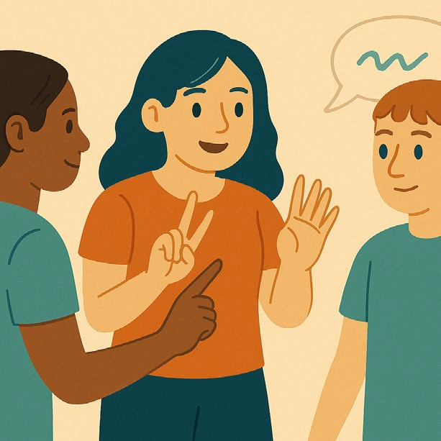

ADS Engagement Plan

The Council agreed on the advice they would give for the ADS Engagement Plan.

Engagement means the community can share their ideas with the government.
They said there needed to be

- Good ways of communicating
- Ways to work that are right for the community


- The government being accountable

Being accountable is taking responsibility for your actions.


- Being able to give feedback

Feedback says what you think about something.

It will help

- Find problems
- Make it better in the future.

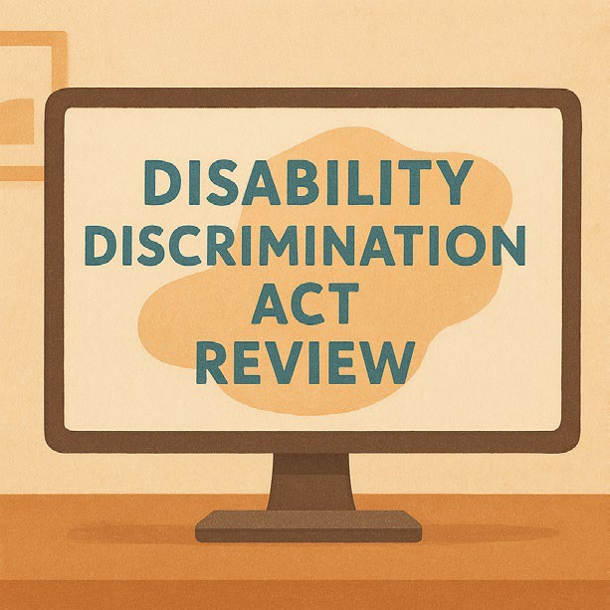
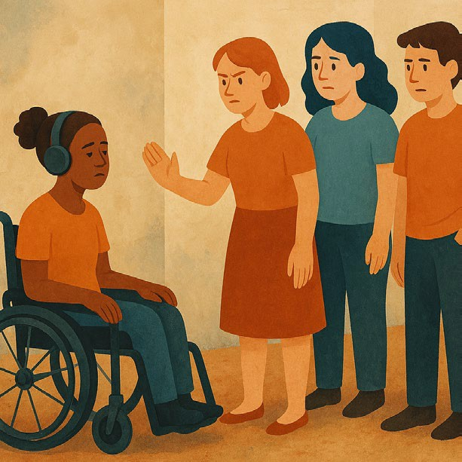
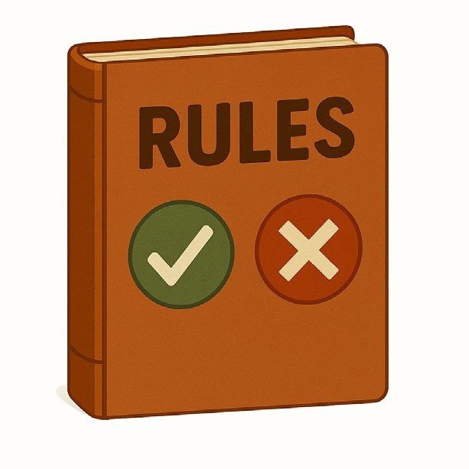
Attorney Generals presentation

The Council talked about the presentation from the Attorney Generals Department.

The presentation was about the Disability Discrimination Act Review.

We call it DDA Review for short.
Discrimination means treating someone unfairly because of something about them they can not change.

Like they have a disability.
An Act is a law.

Laws are rules for how we live.


A review is when you check what

- Works
- Needs to change.

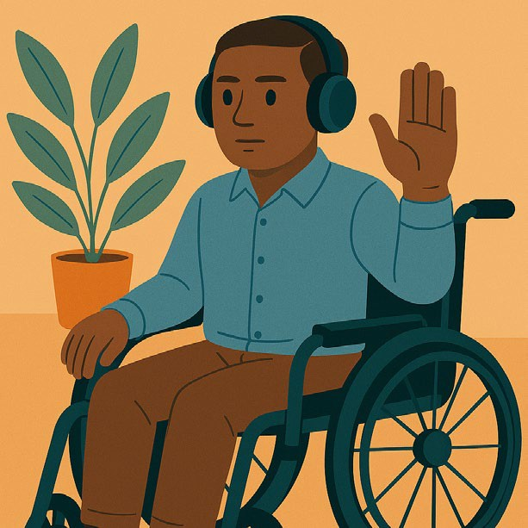
The Council shared ideas to help with

- Ways to stop discrimination

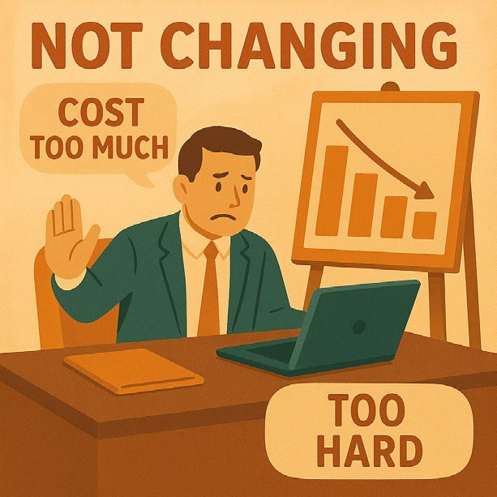
- A better way to explain unjustifiable hardship

Unjustifiable hardship means organisations not needing to change something because it would

- Cost too much
- Be too hard to do.

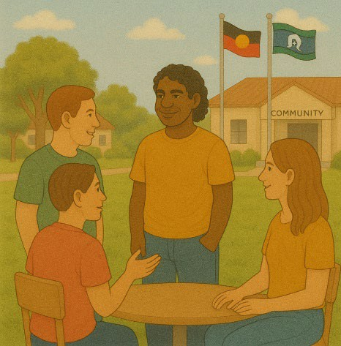
- For it to be culturally safe

Culturally safe means respecting peoples

Rights
- Cultures
- Traditions.

This helps people feel safe to be themselves. It can also be called cultural safety.


Rights are rules about treating everyone

- Fair
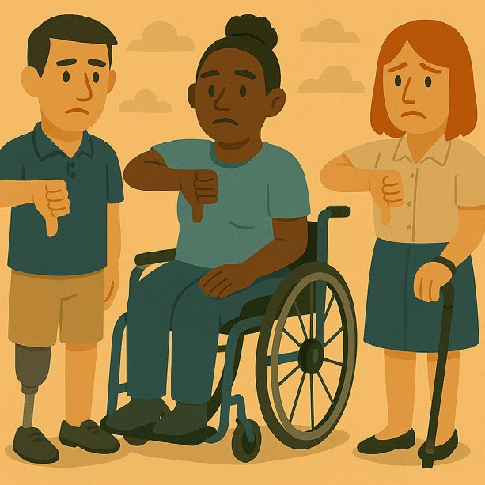
- Equal.

- For making complaints

Complaints are when you tell someone they have not done a good job.

Everyone has the right to make a complaint.

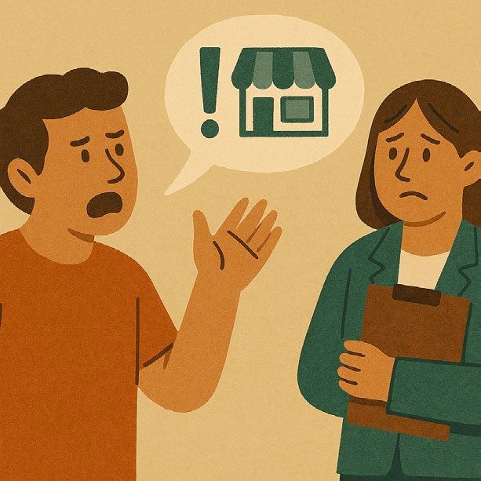
The Council said the DDA needs people with disability to

- Speak up about problems
- Help fix problems

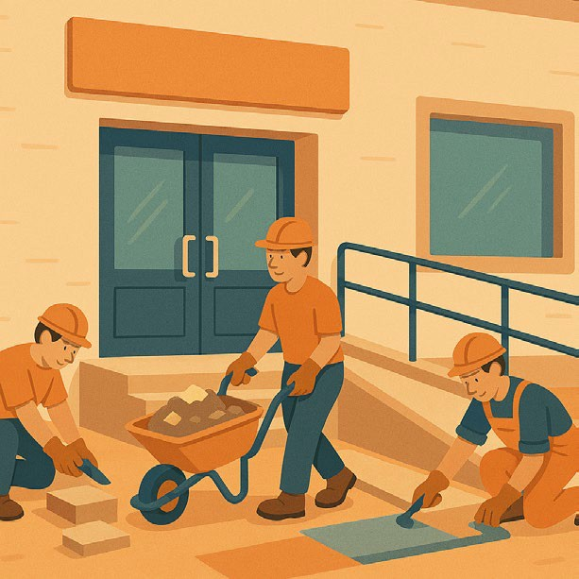
With businesses and organisations.

Rather than the business or organisation being responsible.


Responsible means the things you need to do.

The Council will keep speaking up for changes to the DDA.


The Council agreed to write a formal submission.

A formal submission is a document with ideas to do things better.

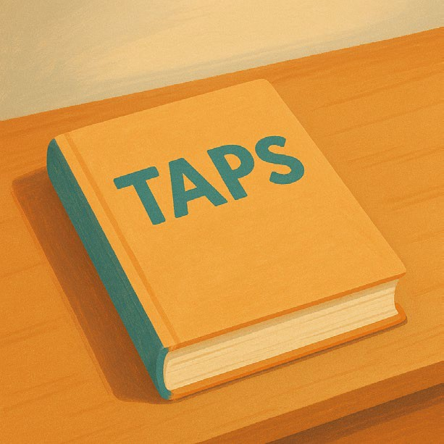

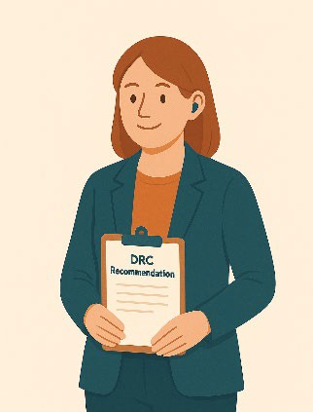
Updates

There were updates for

1. Advice the Council gave about the
Targeted Action Plans

We call them TAPs for short.
TAPs will be ready to put on the website by the end of 2025.

www.disabilitygateway.gov.au/ads/strategy
2. The Disability Royal Commission
progress report We call it DRC for short.
The progress report will be put on the website
in 2025.

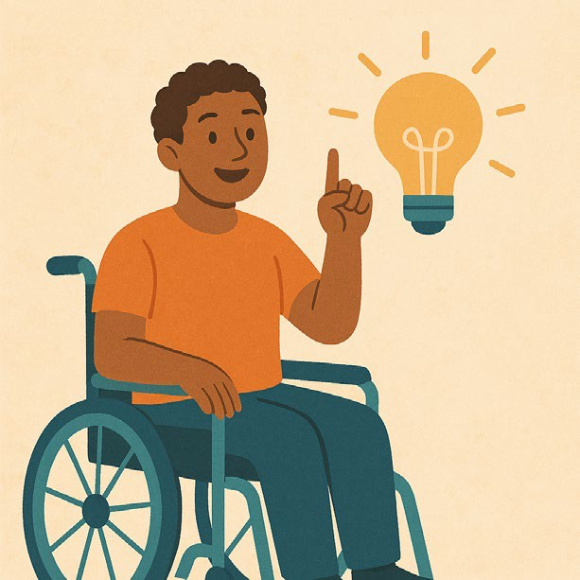
The DRC looked at how people with disability are treated.

It made recommendations.

Recommendations are ideas to do things better.


The Council liked the ideas for the way the

- Website would look for the new reports

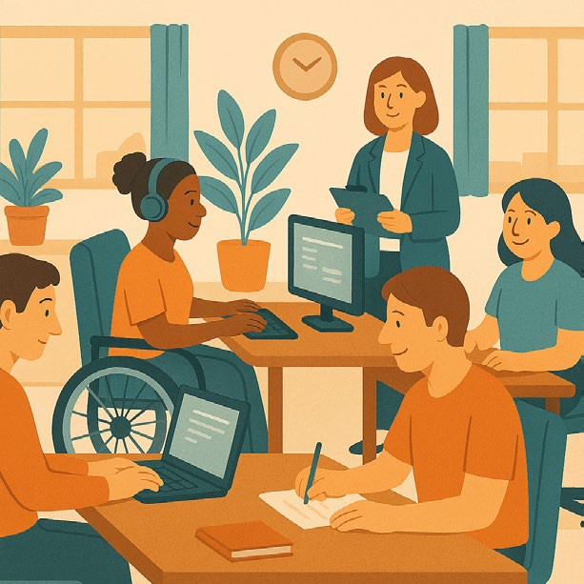
- Ways to show what parts are being worked on

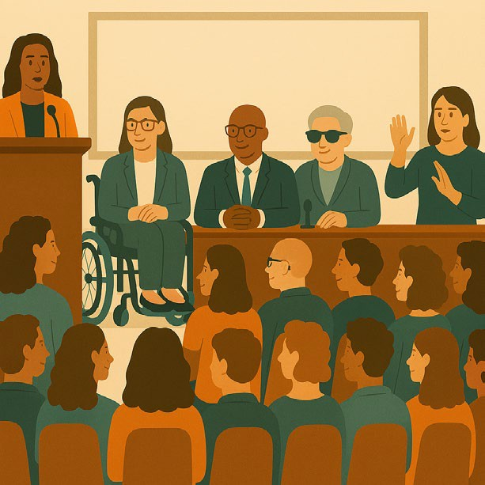
The Council want to see who the leaders are for DRC implementation.

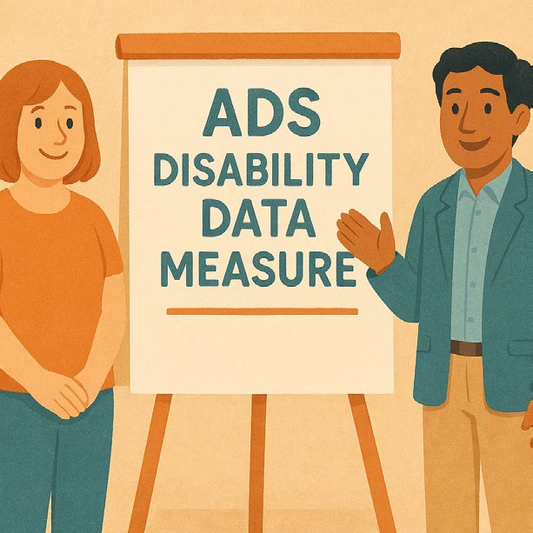
Implementation means doing what you promised you would.

- Information on the ADS Disability Data Measure project

We call it DDM for short.


Data is

  - Facts
  - Information
  - Records.

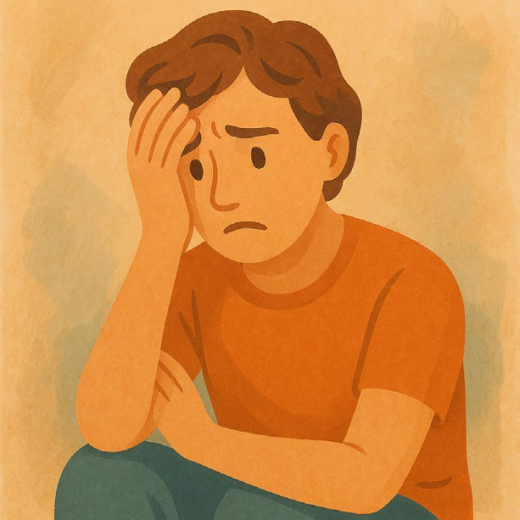
The Council said they were worried about how disability would be measured.

They think it would be better to

  - Look at barriers.

Rather than someones medical condition


  - Involve people with disability to share their experiences


  - Have community consultation

Consultation is the governments way of working with the disability community.

It makes sure that the government is listening to communities.


  - Learning from research that has been done

Research means

  - Finding out what people think about things
  - Using the information to help others.


- States and territories shared updates

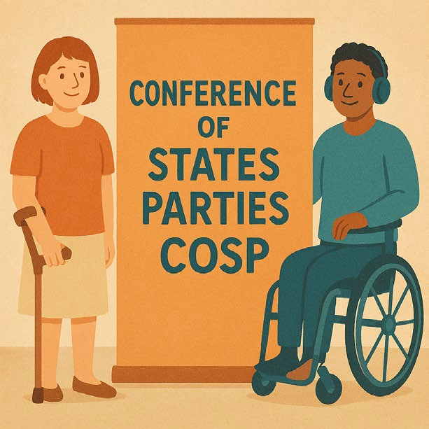
- Jane shared about

  - Taking part in the Conference of State Parties

We call it COSP for short.


COSP is a meeting between different countries about the rights of people with disability.

COSP happens every year.


You can go to our website to read more about it.

www.dss.gov.au/news/australians-disability- take-part-18th-session-conference-states- parties-cosp18

It is not in Easy Read.

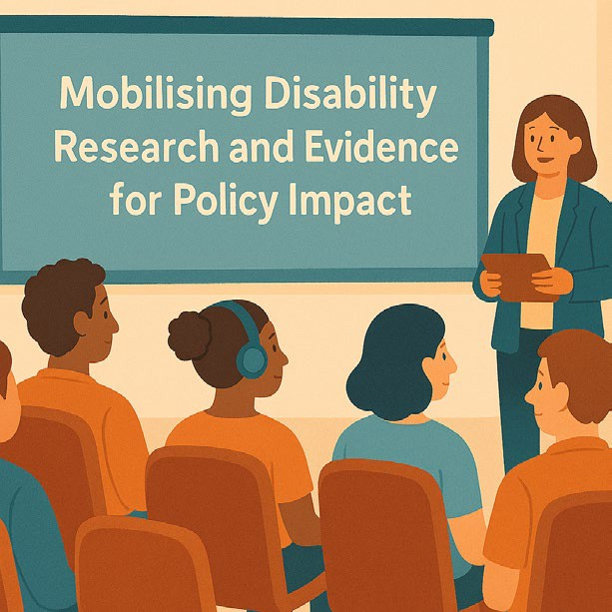
  - The National Disability Research Partnership event

It is called mobilising disability research and
evidence for policy impact.

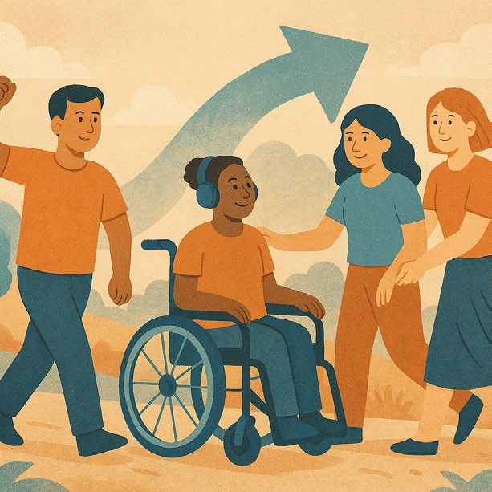
Mobilising means collecting information to make change.


Evidence is proof that something is true.

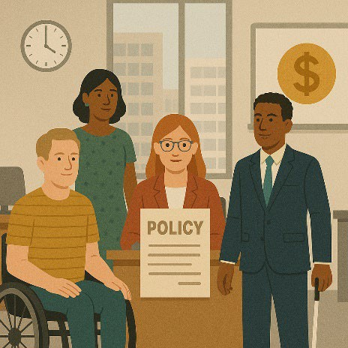
Policies are plans for how to do things.


  - The aes25 Conference on inclusive

evaluation

Evaluation means you look at what


  - Went well
  - Could be done better.

You can do an evaluation of a

  - Service
  - Program
  - Plan.

You can go to the website to read more. www.aes25.aes.asn.au/
It is not in Easy Read.




The next meeting

The next Council meeting will be on 28 November 2025.
You can go to the Council website if you need more information.

www.disabilitygateway.gov.au/ads/advisory- council
You can email us. ADSAdvisoryCouncil@health.gov.au

Images in this Easy Read must not be used or copied without permission

