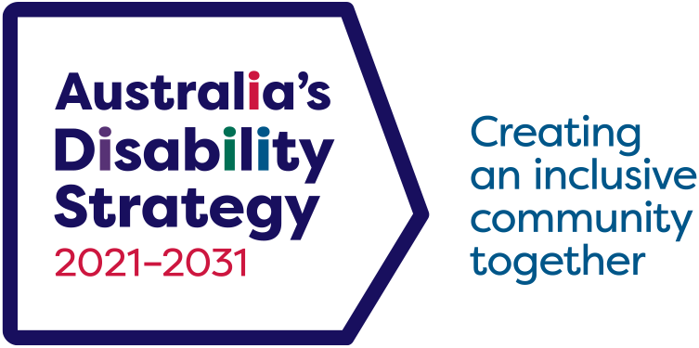

Australia’s Disability Strategy Survey
  - Wave 2 Report

© 2025 Commonwealth of Australia as represented by the Department of Health, Disability and Ageing
This publication is licensed under the Creative Commons Attribution 4.0 International Public License available from https://creativecommons.org/licenses/by/4.0/legalcode (“Licence”). You must read and understand the Licence before using any material from this publication.
Restrictions
The Licence may not give you all the permissions necessary for your intended use. For example, other rights (such as publicity, privacy and moral rights) may limit how you use the material found in this publication.
The Licence does not cover, and there is no permission given for, use of any of the following material found in this publication:
- the Commonwealth Coat of Arms. (by way of information, the terms under which the Coat of Arms may be used can be found on the Department of the Prime Minister and Cabinet website https://www.pmc.gov.au/resources/commonwealth-coat-arms-information-and-guidelines);
- any logos and trademarks;
- any photographs and images;
- any signatures; and
- any material belonging to third parties identified in this publication.
Attribution
Without limiting your obligations under the Licence, the Department of Health, Disability and Ageing requests that you attribute this publication in your work. Any reasonable form of words may be used provided that you:
- include a reference to this publication and where practicable, the relevant page numbers;
- make it clear that you have permission to use the material under the Creative Commons Attribution 4.0 International Public License;
- make it clear whether or not you have changed the material used from this publication;
- include a copyright notice in relation to the material used. In the case of no change to the material, the words “© Commonwealth of Australia (Department of Health, Disability and Ageing) 2025” may be used. In the case where the material has been changed or adapted, the words: “Based on Commonwealth of Australia (Department of Health, Disability and Ageing) material” may be used; and
- do not suggest that the Department of Health, Disability and Ageing endorses you or your use of the material.
Enquiries
Enquiries regarding any other use of this publication should be addressed to the Branch Manager, Corporate Communication Branch, Department of Health, Disability and Ageing, GPO Box 9848, Canberra ACT 2601, or via e-mail to copyright@health.gov.au
ISBN 978-1-921975-35-6
Suggested citation
Australian Institute of Health and Welfare (2025) Australia’s Disability Strategy Survey: Wave 2 Report, Australian Department of Health, Disability and Ageing. Canberra, Australia.

Executive summary
This Report presents findings from Wave 2 of Australia’s Disability Strategy Survey – Share with Us (ADS Survey). The survey was set up to gather information about community attitudes towards people with disability, under Australia’s Disability Strategy 2021–2031.
Australia’s Disability Strategy 2021–2031 (the Strategy) is the national plan for continuing to improve the lives of people with disability. It recognises the importance of community attitudes as one of the major drivers for achieving a more inclusive Australia.
The ADS Survey is run by the Australian National University on behalf of the Australian Government Department of Health, Disability and Ageing. Wave 1 of the ADS Survey was undertaken in 2022, and Wave 2 was run in 2024. The survey is planned to continue to run every 2–3 years until the end of the Strategy.
Results from the 2024 survey show that community attitudes towards people with disability are generally positive. Most people with disability have positive experiences in participating in society. About half of people with disability said they felt valued, respected, and well-represented in the community.
Attitudes and experiences differed for different groups of people with disability. The awareness of disability in the community was higher for physical conditions. Mental health conditions or invisible disabilities were less likely to be recognised as disability. People with psychosocial or intellectual disability also experienced more negative attitudes. This was particularly the case when people with disability were considered in professional roles, such as a doctor or a boss.
People with disability also sometimes felt prevented by the attitudes or behaviours of others to do the things they wanted to do, such as study, work, or travel. This was more pronounced for people with visible disability or more severe forms of disability. The same was the case for people with intellectual or psychosocial disability, or disability related to head injury, stroke, or acquired brain injury. People with more severe disability, and those with intellectual or psychosocial disability were also less likely to want to disclose their disability to others.
People with hiring responsibilities (employers) reported positive attitudes towards employing and promoting people with disability. Still, just 4 in 10 workplaces had recently hired someone with disability, and this varied depending on the industry. The 2 most common barriers to hiring people with disability, according to employers, were the difficulty in finding qualified people with disability, and the nature of work being such that it could not be done by a person with disability.
The survey collected information about attitudes towards people with disability in 4 key service sectors: health care, education, personal and community support, and justice and legal. In all 4 sectors, most workers felt confident that they respond to people with disability in a positive way.
Workers in the 4 sectors had different rates of interaction with people with disability. Those who had more frequent interactions were more confident in their ability to assist people with disability. The same was true for workers who had experience with disability (other than their own) or had disability themselves.

However, workers were less confident to assist people whose disability was not a physical disability. Workers also tended to have less inclusive attitudes towards people with intellectual, neurological, or psychosocial disability.
People with disability reported overall positive experiences when engaging with the 4 service sectors. Most people with disability thought they had been treated with respect, that things were explained clearly to them, and that their disability did not affect how they were treated by the service providers. At the same time, experiences were worse for some people with disability. Those with more severe forms of disability, those with intellectual or psychosocial disability, and younger people with disability tended to have worse experiences in their interactions with key services.
There were few changes in attitudes or experiences between Waves 1 and 2 of the ADS Survey. The 2 main differences between Waves 1 and 2 were that:
- a higher proportion of 2024 respondents thought that people with disability were well represented in all aspects of life, compared with respondents in 2022.
- general community attitudes towards people with disability were slightly less positive in 2024 than in 2022. There were fewer strongly positive responses and more “somewhat” positive responses in 2024 than in 2022.
The absence of big changes in attitudes between 2022 and 2024 is not unexpected. Changing society’s attitudes is a gradual and complex process that requires education, positive experiences, and systemic change. The value of continuous reporting on ADS Surveys will be to track these changes over time.

Acknowledgements
This report was written by the Australian Institute of Health and Welfare (AIHW). The authors thank the Australian Government Department of Health, Disability and Ageing (DHDA) for funding this report and for their support throughout the project.
The Australia’s Disability Strategy Survey – Share with Us – is funded by DHDA under Australia’s Disability Strategy 2021–2031. The Wave 2 survey was conducted in 2024 by POLIS: The Centre for Social Policy Research at the Australian National University in partnership with the Social Research Centre.

Abbreviations
ABS Australian Bureau of Statistics
AIHW Australian Institute of Health and Welfare
DHDA Department of Health, Disability and Ageing
DRC The Royal Commission into Violence, Abuse, Neglect and Exploitation of People with Disability (Disability Royal Commission)
DSS Department of Social Services
SDAC ABS Survey of Disability, Ageing and Carers
SDM Short Disability Module

Glossary
Employers | In this Report, people who have hiring responsibilities. This includes people who write job descriptions, look at resumes, interview people, or have a say in who is hired.
Experience with disability | In this Report, people who have experience with disability (other than their own) are those who have ever:  - been a paid and/or unpaid carer to a person with disability  - lived with a person with disability  - had a partner, family member, colleague or boss, teacher, lecturer or classmate with disability.  A person’s own disability is not considered when determining experience with disability (other than own).
People with disability | In this Report, people with disability are those who have functional limitations or restrictions that restrict their everyday activities and have lasted, or are likely to last, for at least six months, and who self-identify as having disability or a restrictive long-term health condition. Where the Report talks about outcomes such as employment, disability is only based on functional limitations and not on self-identification. For more information on how disability is defined in the Report, see Appendix A: Technical Appendix.
Severe or profound disability | In this Report, severe or profound disability is disability where a person needs assistance with core activities of daily living: self-care, mobility, and/or communication.

Contents
Introduction 1
How to read this Report 2
1. Our community: An overview 3
What is disability? 3
People with disability in the ADS Survey 5
Attitudes towards people with disability 7
Attitudes to people with different types of disability 9
Experiences of people with disability 12
2. Work and employment 16
Engagement in paid and volunteer work by people with disability 16
General attitudes to people with disability and work 17
People with disability in the workforce 19
Employer attitudes to hiring and promoting people with disability 22
Barriers to employing people with disability 26
3. Healthcare sector 28
Confidence and attitudes of healthcare workers 29
Experiences of people with disability accessing healthcare services 34
4. Education sector 38
Confidence and attitudes of education workers 39
Experiences of people with disability accessing education services 44
5. Personal and community support sector 47
Confidence and attitudes of personal and community support workers 48
Experiences of people with disability accessing personal and community
support services 52
6. Justice and legal sector 55
Confidence and attitudes of legal and justice sector workers 56
Experiences of people with disability accessing justice and legal services 60
7. Sector comparison 65
Professional attitudes across key sectors 66
People with disability using key services 68
Discussion 71
Conclusion 72
References 74
Appendix A: Technical Appendix 75

Introduction
About 1 in 5 Australians have disability – in 2022, there were 5.5 million people with disability in Australia (ABS 2024). Disability can have many forms. Some are easier to see, like physical impairments that lead to problems with moving or walking. Others are harder to notice, like challenges with thinking, learning, or behaviour. People with disability have different needs and may face unfair treatment or difficulties because of their disability (DSS 2021).
One of the biggest problems people with disability face is how others treat them. Negative attitudes, misunderstandings, and unfair beliefs can make life harder for people with disability and affect their wellbeing. Changing these attitudes can help build a fairer and more welcoming society where everyone enjoys the same rights and freedoms.
Australia’s Disability Strategy 2021–2031 asks all Australians to help make sure people with disability are treated equally and can take part in all parts of life. The Strategy shares a goal of a more inclusive Australia, where barriers are removed, and people with disability have more chances to succeed and be respected (DSS 2021).
Community attitudes is one of the focus areas of Australia’s Disability Strategy. It is about the importance of changing how people think about disability. It focuses on helping people understand disability better and accept it in everyday life and work.
To see how attitudes are changing, the Australian Government funded Australia’s Disability Strategy Survey – Share with Us. The first survey was done in 2022 – this is referred to as Wave 1. A second round of the survey was run in 2024 – this is referred to as Wave 2. The survey is run by the Australian National University on behalf of the Australian Government Department of Health, Disability and Ageing.
This report presents key findings from Wave 2 (2024) of the ADS Survey. The report on Wave 1 of the survey can be found in the data and research section of Australia’s Disability Strategy Hub.
More information about the ADS Survey is available from the survey’s website (sharewithus.com.au).

How to read this Report
This report has 7 chapters. Here is what each chapter covers:
- Chapter 1: Our community – An overview
Talks about how people in society feel about disability and what people with disability experience in their communities.
- Chapter 2: Work and employment
Looks at how people feel about disability in the workplace. It also shares what employers think about hiring and promoting people with disability.
- Chapters 3 to 6: Key services
These chapters focus on four important areas: health care, education, personal and community support, and justice and legal services. They show how people with disability feel when using these services and how others treat them.
- Chapter 7: Sector comparisons
Compares the four service areas and explains why attitudes and experiences might be different in each one.
Throughout the Report, we look at how attitudes and experiences differ depending on things like gender, age, or how severe a person’s disability is. We also compare results from the 2024 survey (Wave 2) with the 2022 survey (Wave 1) to see what has changed.
Differences and changes are only reported on if they are statistically significant – that is, the changes are likely to be real and not caused by chance. Some results were estimated with high degree of error, meaning we can be less certain they are correct. This is often because there were not many people answering a question or providing relevant information. Where possible, we do not include results like these to avoid reporting results that might be wrong.
All proportions (percentages) in the Report are weighted. This means the numbers are adjusted to better match the real population of Australia in 2024, based on things like age, gender, location, and education. Where the Report talks about numbers of respondents, these are actual numbers of people who responded to specific sections of the survey.
All numbers in this Report are rounded. Due to rounding, components may not always add up to totals.
Data for all figures in the Report are provided as tables in Appendix B, downloadable from the Data and Research page of Australia’s Disability Strategy Hub.
The figures in this Report use legends and notes to describe and explain data, if needed. The figures use blue colours to denote positive attitudes or experiences, while red colours denote negative attitudes or experiences.

Our community: An overview
This chapter looks at community attitudes towards people with disability, and the experiences of people with disability of community attitudes towards them.
The chapter looks at how society views disability, how it values people with disability, and whether the decisions and intentions of people with disability are respected by others. It reports on areas where attitudes act as barriers for people with disability to do the things they want to do, such as study, work, or travel. We also report on whether people with disability feel valued, respected, and represented. And finally, we report the rates at which people with disability choose not to tell people they have disability because of attitudes or behaviours of others.
Key findings
The recognition of disability is higher for physical, easy-to-see impairments. Mental health conditions or invisible disabilities are less likely to be recognised as disability.
While individual attitudes towards people with disability are generally positive, there is a perception that society as a whole has negative views on disability. Individual attitudes were least positive towards people with psychosocial conditions, and those with intellectual disability, particularly in professional settings.
Most people with disability do not feel excluded from participating in society. About half feel valued and respected, and well-represented in the community. People with severe or profound disability, and those with intellectual or psychosocial conditions are more affected by negative attitudes and are less likely to think they are valued, respected, and represented in various aspects of community life.

What is disability?
Disability has been understood and defined in various ways throughout history. Today, 2 ways of looking at disability are the medical model and the social model of disability.
- The medical model of disability says that a person’s disability is caused by their health conditions, impairments, and functional limitations. This model looks at how to ‘fix’ the individual through diagnosis, treatment, rehabilitation, and cure.
- The social model of disability argues that disability is created by the world around the individual. Although people may have physical, sensory, intellectual, or mental health differences, disability is caused by barriers, attitudes and structures in society that exclude or marginalise people with these differences.
Today, disability is broadly understood as an interaction between a person’s health condition and personal and environmental factors. These factors can include negative attitudes, inaccessible transport and public buildings, and limited social support. Disability can encompass impairments of body function or structure, limitations in activities or tasks a person can perform, and restrictions to participation in various aspects of life.
The ADS Survey asked respondents whether they thought a person with certain conditions has disability. Responses to this question can provide a broad sense of the Australian community’s understanding of disability. The proportions of people who thought a person with specific condition has disability are shown in Figure 1.1. The conditions the survey asked about range from blindness and Down syndrome to HIV/AIDS and cancer. The numbers in Figure 1.1 provide insight into whether the community's understanding matches with how disability is defined in policy and law. This can show possible challenges in putting policies and laws into practice.
Figure 1.1: Proportions of people who think a person with specified condition has disability, 2024
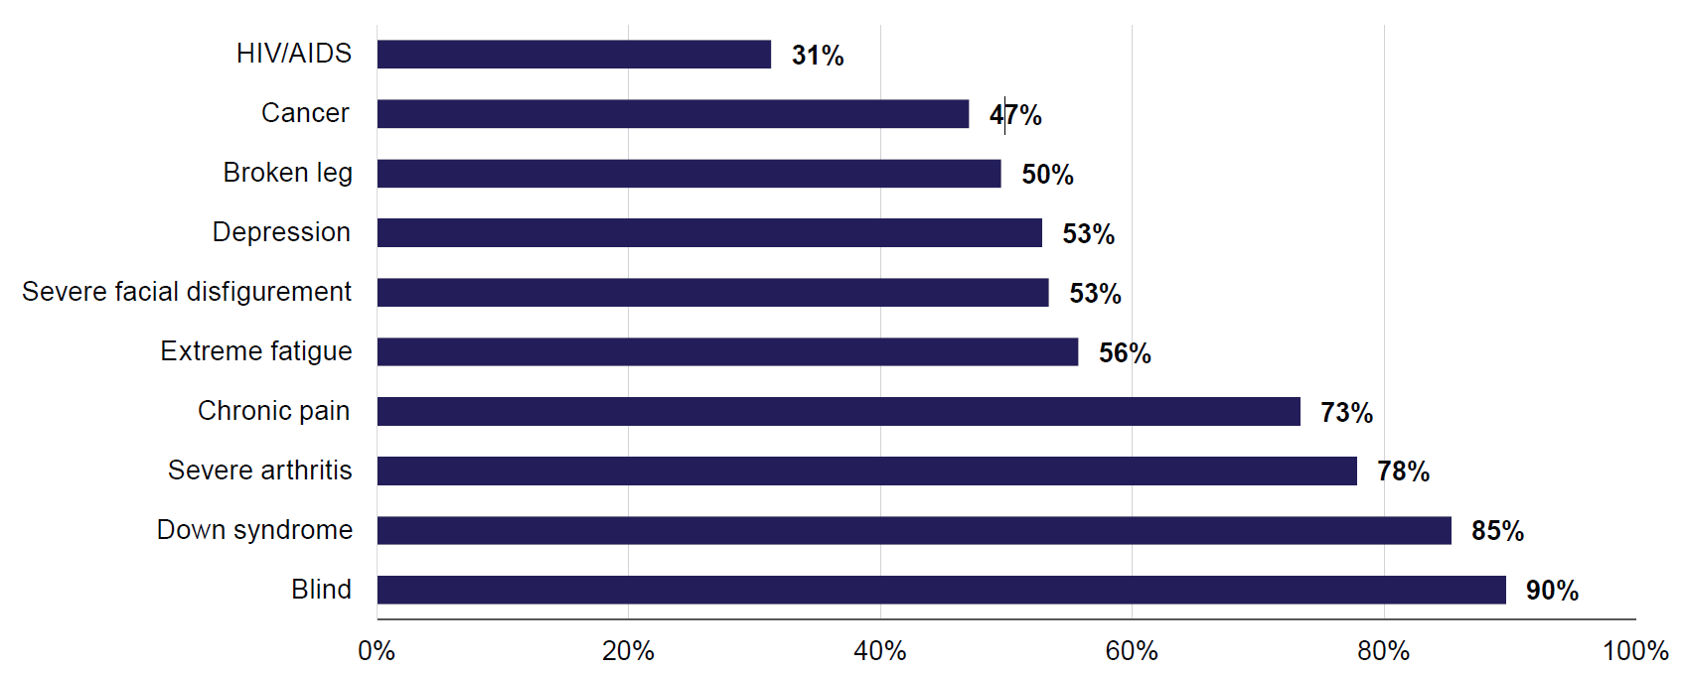
In 2024, most people thought that a person who is blind or who has Down syndrome has disability (90% and 85%, respectively). About 3 in 4 people thought that someone who has severe arthritis or chronic pain has disability (78% and 73%, respectively).
The findings show that people are more likely to recognise physical disabilities that are easy to see, permanent, and associated with loss of physical function. Other disabilities may not be as widely recognised, which could cause challenges for a person who has this type of disability. These include:
- temporary impairments (such as broken leg)
- mental health conditions (such as depression)
- invisible conditions (such as extreme fatigue)
- conditions where loss of function may be less well understood (facial disfigurement).
Lower rates of recognition for HIV/AIDS or cancer could be because the impact of these conditions on a person’s life may vary greatly. With timely treatment and supportive care, some people with these conditions can keep a high quality of life. People also might think of disability as something a person is born with, or something resulting from an injury.
All conditions in Figure 1.1 may meet legal or government definitions of disability, depending on their impact on a person’s life. People in late stages of terminal illness may be eligible to receive Disability Support Pension (DSP). A person with a broken leg has a right to reasonable accommodations in the workplace and may be eligible for disability parking. The Disability Discrimination Act 1992 defines disability to include permanent or temporary, visible or invisible, and past, present, or future disability.
Respondents in the ADS Survey were more likely to say that each of the listed conditions was a disability if they:
- had disability themselves. The differences were particularly large for depression (68% of people with disability and 47% of people without disability thought that depression was disability) and extreme fatigue (69% of people with disability and 50% of people without disability thought that extreme fatigue was disability).
- had experience with disability (other than their own) – this means they have been a paid or an unpaid carer, lived with a person with disability, or had a close relative, partner, friend, work colleague or boss, teacher, lecturer or classmate with disability. As above, depression and extreme fatigue had the largest differences in being recognised as disability (57% and 40%, respectively, for depression, and 60% and 40% for extreme fatigue).
- were older. The largest differences were observed for depression (67% of people aged 65 and over thought it was a disability, compared with 41% of those aged 18–34) and cancer (59% of people aged 65 and over thought it was a disability, compared with 39% of those aged 18–34).
Women were more likely than men to say that each of these conditions was a disability, and people with gender identity other than man or woman were even more likely to say so. The largest difference was for extreme fatigue, which was considered disability by 52% of men, 59% of women, and 78% of people with gender identity other than man or woman.
There were some changes in perceptions of disability between the 2 waves of the survey. The proportions of people who recognised arthritis, depression, extreme fatigue, and chronic pain as disability dropped by 2–4 percentage points between 2022 and 2024. At the same time, more people recognised severe facial disfigurement as disability in Wave 2 than in Wave 1 (53% in 2024 compared with 51% in 2022).

People with disability in the ADS Survey
Among the ADS Survey respondents in 2024, more than 10,000 reported having long-term health conditions which restricted their everyday activities. This group of people could be considered to have disability or a restrictive long-term condition. However, not all people in this group self-identified as having disability or a long-term health condition. The ADS Survey data show that only about 78% of people with functional restrictions or activity limitations self-identified as having disability. As this Report largely looks at attitudes of people, it is important to consider self-identification as it shapes people’s experiences and expectations. Therefore, this Report uses ‘people with disability’ to refer to the group of people who both have functional limitations and restrictions, and self-identify as having disability. Appendix A: Technical Appendix has more information on how disability is determined in the ADS Survey.
The profile of people with disability in the ADS Survey shows the diversity of the disability community in Australia. About 3 in 10 (29%) people with disability were born overseas, and 3.0% were Aboriginal and/or Torres Strait Islander. One in 5 (20%) had completed a Bachelor degree or higher, 43% had achieved a Diploma or Certificate III/IV, 16% had the highest education of Year 12 or equivalent, and 17% had the highest education of Year 11 or below.

Around 1 in 5 (21%) people with disability had severe or profound disability. This means they are restricted in their ability to do core daily tasks such as moving around, taking care of themselves (showering or dressing), or communicating with others. About 4 in 5 (82%) people with disability considered their disability not visible – not obvious to others. The remaining 18% of people with disability thought others would be able to tell they have disability even when meeting them for the first time.
Table 1.1 shows the proportions of people with disability who have different types of disability. The ADS Survey offers 2 ways to look at types of disability a person may have. One approach is based on broad functional limitations or activity restrictions. The other approach is based around self-reported diagnoses that could cause disability.
Most people with disability have more than one type of disability. This could be because they have multiple conditions, or have one condition that causes limitations in different activities.
Table 1.1 Types of disability, 2024
Type of disability | Per cent
By broad functional limitation or activity restriction:
Physical (shortness of breath, chronic or recurring pain, seizures or loss of consciousness, limited use of limbs, fingers or feet, difficulty gripping things, a condition limiting physical activity or physical work, any disfigurement or deformity) | 77%
Sensory or speech (hearing or speech problems, sight problems not corrected by glasses or contact lenses) | 44%
Psychosocial (nervous or emotional condition, mental illness for which help or supervision is required) | 40%
Intellectual (difficulty learning or understanding things) | 16%
Head injury, stroke, or acquired brain injury | 5.7%
Other | 56%
More than one type | 71%
Based on self-reported diagnosis or cause:
Physical or neurological:
Physical (e.g., reduced mobility or movement, cerebral palsy, multiple sclerosis) | 32%
Neurological (e.g., autism, ADHD, epilepsy, Alzheimer’s disease, Parkinson’s disease) | 24%
Sensory or speech-related:
Hearing related (e.g., deafness, hearing loss, hearing impairment) | 29%
Sight related (e.g., blindness, vision impairment) | 17%
Speech related (e.g., speech loss, speech impairment) | 5.4%
Psychosocial (e.g., anxiety disorders, depression, schizophrenia) | 47%
Intellectual or learning-related:
Learning-related (e.g., dyslexia, dysgraphia) | 12%
Intellectual (e.g., Down syndrome, Fragile X syndrome) | 3.2%
An acquired brain injury (e.g., caused by an accident or stroke) | 5.8%
More than one type | 60%

Attitudes towards people with disability
All respondents in the ADS Survey were presented with a series of statements about people with disability and were asked how much they agreed or disagreed with each statement. The statements touched on general attitudes towards people with disability in various aspects of life. This section discusses findings by looking at these statements grouped under 3 broad themes:
1. People’s perceptions of society’s attitudes towards people with disability
2. Individual’s positive attitudes towards people with disability
3. Individual’s negative attitudes towards people with disability.
The first group of statements is presented in Figure 1.2. This group could be viewed as people’s perceptions of society’s attitudes towards people with disability, and not necessarily representing their personal views.
The overall high level of agreement in Figure 1.2 indicates that there is a perception that society as a whole has negative attitudes towards people with disability. For example, 61% of people agreed that people with disability are easier to take advantage of (exploit or treat badly) than people without disability. About 1 in 10 (11%) people strongly agreed with this statement and 49% somewhat agreed.
Figure 1.2: Perceptions of society’s attitudes towards people with disability, 2024
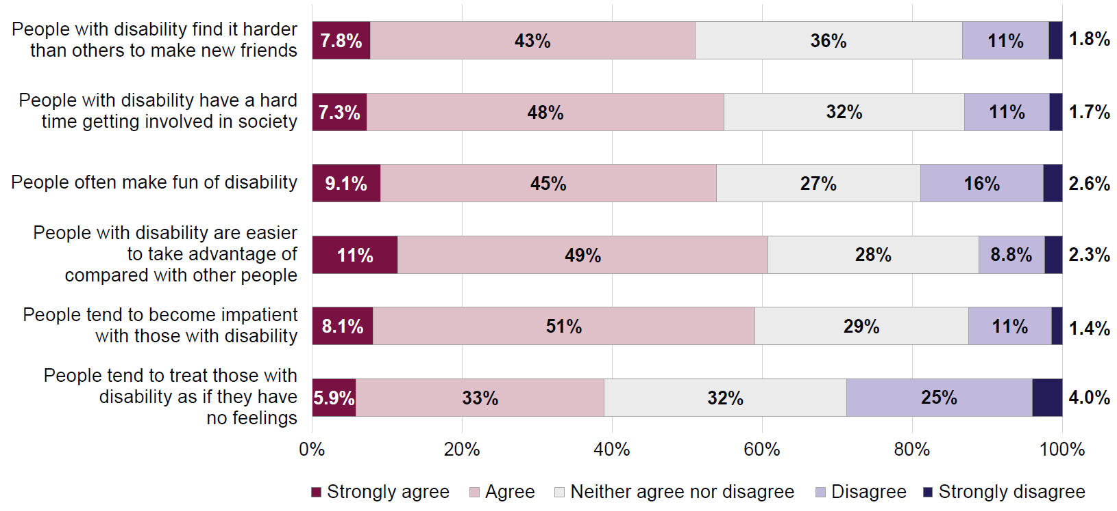
Survey respondents in the ADS Survey who had disability themselves or had experience with disability (other than their own) had higher average rates of agreement with these statements than those who had no disability or no experience with disability. Women had higher average rates of agreement than men, and people with gender identity other than man or woman had the highest average rate of agreement. Younger people aged 18–34 had higher average rates of agreement than those aged 35 and over.
There were some small changes between the 2 waves of the ADS Survey, with people slightly less likely to strongly agree with these statements in Wave 2, and slightly more likely to neither agree nor disagree.
The second group of statements is about positive attitudes towards people with disability (Figure 1.3). These statements focus on personal views rather than what society thinks. This group of statements looks at how open people are to acknowledging the value and strengths that can emerge from living with disability. The responses are indicative of community awareness of potential gains or benefits that can be created by learning to manage life, and live well, with disability.
More than half (59%) of people in the survey agreed that having a disability can make someone a stronger person, and 46% agreed that some people achieve more (are more successful) because of their disability.
People with disability and those who had experience with disability (other than their own) had higher average rates of agreement with these statements. Women had higher average rates of agreement than men, and people with gender identity other than man or woman had the lowest average rates of agreement. People aged 65 and over were more likely to agree than those who were younger.
Between 2022 and 2024, the level of agreement with these statements decreased, with fewer people strongly agreeing and more people saying they neither agree nor disagree.
Figure 1.3: Strengths of people with disability, 2024
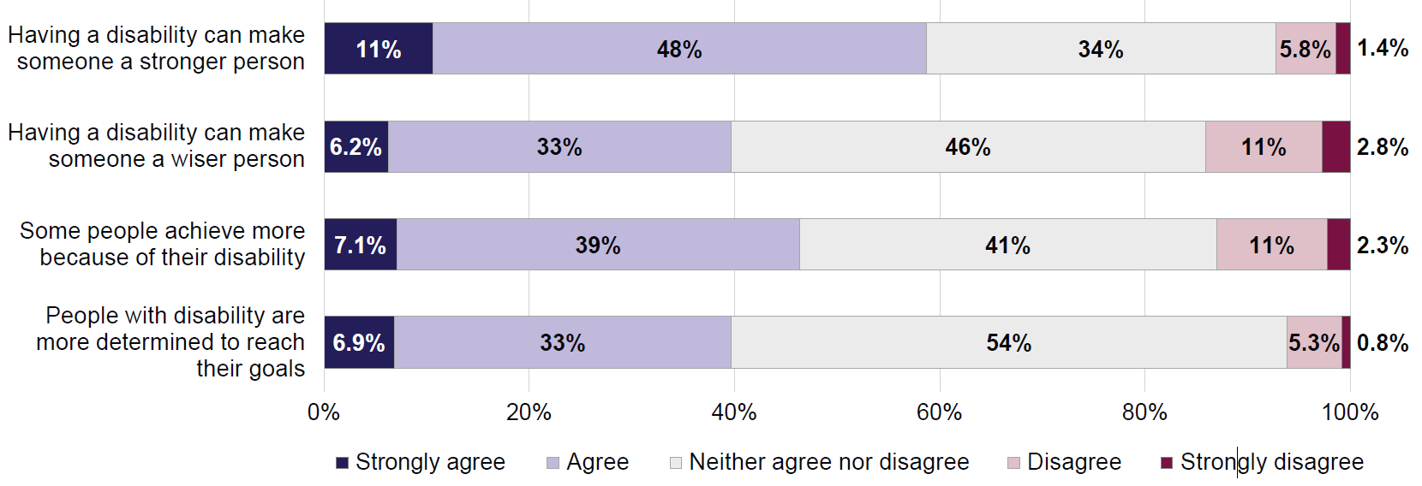
The final group of statements looks at negative attitudes towards people with disability (Figure 1.4). These negative attitudes can serve as barriers to social inclusion and can lead to people with disability experiencing loss of agency.
As Figure 1.4 shows, not many people hold these negative views. Most people (73% in total) disagreed that people with disability are a burden on society, and 81% disagreed that people with disability should not be optimistic about their future. Although the numbers of people agreeing with these statements were smaller, they were still relatively high for some statements:
- 17% agreed that people with disability are a burden on their family
- 15% agreed that others should not expect too much from those with disability
- 14% agreed that people with disability have less to look forward to than others.
Figure 1.4: Negative attitudes to people with disability, 2024
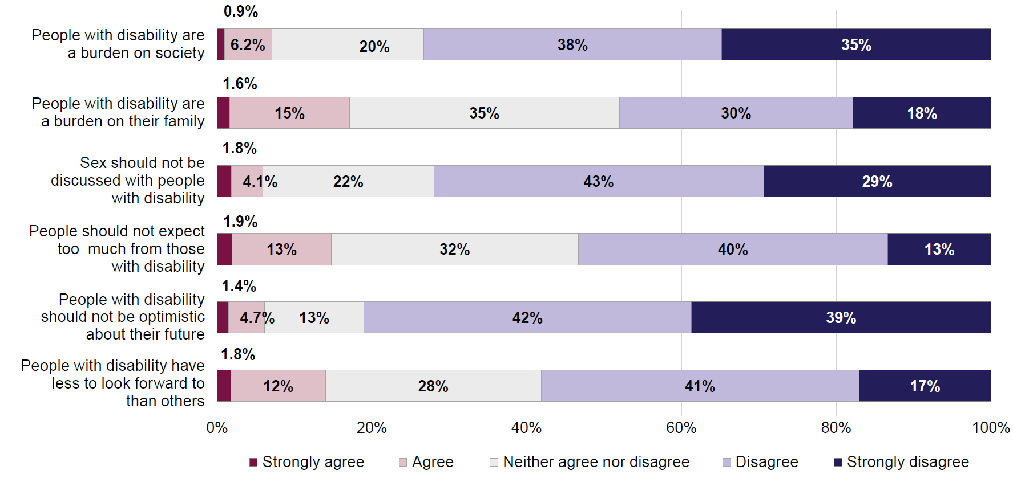
The differences between groups of respondents highlight an important distinction between statements in Figure 1.4 and those in Figures 1.2 and 1.3. For statements in Figure 1.4, people with disability had similar views to those without disability. However, people who had experience with disability other than their own had lower average rates of agreement with these statements, indicating more positive attitudes.
Men were more likely to agree with these statements than women, and people with gender identity other than man or woman were the least likely to agree. People aged 65 and over were more likely to agree than those who were younger.
As with the 2 other groups of statements discussed above, the views on the statements in Figure 1.4 were somewhat less positive in 2024 compared with 2022, with fewer people strongly disagreeing with the statements and more people saying they neither agree nor disagree.

Attitudes to people with different types of disability
Respondents in the ADS Survey were asked to imagine 3 situations where they would interact with a person with disability and asked how they would feel in each of these situations. The situations were:
- a close relative being in a relationship with a person with disability
- having a GP with disability
- having a boss with disability.
The last 2 situations have people with disability in roles of authority and expertise. To be comfortable with a GP with disability, a respondent must feel both that the doctor is there on merit and has the relevant expertise for the role, and that the doctor’s disability does not create any barriers to providing effective care. Responses to this question could be read as indicative of people’s trust in the professional or technical expertise of people with disability.
Similarly, to feel comfortable with a boss who has disability would usually require that a person feels comfortable accepting leadership and taking direction from a person with disability and deferring to their judgement and expertise.
Respondents were randomly divided into 5 groups, and each group was asked questions about a specific type of disability:
- sensory or communication impairment, such as being partially or fully blind or deaf
- physical disability, such as reduced mobility or movement
- psychosocial condition, such as severe anxiety or depression
- neurological condition, such as autism or attention deficit hyperactivity disorder (ADHD)
- intellectual disability, such as Down syndrome.
Respondents could be assigned to different disability groups for each of the 3 situations.
The results are presented in Figures 1.5–1.7. Overall, people were more comfortable with situations if the person they would be interacting with had physical disability. Over 90% said they would be very or fairly comfortable if their boss had physical disability, or if their close relative was in a relationship with someone who had physical disability. Similarly, more than 90% of people thought that they would receive the same quality of treatment from a GP with physical disability, compared with a GP who did not have disability.
Results for other types of disability were more varied. For example, people were comfortable to interact with a person who had sensory or communication impairment, except for having a GP with this type of disability. This could be related to perceived difficulties for the GP to be able to gather the same amount of information as the person who did not have this impairment, or difficulties in communicating with a GP with this type of disability.
For situations involving people with neurological conditions, the level of overall agreement or comfort was similar to situations where a person had physical disability. However, far smaller proportions of respondents said they would feel very comfortable in these situations or strongly agreed they would receive high-quality care.
The least positive attitudes were expressed in situations involving people with psychosocial conditions or with intellectual disability. For professional settings and especially with GPs, these attitudes may be at least partially explained by misconceptions about the capabilities of people with disability. These misconceptions may lead to lack of trust and confidence in judgement, or communication and safety concerns.
Improved awareness of disability, and trust in the systems that support people with disability to qualify for and perform in their chosen career would help ensure that professionals do not face prejudice because of their disability.
Figure 1.5: How comfortable would people feel to have a close relative in a relationship with someone with disability, by disability type, 2024
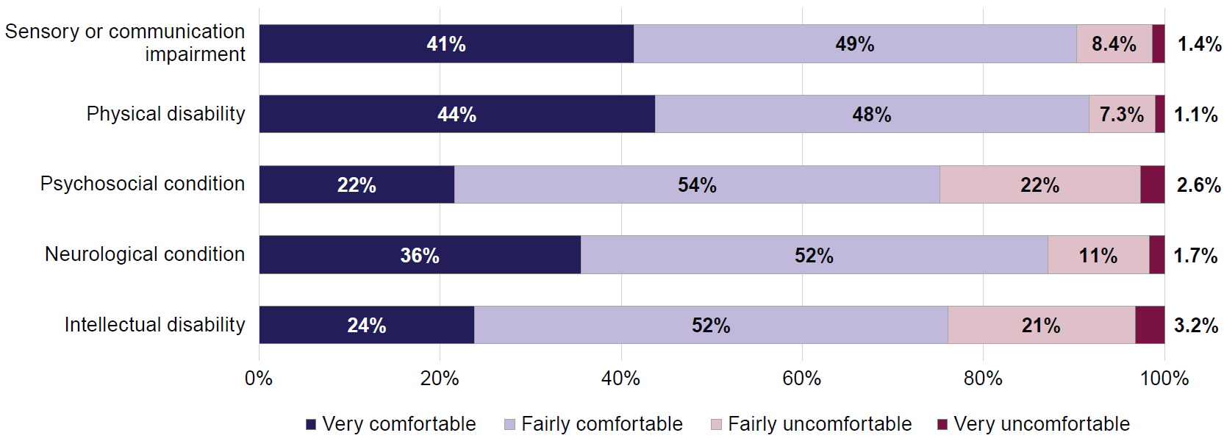
Figure 1.6: Whether people agree they would receive the same quality of treatment from a GP with disability, by disability type, 2024
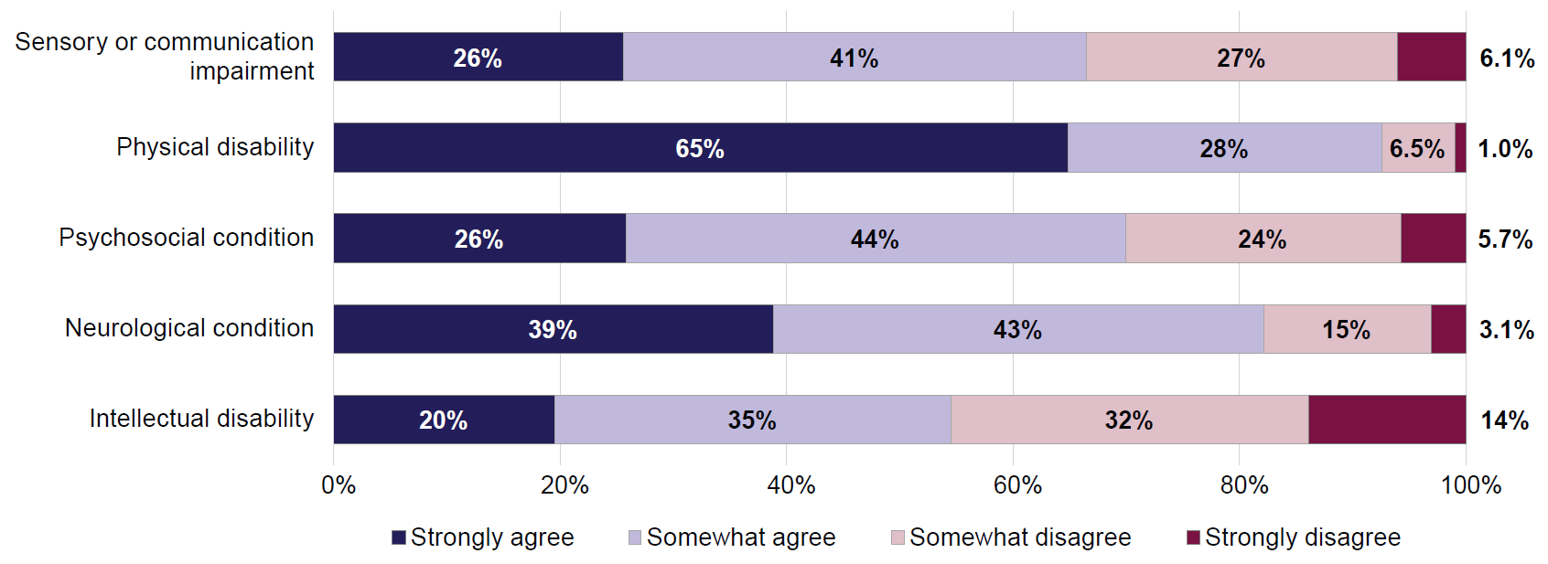
Figure 1.7: How comfortable would people feel to have a boss with disability,
by disability type, 2024
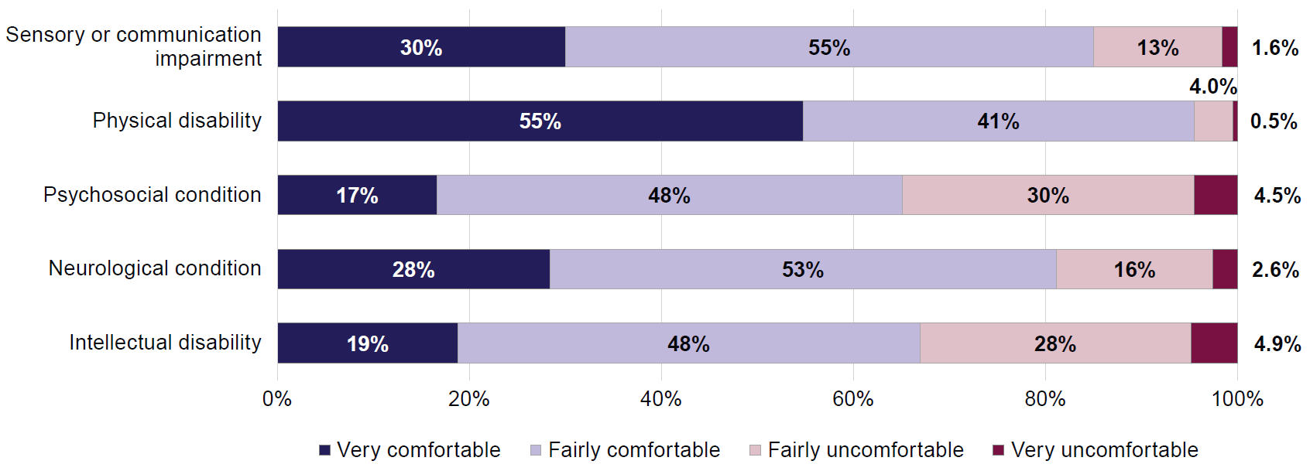

Experiences of people with disability

Effect of other people’s attitudes
Negative attitudes can significantly impact the well-being of people with disability. Unfair treatment, bullying or discrimination can result in social exclusion, isolation, and act as barriers to participation in various aspects of life. People with disability in the ADS Survey were asked if the attitudes or behaviours of others had ever stopped them from doing the things they want to do, or from telling other people that they have disability (Figure 1.8).
Figure 1.8: People with disability – How often the attitudes and behaviours of others prevented activity participation or disability disclosure, 2024
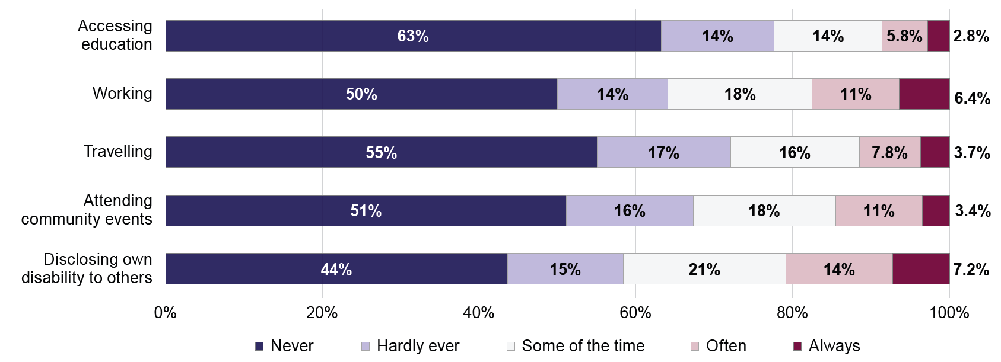
More than half of people with disability had never or hardly ever been prevented from participating in society by other people’s attitudes. However, there were some differences depending on the types of activities. For example, about 3 in 4 people with disability said they had never or almost never been prevented from accessing education (78%) or travelling (72%). Fewer people said the same about working (64%) or telling others about their disability (58%). In fact, about 1 in 5 (21%) people with disability said that they were often or always prevented from disclosing their disability to others due to negative attitudes. Similarly, 17% said other people’s attitudes had always or often stopped them from working (including finding or keeping a job, or getting a promotion). The attitudes towards people with disability and work, and the attitudes of employers in hiring and promoting people with disability are discussed in greater detail in the Work and employment section of this Report.
Some groups of people with disability were more likely to be affected by negative attitudes of others:
- People with visible disability were more likely to say that attitudes had often or always stopped them from accessing education (14%), travelling (21%), or attending community events (24%). This compares with 7.4%, 9.3%, and 12%, respectively, for people whose disability was not easy to see.
- People with severe or profound disability were more likely to say that attitudes had often or always stopped them from accessing education (18%), travelling (26%), or attending community events (27%). These proportions were 6.1%, 7.6%, and 11%, respectively, for people with milder forms of disability.
- People with intellectual disability, psychosocial disability, or disability related to head injury, stroke or acquired brain injury were more affected by negative attitudes. This is especially the case for people with intellectual disability when accessing education. About 1 in 4 (26%) people with intellectual disability said they had often or always been prevented from accessing education by negative attitudes, compared with 8.6% for all people with disability.
When it comes to disclosing own disability to others, proportions of people with disability who chose not to disclose they had disability due to the attitudes of others were similar for people with visible and non-visible disability. However, people with severe or profound disability, and people with intellectual disability were more likely to feel prevented from disclosing their disability:
- 31% of people with severe or profound disability, and 18% of people with milder forms of disability often or always chose not to disclose their disability due to negative attitudes.
- 42% of people with intellectual disability, and 35% with psychosocial disability often or always chose not to disclose their disability.
Compared with 2022, in 2024 lower proportions of people with disability said they were never prevented from participating in activities by attitudes of others, and higher proportions said they were hardly ever prevented. Response patterns for being stopped from disclosing disability remained the same in both years.

Feeling valued and respected in community
Feeling valued and respected is important to the wellbeing of all people. It boosts individual self-esteem, mental health and happiness, and is key to creating stronger, united and more inclusive communities.
Just over half (53%) of people with disability in the ADS Survey said they always or often feel valued and respected in community (Figure 1.9). A third (32%) feel this some of the time, and 14% hardly ever or never.
Figure 1.9: People with disability – How often felt valued and respected in community, 2024
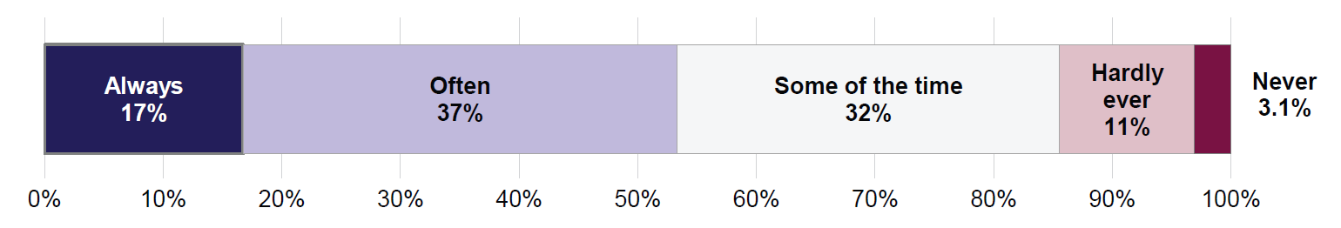
About half of men (55%) and women (53%) with disability said they always or often feel valued. This was lower for people with disability whose gender identity was other than man or woman, with only 1 in 5 (20%) saying they always or often feel valued. People with disability aged 65 and over were much more likely to say they always feel valued and respected (27%), compared with those aged 18–64 (12%).
There were also differences depending on people’s disability characteristics (Figure 1.10). People with severe or profound disability, and people with intellectual or psychosocial disability were much less likely to say they always felt valued and respected.
Figure 1.10: Proportion of people with disability who always feel valued and respected in community, by disability characteristics, 2024
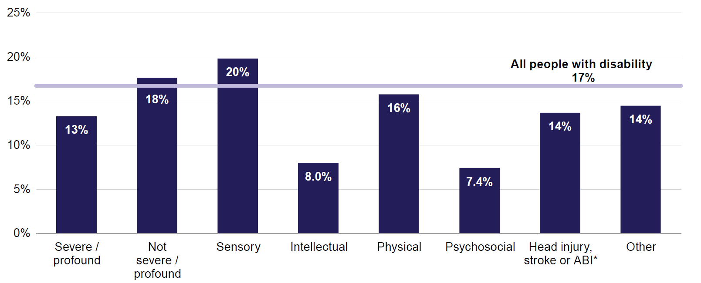
Note: * ABI = acquired brain injury.
Between 2022 and 2024, the proportions of people saying they had always felt valued and respected declined (from 20% in 2022 to 17% in 2024), while the proportion of people saying they often felt valued increased from 34% in 2022 to 37% in 2024. Other responses have remained largely unchanged.

People with disability being represented in community
Representation in a community or social settings matters, particularly for people with disability. When people with disability are seen in positions of leadership, in media, or simply participating in community activities, this can lead to improved understanding of disability. For people with disability, this can validate their own experiences and show that they are not alone.
Respondents in the ADS Survey were asked whether, in their opinion, people with disability were well represented in various aspects of life (Figure 1.11). Respondents were asked about disability representation across 4 areas: leadership roles, the workplace, the community, and the media.
Figure 1.11: Proportions of people who think that people with disability are well represented in various areas of life, 2022 and 2024
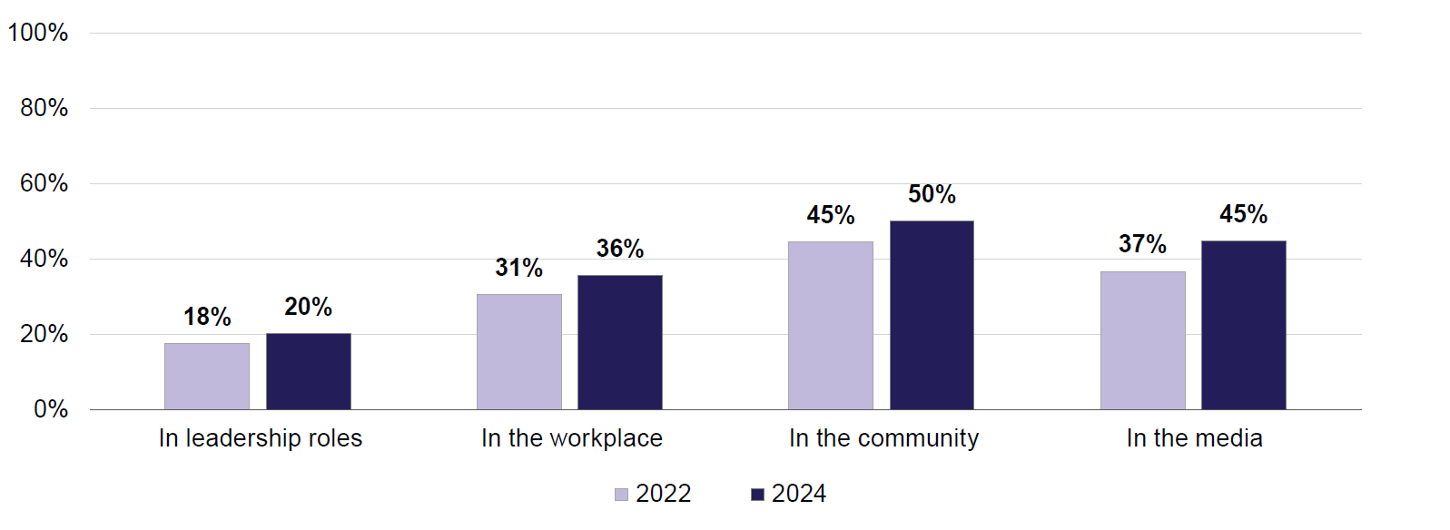
Half of all people (50%) thought that people with disability are well represented in the community, while only 1 in 5 (20%) thought people with disability are well represented in leadership roles. For all 4 areas, the level of agreement increased since 2022.
For all areas, men were the most likely to think that people with disability are well represented, and people with gender identity other than man or woman the least likely to think so. Older people were more likely to think that people with disability are well represented in leadership roles (25%) than people aged 18–64 (19%), however there were no differences by age for other areas of life.
People who had disability themselves were more likely to think that people with disability are well represented in leadership roles (23%) and in the workplace (39%) compared with those without disability (19% and 35%, respectively).
Among people with disability, those with severe or profound disability were less likely to think that people with disability were well represented in:
- the workplace: 32% of people with severe or profound disability thought that people with disability were well represented, compared with 40% of people with milder forms of disability
- the community: 45% of people with severe or profound disability thought that people with disability were well represented, compared with 53% of people with milder forms of disability
- the media: 37% of people with severe or profound disability thought that people with disability were well represented, compared with 46% of people with milder forms of disability.
People with physical, or sensory or speech disability were the most likely to agree that people with disability are well represented across aspects of life, while those with intellectual or psychosocial disability were the least likely:
- 25% of people with sensory or speech disability thought that people with disability are well represented in leadership roles, compared with 16% of people with psychosocial disability
- 40% of people with sensory or speech disability and 38% of those with physical disability thought that people with disability are well represented in the workplace, compared with 31% of people with intellectual disability and 32% of people with psychosocial disability
- 54% of people with sensory or speech disability thought that people with disability are well represented in the community, compared with 44% of people with intellectual disability and 45% of people with psychosocial disability
- 44% of people with sensory or speech, or physical disability thought that people with disability are well represented in the media, compared with 36% of people with intellectual disability and 37% of people with psychosocial disability.

Work and employment
Work is vital for people with disability, offering benefits beyond financial stability. It fosters independence, enhances self-esteem, provides a sense of purpose, and contributes to social inclusion. Employment also reduces reliance on government supports and can have positive impacts on health and well-being. However, attitudes of co-workers, managers, clients and the community in general can negatively affect the employment of people with disability. These attitudes, often based on lack of information or misconception, can lead to barriers in accessing and maintaining employment, or to discrimination in hiring and promotion processes.
This chapter looks at employment and work-related outcomes and experiences of people with disability in the ADS Survey. It also looks at attitudes of people with hiring responsibilities (employers) on employing people with disability. Finally, it discusses challenges employers may have experienced in hiring a person with disability at their workplace.
Key findings
While people with disability have lower rates of economic participation than those without disability, many people with disability are involved in paid or volunteer work.
People with disability still experience negative attitudes which may prevent them from finding or keeping a job, or applying for a promotion. These negative attitudes are experienced more strongly by people with visible disability, those with more severe forms of disability, and those with psychosocial, intellectual, or neurological disability.
For employers, the perceived barriers to hiring people with disability vary depending on the sector of employment. Difficulty finding qualified workers and the nature of the job are the 2 reasons most often named as barriers to employing people with disability.
There were few changes in attitudes or experiences related to work and employment for people with disability between Wave 1 and 2 of the ADS Survey. There was a small tendency towards more negative attitudes about people with disability and work.

Engagement in paid and volunteer work by people with disability
People with disability are generally less likely to work than those without disability. This may be due to many reasons, including ill health, lack of necessary education, or attitudes of employers and within society. People’s limitations and restrictions in doing certain activities are also likely to affect employment. For this reason, in reporting on employment and volunteering rates, disability status is based on activity limitations, and not on the person self-identifying as having disability. (For further information on the 2 approaches used to define disability in the ADS Survey see Appendix A: Technical Appendix.)
In 2024, according to the ADS Survey, 70% of people with disability aged 18–64 were employed, compared with 86% of people without disability (Figure 2.1). These proportions were similar in Wave 1 of the survey (2022), when they were 69% and 86%, respectively.
The employment rates in the ADS Survey are higher than those reported by the ABS 2022 Survey of Disability, Ageing and Carers (SDAC) for people aged 15–64 (Figure 2.1). This is the case for people without disability (82%) and even more so for people with disability (56%). The differences between the 2 sets of findings could be due to different age cut-offs (the ADS Survey does not include people aged 15–17), different methodologies used to identify people with disability, or the differences in characteristics of respondents in these 2 surveys.
Figure 2.1: Proportion of people who are employed, by disability status*, 2024 and 2022
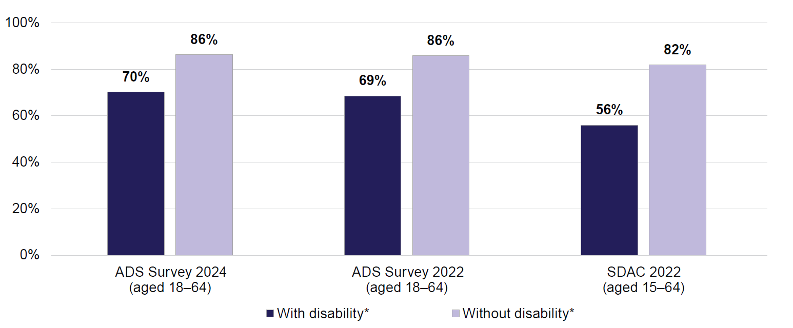
Note: * The disability status in this figure is based on reported activity limitations and restrictions, not on whether a person self-identifies as having disability. For more information about how disability is determined in the ADS Survey, see Appendix A: Technical Appendix.
Apart from paid employment, 30% of both people with and without disability in the ADS Survey in 2024 reported participating in voluntary work in the past year. The rates of volunteering were slightly higher for people aged 65 and over:
- 29% of people both with and without disability aged 18–64 were engaged in volunteering
- 33% of people aged 65 and over with disability and 37% without disability were engaged in volunteering.
The volunteering rates for people aged 18–64 were similar in 2022 (28% for people with disability and 27% without disability). However, people aged 65 and over were more likely to volunteer in 2024 than they were 2 years ago: in 2022, 29% of people with disability and 33% of people without disability were volunteering.
Overall, about 77% of people with disability aged 18–64 were engaged in paid or volunteer work in 2024, as were 41% of people with disability aged 65 and over.

General attitudes to people with disability and work
Attitudes toward people with disability can greatly affect their ability to work. Negative attitudes, stereotypes, and prejudice can create barriers to employment, while positive attitudes and inclusive practices can act as enablers.
In 2024, around 1 in 25 people (3.7%) in the general community agreed with the notion that “people with disability do not want to work, they do not look for a job”; most people either disagreed (45%) or strongly disagreed (31%) with this statement. People with disability, and those who have experience with disability (other than their own) are more likely to strongly disagree with this statement:
- 34% of people with disability strongly disagreed, compared with 29% of those without disability
- 33% of people who had experience with disability strongly disagreed, compared with 21% of those who had no experience with disability
- Employers (people who have hiring responsibilities) were slightly more likely to strongly disagree with this statement (34%) compared with non-employers (30%; non-employer group includes employed people who do not have hiring responsibilities and people who are not employed).
Somewhat more common is the opinion that people with disability work less efficiently than those without disability – about 1 in 6 people (16%) agreed with this statement:
- People with and without disability were equally likely to agree with this statement.
- People who had experience with disability (other than their own) were less likely to agree (16%), compared with those who had no experience (19%).
- 19% of employers agreed with this statement, compared with 16% of non-employers.
The above 2 statements are examples of negative attitudes which can act as barriers for people with disability to find or keep a job. On the other hand, positive attitudes can act as enablers. More than 8 in 10 (86%) people agree that it is easier for people with disability to do their job if they have the right support and equipment at work:
- 39% of all people strongly agree with this statement and 47% somewhat agree
- 43% of people with disability strongly agree
- 43% of people who have experience with disability (other than their own) strongly agree
- 43% of employers strongly agree.
About 6 in 10 (58%) people think that employing people with disability improves a company’s image. These numbers are similar for employers and non-employers. People with disability are more likely to agree (60%) than those without disability (57%). People who have experience with disability (other than their own) are more likely to agree (60%) than those who have no experience (52%).
Looking at the changes in society’s attitudes towards people with disability and work between 2022 and 2024, there was a small trend towards less positive attitudes in the latter year:
- Fewer people strongly disagreed with the notion that people with disability do not want to work (36% in 2022 and 31% in 2024).
- More people agreed that people with disability work less efficiently (14% in 2022 and 16% in 2024).
- Fewer people strongly agreed that the right support and equipment would make it easier for people with disability to do their job (46% in 2022 and 39% in 2024).
While people with disability in the ADS Survey were not asked if they had experienced negative attitudes in the course of their employment or job search, they were asked if the attitudes of others had ever stopped them from working (including trying to get a job, keeping a job, or getting a promotion). Half (50%) of people with disability said in 2024 that the attitudes of others had never stopped them from working (Figure 2.2), and a third (32%) said this happened infrequently (some of the time or hardly ever). However, for about 1 in 6 (17%) people with disability this has happened always (6.4%) or often (11%).
Figure 2.2: People with disability – How often other people’s attitudes have stopped you from working, 2024 and 2022
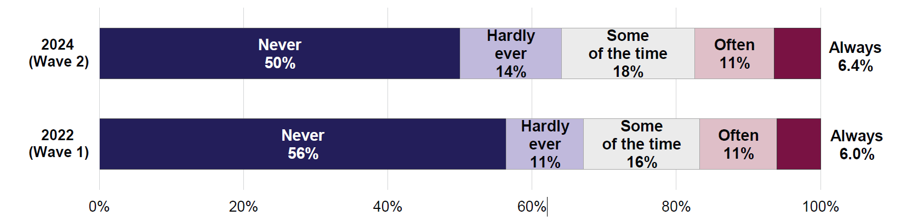
Some groups of people with disability were more likely to say that other people’s attitudes had stopped them from working. Compared with 17% of all people with disability, the proportions of those who said other people’s attitudes had always or often stopped them from working were (in 2024):
- 26% for people who had visible disability (where others could easily tell they had disability)
- 31% for people with severe or profound disability
- 37% for people with intellectual disability, 30% for people with psychosocial disability, and 29% for people with disability related to head injury, stroke or acquired brain injury
- 29% for younger people (aged 18–34) with disability.
The higher rate for the young people (aged 18–34) could be related to the type of disability. People with intellectual disability or psychosocial disability tend to be younger on average than people with other types of disability.
The proportions of people with disability who said the attitudes of others had often or always stopped them from working have not changed between 2022 and 2024 (17% in both years). However, over this period, the proportion of people with disability who said negative attitudes have never stopped them from working has fallen (from 56% in 2022 to 50% in 2024), and the proportions for whom this happened rarely or some of the time have increased (Figure 2.2).

People with disability in the workforce
The sections above show that people with disability have lower employment rates than those without disability. This could be due to a combination of health factors, lack of support systems, and negative community attitudes. As a result, people with disability tend to be underrepresented in the workplace.
In 2024, over a third (36%) of people thought that people with disability are well represented in the workplace. This has improved since 2022, when 31% of people thought that people with disability were well represented.
The opinions in 2024 differed depending on people’s own disability status, type of disability, and gender:
- 39% of people with disability and 35% of people without disability thought that people with disability are well-represented in the workplace. At the same time, 61% of people with disability and 65% of people without disability did not think that this was the case.
- People with intellectual disability and people with psychosocial disability particularly felt that disability is not well represented in the workplace. In these groups, 31% and 32%, respectively, thought that people with disability are well represented.
- Women (regardless of their own disability status) were less likely than men to think that people with disability are well-represented in the workplace. About 3 in 10 (31%) women thought people with disability are well represented. For men, the view depended on their own disability status. Just under half (46%) of men with disability and 39% of men without disability thought that people with disability are well-represented in the workplace. At the same time, 14% of people with gender identity other than man or woman thought that people with disability are well-represented.
People with disability may be under- or overrepresented in certain types of jobs. While the ADS Survey did not collect data about exact occupations or job titles, information about the industry of employment is available and can be compared for people with and without disability.
Figure 2.3 shows the distribution of employed people across selected key industries, by disability status (based on reported activity limitations, not on whether the person self-identified as having disability). The 2 sets of bars in the figure each add up to 100%, the total number of employed people with or without disability. For example, the figure shows that about 12% of all employed people with disability worked in the education sector; similarly, about 12% of all employed people without disability worked in the education sector. This means that people with and without disability were equally likely to work in education. The industries in Figure 2.3 include the 4 key service sectors (health care, education, personal and community support, and justice and legal services) discussed in more detail in the later chapters of this Report. The figure also includes other major industry groups, for a more complete picture of industries that employ people with disability.
Figure 2.3 shows that people with disability are less likely than those without disability to work in the health sector and in the professional, scientific and technical services industry:
- 10% of all employed people with disability worked in the health industry, compared with 12% of all employed people without disability
- 6.3% of employed people with disability worked in the professional, scientific and technical services industry, compared with 9.6% of all employed people without disability.
At the same time, people with disability were more likely to be employed in personal and community support sector than those without disability:
- 9.8% of all employed people with disability worked in personal and community support sector, compared with 7.1% of all employed people without disability.
Figure 2.3: Distribution of employed people across sectors of employment, by disability status*, 2024
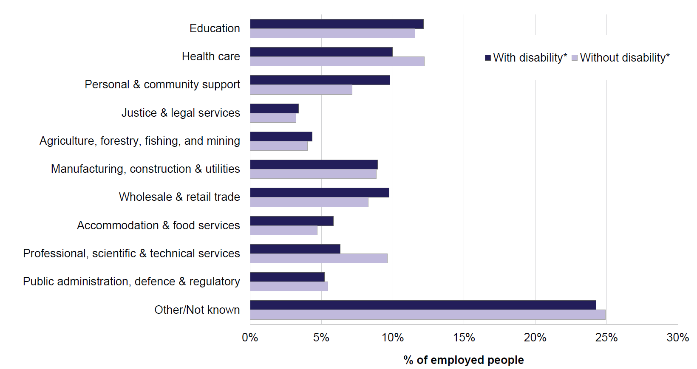
Note: * The disability status in this figure is based on reported activity limitations and restrictions, not on whether a person self-identifies as having disability. For more information about how disability is determined in the ADS Survey, see Appendix A: Technical Appendix.
People in the ADS Survey who had hiring responsibilities (employers) were asked if they had ever been personally involved in hiring someone with disability, and whether, to the best of their knowledge, their current workplace had recently hired someone with disability. In 2024:
- 37% of employers said their workplace had hired a person with disability in the past year
- 27% of employers had personal experience hiring someone with disability (13% in the past year and 15% more than a year ago).
There were no significant changes in these percentages since 2022.
Looking at workplace hiring practices by industry, Figure 2.4 shows the proportion of employers in each industry who said their workplace had hired someone with disability in the past year.
The 2 sectors with the highest proportion of workplaces that had hired a person with disability in the past year were personal and community support (62%), and public administration, defence and regulatory services (64%). The industries with the lowest proportions of workplaces that had recently hired a person with disability were manufacturing, construction and utilities (23%), agriculture, forestry, fishing, and mining (26%), and professional, scientific and technical services sector (27%).
Figure 2.4: Proportion of employers who said their workplace had hired someone with disability in the past year, by sector of employment, 2024
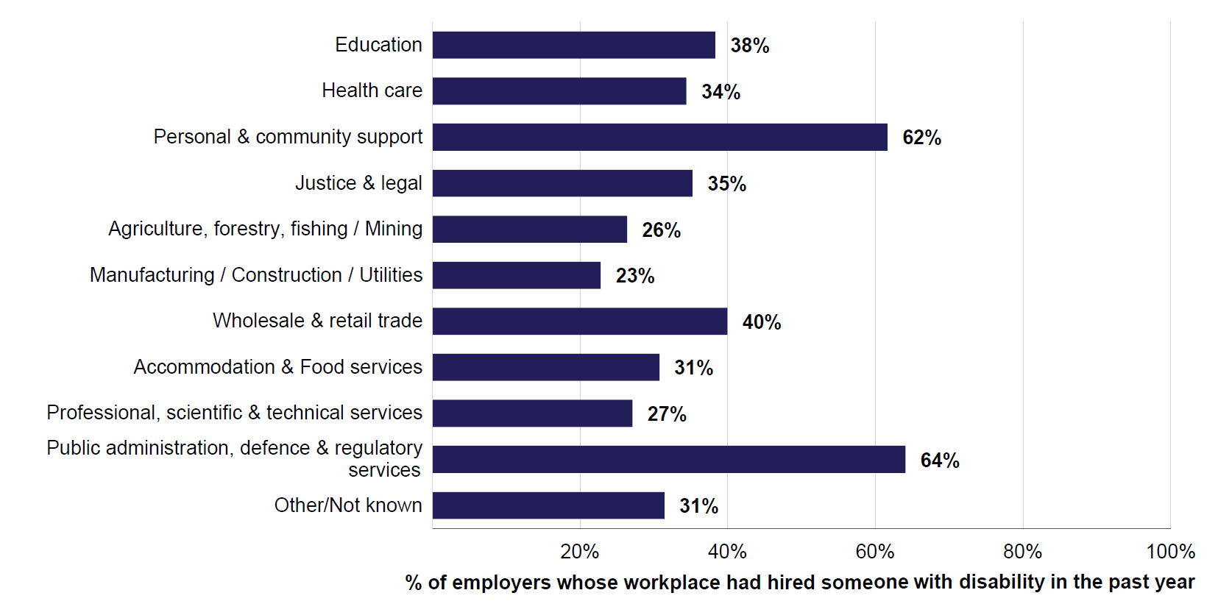
In 2024, 27% of employers said that their workplace was more prepared to hire someone with disability than a year ago, and 62% of employers said their workplace was equally prepared. These results were similar to 2022 (30% and 63%, respectively). However, in 2024 employers were more likely to say their workplace was less prepared to hire a person with disability (11% in 2024, compared with 7.6% in 2022).

Employer attitudes to hiring and promoting people with disability
More than 8 in 10 (86%) of employers agreed that hiring people with disability benefits their workplace (35% strongly agree and 50% somewhat agree). Furthermore, 9 in 10 (90%) employers agreed that people with disability would make a valuable contribution to their workplace (43% strongly agree and 47% somewhat agree).
Employers in workplaces which had hired a person with disability in the past year were more likely to agree that hiring people with disability benefits their workplace, and that people with disability make a valuable contribution to the workplace (Figures 2.5 and 2.6). The same can be said about employers who had been personally involved in hiring a person with disability (Figures 2.7 and 2.8).
These results show how connected attitudes and outcomes are. The attitudes of employers and workplaces drive workplace hiring practices. In turn, the hiring of people with disability and closer contact with co-workers with disability improves understanding of and attitudes towards disability.

Figure 2.5: Employers – Hiring people with disability benefits workplace, by workplace hiring history in the past year, 2024
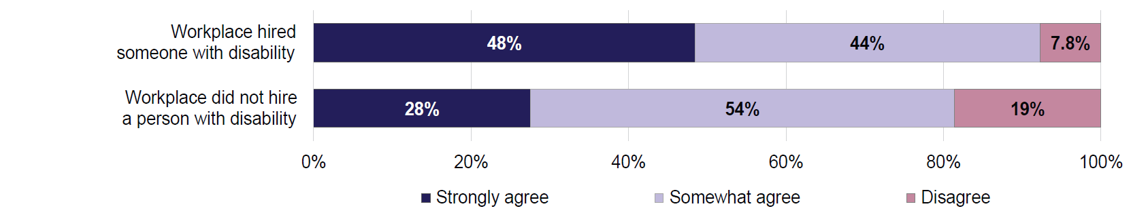
Note: Due to small number of responses, response categories ‘Somewhat disagree’ and ‘Strongly disagree’ were combined into a single category ‘Disagree’.
Figure 2.6: Employers – People with disability would make a valuable contribution to my workplace, by workplace hiring history in the past year, 2024
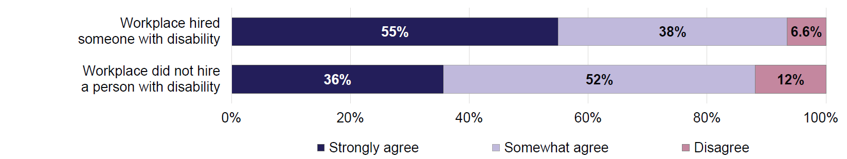
Note: Due to small number of responses, response categories ‘Somewhat disagree’ and ‘Strongly disagree’ were combined into a single category ‘Disagree’.
Figure 2.7: Employers – Hiring people with disability benefits workplace, by individual hiring history, 2024
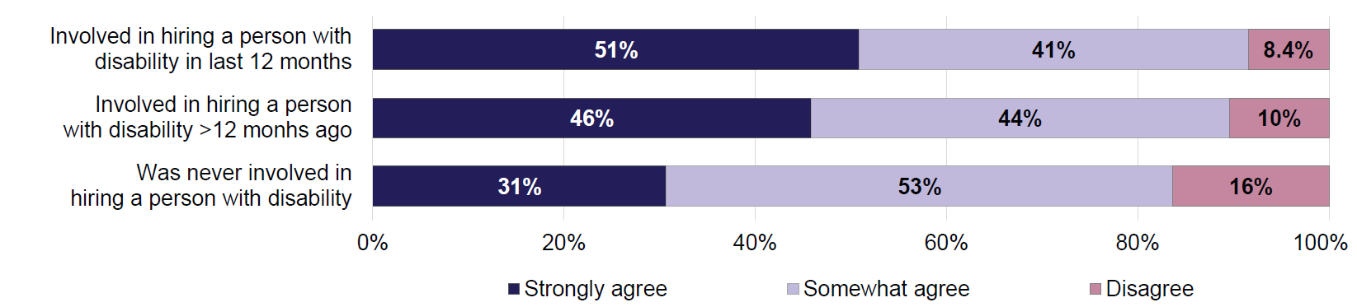
Note: Due to small number of responses, response categories ‘Somewhat disagree’ and ‘Strongly disagree’ were combined into a single category ‘Disagree’.
Figure 2.8: Employers – People with disability would make a valuable contribution to my workplace, by individual hiring history, 2024
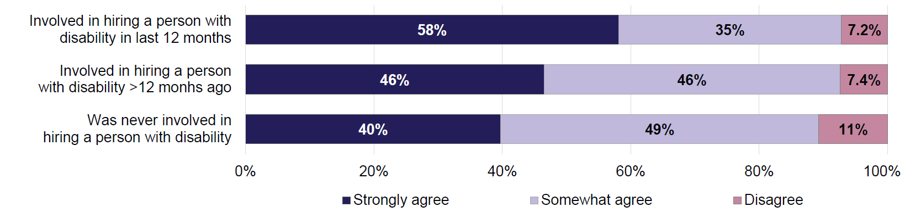
Note: Due to small number of responses, response categories ‘Somewhat disagree’ and ‘Strongly disagree’ were combined into a single category ‘Disagree’.
Employers were also asked for their views on how a business should go about hiring or promoting a person with disability. They were asked how much they agreed with the following 2 statements:
- A business should employ [a person with specific type of disability] if they have the experience and can physically do the job.
- A business should provide the support and training required to help an effective worker [with specific type of disability] get promoted.
For these questions, employers were divided into 5 groups, and each group was asked questions about one specific type of disability:
- sensory or communication impairment, such as being partially or fully blind or deaf
- physical disability, such as reduced mobility or movement
- psychosocial condition, such as severe anxiety or depression
- neurological condition, such as autism or attention deficit hyperactivity disorder (ADHD)
- intellectual disability, such as Down syndrome.
The groups were assigned randomly, and employers could be assigned to different groups for the 2 statements.
Results for the 2 statements are presented in Figures 2.9 and 2.10.
For the first statement, between 50% and 74% of employers strongly agreed that a business should employ a person with disability if they have the experience and can physically do the job (Figure 2.9). The results were similar for sensory or communication impairment and physical disability, with more than 7 in 10 employers strongly agreeing.
Employer opinions were more negative when the scenario was about hiring a person with a psychosocial condition. Only half (50%) of employers strongly agreed that a person with a psychosocial condition should be hired in these circumstances. The intellectual disability group had the second lowest level of strong agreement (64%). The findings for people with neurological conditions were affected by the high level of uncertainty in the data. As a result, findings for this group were statistically similar to both intellectual and sensory disability groups.
This response pattern may be explained by the wording of the question. The question stated that the job candidate with disability had the physical ability to do the job. However, it did not mention skills such as the candidate’s ability to manage mental and emotional demands of a job, problem-solving, decision-making, and coping with stress.

Figure 2.9: Employers – A business should employ a person with disability if they have the experience and can physically do the job, by disability type, 2024
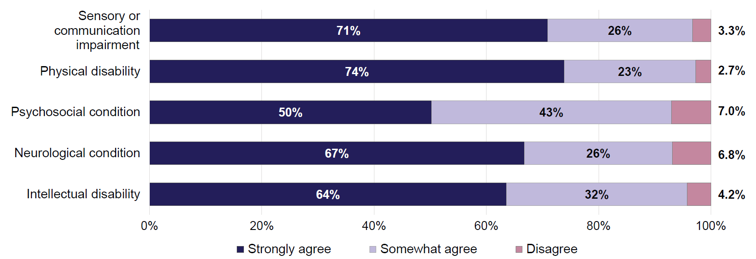
Note: Due to small number of responses, response categories ‘Somewhat disagree’ and ‘Strongly disagree’ were combined into a single category ‘Disagree’.
Figure 2.10: Employers – A business should provide the support and training to help an effective worker with disability get promoted, by disability type, 2024
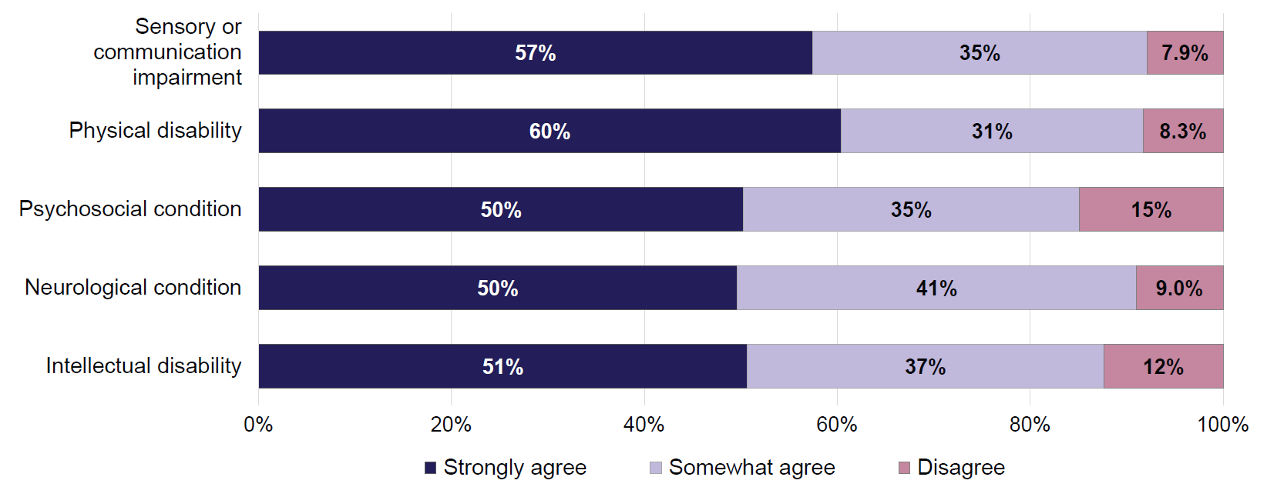
Note: Due to small number of responses, response categories ‘Somewhat disagree’ and ‘Strongly disagree’ were combined into a single category ‘Disagree’.
Responses to the statement about providing support and training to help an effective worker with disability get promoted are shown in Figure 2.10. Half or more of employers (between 50% and 60%) strongly agreed that such support and training should be provided. Compared with the statement about hiring a person with disability, fewer employers agreed that a worker with disability should receive support towards promotion.
Employers’ opinions about promotion were similar for a worker with physical disability (60% strongly agree) or a worker with sensory or communication impairment (57%). Support was lower for promoting workers with psychosocial or neurological conditions, or intellectual disability. Just half (50% or 51%) of employers strongly agreed that supports and training to help with promotion should be provided to workers with these disabilities.

Barriers to employing people with disability
The ADS Survey asked employers whether there were any challenges to hiring people with disability at their workplace. Respondents could say things were a major challenge, minor challenge, or not a challenge (Figure 2.11). In 2024, the 2 major challenges most often named by employers were:
- cannot find qualified people with disability (33% of all employers said this was a major challenge)
- the nature of work was such that it could not be done by people with disability (28% of employers said this was a major challenge).
While attitudes of co-workers, managers and clients were seen as less of a challenge, they still presented a challenge in most workplaces:
- 58% of employers said that co-worker attitudes were a challenge (12% major and 46% minor challenge)
- 55% said that manager attitudes were a challenge (16% major and 39% minor challenge)
- 59% said that client attitudes were a challenge (18% major and 41% minor challenge).
There were no significant changes since 2022 in the challenges identified by employers. The only exception was attitudes of co-workers, which were seen as a challenge by 53% of employers in 2022 and 58% of employers in 2024.
Figure 2.11: Employers – Challenges in hiring a person with disability, 2024
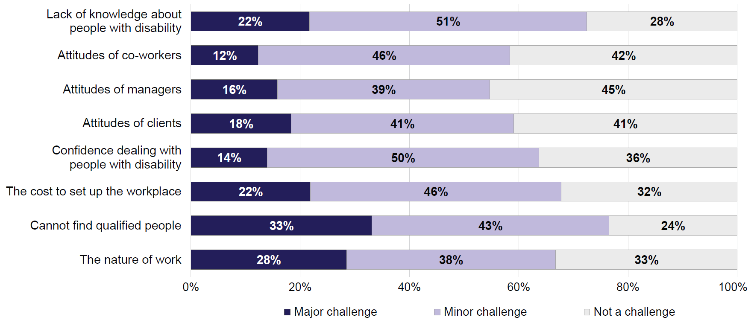

Challenges differed depending on industry of employment. In 2024:
- Lack of knowledge about people with disability was seen as a challenge especially in public administration, defence and regulatory services industry, where 81% of employers picked this as either a major or minor challenge. This compares with 72% for all employers.
- Attitudes of co-workers, managers or clients were seen as particular challenges in the accommodation and food services industry. Between 67% and 72% of employers in this industry said attitudes were a barrier, compared with 55% to 59% of all employers.
- The cost to set up the workplace for a worker with disability was seen as a particular challenge in the health sector (80%), compared with 68% for all employers.
- Difficulty finding qualified people with disability was seen as a challenge by 87% of employers in the justice and legal services sector, and 84% of employers in manufacturing, construction, and utilities industry. This compares with 76% for all employers.
- The nature of work being such that it could not be done by people with disability was seen as a challenge in agriculture, forestry, fishing, and mining industry (92% of employers) and manufacturing, construction, and utilities industry (85%). This compares with 67% for employers in all industries.
The industries where the employers picked the highest number of challenges (out of possible 8) were:
- accommodation and food services (average of 5.9 challenges out of 8)
- manufacturing, construction and utilities, as well as agriculture, fishing, forestry, and mining industries (5.7 each)
- healthcare sector, and justice and legal services (5.6 each).
The employers in personal and community support services sector selected the smallest number of challenges compared with other industries. However, even in this industry employers had selected multiple challenges (average of 4.6 challenges out of 8). Overall, lower proportions of employers in the personal and community support sector (compared with employers in other industries) tended to think any of the 8 potential barriers to employment were a challenge in hiring someone with disability at their workplace. This is in line with earlier findings that the personal community and support sector employs relatively more people with disability, as evidenced by both the high proportion of people with disability employed in the sector, and the high proportion of workplaces in the sector which had recently hired a worker with disability.

3. Healthcare sector
Healthcare services are essential for people with disability. They provide access to necessary medical care, support, and resources that enhance quality of life. People with disability often face difficulties when trying to access healthcare services, from not being able to get to medical facilities to experiences of discrimination. This may result in people with disability avoiding medical facilities and contribute to lower health outcomes (AIHW 2024).
The attitudes of healthcare workers towards people with disability play a critical role in shaping healthcare experiences and outcomes. Positive attitudes, characterised by respect, understanding, and inclusivity, can improve accessibility of healthcare services, foster trust between healthcare providers and people with disability, and contribute to improved health and wellbeing. At the same time, negative attitudes, including unconscious bias and discrimination, may act as barriers to quality care, limiting opportunities for people with disability to receive appropriate support.
This chapter looks at the attitudes of healthcare workers in the ADS Survey towards people with disability, and the experiences of people with disability who used healthcare services.
Key findings
Health care is the most commonly used service by people with disability. Almost 9 in 10 (88%) people with disability had used healthcare services in the last year, and half (50%) of healthcare workers had often or very often interacted with people with disability in their job.
The majority of healthcare workers were confident in their ability to support patients with disability and were certain their attitudes towards people with disability were positive. Similarly, people with disability reported largely positive experiences when interacting with healthcare services.
There were differences in confidence and attitudes of healthcare workers depending on the type of disability of their patient. Workers were more confident in their ability to assist a person with physical disability than someone with sensory or communication, or intellectual disability. Workers were also less likely to think that a person with intellectual, psychosocial or neurological disability should be able to make their own decisions about treatment, or to access the same range of family planing services.
People with intellectual or psychosocial disability reported worse experiences when interacting with healthcare services. The same was the case for people with severe or profound disaiblity, and for younger people with disability.

Confidence and attitudes of healthcare workers

Healthcare workers in the ADS Survey
According to the ABS Labour Force Survey, more than 1.3 million people were working in the healthcare sector (including hospitals, medical and other healthcare services) in November 2024. This represented 9.0% of Australia’s total workforce (ABS 2025a).
Around 1,550 healthcare workers participated in Wave 1 of the ADS Survey in 2022 and 1,690 in Wave 2 in 2024; 620 healthcare workers participated in both waves of the survey.
In 2024, among healthcare workers in the ADS Survey:
- 72% were women
- 46% were aged 18–34
- 16% self-identified as having disability
- 86% had experience with disability (other than their own). This means they had been a paid or unpaid carer, lived with a person with disability, or had a close family member, partner, friend, work colleague or boss, or teacher, lecturer or classmate with disability.
The ADS Survey asked healthcare workers how often they had advised, assisted, or treated a person with disability as part of their job in the last 12 months. In 2024, about 3 in 4 (73%) healthcare workers said they assisted people with disability at least a few times during the past year (Figure 3.1). Just under 1 in 7 (15%) workers had not assisted any people with disability in the past year.
Figure 3.1: Healthcare workers – Frequency advised, assisted, or treated people with disability as part of their job in the last 12 months, 2024
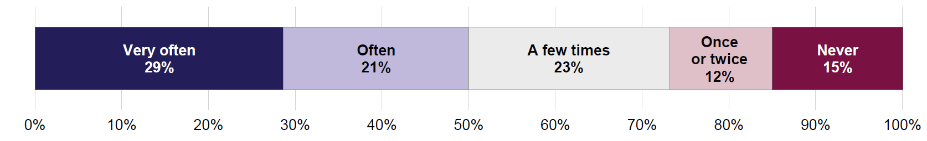
Among healthcare workers, women tended to interact with people with disability more frequently than men:
- 53% of women often or very often advised, assisted, or treated people with disability in the last year compared with 42% of men
- 13% of women had never advised, assisted, or treated people with disability compared with 21% of men.
The findings were similar to Wave 1 (2022) of the ADS Survey, when 55% of healthcare workers often or very often advised, assisted, or treated people with disability.

Confidence of healthcare workers in interacting with people with disability
Healthcare workers were asked how confident they are in their ability to advise, assist or treat people with disability in their current job. Healthcare workers could rate their confidence level from ‘very confident’ to ‘not at all confident’.
Most healthcare workers said that they were very confident or quite confident in their ability to advise, assist or treat people with disability (Figure 3.2). However, the levels of confidence varied depending on the type of disability a person had:
- 27% of healthcare workers were very confident in their ability to assist people with a physical disability such as reduced mobility or movement
- 20% were very confident with neurological conditions such as autism or attention deficit hyperactivity disorder (ADHD)
- 19% with psychosocial conditions such as severe anxiety or depression
- 15% with sensory or communication impairments such as being deaf or blind
- 13% with intellectual disability such as Down syndrome (Figure 3.2).
The overall confidence levels of healthcare workers remained similar between Waves 1 and 2 of the ADS Survey.
Figure 3.2: Healthcare workers – How confident in their ability to advise, assist or treat people with disability, by disability type, 2024
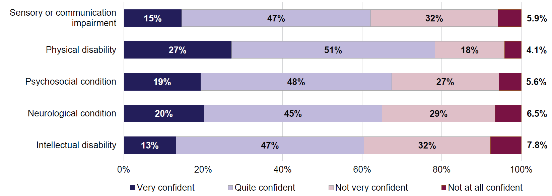
The confidence of healthcare workers in their ability to support people with disability also varied depending on the characteristics of healthcare workers themselves. In 2024, confidence levels were higher for:
- healthcare workers who often or very often advised, assisted, or treated people with disability. For example, the proportion of workers who were very confident in their ability to support someone with a physical disability was 40% for healthcare workers who often or very often interacted with people with disability, and 14% for those who had less frequent interactions.

- workers who had experience with disability (other than their own). For example, 30% of healthcare workers who had experience with disability were very confident in their ability to support a person with physical disability, compared with 11% of those who had no experience.
- workers who had disability themselves. This was especially the case when assisting people with psychosocial or neurological conditions. For example, 27% of workers who had disability were very confident in their ability to assist people with psychosocial conditions compared with 18% of those without disability. Similarly, 28% of workers with disability and 19% without disability were very confident in their ability to assist people with neurological conditions.
- younger healthcare workers (aged 18–34), when assisting people with neurological conditions. Almost 1 in 4 (24%) of workers aged 18–34 were very confident, compared with 13% of workers aged 55 and over.
Healthcare workers were also asked how confident they were that they respond to people with disability in a positive way. In 2024, around 9 in 10 (92%) healthcare workers were confident in their positive attitudes, and 8.4% of workers were not confident (Figure 3.3). The levels of confidence were similar to those reported in Wave 1.
Figure 3.3: Healthcare workers – How confident they respond in a positive way to people with disability, 2024
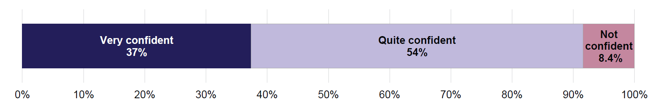
Note: Due to small number of responses, the response categories ‘Not very confident’ and ‘Not at all confident’ were combined into a single category ‘Not confident’.
Healthcare workers who had disability themselves and those who often or very often interacted with people with disability were more confident of their positive attitudes. In 2024, 50% of workers with disability, and 46% of workers who had frequent interactions, were very confident they respond in a positive way, compared with 37% for all healthcare workers.

Attitudes of healthcare workers regarding treatment of people with disability
This section explores the attitudes of healthcare workers and how they vary depending on the type of disability a person has.
Healthcare workers participating in the ADS Survey were randomly divided into 5 groups, and each group was asked questions about a specific type of disability:
- sensory or communication impairment, such as being deaf or blind
- physical disability, such as reduced mobility or movement
- psychosocial condition, such as severe anxiety or depression
- neurological condition, such as autism or attention deficit hyperactivity disorder (ADHD)
- intellectual disability, such as Down syndrome.
Healthcare workers were asked how much they agreed with the following 2 statements:
- a patient with [specific disability type] should be able to make their own decisions about treatment
- people with [specific disability type] should be able to access the same range of fertility or family planning services as people without disability.
The opinions of healthcare workers on whether a patient with disability should be able to make their own treatment decisions varied depending on the disability type. In 2024:
- 74% of healthcare workers strongly agreed that a patient with physical disability should be able to make their own decisions about treatment (4.2% disagreed)
- 70% strongly agreed for a patient with sensory or communication impairment (4.7% disagreed)
- 41% strongly agreed for a patient with neurological condition (11% disagreed)
- 33% strongly agreed for a patient with psychosocial condition (18% disagreed)
- 24% strongly agreed for a patient with intellectual disability (19% disagreed) (Figure 3.4).
Figure 3.4: Healthcare workers – Whether agree that a patient with disability should be able to make their own decisions about treatment, by type of disability, 2024
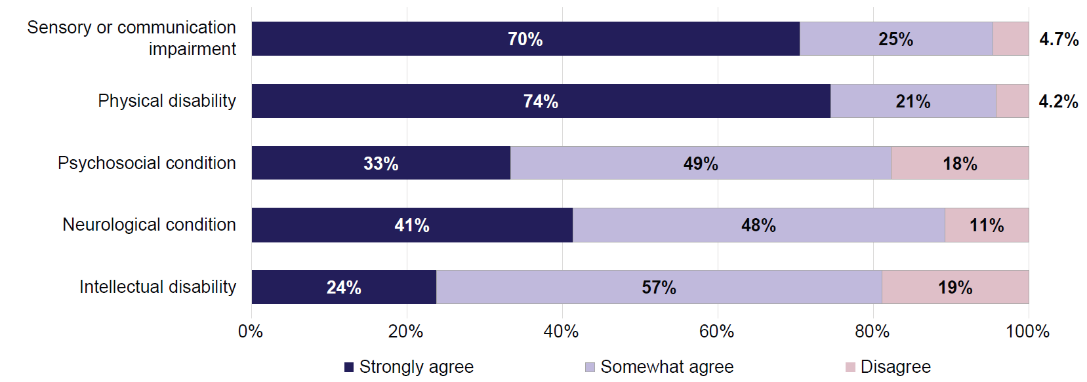
Note: Due to small number of responses, response categories ‘Strongly disagree’ and ‘Somewhat disagree’ were combined into a single category ‘Disagree’.
Between 2022 and 2024, there was a decline in the proportion of healthcare workers who strongly agreed that a patient with sensory or communication impairment should be able to make their own treatment decisions (81% in 2022 to 70% in 2024). The proportion of healthcare workers who somewhat agreed increased from 15% in 2022 to 25% in 2024. Responses for other types of disability were largely similar between the 2 waves of the survey.
In 2024, healthcare workers were more likely to strongly agree that a patient with disability should be able to make their own treatment decisions if they:
- were women. For example, 38% of women and 21% of men strongly agreed patients with psychosocial disability should be able to make their own treatment decisions.
- often or very often advised, assisted, or treated people with disability. For example, 42% of workers who often assisted people with disability strongly agreed regarding a patient with psychosocial disability, compared with 25% of workers who less often assisted people with disability.
- identified as a person with disability themselves. For example, 85% of healthcare workers with disability and 68% without disability strongly agreed that a patient with sensory or communication disability should be able to make their own treatment decisions.
Responses for the second statement are presented in Figure 3.5. Most healthcare workers agreed (strongly or somewhat) that people with disability should be able to access the same range of fertility or family planning services as people without disability. At the same time, the proportions of workers who strongly agreed varied by type of disability. In 2024:
- 68% of healthcare workers strongly agreed for people with sensory or communication impairment
- 63% for people with physical disability
- 51% for people with psychosocial conditions
- 48% for people with neurological conditions
- 29% for people with intellectual disability (Figure 3.5).
About 1 in 4 (26%) healthcare workers disagreed that people with intellectual disability should be able to access the same range of fertility or family planning services as people without disability. This compares with 3.2% for sensory or communication impairment, 6.6% for neurological conditions, 6.9% for physical disability, and 12% for psychosocial conditions (Figure 3.5).
Figure 3.5: Healthcare workers – Whether agree that people with disability should be able to access the same range of fertility or family planning services as people without disability, by type of disability, 2024
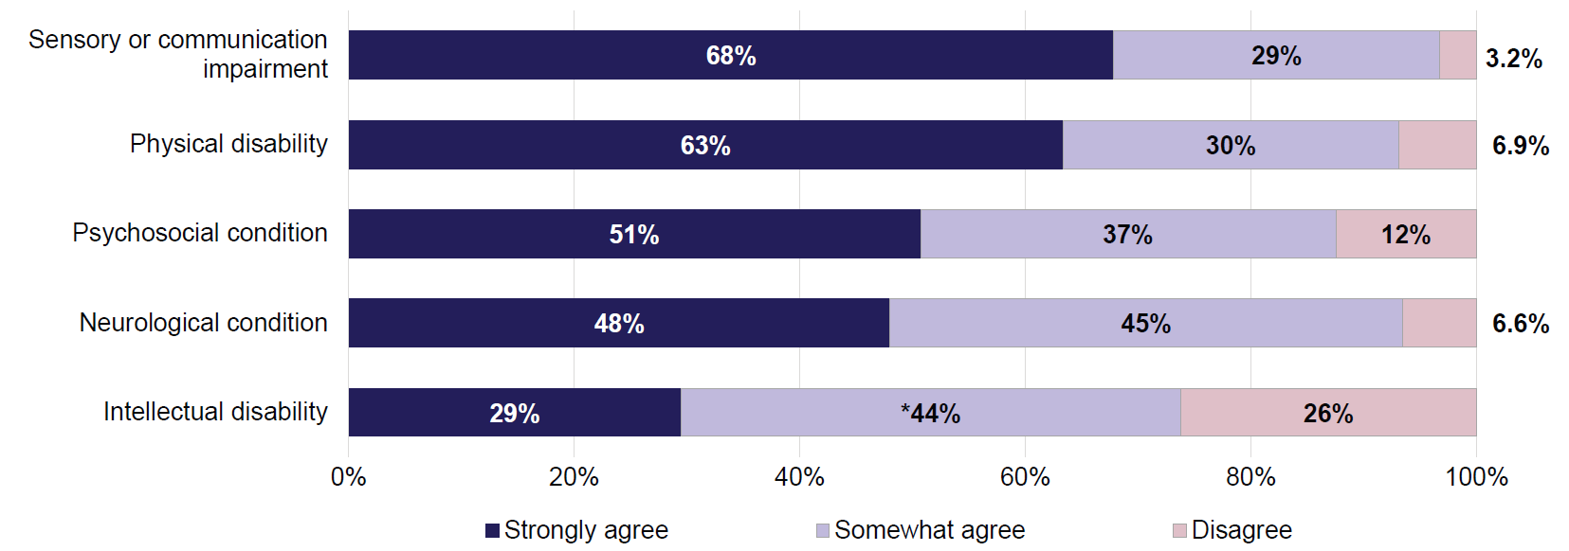
Notes:
- Percentage marked with asterisk * was estimated with a high degree of error and should be used with caution.
- Due to small number of responses, response categories ‘Strongly disagree’ and ‘Somewhat disagree’ were combined into a single category ‘Disagree’.
Between 2022 and 2024, there were significant changes in response patterns to this question for sensory or communication impairment, and intellectual disability. The proportion of workers who strongly agreed that people with sensory or communication disability should be able to access the same range of family planning services as people without disability had fallen from 83% in 2022 to 68% in 2024. At the same time, the proportion of healthcare workers who disagreed that people with intellectual disability should be able to access the same range of family planning services increased from 10% in 2022 to 26% in 2024. It is unclear from the available data what could have contributed to this change in attitudes.
Women, workers who often or very often assisted people with disability, and those who had disability themselves were more likely to agree that people with disability should have access to the same range of family planning services. In 2024:
- 72% of women strongly agreed that people with sensory or communication impairment should be able to access the same range of fertility or family planning services as people without disability, compared with 55% of men
- 73% of healthcare workers who often or very often advised, assisted, or treated people with disability strongly agreed for people with physical disability, compared with 53% of workers who less often assisted people with disability
- 80% of healthcare workers with disability strongly agreed for people with sensory or communication impairment, compared with 67% of workers without disability.

Experiences of people with disability accessing healthcare services

Use of healthcare services by people with disability
In 2024, almost 9 in 10 (88%) people with disability in the ADS Survey said they had used or interacted with healthcare services in the last 12 months. Women (91%) with disability were more likely to have used healthcare services than men (85%). People who were older were also more likely to have used healthcare services: 91% of people with disability aged 55 and over have used these services, compared with 86% of those aged 18–54. People with severe or profound disability and those with milder forms of disability were about equally likely to have used healthcare services (90% and 88%, respectively).
For the first time in 2024, people with disability in the ADS Survey were also asked if they had accessed community-based allied health services such as a physiotherapist or dietitian in the last 12 months. More than 8 in 10 (84%) people with disability had accessed community-based allied health services in the past year.

Experiences of people with disability when interacting with healthcare services
People with disability in the ADS Survey were asked whether, in the past 12 months, they have used or interacted with 4 key services (health care, education, personal and community support, or justice and legal services). Those who used the services were asked to rate their experiences when interacting with the service. People who had used more than one type of services were only asked about their experiences with the service of their most recent interaction.
In 2024, healthcare services were the most recent type of service use or interaction for 3 in 4 (74%) people with disability in the ADS Survey. Their experiences when interacting with healthcare services are summarised in Figure 3.6.
Figure 3.6: People with disability – Experiences when interacting with healthcare services, 2024
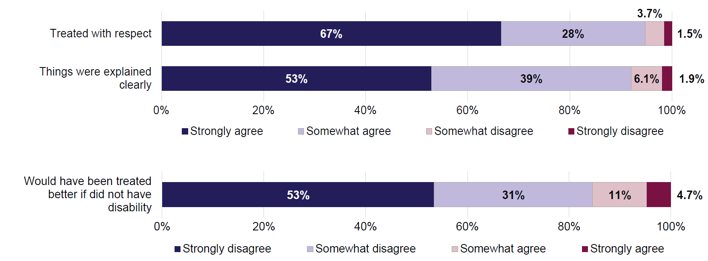
Note: For the last statement (about unequal treatment due to disability), the order of response categories is reversed to reflect that disagreement represents a positive service experience.
Most people with disability had positive experiences when using healthcare services. In 2024, the majority (95%) agreed they were treated with respect by the healthcare workers (67% strongly agreed and 28% somewhat agreed) (Figure 3.6). This was similar to Wave 1 (2022) of the ADS Survey.
Some groups of people with disability were less likely to have been treated with respect. This was the case for:
- people who were younger (aged under 55). Fewer than 6 in 10 (57%) of those aged 18–54 strongly agreed they were treated with respect, compared with 71% of those aged 55–74, and 80% of those aged 75 and over.
- people with severe or profound disability. Around 6 in 10 (59%) people with severe or profound disability strongly agreed they were treated with respect, compared with 68% of those with milder forms of disability.
- people with intellectual or psychosocial disability. Half (53%) of people with intellectual disability and 58% of those with psychosocial disability strongly agreed they were treated with respect, compared with 65% of those with physical disability, and 68% of those with sensory or speech disability.
Most people with disability agreed that things were explained clearly to them during their healthcare service contact. In 2024, 92% agreed that things were explained clearly (53% strongly agreed and 39% somewhat agreed) (Figure 3.6). Between 2022 and 2024, the proportion of people who strongly agreed fell slightly, from 56% in 2022 to 53% in 2024. There were no changes to the proportion of people who disagreed things were explained clearly.

Similar to being treated with respect, some groups of people with disability were less likely to agree that things were explained clearly to them. In 2024, this was the case for:
- younger people with disability (aged under 55). Under half (47%) of people with disability aged 18–54 strongly agreed that things were explained clearly, compared with 56% of those aged 55–74, and 63% of those aged 75 and over.
- people with severe or profound disability. Under half (46%) of people with severe or profound disability strongly agreed that things were explained clearly, compared with 55% of those with milder forms of disability.
- people with intellectual or psychosocial disability. The proportions strongly agreeing that things were explained clearly were 41% for people with intellectual disability and 45% for those with psychosocial disability. This was higher for people with physical disability (51%), or sensory or speech disability (54%).
Most people with disability did not think they would have been treated better by healthcare workers if they did not have disability. Note that, for this question, disagreement represents a more positive experience.
In 2024, 85% of people with disability disagreed they would have been treated better by healthcare workers if they did not have disability (53% strongly disagreed and 31% somewhat disagreed) (Figure 3.8). At the same time, the proportion of people who agreed (15%) was higher than for other aspects of service experience.
The proportions of people agreeing or disagreeing with this statement were similar in 2022 and 2024.
Some groups of people with disability were more likely to think that their disability affected how they were treated by healthcare workers. In 2024, these were:
- women – 17% had (strongly or somewhat) agreed that they would have been treated better if they did not have disability, compared with 13% of men
- younger people with disability – 27% of people aged 18–34 agreed, 18% of those aged 35–54, 12% of those aged 55–74, and 7.3% of those aged 75 and over
- people with severe or profound disability – 27% agreed, compared with 12% of those with milder forms of disability
- people with visible disability – 20% agreed, compared with 14% of those with invisible disability.
The level of agreement also differed by disability type. About 1 in 3 (34%) of those with intellectual disability agreed that they would have been treated better by healthcare workers if they did not have disability. This proportion was 25% for those with head injury, stroke or acquired brain injury, 24% for those with psychosocial disability, 17% for those with physical disability, and 15% for those with sensory or speech disability.
People with disability who had used community-based allied health services in the past year were asked about their satisfaction with the quality of care they received during their most recent visit. These data were collected for the first time in 2024.
Most (89%) people with disability were satisfied with the quality of care received (52% very satisfied and 37% somewhat satisfied) (Figure 3.7).
Figure 3.7: People with disability – Satisfaction with quality of care received during most recent visit to community-based allied health services, 2024
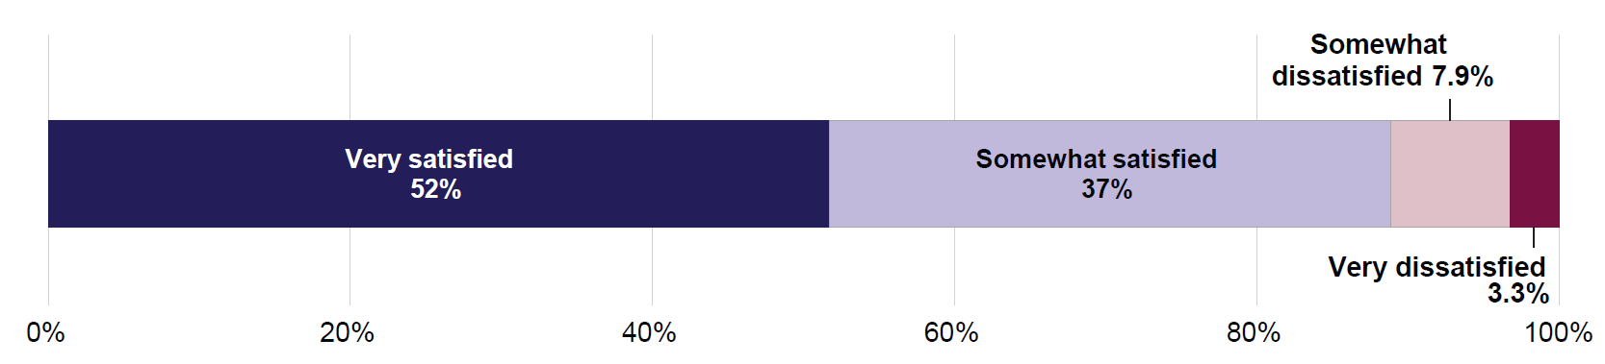
The levels of satisfaction with the quality of care received from allied health services varied depending on the person’s characteristics:
- Younger people were less satisfied with the quality of care. Just under 1 in 5 (18%) of people aged 18–34 were dissatisfied, 13% of those aged 35–54, 7.5% of those aged 55–74, and 5.1% of those aged 75 and over.
- People with severe or profound disability had lower levels of satisfaction: 16% were dissatisfied, compared with 9.7% of those with milder forms of disability.
- The level of satisfaction varied by disability type. One in 10 (10%) of people with sensory or speech disability were dissatisfied, 12% of those with physical disability, 15% of those with psychosocial disability, 16% of those with head injury, stroke or acquired brain injury, and 19% of those with intellectual disability.

4. Education sector
Education provides the knowledge and skills that are needed to fully participate in all aspects of daily life. For people with disability, access to education that meets their support and accessibility needs is essential. Inclusive education, provided by well-equipped educators, can improve employment outcomes, support economic independence, and enhance participation in society.
In 2024, around 1.1 million school students in Australia (26% of all enrolled students) received an educational adjustment due to disability (ACARA 2025). Proportions of students with disability in post-school education are lower: in 2023, 13% of domestic undergraduate higher education students, and 3.9% of domestic VET students had disability (AIHW 2025).
People with disability tend to have lower levels of educational attainment than those without disability (ABS 2024). This may be due to health reasons, but can also be driven by systemic barriers, inadequate supports, exclusionary practices, and negative attitudes. In 2022, it was estimated that 20% of children and young people with disability aged 5–20 had been excluded from school-based activities, and 15% had been suspended or expelled from school (ABS 2025b). The Royal Commission into Violence, Abuse, Neglect and Exploitation of People with Disability noted in its final report the lack of support to help students with disability transition from school to further education (DRC 2023).
This chapter looks at the attitudes of education workers and their confidence in supporting people with disability, and the experiences of people with disability when interacting with the education sector based on the ADS Survey.
Key findings
Relatively few education workers in the ADS Survey said they interact with people with disability on a regular basis as part of their job. About half had not interacted with people with disability more than once or twice in the past year.
The majority of education workers were certain that they respond positively towards people with disability. However, only about half of them were confident in their ability to assist or advise a person with disability.
Education workers were more confident in assisting a person with physical or neurological disability, and less confident with psychosocial, intellectual, or sensory or communication disability. Workers who frequently interacted with people with disability as part of their job or had experience with disability reported higher levels of confidence.
People with disability had overall positive experiences when interacting with education services. However, about 1 in 4 thought that they would have been treated better if they did not have disability.
Due to smaller numbers of people with disability using education services among the ADS Survey respondents, findings about experiences of sub-groups of people with disability could not be reported.

Confidence and attitudes of education workers

Education workers in the ADS Survey
According to the ABS Labour Force Survey, about 1.3 million people reported working in the Education and Training industry in Australia in November 2024. This represented 9.0% of the total workforce (ABS 2025a).
In Wave 1 of the ADS Survey (2022), around 1,650 respondents were working in the education sector, and around 1,800 in Wave 2 (2024). Around 710 education workers participated in both waves of the survey.
In the ADS Survey, education workers included those working in childcare, preschools, primary, secondary and special schools, technical and vocational education, universities and other higher education institutions, adult education, and community education.
In 2024, among education workers in the ADS Survey:
- 66% were women
- 37% were aged 18–34, 45% were aged 35–54, and 18% were 55 and over
- 20% self-identified as having disability
- 82% had experience with disability (other than their own).
The ADS Survey asked education workers how often they had advised, assisted, or treated a person with disability as part of their job in the last 12 months. In 2024, half (52%) of education workers have reported interacting with people with disability at least a few times during the past year (Figure 4.1). About 3 in 10 (31%) had not interacted with any people with disability during the past year. The proportion of workers who had no interactions with people with disability in their job in the last 12 months increased from 26% in 2022 to 31% in 2024.
Figure 4.1: Education workers – How often advised or assisted people with disability as part of their job in the last 12 months, 2024
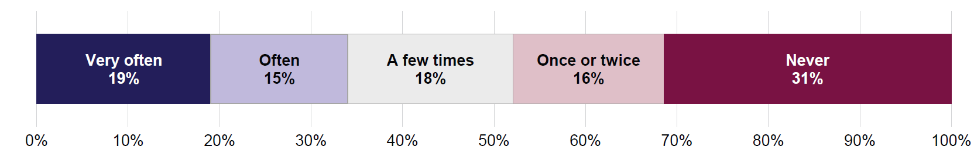
Among education workers in the ADS Survey, women and people aged 35–54 tended to interact more with people with disability:
- 39% of women have often or very often supported people with disability in the last year, compared with 24% of men
- 39% of workers aged 35–54 had often or very often interacted with people with disability, compared with 29% of those aged 18–34.

Confidence of education workers in interacting with people with disability
The ADS Survey asked education workers how confident they were in their ability to advise or assist people with disability in their current roles. Responses ranged from ‘very confident’ to ‘not at all confident’.
Over half of respondents reported feeling either very confident or quite confident in their ability to advise or assist people with disability (Figure 4.2). However, the level of confidence varied depending on the type of disability involved:
- 68% of education workers were (quite or very) confident to advise or assist people with a physical disability such as reduced mobility or movement
- 66% were confident with neurological conditions such as autism or attention deficit hyperactivity disorder (ADHD)
- 55% were confident with psychosocial conditions such as severe anxiety or depression
- 51% were confident with intellectual disability such as Down syndrome
- 49% were confident with sensory or communication impairments such as being deaf or blind (Figure 4.2).
The proportions of education workers who were very confident in their ability to support people with disability were relatively high for people with neurological conditions (22%), and ranged between 8.7% and 14% for other types of disability.
The confidence levels of workers were similar in Waves 1 and 2 of the survey.
Figure 4.2: Education workers – How confident in ability to advise or assist people with disability, by disability type, 2024
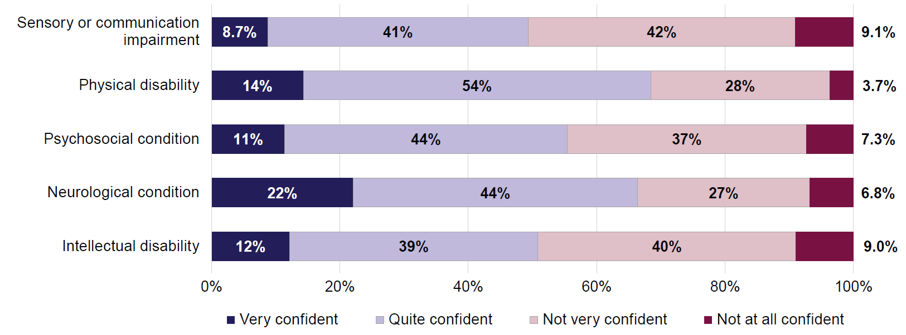
The confidence of education workers in their ability to support a person with disability varied not only by the type of disability of the person, but also by the characteristics of the workers themselves. In 2024:
- Women reported higher confidence levels than men for people with intellectual disability, or neurological or psychosocial conditions. For example, 72% of women were confident in their ability to support a person with a neurological condition, compared with 55% of men.
- Education workers aged 35 and over were more confident than younger workers in supporting people with intellectual or physical disability, or sensory or communication impairment. For example, 42% of those aged 18–34 were confident with intellectual disability, compared with 55% of those aged 35–54 and 59% of those aged 55 and over.
- Workers who often or very often interacted with people with disability reported higher levels of confidence for all types of disability. For example, 88% of education workers who often or very often interacted with people with disability were confident in their ability to support someone with a neurological condition, compared with 55% of workers who had less often interacted with people with disability.
- Workers who had disability themselves were more confident than those without disability in supporting people with neurological or psychosocial conditions. For example, 67% of education workers with disability were confident in their ability to support someone with a psychosocial condition, compared with 53% of those without disability.
- Workers who had experience with disability (other than their own) were more confident than those who had no experience for all types of disability. For example, 59% of education workers with disability experience were confident in their ability to support someone with a psychosocial condition, compared with 39% of those without experience.
Most education workers (89%) in 2024 were (quite or very) confident that they respond to people with disability in a positive way (Figure 4.3). These results were similar to Wave 1 (2022) of the survey.
Figure 4.3: Education workers – How confident they respond to people with disability in a positive way, 2024
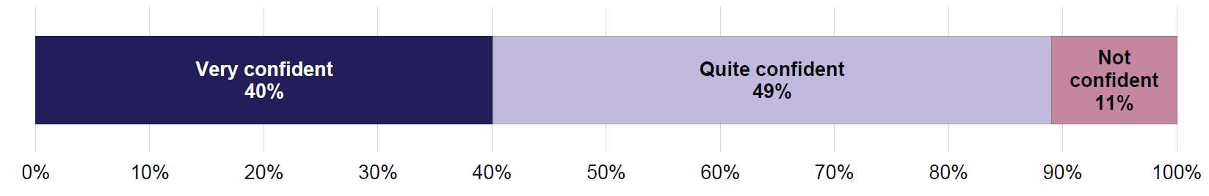
Note: Due to small number of responses, the response categories ‘Not very confident’ and ‘Not at all confident’ were combined into a single category ‘Not confident’.
In 2024, education workers who often or very often advised or assisted people with disability, those who had disability themselves or had experience with disability (other than their own), and those aged 55 and over had higher levels of confidence that they respond to people with disability in a positive way:
- 97% of workers who had often assisted people with disability were confident (very or quite), compared with 85% of workers who less often interacted with people with disability
- 93% of workers with disability were confident, compared with 88% of workers without disability
- 91% of workers who had experience with disability were confident, compared with 81% of those who had no experience
- 93% of workers aged 55 and over were confident, compared with 87% of those aged 18–34.

Attitudes of education workers about inclusion of people with disability
This section looks at the attitudes of education workers towards people with disability and how these attitudes may differ depending on the type of disability involved.
Education workers participating in the ADS Survey were randomly divided into 5 groups, and each group was asked questions about a specific type of disability:
- sensory or communication impairment, such as being deaf or blind
- physical disability, such as reduced mobility or movement
- psychosocial condition, such as severe anxiety or depression
- neurological condition, such as autism or attention deficit hyperactivity disorder (ADHD)
- intellectual disability, such as Down syndrome.
Education workers were asked how much they agreed with the following 2 statements:
- a teenager with [specific disability type] should attend sex education classes with their peers
- a young person with [specific disability type] should be excluded from activities such as basketball.
In 2024, around 3 in 4 education workers strongly agreed that a teenager with physical disability (76%), sensory or communication impairment (71%), neurological condition (70%), or intellectual disability (69%) should attend sex education classes with their peers. In contrast, less than half (45%) strongly agreed with this statement when considering a teenager with psychosocial condition (Figure 4.4).
Proportions of education workers who strongly agreed that a teenager with disability should attend sex education classes have decreased since Wave 1 (2022) for psychosocial conditions (61% in 2022 to 45% in 2024) and sensory or communication impairment (80% in 2022 to 71% in 2024). There were no significant changes for other disability types.
Figure 4.4: Education workers – Whether agree that a teenager with disability should attend sex education classes with their peers, by type of disability, 2024
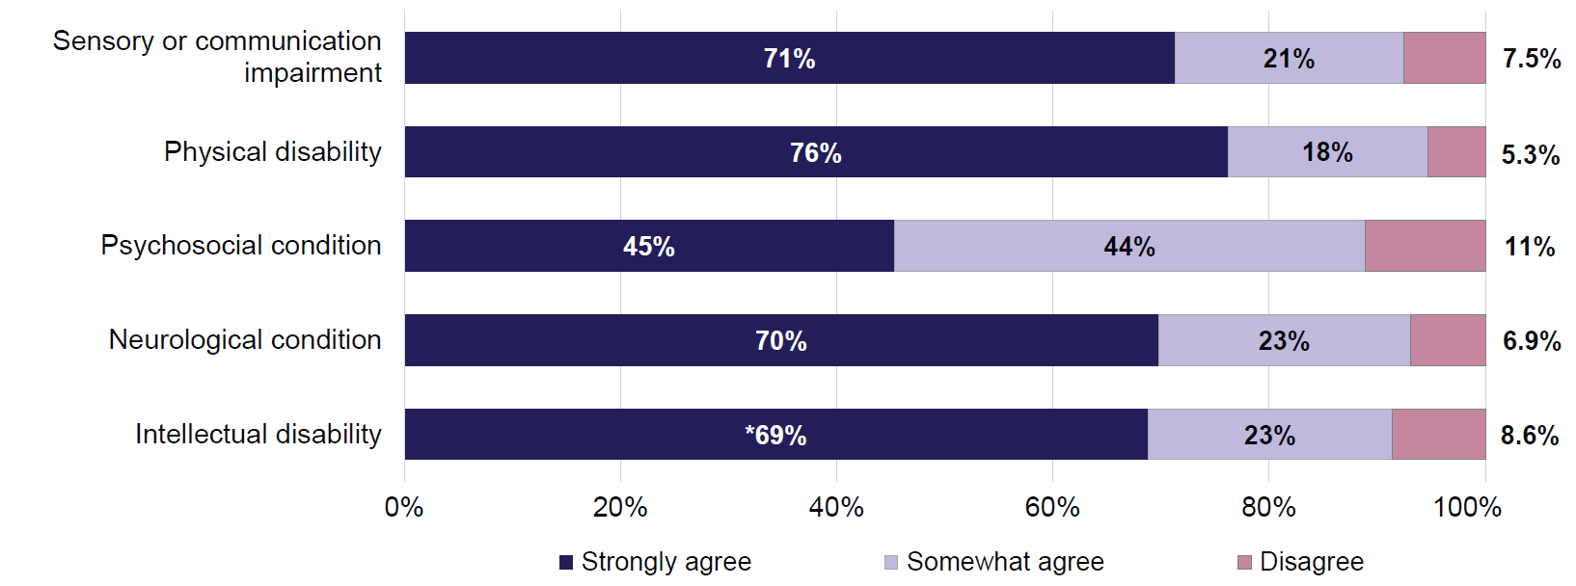
Notes:
- Percentage marked with asterisk * was estimated with a high degree of error and should be used with caution.
- Due to small number of responses, the response categories ‘Strongly disagree’ and ‘Somewhat disagree’ were combined into a single category ‘Disagree’.
In 2024, education workers who often or very often advised or assisted people with disability, and those who had disability themselves, were more likely to strongly agree (86% for both groups) that a teenager with sensory or communication impairment should attend sex education classes with their peers, compared with 71% of all workers.
In terms of the second situation, most education workers did not think that a young person with disability should be excluded from activities such as basketball (Figure 4.5). However, the proportion of workers who expressed strong disagreement varied by the type of disability a young person had. In 2024:
- 84% of workers strongly disagreed for young people with neurological conditions
- 67% for young people with intellectual disability
- 66% for young people with psychosocial conditions
- 60% for young people with physical disability
- 49% for young people with sensory or communication impairment (Figure 4.5).
Workers were about twice as likely to agree that a young person with sensory or communication impairment (21%) should be excluded from such activities compared with the other 4 selected disability types (Figure 4.5).
Figure 4.5: Education workers – Whether agree that a young person with disability should be excluded from activities such as basketball, by type of disability, 2024
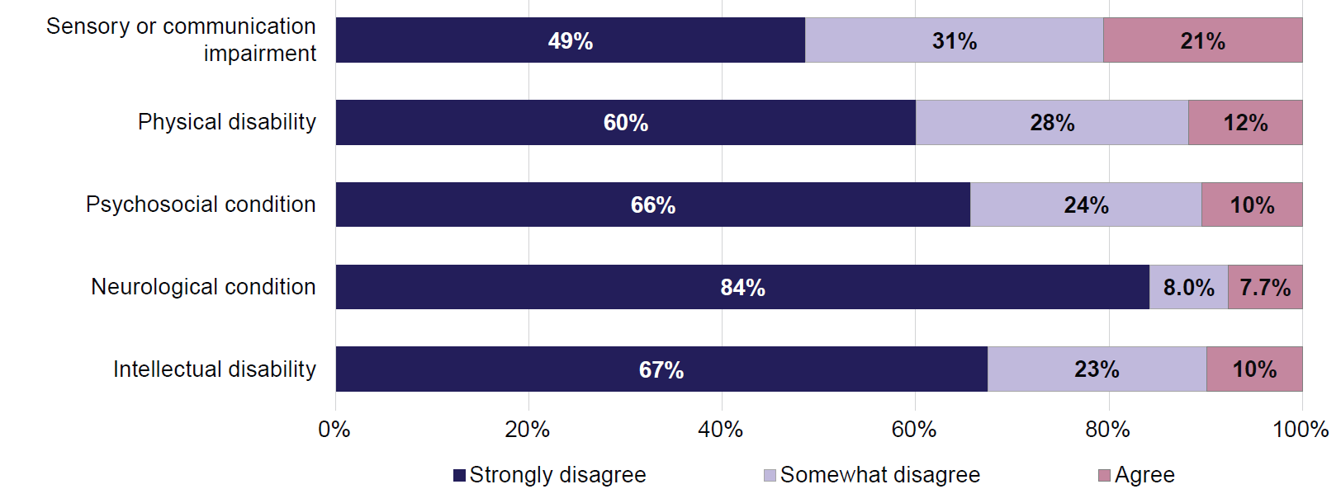
Note: Due to small number of responses, the response categories ‘Strongly agree’ and ‘Somewhat agree’ were combined into a single category ‘Agree’.
Compared with Wave 1 (2022), the proportion of education workers who strongly disagreed that a young person with disability should be excluded from certain activities was lower in 2024 for intellectual disability (82% in 2022 to 67% in 2024) and psychosocial disability (79% in 2022 to 66% in 2024).

Workers who were older, had disability themselves, or often or very often engaged with people with disability in their job were more likely to strongly disagree with this statement. In 2024:
- 66% of education workers aged 35 and over strongly disagreed that a young person with physical disability should be excluded from certain activities, and 56% for a young person with sensory or communication impairment (compared with 60% and 49%, respectively, for all education workers)
- 72% of workers who had disability themselves and 70% of those who often or very often engaged with people with disability in their job strongly disagreed that a young person with physical disability should be excluded (60% for all education workers).
Since, for the 2 situations, education workers in the ADS Survey were split into 5 groups each to respond about one specific disability type, the numbers of respondent in each group were relatively low. This resulted in higher uncertainty in the data and meant that some analyses for sub-groups of workers could not be reported.

Experiences of people with disability accessing education services

Participation and interaction with education services among people with disability
People with disability in the ADS Survey were asked whether, in the past 12 months, they have used education services or interacted with the education sector. This could include participation in education, and interaction with services such as child-care or schools by parents or carers with disability.
In 2024, around 1 in 4 (24%) people with disability in the ADS Survey reported interacting with the education sector in the last 12 months. Women were more likely to have interacted with the education sector than men (31% of women with disability have used or interacted with education services, compared with 17% of men). People aged 18–54 (39%) were more likely to have interacted with the education sector than those aged 55 and over (9.5%). People with severe or profound disability and those with milder forms of disability had the same rate of interactions (24%).
The 2024 ADS Survey also collected data on learning activities people with disability participated in during the past year:
- 23% of people with disability participated in formal learning activities (such as in a classroom, as part of a paid course, or structured workplace training – something that would usually result in a qualification or a certificate)
- 23% participated in semi-formal learning activities (similar to formal learning but without receiving a qualification or a certificate at the end)
- 54% participated in informal activities (such as learning hobbies or crafts, or learning from YouTube)
- 38% did not participate in any learning activities.

Experiences of people with disability when interacting with education services
This section explores the experiences of people with disability in their interactions with the education sector. People with disability in the ADS Survey were asked whether, in the past 12 months, they have used or interacted with 4 key services (health care, education, personal and community support, or justice and legal services). Those who used the services were asked to rate their experiences when interacting with the service. People who had used more than one type of services were only asked about their experiences with the service of their most recent interaction.
Education services were the most recent type of service use or interaction for 9.0% people with disability in 2024. Because of smaller numbers of respondents and higher level of uncertainty in the data, some analyses for sub-groups of people with disability could not be undertaken.
Figure 4.6: People with disability – Experiences when interacting with education sector, 2024
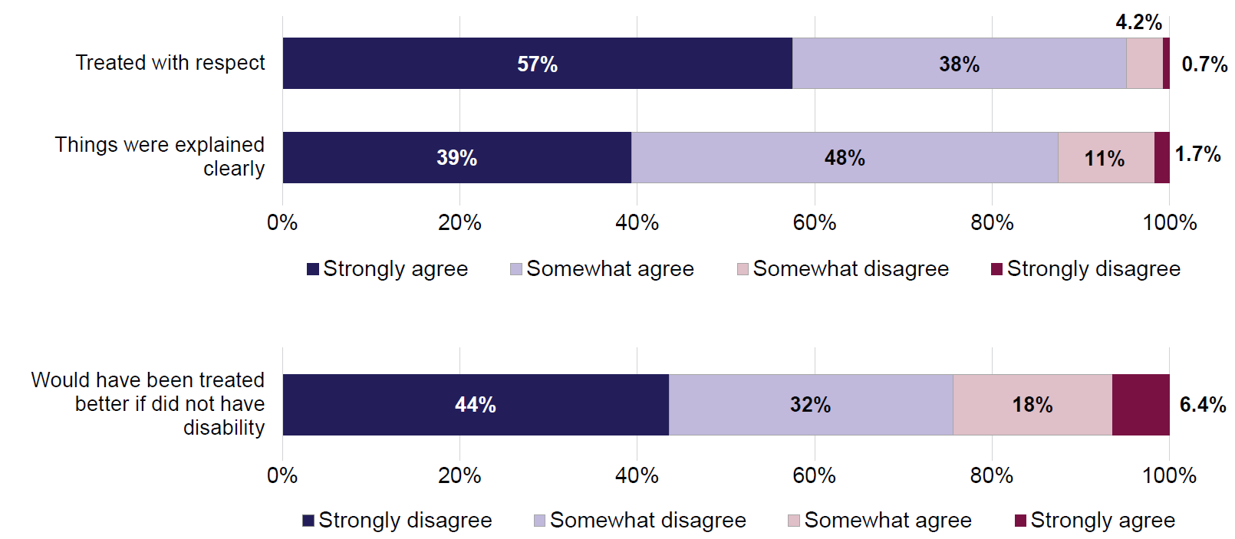
Note: For the last statement (about unequal treatment due to disability), the order of response categories is reversed to reflect that disagreement represents a positive service experience.
The experiences of people with disability when interacting with the education sector were overall positive (Figure 4.6). In 2024, 95% of people with disability agreed that they were treated with respect by education service providers (57% strongly agreed and 38% somewhat agreed). There were no changes in the levels of agreement since Wave 1 (2022).
Most people with disability who interacted with the education sector in 2024 also agreed that things were explained clearly to them (39% strongly agreed and 48% somewhat agreed (Figure 4.6).
The proportion of people who strongly agreed that they received clear explanations fell from 48% in 2022 to 39% in 2024. At the same time, the proportion of people who somewhat agreed increased from 39% in 2022 to 48% in 2024, while the proportion of those who disagreed remained unchanged.

In 2024, some groups of people with disability were less likely to say they received clear explanations:
- 24% of people with severe or profound disability strongly agreed that things were explained clearly to them, compared with 42% of people with milder forms of disability
- 21% of people with intellectual disability strongly agreed that things were explained clearly, compared with 41% of people with physical disability.
Most people with disability did not think they would have been treated better during their interaction with the education sector if they did not have disability.
In 2024, 76% of people with disability disagreed that their disability affected how they were treated (44% strongly disagreed and 32% somewhat disagreed) (Figure 4.6). Note that disagreement with this statement indicates a more positive service experience. At the same time, about 1 in 4 (24%) people with disability agreed that they would have been treated better if they did not have disability.
The response patterns remained similar between 2022 and 2024.
Younger people had worse experiences in equal treatment by education providers. In 2024, 31% of those aged 18–34 thought that they would have been treated better if they did not have disability, compared with 19% of those aged 35–54 and 15% of those aged 55 and over.
There are indications that people with severe or profound disability, those with visible disability, and those with intellectual disability were more likely to face unequal treatment. However, due to small respondent numbers the findings were estimated with a high degree of error and could not be reported.

5. Personal and community support sector
The personal and community support sector plays an important role in the lives of many people with disability. It provides services that can enable independent living, improve participation in community life, and strengthen wellbeing. High-quality care in this sector is key to ensuring dignity, respect, and equitable outcomes.
This sector contributes to Australia’s welfare through residential care and social or community services. In 2022, 3.3% (181,000) of people with disability lived in cared accommodation (residential care) which provides access to more intensive care (ABS 2024). Although the care needs are lower for the 5.3 million people with disability who live in the community, many still require assistance from time to time. This assistance could include support from friends and family (informal) as well as from paid carers, specialist providers, or government or private organisations (formal). Among people with disability living in the community, 60% (3.2 million) needed assistance with daily tasks. Of those who needed assistance, 57% (1.8 million) received assistance from formal service providers (ABS 2024).
This chapter begins by looking at attitudes and confidence of personal and community support workers when assisting people with disability. It then looks at experiences of people with disability who recently accessed personal and community support services.
Key findings
Personal and community support workers regularly interact with people with disability as part of their job. Most workers feel confident that they respond to people with disability in a positive way.
Support workers are most confident in their ability to assist people with physical disability, and less so for people with sensory or communication impairments, or intellectual disability.
Workers overwhelmingly supported the idea that people with disability should be able to access services provided by their organisation (if eligible). However, this varied by type of disability, with fewer workers agreeing that someone with a sensory or communication impairment or a psychosocial condition should be able to access services, compared with those with intellectual disability. Workers were also less likely to agree that people with psychosocial conditions or sensory or communication impairment should be able to communicate directly with service providers, compared with someone who had physical disability.
People with disability reported overall positive experiences when interacting with personal and community support services. However, about 3 in 10 believed they would have been treated better if they did not have disability.

Confidence and attitudes of personal and community support workers

Personal and community support workers in the ADS Survey
Compared with healthcare and education sectors, there were relatively few respondents from the personal and community support sector in the ADS Survey. Around 970 personal and community support workers participated in Wave 2 (2024) of the survey, up from around 870 in Wave 1 (2022). Around 450 personal and community support workers were interviewed in both waves of the survey. Due to the smaller number of respondents, there is a high level of uncertainty in the data, which meant that some analyses for sub-groups of workers could not be undertaken.
In the 2024 survey, support workers were predominantly women (64%). Age distribution was fairly balanced, with 35% aged 18–34, 42% aged 35–54, and 24% aged 55 and over. Around 1 in 4 workers (26%) had disability themselves, and almost all (94%) had experience with disability other than their own.
Personal and community support workers reported frequent interactions with people with disability. In 2024, 2 in 3 (67%) workers reported they had often or very often advised, assisted, or treated a person with disability as part of their job (Figure 5.1). Only 1 in 10 (9.9%) workers said they had not done so in the past year, and an additional 6.8% had only done so once or twice.
Figure 5.1: Personal and community support workers – How often advised, assisted or treated a person with disability in the last 12 months, 2024
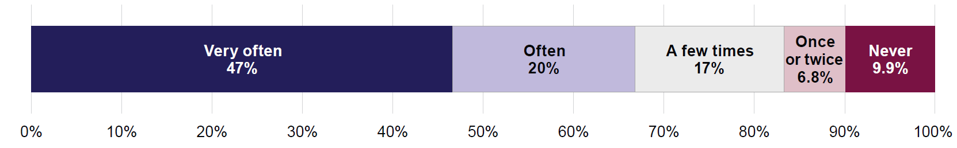
Although these levels of interaction were high, they were even higher in 2022 (Wave 1). In 2022, 55% of support workers very often assisted people with disability, compared with 47% in 2024.
Among support workers, women had more frequent interactions with people with disability. In 2024, 50% of women very often assisted people with disability, compared with 40% of men.
The levels of engagement were similar for support workers of different ages and for those who did or did not have disability themselves.

Confidence in interacting with people with disability
Most personal and community support workers (between 68% and 82%) said they felt confident in their ability to advise, assist, or treat people with various types of disability (Figure 5.2). Fewer than 1 in 10 (2.8%–7.2%) workers did not feel at all confident in supporting people with disability.
Figure 5.2: Personal and community support workers – How confident in ability to advise, assist or treat people with disability, by disability type, 2024
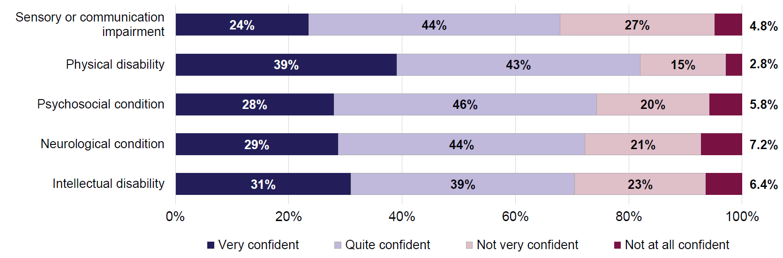
The confidence of support workers varied depending on the type of disability. Workers reported higher levels of confidence in their ability to assist people with physical disability compared with other types of disability:
- 39% of support workers were very confident in their ability to assist people with a physical disability such as reduced mobility or movement
- 31% were very confident with intellectual disability such as Down syndrome
- 29% were very confident with neurological conditions such as autism or attention deficit hyperactivity disorder (ADHD)
- 28% with psychosocial conditions such as severe anxiety or depression
- 24% with sensory or communication impairments such as being deaf or blind (Figure 5.2).
These patterns were similar in Wave 1 of the survey.
The levels of worker confidence also varied depending on the age and gender of the workers, and whether they often interacted with people with disability in their job. In 2024:
- younger workers (aged 18–54) were more confident than those aged 55 and over in assisting people with neurological and psychosocial conditions. For example, 32% of workers aged 18–54 were very confident in assisting someone with neurological condition, compared with 19% of workers aged 55 and over.
- women were more confident than men in their ability to assist someone with neurological or psychosocial condition, or sensory or communication impairment. For example, 27% of women said they were very confident in their ability to assist someone with sensory or communication impairment, compared with 16% of men.
- workers who had interacted more frequently with people with disability reported higher levels of confidence in assisting people with all types of disability. The difference was most pronounced for physical disability: 51% of workers who had often or very often interacted with people with disability as part of their job felt very confident to assist people with this type of disability, compared with 15% of those who had less frequent contact.
There was no difference in the levels of confidence among support workers with or without disability.
Personal and community support workers were also asked how confident they feel that they respond to people with disability in a positive way. An overwhelming majority of workers (95%) felt quite confident or very confident, while 5.4% said they did not feel confident (Figure 5.3).
Figure 5.3: Personal and community support workers – How confident that they respond in a positive way to people with disability, 2024
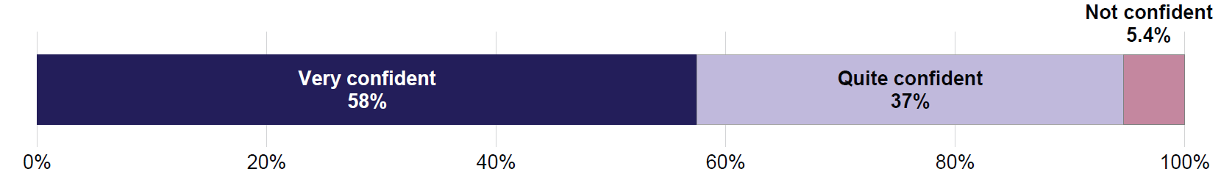
Note: Due to small number of responses, response categories ‘Not very confident’ and ‘Not at all confident’ were combined into a single category ‘Not confident’.
While these results from Wave 2 of the survey were strongly positive, confidence levels were even higher in Wave 1. In 2022, 67% of workers reported feeling very confident, compared with 58% in 2024. Additionally, only 2.0% of support workers reported not feeling confident in 2022, compared with 5.4% in 2024.
Support workers who had often or very often interacted with people with disability were more confident that they respond to people with disability in a positive way. Almost 7 in 10 (69%) felt very confident, compared with 33% of workers who had less frequent interactions. Confidence levels were similar regardless of gender, age, and whether the workers had disability themselves.

Professional attitudes towards people with different types of disability
Personal and community support workers in the ADS Survey were asked for their views on the rights of people with disability in two hypothetical situations. In each case, the survey questions focused on a specific type of disability, with respondents randomly assigned to answer questions about one of 5 disability groups:
- sensory or communication impairment, such as being deaf or blind
- physical disability, such as reduced mobility or movement
- psychosocial condition, such as severe anxiety or depression
- neurological condition, such as autism or attention deficit hyperactivity disorder (ADHD)
- intellectual disability, such as Down syndrome.
Support workers were then asked whether they agree or disagree that a person with [specific disability] should be able to:
- access services the worker’s organisation provides, if they are eligible
- communicate directly with a service provider, rather than through someone else.
Most personal and community support workers (between 73% and 90%) strongly agreed that people with disability should be able to access the services provided by their organisation if they were eligible (Figure 5.4). Workers were more likely to strongly agree that a person with intellectual disability should be able to access their organisation’s services (90%), compared with someone with a sensory or communication impairment (76%) or a psychosocial condition (73%). These findings were similar to Wave 1 results.
Figure 5.4: Personal and community support workers – Whether agree that people with disability should be able to access services if eligible, by disability type, 2024
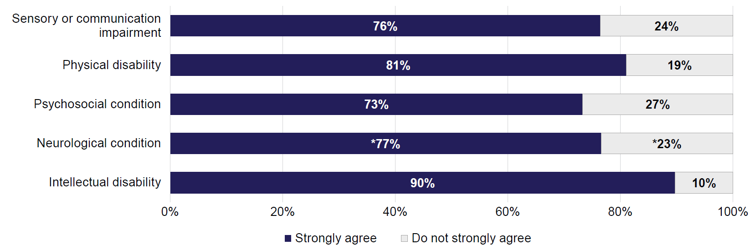
Notes:
1. Percentages marked with asterisk * were estimated with a high degree of error and should be used with caution.
2. Due to small number of responses, response categories ‘Somewhat agree’, ‘Somewhat disagree’ and ‘Strongly disagree’ were combined into a single category ‘Do not strongly agree’.
Responses for the second situation were also highly positive, though slightly less so than for service access. Between 59% and 74% of personal and community support workers strongly agreed that people with disability should be able to communicate with service providers directly, rather than through someone else (Figure 5.5). Disagreement was low, at 10% or lower.
The highest rate of agreement was for physical disability. About 3 in 4 (74%) of personal and community support workers strongly agreed that a person with physical disability should be able to communicate directly with a service provider. This compares with 64% of workers strongly agreeing for a person with sensory or communication impairment, and 62% for someone with psychosocial condition.
These results were largely similar in Wave 1, except the proportion of workers who strongly agreed that people with physical disability should be able to communicate with service providers directly fell from 88% in 2022 to 74% in 2024.
Smaller numbers of respondents for the personal and community support sector meant that results for some groups were estimated with a high degree of error, and attitudes could not be compared for sub-groups of workers.
Figure 5.5: Personal and community support workers – Whether agree that people with disability should be able to communicate directly with service provider, by disability type, 2024
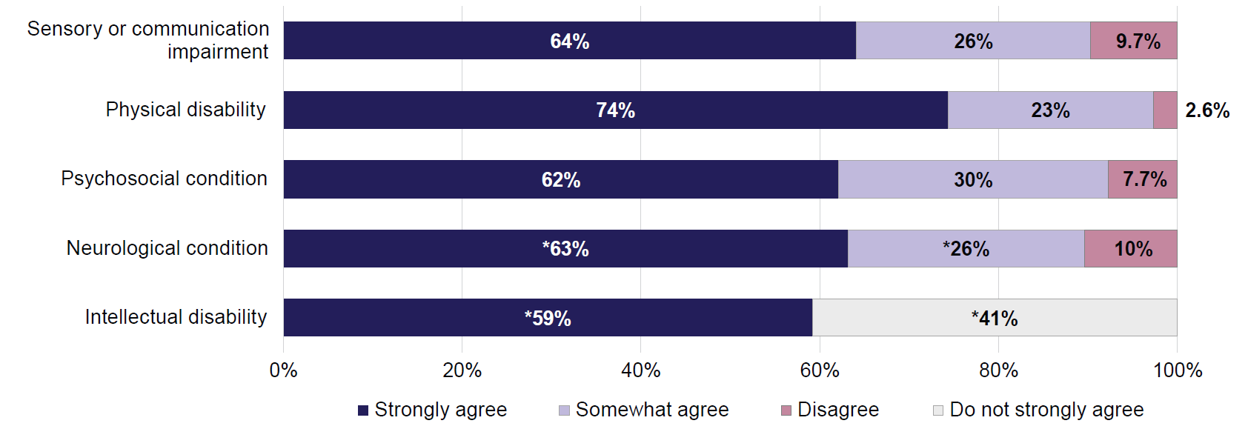
Notes:
- Percentages marked with asterisk * were estimated with a high degree of error and should be used with caution.
- Due to small number of responses, response categories ‘Somewhat disagree’ and ‘Strongly disagree’ were combined into single category ‘Disagree’. For the group of respondents who answered questions about people with intellectual disability, response categories ‘Somewhat agree’, ‘Somewhat disagree’ and ‘Strongly disagree’ needed to be combined into a single category ‘Do not strongly agree’.

Experiences of people with disability accessing personal and community support services

Use of personal and community support services by people with disability
The ADS Survey asked people with disability whether they had used or interacted with residential care or social and community support services in the past 12 months. In Wave 2 of the survey (2024), 8.3% reported using residential care, and 18% accessed social and community support services. Nearly 1 in 4 people with disability (23%) engaged with at least one of these services, consistent with service use in Wave 1 (2022).
Women were more likely than men to have used personal and community support services: 25% of women and 20% of men with disability have used these services in the past year. Younger people with disability (aged 18–34) were more likely to have used these services than those aged 55 and over:
- 27% of people aged 18–34 used personal and community support services
- 23% of people aged 35–54
- 20% of people aged 55 and over.
People with severe or profound disability were twice as likely to have used these services as those with milder forms of disability (38% compared with 19%, respectively).
The use of personal and community support services also varied by disability type:
- The high-use group included people with intellectual disability (38% have used support services in the past year), disability related to head injury, stroke or acquired brain injury (37%), and psychosocial disability (32%).
- People with sensory or speech, or physical disability were relatively less likely to have used these services (23% and 24%, respectively).

Experiences of people with disability when using personal and community support services
This section explores the experiences of people with disability in their interactions with the personal and community support sector. People with disability in the ADS Survey were asked about their experiences in their most recent interaction with the 4 key services (health care, education, personal and community support, or justice and legal services). People who had used more than one type of services were only asked about their experiences with the service of their most recent interaction.
For most people with disability who had accessed personal and community support services in the past year, this was not their most recent service interaction. Only 5.4% of all people with disability in the 2024 survey named personal and community support as their most recently used service. As such, only a small group of respondents were asked further questions about their experiences in this sector. This introduced uncertainty in the data and, at times, high degree of error in the estimates. Therefore, in most cases experiences could not be compared for groups of service users.
People with disability generally felt they were treated with respect during their interaction with personal and community support services. In total, 91% agreed they felt respected, including 57% who strongly agreed (Figure 5.6). Fewer than 1 in 10 (8.8%) did not agree they were treated with respect, consistent with Wave 1 of the survey.
Due to small respondent numbers, findings by age group, gender, and disability characteristics could not be reported.
Figure 5.6: People with disability – Experiences when interacting with personal and community support services, 2024
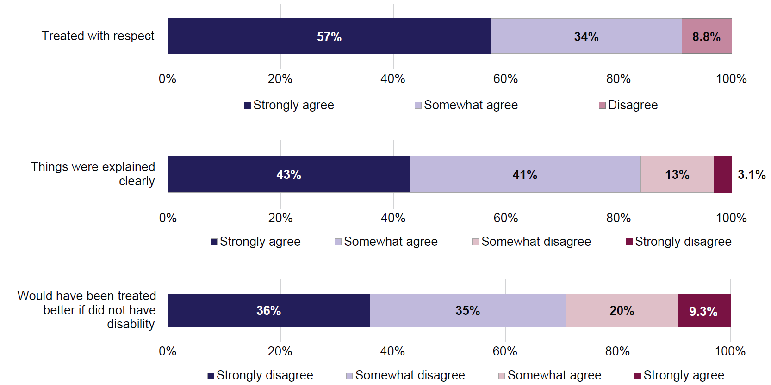
Notes:
- Due to small numbers of responses, for the statement ‘Treated with respect’ response categories ‘Somewhat disagree’ and ‘Strongly disagree’ were combined into a single category ‘Disagree’.
- For the last statement (about unequal treatment due to disability), the order of response categories is reversed to reflect that disagreement represents a positive service experience.
Similarly, 84% of people with disability agreed that things were clearly explained to them during their most recent interaction, including 43% who strongly agreed (Figure 5.6). Around 16% indicated they did not receive clear explanations. As with being treated with respect, responses were consistent with Wave 1 of the survey. Findings for sub-groups of service users could not be reported due to small number of respondents.
People with disability were also asked whether they believed they would have been treated better by personal and community support service workers if they did not have disability. While the majority (70%) disagreed, a notable minority (30%) agreed, including 9.3% who strongly agreed. These patterns have not changed since Wave 1 of the survey.
Younger people with disability (aged 18–54 years) tended to have worse experience in this regard than those aged 55 and over. Around 1 in 4 (27%) people aged 18–54 strongly disagreed that they would have been treated better if they did not have disability, compared with nearly half (48%) of those aged 55 years or older [note that, for this question, higher rate of disagreement indicates better service experience].

6. Justice and legal sector
Equal access to justice for people with disability is a fundamental human right. It is enshrined in international legal instruments like the United Nations Convention on the Rights of Persons with Disabilities (UN CRPD). Equal access to justice means ensuring that people with disability can participate in the legal process, including as witnesses or defendants, on an equal basis with others.
Achieving equal access requires effort by the legal community, including:
- recognising that people with disability have the same legal capacity as everyone else, with appropriate support if needed
- providing reasonable accommodations to remove physical or communication barriers to participate in legal proceedings
- appropriate training for those working in the justice system, to improve awareness and effectively support people with disability.
This chapter begins by looking at attitudes and confidence of justice and legal sector workers when interacting with people with disability. It then explores experiences of people with disability who recently accessed justice and legal services. This includes looking at support provided to people with disability to communicate with police or judicial officers.
Key findings
People with disability interact with the justice system less frequently than with other key services (such as health care or education). Similarly, workers in the justice and legal sector do not often have the opportunity to assist or advise a person with disability.
Nevertheless, the workers in the justice and legal sector had fairly high levels of confidence in their ability to assist people with disability, and in their positive attitudes towards people with disability.
For people with disability, their interactions with justice and legal sector were largely positive. Younger people with disability (aged 18–54) tended to have less positive experiences, and men were less likely than women to say they were treated with respect in their interactions.
About half to 60% of people with disability needed communication support when interacting with police or judicial officers. Most of those who needed support agreed that such support was provided. Once again, younger people with disability (aged 18–54) were less likely to say they were provided support to communicate, as were people with severe or profound disability, and people with intellectual disability.

Confidence and attitudes of legal and justice sector workers

Justice and legal sector workers in the ADS Survey
There were relatively few justice and legal sector workers among the respondents of the ADS Survey. In Wave 2 (2024), around 390 justice and legal workers were interviewed, with around 350 in Wave 1 (2022). Across the 2 waves of the survey, just under 150 people who were justice or legal workers in both years were interviewed. As the numbers of respondents are small, there is high uncertainty in the data. This meant that some analyses for sub-groups of workers could not be undertaken.
Among justice and legal workers in the ADS Survey in 2024, 39% were aged 18–34, 44% aged 35–54, and 16% aged 55 and over. There were slightly more women (54%) than men (44%); 22% of workers had disability themselves, and 82% had experience with disability (other than their own).
Workers in the justice and legal sector interact with people with disability as part of their work relatively infrequently. About 1 in 3 (34%) have never advised or assisted a person with disability in the past year, and a further 22% have done so once or twice only (Figure 6.1). About 1 in 5 workers have often (14%) or very often (6.0%) advised or assisted a person with disability.
Figure 6.1: Justice and legal workers – How often advised or assisted a person with disability in the last 12 months, 2024
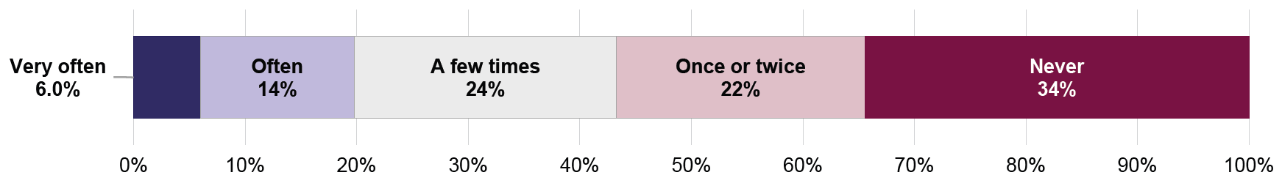

Confidence in interacting with people with disability
Overall, just over half of justice and legal workers were confident in their ability to advise or assist a person with disability (Figure 6.2). The levels of confidence varied depending on the type of disability of the client:
- Confidence to assist a person with physical disability was relatively high: 21% of workers were very confident and a further 56% quite confident.
- Workers were less confident in their ability to assist a person with intellectual disability: 8.0% very confident and a further 47% quite confident.
The levels of confidence did not change much since 2022. The only exception was in confidence to assist people with neurological conditions, which increased from 54% (very or quite confident) in 2022 to 65% in 2024.
Figure 6.2: Justice and legal workers – How confident in ability to advise or assist people with disability, by disability type, 2024
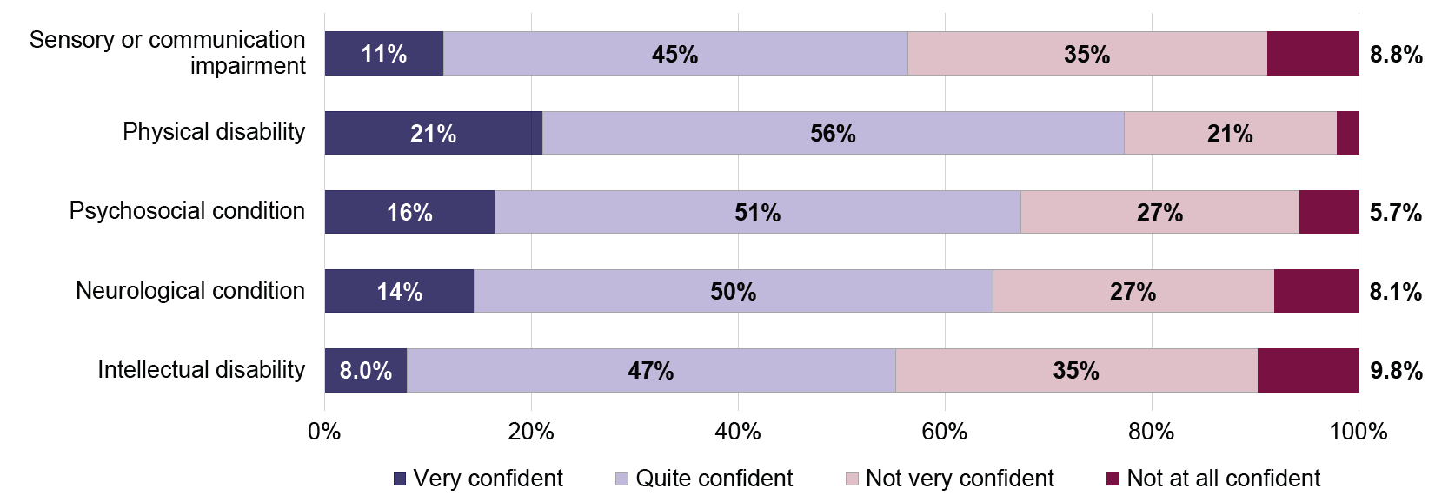
Note: Due to small number of responses, the proportion of workers not at all confident to assist people with physical disability could not be reported.
In 2024, there were few differences in the levels of confidence between sub-groups of justice and legal workers:
- Older workers (aged 55 and over) were more confident in their ability to assist people with physical disability. Among workers aged 55 and over, 89% were (very or quite) confident, compared with 75% of workers aged 18–54.
- Workers who had disability themselves were more confident in their ability to assist people with physical or psychosocial disability. For example, 80% of workers with disability felt confident in assisting people with psychosocial conditions, compared with 64% of workers without disability.
Workers who had often or very often interacted with people with disability tended to have higher levels of confidence. However, due to small number of workers who had frequent interactions, percentages for this group were estimated with a high degree of error and could not be reported.
About 9 in 10 (90%) of justice and legal sector workers were confident that they respond in a positive way to people with disability (Figure 6.3). The numbers were similar to Wave 1 findings, and did not vary in 2024 by age, gender, experience with disability, or own disability status of the worker.
As with confidence in the ability to assist people with disability, workers who had frequent interactions with people with disability tended to be more certain of their positive attitudes. Again, due to small number of respondents and high uncertainty in the data for this group, percentages for this group could not be reported.
Figure 6.3: Justice and legal workers – How confident that respond to people with disability in a positive way, 2024
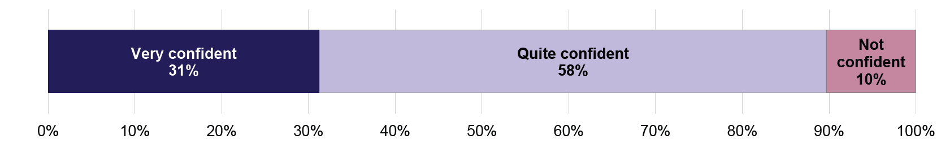
Note: Due to small number of responses, response categories ‘Not very confident’ and ‘Not at all confident’ were combined into a single category ‘Not confident’.

Professional attitudes in assisting people with different types of disability
Similarly to workers in other key industries, justice and legal sector workers were asked about their views about professionally assisting a person with disability in hypothetical situations. The survey questions were limited to a specific type of disability which randomly varied across survey respondents. The workers were randomly allocated into groups and asked about one of the following 5 disability types:
- sensory or communication impairment, such as being deaf or blind
- physical disability, such as reduced mobility or movement
- psychosocial condition, such as severe anxiety or depression
- neurological condition, such as autism or attention deficit hyperactivity disorder (ADHD)
- intellectual disability, such as Down syndrome.
The workers were then asked to give their opinions about the following 2 situations:
- whether they agree or disagree that a person with [specific disability type] is likely to be believed if they report abuse
- whether they would be comfortable dealing with a situation where an adult with [specific disability type] stole something from a shop.
It should be noted that the nature of these 2 statements differs from the statements posed to workers in other key service industries (health care, education, and personal and community support). Workers in the other sectors were asked about their individual opinions about treating a person (a patient, a student, or a client) with disability. For the justice and legal sector workers, the first statement is more about their perception of systemic attitudes towards a person with disability. The second statement is more about the worker’s confidence in dealing with a situation involving a person with disability.
There is another difference between the situations posed to justice and legal sector workers and those presented to workers in the 2 other mainstream sectors (health care and education). The statements for the other 2 sectors ask the workers to compare treatment of people with and without disability. For example, healthcare workers were asked if the person with disability should be able to access the same range of family planning services as people without disability. Similarly, the education workers were asked if teenagers with disability should attend sex education classes with their peers. For situations posed to the justice and legal workers, this comparison is not present. Therefore, we do not know how the workers would have responded to these statements about a person without disability.
Figure 6.4: Justice and legal workers – Whether think a person with disability is likely to be believed if they report abuse, by disability type, 2024
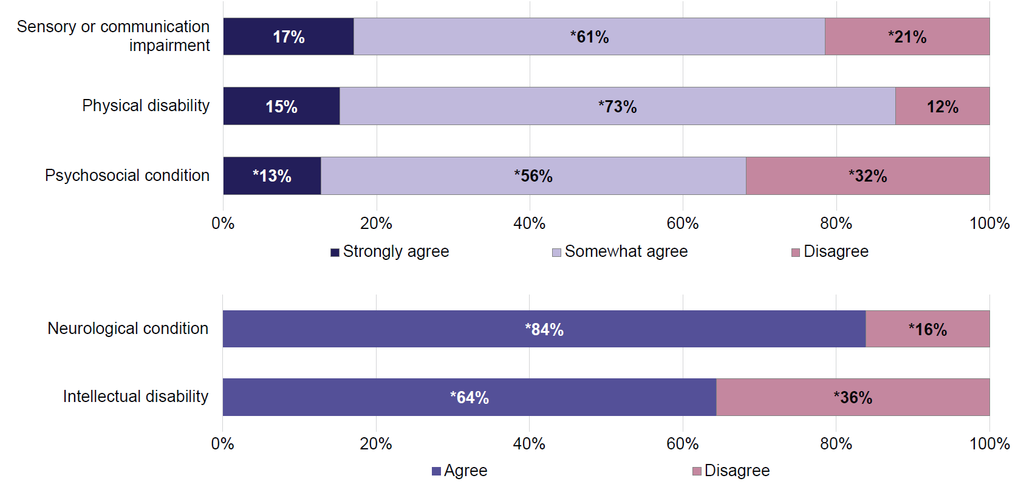
Notes:
- Due to small number of responses, response categories ‘Somewhat disagree’ and ‘Strongly disagree’ were combined into a single category ‘Disagree’. For neurological condition and intellectual disability groups, response categories ‘Strongly agree’ and ‘Somewhat agree’ were combined into a single category ‘Agree’.
- Percentages marked with asterisk * were estimated with a high degree of error and should be used with caution.
Figure 6.4 presents justice and legal sector workers’ responses about whether they think a person with disability would be believed if they report abuse. Depending on the type of disability, up to 17% of justice and legal workers strongly agreed that a person with disability would be believed. Between 12% and about a third of workers disagreed with this statement. Due to small numbers of respondents, most percentages presented in Figure 6.4 were estimated with a large degree of error and should be used with caution. The small numbers of respondents also meant that any differences in responses for specific types of disability could be attributed to chance. Likewise, results in Wave 2 (2024) of the survey were similar to Wave 1 (2022) findings.
Figure 6.5 shows workers’ responses about the situation where an adult with disability had stolen something from a shop. On average, about 60% of justice and legal sector workers said that they would be comfortable dealing with this situation, with the remaining 40% saying they would not be comfortable. As previously noted, this situation may be interpreted as asking the workers to evaluate their level of confidence in assisting a person with disability through this situation. It is also not known how comfortable the workers would have been dealing with such a situation if it concerned a person without disability.
The numbers of respondents were too small and the uncertainty in the data too high to draw any further conclusions.
Figure 6.5: Justice and legal workers – Whether would be comfortable dealing with a situation where an adult with disability stole something from a shop, by disability type, 2024
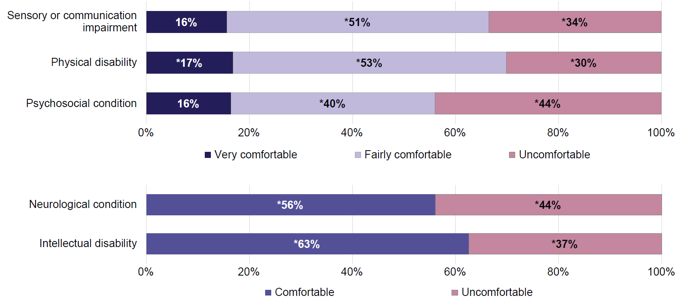
Notes:
- Due to small number of responses, response categories ‘Very uncomfortable’ and ‘Fairly uncomfortable’ were combined into a single category ‘Uncomfortable’. For neurological condition and intellectual disability groups, response categories ‘Very comfortable’ and ‘Fairly comfortable’ were combined into a single category ‘Comfortable’.
- Percentages marked with asterisk * were estimated with a high degree of error and should be used with caution.

Experiences of people with disability accessing justice and legal services

Use of justice and legal services by people with disability
People with disability in the ADS Survey were asked if, in the last 12 months, they had used or interacted with justice and legal services. These included:
- legal services such as barristers and solicitors, conveyancing, legal aid, or courts
- public order and safety, including police, gaols, correctional centres, juvenile detention, or remand centres.
In 2024, about 13% of people with disability reported using legal services in the past 12 months, and 7.6% used or interacted with public order and safety services. Overall, 17% of people with disability had contact with one or both of these services.
The use of legal services remained similar between 2022 and 2024. At the same time, the proportion of people with disability interacting with public order and safety services increased from 4.9% in 2022 to 7.6% in 2024. Consequently, the overall proportions accessing one or both services increased from 15% in 2022 to 17% in 2024.
In 2024, the likelihood of people with disability having contact with justice and legal services did not differ by gender. Among men and women with disability, 17% had contact with these services, as did 18% of people whose gender identity was other than man or woman. Younger people (aged 18–54) were more likely to have had contact with justice and legal services than those aged 55 and over (19% and 16%, respectively).
People with severe or profound disability were more likely to have contact with justice and legal services (21%), compared with people with milder forms of disability (16%).
The proportions of people who had contact with justice and legal services also varied by disability type:
- people with disability related to head injury, stroke or acquired brain injury, intellectual disability, or psychosocial disability were more likely to have contact with these services (29%, 24%, and 22%, respectively)
- people with sensory or speech, or physical disability were less likely to have contact with these services (17% and 18%, respectively).

Experiences of people with disability when using or interacting with the justice and legal sector
This section explores the experiences of people with disability in their interactions with the justice and legal sector. People with disability in the ADS Survey were asked about their experiences in their most recent interaction with the 4 key services (health care, education, personal and community support, or justice and legal services). People who had used more than one type of services were only asked about their experiences with the service of their most recent interaction.
For most people with disability who had interacted with justice or legal services in the past year, this was not their most recent service interaction. Only about 3% of all people with disability in the ADS Survey had interacted most recently with this sector. Therefore, only a small number of respondents were eligible to answer questions about their experiences when interacting with justice and legal sector. This limited the ability to report results for sub-groups of service users.
Figure 6.6: People with disability – Experiences when interacting with justice and legal services, 2024
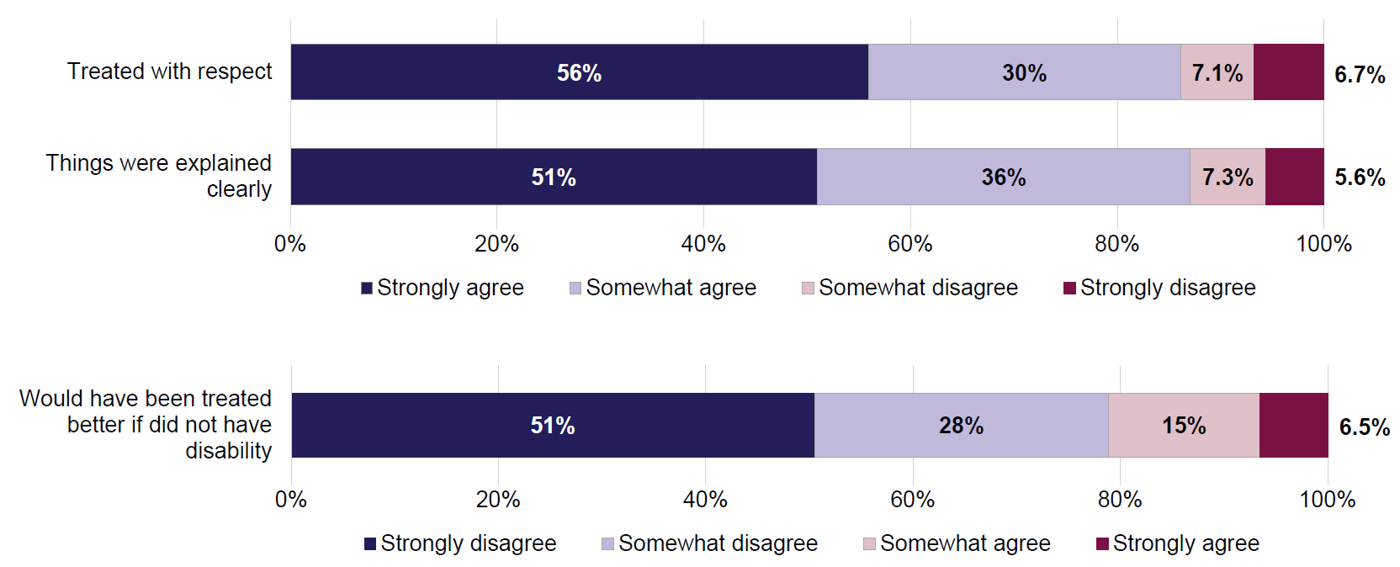
Note: For the last statement (about unequal treatment due to disability), the order of response categories is reversed to reflect that disagreement represents a positive service experience.

Most people with disability who had a recent interaction with justice and legal services reported an overall positive experience (Figure 6.6). Just under 9 in 10 people said that they were treated with respect (86%) and that things were explained clearly to them (87%). Similarly, 8 in 10 (79%) people thought that their disability did not affect how they were treated by the service workers (note that for this statement, disagreement indicates positive experience). There were no changes in response patterns for any of the aspects of service experience between Wave 1 (2022) and Wave 2 (2024) of the survey.
Men were less likely than women to say they were treated with respect by the sector workers. In 2024, 81% of men agreed with this statement, compared with 93% of women.
Younger people with disability also had worse experiences:
- 80% of people aged 18–54 agreed that they were treated with respect, compared with 94% of those aged 55 and over
- 81% of people aged 18–54 agreed that things were explained clearly to them, compared with 95% of those aged 55 and over.

Support to communicate with police and judicial officers
One of the key aspects of ensuring equal access to justice for people with disability is the provision of necessary modifications and adjustments to remove barriers to participation in legal proceedings. These barriers may be physical (such as access to court buildings) or related to communication, including difficulties in understanding legal jargon or lack of language and communication support. This section looks at supports provided to people with disability to help them communicate with police or judicial officers.
In 2024, about 1 in 4 (24%) people with disability in the ADS Survey reported having had interactions with police in the last 12 months, and 6.7% had interactions with judicial officers (judges or magistrates). These interactions may have included random breath tests, giving witness statements, jury duty, requesting assistance, or court proceedings. Just 4.0% of people with disability had interactions with both police and judicial officers, and 26% had interactions with either (or both) branches of the justice system.
Men and women with disability were about equally likely to have contact with the justice system. Younger people with disability (aged 18–54) were more likely to have contact with the system, compared with people aged 55 and over:
- 31% of people with disability aged 18–54 had contact with the justice system (police or judicial officers), compared with 21% of people aged 55 and over.
The rate of contact with the justice system was similar for people with severe or profound disability and for people with milder forms of disability, however it varied somewhat depending on the type of disability. People with psychosocial disability were more likely to have contact with the justice system (31% had contact, compared with 26% for all people with disability).
Among people with disability who had interacted with police, 52% needed communication support during the interaction. Among those interacting with judicial officers, 62% needed support.
People with severe or profound disability, and people with intellectual disability were more likely to have required communication support:
- 65% of people with severe or profound disability needed support to help them communicate with police (49% of people with milder forms of disability)
- 79% of people with severe or profound disability needed support to help communicate with judicial officers (55% of people with milder forms of disability)
- 71% of people with intellectual disability needed communication support in interactions with police. This compared with 52% of people with physical disability, 56% of people with psychosocial disability, and 58% of people with sensory or speech disability.
- 80% of people with intellectual disability needed communication support in interactions with judicial officers. This compared with 64% of people with physical disability, 67% of people with sensory or speech disability, and 68% of people with psychosocial disability.
Among people with disability who needed communication support, about 7 in 10 (72%) agreed they received the necessary support to communicate with police (37% strongly agreed) (Figure 6.7). Six in 10 (59%) agreed they received the supports to communicate with judicial officers (25% strongly agreed).
Figure 6.7: People with disability – Whether were provided support to communicate with police or judicial officers, 2024
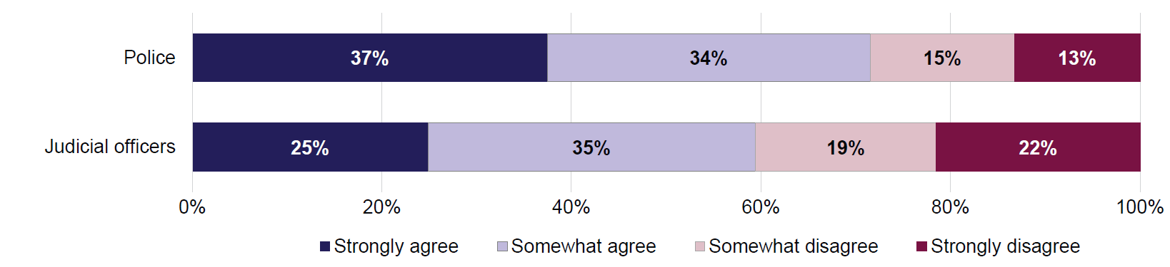
Note: The population for this chart is restricted to people with disability who had interacted with police or judicial officers in the last 12 months and indicated they needed communication support in their interaction.
The level of agreement varied depending on age, and severity and type of disability (Figures 6.8 and 6.9):
- Younger people (aged 18–54) were less likely to strongly agree that they were supported to communicate with police (32%), compared with those aged 55 and over (45%).
- People with severe or profound disability were less likely to give strong agreement, compared with people who had milder forms of disability.
- People with intellectual disability were less likely to agree they were supported to communicate with police (25%), compared with people with other types of disability.
Due to small numbers of respondents who interacted with and needed support to communicate with judicial officers, some proportions in Figure 6.9 were estimated with a high degree or error and should be used with caution.
Figure 6.8: People with disability – Percentage who strongly agreed they were supported to communicate with police, by selected characteristics, 2024
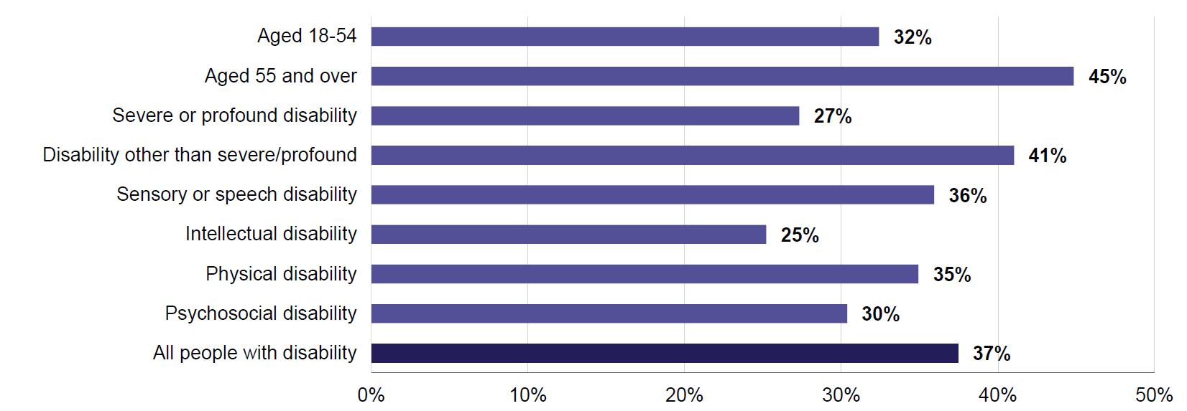
Note: The population for this chart is restricted to people with disability who had interacted with police in the last 12 months and indicated they needed communication support in their interaction.
Figure 6.9: People with disability – Percentage who strongly agreed they were supported to communicate with judicial officers, by selected characteristics, 2024
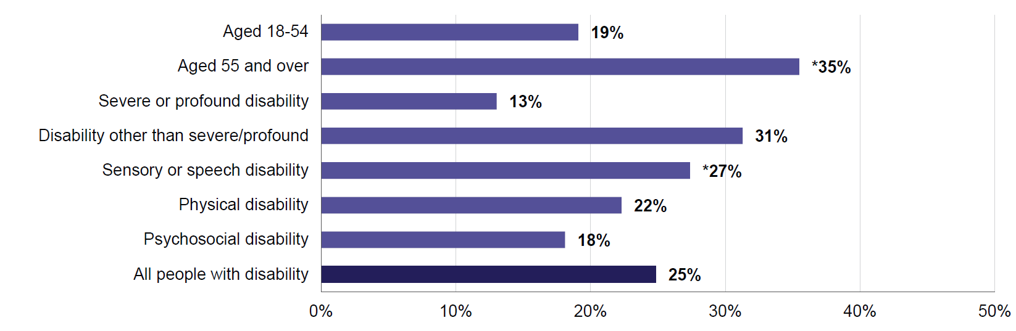
Notes:
- The population for this chart is restricted to people with disability who had interacted with judicial officers in the last 12 months and indicated they needed communication support in their interaction.
- Due to small number of responses, proportion for people with intellectual disability could not be reported.
- Percentages marked with asterisk * were estimated with a high degree of error and should be used with caution.

7. Sector comparison
The preceding 4 chapters of this Report discussed attitudes and confidence of workers in assisting people with disability in 4 key service sectors: health care, education, personal and community support, and justice and legal services. They also looked at experiences of people with disability when interacting with or using these services.
The frequency of on-the-job interactions with people with disability varied across sectors. Similarly, proportions of people with disability using these services varied depending on the service.
Most workers were confident that they respond in a positive way to people with disability. At the same time, workers’ confidence in their ability to support people with disability varied across sectors, for different types of disability, and depending on workers’ own characteristics. Likewise, people with disability reported overall positive experiences when interacting with the services, although experiences were worse for some sub-groups of service users.
This chapter focuses on comparison of key attitudes, confidences, and experiences across the key service sectors. It looks broadly at all workers and all service users with disability. For attitudes of sub-groups of workers and experiences of sub-groups of people with disability when interacting with services, see the individual chapters for each sector.
Key findings
The frequency of contact with people with disability varies significantly across key service sectors. For instance, nearly half (47%) of personal and community support workers very often assist people with disability, compared with just 6.0% of workers in the justice and legal sector. These differences in contact are reflected in the varying levels of workers’ confidence in their ability to assist people with disability.
However, regardless of sector of employment, most workers are confident of their positive attitudes towards people with disability.
People with disability report largely positive experiences with key service sectors. Health care, the most commonly used service, remains the sector with the highest rates of positive service use experience. Findings for other sectors were more mixed. People interacting with personal and community support sector in particular had less positive experiences, which seems at odds with high frequency of engagement and high confidence levels of the sector workers.
It is possible that the nature of service interactions, or the characteristics of people with disability themselves, affect their experience with services. More research is needed to explore the impact of these factors.

Professional attitudes across key sectors

Frequency of supporting people with disability
Before we can begin the comparison between sectors, it is important to remember that attitudes towards people with disability were not uniform within each sector. They differed based on age, gender, and experience of the worker, and depending on the type of disability of the client, student, or patient. Secondly, the number of respondents in the ADS Survey varied across sectors. The fewest responses came from workers in the justice and legal sector, followed by personal and community support, while the highest representation was from workers in health care and education. These differences in respondent numbers may affect how representative the findings are for each sector, particularly where the numbers were low.
Workers in the 4 key sectors were asked how frequently they advised, assisted, or treated people with disability as part of their job. There was noticeable variation across the sectors (Figure 7.1). Personal and community support workers reported the most frequent engagement, with 2 in 3 (67%) reporting they advised, assisted, or treated a person with disability often or very often in the past year. The healthcare sector followed, with 50% of workers reporting frequent engagement.
In contrast, large proportions of justice and legal workers (57%) and education workers (48%) indicated that they had interacted with people with disability no more than once or twice in the past year.
These patterns were consistent with those observed in Wave 1 of the ADS Survey.
Figure 7.1: Key sector workers – How often advised, assisted, or treated a person with disability in the last 12 months, by sector, 2024
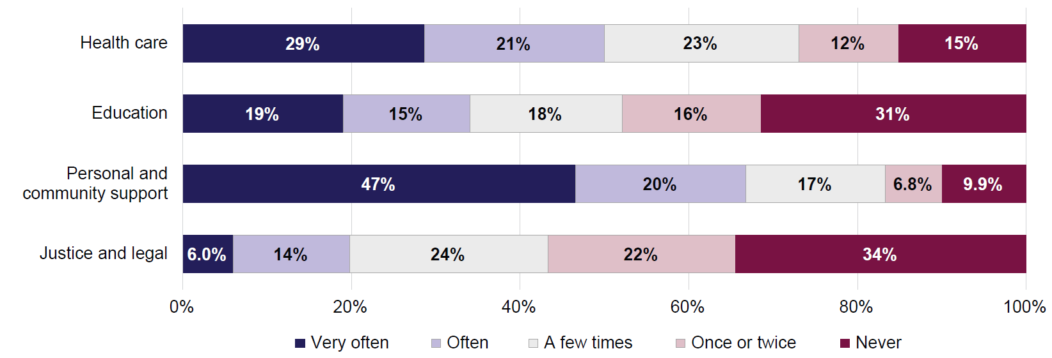

Confidence to support people with disability
Key sector workers were asked how confident they were in their ability to advise, assist or treat people with disability. This information was collected separately about 5 types of disability: sensory or communication, physical, psychosocial, neurological, and intellectual disability. The sector-specific chapters discuss workers’ confidence in supporting people with different types of disability. This section uses a measure of overall confidence to enable easier comparison between the sectors. Overall confidence was derived by taking an average of responses about 5 disability types for each responding worker.
Confidence of workers in their ability to assist people with disability varied across sectors (Figure 7.2). Nearly 4 in 5 (78%) personal and community support workers felt confident, compared with 61% of education workers. Notably, one quarter of personal and community support workers (24%) reported feeling very confident, likely reflecting their frequent on-the job interactions with people with disability.
The proportion of workers who felt not at all confident was low across all sectors (around 5% or less). However, 35% of education workers reported feeling not very confident – the highest of any sector. This may reflect having less experience in assisting people with disability.
These patterns align with findings from Wave 1 (2022) of the survey.
Figure 7.2: Key sector workers – How confident in ability to advise, assist or treat people with disability, by sector, 2024
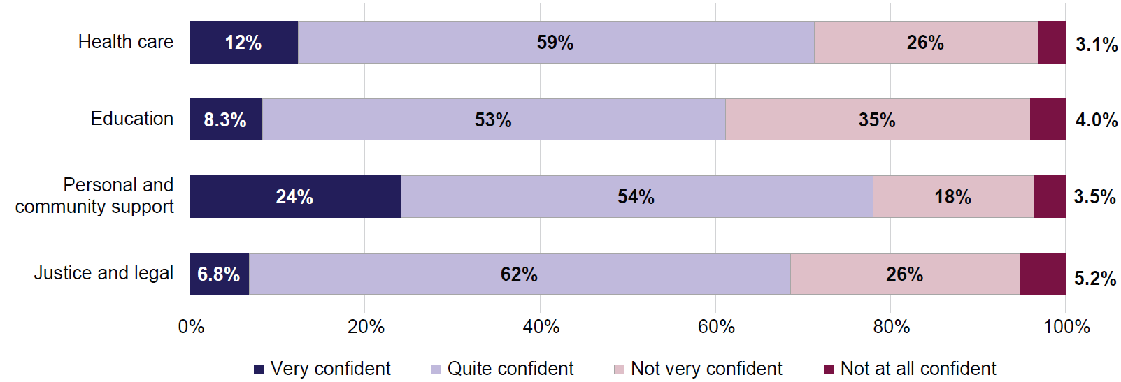

Responding positively to people with disability
Most people working in key service sectors felt confident that they respond to people with disability in a positive way (Figure 7.3). Between 89% and 95% of workers were quite or very confident of their positive attitudes. Personal and community support workers reported the highest level of confidence, with 58% saying they felt very confident. Across all sectors, less than 1 in 10 workers (8.8%) did not feel confident, with an even lower rate for personal and community support workers (5.4%).
Responses to this question were similar in Wave 2 (2024) and Wave 1 (2022) of the survey. The only change was in the personal and community support sector, where the proportion of workers who felt very confident fell from 67% in 2022 to 58% in 2024.
These findings, compared with those from the previous section, highlight an important difference. While many workers feel confident in their positive attitudes towards people with disability, fewer workers may feel adequately equipped to provide assistance specific to their roles. These results suggest a potential disconnect between individual attitudes, and the need for specialised knowledge and training.
Figure 7.3: Key sector workers – How confident they respond in a positive way to people with disability, by sector, 2024
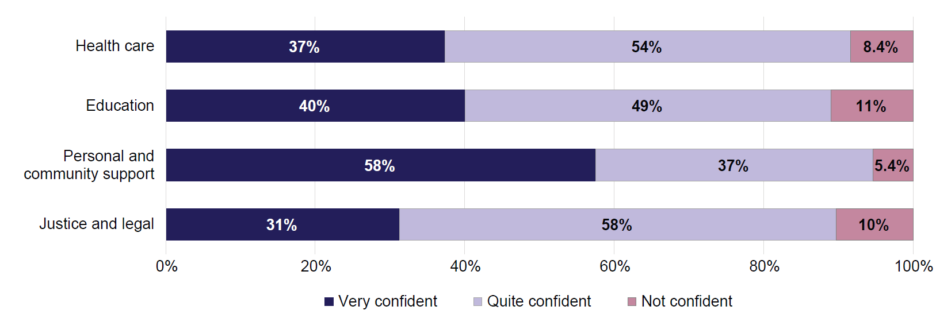
Note: Due to small number of responses, response categories ‘Not very confident’ and ‘Not at all confident’ were combined into a single category ‘Not confident’.

People with disability using key services
To build a fuller picture of service delivery, this section turns to experiences of people with disability who recently accessed services across the 4 key sectors.

Interactions with key services
In 2024, people with disability used or interacted with services at varied levels. Healthcare services had by far the highest engagement, with 88% people with disability saying they had used healthcare services in the past year (Figure 7.4). In comparison, around 1 in 4 people with disability had interacted with personal and community support (23%) or education services (24%). Interaction with the justice and legal sector was lowest, at 17%. These patterns were consistent with Wave 1 findings.
Most people with disability (91%) had interacted with at least one of the 4 key sectors in the past year, and 44% had engaged with more than one.
Figure 7.4: People with disability – Percentage who used or interacted with key services in the last 12 months, 2024
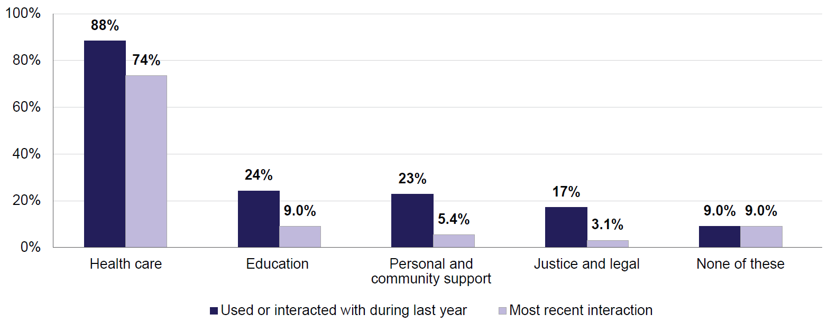
Note: Excludes a small number of people with disability who did not provide a complete response about their service use.

Experiences of people with disability when interacting with key services
People with disability who reported using services in the key sectors were asked follow-up questions about their experiences with the service. Those who had used more than one type of services were only asked about their experiences with the service of their most recent interaction. As a result, the survey may not reflect experiences across multiple sectors or multiple service interactions.
This approach also reduced the number of responses for each sector, especially for personal and community support, and justice and legal sectors. For instance, out of all people with disability in the ADS Survey in 2024, the proportion of people for whom justice and legal services was the most recent interaction was just 3.1% (Figure 7.4). This means the findings for these sectors carry a higher degree of uncertainty.
Across sectors, most people with disability (between 86% and 95%) said they were treated with respect during their most recent service interaction (Figure 7.5). More than half (56% or higher) of respondents strongly agreed they were treated with respect, even more so in healthcare services (67%). Disagreement was relatively low across sectors, except for the justice and legal sector where 6.7% of respondents strongly disagreed that they were treated with respect. These findings were consistent with Wave 1 survey results, reinforcing that people with disability generally feel respected when accessing key services.
Figure 7.5: People with disability – Whether were treated with respect by service workers, by sector, 2024
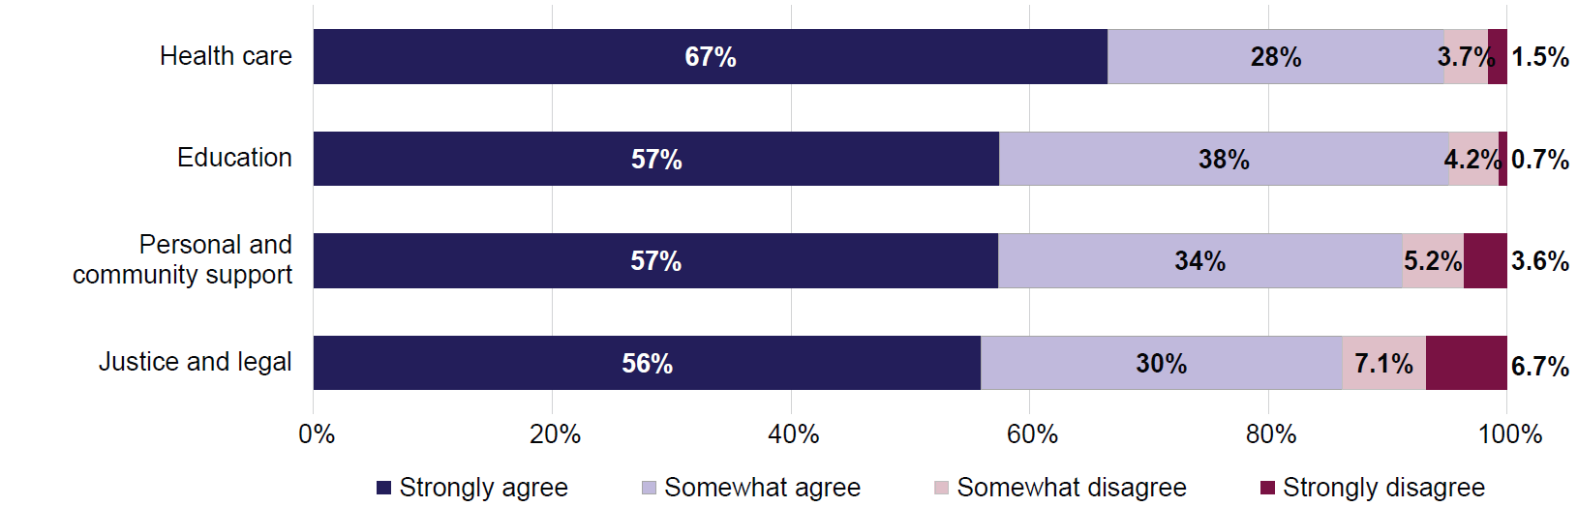
Similarly, most people with disability (between 84% and 92%) agreed that things were explained clearly to them during their most recent service interaction (Figure 7.6). More than half of people with disability strongly agreed that this was the case in their interaction with healthcare, and justice and legal sectors (53% and 51%, respectively). Those who interacted with education services were less likely to strongly agree (39%). Disagreement was low, at around 10%.
These patterns were largely consistent with Wave 1 findings. The main difference between the two waves was a shift in the strength of agreement. In Wave 2, fewer respondents strongly agreed, and more respondents somewhat agreed, particularly in the healthcare and education sectors. Despite this shift, overall agreement remained similar across both waves.
Figure 7.6: People with disability – Whether agreed that things were explained clearly to them, by sector, 2024
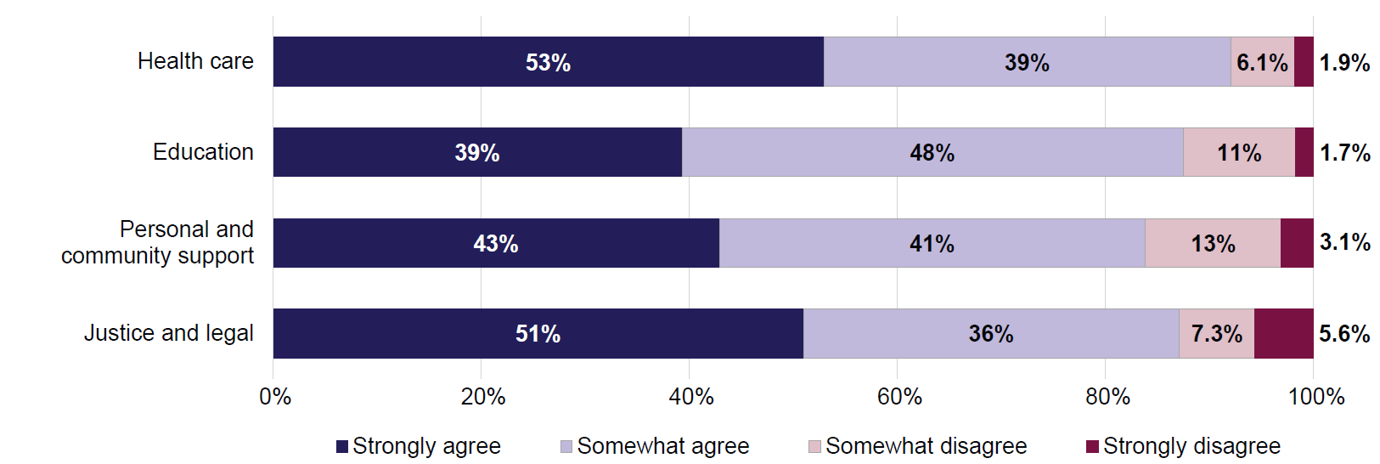
People with disability were also asked if, during their most recent service interaction, they thought they would have been treated better if they did not have disability. While most respondents disagreed with this notion, a notable minority still agreed. Agreement ranged from 15% for experiences with healthcare services to 30% for experiences with personal and community support (Figure 7.7). Perceptions about unequal treatment due to disability were consistent with Wave 1 findings.
Figure 7.7: People with disability – Whether would have been treated better if did not have disability, by sector, 2024
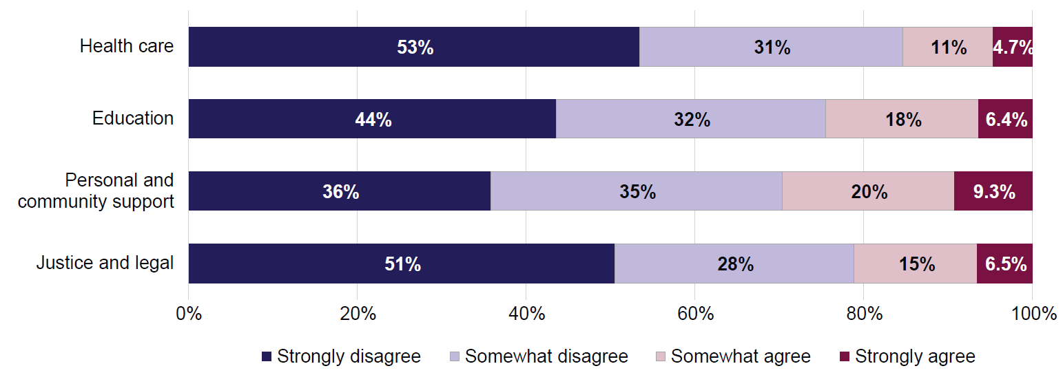
Note: For this statement, disagreement indicates a ‘positive’ response and better service experience.

Discussion
In general, people with disability reported positive experiences when using key services, although there was variation between the 4 key service sectors. Health care remained the sector where people with disability most frequently reported positive experiences in terms of feeling respected, receiving clear explanations, and being treated the same as people without disability. This is important since health care is the most frequently used service by people with disability.
Results were somewhat less positive for other sectors. Workers in the personal and community support sector reported the most frequent interactions with people with disability and had higher than average levels of confidence in their ability to support and respond positively. At the same time, the experiences of people with disability were generally less positive in this sector, with lower proportions saying they received clear explanations, and higher proportions believing that they would have been treated better if they did not have disability.
Workers in the education and justice and legal sectors were the least likely to interact frequently with people with disability. This was reflected in lower confidence to support and respond positively to people with disability. The experiences of people with disability in interacting with these 2 sectors were somewhat mixed, generally worse than the healthcare sector but comparable to personal and community support.
Although this chapter did not look at characteristics of people with disability using the key services, these may help explain the variation in service experience between sectors. The 4 sector-specific chapters have shown that people with severe or profound disability generally have worse service experiences. Younger people with disability also tend to have less positive experiences, as do people with intellectual or psychosocial disability.
Therefore, if people with these characteristics are more likely to use, for example, personal and community support services, this will affect the rates of user experience for the sector.
The nature of interactions people with disability have with the services may also affect their perception of workers’ attitudes and behaviours. People may feel vulnerable during interactions with service providers due to such things as their dependence on the service, the emotional nature of the interaction, and the potential for difficult or sensitive discussions. These feelings of vulnerability can affect their engagement and experience of the interaction.
More research is needed to learn how the nature of service interactions may affect people’s experience, and what needs to be done to improve experiences of people with disability when they come into contact with services.

Conclusion
This report presented findings from Wave 2 of the ADS Survey. It examined how people feel and act towards people with disability in everyday life and at work. It also looked at how views and actions of others affect people with disability, and whether people with disability feel valued and respected.
The report then turned to attitudes and experiences in key service sectors. These sectors include health care, education, personal and community support, and justice and legal services. The report looked at both how workers viewed people with disability, and how people with disability felt when they used these services.

How society views disability
Disability can be different for different people. Some disabilities – like physical impairments – are easier to see. Others – such as mental health issues – are not as visible. Recognising that disability can take many forms is important for creating an inclusive society that respects and supports people with disability.
The ADS Survey showed that people are more likely to recognise disability in the form of physical impairments. Attitudes towards people with physical disability are also more positive. On the other hand, people with mental health conditions are less likely to be recognised as people with disability, and may face worse attitudes. The attitudes were also worse towards people with intellectual disability. This was particularly true when considering people with disability in jobs such as a doctor or a boss.
The ADS Survey also showed that individual attitudes towards people with disability were generally positive. However, there was a perception that society as a whole has negative views on disability. About half of respondents agreed that people with disability can have difficulty getting involved or making friends, and that people with disability are easier to take advantage of than others.

Do people with disability feel included in community life?
Most people with disability said they feel respected and included in their communities. Other people’s attitudes or behaviours rarely stopped them from doing things they wanted to do, like work, study, or travel. However, many felt they were not well represented in all areas of life, such as in leadership roles or the media.
People with more severe disability were less likely to feel respected and well represented in all areas of life, and more often felt prevented from doing things they wanted to do. The same was the case for people with intellectual or psychosocial disability.

Employers’ views
People who hire workers (employers) had more positive attitudes towards people with disability if they or their workplace had hired someone with disability in the past. However, employers still said hiring people with disability could be challenging. Common reasons were the difficulty of finding qualified people with disability to do the job, or thinking the job could not be done by someone with disability.

Workers in key service sectors
Most workers in key service sectors said they respond to people with disability in a positive way. This was the case in all 4 sectors looked at in the ADS Survey, including health care, education, personal and community support, and justice and legal services. However, many workers did not feel confident helping people with certain types of disability. This most often occurred where the disability was not a physical disability.
This shows that there is a difference between attitudes or ways of thinking, and confidence in own knowledge or abilities. A worker may have good attitudes or interpersonal skills, but may still be unsure how to best support people with specific types of disability. There is a need for resources and training to adapt service delivery to specific needs of people with disability. This will help create more effective and inclusive services.
How often workers supported people with disability in their job varied between sectors, and between workers in the same sector. Personal and community support workers interacted with people with disability most often, while legal workers had the least contact. Generally, workers who more often helped people with disability were more confident in doing so. Workers who had experience with disability (other than their own) were also more confident, as were workers who had disability themselves.

Experiences of people with disability using key services
Most people with disability said they were treated well by people working in the healthcare, education, personal and community support, and legal and justice sectors. They felt respected, and things were explained clearly to them. They also felt their disability did not affect how they were treated by the service providers.
Some groups of people with disability had less positive experiences. Younger people (aged 18–54) and people with more severe forms of disability had worse experiences. Men with disability felt less respected than women when interacting with justice and legal services.
Health care was the most used service and had the most positive feedback. Findings for the other 3 service areas were more mixed, although this could have been due to smaller numbers of respondents, for both workers and service users.
The larger number of respondents in the healthcare sector allows a closer look at how attitudes and confidence levels of workers may affect experience of service users.
People with physical disability had the best experience using healthcare services. People with intellectual or psychosocial conditions had worse experiences. This was consistent with the lower confidence and less positive attitudes expressed by healthcare workers toward these groups.
People with sensory or communication disability had good experiences. This was despite healthcare workers feeling less confident in supporting people with these disabilities. However, workers believed that people with these disabilities should make their own decisions about treatment.

Understanding attitudes and experiences matters
The characteristics and needs of service users, providers’ experience, attitudes and knowledge, and the nature of service itself can all affect service use experience. Understanding how these factors link together can help improve services for people with disability and make sure everyone is treated fairly and respectfully.

References
ABS (Australian Bureau of Statistics) (2024) Disability, Ageing and Carers, Australia: Summary of Findings, 2022, ABS, accessed 17 June 2025.
ABS (2025a) Labour Force, Australia, Detailed, July 2025, Table 6, ABS, accessed 22 August 2025.
ABS (2025b) Children and young people with disability, 2022, ABS, accessed 17 June 2025.
AIHW (Australian Institute of Health and Welfare) (2024) People with disability in Australia, AIHW, accessed 19 May 2025.
AIHW (2025) Reporting on Australia’s Disability Strategy 2021–2031, AIHW, accessed 4 July 2025.
DRC (The Royal Commission into Violence, Abuse, Neglect and Exploitation of People with Disability) (2023) Final Report – Volume 7, Inclusive education, employment and housing, accessed 23 June 2026.
DSS (Department of Social Services) (2021) Australia’s Disability Strategy 2021–2031, Commonwealth of Australia (Department of Social Services), accessed 17 June 2025.

Appendix A: Technical Appendix

How disability is determined in the ADS Survey
The ADS Survey determines if a respondent has disability in 2 steps. First, the respondent is asked a series of questions about long-term conditions they may have, and whether these conditions cause any restrictions in everyday activities or in core activities (which include self-care, mobility, and communication). These questions are a version of the Short Disability Module which the Australian Bureau of Statistics (ABS) uses in non-disability specific surveys (such as the National Health Survey and Personal Safety Survey) to determine whether a person does or does not have disability or a restrictive long-term health condition. This set of questions also allows to determine a degree of disability a person has (from profound core activity limitation to no specific limitation or restriction), as well as general types of disability a person may have (these include sensory or speech, intellectual, physical, psychosocial disability, disability related to head injury, stroke or acquired brain injury, or other type of disability).
At the second step, respondents who are identified to have disability or a restrictive long-term health condition using the ABS method are then asked if they thought they had certain types of disability or long-term health conditions. This step essentially allows respondents to self-identify as a person with disability or a long-term health condition. Not all people identified to have disability or a restrictive long-term health condition at Step 1 (according to the ABS method) think of themselves as having disability or a long-term health condition.
Diagram A.1 shows how the sample of respondents in Wave 2 of the ADS Survey is classified by disability status.
Diagram A.1 Disability in the ADS Survey Wave 2 sample, unweighted numbers and percentages

Where the ADS Survey collects information specific to experiences of people with disability, this is done by asking questions only of people who self-identify as having disability or a long-term health condition (and who, by definition, are also identified as having disability or a restrictive long-term health condition using the ABS method). To keep reporting consistent, this Report uses ‘people with disability’ to refer to those who self-identify as having disability or long-term health conditions.
Where the ADS Survey collected information from all respondents regardless of their disability status, comparisons of attitudes in this Report are also made using the person’s self-identified disability status; that is, ‘people with disability’ refers to people who self-identify as having disability or long-term health conditions, and ‘people without disability’ refers to people who either do not have or do not self-identify as having disability or long-term health condition. This is done because a person’s attitudes towards disability are assumed to have a closer relationship with their perception of their own disability status, rather than their reported activity restrictions.
However, where objective outcomes (like employment) are compared, functional disability status (based on the ABS method only) is used to compare people with and without disability. These comparisons based on the ABS method of identifying disability are an exception to the general reporting and are clearly noted in the Report.

Profile of respondents in Wave 2 of the ADS Survey
This section shows the composition of the ADS Survey Wave 2 sample according to selected demographic and socio-economic characteristics of respondents, based on their disability status. Two disability groups are presented according to how disability status was identified in survey respondents:
- disability based on functional capacity using the version of the ABS Short Disability Module (see Step 1 of the 2-step disability identification method mentioned above)
- disability that is restricted to people who self-identify as having disability or long-term health condition (Step 1 and Step 2 of the 2-step disability identification method mentioned above).
Table A.1 shows raw (unweighted) numbers and proportions in the sample, while Table A.2. shows population-weighted proportions, which adjust the survey sample to look more like the population of Australia in 2024.
Looking at Table A.2, compared with people without disability, people with disability are generally older, are more likely to have gender identity other than man or woman, to be Aboriginal and/or Torres Strait Islander, to be born in Australia, more likely to live alone and less likely to be living in a couple household with dependent children, less likely to have achieved education of Bachelor degree or higher and more likely to have the highest education of Year 11 or below. People with disability tend to have lower levels of household income and are less likely to be employed. People with disability are also more likely to have experience with disability (other than their own).
Table A.1: Respondent profile, by disability status (unweighted)
 | Does not have disability  (ABS method) | Has disability (ABS method) | Self-identifies as having disability
Total number in sample | n=8,623 | n=10,585 | n=8,275
Gender
Man or male | 37.3% | 37.6% | 37.4%
Woman or female | 62.0% | 61.1% | 61.1%
Non-binary or other | 0.5% | 1.1% | 1.4%
Age groups
18–24 | 14.2% | 10.4% | 10.1%
25–34 | 13.3% | 7.8% | 8.0%
35–44 | 18.2% | 10.5% | 10.3%
45–54 | 15.8% | 11.5% | 11.7%
55–64 | 16.6% | 17.0% | 17.5%
65–74 | 15.5% | 23.8% | 23.6%
75 and over | 6.3% | 18.7% | 18.7%
Indigenous status
Indigenous | 1.3% | 2.3% | 2.5%
Non-Indigenous | 98.5% | 97.4% | 97.2%
Country of birth
Born in Australia | 69.9% | 75.5% | 77.2%
Born overseas | 29.9% | 24.4% | 22.7%
Household composition
Person living alone | 15.8% | 24.8% | 25.8%
Couple living alone | 28.5% | 31.8% | 31.3%
Couple – with non-dependent child(ren) | 11.7% | 9.8% | 9.5%
Couple – with dependent child(ren) | 23.9% | 12.8% | 12.1%
Couple – with dependent and non-dependent child(ren) | 4.0% | 2.9% | 2.8%
Single parent – with non-dependent child(ren) | 2.4% | 3.4% | 3.6%
Single parent – with dependent child(ren) | 3.2% | 3.4% | 3.6%
Single parent – with dependent and non-dependent child(ren) | 0.8% | 1.1% | 1.1%
Adults who are not related – sharing residence | 5.8% | 5.0% | 5.1%
Other household type | 3.5% | 4.5% | 4.9%
Highest educational qualification
Postgraduate degree | 19.8% | 14.3% | 13.5%
Graduate diploma or certificate | 9.8% | 9.0% | 8.8%
Bachelor degree | 27.6% | 20.4% | 20.4%
Advanced diploma or diploma | 9.2% | 11.4% | 11.8%
Certificate III/IV | 11.9% | 15.4% | 16.2%
Year 12 or equivalent | 13.7% | 12.4% | 12.1%
Year 10 or 11 | 5.7% | 10.9% | 10.9%
Below Year 10 (includes Certificate I/II) | 0.9% | 2.6% | 2.7%
Other | 0.8% | 2.3% | 2.5%
Annual pre-tax household income*
Below $26,000 | 7.4% | 15.0% | 15.6%
$26,000−$33,799 | 3.3% | 9.5% | 10.2%
$33,800−$41,599 | 3.5% | 6.2% | 6.4%
$41,600−$51,999 | 4.6% | 7.1% | 7.5%
$52,000−$64,999 | 6.4% | 7.8% | 7.7%
$65,000−$77,999 | 6.6% | 6.8% | 6.6%
$78,000−$90,999 | 7.7% | 6.5% | 6.5%
$91,000−$103,999 | 7.5% | 6.2% | 5.9%
$104,000−$155,999 | 17.0% | 12.5% | 12.4%
$156,000−$181,999 | 8.7% | 5.0% | 4.8%
$182,000−$207,999 | 6.4% | 3.6% | 3.3%
$208,000 or more | 14.2% | 6.0% | 5.4%
No response | 6.5% | 7.8% | 7.7%
Employment status
Employed | 72.8% | 48.4% | 46.5%
Not employed | 26.8% | 51.2% | 53.1%
Experience with disability**
Has experience | 80.6% | 89.0% | 90.5%
Does not have experience | 19.2% | 10.8% | 9.3%
Notes:
For each grouping, there is a small number of ‘Not sure’, ‘Prefer not to say’ and skipped responses which are included in the total but are not reported on separately. Because of this, percentages will add up to less than 100%.
* Annual income below $26,000 includes negative income (loss) and nil income. For annual income, ‘No response’ category is included in the table due to high proportion of respondents who did not provide information about their annual income.
** Experience with disability refers to experience with disability other than own and includes any of the following: having ever been a paid or an unpaid carer for a person with disability; ever having had a close family member, partner, close friend, work colleague, boss or supervisor, teacher or lecturer, or classmate with disability; ever having lived with a person with disability.

Table A.2: Respondent profile, by disability status (weighted)
 | Does not have disability  (ABS method) | Has disability (ABS method) | Self-identifies as having disability
Weighted total number | n(w)=12,215 | n(w)=6,983 | n(w)=5,421
Gender
Man or male | 48.8% | 49.5% | 49.0%
Woman or female | 50.7% | 49.0% | 49.2%
Non-binary or other^ | 0.5% | 1.4% | 1.8%
Age groups
18–24^ | 13.4% | 7.9% | 7.4%
25–34^ | 20.3% | 16.1% | 16.8%
35–44^ | 20.4% | 13.2% | 12.4%
45–54^ | 17.1% | 13.4% | 13.4%
55–64^ | 13.4% | 16.4% | 16.9%
65–74^ | 10.5% | 17.8% | 18.0%
75 and over^ | 4.8% | 15.0% | 15.0%
Indigenous status
Indigenous^ | 1.3% | 2.7% | 3.0%
Non-Indigenous^ | 98.5% | 96.9% | 96.6%
Country of birth
Born in Australia^^ | 60.8% | 68.5% | 71.2%
Born overseas^^ | 39.1% | 31.4% | 28.7%
Household composition
Person living alone^ | 14.6% | 22.5% | 23.7%
Couple living alone^ | 26.0% | 29.2% | 29.1%
Couple – with non-dependent child(ren)^ | 11.8% | 10.4% | 10.0%
Couple – with dependent child(ren)^ | 26.4% | 15.5% | 14.4%
Couple – with dependent and non-dependent child(ren)^ | 4.5% | 3.2% | 3.2%
Single parent – with non-dependent child(ren)^ | 2.1% | 3.5% | 3.8%
Single parent – with dependent child(ren) | 3.0% | 3.4% | 3.4%
Single parent – with dependent and non-dependent child(ren) | 0.7% | 1.0% | 1.1%
Adults who are not related – sharing residence | 6.5% | 5.8% | 5.6%
Other household type^ | 4.0% | 5.0% | 5.4%
Highest educational qualification
Postgraduate degree^^ | 13.6% | 7.2% | 6.1%
Graduate diploma or certificate^ | 5.7% | 4.0% | 3.9%
Bachelor degree^ | 19.3% | 10.5% | 9.8%
Advanced diploma or diploma^ | 14.4% | 17.1% | 17.2%
Certificate III/IV^ | 18.5% | 24.0% | 25.6%
Year 12 or equivalent | 18.9% | 16.6% | 16.3%
Year 10 or 11^ | 6.8% | 13.6% | 13.8%
Below Year 10 (includes Certificate I/II)^ | 1.3% | 3.2% | 3.4%
Other^ | 0.8% | 2.4% | 2.5%
Annual pre-tax household income*
Below $26,000^ | 8.1% | 16.8% | 17.7%
$26,000−$33,799^ | 3.5% | 9.4% | 10.0%
$33,800−$41,599^ | 3.2% | 6.3% | 6.7%
$41,600−$51,999^ | 4.9% | 7.2% | 7.5%
$52,000−$64,999 | 6.8% | 7.6% | 7.7%
$65,000−$77,999 | 6.8% | 7.1% | 6.9%
$78,000−$90,999^ | 8.0% | 6.5% | 6.3%
$91,000−$103,999^ | 7.4% | 6.3% | 5.9%
$104,000−$155,999^ | 17.0% | 12.0% | 11.9%
$156,000−$181,999^ | 8.5% | 4.9% | 4.4%
$182,000−$207,999^ | 6.7% | 3.2% | 3.0%
$208,000 or more^ | 13.2% | 5.6% | 5.0%
No response^ | 5.7% | 7.1% | 7.1%
Employment status
Employed^^ | 76.7% | 51.5% | 48.3%
Not employed^^ | 23.1% | 48.0% | 51.2%
Experience with disability**
Has experience^^ | 73.9% | 85.5% | 87.3%
Does not have experience^^ | 25.8% | 14.2% | 12.5%
Notes:
For each grouping, there is a small number of ‘Not sure’, ‘Prefer not to say’ and skipped responses which are included in the total but are not reported on separately. Because of this, percentages will add up to less than 100%.
* Annual income below $26,000 includes negative income (loss) and nil income. For annual income, ‘No response’ category is included in the table due to high proportion of respondents who did not provide information about their annual income.
** Experience with disability refers to experience with disability other than own and includes any of the following: having ever been a paid or an unpaid carer for a person with disability; ever having had a close family member, partner, close friend, work colleague, boss or supervisor, teacher or lecturer, or classmate with disability; ever having lived with a person with disability.
^ Proportions are statistically significantly different (at 95% level) between data columns 1 and 2, and between data columns 1 and 3, but not between data columns 2 and 3.
^^ Proportions are statistically significantly different (at 95% level) between all 3 data columns.

Note that this question asks about sensory or communication impairment, while the data about type of disability collected for people with disability in the ADS Survey relate to sensory or speech disability. Communication is a more general term which includes speech as well as other aspects and ways of receiving and conveying information.
Note that this question asks about neurological conditions. This group is not separately identified among types of disability based on broad functional limitations for people with disability (see Appendix A). A neurological condition may affect a person’s sensory, speech, physical, intellectual, or psychosocial functioning, or cause another type of disability. Therefore, the neurological disability is not separately reported on in the analyses of experiences of people with disability in this Report.

