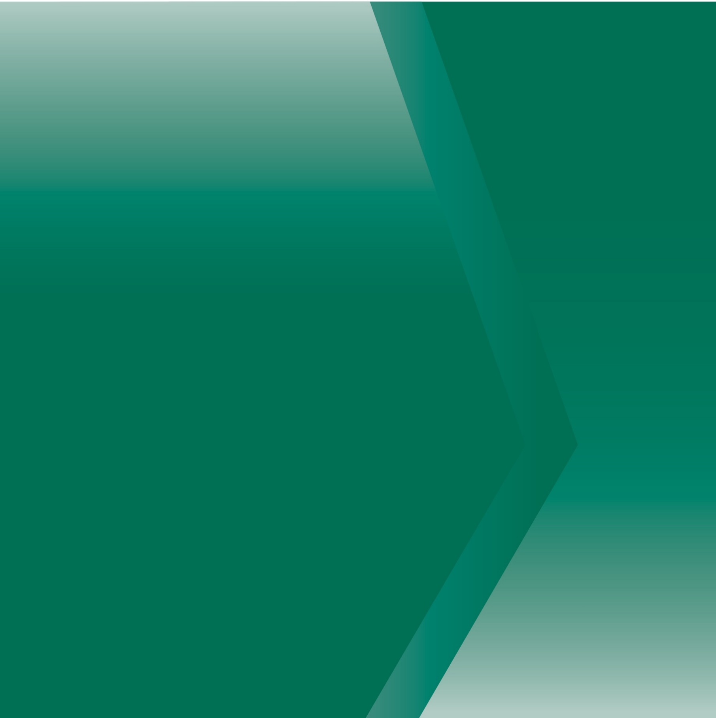

Disability and
Young People

Summary Report

A qualitative study

Copyright notice


This document, “A Lot of Judgement Stems from Stereotypes”: Young People’s Views on Australian Attitudes towards Disability, Summary Report June 2025, is licensed under the Creative Commons Attribution 4.0 BY-ND International License, with the exception of:
- Australia’s Disability Strategy 2021–2031 logo and branding
- Any third-party material
- All images and/or photographs
- Australian Commonwealth Coat of Arms: The terms under which the Coat of Arms can be used are detailed on the Department of the Prime Minister and Cabinet website: https://www.pmc.gov.au/honours-and-symbols/commonwealth-coat-arms
More information on this CC BY-ND 4.0 license is set out at the Creative Commons website: https://creativecommons.org/licenses/by-nd/4.0/legalcode.en

Accessibility:
Access Hub provides information about communication options (including the National Relay Service) for people who are d/Deaf, hard of hearing and/or have speech communication difficulty. For further information, go to https://www.accesshub.gov.au/
This Report is available online, in multiple accessible formats. For further information, go to Disability Gateway, https://www.disabilitygateway.gov.au/ads
Attribution:
Use of all or part of this document must include the following attribution: © Commonwealth of Australia (Department of Health, Disability and Ageing) 2025
Web links, telephone numbers and titles correct at the time of publication. They may have changed after publication
Suggested Citation:
Moore, T., Couch, J., Hussey, E., Esler, M., Hudson, L., Gay, M., & Trew, S. (2025). “A Lot of Judgement Stems from Stereotypes”: Young People’s Views on Australian Attitudes Towards Disability. Melbourne: Institute of Child Protection Studies, Australian Catholic University.

Web links, telephone numbers and titles correct at the time of publication. They may have changed after publication

ISBN 978-1-921975-23-3
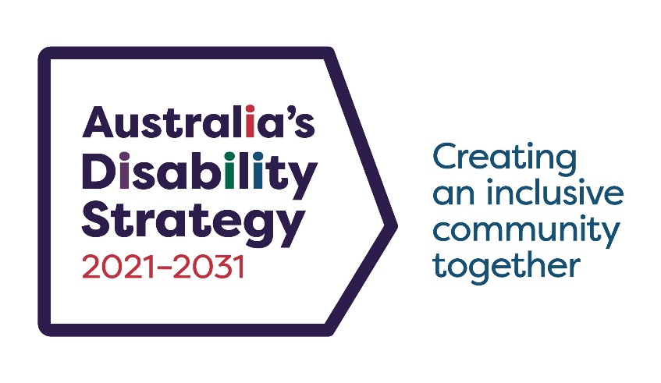

“A Lot of Judgement Stems from Stereotypes”:
Young People’s Views on Australian Attitudes towards Disability

Summary Report

Report for the Department of Health, Disability and Ageing

Tim Moore, Jen Couch, Emma Hussey, Marian Esler, Liz Hudson, Madeleine Gay & Sebastian Trew

2025

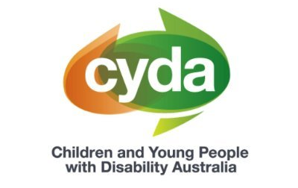

Introduction
This report looks at how young people perceive society’s attitudes towards disability in Australia. Focus groups were run with 39 young people with and without disability. The groups included people from culturally and linguistically diverse (CALD) backgrounds and carers. Young people in Australia shared how other people’s views shape their experiences in education, work, and their communities.
This study was run by researchers from the Institute of Child Protection Studies at the Australian Catholic University, Children and Young People with Disability Australia, and the Australian National University. The Australian Government Department of Health, Disability and Ageing paid for this study as part of the work for Australia’s Disability Strategy 2021-2031.

Attitudes towards disability
Young people told us society often views disability as a problem and focuses on what people can’t do rather than what they can do.
Young people described negative attitudes towards disability such as:
- incapacity
- dependence
- pity
- a problem to be fixed
- helplessness
- powerlessness.
Negative attitudes towards disability are often based on assumptions and a lack of understanding. For young people with disability, these negative attitudes can make it harder to take part in many areas of life, such as:
- education
- work
- social events.
Young people also described positive attitudes towards disability such as:
- strength
- independence
- resilience
- difference rather than deficit
- valued contributions
- pride.
Young people stressed that disability should be seen as just being different, not as something wrong or needing to be fixed.
Disability pride was noted as a good way of dealing with negative attitudes. Many young people with disability had a strong sense of pride in themselves and viewed their disability as part of who they are. This sense of pride is tied to their lived experiences, which made them strong, flexible and determined to overcome barriers. Young people with disability said that disability pride helps them embrace who they are and feel good about themselves.

Factors influencing attitudes
Young people identified important things which influence attitudes towards disability, including:
- Personal experience – People tend to be more accepting and inclusive when they have direct experience with people with disability.
- Upbringing – Children and young people learn attitudes and behaviours about disability from their family and community.
- School – Awareness, acceptance, and accommodation of disability in schools boosts positive attitudes towards disability.
- Where you live – Barriers may be more likely in regional and remote areas, although this depends on community exposure and awareness.
- Media – Public attitudes are often shaped by negative stereotypes shown in movies, TV shows and advertising.
- Social media – Attitudes can be changed through social media with positive role models, promoting awareness, acceptance and inclusion.

Impact of negative attitudes
Young people with disability face harmful attitudes that make them feel left out, worthless, and alone. These negative attitudes and experiences hurt their mental health and emotional wellbeing, often leading to anxiety, low self-worth, and depression.
Even though disability rights have improved, false assumptions about disability are still common, creating barriers for people with disability. Physical barriers also still exist. This makes it hard for people with disability to fully take part in society. People often wrongly think that people with disability are either fully independent or totally dependent on others. This can affect how society treats young people with disability and can hold them back in education, work, and social life.
In schools, students with disability may not reach their full potential when teachers expect less from them. Many schools and teachers lack proper training and resources to support students with disability. This can cause students to lose interest in learning, get lower grades, and feel left out.
Work also posed challenges, with some young people saying they don’t get the support they need and can miss chances at work. For example, negative attitudes of the general public can make it difficult for young people to keep their jobs.
Young carers also talked about the toll that caring could take, particularly when not supported. Some young people had caring roles which made it hard to go to school or university and to spend time with friends. Young carers at school often felt alone because teachers and classmates didn’t know about or understand their caring responsibilities.

Changing attitudes
Young people in the study had good ideas about how to change negative attitudes and make people feel more welcome. They believed working together with people with disability, their families and carers would make awareness campaigns better.
Teachers, staff and students need training to improve attitudes in schools. This training should include how to support people with disability, and how to understand and respect them. Schools should also teach about disability as a normal part of human diversity. Workplaces also need to improve how they think about disability. Training workers is important for making long-term positive changes. This training should be for people in all kinds of jobs, but especially in health and transport.
Young people with disability find it helpful to connect with others who have similar experiences. Being with peers who understand them helps them feel accepted.

Media and social media
Social media sites like Instagram and TikTok reach large audiences of younger people. This provides a chance to use these sites to question negative views of disability. Social media campaigns can show real stories from people with disability. These campaigns can focus on people with disability's successes, struggles, and everyday lives. When real people share their own stories, it helps others see them as capable individuals rather than feel sorry for them. It was seen as important to create different campaigns for different cultures and regions to improve awareness and attitudes towards disability.
Social media also helps young people with disability to connect with others, share their experiences, and support each other. It also helps change how society thinks about disability and creates a more welcoming community.

Support services
It is harder for people with disability to take part in education, work, and social activities when supports do not meet their daily needs. Disability services, including the National Disability Insurance Scheme (NDIS), need to be more accessible and flexible. Improving these services would allow people with disability to spend less time dealing with processes and more time living their life. Support services should extend to families and carers of young people with disability.

Recommendations for change
Ways to make things better for young people with disability include:
- moving to a view that society should change to include everyone (social model of disability), instead of trying to fix people with disability
- increasing disability awareness through campaigns, particularly using social media to reach younger people and challenge stereotypes
- building peer support networks and more accessible community spaces for young people with disability and their families to connect, make friends and get helpful guidance
- adapting schools, universities and workplaces to suit different needs of young people with disability
- making systems like the NDIS work to meet the needs of young people with disability.

Conclusion
This study shows we need to change how Australians view and include young people with disability. While there have been some improvements, these young people still face many barriers. To create real change, we need to:
- make society more welcoming
- improve how schools, universities and workplaces understand disability
- show more people with disability in the media.
These changes will help all young people to be treated fairly and with respect and to achieve their goals.

