Australia’s Disability Strategy 2021 to 2031

Targeted Action Plans Report

2025
New South Wales update
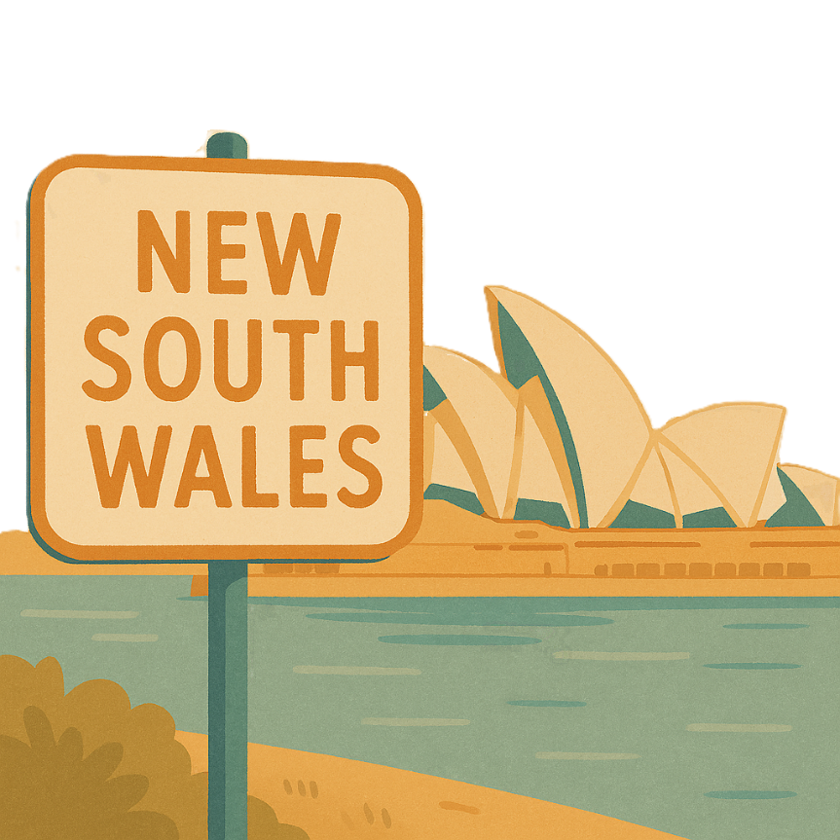
 | The Australian Government Department of Health Disability and Ageing wrote this.  We say DHDA for short.  When you see the word we it means DHDA.
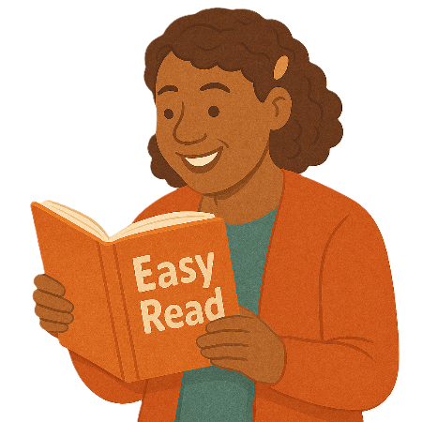 | We wrote this in an easy to read way.  We use pictures to explain some ideas.
 | We have some words in bold.  This means the letters are thicker and darker.  These are important words.
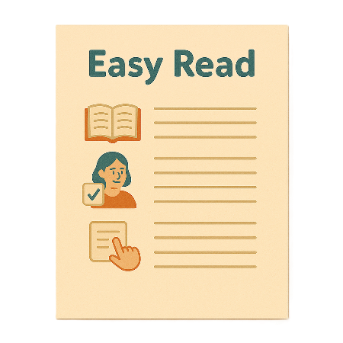 | This is an Easy Read summary of another document.  This means it has the most important ideas.
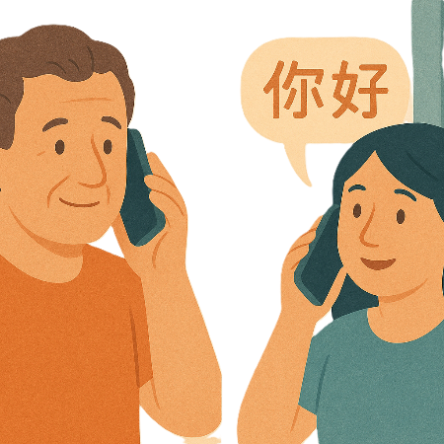 | If you speak a language other than English  - Call Translating and Interpreting Services.  1800 131 450
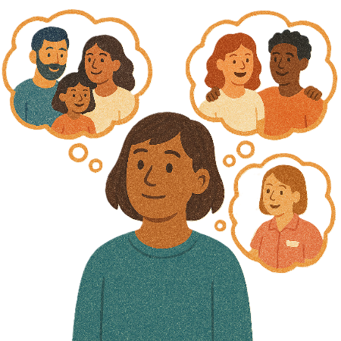 | You can ask for help to read this document.  You can ask  - A friend  - Family members  - A support person.
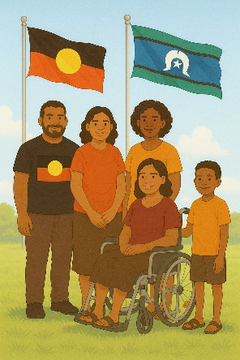 | We recognise Aboriginal and Torres Strait Islander people as the Traditional Owners of the land we live on.
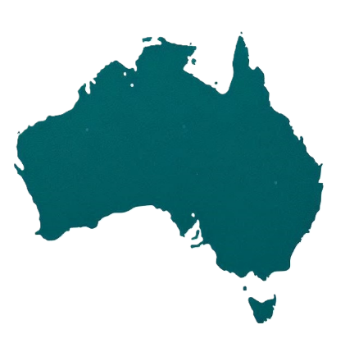 | They were the first people to live on and use the  - Land  - Waters.

Contents

About this document | 5
Australia’s Disability Strategy | 8
What are Targeted Action Plans | 9
New South Wales update | 11
Community Attitudes TAP | 13
Inclusive Homes and Communities TAP | 17
Safety Rights and Justice TAP | 21

About this document

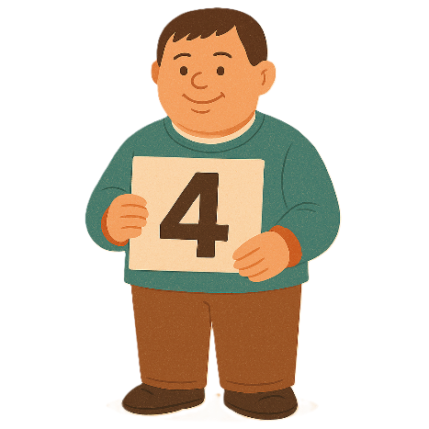 | This document has 4 parts
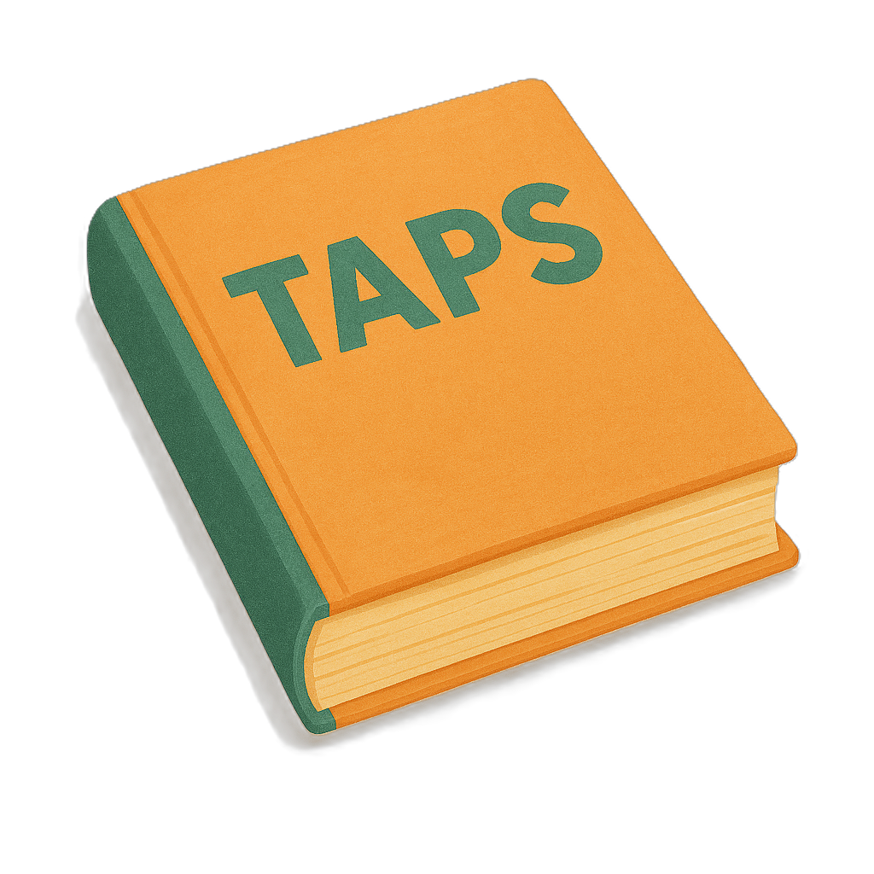 | Part 1 talks about  - What are Targeted Action Plans  We call them TAPs for short.
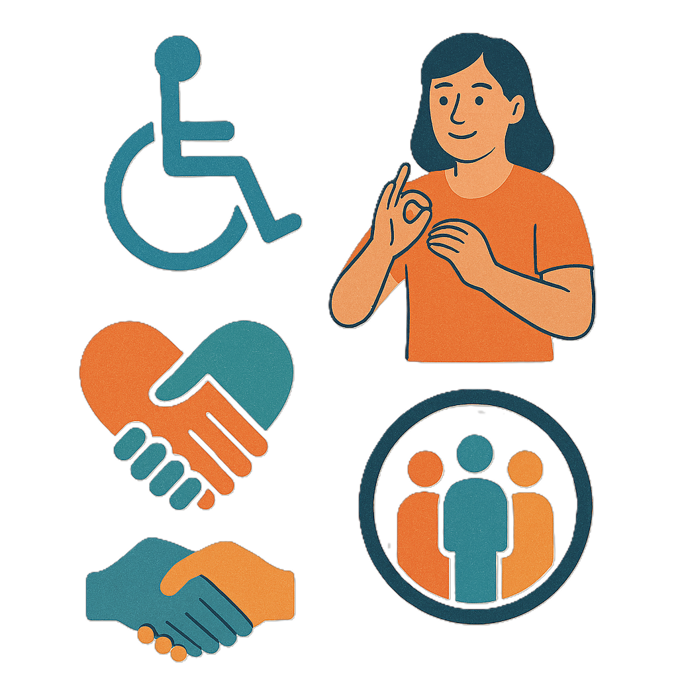 | Part 2 talks about  - Community Attitudes TAP
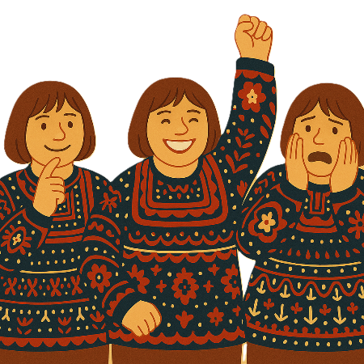 | Attitudes are what people  - Think  - Feel  - Believe.
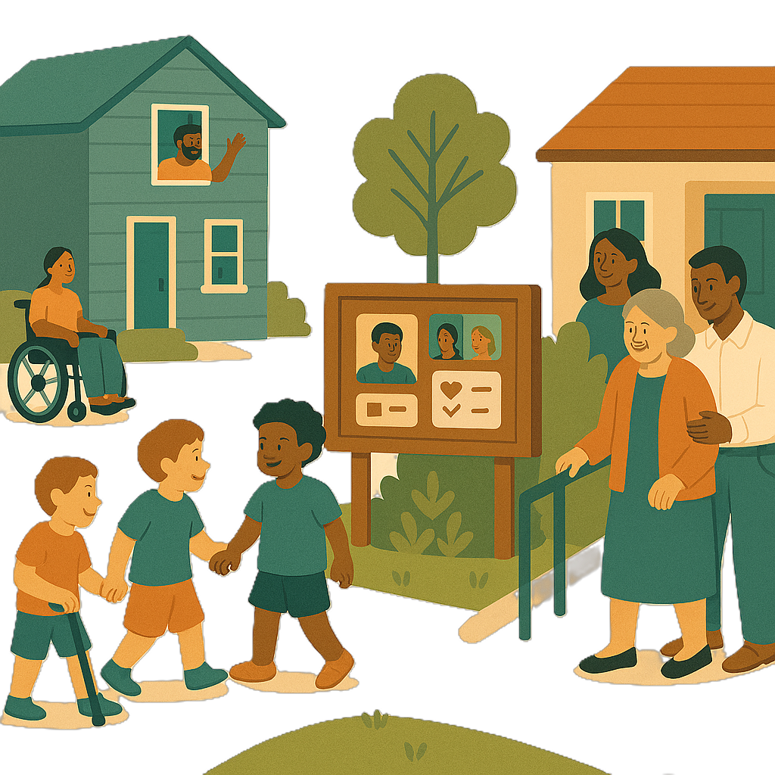 | Part 3 talks about  - Inclusive Homes and Communities TAP
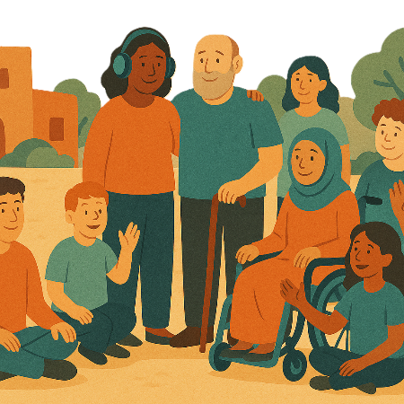 | Inclusive is when everyone  - Can take part  - Feel like they belong.
Part 4 talks about

- Safety Rights and Justice TAP

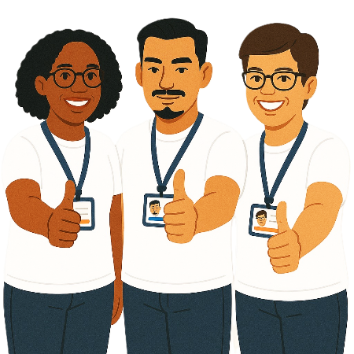 | Rights are rules about treating everyone  - Fair  - Equal.
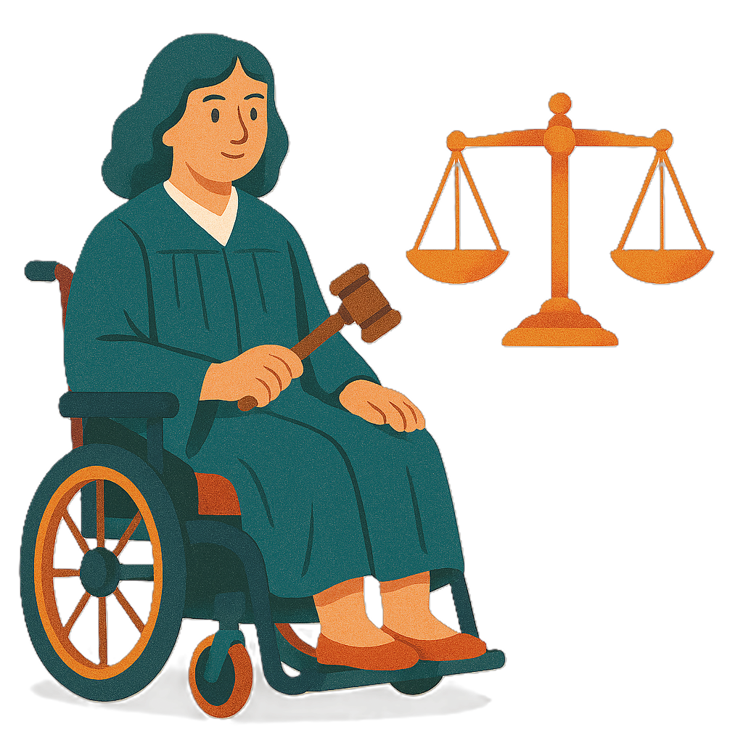 | Justice is  - The law  - Police  - The courts  - Prisons.  Laws are rules for how we live.
 | You can go to our website to read the updates from other states and territories.  www.disabilitygateway.gov.au/ads/easy-read-strategy  It is in Easy Read.

Australia’s Disability Strategy

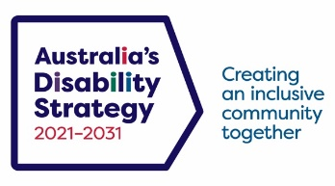 | The government set up Australia’s Disability Strategy.  We call it the Strategy for short.  It was also called ADS.
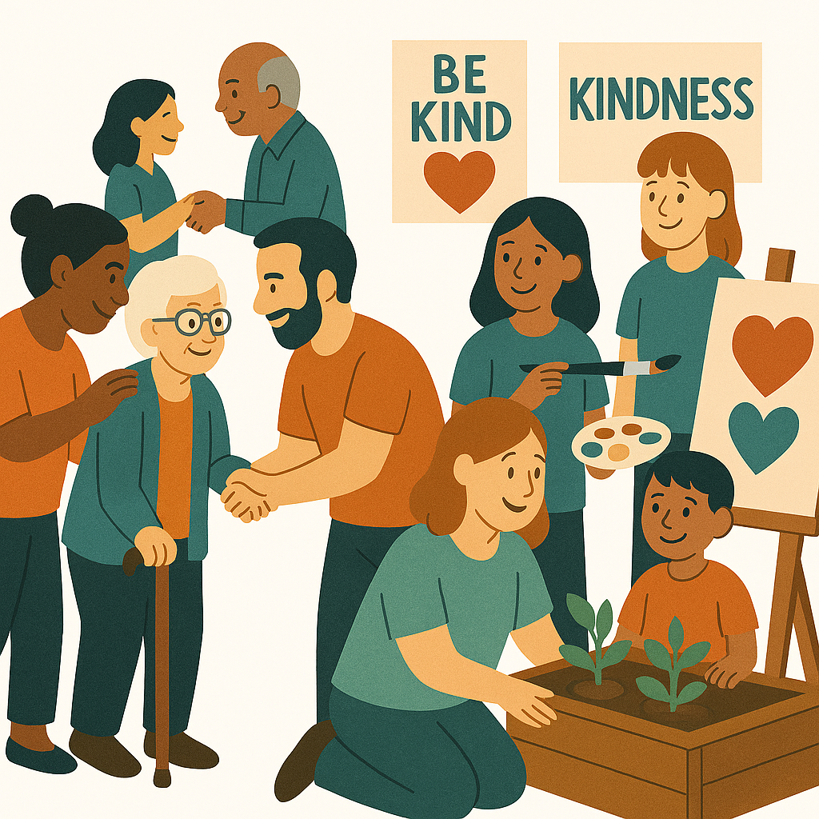 | The Strategy is the governments way of working together to support people with disability to live good lives.  They do this by working with  - People with disability  - The community.  This makes the community a more welcoming place for everyone.

What are Targeted Action Plans

We made small plans to help us work on the Strategy.

The small plans are called TAPs.
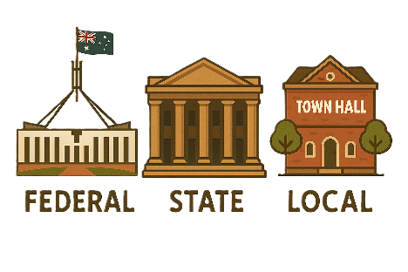 | TAPs are made by all governments in Australia.  All governments include  - Australian Government  - State and territory governments  - Local governments.
There are 3 TAPs.

- Community Attitudes
 | - Inclusive Homes and Communities
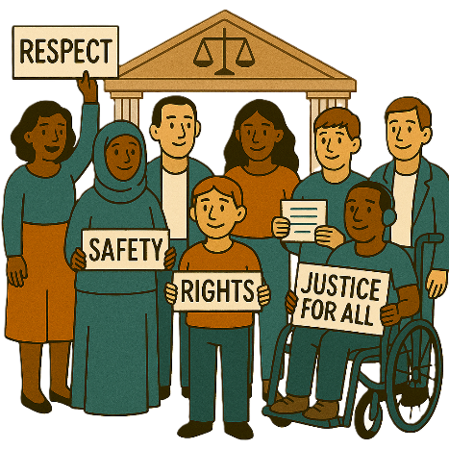 | - Safety Rights and Justice

New South Wales update

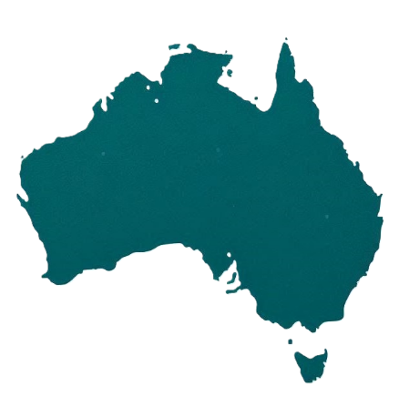 | Each state and territory government have made their own actions.  This makes sure that they meet the needs of their communities.  Actions are the things that we will do.
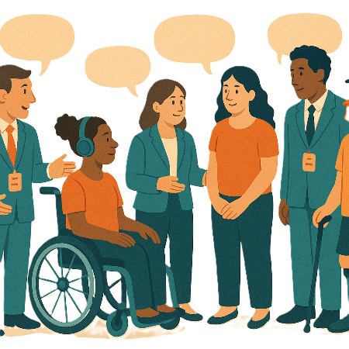 | Each government says how the actions will include  - People with disability
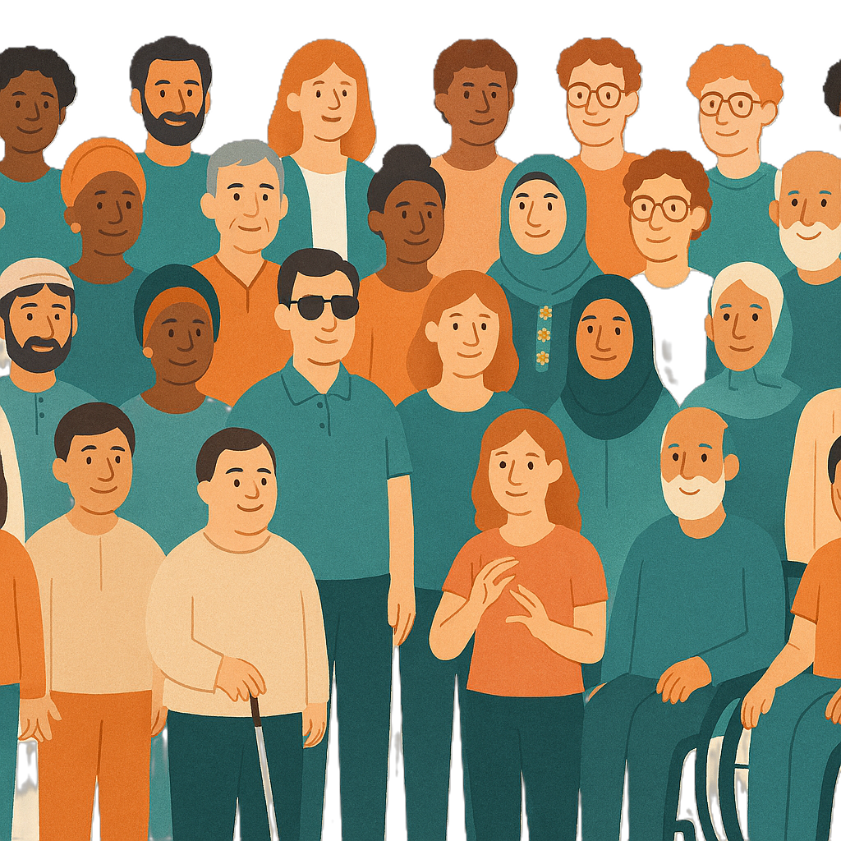 | - The disability community.
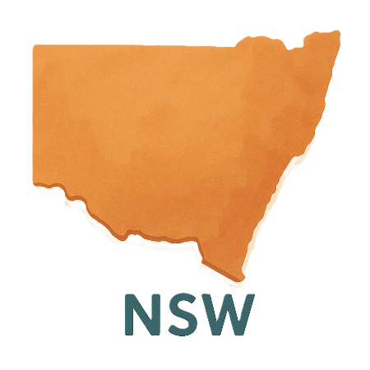 | This document talks about some actions New South Wales is doing in the 3 TAPs.  We call them NSW for short.

Community Attitudes TAP

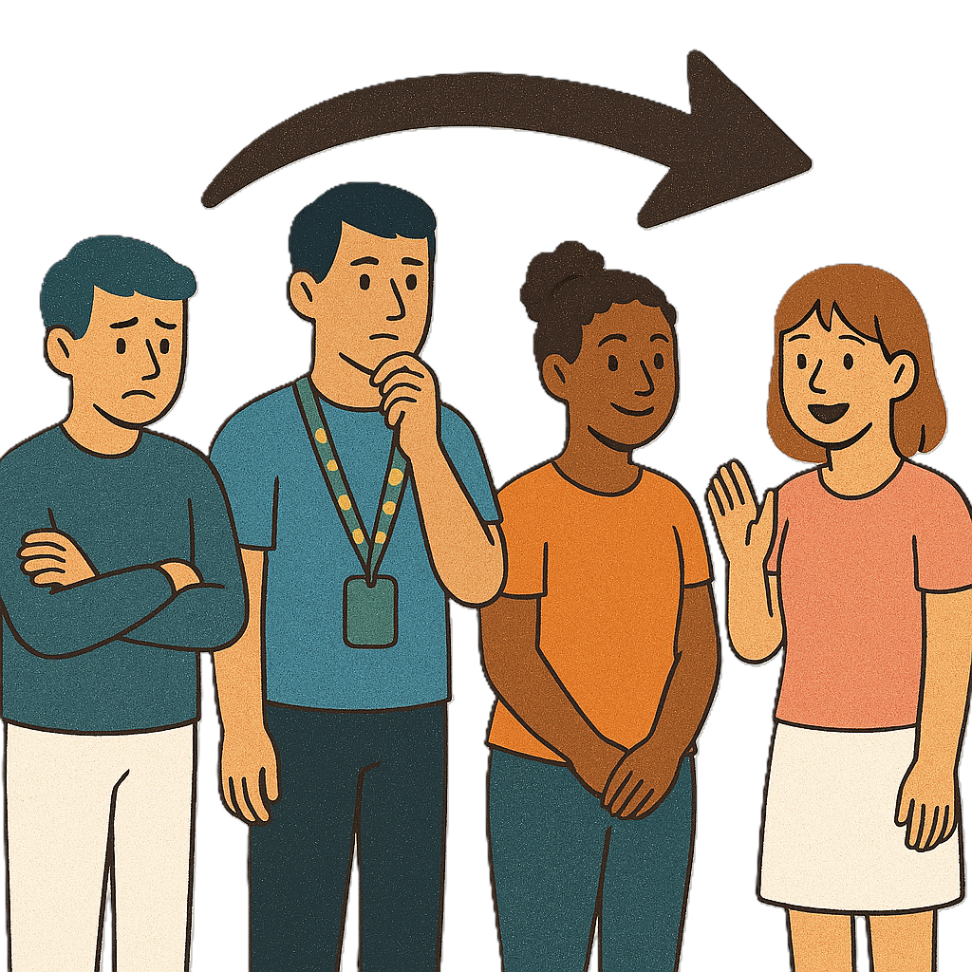 | This TAP wants to change  - How people behave  Behave means  - How you act  - What you do.
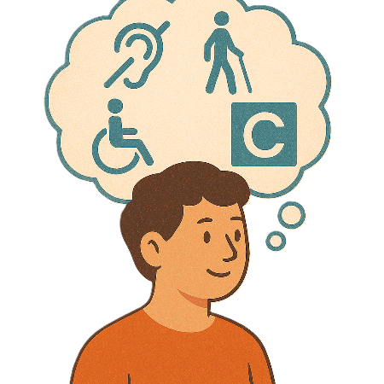 | What people think about disability.
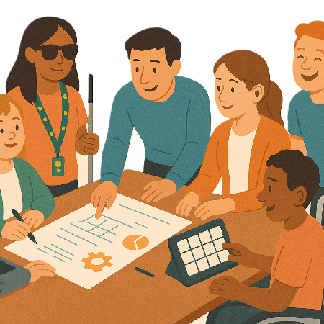 | The NSW Ageing and Disability Commission is working with  - National Centre of Excellence in Intellectual Disability Health.  We call it ADC for short.  They are doing a project together.
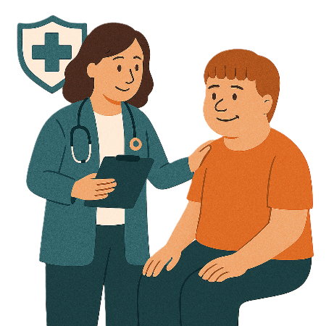 | They want to improve preventative health care for people with intellectual disability.
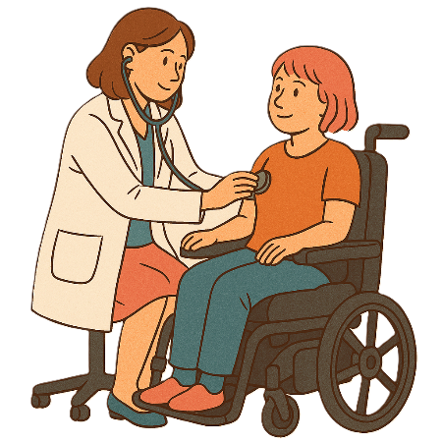 | Preventative health care means looking after your health before you get sick.  It can be things like  - Getting a check up  - Going to the dentist to check your teeth  - Getting tests done.  It helps keep your body healthy.
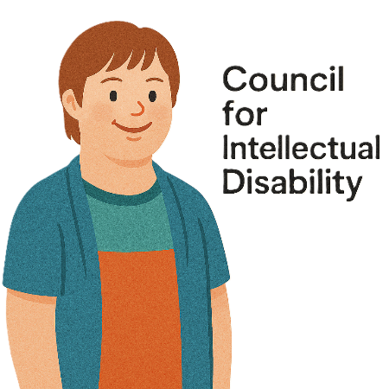 | Other people are involved in the project are  - Council for Intellectual Disability  We call it CID for short.
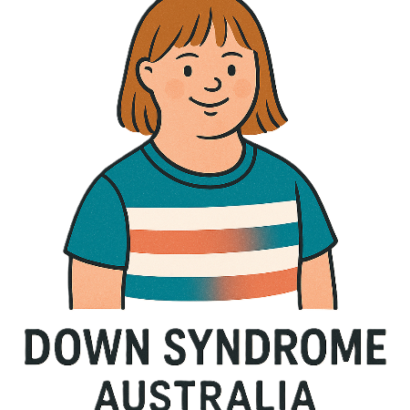 | - Down Syndrome Australia
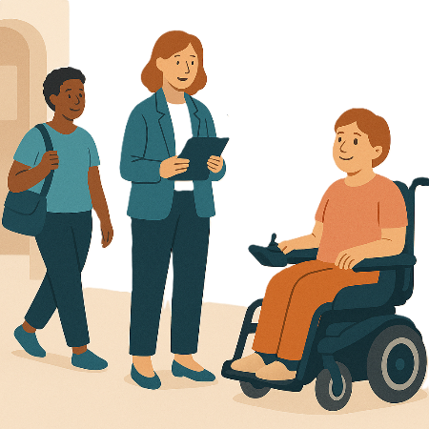 | - Central and Eastern Primary Health Network.
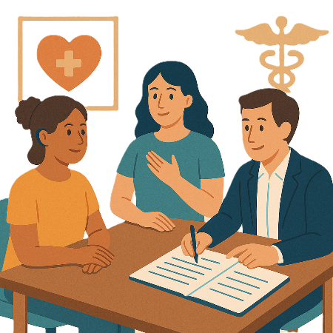 | The project wants people to share their experience with  - Health planning
 | - Preventative health care.
You can go to the website to read more about the project.

nceidh.org.au/our-work/projects/improving-preventive-healthcare

It is in Easy Read.

Inclusive Homes and Communities TAP

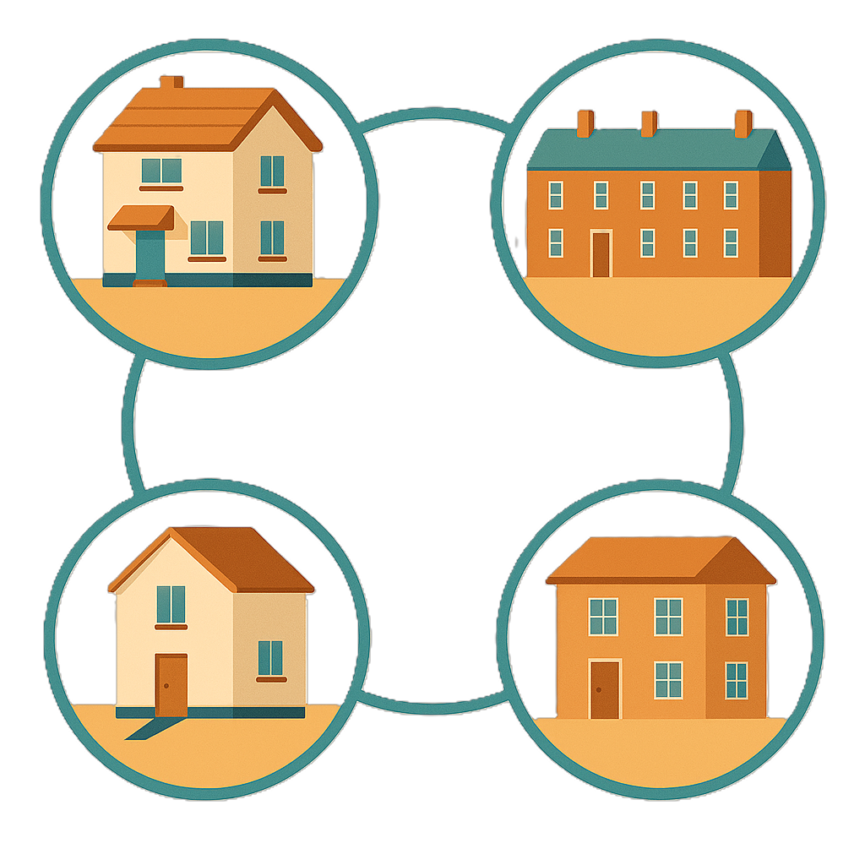 | This TAP wants to make  - Homes
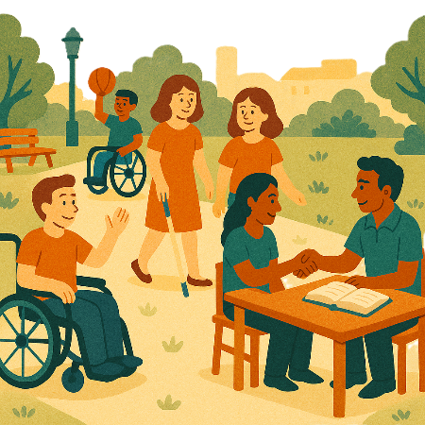 | - The community  Easier to access.
 | We also want them to be more welcoming.
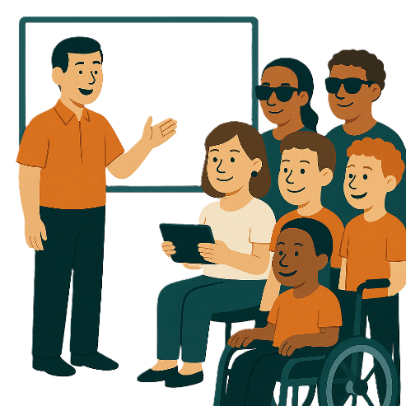 | The NSW government is working on a new technology forum.  We call it a forum for short.  A forum is a meeting to talk about a problem.
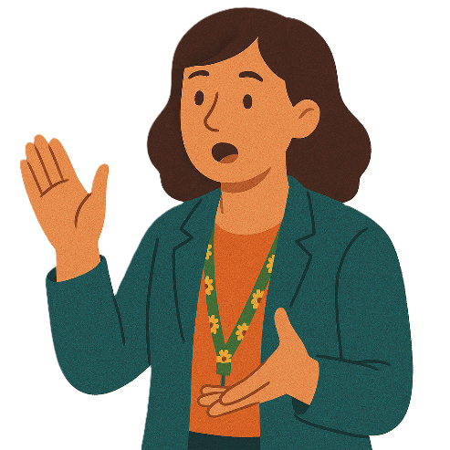 | A forum is a place where people can  - Talk  - Share ideas  - Ask questions
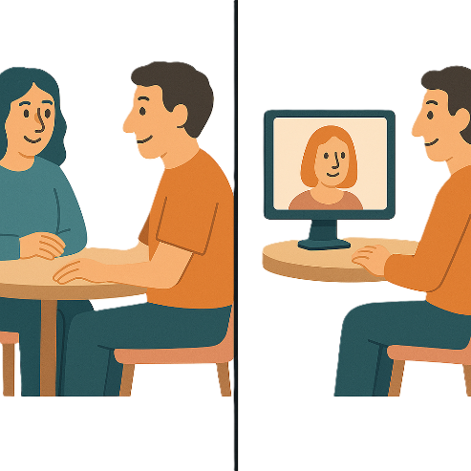 | The meeting can be  - In person  - Online.
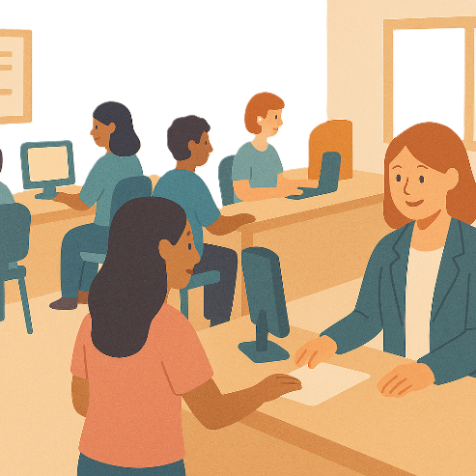 | There are 2 Departments working on the new technology forum.  They are  - NSW Department of Customer Service
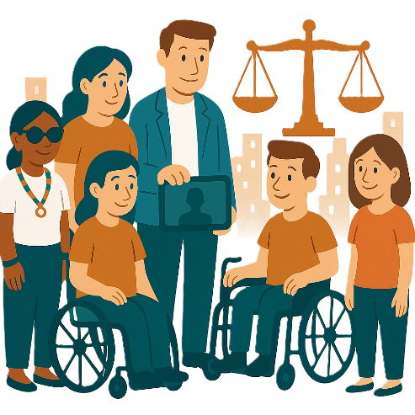 | - Department of Communities and Justice.
 | They will look at new ways technology can help like  - Artificial Intelligence  Artificial intelligence is when computers are able to think and learn like people.  This could be things like writing an email for us.  We call it AI for short.
 | - Telecommunications  Telecommunications are things like  - The internet  - Phones  - Radio  - TV.
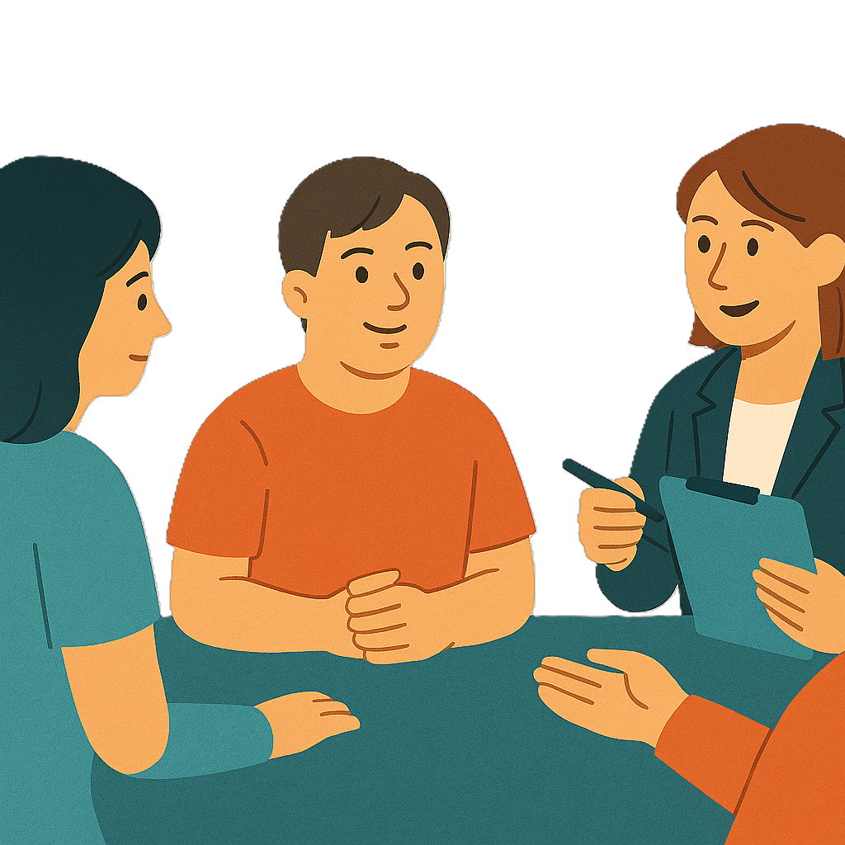 | They will also support people with disability to  - Use government services
 | - Take part in the community safely.

Safety Rights and Justice TAP

 | This TAP wants to make sure people with disability are  - Safe  - Treated fairly.
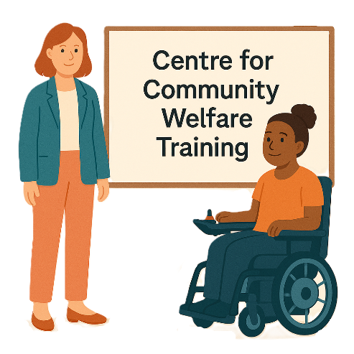 | The NSW government is working with the Centre for Community Welfare Training.  We call them CCWT for short.
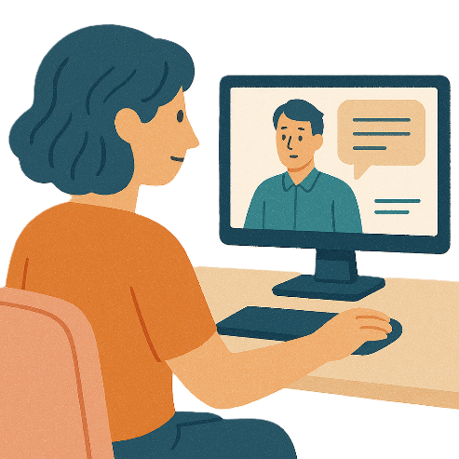 | They ran free webinars in 2025.  The webinars are called Effective Interventions and Coercive Control.  A webinar is when you watch someone on your computer talk about something.
 | Effective is when something is working well.
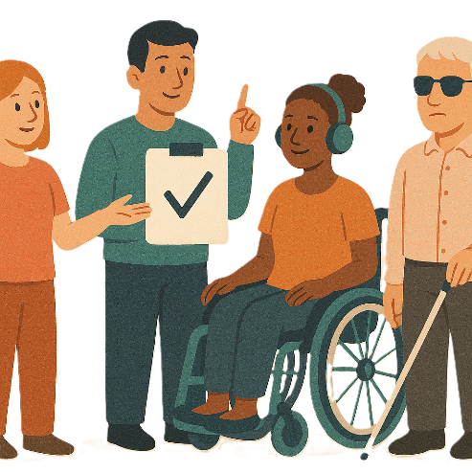 | Interventions are different things to change to make things better.
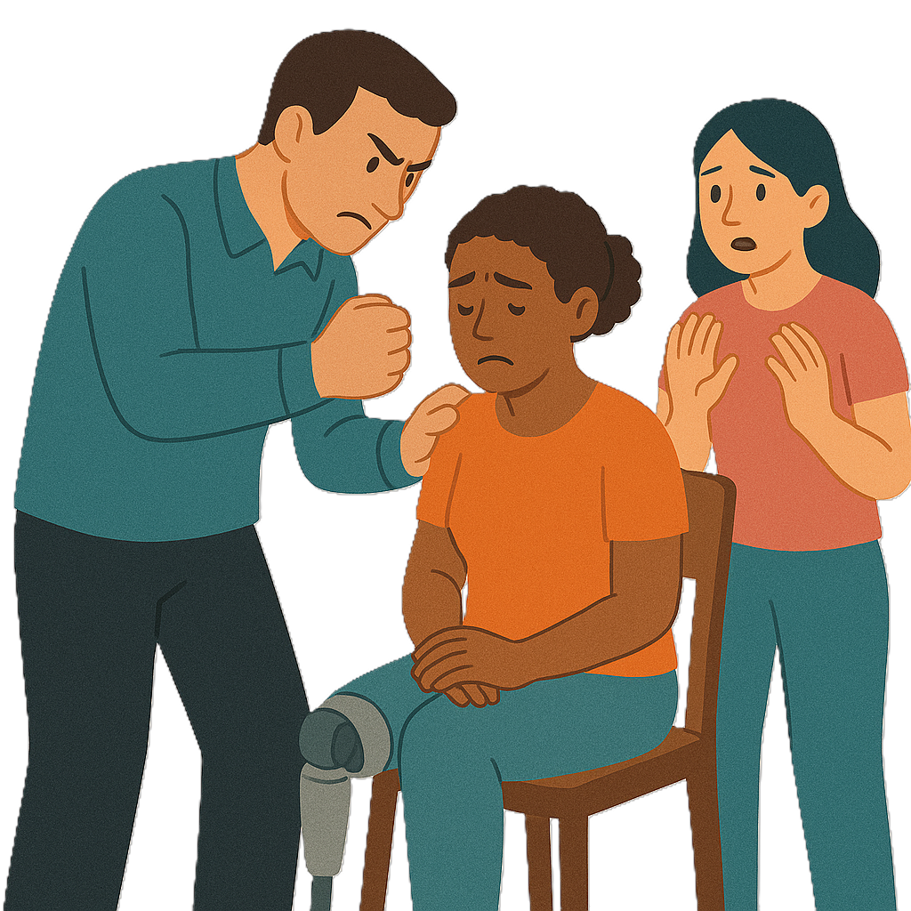 | Coercive control is a type of abuse.  Abuse is when someone treats you badly.
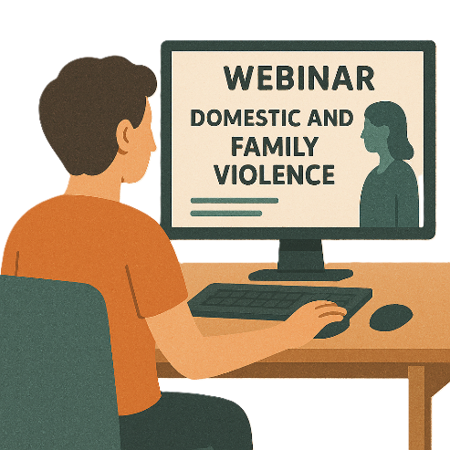 | The webinars are for people working in domestic and family violence.
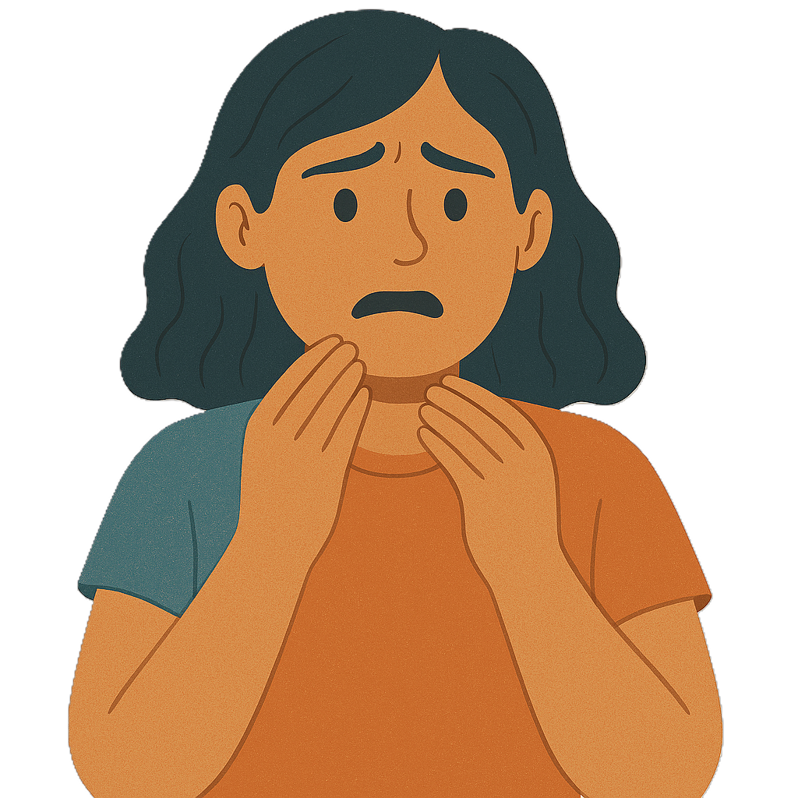 | Family violence is when someone in your family  - Hurts you  - Makes you feel scared.  It can happen between  - Partners  - Parents and children  - Brothers and sisters  - Carers and the people they care for.  It can also be called domestic violence.
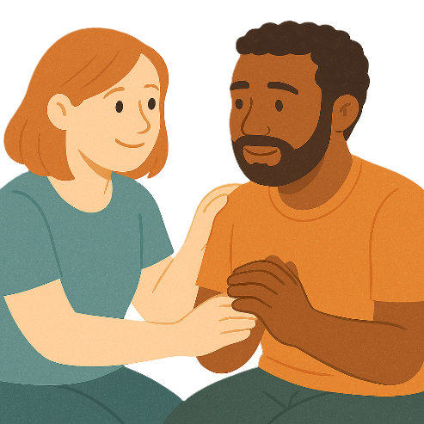 | The NSW government wants the webinars to help workers understand coercive control.
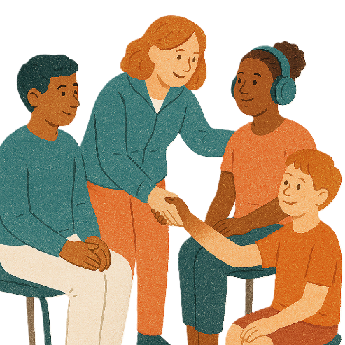 | This will help workers be able to help people with disability.

Images in this Easy Read must not be used or copied without permission

