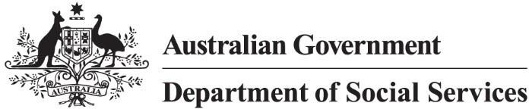

Targeted Action Plans 2025 to 2027
Community Attitudes

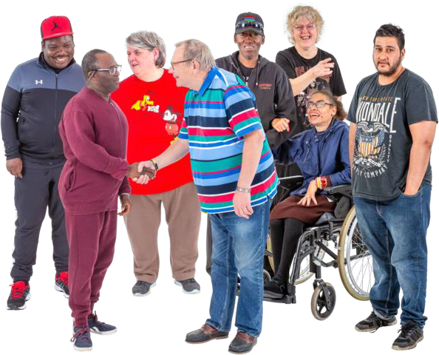

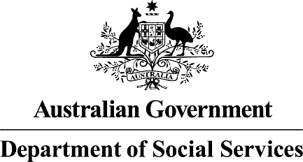 | The Australian Government Department of Social Services wrote this.  We say DSS for short.  When you see the word we it means the DSS.
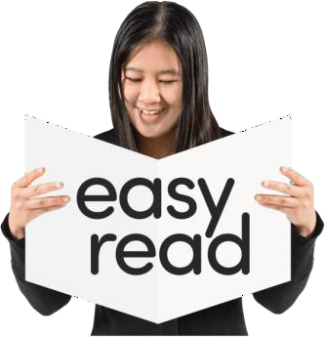 | We wrote this in an easy to read way. We use pictures to explain some ideas.
 | We have some words in bold.  This means the letters are thicker and darker.  These are important words.
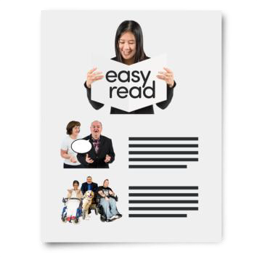 | This is an Easy Read summary of another document.  This means it has the most important ideas.

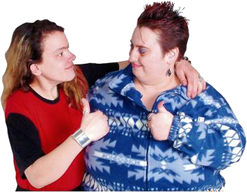 | You can ask for help to read this document. You can ask  - A friend  - Family members  - A support person.
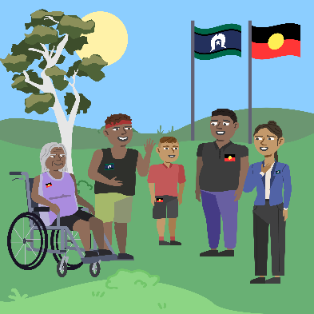 | We recognise Aboriginal and Torres Strait Islander people as the Traditional Owners of the land we live on.
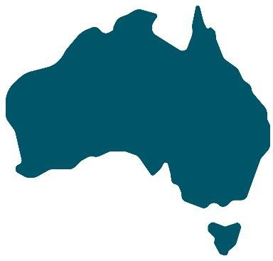 | They were the first people to live on and use the  - Land  - Waters.

Contents

What are TAPs | 5
Better community attitudes | 8
Why this TAP | 9
What will the TAP do | 10
Who will this TAP support | 11
Including people with disability | 12
Reports | 14

What are TAPs

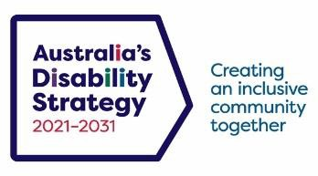 | The government set up Australia’s Disability Strategy.  We call it ADS for short.
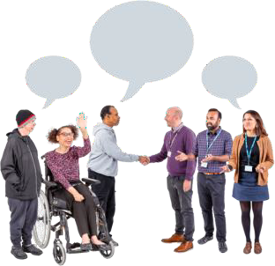 | ADS is the governments way of working  together to support people with disability to live good lives.  They do this by working with  - People with disability  - The community  This makes the community a more welcoming place for everyone.
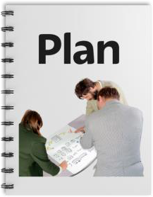 | To make it easier to work on ADS we make lots of small plans.  These small plans are part of the bigger ADS.

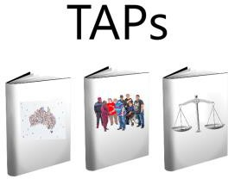 | The small plans are called Targeted Action Plans.  We call them TAPs for short.
  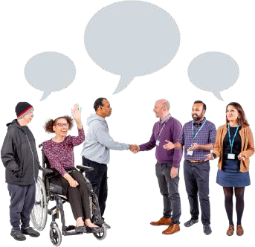 | All governments will work together to do TAPs. All governments include  - Australian Government  - State and territory governments  - Local Government.
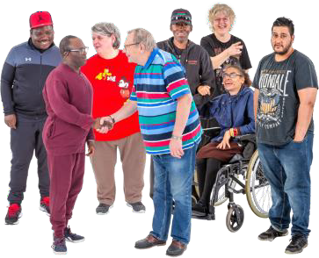   | A new TAP called community attitudes was made this year.  Attitudes are what people  - Think  - Feel  - Believe.

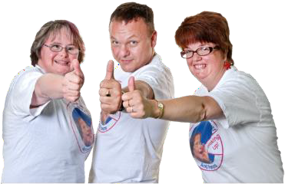 | We wrote this TAP so the community will  - Think  - Feel  - Believe  Good things about people with disability.
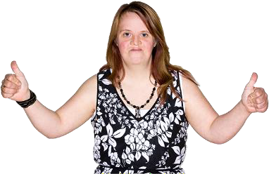 | This will help people with disability  - Live good lives  - Be treated equal  - Be part of the community.

Better community attitudes

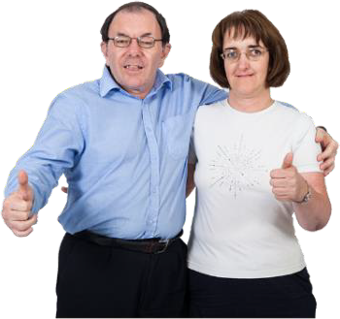 | Better community attitudes will help people with disability live safe and happy lives.
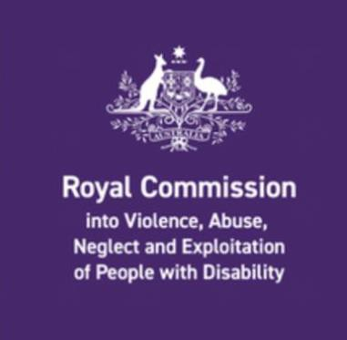 | The Disability Royal Commission looked at how people with disability have been treated.  We call it DRC for short.
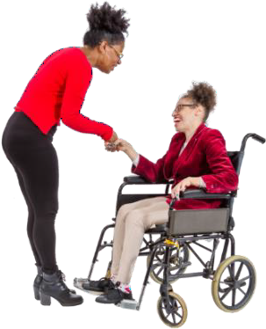 | People with disability told the DRC they wanted  - To live better lives  - Be treated better.  This is very important for everyone including people with disability.
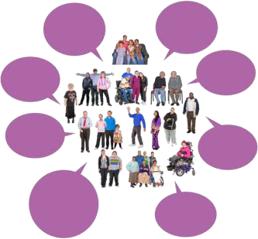 | We listened to what people with disability said to the DRC.  We wrote the community attitudes TAP.

Why this TAP

 | This TAP will make Australia a better place for people with disability.  It will make sure people with disability are
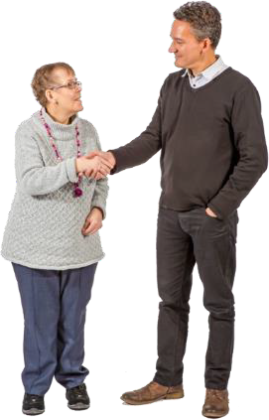 | - Respected  - Treated as equal
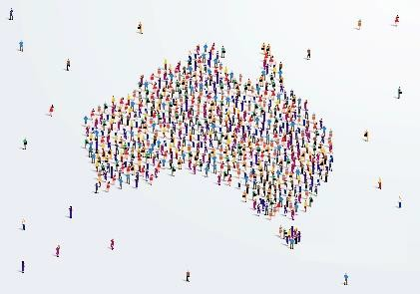 | - Know they belong  - Can take part in the community
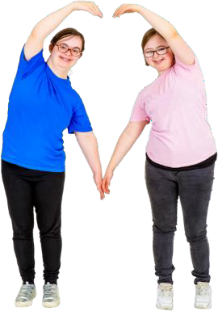 | - Live good lives.

What this TAP will do

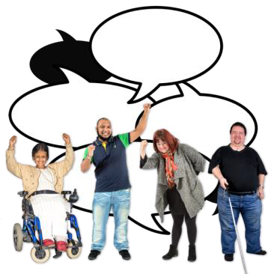 | This TAP will  - Make sure more people with disability become leaders
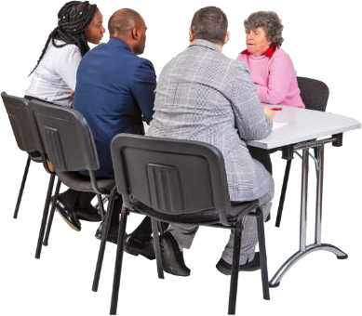 | - Help employers understand what good workers people with disability are.  An employer is someone who pays someone to do work for them.
 | - Help the community to know and feel good about supporting people with disability.
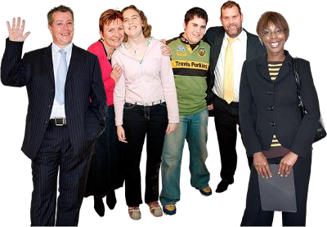 | - Help the community have better  attitudes about people with disability.

Who will this TAP support

  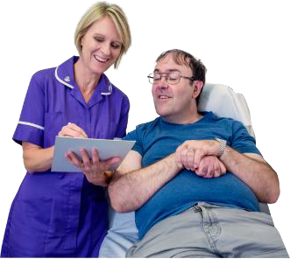 | This TAP will support people from the community to work with people with disability.  Like  - Doctors  - Nurses
 | - Teachers
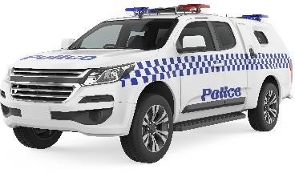  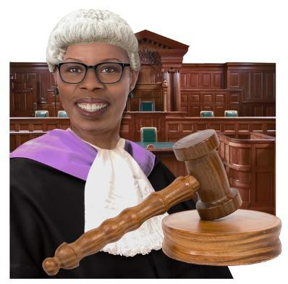 | - The police  - The law  - Courts  - Prisons.

Including people with disability

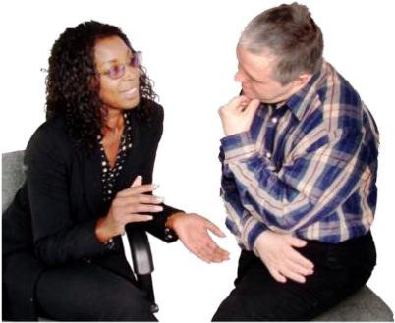 | The government wants to make sure people with disability are heard.
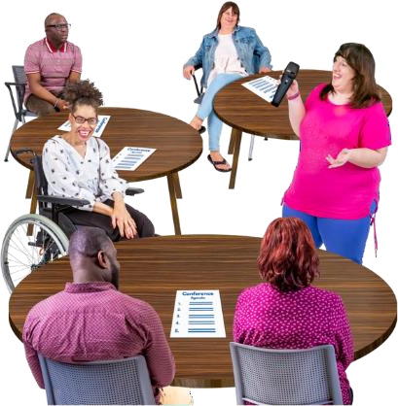 | They will work with local disability groups to do what TAPs say.
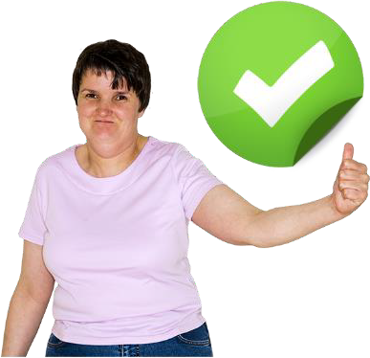 | This will make sure that governments do everything they say they will in TAPs.
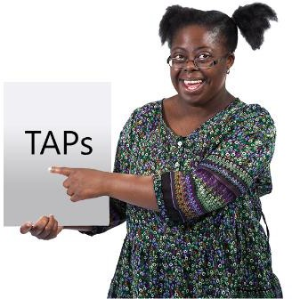 | It will also help people with disability keep being involved in TAPs.

 | You can go to our website to look at this TAP.  www.disabilitygateway.gov.au/ads/strategy

Reports

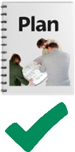 | We have a plan to check how we are going with TAPs.
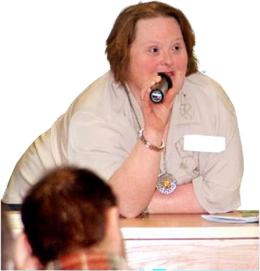 | We will give updates as we go.
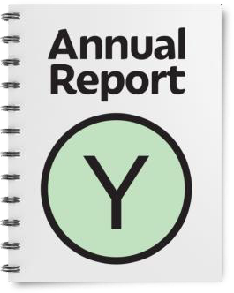 | We will write a report every year.  It will be ready by the end of December.
 | We have done lots of other work. You can look at it on our website.  www.disabilitygateway.gov.au



easyread.tech created these original illustrations. Please do not use these illustrations without permission. Visit easyread.tech for more information.

