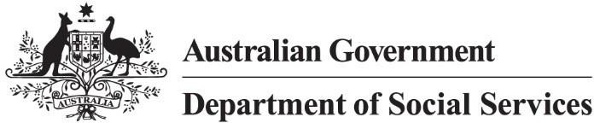

Targeted Action Plans 2025 to 2027
Inclusive Homes and Communities

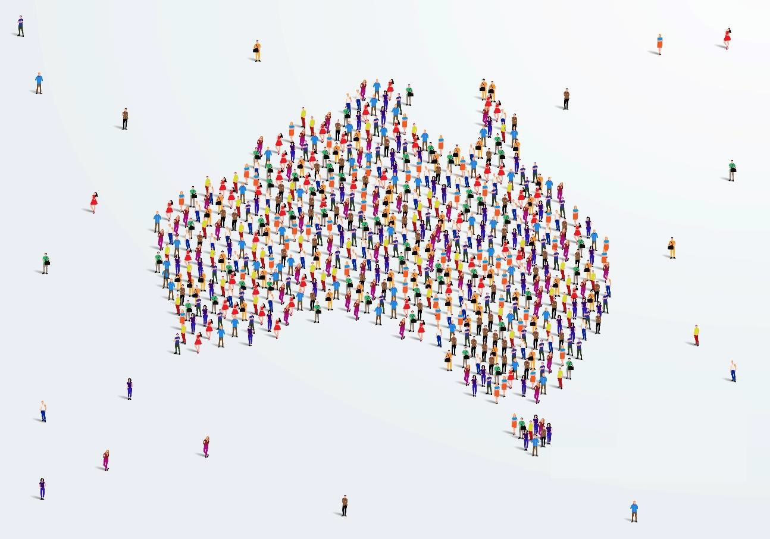

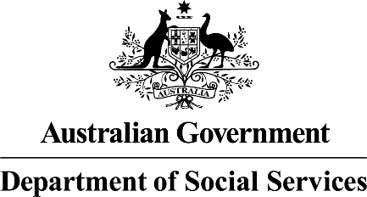 | The Australian Government Department of Social Services wrote this.  We say DSS for short.  When you see the word we it means the DSS.
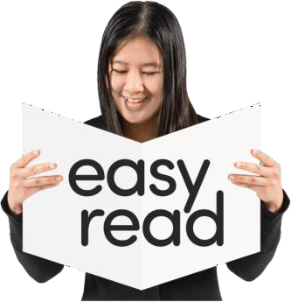 | We wrote this in an easy to read way. We use pictures to explain some ideas.
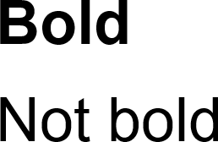 | We have some words in bold.  This means the letters are thicker and darker.  These are important words.
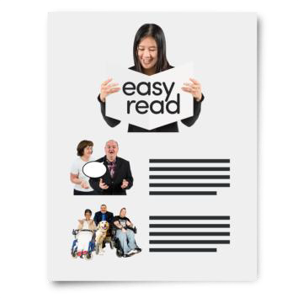 | This is an Easy Read summary of another document.  This means it has the most important ideas.

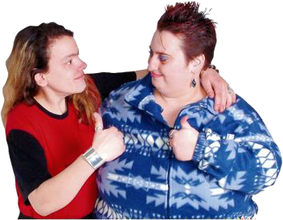 | You can ask for help to read this document. You can ask  - A friend  - Family members  - A support person.
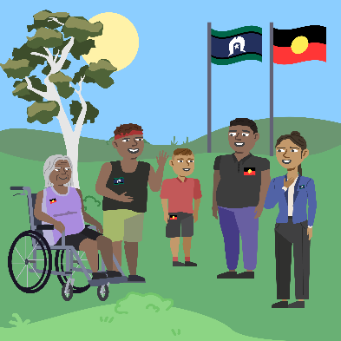 | We recognise Aboriginal and Torres Strait Islander people as the Traditional Owners of the land we live on.
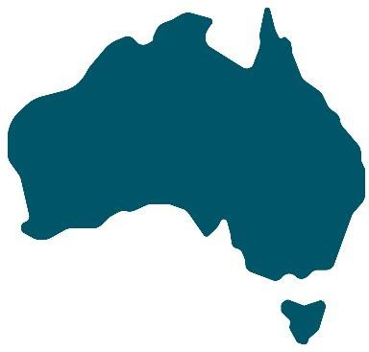 | They were the first people to live on and use the  - Land  - Waters.

Contents

What are TAPs | 5
Inclusive Homes and Communities | 7
Why this TAP | 9
What this TAP will do | 10
Including people with disability | 11
Reports | 13

What are TAPs

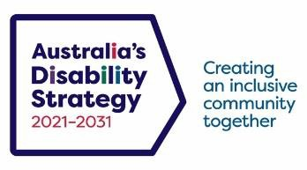 | The government set up Australia’s Disability Strategy.  We call it ADS for short.
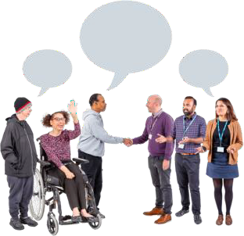 | ADS is the governments way of working  together to support people with disability to live good lives.  They do this by working with  - People with disability  - The community  This makes the community a more welcoming place for everyone.
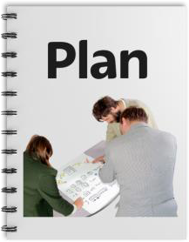 | To make it easier to work on ADS we make lots of small plans.  These small plans are part of the bigger ADS.

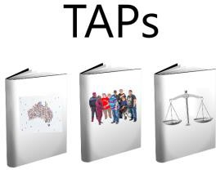 | The small plans are called Targeted Action Plans.  We call them TAPs for short.
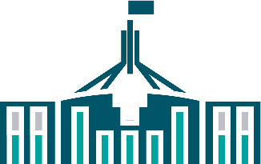  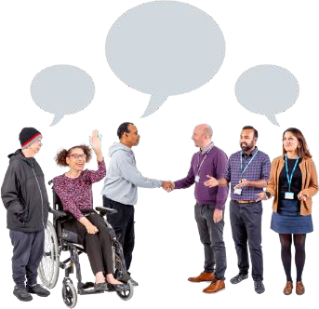 | All governments will work together to do TAPs. All governments include  - Australian Government  - State and territory governments  - Local Government.
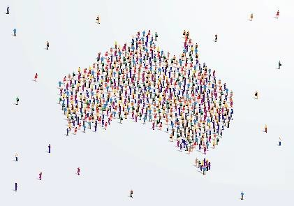 | A new TAP called inclusive homes and communities was made this year.  Inclusive is when everyone  - Can take part  - Feel like they belong.

Inclusive Homes and Communities

 | Inclusive homes and communities will help people with disability live good lives.
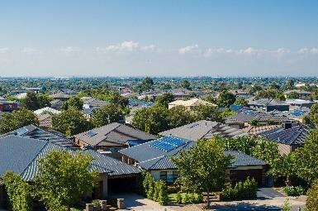 | People with disability told the government that housing was important to them.  This helps us know how we can support people with disability better.
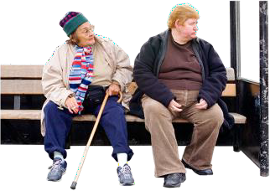  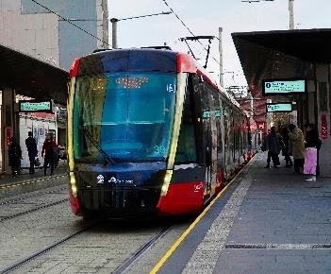 | People with disability told us that transport  systems need to be better.  Transport helps us move around the community.  It could be using a  - Bus  - Car  - Train.

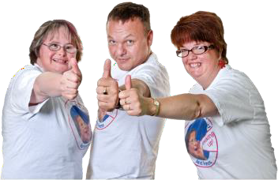 | This means that more people with disability can take part in the community.
People with disability told the government they wanted communities to have accessible
environments.
The environment is areas around people. Accessible means everyone can use it.

Why this TAP

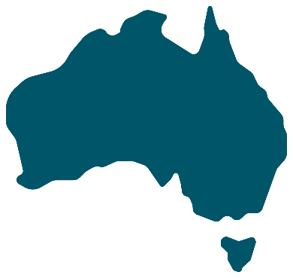 | This TAP will make Australia a better place for people with disability.  It will make sure people with disability are
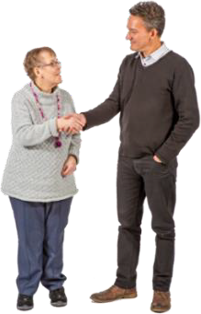 | - Respected  - Treated as equal
- Know they belong

- Can take part in the community
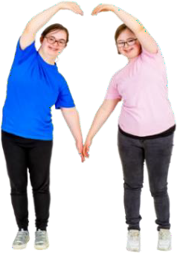 | - Live good lives
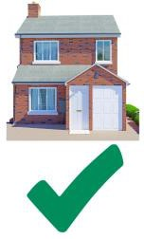 | - Have good homes.

What this TAP will do

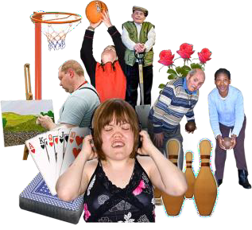 | This TAP will  - Make sure people with disability can take part in the community
- Help communities have accessible environments

The environment is areas around people.

Accessible means everyone can use it.
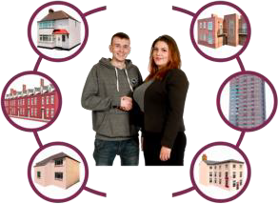 | - Help people with disability make choices about their homes  - Make more homes accessible
 | - Make sure the whole community can use transport systems.

Including people with disability

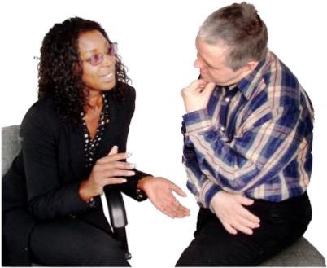 | The government wants to make sure people with disability are heard.
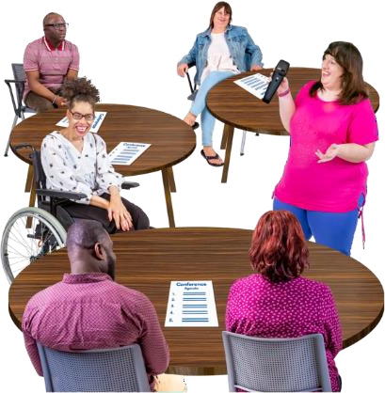 | They will work with local disability groups to do what TAPs say.
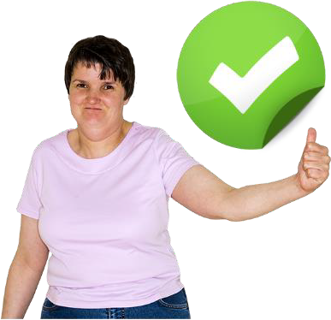 | This will make sure governments do everything they say they will in TAPs.

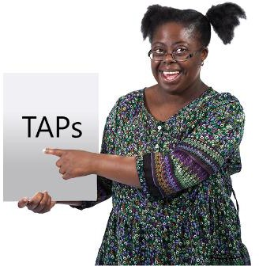 | It will also help people with disability keep being involved in TAPs.
 | You can go to our website to look at this TAP.  www.disabilitygateway.gov.au/ads/strategy

Reports

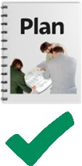 | We have a plan to check how we are going with TAPs.
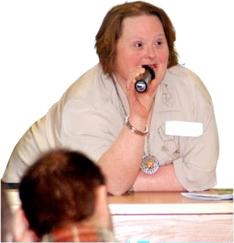 | We will give updates as we go.
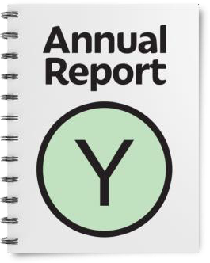 | We will write a report every year.  It will be ready by the end of December.
 | We have done lots of other work. You can look at it on our website.  www.disabilitygateway.gov.au


easyread.tech created these original illustrations. Please do not use these illustrations without permission. Visit easyread.tech for more information.

