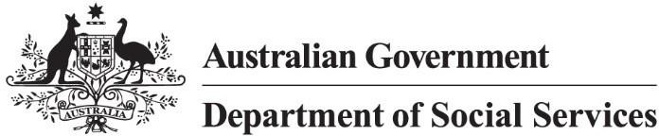

Targeted Action Plans
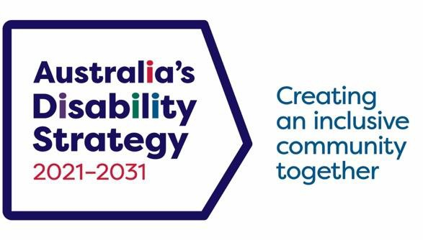
Overview 2025 to 2027

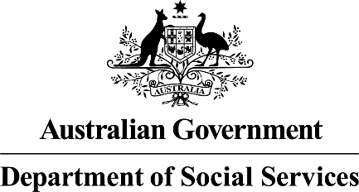 | The Australian Government Department of Social Services wrote this.  We say DSS for short  When you see the word we it means the DSS.
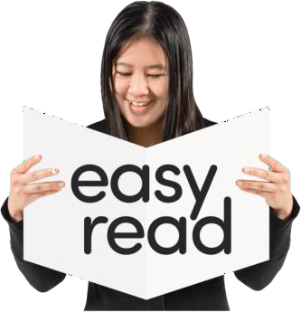 | We wrote this in an easy to read way. We use pictures to explain some ideas.
 | We have some words in bold.  This means the letters are thicker and darker.  These are important words.
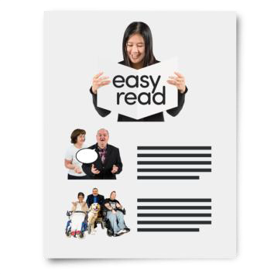 | This is an Easy Read summary of another document.  This means it has the most important ideas.

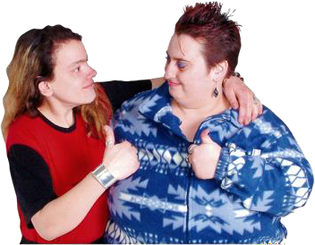 | You can ask for help to read this document. You can ask  - A friend  - Family members  - A support person.
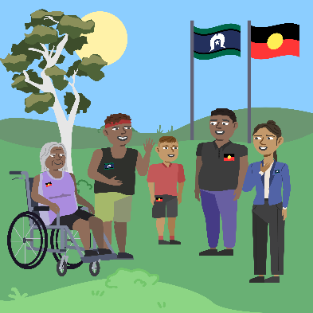 | We recognise Aboriginal and Torres Strait Islander people as the Traditional Owners of the land we live on.
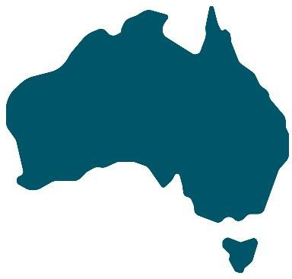 | They were the first people to live on and use the  - Land  - Waters.

Contents

What are TAPs | 5
Why these TAPs | 9
What these TAPs will do | 10
Including people with disability | 12
Checking and reports | 14

What are TAPs

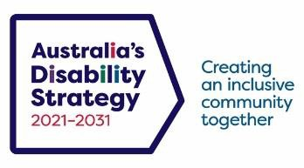 | The government set up Australia’s Disability Strategy.  We call it ADS for short.
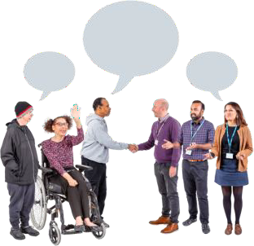 | ADS is the governments way of working  together to support people with disability to live good lives.  They do this by working with  - People with disability  - The community  This makes the community a more welcoming place for everyone.
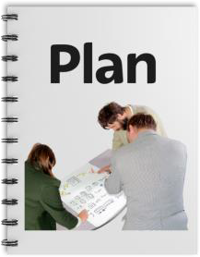 | To make it easier to work on ADS we make lots of small plans.  They are all working towards ADS.

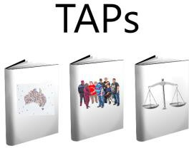 | The small plans are called Targeted Action Plans.  We call them TAPs for short.
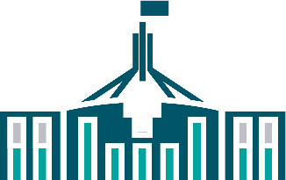  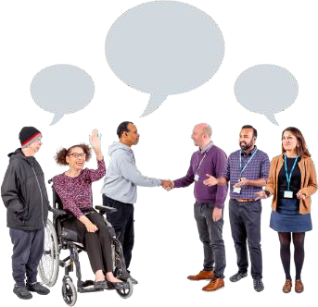 | All governments will work together to do TAPs. All governments include  - Australian Government  - State and territory governments  - Local Government.
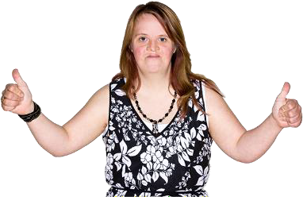 | We want people with disability to live good lives.

 | 3 new TAPs were made this year. They are
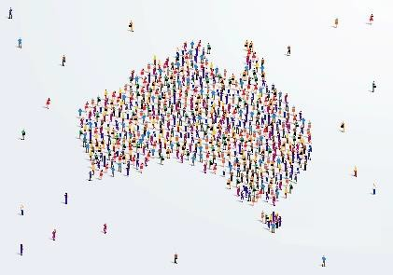 | 1  - Inclusive homes and communities
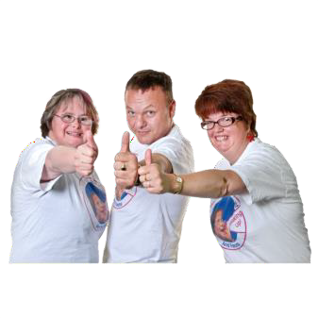 | Inclusive is when everyone  - Can take part  - Feel like they belong.
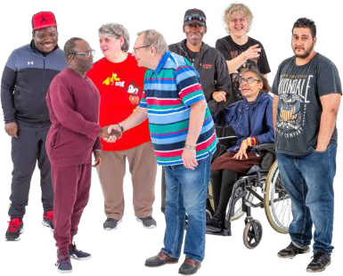 | 2  - Community attitudes

 | Attitudes are what people  - Think  - Feel  - Believe.
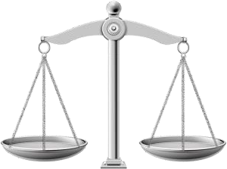 | 3  - Safety rights and justice
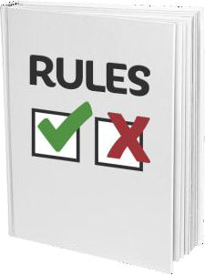 | Rights are rules about treating everyone  - Fair  - Equal.
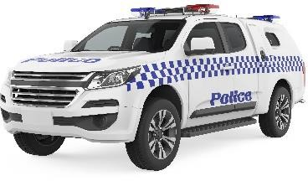  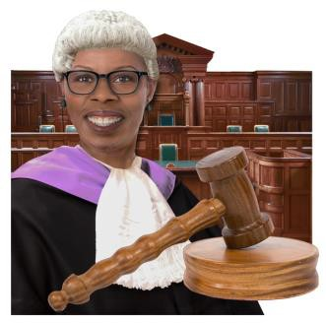 | Justice is  - The law  - Police  - The courts  - Prisons.

Why these TAPs

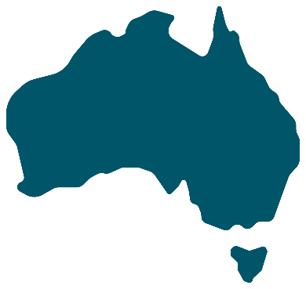 | These TAPs will make Australia a better place for people with disability.  It will make sure people with disability are
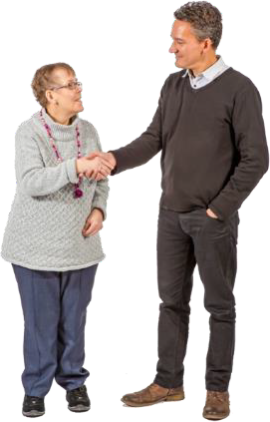 | - Respected  - Treated as equal
- Know they belong

- Can take part in the community
 | - Live good lives.

What these TAPs will do

 | These TAPs will
 | - Help people with disability to take part in their communities more and have good homes
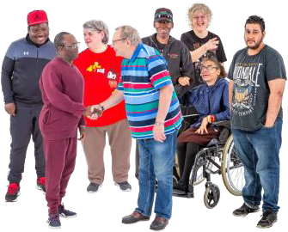 | - Help the community have better attitudes about people with disability
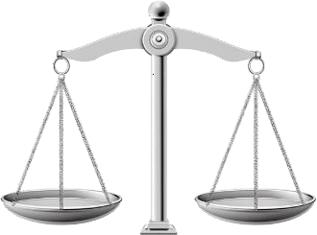 | - Help keep people with disability safe.

 | You can go to our website to look at TAPs  www.disabilitygateway.gov.au/ads/strategy

Including people with disability

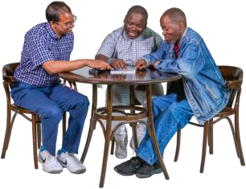 | We know it is important to include people with disability to make plans about them.
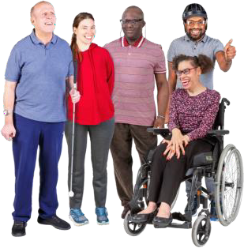 | We talked to  - People with disability
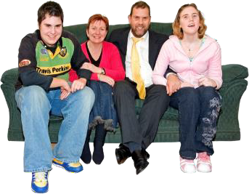 | - Family members  - Carers
 | - Disability Representative Organisations  - ADS Advisory Council.  A council is a group of people that work together in an area for the local government.

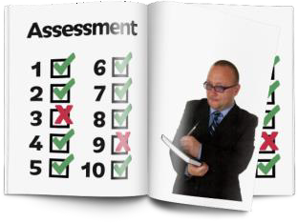 | We did a review of ADS.  A review is when you check  - What is working  - What needs to change.  This helps us  - Change our TAPs  - Make new plans.
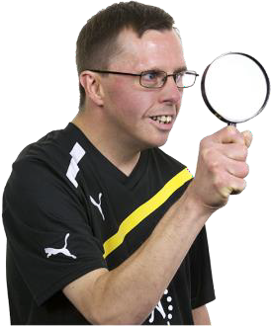 | To help the review we looked at research.  Research means  - Finding out what people think about things.  - Using the information to help others.
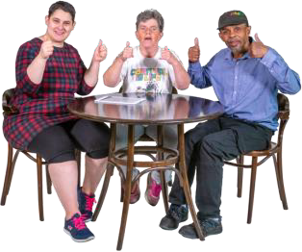 | We listened to people from the disability community.  This is very important.

Checking and reports

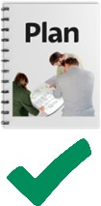 | We have a plan to check how we are going with TAPs.
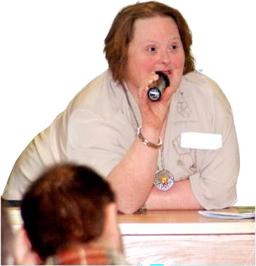 | We will give updates as we go.
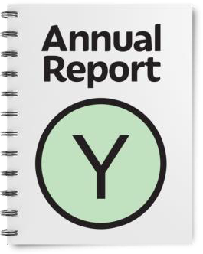 | We will write a report every year.  It will be ready by the end of December.
 | We have done lots of other work.  You can look at it on our website. www.disabilitygateway.gov.au/


easyread.tech created these original illustrations. Please do not use these illustrations without permission. Visit easyread.tech for more information.

