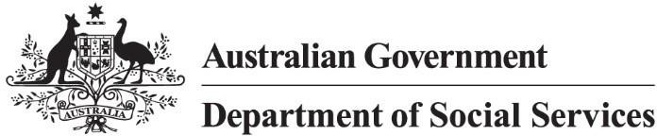

Targeted Action Plans 2025 to 2027
Safety Rights and Justice

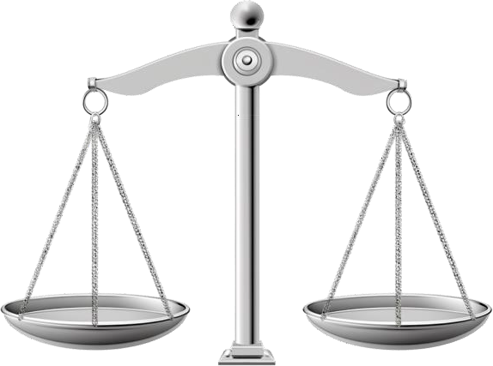

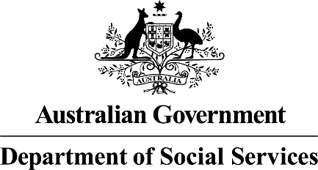 | The Australian Government Department of Social Services wrote this.  We say DSS for short.  When you see the word we it means the DSS.
 | We wrote this in an easy to read way. We use pictures to explain some ideas.
 | We have some words in bold.  This means the letters are thicker and darker.  These are important words.
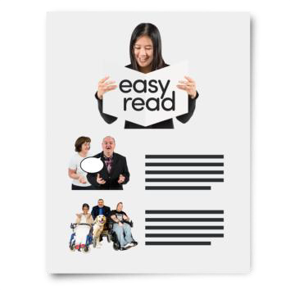 | This is an Easy Read summary of another document.  This means it has the most important ideas.

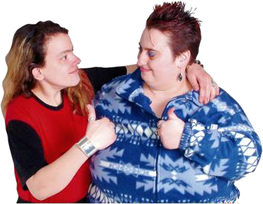 | You can ask for help to read this document. You can ask  - A friend  - Family members  - A support person.
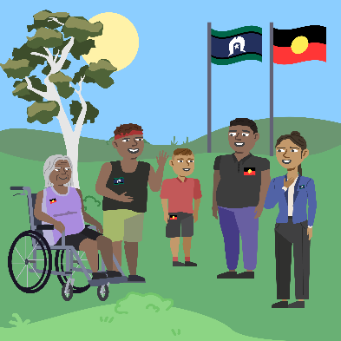 | We recognise Aboriginal and Torres Strait Islander people as the Traditional Owners of the land we live on.
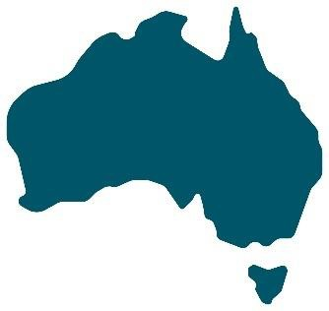 | They were the first people to live on and use the  - Land  - Waters.

Contents

What are TAPs | 5
Safety Rights and Justice | 8
Why this TAP | 10
What this TAP will do | 11
Including people with disability | 12
Reports | 14

What are TAPs

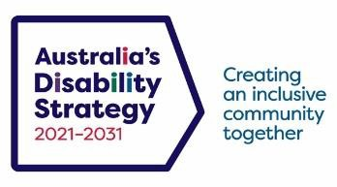 | The government set up Australia’s Disability Strategy.  We call it ADS for short.
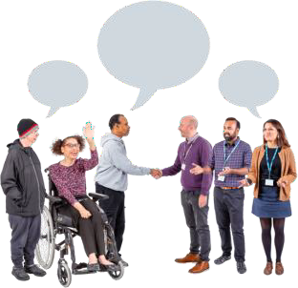 | ADS is the governments way of working  together to support people with disability to live good lives.  They do this by working with  - People with disability  - The community  This makes the community a more welcoming place for everyone.
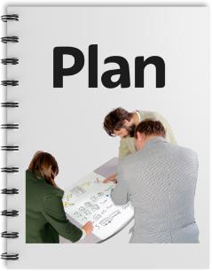 | To make it easier to work on ADS we make lots of small plans.  These small plans are part of the bigger ADS.

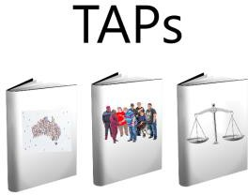 | The small plans are called Targeted Action Plans.  We call them TAPs for short.
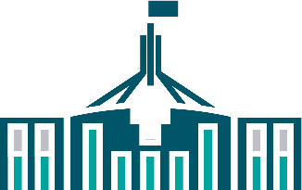  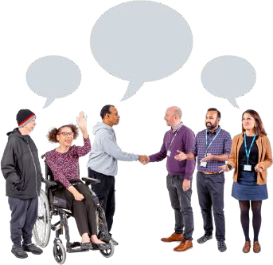 | All governments will work together to do TAPs. All governments include  - Australian Government  - State and territory governments  - Local Government.
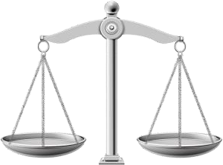 | A new TAP called safety rights and justice  was made this year.

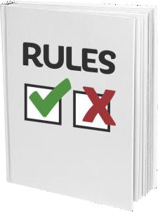 | Rights are rules about treating everyone  - Fair  - Equal.
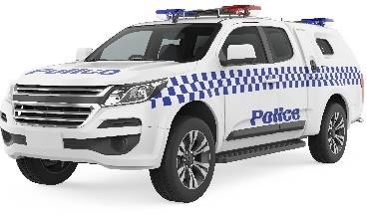  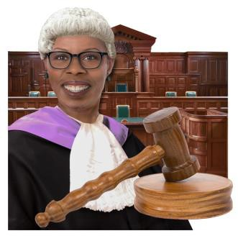 | Justice is  - The law  - Police  - The courts  - Prisons.
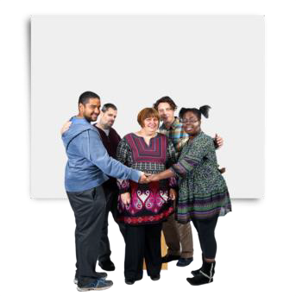 | We want people with disability  - To feel safe  - Have their rights respected.
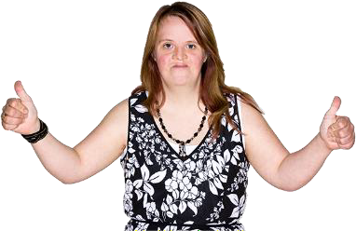 | This will help people with disability live good lives.

Safety Rights and Justice

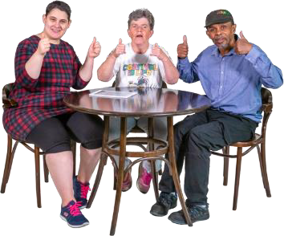 | Better  - Safety  - Rights  - Justice  Will help people with disability live safe and happy lives.
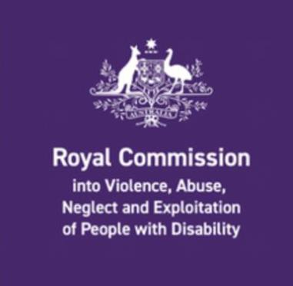 | The Disability Royal Commission looked at how people with disability have been treated.  We call it DRC for short.
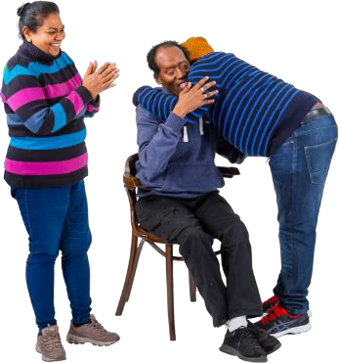 | People with disability told the DRC they wanted to be  - Safe  - Respected  - Treated as equal

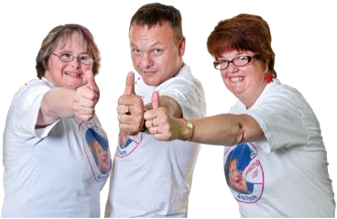 | - Know their rights  - Free from harm  - Be able to be supported in all areas of the community.  Harm is when someone is hurt.
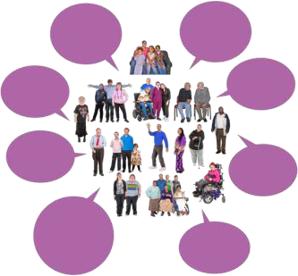 | We listened to what people with disability said to the DRC.  We wrote the safety rights and justice TAP.
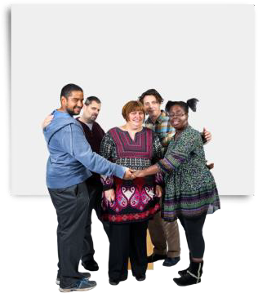 | We want better ways to keep people with disability safe.

Why this TAP

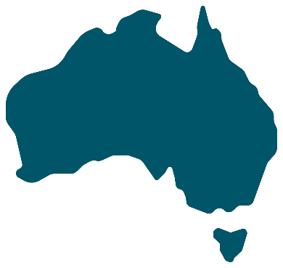 | This TAP will make Australia a better place for people with disability.  It will make sure people with disability are
 | - Respected  - Treated as equal
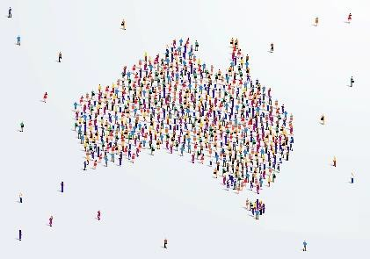 | - Know they belong  - Can take part in the community
 | - Live good lives
- Be safe

- Are not hurt.

What this TAP will do

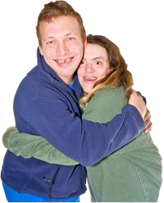 | This TAP will  - Make sure people with disability feel safe.
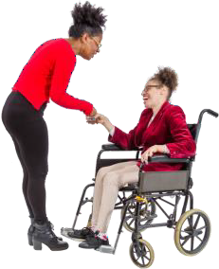 | - Make sure people with disability are respected.
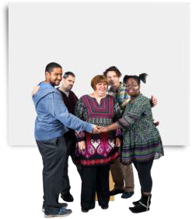 | - Help people with disability to have their rights protected.
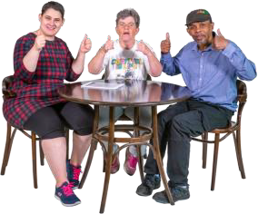 | - Make sure communities to treat people with disability as equal.

Including people with disability

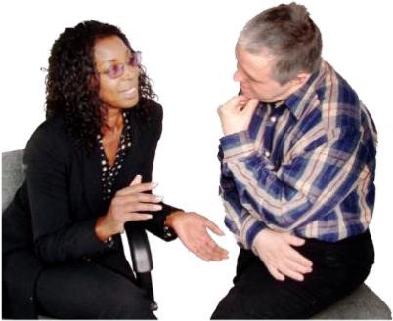 | The government want to make sure people with disability are heard.
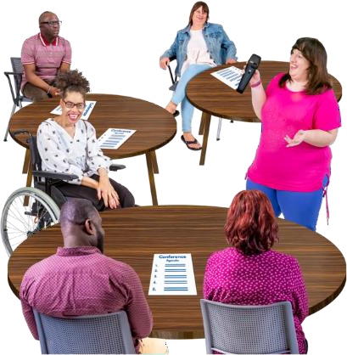 | They will work with local disability groups to do what TAPs say.
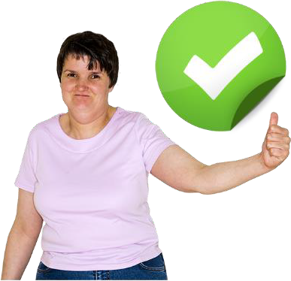 | This will make sure governments do everything they say they will in TAPs.

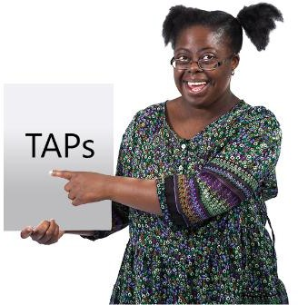 | It will also help people with disability keep being involved in TAPs.
 | You can go to our website to look at this TAP.  www.disabilitygateway.gov.au/ads/strategy

Reports

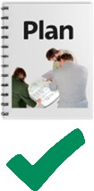 | We have a plan to check how we are going with TAPs.
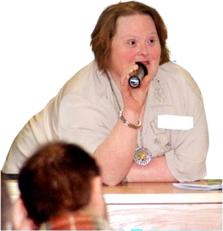 | We will give updates as we go.
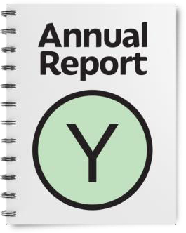 | We will write a report every year.  It will be ready by the end of December.
 | We have done lots of other work. You can look at it on our website.  www.disabilitygateway.gov.au


easyread.tech created these original illustrations. Please do not use these illustrations without permission. Visit easyread.tech for more information.

