Australia’s Disability Strategy 2021 to 2031

Targeted Action Plans Report

2025

Australian Capital Territory update
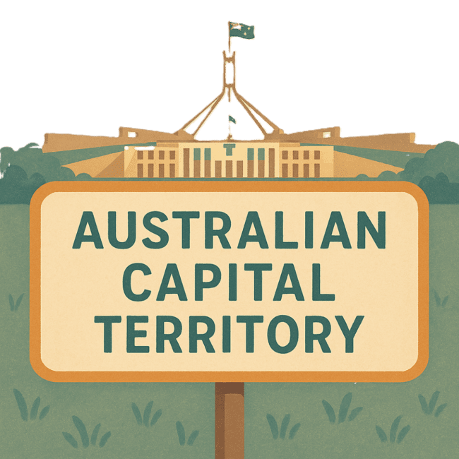

 | The Australian Government Department of Health Disability and Ageing wrote this.  We say DHDA for short.  When you see the word we it means DHDA.
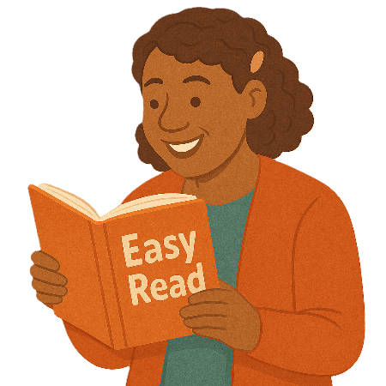 | We wrote this in an easy to read way.  We use pictures to explain some ideas.
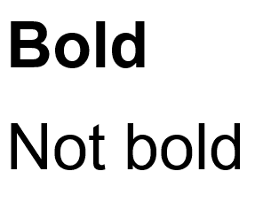 | We have some words in bold.  This means the letters are thicker and darker.  These are important words.
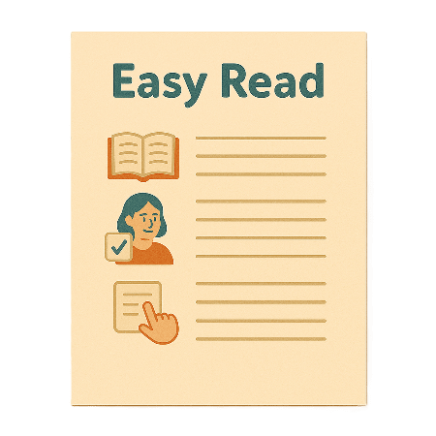 | This is an Easy Read summary of another document.  This means it has the most important ideas.
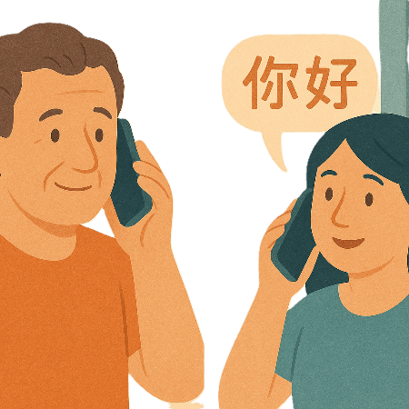 | If you speak a language other than English  - Call Translating and Interpreting Services.  1800 131 450
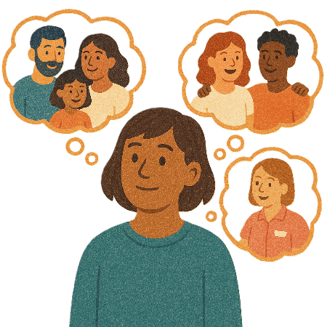 | You can ask for help to read this document.  You can ask  - A friend  - Family members  - A support person.
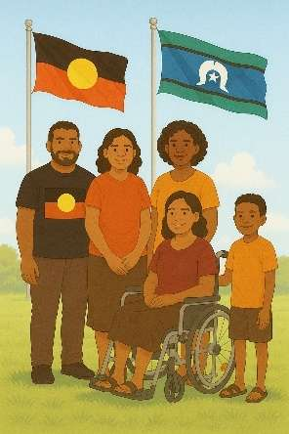 | We recognise Aboriginal and Torres Strait Islander people as the Traditional Owners of the land we live on.
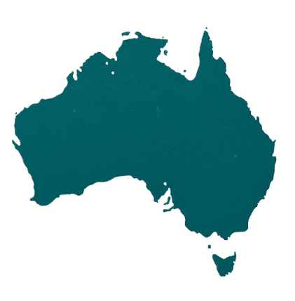 | They were the first people to live on and use the  - Land  - Waters.

Contents

About this document | 5
Australia’s Disability Strategy | 8
What are Targeted Action Plans | 9
Australian Capital Territory Update | 11
Community Attitude TAP | 13
Inclusive Homes and Communities TAP | 17
Safety Rights and Justice TAP | 21

About this document

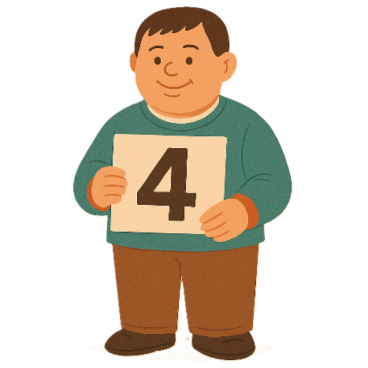 | This document has 4 parts
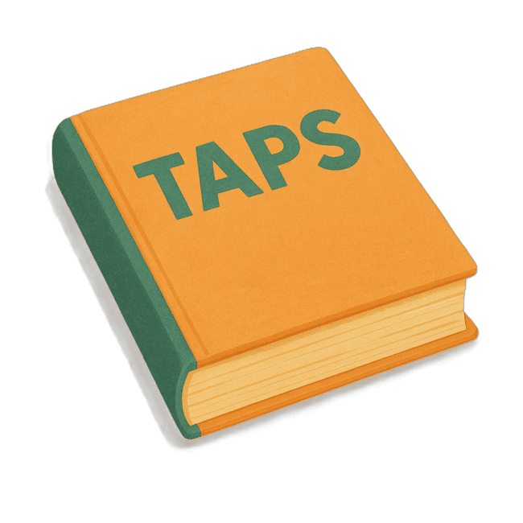 | Part 1 talks about  - What are Targeted Action Plans  We call them TAPs for short.
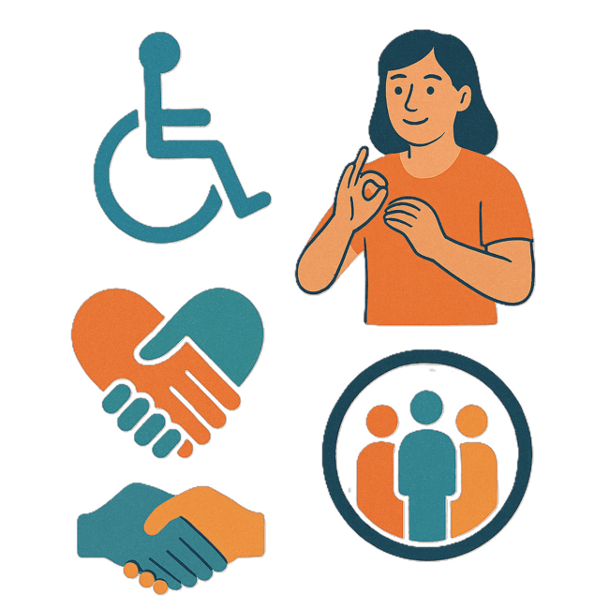 | Part 2 talks about  - Community Attitudes TAP
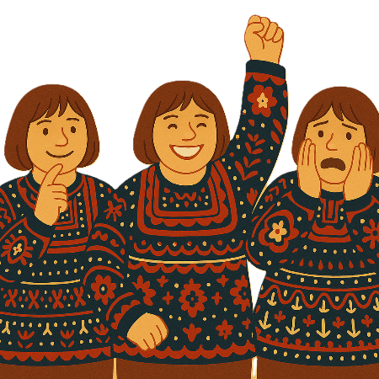 | Attitudes are what people  - Think  - Feel  - Believe.
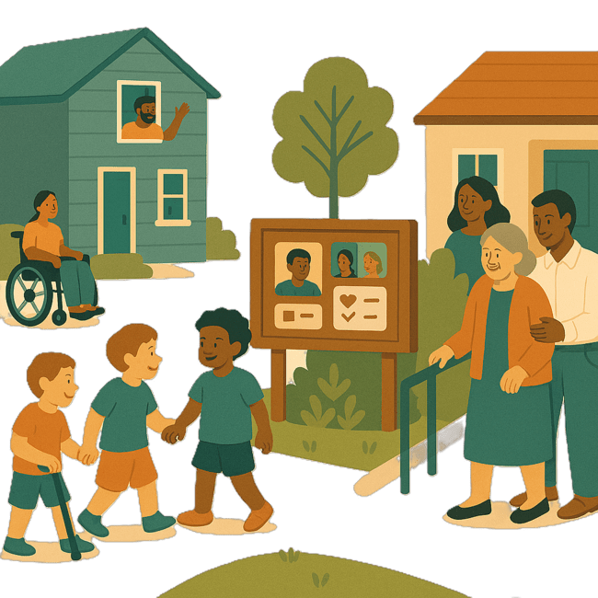 | Part 3 talks about  - Inclusive Homes and Communities TAP
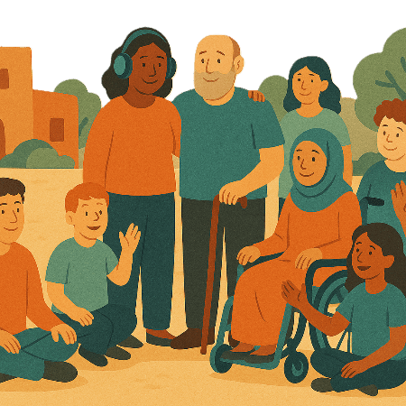 | Inclusive is when everyone  - Can take part  - Feel like they belong.
Part 4 talks about

- Safety Rights and Justice TAP
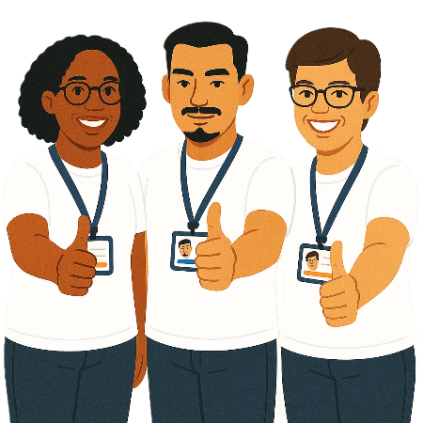 | Rights are rules about treating everyone  - Fair  - Equal.
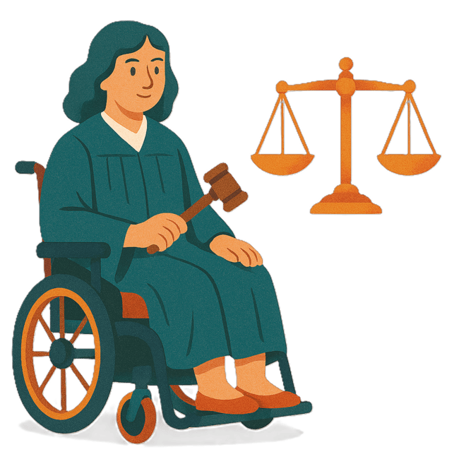 | Justice is  - The law  - Police  - The courts  - Prisons.  Laws are rules for how we live.
 | You can go to our website to read the updates from other states and territories.  www.disabilitygateway.gov.au/ads/easy-read-strategy  It is in Easy Read.

Australia’s Disability Strategy

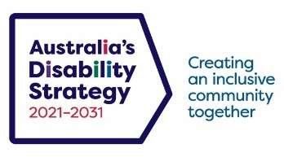 | The government set up Australia’s Disability Strategy.  We call it the Strategy for short.  It was also called ADS.
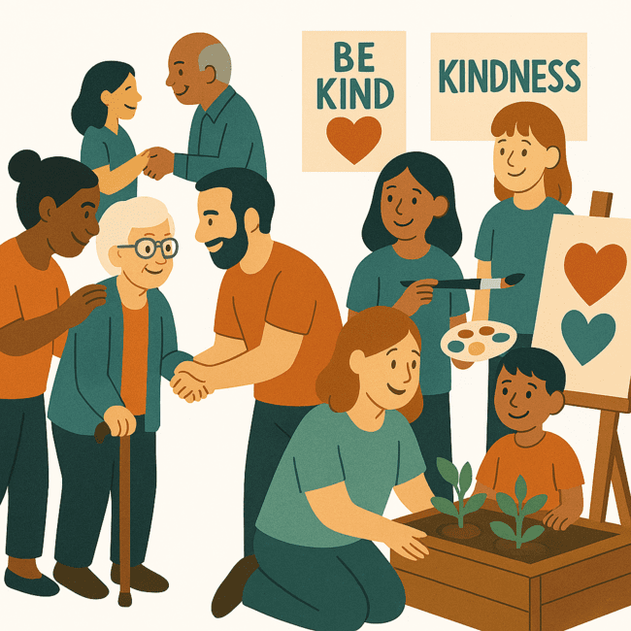 | The Strategy is the governments way of working together to support people with disability to live good lives.  They do this by working with  - People with disability  - The community.  This makes the community a more welcoming place for everyone.

What are Targeted Action Plans

We made small plans to help us work on the Strategy.

The small plans are called TAPs.
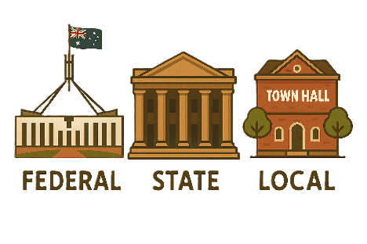 | TAPs are made by all governments in Australia.  All governments include  - Australian Government  - State and territory governments  - Local governments.
There are 3 TAPs.

- Community Attitudes
 | - Inclusive Homes and Communities
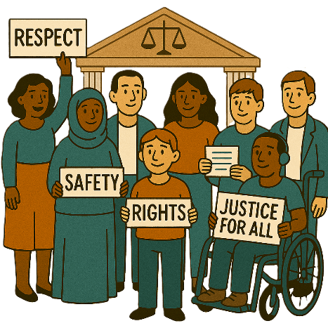 | - Safety Rights and Justice

Australian Capital Territory update

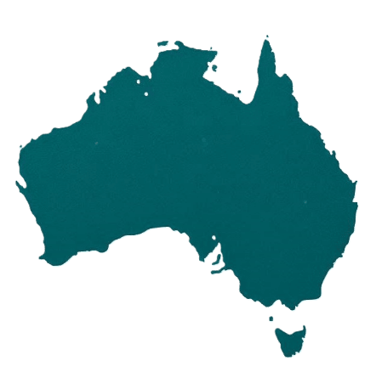 | Each state and territory government have made their own actions.  This makes sure that they meet the needs of their communities.  Actions are the things that we will do.
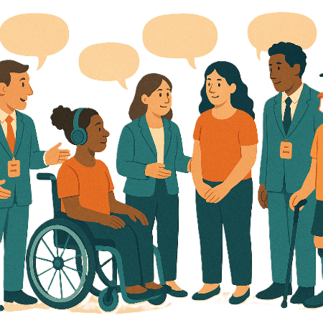 | Each government says how the actions will include  - People with disability
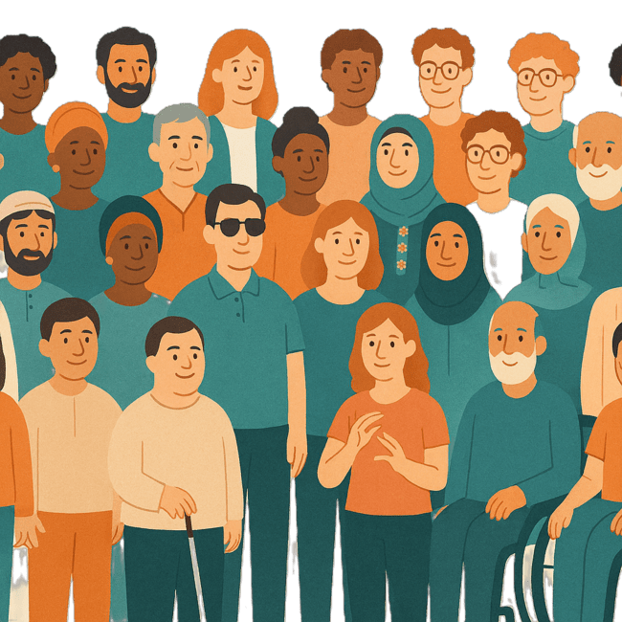 | - The disability community.
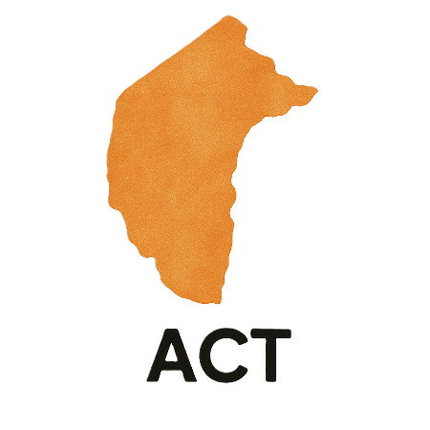 | This document talks about some actions the Australian Capital Territory government is doing in the 3 TAPs.  We call them ACT for short.

Community Attitudes TAP

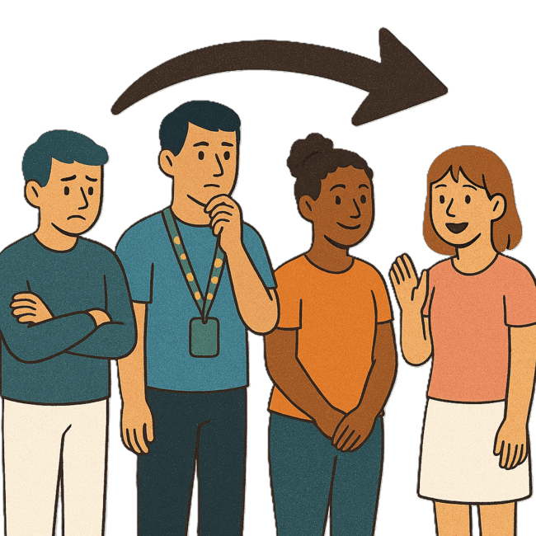 | This TAP wants to change  - How people behave  Behave means  - How you act  - What you do.
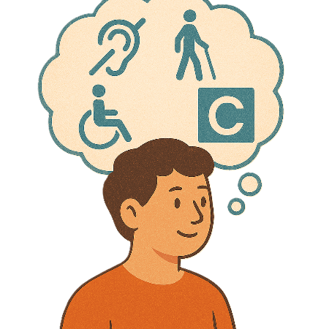 | - What people think about disability.
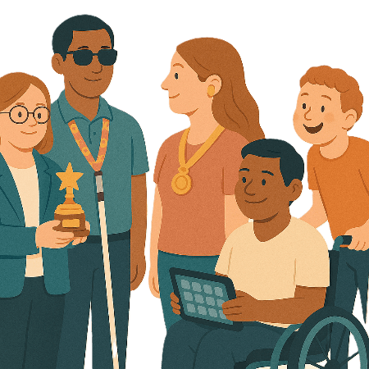 | The ACT government has Disability Inclusion Awards every year.
They help to encourage

- Inclusive attitudes
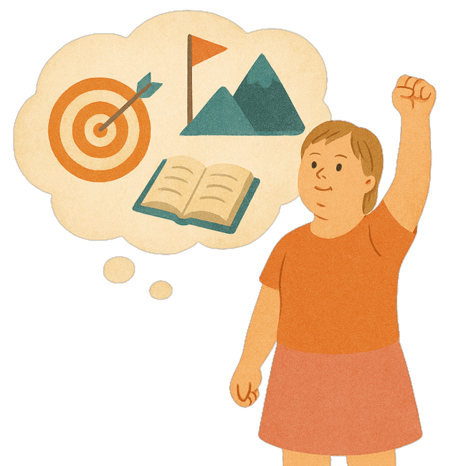 | - Aim to have less stigma  Aims are things you want to do.
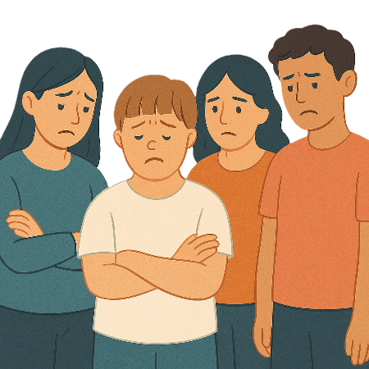 | Stigma is when people are treated unfairly because of who they are.  They might feel bad about themselves.
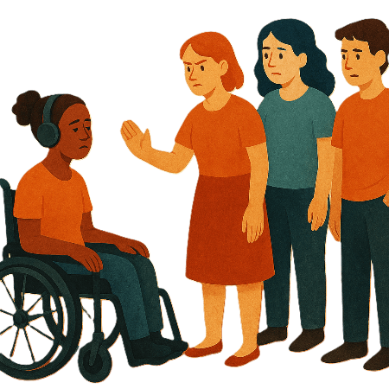 | - Aim to have less discrimination  Discrimination means treating someone unfairly because of something about them they can not change.  Like their  - Disability  - Age  - Skin colour.
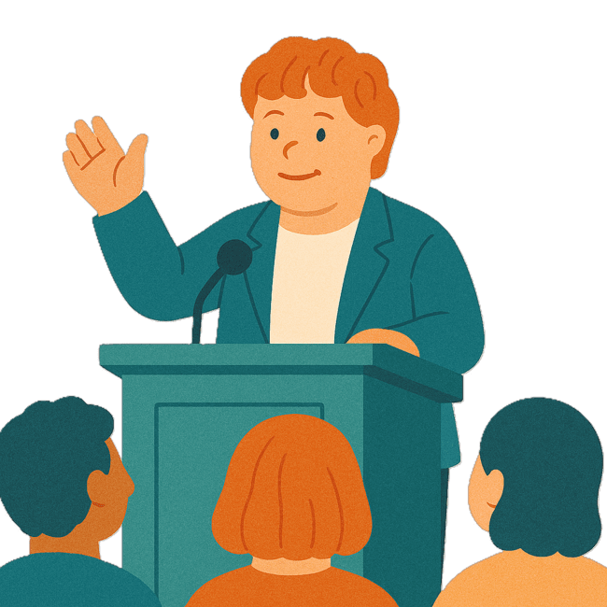 | People who can win awards are  - Leaders with disability
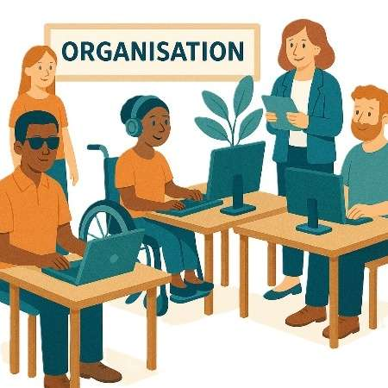 | - Organisations that are  - Accessible  - Inclusive.
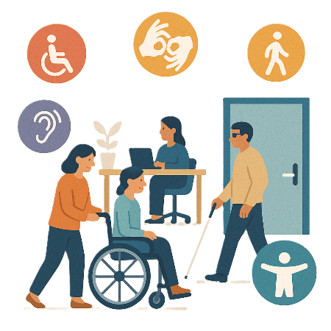 | Accessible means everyone can use it.

Inclusive Homes and Communities TAP

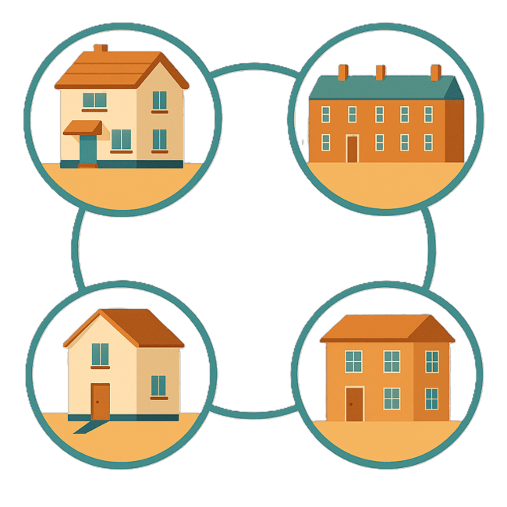 | This TAP wants to make  - Homes
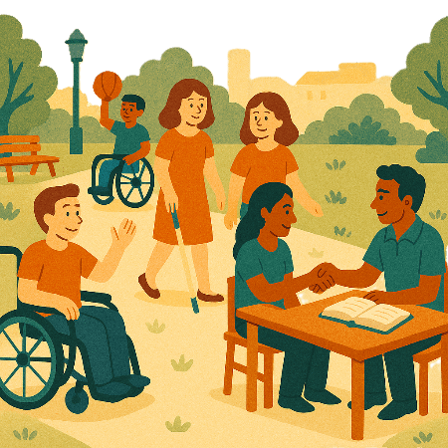 | - The community  Easier to access.
 | We also want them to be more welcoming.
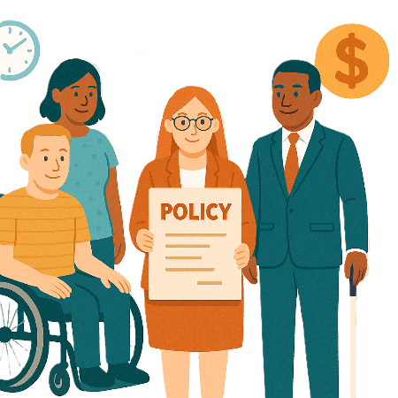 | The ACT government is working to improve  - Policies  Policies are plans for how to do things.
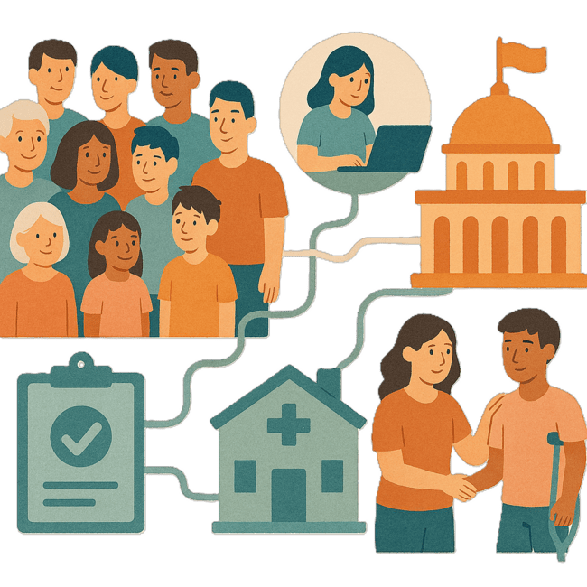 | - Systems  Systems are  - All the people  - Services  - Rules  - Government  - Mainstream services  They work together to support people with disability.
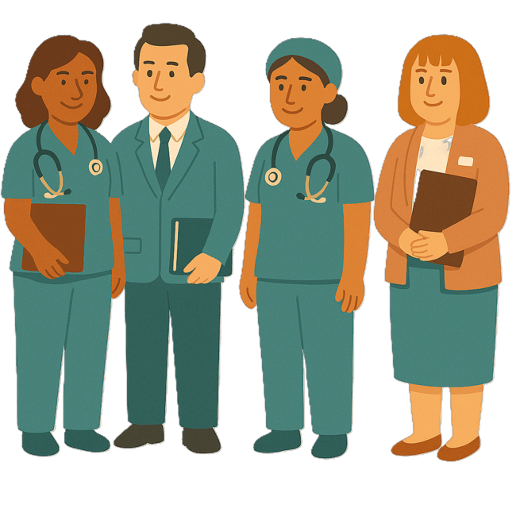 | Mainstream supports are other supports you get from government services like  - Health  - Aged care  - Mental health services.  Mainstream supports are supports everyone can access.
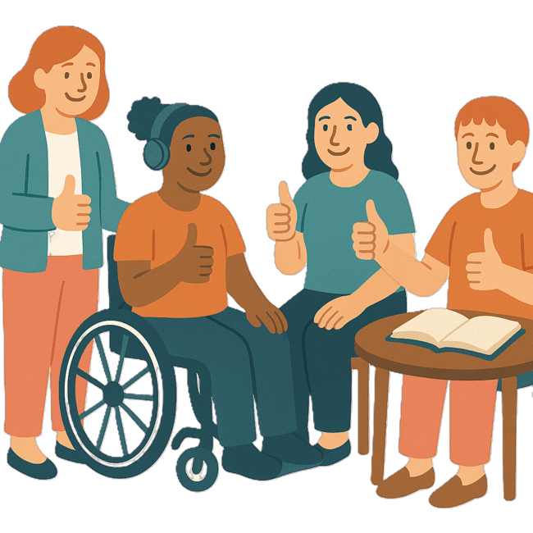 | - Services  For people with disability
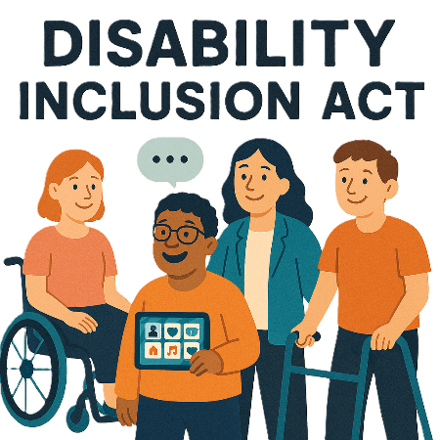 | They are doing this work as part of the Disability Inclusion Act 2024
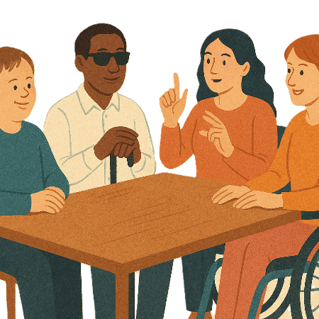 | The Disability Inclusion Act says  - A Disability Advisory Council needs to be set up  An advisory council is a group of people who know a lot about something.  They give advice to the government.
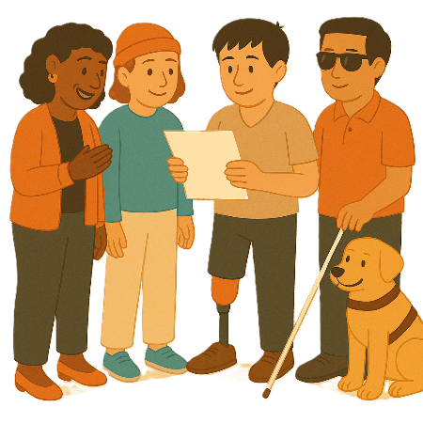 | All ACT government organisations need to make Disability Inclusion Plans  The plans need to be made with  - People with disability
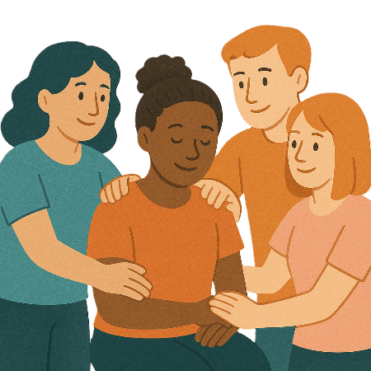 | - Families and carers
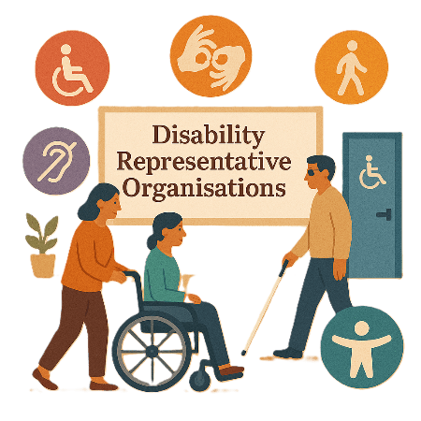 | - Disability Representative Organisations  We call them DROs for short.
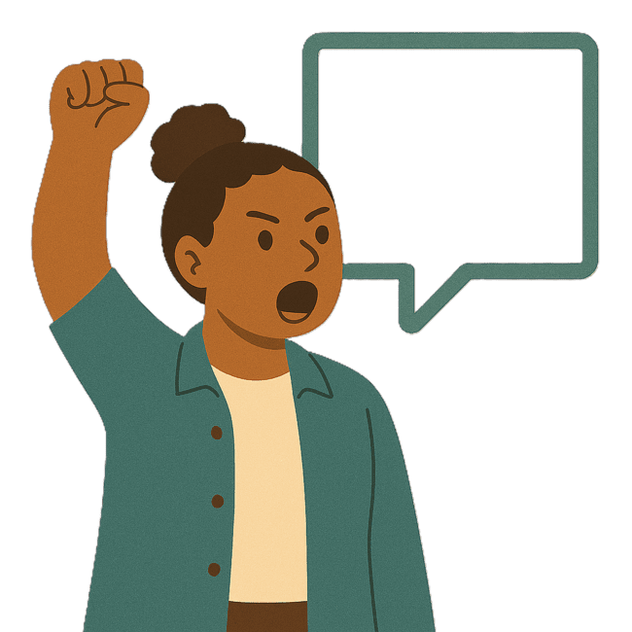 | - Advocacy groups  Advocacy is when someone supports you to speak up for your rights.

Safety Rights and Justice TAP

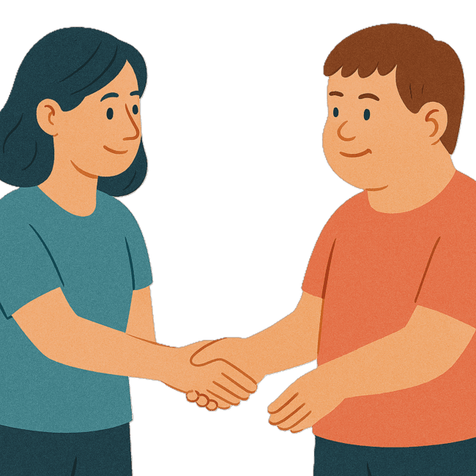 | This TAP wants to make sure people with disability are  - Safe  - Treated fairly.
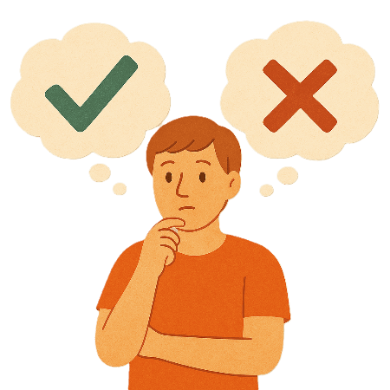 | The ACT Government is working with the community to make good laws for  - Making decisions
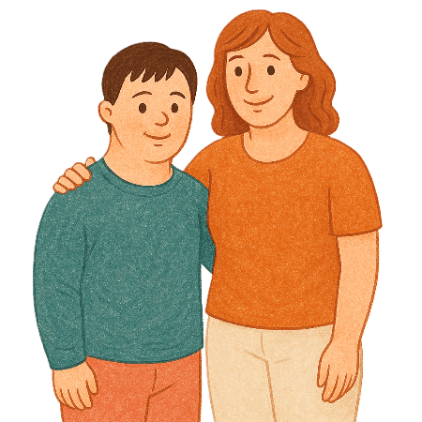 | - Guardians.
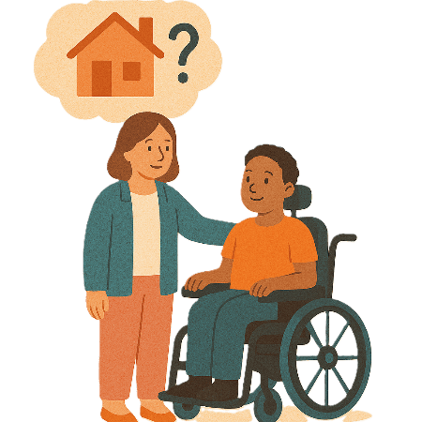 | Guardians help people who can not make decisions for themselves.  They can decide things like  - Where the person lives
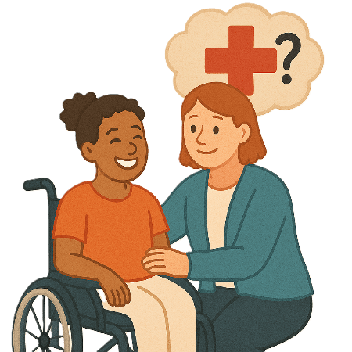 | - What health care the person gets
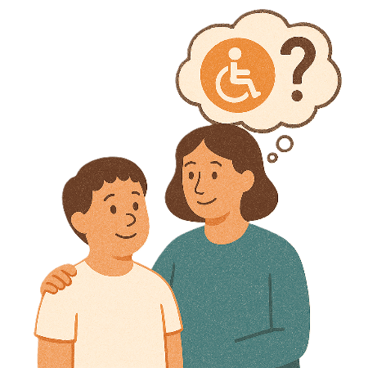 | - What services the person needs.
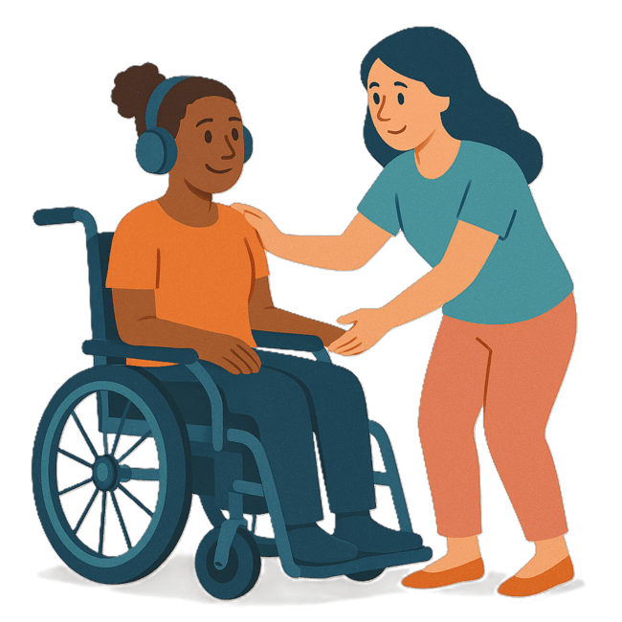 | - What support people with disability need when going to Court.
A court is where someone goes to help solve problems or if someone broke the law.

In a court

- A judge listens to what happened
- People say what happened
- A judge decides what is fair and should happen.

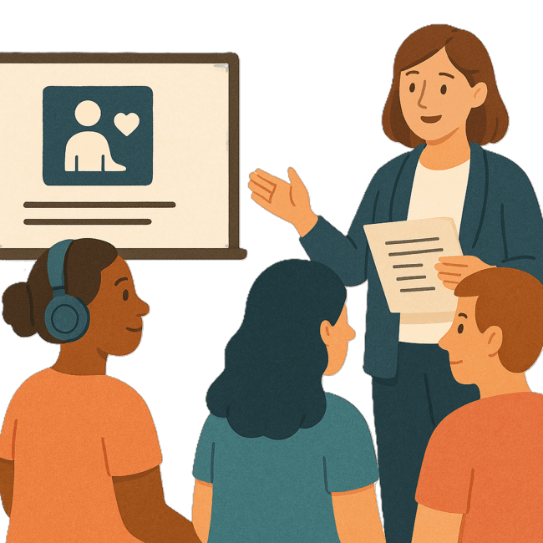 | - What training is needed for support workers.
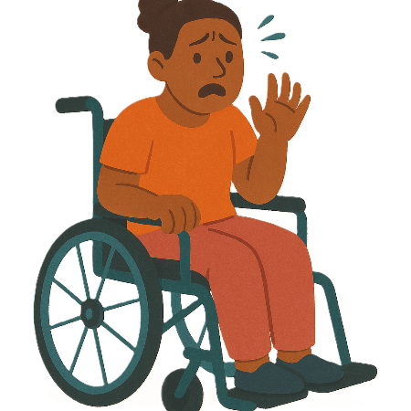 | The training helps workers understand  - Trauma  Trauma is when something happens that makes a person feel  - Upset  - Scared  - Unsafe.
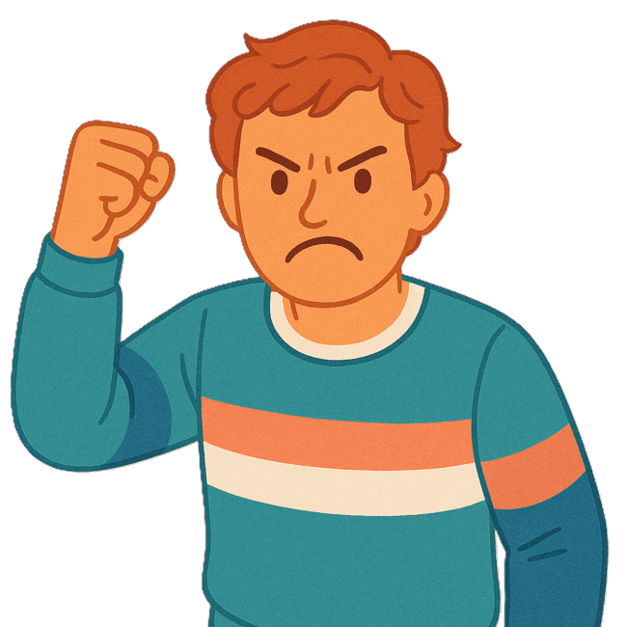 | - Violence  Violence is when someone hurts your body.
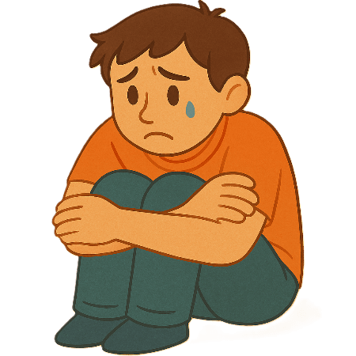 | - Neglect  Neglect is not giving someone the care or help they need.
 | People with disability who have experienced these things will  - Help the ACT government make the training.  This will help the ACT government make these changes.

Images in this Easy Read must not be used or copied without permission

