Australia’s Disability Strategy 2021 to 2031

Targeted Action Plans Report

2025
Community Attitudes
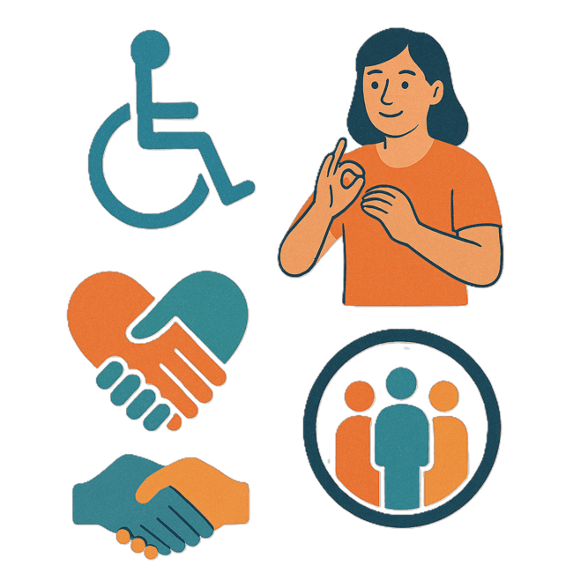
 | The Australian Government Department of Health Disability and Ageing wrote this.  We say DHDA for short.  When you see the word we it means DHDA.
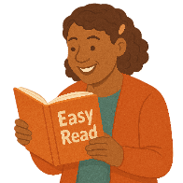 | We wrote this in an easy to read way.  We use pictures to explain some ideas.
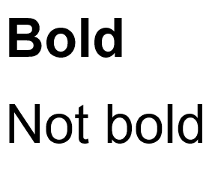 | We have some words in bold.  This means the letters are thicker and darker.  These are important words.
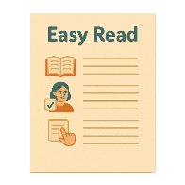 | This is an Easy Read summary of another document.  This means it has the most important ideas.
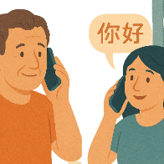 | If you speak a language other than English  - Call Translating and Interpreting Services.  1800 131 450
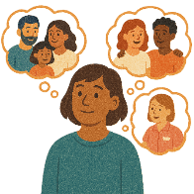 | You can ask for help to read this document.  You can ask  - A friend  - Family members  - A support person.
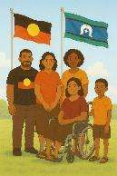 | We recognise Aboriginal and Torres Strait Islander people as the Traditional Owners of the land we live on.
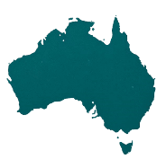 | They were the first people to live on and use the  - Land  - Waters.

Contents

About this document | 5
Australia’s Disability Strategy | 7
What are Targeted Action Plans | 8
What this TAP is trying to do | 11
Thinking about experiences | 13
National Actions | 16
Helping people with disability work in the government | 17
Data about community attitudes | 19

About this document

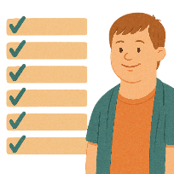 | This document talks about
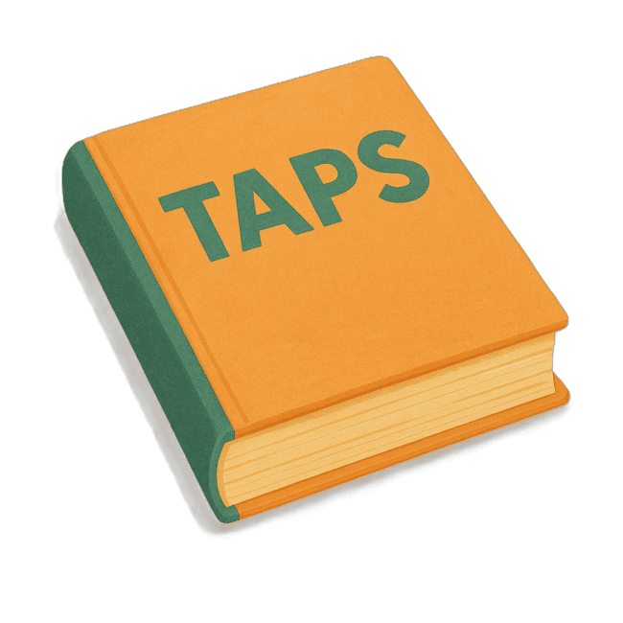 | - What are Targeted Action Plans  We call them TAPs for short.
 | - What the TAP is trying to do
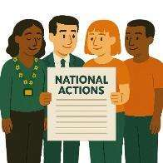 | - National actions  National Actions are things that all governments will do.  We want all parts of Australia to have the same way of doing things.
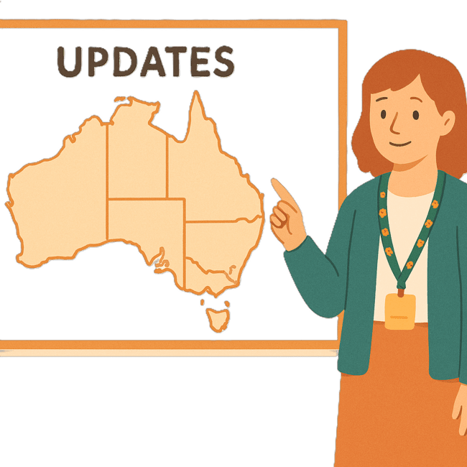 | We have other Easy Reads that talk about what the state and territory governments are doing.
 | You can go to our website to read the updates from the states and territories.  www.disabilitygateway.gov.au/ads/easy-read-strategy  It is in Easy Read.

Australia’s Disability Strategy

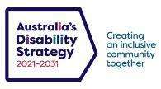 | The government set up Australia’s Disability Strategy.  We call it the Strategy for short.  It was also called ADS.
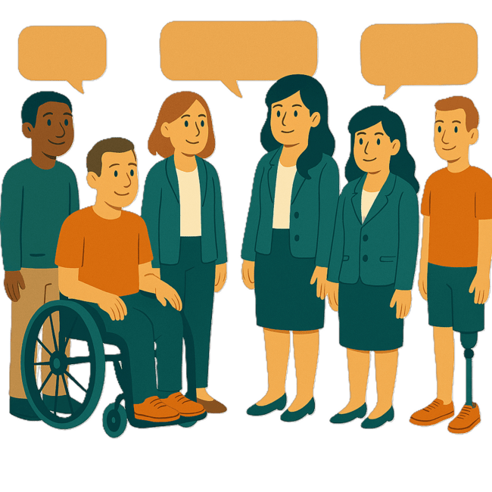 | The Strategy is the governments way of working together to support people with disability to live good lives.  They do this by working with  - People with disability  - The community.  This makes the community a more welcoming place for everyone.

What are Targeted Action Plans

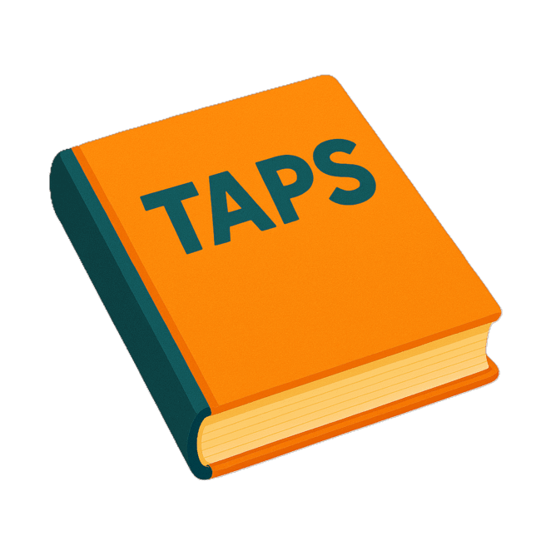 | We made small plans to help us work on the Strategy.  The small plans are called Targeted Action Plans.  We call them TAPs for short
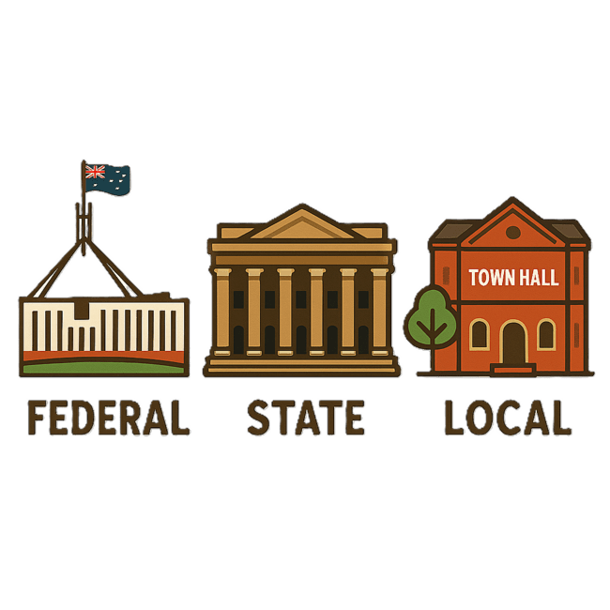 | TAPs are made by all governments in Australia.  All governments include  - Australian Government  - State and territory governments  - Local governments.
There are 3 TAPs.

- Community Attitudes
 | Attitudes are what people  - Think  - Feel  - Believe.
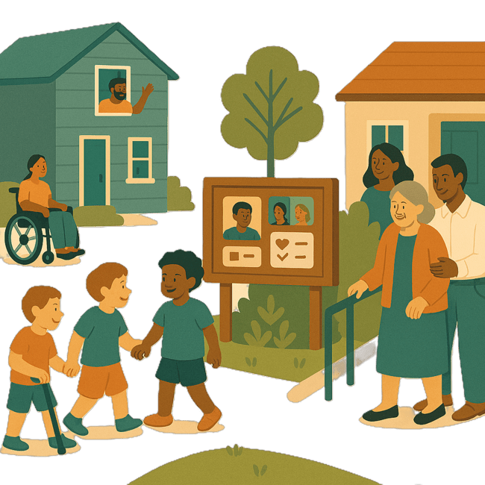 | - Inclusive Homes and Communities
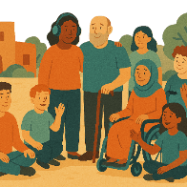 | Inclusive is when everyone  - Can take part  - Feel like they belong.
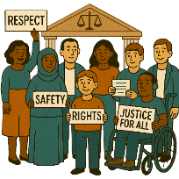 | - Safety Rights and Justice
 | Rights are rules about treating everyone  - Fair  - Equal.
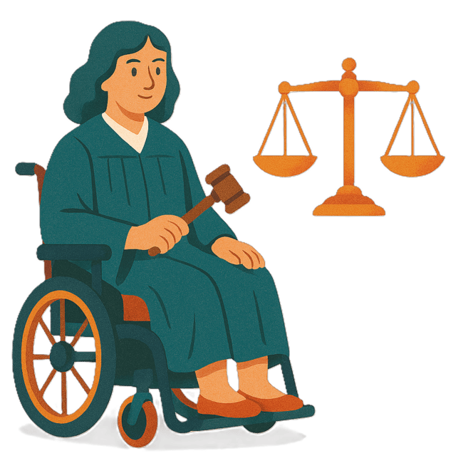 | Justice is  - The law  - Police  - The courts  - Prisons.  Laws are rules for how we live.

What this TAP is trying to do

 | This document talks about the TAP Community Attitudes.
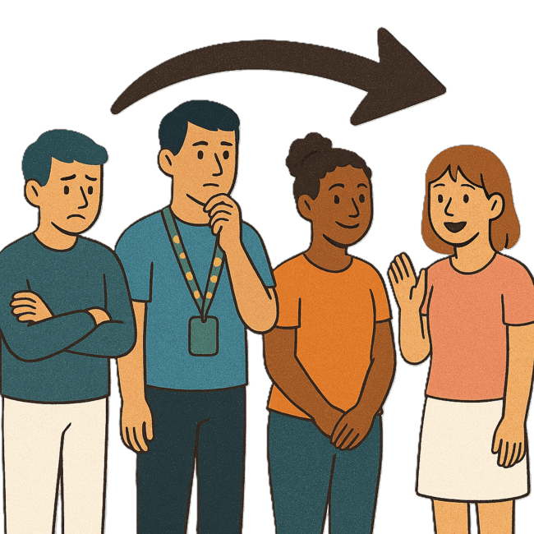 | This TAP wants to change  - How people behave
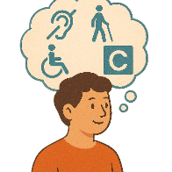 | - What people think about disability.
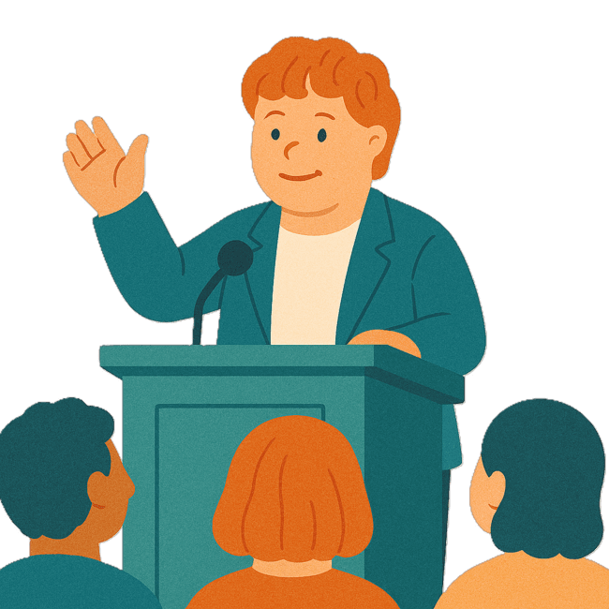 | This TAP wants to help  - More people with disability to be leaders
 | - Help employers know what good workers people with disability are  An employer is someone who pays someone to do work for them.
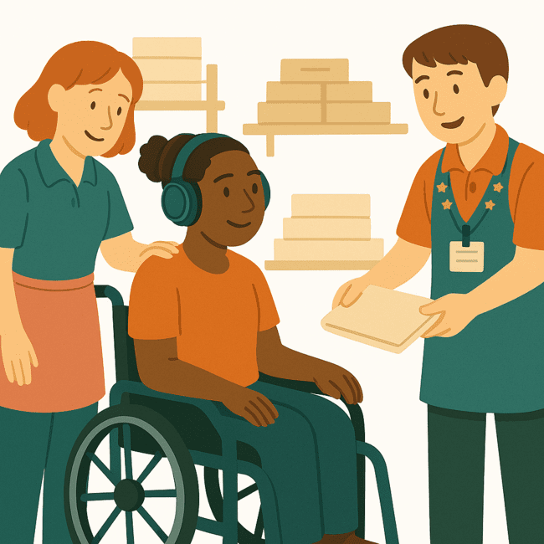 | - Workers know how to support people with disability
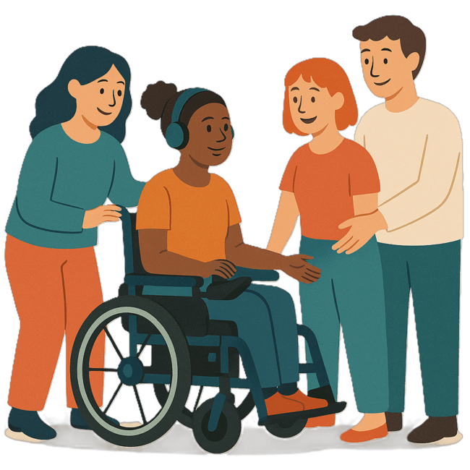 | - Help the community have better attitudes about people with disability.

Thinking about experiences

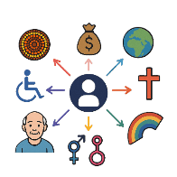 | This TAP will look at how to  - Support people with disability and the different parts of who they are.  This might change what their experience is like.  This is called intersectionality.
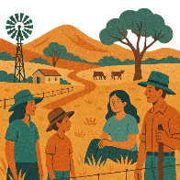 | This could be  - People with disability who live in rural or remote areas
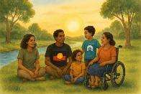 | - First Nations people with disability
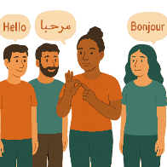 | - People who speak different languages
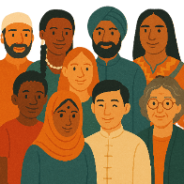 | - People from different cultures
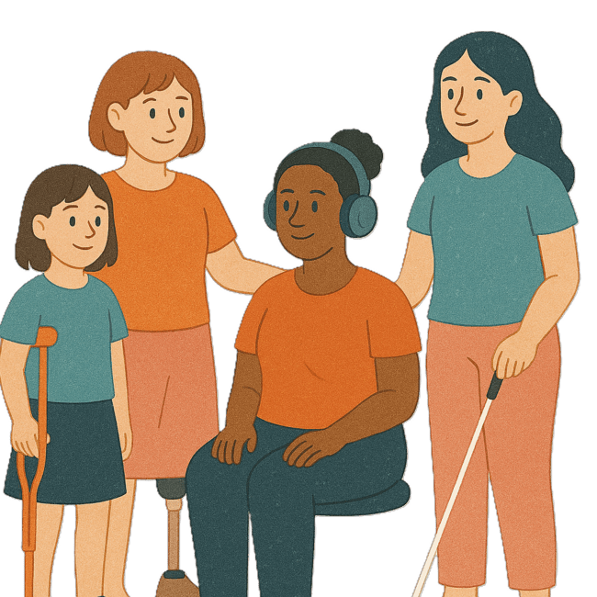 | - Women and girls with disability
 | - People with disability who are LGBTQIA+
 | - Children and young people with disability.
 | Some people fit into more than 1 of these groups.

National Actions

The Australian Government will work with people with disability on this TAP.

All governments will put the plan into action.
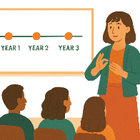 | All governments will work on the actions over the next 3 years.
 | They will also work with people with disability.

Helping people with disability work in government

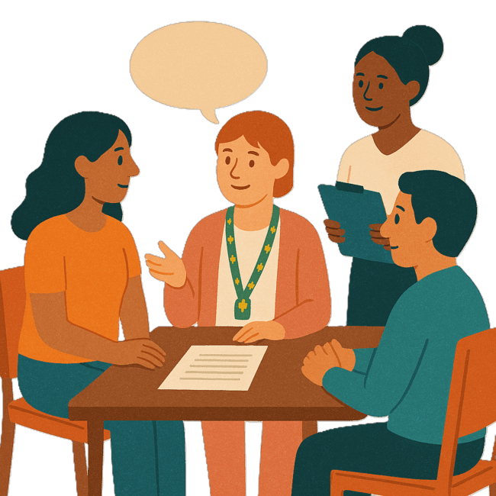 | 1 action in the TAP is about helping people with disability work in government.
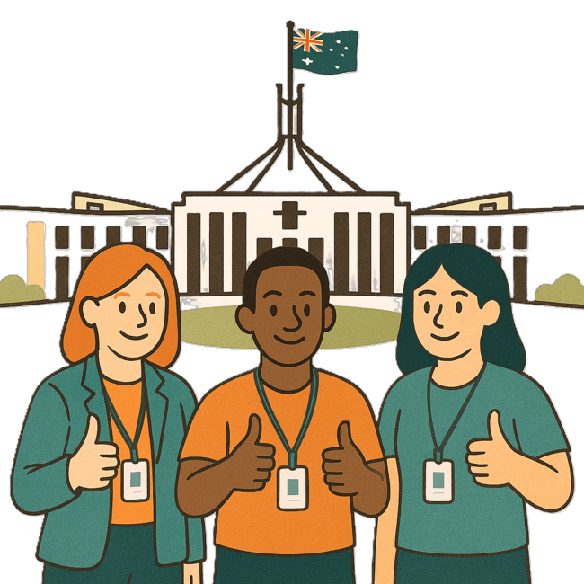 | The Australian Public Service Commission is doing a project.  We call them APSC for short.
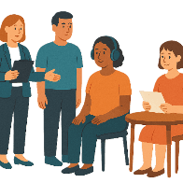 | The project is  - Making goals to hire more people with disability  Hire means pay them money to do work.
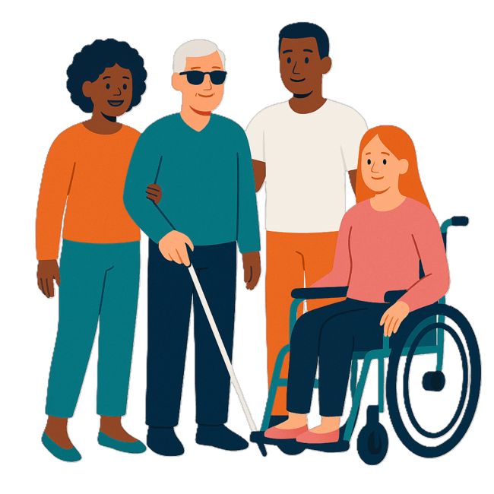 | APSC is asking workers with disability what they think.
 | APSC has made a working group with state and territory governments.  Working groups are a group of people working together on a topic.
 | This will help to  - Share ideas
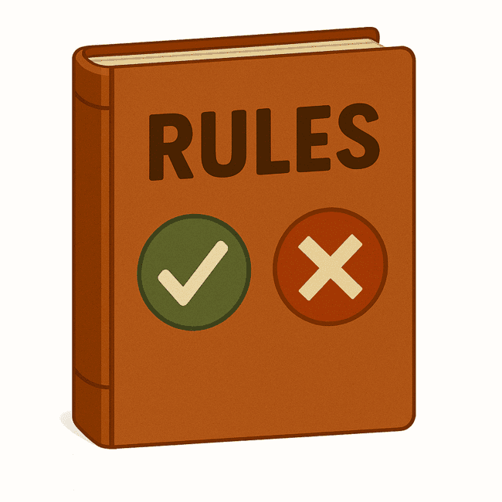 | - Agree on rules.

Data about community attitudes

 | The Strategys survey collects data over a long time.
 | Data is  - Facts  - Information  - Records.
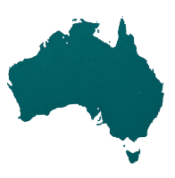 | It collects data from people  - All over Australia
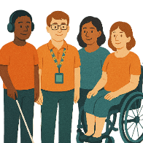 | - With disability
 | - Who hire people
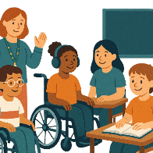 | - Who work in  - Education
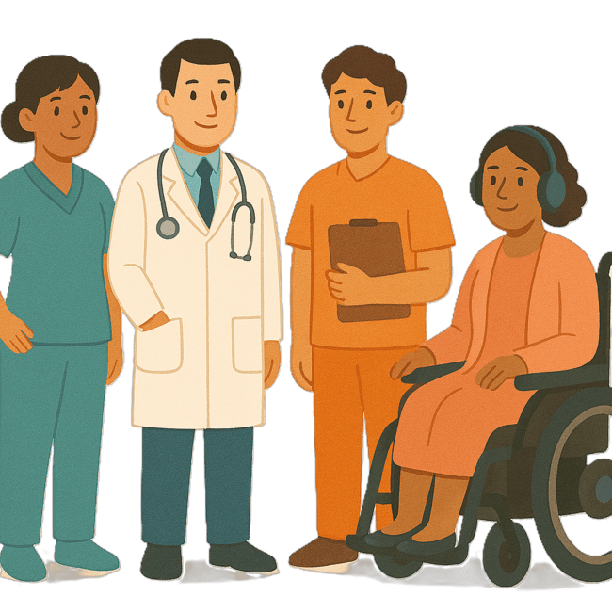 | - Health
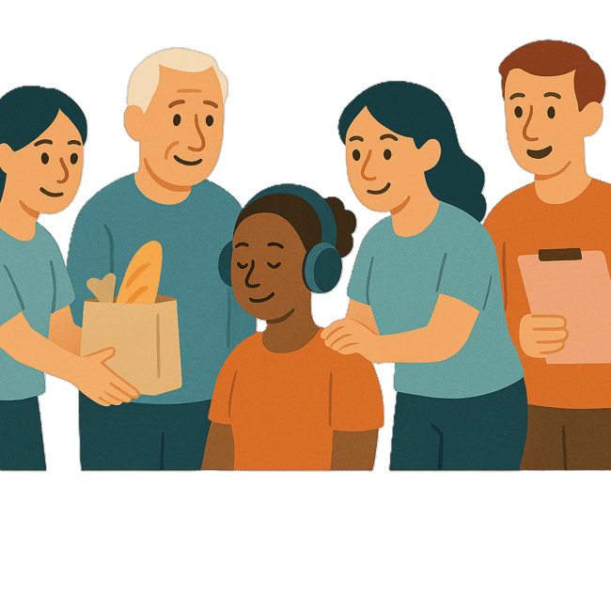 | - Community services
 | - Law and justice
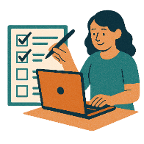 | The data helps us check how we are going.
We will share reports on our website.

www.disabilitygateway.gov.au/ads
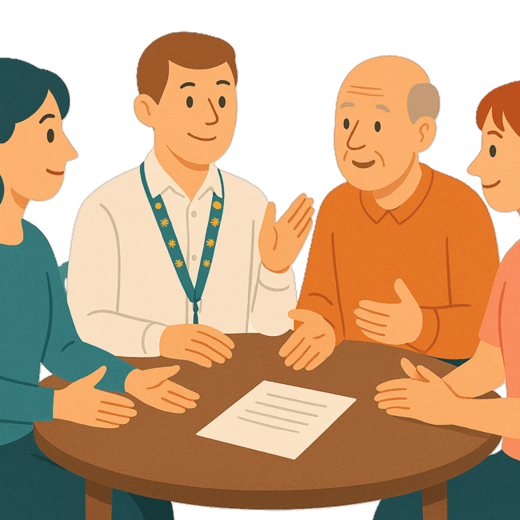 | We are also collecting information from certain groups of people with disability.  We are doing this with focus groups.
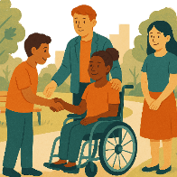 | They help us understand how people with disability take part in their community.
The groups taking part in the focus groups are

- Young people with disability
 | - People who speak different languages
 | - People from different cultures
 | - First Nations people with disability.
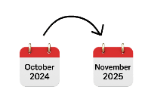 | The focus groups happened between  - October 2024  - November 2025.

Images in this Easy Read must not be used or copied without permission

