Australia’s Disability Strategy 2021 to 2031

Targeted Action Plans Report

2025
Inclusive homes and communities
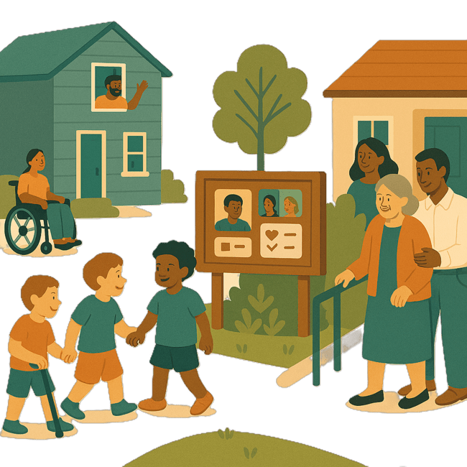
 | The Australian Government Department of Health Disability and Ageing wrote this.  We say DHDA for short.  When you see the word we it means DHDA.
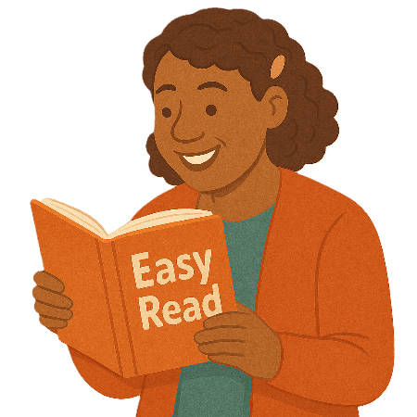 | We wrote this in an easy to read way.  We use pictures to explain some ideas.
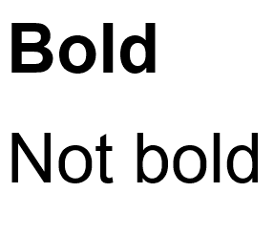 | We have some words in bold.  This means the letters are thicker and darker.  These are important words.
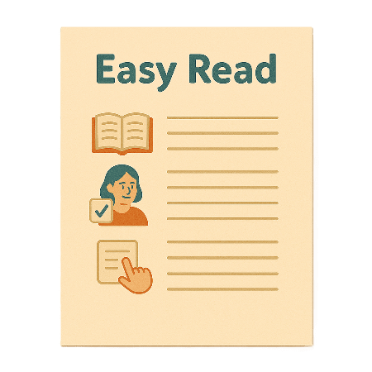 | This is an Easy Read summary of another document.  This means it has the most important ideas.
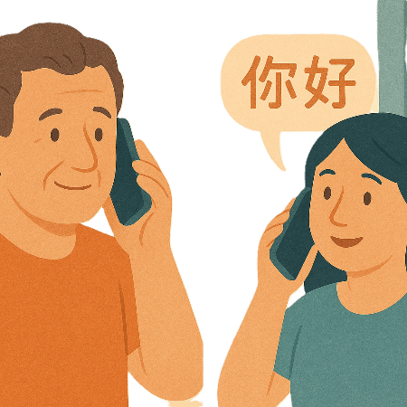 | If you speak a language other than English  - Call Translating and Interpreting Services.  1800 131 450
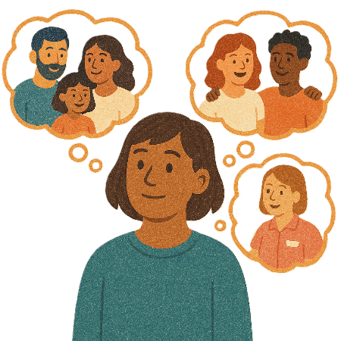 | You can ask for help to read this document.  You can ask  - A friend  - Family members  - A support person.
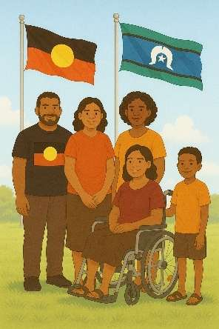 | We recognise Aboriginal and Torres Strait Islander people as the Traditional Owners of the land we live on.
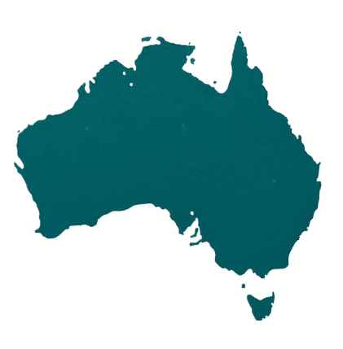 | They were the first people to live on and use the  - Land  - Waters.

Contents

About this document | 5
Australia’s Disability Strategy | 7
What are Targeted Action Plans | 8
What this TAP is trying to do | 11
Thinking about experiences | 15
National Actions | 18
Local government support | 19
Accessible transport | 22

About this document

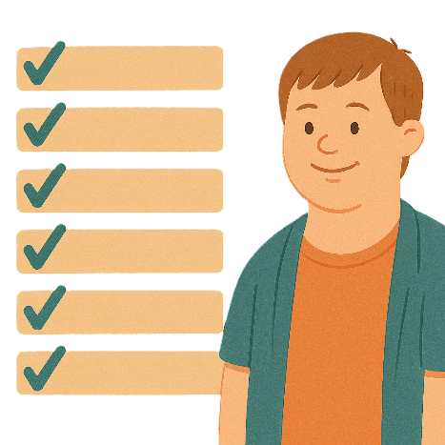 | This document talks about
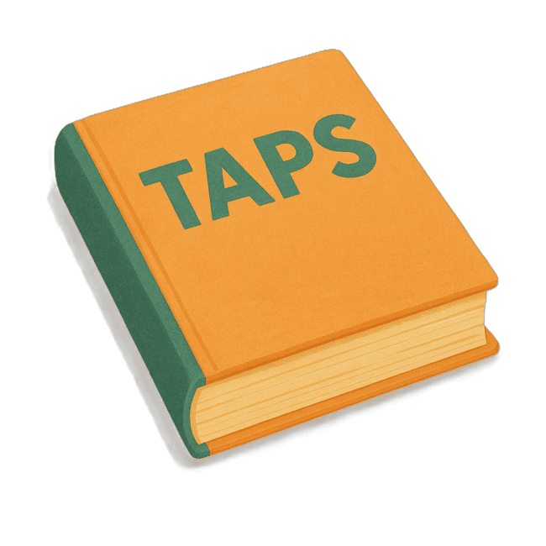 | - What are Targeted Action Plans  We call them TAPs for short.
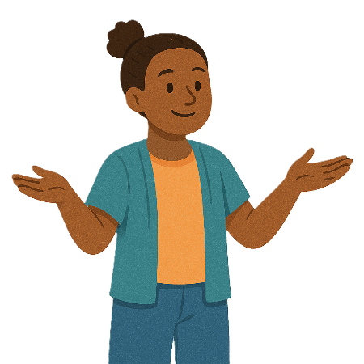 | - What the TAP is trying to do
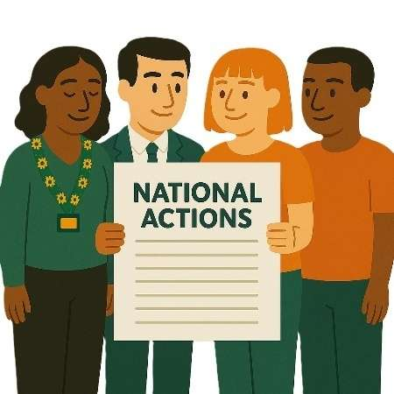 | - National actions  National Actions are things that all governments will do.  We want all parts of Australia to have the same way of doing things.
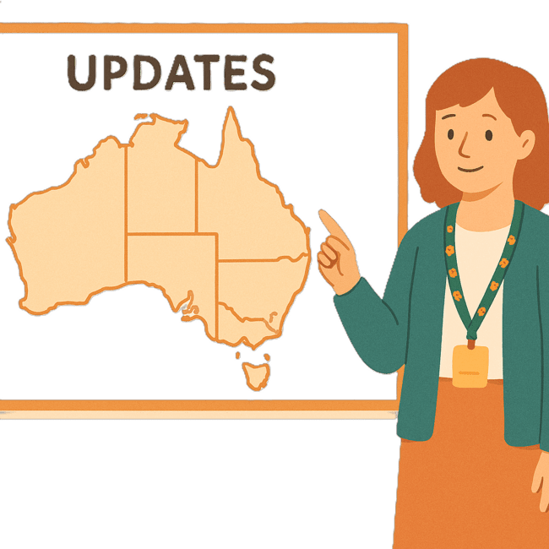 | We have other Easy Reads that talk about what the state and territory governments are doing.
 | You can go to our website to read the updates from the states and territories.  www.disabilitygateway.gov.au/ads/easy-read-strategy  It is in Easy Read.

Australia’s Disability Strategy

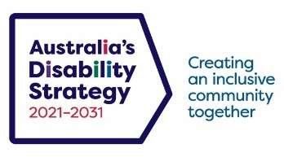 | The government set up Australia’s Disability Strategy.  We call it the Strategy for short.  It was also called ADS.
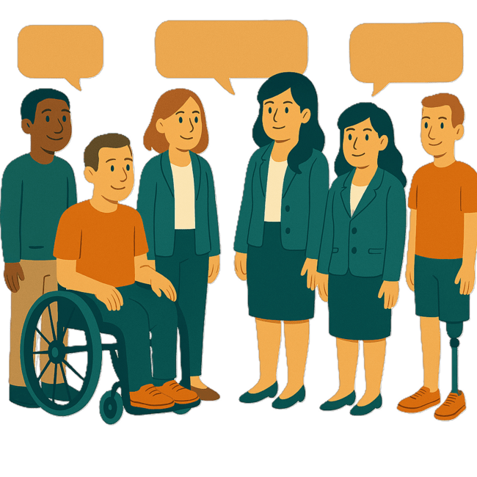 | The Strategy is the governments way of working together to support people with disability to live good lives.  They do this by working with  - People with disability  - The community.  This makes the community a more welcoming place for everyone.

What are Targeted Action Plans

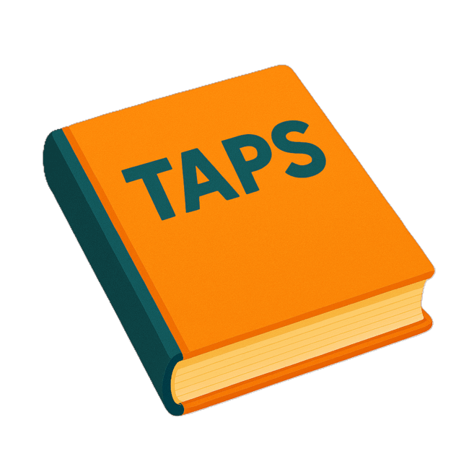 | We made small plans to help us work on the Strategy.  The small plans are called Targeted Action Plans.  We call them TAPs for short.
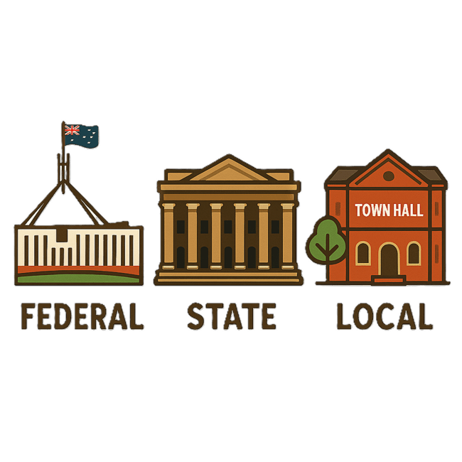 | TAPs are made by all governments in Australia.  All governments include  - Australian Government  - State and territory governments  - Local governments.
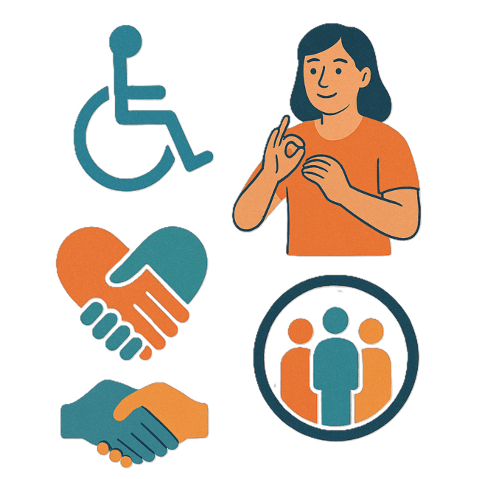 | There are 3 TAPs.  - Community Attitudes
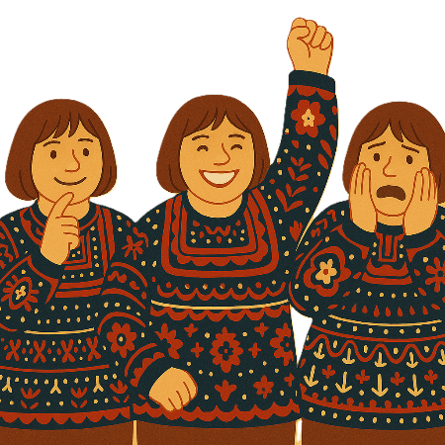 | Attitudes are what people  - Think  - Feel  - Believe.
 | - Inclusive Homes and Communities
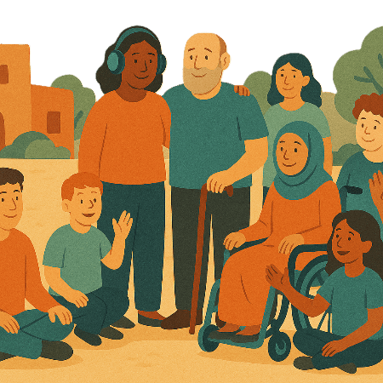 | Inclusive is when everyone  - Can take part  - Feel like they belong.
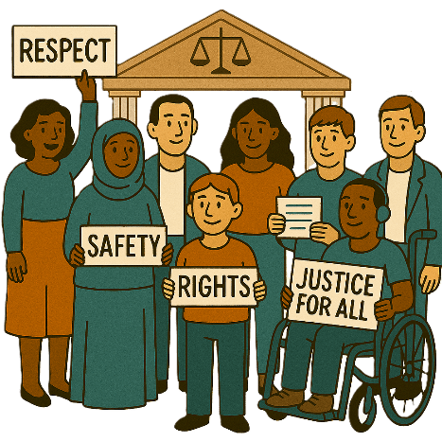 | - Safety Rights and Justice
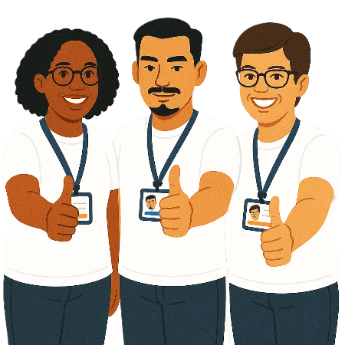 | Rights are rules about treating everyone  - Fair  - Equal.
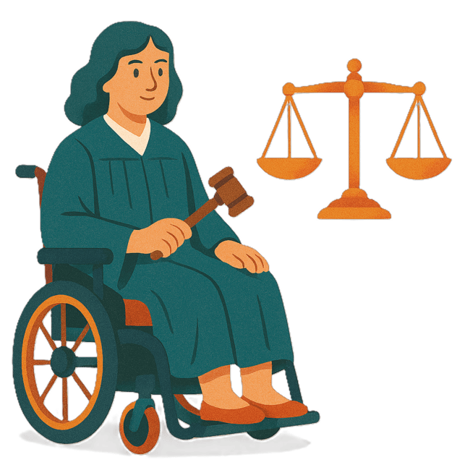 | Justice is  - The law  - Police  - The courts  - Prisons.  Laws are rules for how we live.

What this TAP is trying to do

 | This document talks about the TAP Inclusive Homes and Communities.
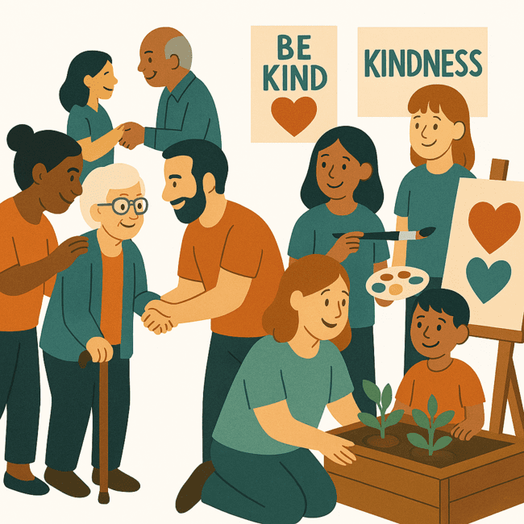 | This TAP wants to make sure people with disability can take part in their community.
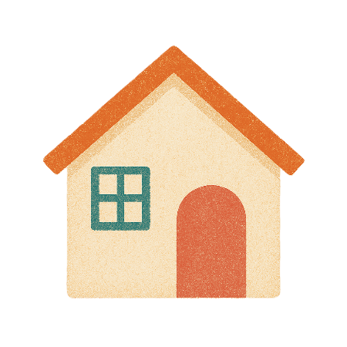 | We want to make sure there is good access to  - Housing
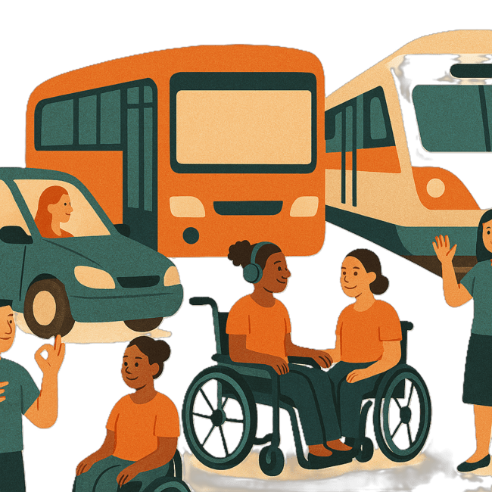 | - Transport  Transport is how people move from one place to another.  You can use  - Cars  - Buses  - Trains.
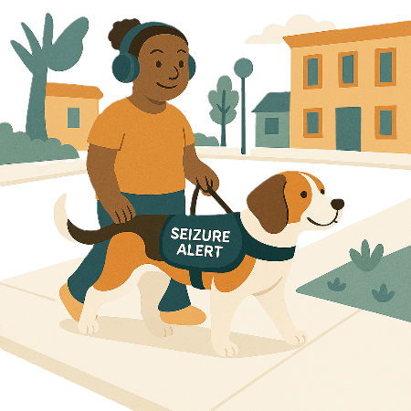 | - Spaces in public
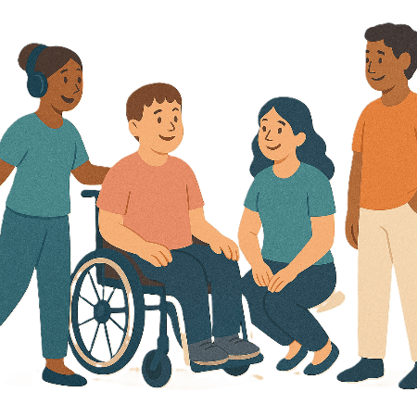 | - Social accessibility  Social accessibility is making sure everyone can  - Join in  - Talk to others  - Be part of the community.
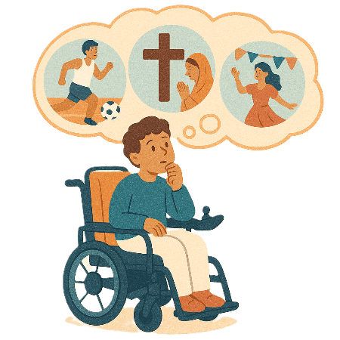 | This TAP wants  - People with disability to be able to take part in their communities  Like  - Religion  - Sport  - Cultural events.
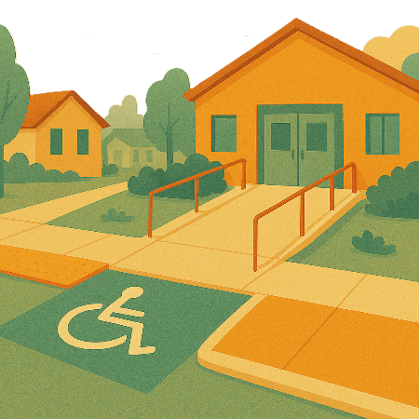 | - Public spaces to be accessible  Accessible means everyone can use it.  This includes  - Buildings  - Streets  - Parks.
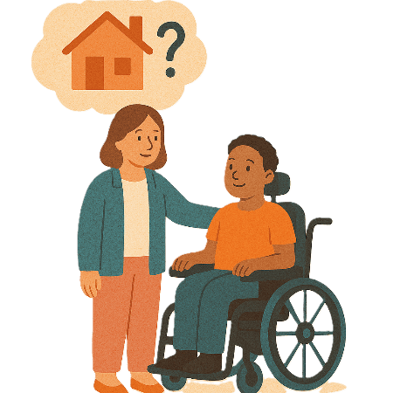 | - People with disability to have accessible homes and be able to choose  - Where to live
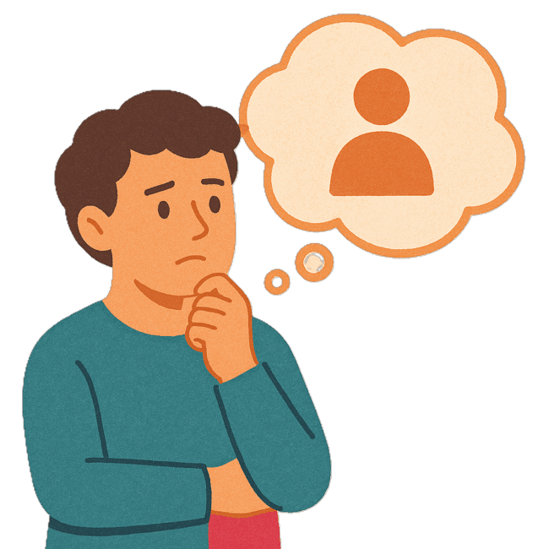 | - Who to live with
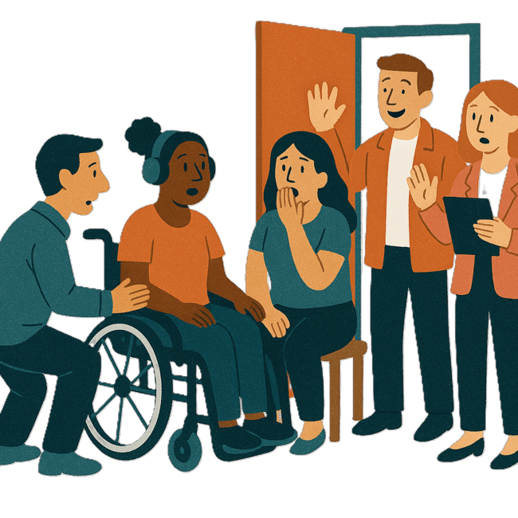 | - Who comes into their home
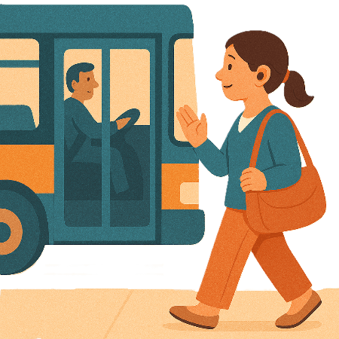 | - Transport that is easy for everyone to use.

Thinking about experiences

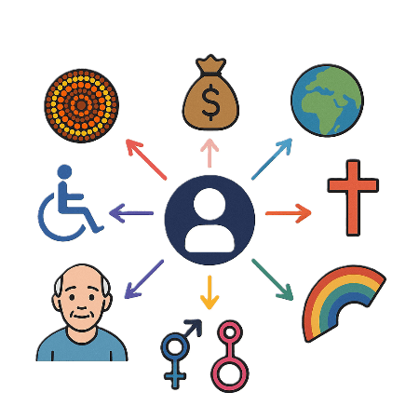 | This TAP will look at how to  - Support people with disability and the different parts of who they are.  This might change what their experience is like.  This is called intersectionality.
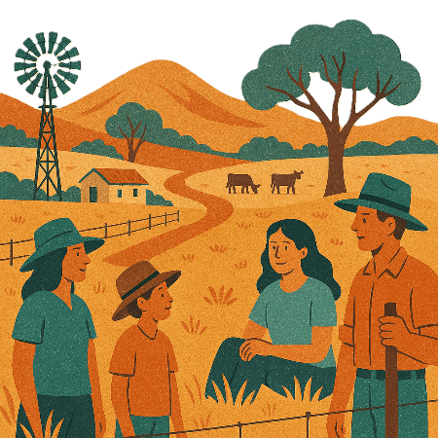 | This could be  - People with disability who live in rural or remote areas
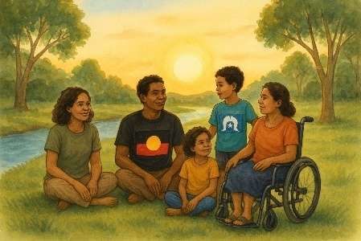 | - First Nations people with disability
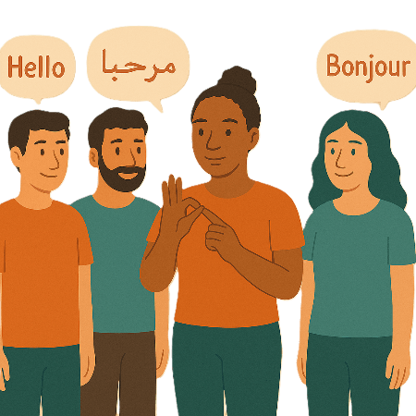 | - People who speak different languages
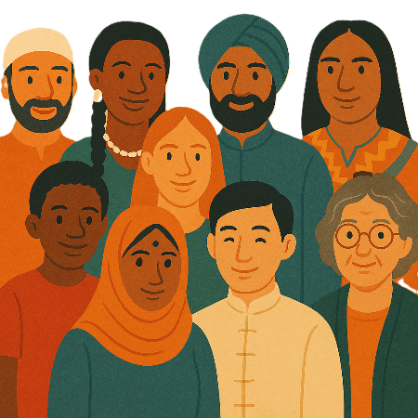 | - People from different cultures
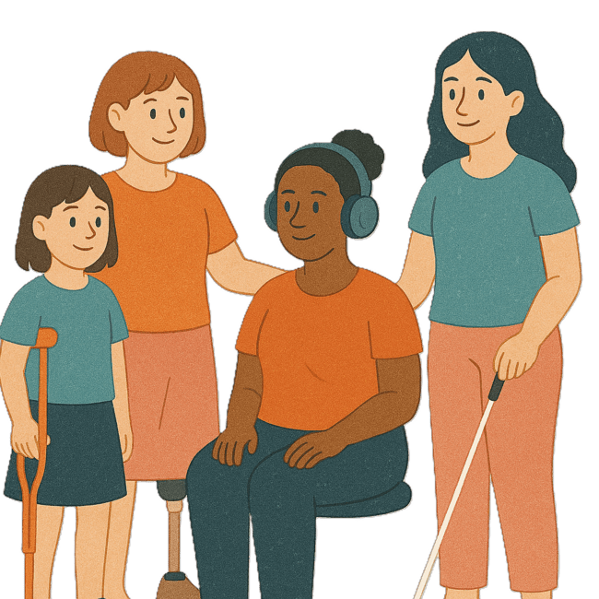 | - Women and girls with disability
 | - People with disability who are LGBTQIA+
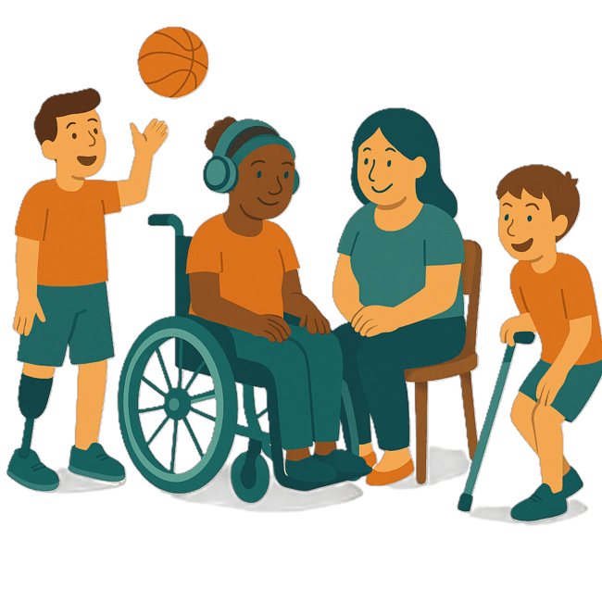 | - Children and young people with disability.
 | Some people fit into more than 1 of these groups.

National Actions

The Australian Government will work with people with disability on this TAP.

All governments will put the plan into action.
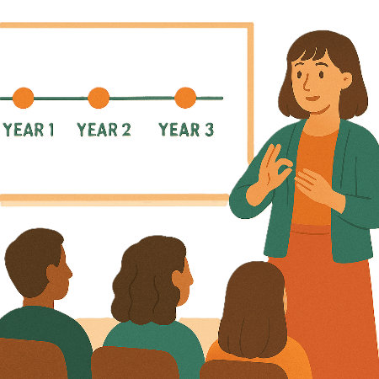 | All governments will work on the actions over the next 3 years.
 | They will also work with people with disability.

Local government support

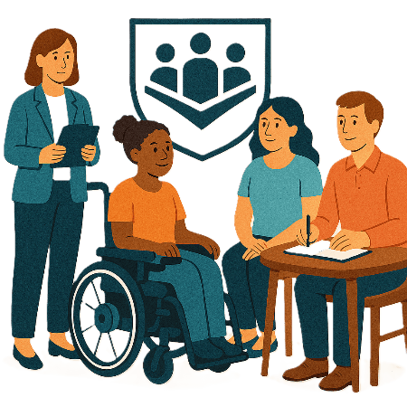 | 1 of the actions is to help local councils.  The Australian Local Government Association helps councils.  We call them ALGA for short.
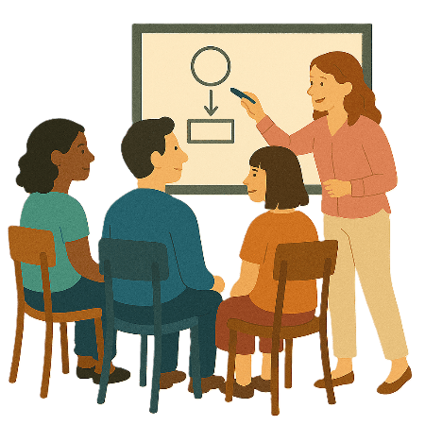 | ALGA will help councils by  - Updating a guide for including people with disability in making plans
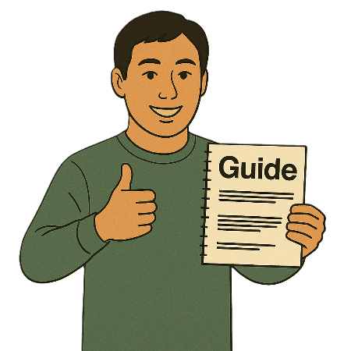 | A guide says  - How things should be done  - Step by step what to do  - Can give recommendations.  Recommendations are ideas to do things better.
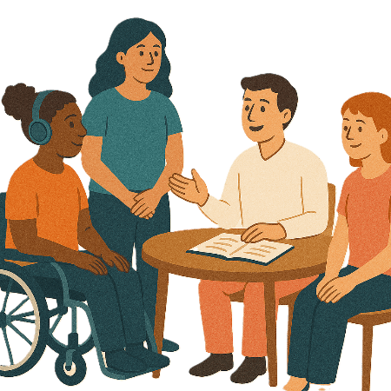 | - Making a Disability Network and Community of Practice  Community of practice is a group of people who talk about a topic.  They  - Share ideas  - Learn from each other.
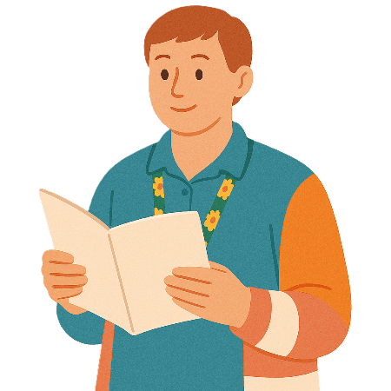 | - Sharing a booklet of all the disability projects that councils have done
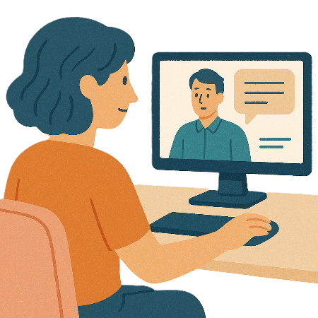 | ALGA will also have  - Webinars  A webinar is when you watch someone on your computer talk about something.
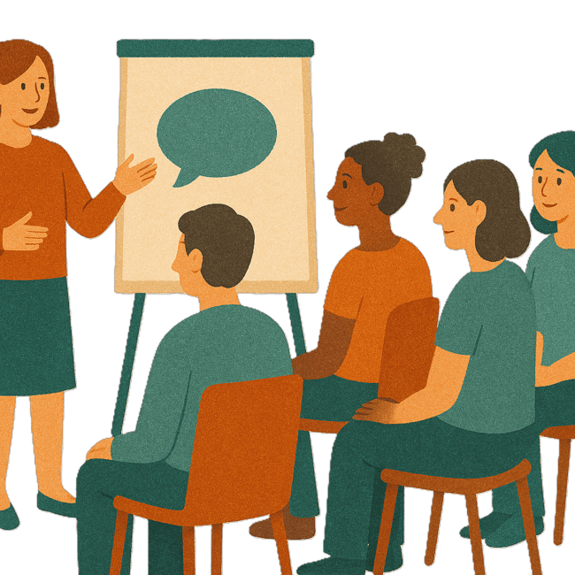 | - Workshops  A workshop is when a group of people meet to talk about something.
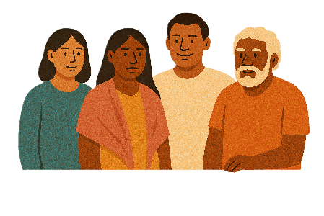 | ALGA will use ideas from  - First Nations Councils
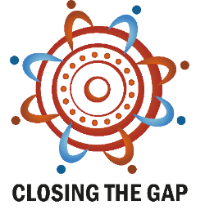 | - What has been learned from the Closing the Gap Agreement.

Accessible transport

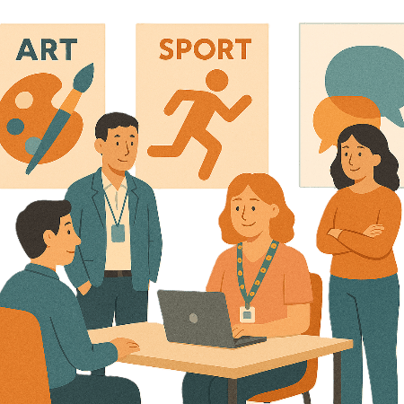 | The Department of Infrastructure Transport Regional Development Communications Sport and the Arts are working on standards.  We call them DITRDCSA for short.
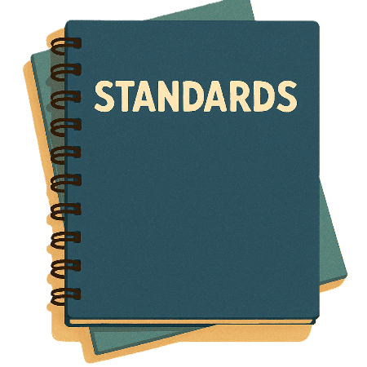 | Standards are rules that people need to follow for something.  It makes sure that everyone is doing the same good work.
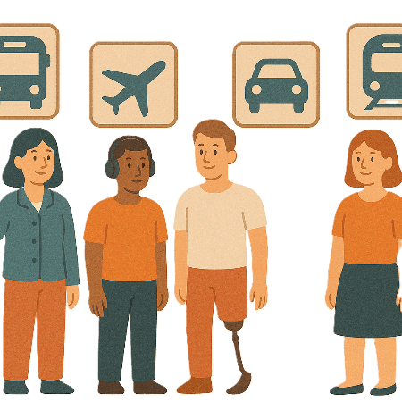 | The standards are called the Disability Standards for Accessible Public Transport 2002.  We call it Transport Standards for short.
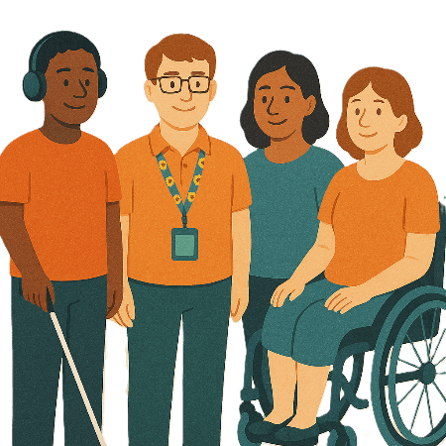 | DITRDCSA are working on the Transport Standards with  - People with disability
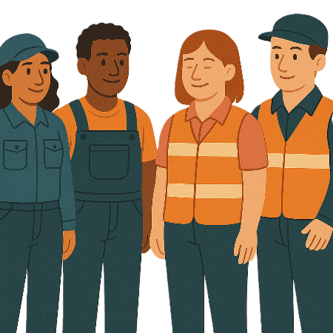 | - Transport providers
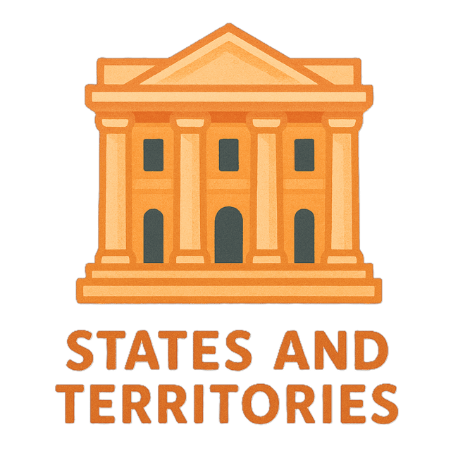 | - State and territory governments.
The Transport Standards will make public transport more accessible for people with disability.

Public transport is

- Buses
- Trains
- Taxis.
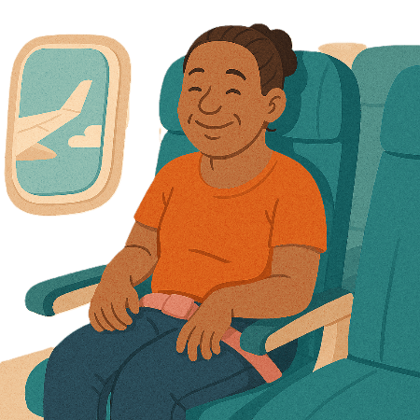 | DITRDCSA is also working to make  - Flying on planes more accessible for people with disability.  They will make new disability standards for air travel.
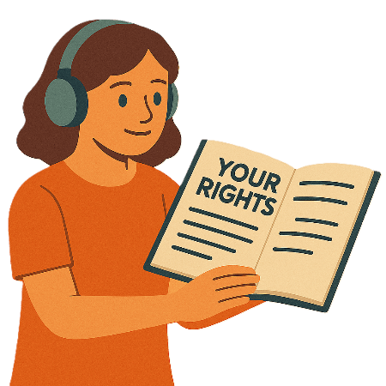 | The new standards will say what  - Rights people with disability have for air travel
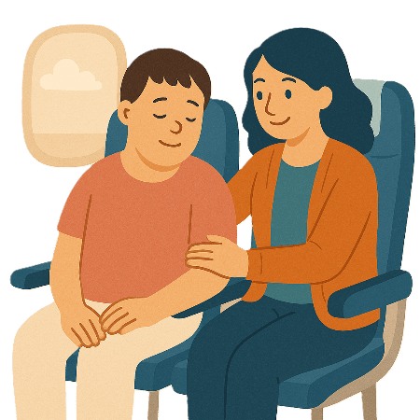 | - Airlines need to do to support people with disability
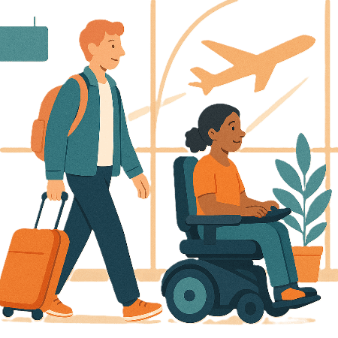 | - Airports need to do to support people with disability.

Images in this Easy Read must not be used or copied without permission

