Australia’s Disability Strategy 2021 to 2031

Targeted Action Plans Report

2025

Northern Territory update
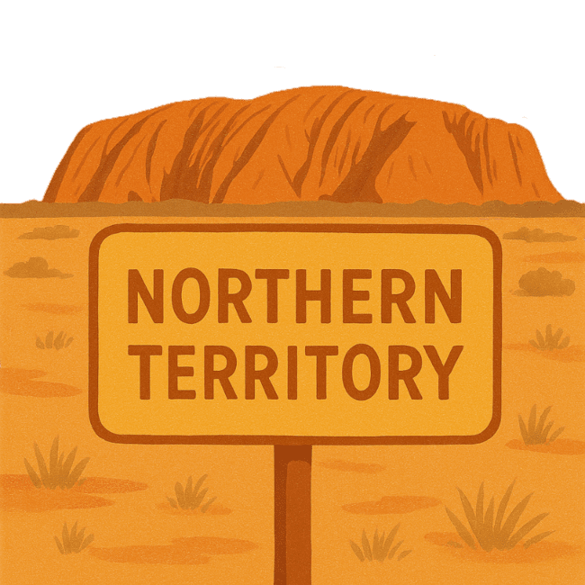
 | The Australian Government Department of Health Disability and Ageing wrote this.  We say DHDA for short.  When you see the word we it means DHDA.
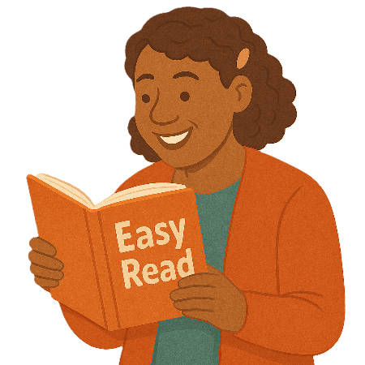 | We wrote this in an easy to read way.  We use pictures to explain some ideas.
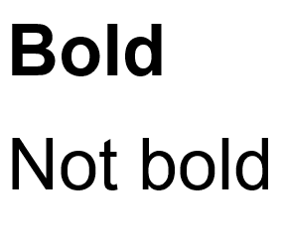 | We have some words in bold.  This means the letters are thicker and darker.  These are important words.
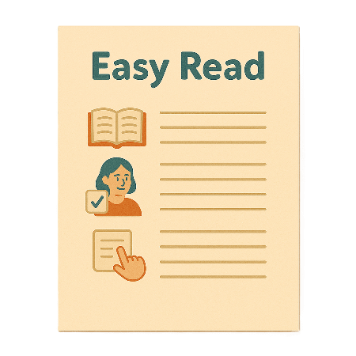 | This is an Easy Read summary of another document.  This means it has the most important ideas.
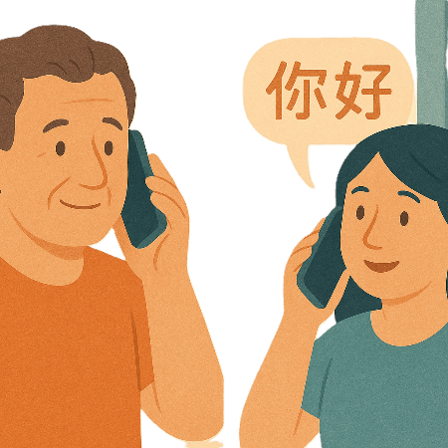 | If you speak a language other than English  - Call Translating and Interpreting Services.  1800 131 450
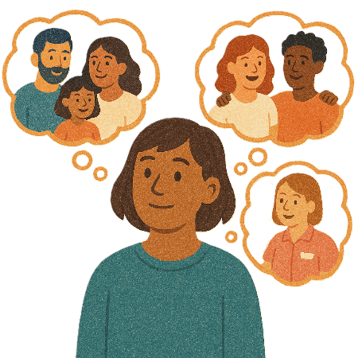 | You can ask for help to read this document.  You can ask  - A friend  - Family members  - A support person.
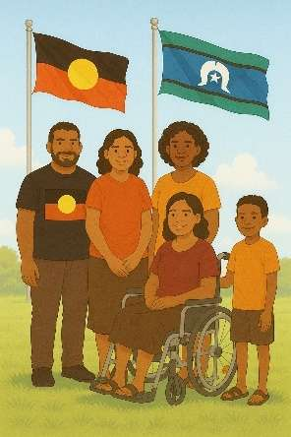 | We recognise Aboriginal and Torres Strait Islander people as the Traditional Owners of the land we live on.
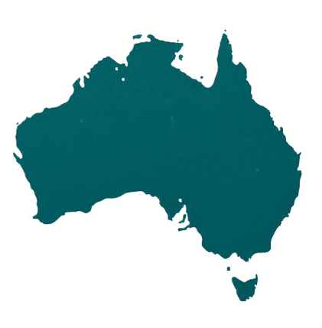 | They were the first people to live on and use the  - Land  - Waters.

Contents

About this document | 5
Australia’s Disability Strategy | 8
What are Targeted Action Plans | 9
Northern Territory Update | 11
Community Attitude TAP | 13
Safety Rights and Justice TAP | 17

About this document

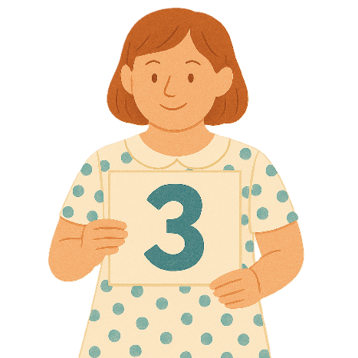 | This document has 3 parts
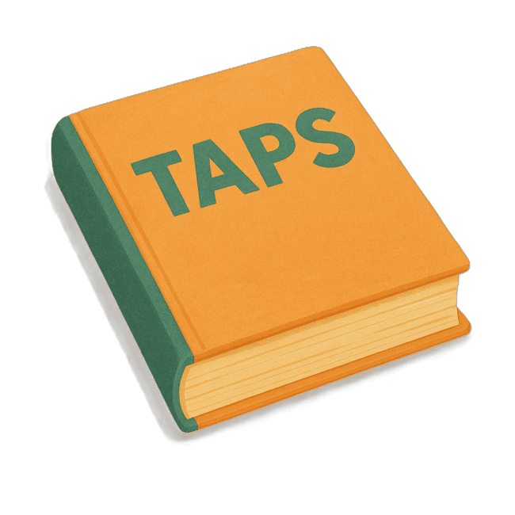 | Part 1 talks about  - What are Targeted Action Plans  We call them TAPs for short.
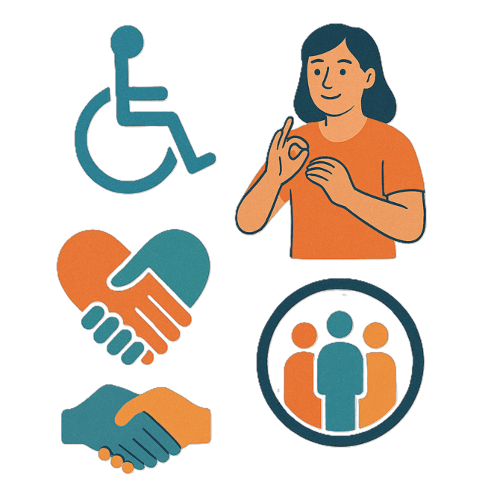 | Part 2 talks about  - Community Attitudes TAP
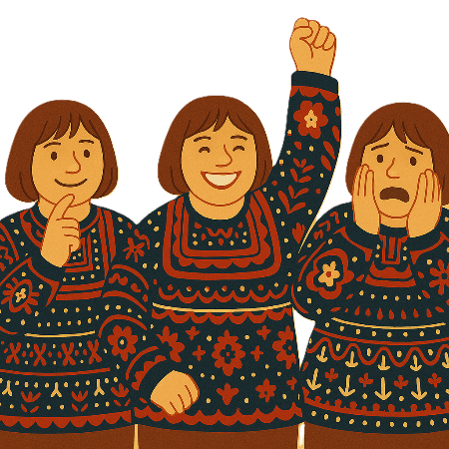 | Attitudes are what people  - Think  - Feel  - Believe.
Part 3 talks about

- Safety Rights and Justice TAP
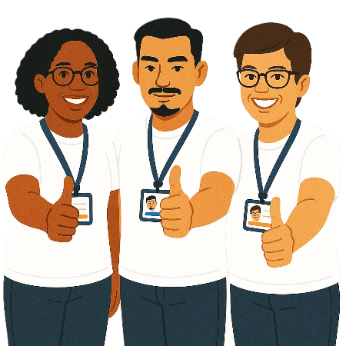 | Rights are rules about treating everyone  - Fair  - Equal.
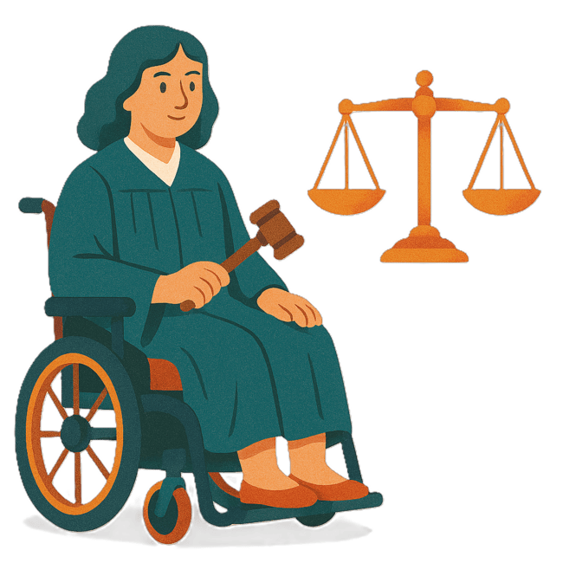 | Justice is  - The law  - Police  - The courts  - Prisons.  Laws are rules for how we live.
 | You can go to our website to read the updates from other states and territories.  www.disabilitygateway.gov.au/ads/easy-read-strategy  It is in Easy Read.

Australia’s Disability Strategy

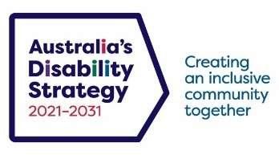 | The government set up Australia’s Disability Strategy.  We call it the Strategy for short.  It was also called ADS.
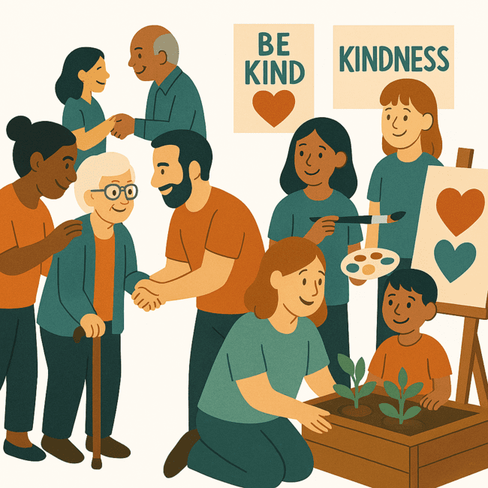 | The Strategy is the governments way of working together to support people with disability to live good lives.  They do this by working with  - People with disability  - The community.  This makes the community a more welcoming place for everyone.

What are Targeted Action Plans

We made small plans to help us work on the Strategy.

The small plans are called TAPs.
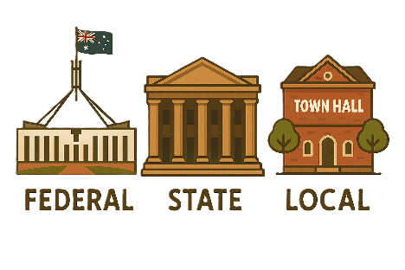 | TAPs are made by all governments in Australia.  All governments include  - Australian Government  - State and territory governments  - Local governments.
There are 3 TAPs.

- Community Attitudes
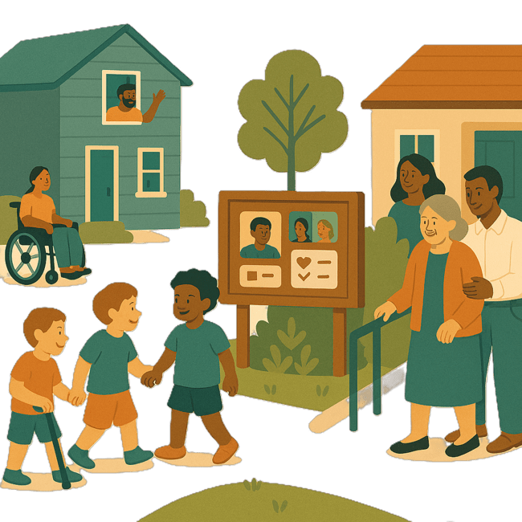 | - Inclusive Homes and Communities
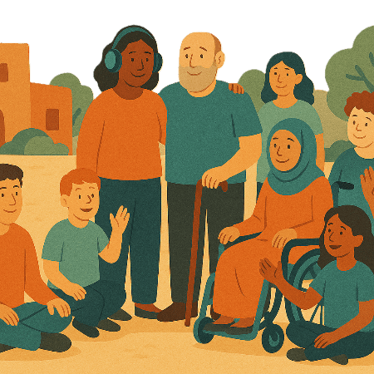 | Inclusive is when everyone  - Can take part  - Feel like they belong.
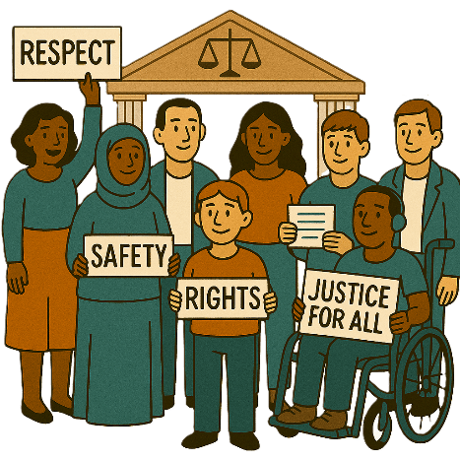 | - Safety Rights and Justice
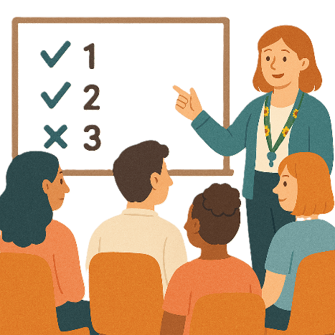 | Some governments do not have actions in all 3 TAPs.  They might have actions in only some of TAPs.

Northern Territory update
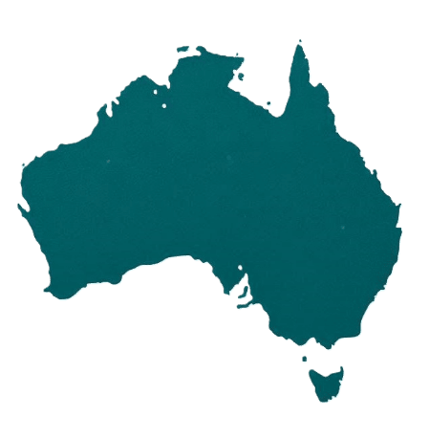 | Each state and territory government have made their own actions.  This makes sure that they meet the needs of their communities.  Actions are the things that we will do.
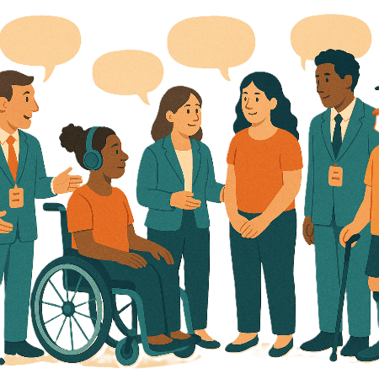 | Each government says how the actions will include  - People with disability
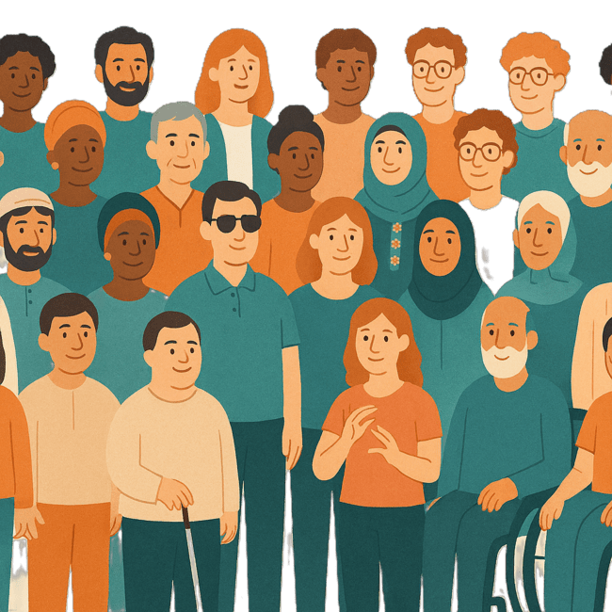 | - The disability community.
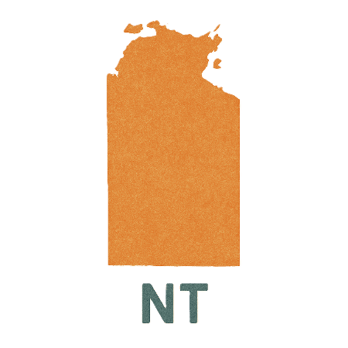 | This document talks about some actions Northern Territory government is doing in their 2 TAPs.  We call them NT for short.

Community Attitudes TAP

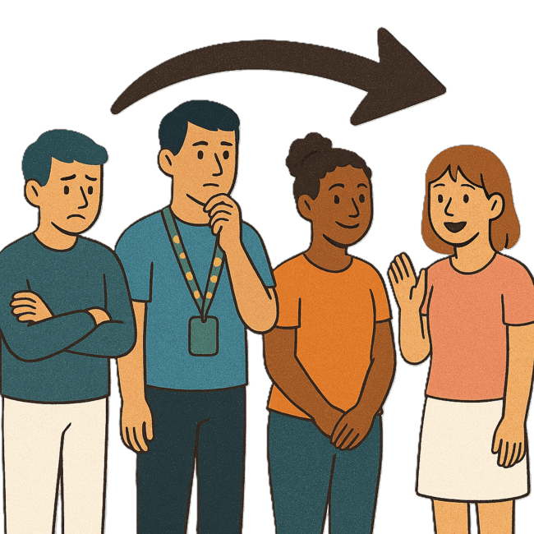 | This TAP wants to change  - How people behave  Behave means  - How you act  - What you do.
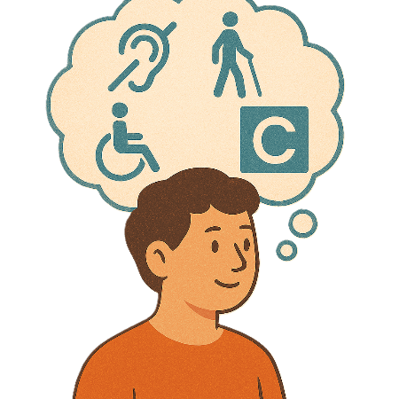 | What people think about disability.
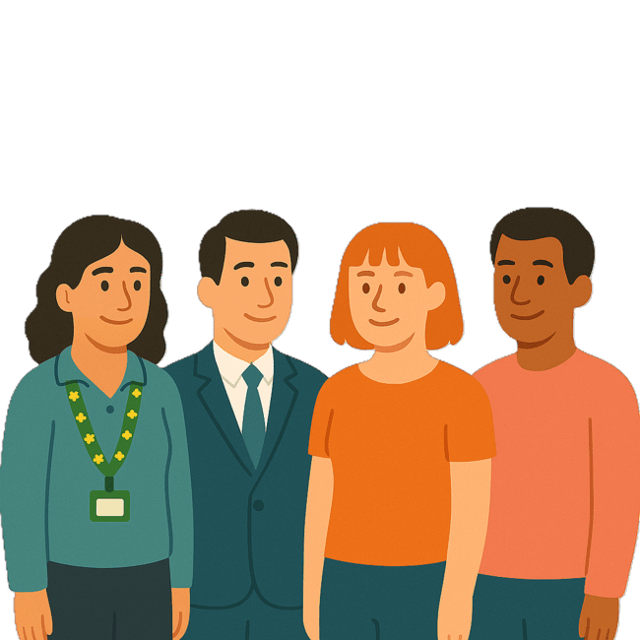 | The NT government is working to help people with disability get jobs with them.
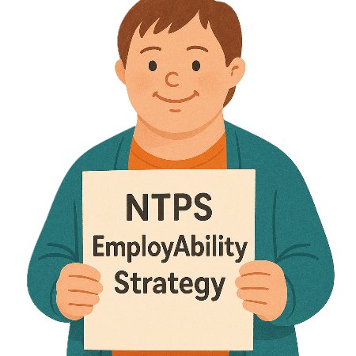 | They have written the  - Northern Territory Public Service EmployAbility Strategy  We call it NTPS EmployAbility Strategy for short.
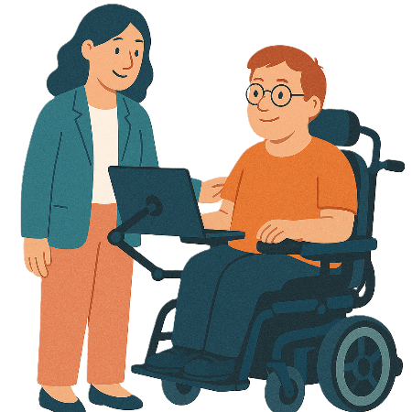 | The NTPS EmployAbility Strategy says people with disability can get help with  - Better assistive technology and things to help at work
 | Assistive technology can be things to help you  - Speak  - Move  - See  - Hear.
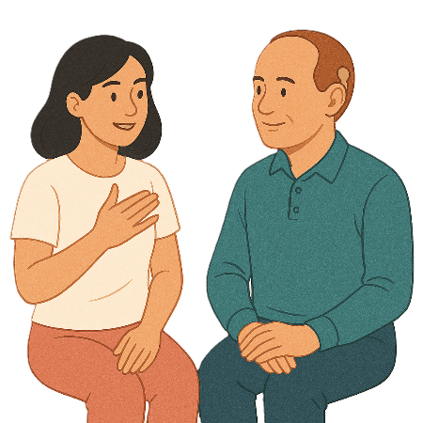 | - Leadership mentoring  Mentors are someone you talk to for advice.
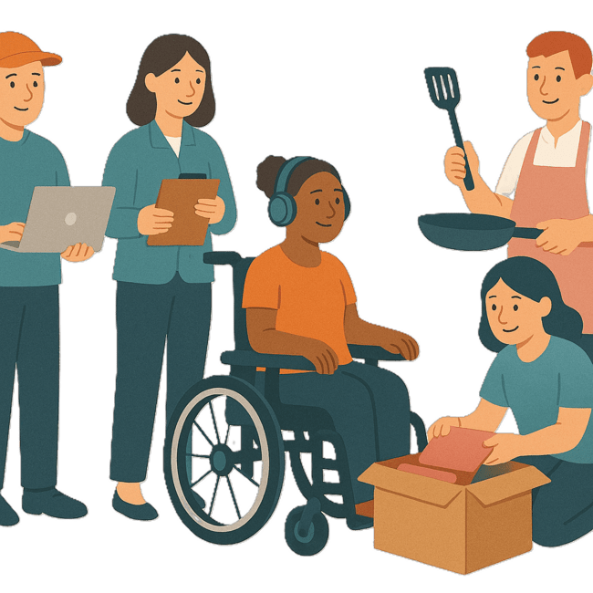 | Support for disability programs like  - Employment programs  Employment is  - Having a job  - Going to work  - Getting money for the work you do.
 | - Graduate programs  A graduate program is a program when someone has finished learning at university.  They start a new job using the skills they learned.
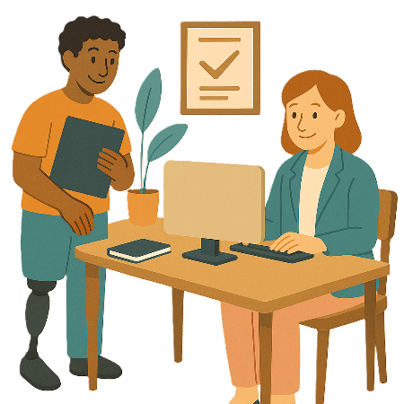 | - Trainee program.  Trainee programs are when you learn while you work.

Safety Rights and Justice TAP

 | This TAP wants to make sure people with disability are  - Safe  - Treated fairly.
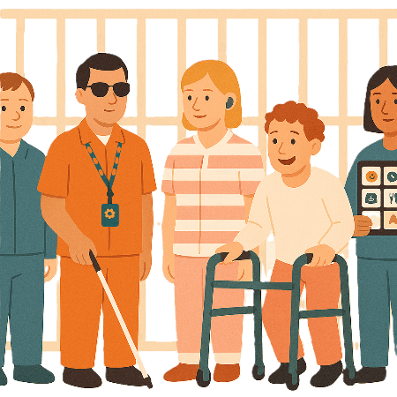 | The NT Department of Corrections is working on ways to support people with disability in prison.  We call them DoC for short.
 | They are  - Improving the ways things are done
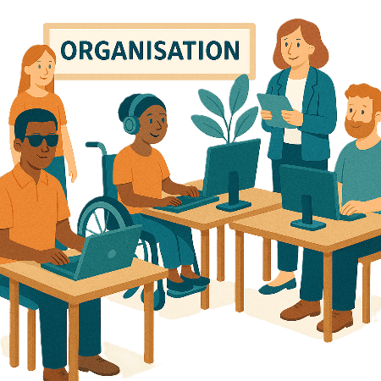 | - Looking for ways to work with community organisations
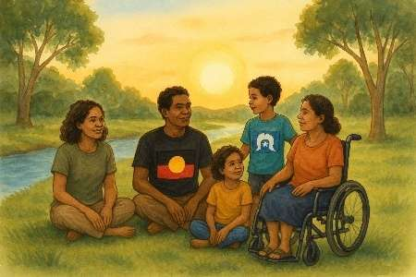 | - Making sure workers are respecting people they support  Like  - First Nations people
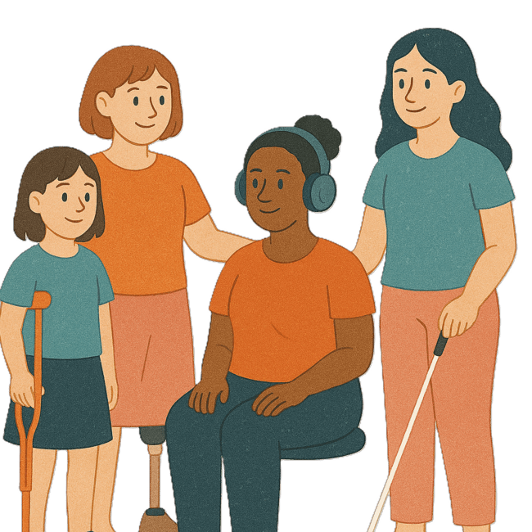 | - Women
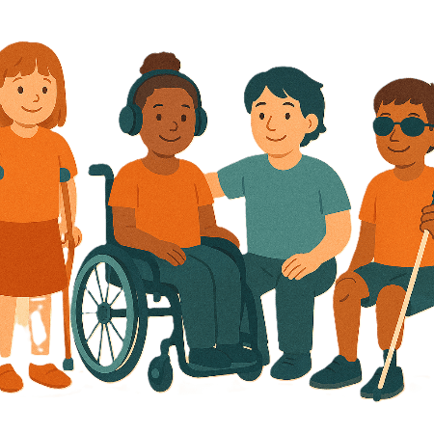 | - Young people
 | - LGBTQIA+ people.
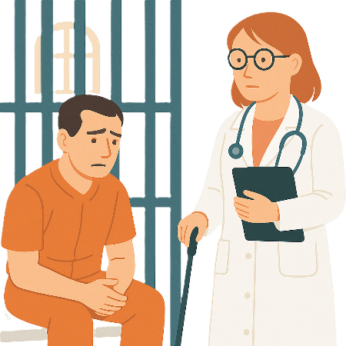 | Some people with disability in prison might have  - Health needs
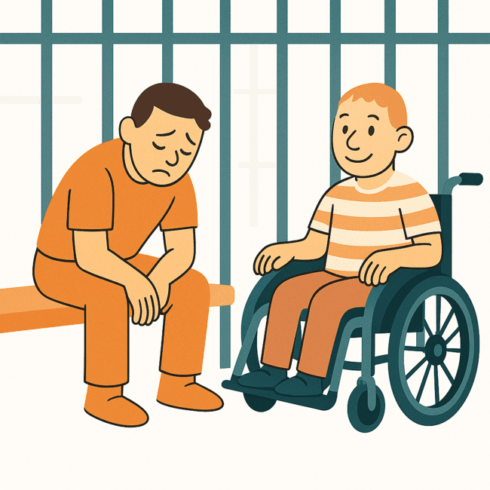 | - Emotional needs.
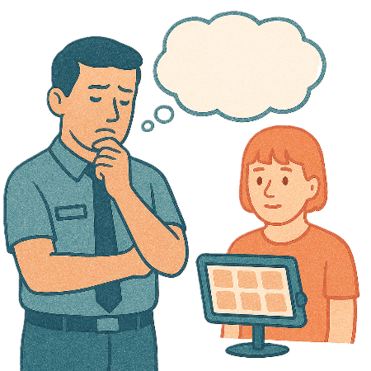 | Prisons need to think of these needs.
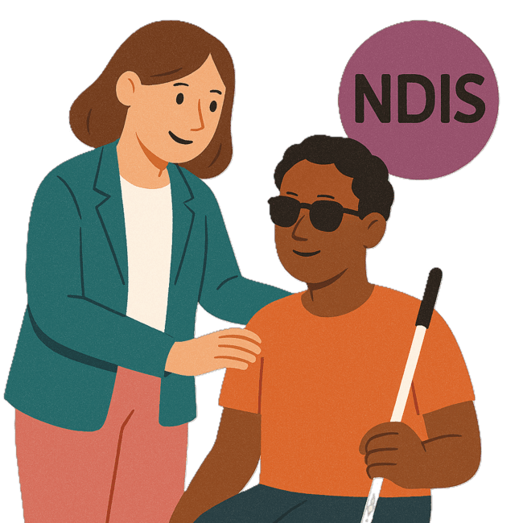 | Some people with disability in prison already have NDIS supports.
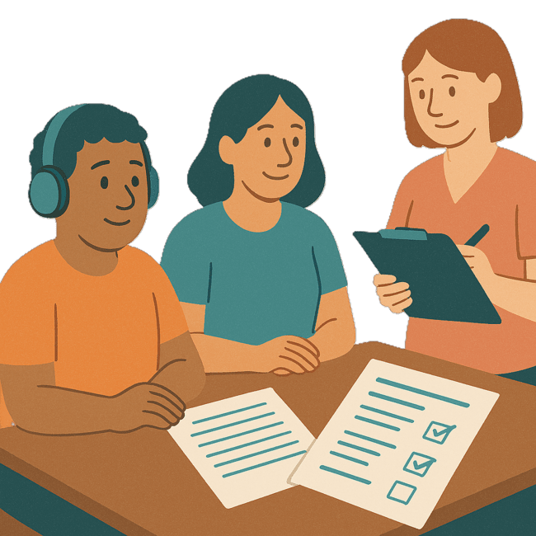 | More people with disability are getting assessments done by allied health workers.  Assessments help us work out what support you need.
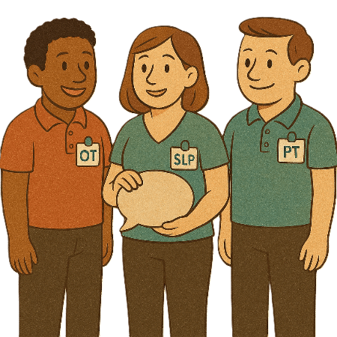 | Allied health workers support people with their health.  They can be people like occupational therapists.  We call them OT for short.
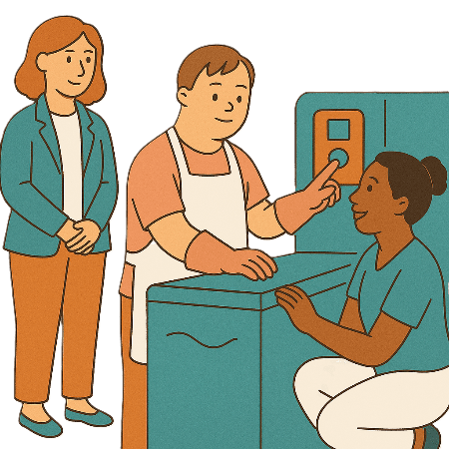 | All workers doing assessments need to take part in clinical supervision.  Clinical supervision helps workers  - Do their job safely
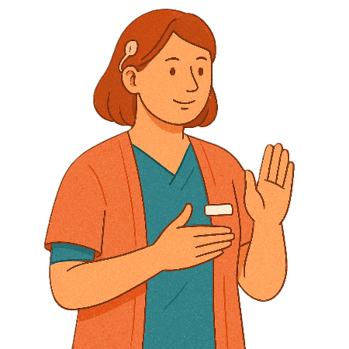 | - Make sure their work is respectful
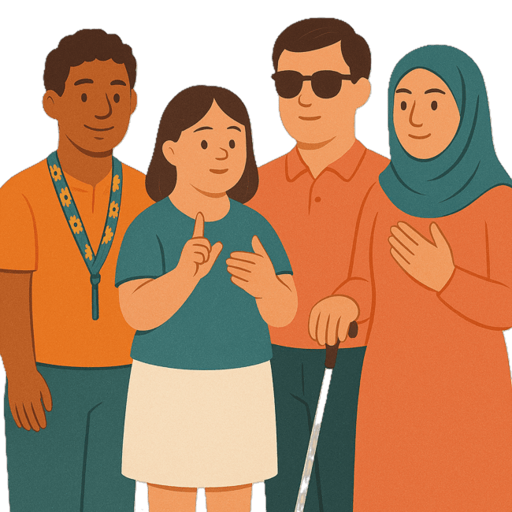 | - Are culturally safe  Culturally safe means respecting peoples  - Rights  - Cultures  - Traditions.  This helps people feel safe to be themselves.
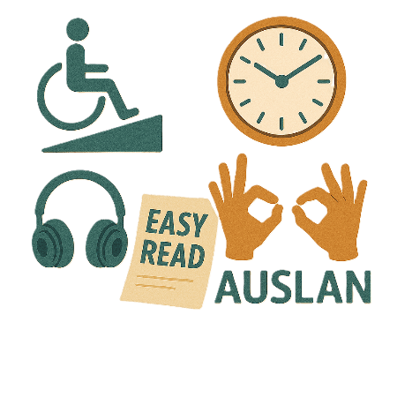 | - Meet each persons needs.

Images in this Easy Read must not be used or copied without permission

