Australia’s Disability Strategy 2021 to 2031

Targeted Action Plans Report

2025
Queensland update
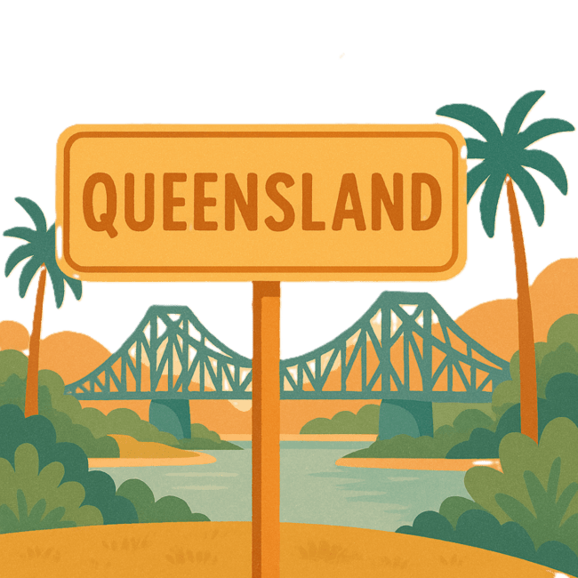
 | The Australian Government Department of Health Disability and Ageing wrote this.  We say DHDA for short.  When you see the word we it means DHDA.
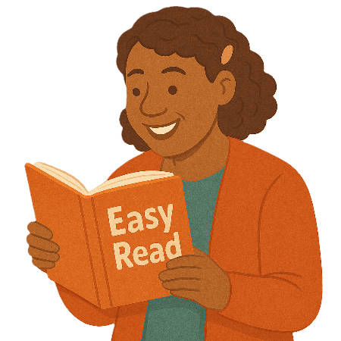 | We wrote this in an easy to read way.  We use pictures to explain some ideas.
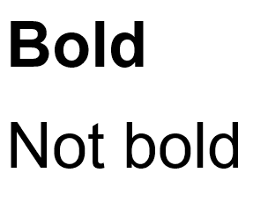 | We have some words in bold.  This means the letters are thicker and darker.  These are important words.
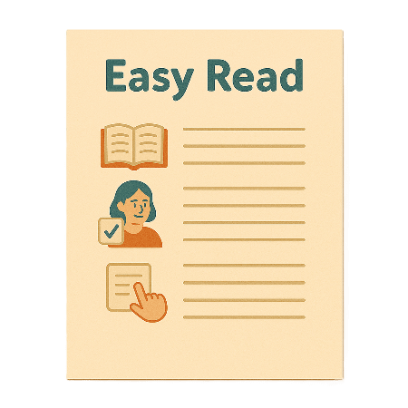 | This is an Easy Read summary of another document.  This means it has the most important ideas.
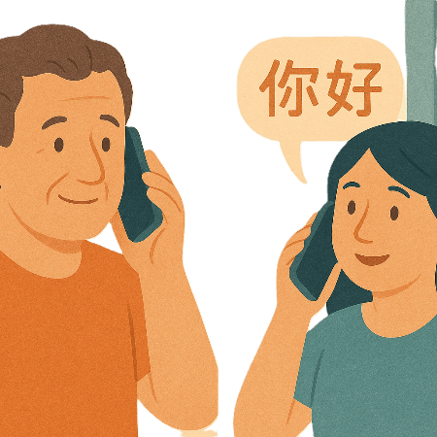 | If you speak a language other than English  - Call Translating and Interpreting Services.  1800 131 450
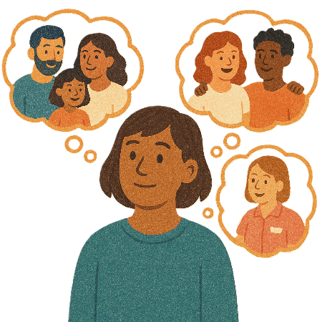 | You can ask for help to read this document.  You can ask  - A friend  - Family members  - A support person.
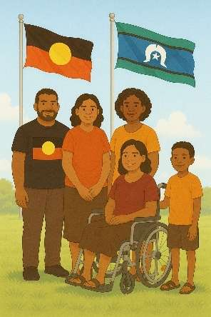 | We recognise Aboriginal and Torres Strait Islander people as the Traditional Owners of the land we live on.
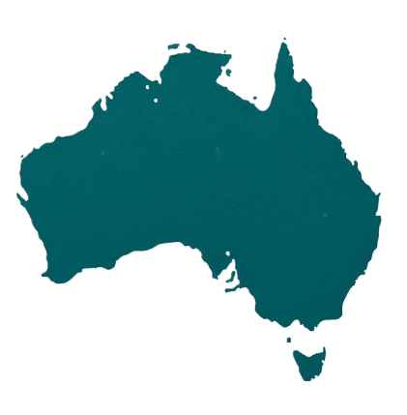 | They were the first people to live on and use the  - Land  - Waters.

Contents

About this document | 5
Australia’s Disability Strategy | 8
What are Targeted Action Plans | 9
Queensland Update | 11
Community Attitude TAP | 13
Inclusive Homes and Communities TAP | 18
Safety Rights and Justice TAP | 21

About this document

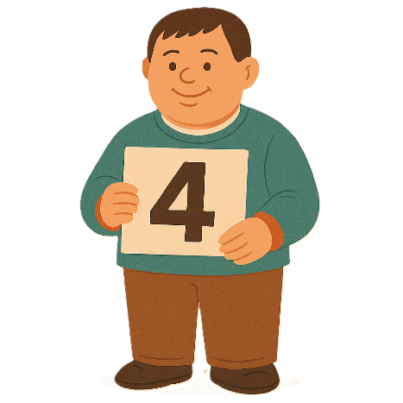 | This document has 4 parts
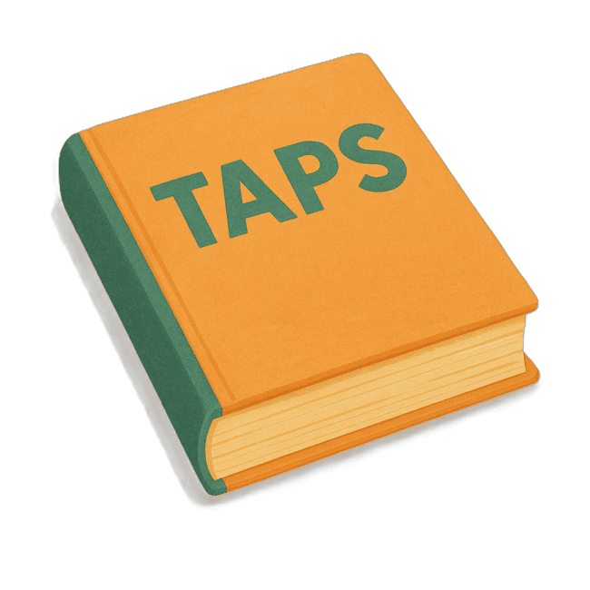 | Part 1 talks about  - What are Targeted Action Plans  We call them TAPs for short.
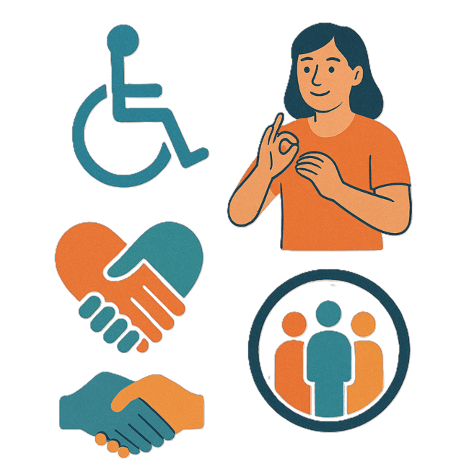 | Part 2 talks about  - Community Attitudes TAP
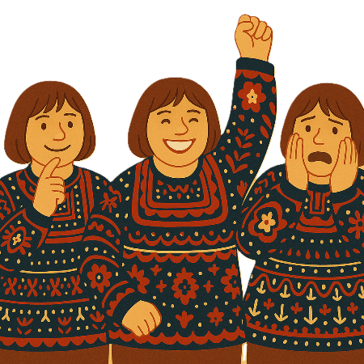 | Attitudes are what people  - Think  - Feel  - Believe.
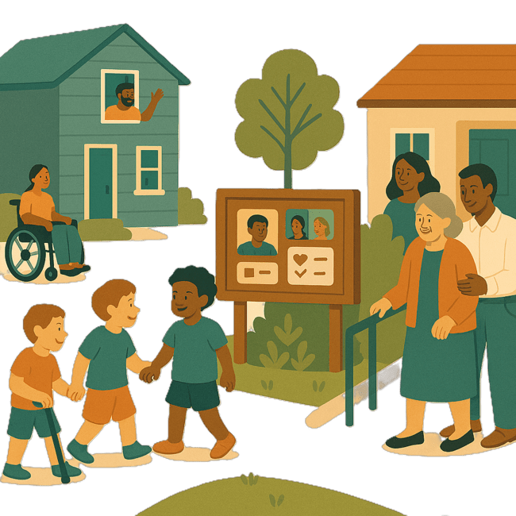 | Part 3 talks about  - Inclusive Homes and Communities TAP
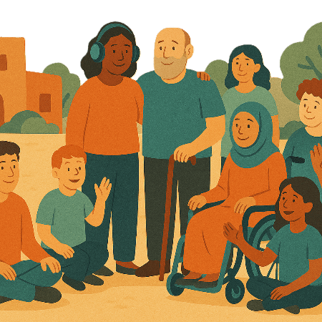 | Inclusive is when everyone  - Can take part  - Feel like they belong.
Part 4 talks about

- Safety Rights and Justice TAP

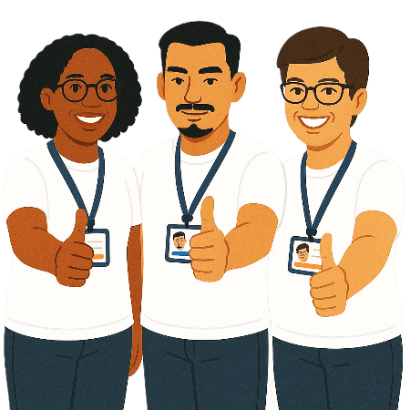 | Rights are rules about treating everyone  - Fair  - Equal.
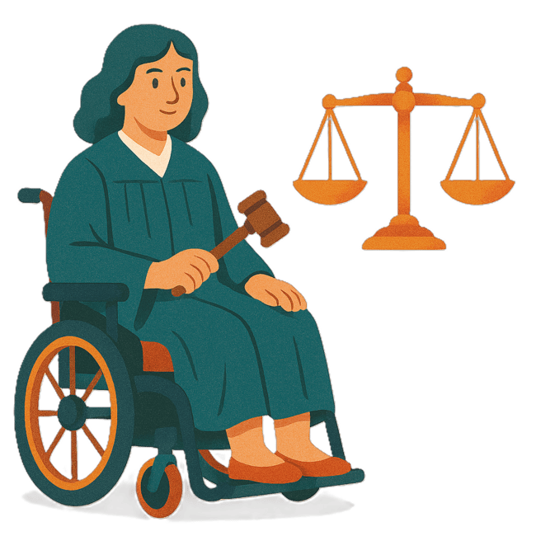 | Justice is  - The law  - Police  - The courts  - Prisons.  Laws are rules for how we live.
 | You can go to our website to read the updates from other states and territories.  www.disabilitygateway.gov.au/ads/easy-read-strategy  It is in Easy Read.

Australia’s Disability Strategy

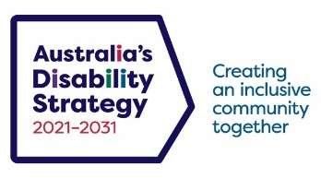 | The government set up Australia’s Disability Strategy.  We call it the Strategy for short.  It was also called ADS.
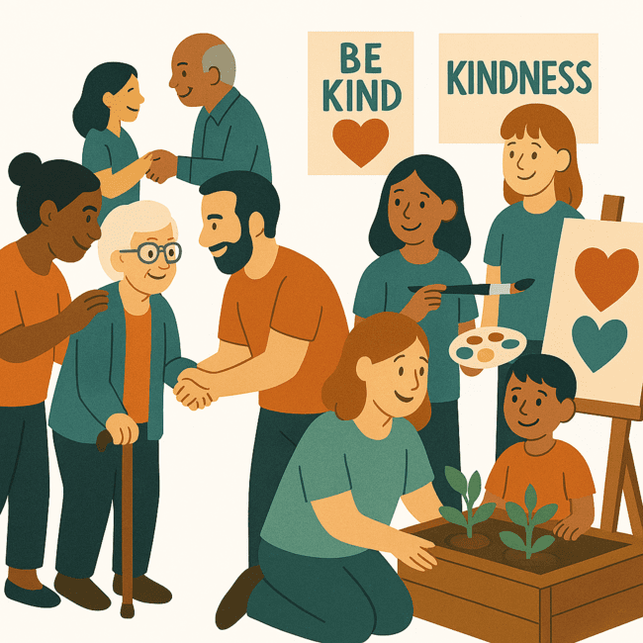 | The Strategy is the governments way of working together to support people with disability to live good lives.  They do this by working with  - People with disability  - The community.  This makes the community a more welcoming place for everyone.

What are Targeted Action Plans

We made small plans to help us work on the Strategy.

The small plans are called TAPs.
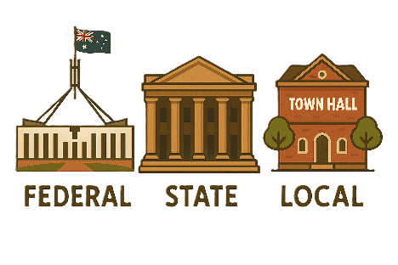 | TAPs are made by all governments in Australia.  All governments include  - Australian Government  - State and territory governments  - Local governments.
There are 3 TAPs.

- Community Attitudes
 | - Inclusive Homes and Communities
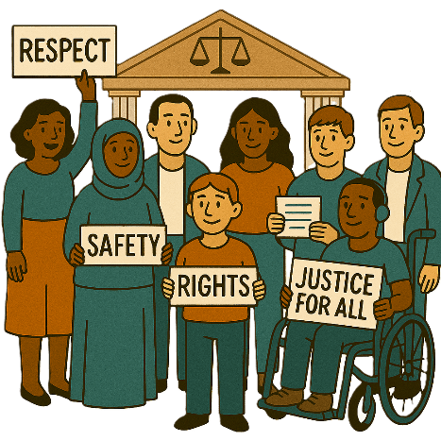 | - Safety Rights and Justice

Queensland update

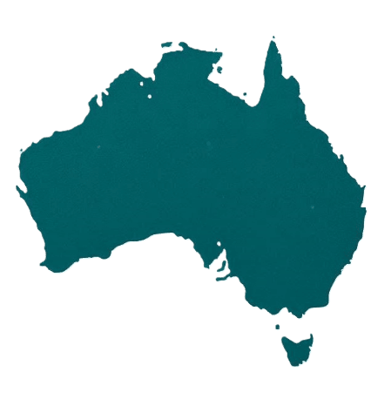 | Each state and territory government have made their own actions.  This makes sure that they meet the needs of their communities.  Actions are the things that we will do.
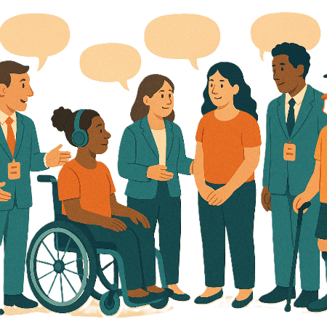 | Each government says how the actions will include  - People with disability
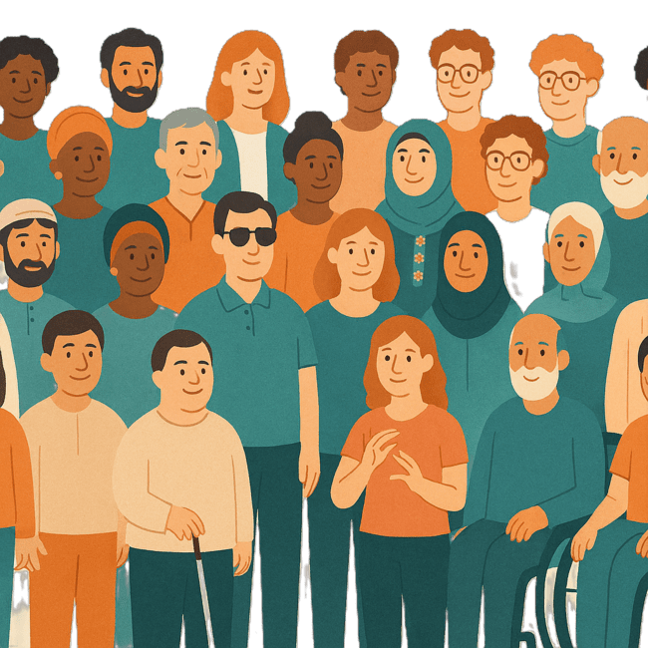 | - The disability community.
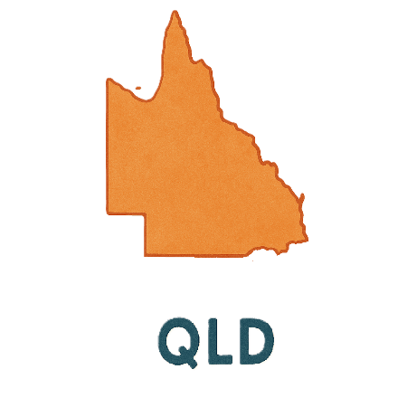 | This document talks about some actions Queensland government is doing in the 3 TAPs.  We call them QLD for short.

Community Attitudes TAP

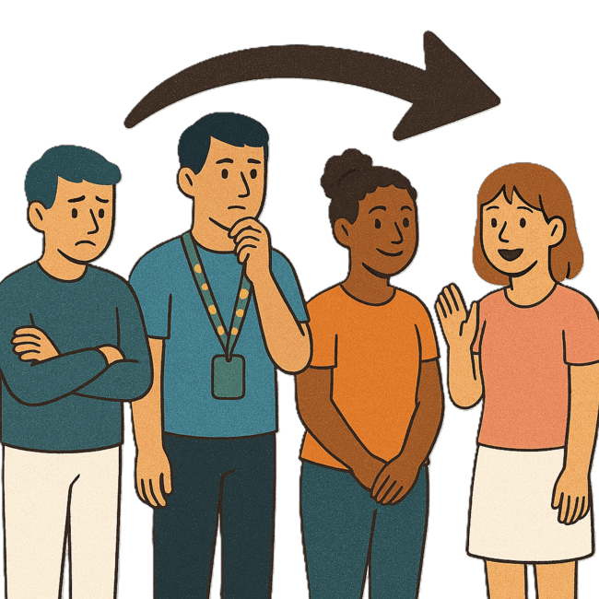 | This TAP wants to change  - How people behave  Behave means  - How you act  - What you do.
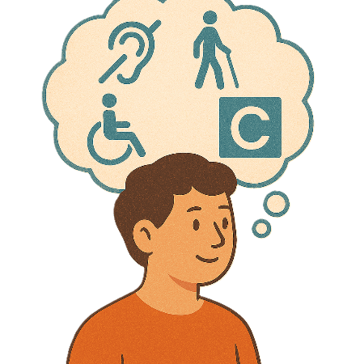 | - What people think about disability.
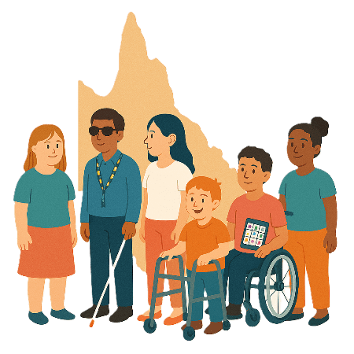 | The QLD Government Department of Families Seniors Disability Services and Child Safety has a survey.  It is called  - The Voice of Queenslanders with Disability survey
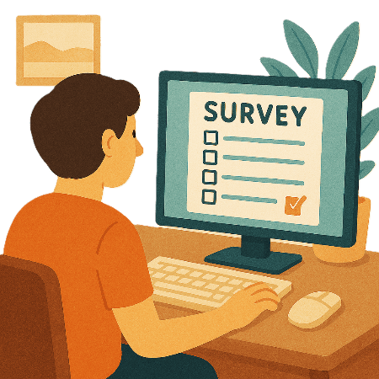 | Surveys have questions about your ideas
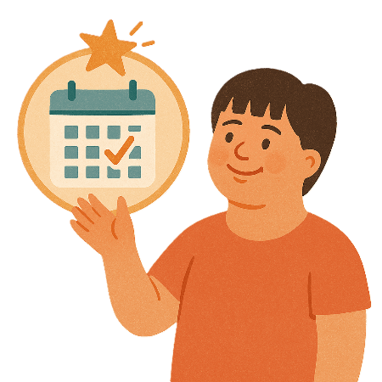 | The Survey is done every year.
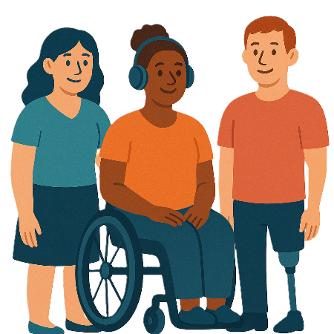 | They do this work with  - Queenslanders with Disability Network  We call them QDN for short.
 | - Griffith University.
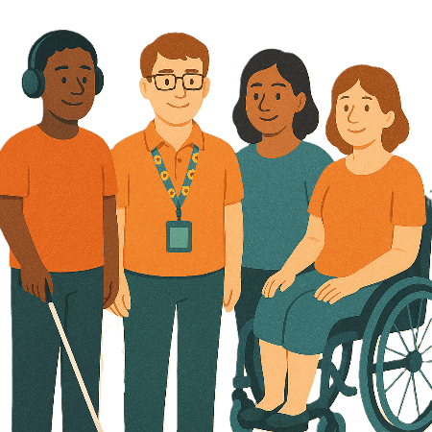 | The survey has questions for  - People with disability
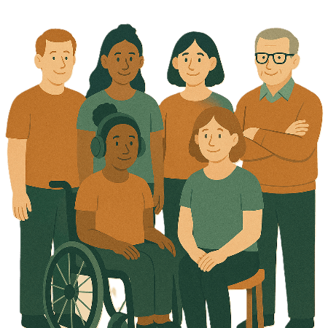 | - Their families and carers
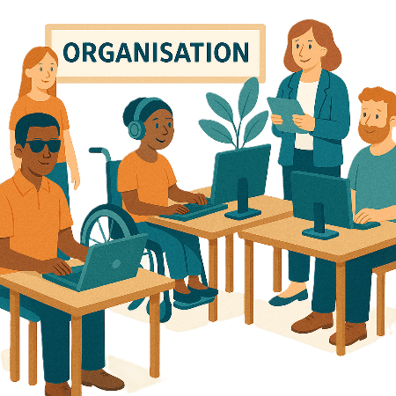 | - Organisations that support people with disability.
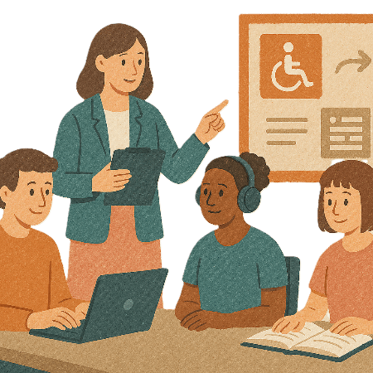 | The survey helps to know  - What issues people with disability have
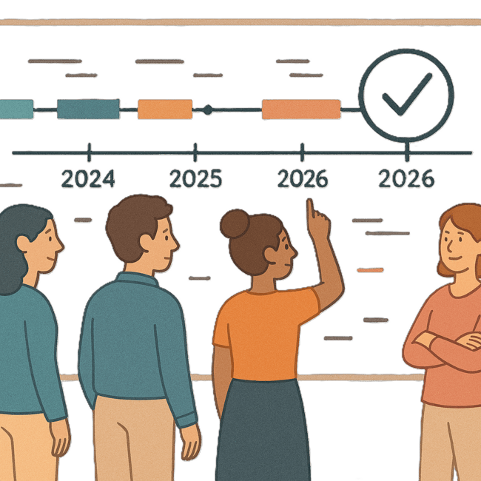 | - How things change over time.
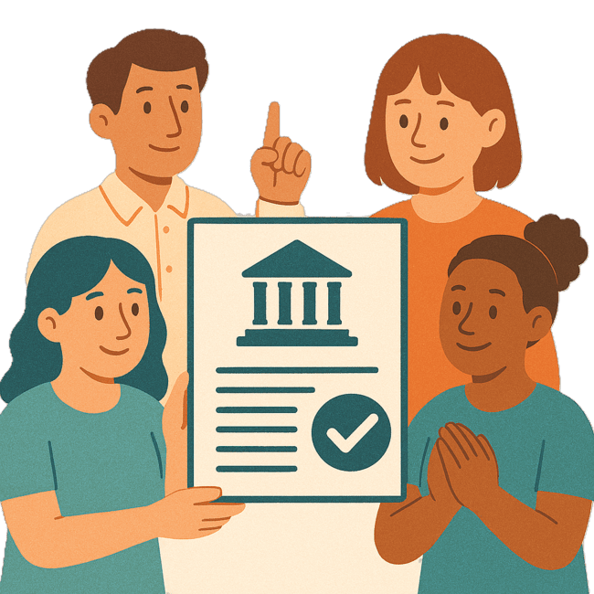 | This helps the QLD government make good  - Plans  - Programs.
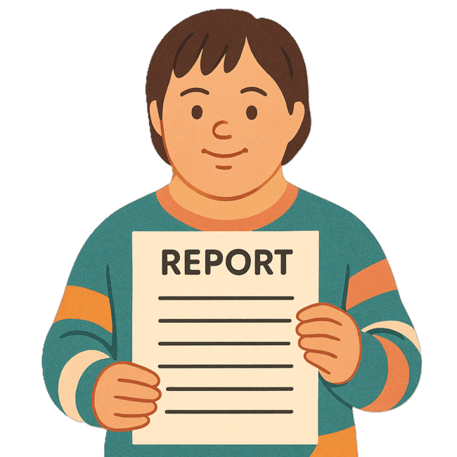 | The report will be shared later in the year.

Inclusive Homes and Communities TAP

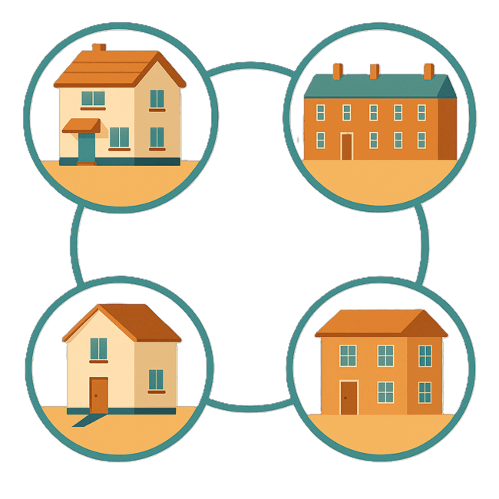 | This TAP wants to make  - Homes
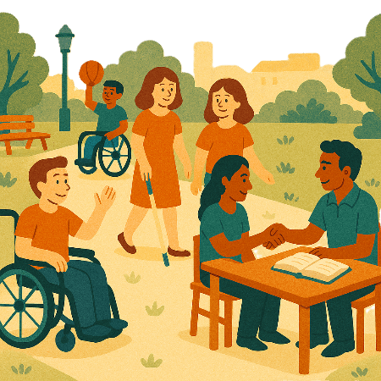 | - The community  Easier to access.
 | We also want them to be more welcoming.
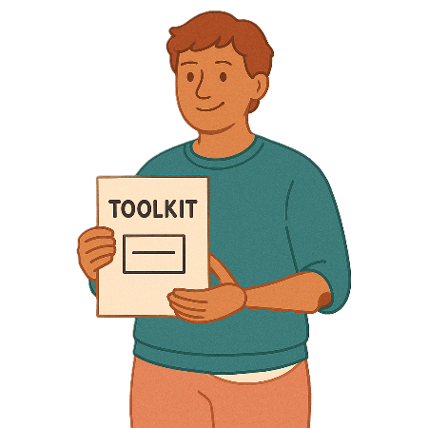 | The QLD government is working on  - My Housing Options Toolkit  A toolkit is  - Information  - Strategies  - Ideas.  All of them can be used to make a plan.
The Queensland Department of Housing and Public Works are working with QDN.

We call it DHPW for short.
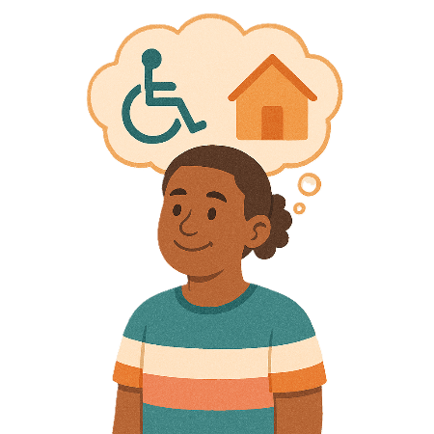 | The toolkit was made with help from people with lived experience of  - Disability  - Housing.
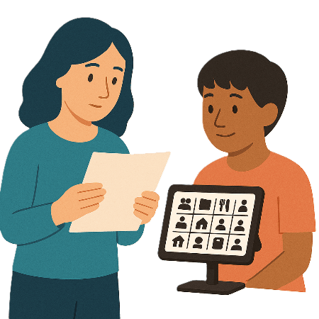 | The toolkit will have  - Information  - Stories
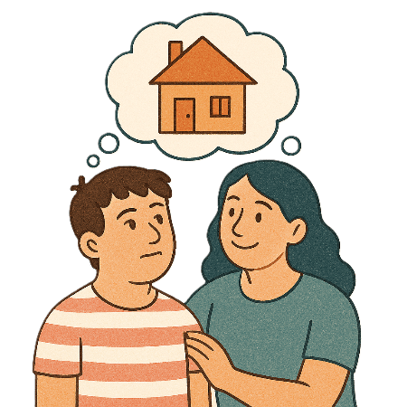 | This will help people with disability and their carers to  - Plan  - Choose  Housing that is right them.
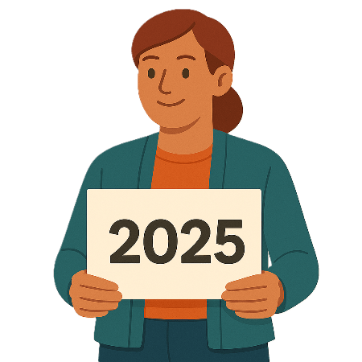 | The toolkit will be ready at the end of 2025.

Safety Rights and Justice TAP

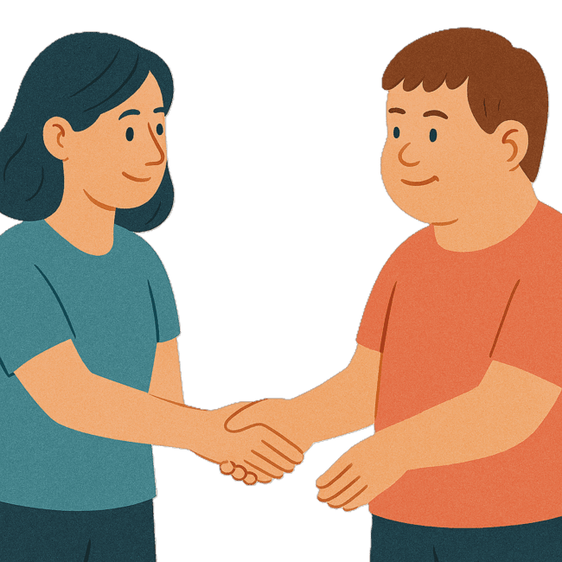 | This TAP wants to make sure people with disability are  - Safe  - Treated fairly.
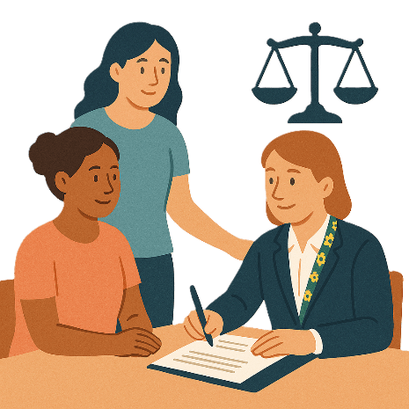 | Legal Aid Queensland wants to make supports better for First Nations people with disability  We call them LAQ for short.
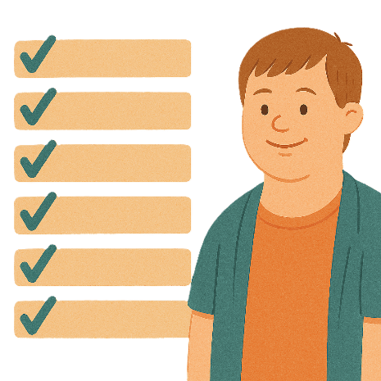 | LAQ have  - Made a list of services that can help people find support
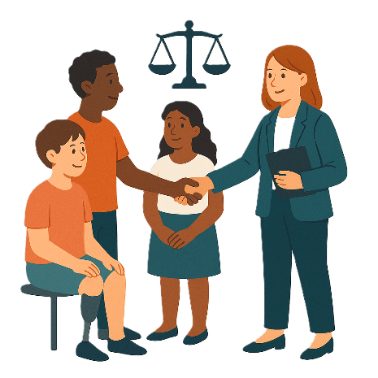 | - Supported workers to learn how to give better legal help  Legal means something about the law.
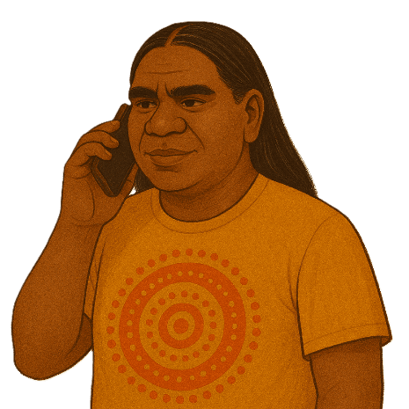 | - Reopened a phoneline for First Nations people  Reopened means the phone number is working again.  People can call it for help.
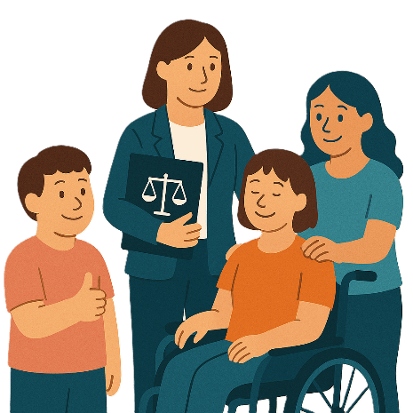 | - Started a project to make legal services more supportive  Including understanding that some people have experiences that are upsetting.

Images in this Easy Read must not be used or copied without permission

