Australia’s Disability Strategy 2021 to 2031

Targeted Action Plans Report

2025

South Australia Update
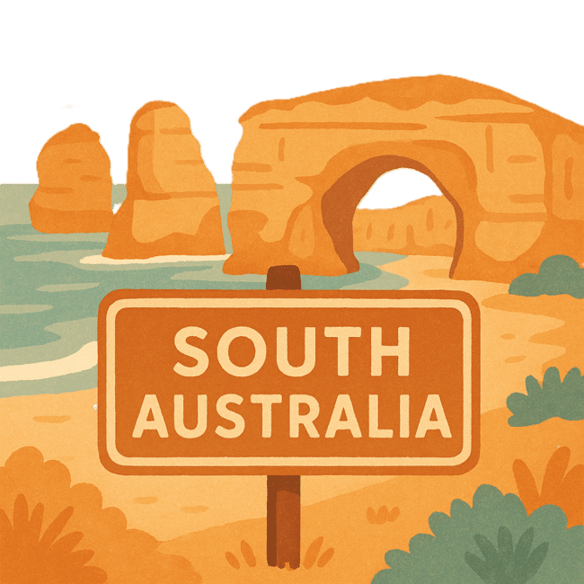
 | The Australian Government Department of Health Disability and Ageing wrote this.  We say DHDA for short.  When you see the word we it means DHDA.
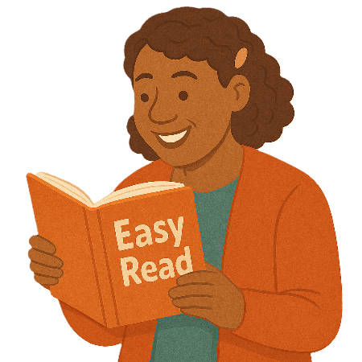 | We wrote this in an easy to read way.  We use pictures to explain some ideas.
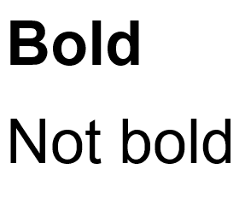 | We have some words in bold.  This means the letters are thicker and darker.  These are important words.
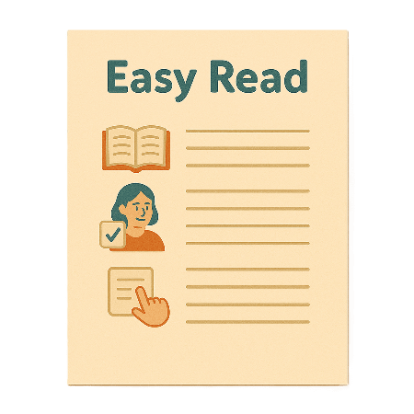 | This is an Easy Read summary of another document.  This means it has the most important ideas.
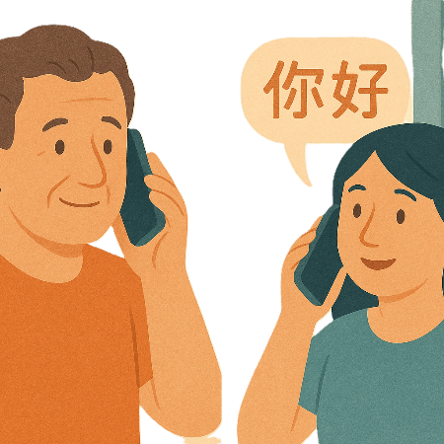 | If you speak a language other than English  - Call Translating and Interpreting Services.  1800 131 450
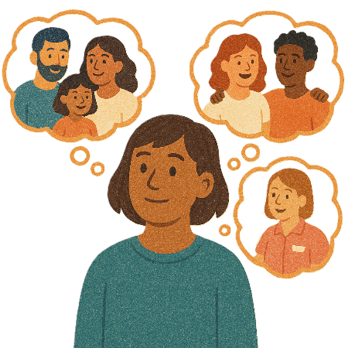 | You can ask for help to read this document.  You can ask  - A friend  - Family members  - A support person.
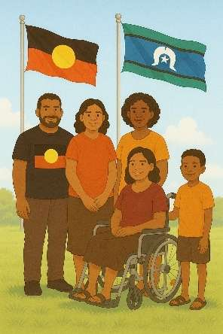 | We recognise Aboriginal and Torres Strait Islander people as the Traditional Owners of the land we live on.
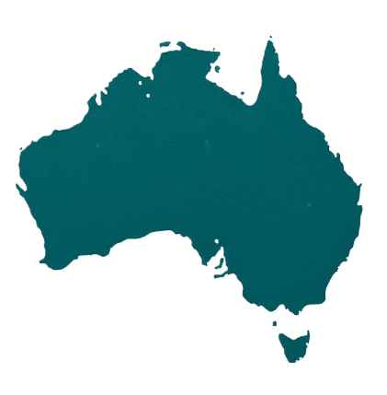 | They were the first people to live on and use the  - Land  - Waters.

Contents

About this document | 5
Australia’s Disability Strategy | 8
What are Targeted Action Plans | 9
South Australia Update | 11
Community Attitude TAP | 13
Inclusive Homes and Communities TAP | 15
Safety Rights and Justice TAP | 19

About this document

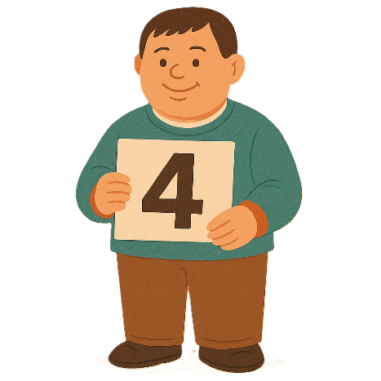 | This document has 4 parts
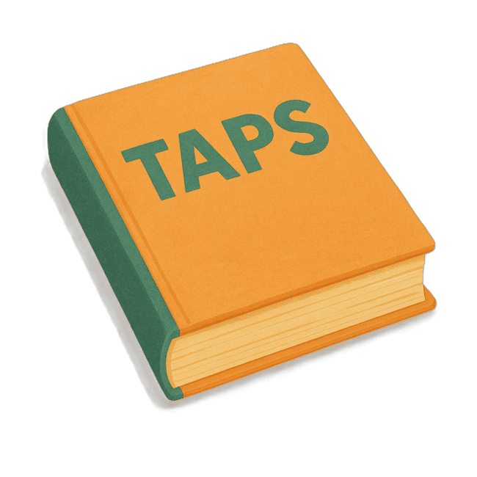 | Part 1 talks about  - What are Targeted Action Plans  We call them TAPs for short.
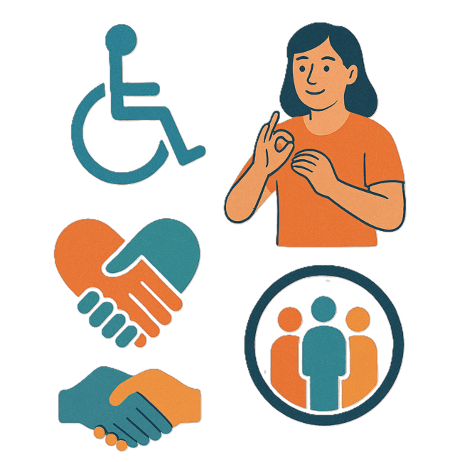 | Part 2 talks about  - Community Attitudes TAP
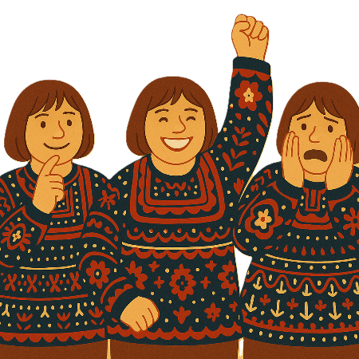 | Attitudes are what people  - Think  - Feel  - Believe.
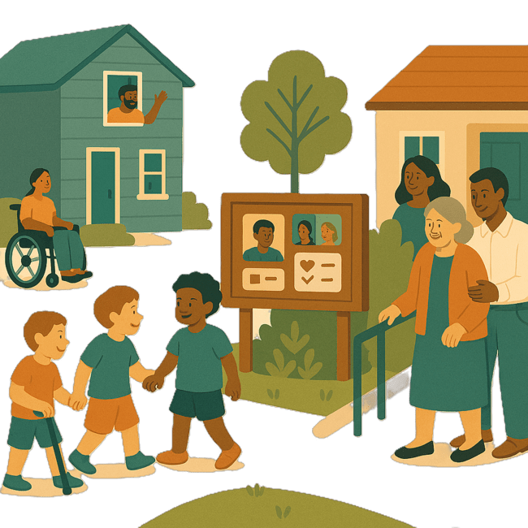 | Part 3 talks about  - Inclusive Homes and Communities TAP
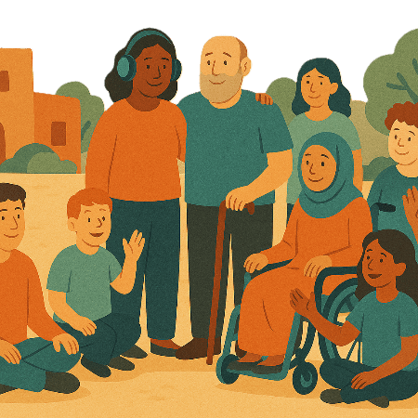 | Inclusive is when everyone  - Can take part  - Feel like they belong.
Part 4 talks about

- Safety Rights and Justice TAP

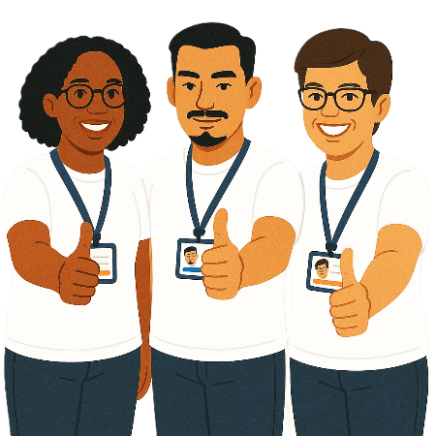 | Rights are rules about treating everyone  - Fair  - Equal.
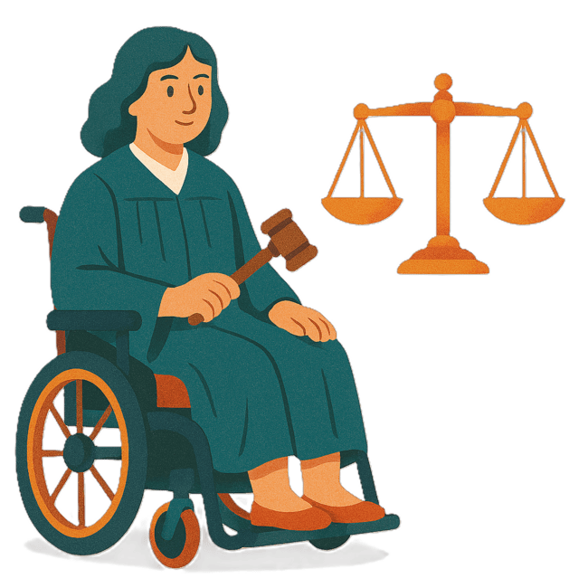 | Justice is  - The law  - Police  - The courts  - Prisons.  Laws are rules for how we live.
 | You can go to our website to read the updates from other states and territories.  www.disabilitygateway.gov.au/ads/easy-read-strategy  It is in Easy Read.

Australia’s Disability Strategy

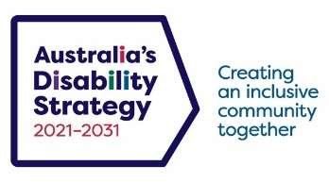 | The government set up Australia’s Disability Strategy.  We call it the Strategy for short.  It was also called ADS.
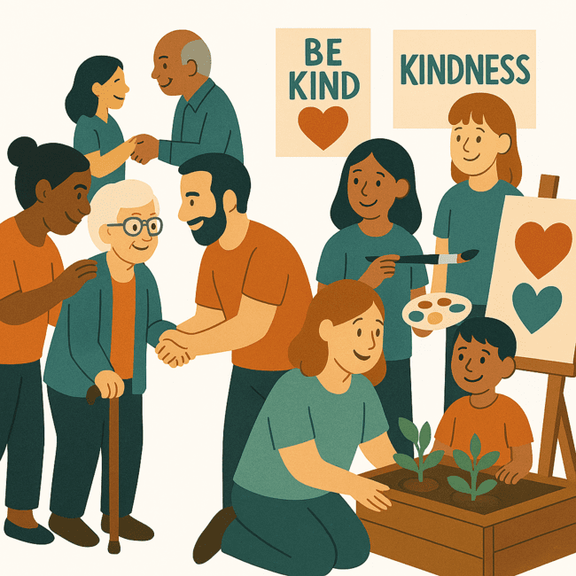 | The Strategy is the governments way of working together to support people with disability to live good lives.  They do this by working with  - People with disability  - The community.  This makes the community a more welcoming place for everyone.

What are Targeted Action Plans

We made small plans to help us work on the Strategy.

The small plans are called TAPs.
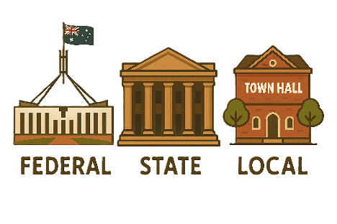 | TAPs are made by all governments in Australia.  All governments include  - Australian Government  - State and territory governments  - Local governments.
There are 3 TAPs.

- Community Attitudes
 | - Inclusive Homes and Communities
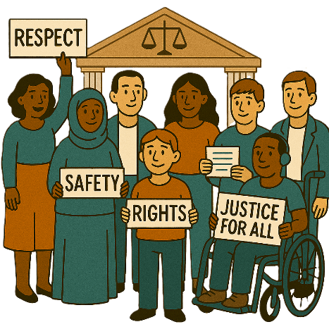 | - Safety Rights and Justice

South Australia update

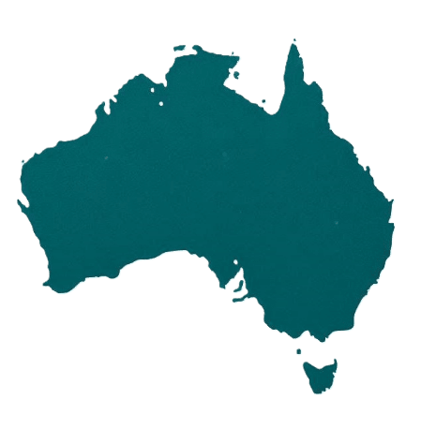 | Each state and territory government have made their own actions.  This makes sure that they meet the needs of their communities.  Actions are the things that we will do.
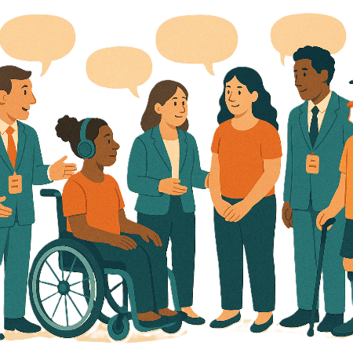 | Each government says how the actions will include  - People with disability
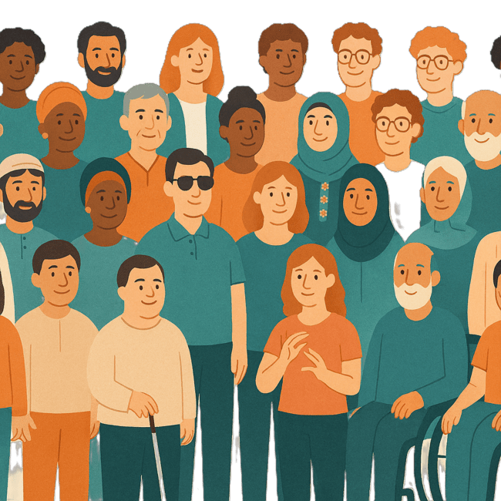 | - The disability community.
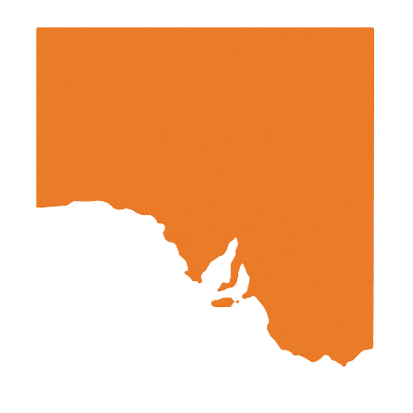 | This document talks about some actions South Australian government is doing in the 3 TAPs.  We call them SA for short.

Community Attitudes TAP

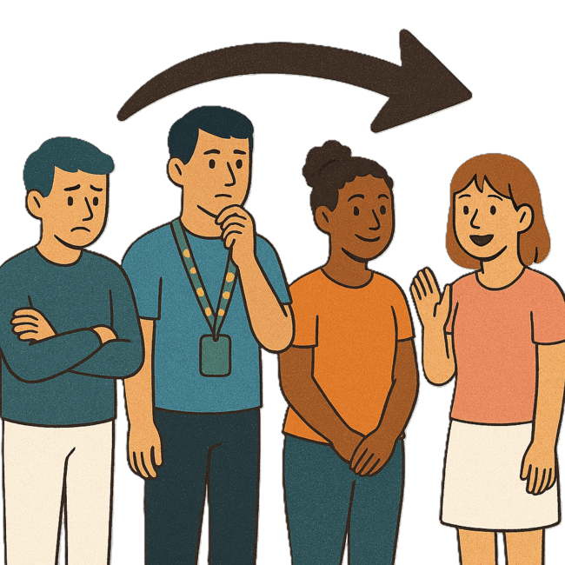 | This TAP wants to change  - How people behave  Behave means  - How you act  - What you do.
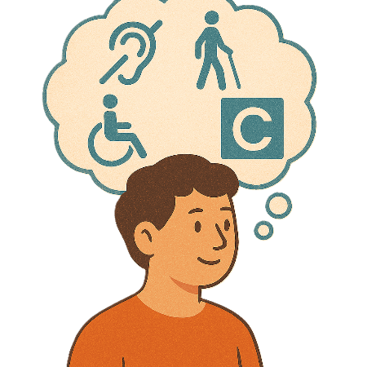 | What people think about disability.
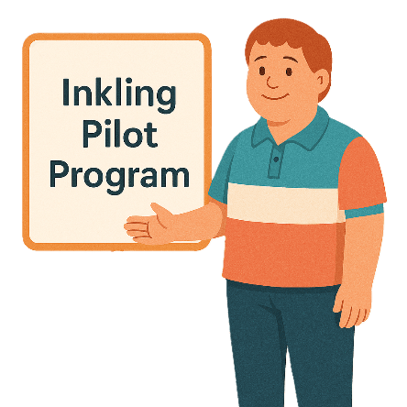 | 1 of the actions the SA government is working on is  - The Inkling Pilot Program.
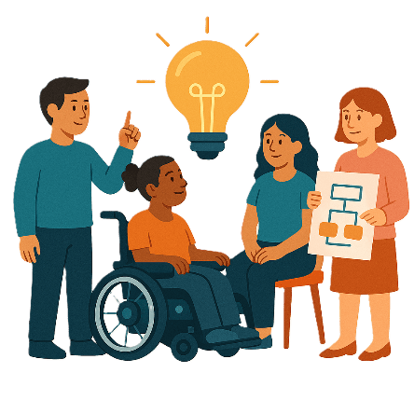 | This program is being done by the Office for Autism.  A pilot program is a test program.  It is used to try out new ideas.
 | This program will be done across all of SA.
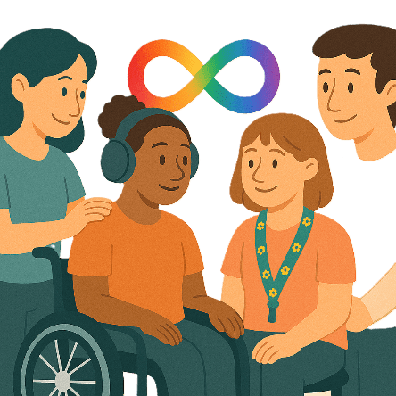 | It will help families  - Understand  - Celebrate  Neurodiversity.
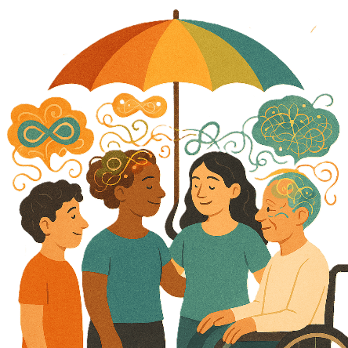 | Neurodiversity is the way peoples brains work differently.  Everyone thinks and feels differently.  They are normal differences.

Inclusive Homes and Communities TAP

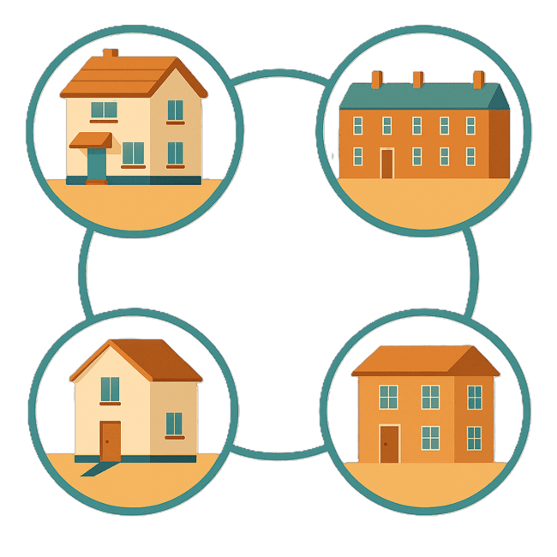 | This TAP wants to make  - Homes
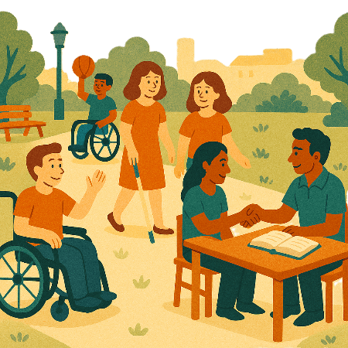 | - The community  Easier to access.
 | We also want them to be more welcoming.
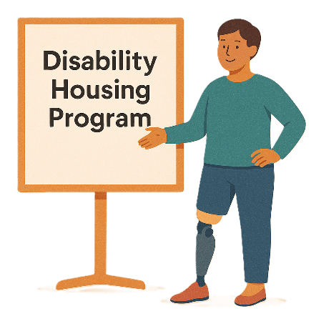 | The SA government is working with SA Housing Trust.  They are working on a project called  - Disability Housing Program
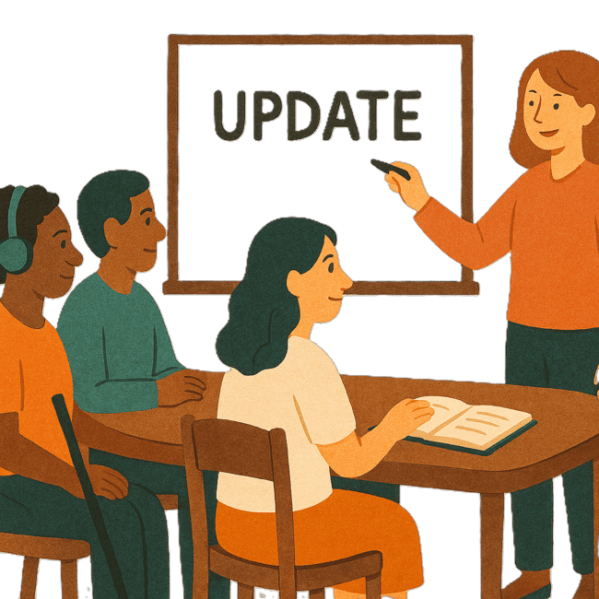 | The Housing Trust is  - Reviewing  - Updating  The Disability Housing Program.
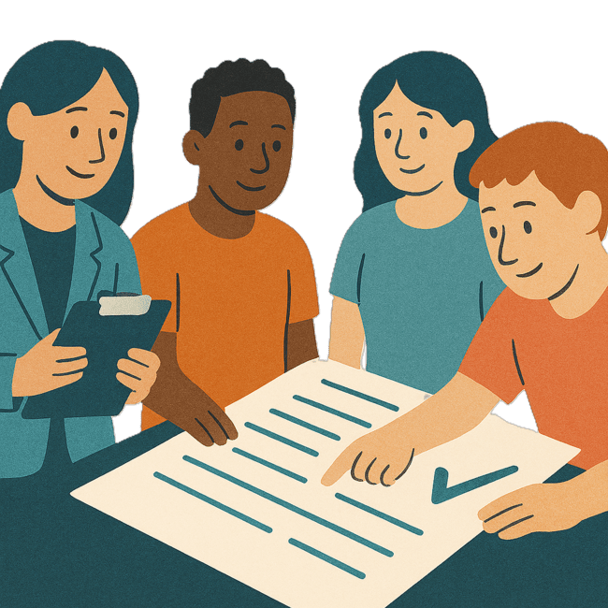 | A review is when you check what  - Works  - Needs to change.
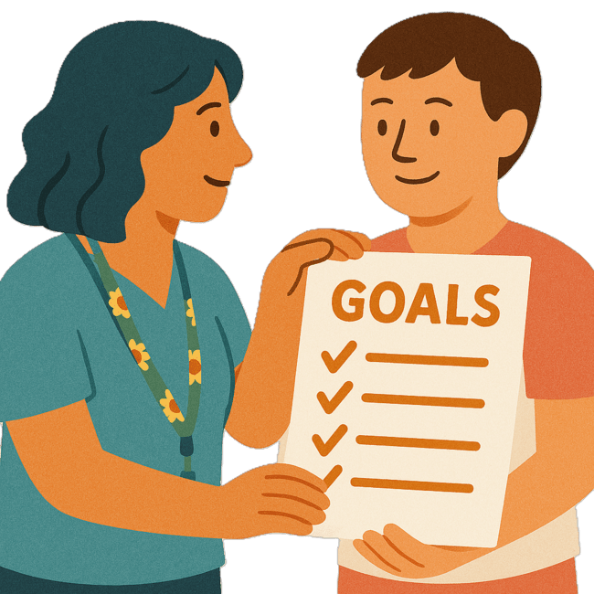 | They have a goal.  Goals are things you want to do.
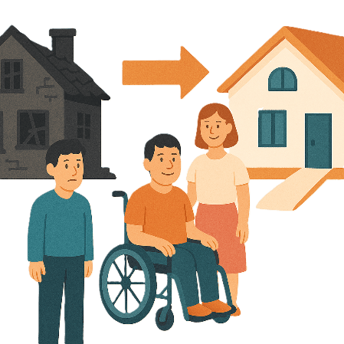 | They want to replace old homes with new accessible homes.  Replace means change 1 thing for another.
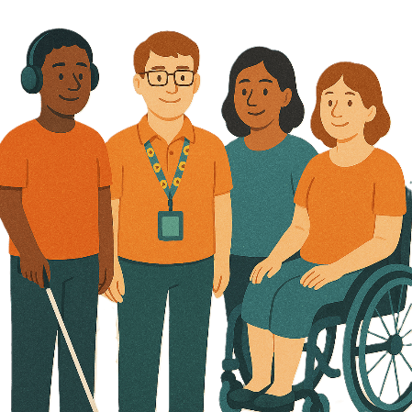 | This work is being done with  - People with disability
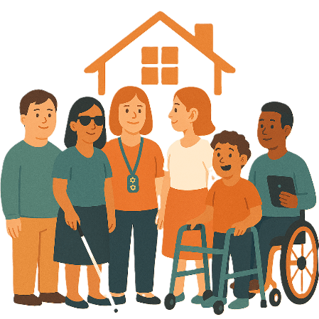 | - Community housing providers.
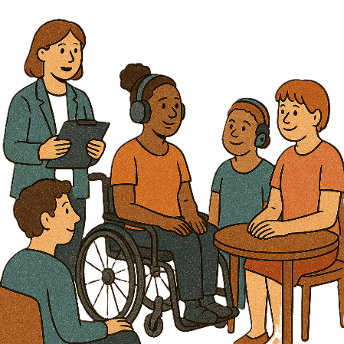 | Consultations in the future will talk to tenants.
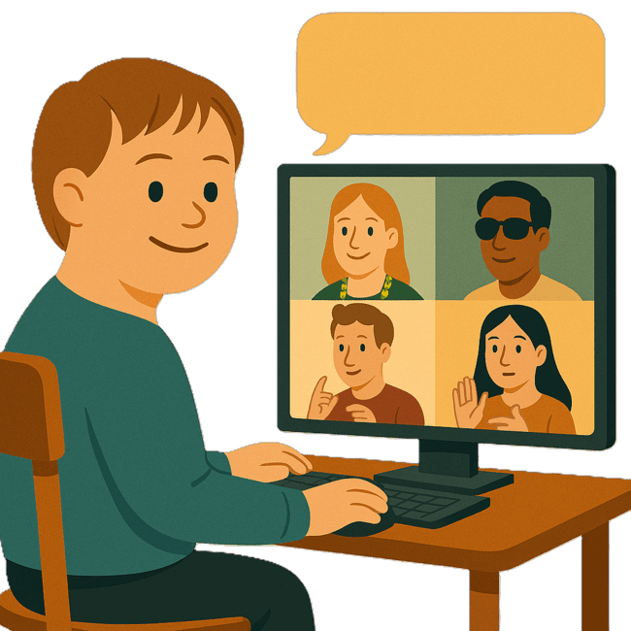 | Consultation is the governments way of working with the disability community.  It makes sure that the government is listening to communities.  This helps the government make better plans to support people with disability.
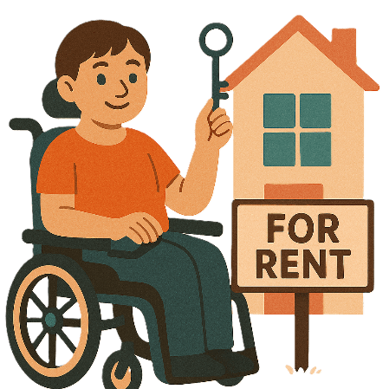 | Tenants are the people who pay rent to live in the homes.
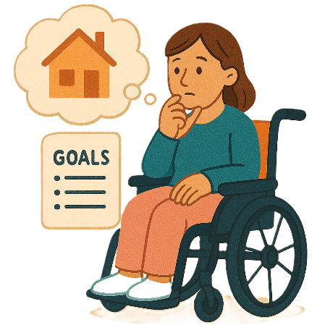 | This will make sure that the housing meets their  - Needs  - Goals.

Safety Rights and Justice TAP

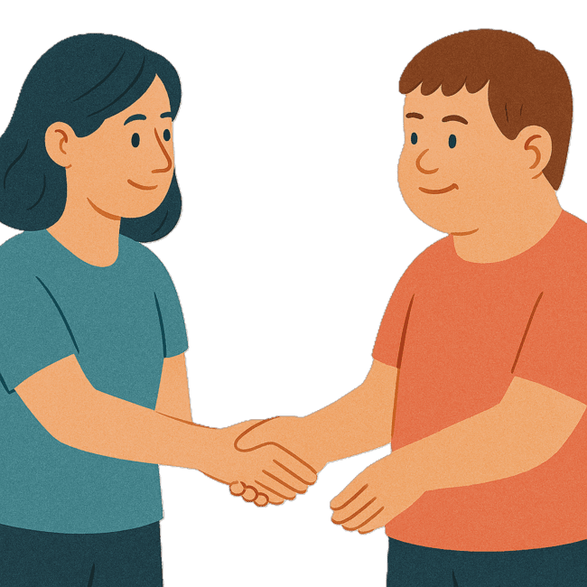 | This TAP wants to make sure people with disability are  - Safe  - Treated fairly.
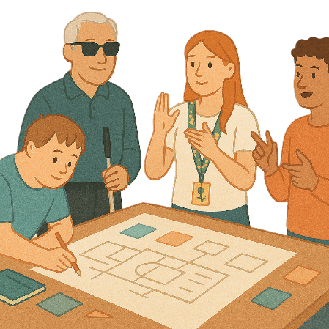 | The SA government is working on the  - Community Visitors Scheme.
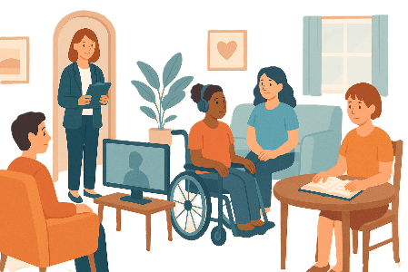 | The Community Visitor Scheme visit people with disability.  We call it CVS for short.  CVS make sure people with disability  - Are getting the services they need  - Have their rights respected.
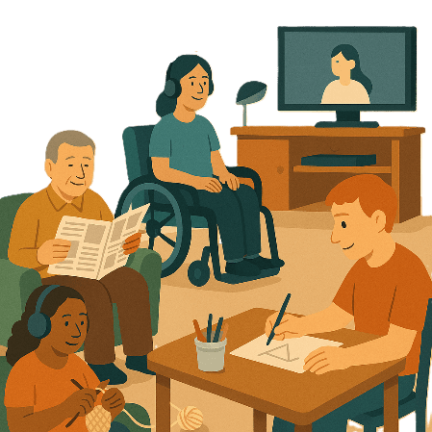 | There is a change to CVS.  CVS can now visit  - Disability services not run by the government
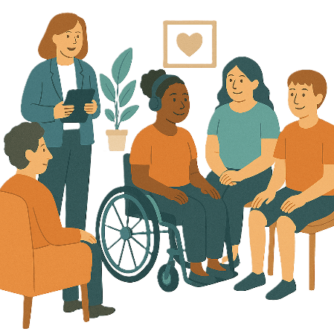 | - Private homes.
The SA government is part of a national project making sure CVS is the same across all Australia.

A national project is something that all states and territories are working on
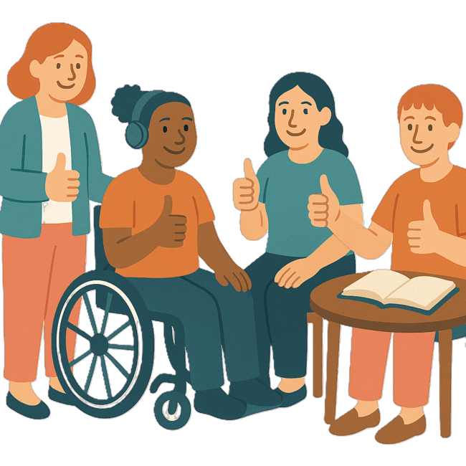 | People with disability are helping with the changes to CVS.  They are doing this by taking part in
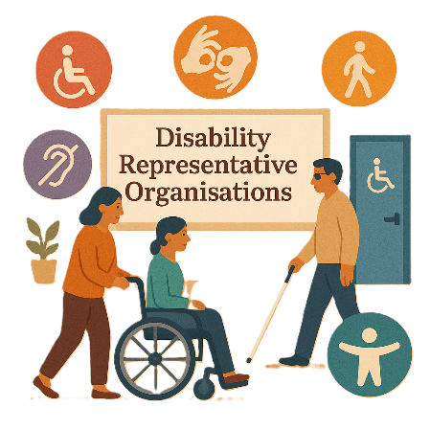 | - Working groups with Disability Representative Organisations  We call it DROs for short.
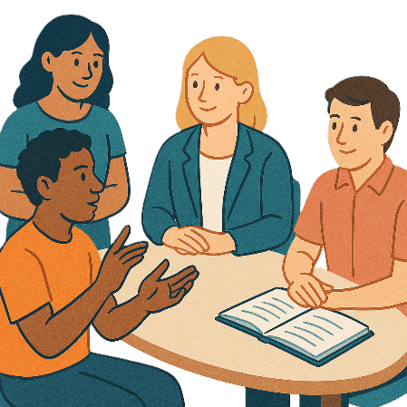 | Working groups are a group of people working together on a topic.
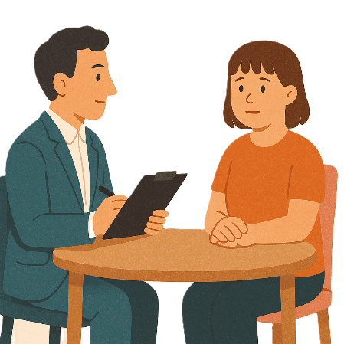 | - Interviews to hear what people think about  - Safety  - Rights
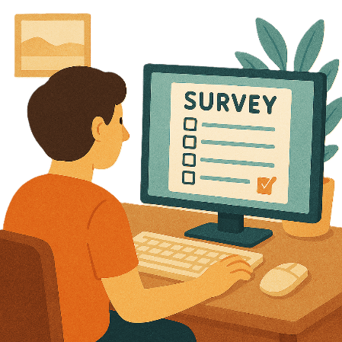 | - Surveys to get feedback from the community.  Surveys have questions about your ideas.
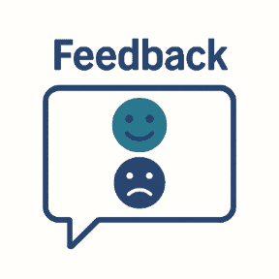 | Feedback says what you think about something.  It will help  - Find problems  - Make it better in the future.
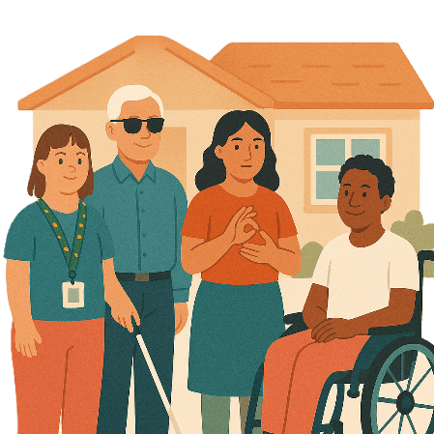 | More people will be able to share their ideas.  Including people who live in  - Supported accommodation  Supported accommodation is for people with disability.  People with disability can  - Live in a house paid for by the NDIS  - Get support to live in the house
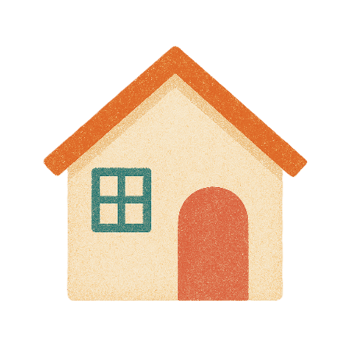 | - Private homes.
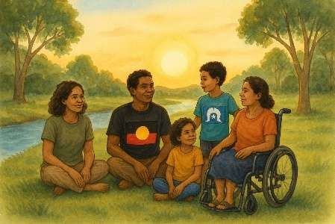 | They could be  - First Nations people
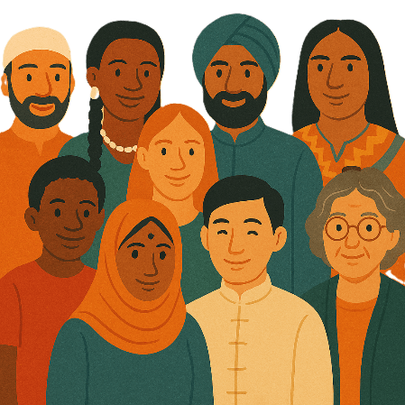 | - People from different cultures
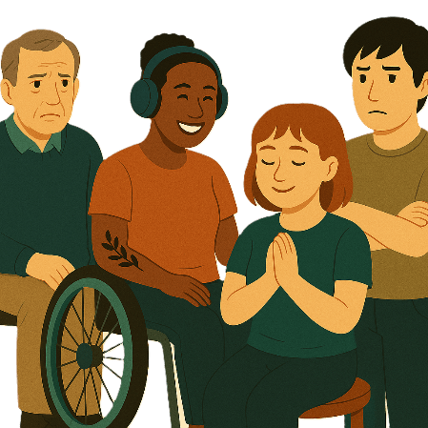 | - People with psychosocial disability  Psychosocial disability is when some people have a disability because of their mental health.

Images in this Easy Read must not be used or copied without permission

