Australia’s Disability Strategy 2021 to 2031

Targeted Action Plans Report

2025
Safety Rights and Justice
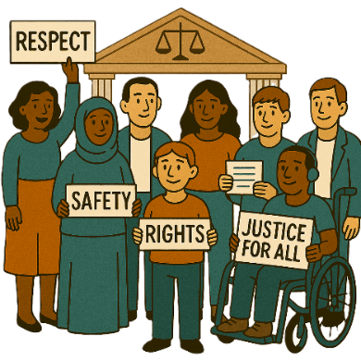
 | The Australian Government Department of Health Disability and Ageing wrote this.  We say DHDA for short.  When you see the word we it means DHDA.
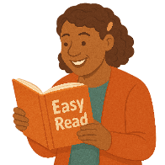 | We wrote this in an easy to read way.  We use pictures to explain some ideas.
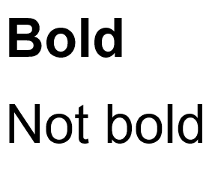 | We have some words in bold.  This means the letters are thicker and darker.  These are important words.
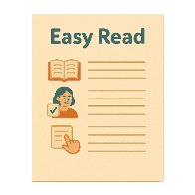 | This is an Easy Read summary of another document.  This means it has the most important ideas.
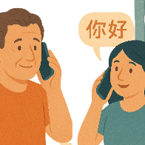 | If you speak a language other than English  - Call Translating and Interpreting Services.  1800 131 450
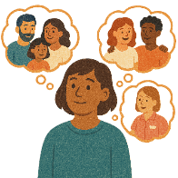 | You can ask for help to read this document.  You can ask  - A friend  - Family members  - A support person.
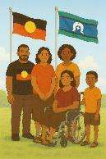 | We recognise Aboriginal and Torres Strait Islander people as the Traditional Owners of the land we live on.
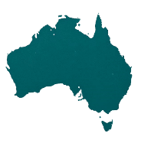 | They were the first people to live on and use the  - Land  - Waters.

Contents

About this document | 5
Australia’s Disability Strategy | 7
What are Targeted Action Plans | 8
What this TAP is trying to do | 11
Thinking about experiences | 14
National Actions | 17
Better support in court | 20
Support for women and children with disability | 23

About this document

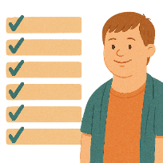 | This document talks about
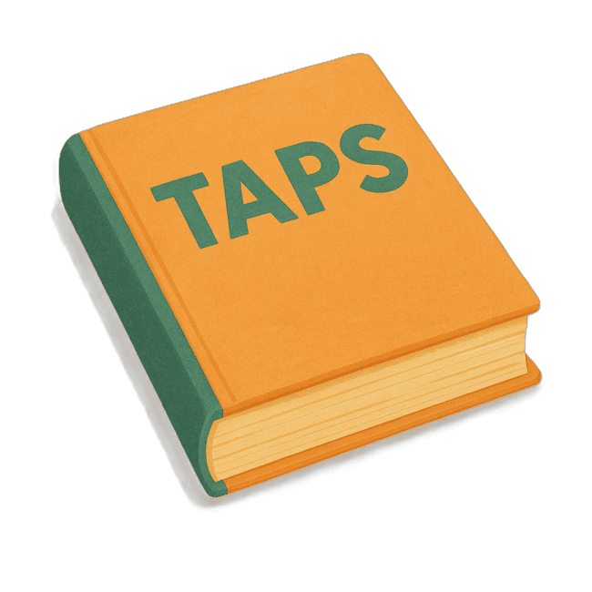 | - What are Targeted Action Plans  We call them TAPs for short.
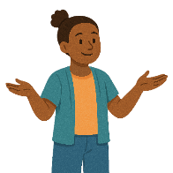 | - What the TAP is trying to do
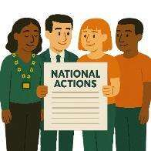 | - National actions  National Actions are things that all governments will do.  We want all parts of Australia to have the same way of doing things.
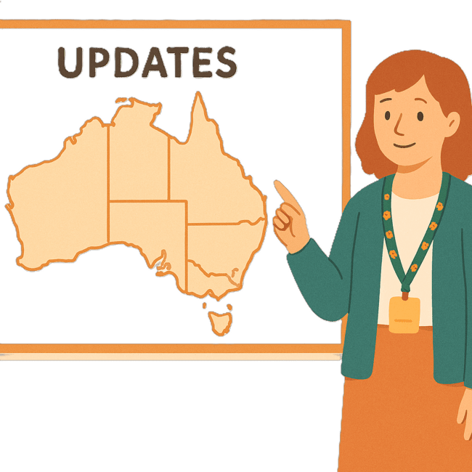 | We have other Easy Reads that talk about what the state and territory governments are doing.
 | You can go to our website to read the updates from the states and territories.  www.disabilitygateway.gov.au/ads/easy-read-strategy  It is in Easy Read.

Australia’s Disability Strategy

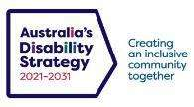 | The government set up Australia’s Disability Strategy.  We call it the Strategy for short.  It was also called ADS.
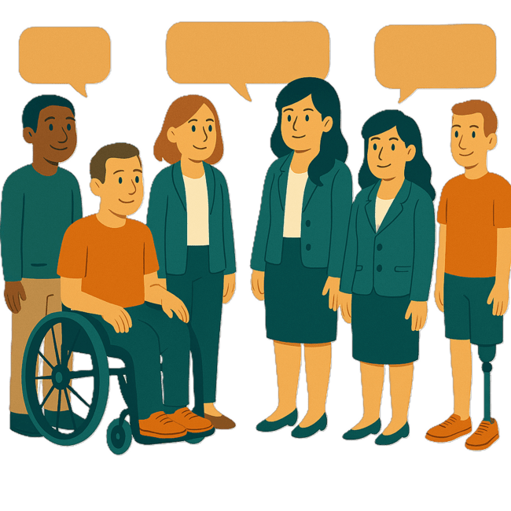 | The Strategy is the governments way of working together to support people with disability to live good lives.  They do this by working with  - People with disability  - The community.  This makes the community a more welcoming place for everyone.

What are Targeted Action Plans

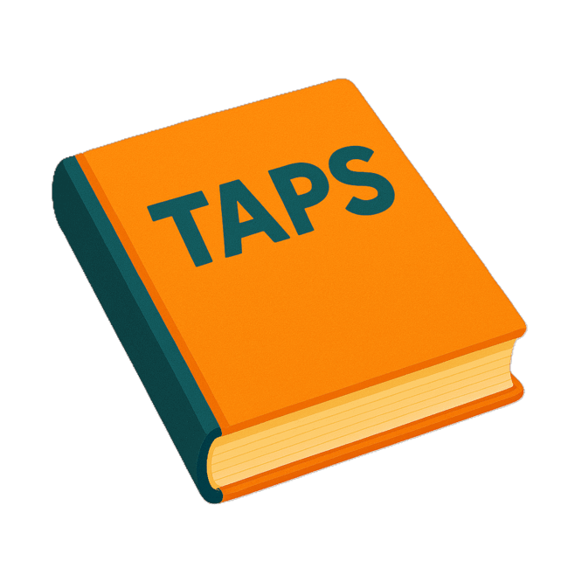 | We made small plans to help us work on the Strategy.  The small plans are called Targeted Action Plans.  We call them TAPs for short.
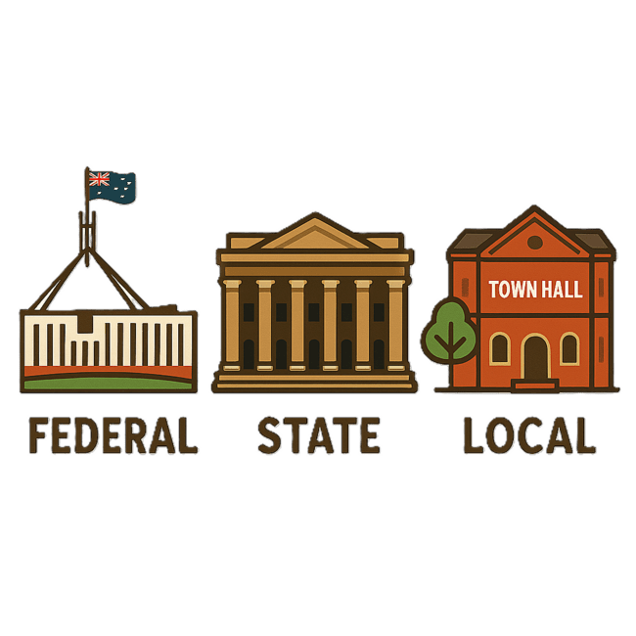 | TAPs are made by all governments in Australia.  All governments include  - Australian Government  - State and territory governments  - Local governments.
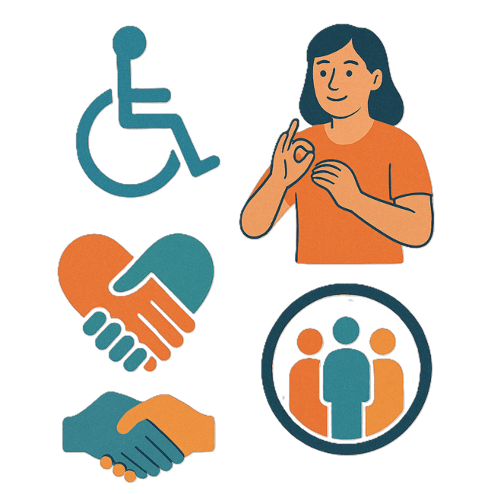 | There are 3 TAPs.  - Community Attitudes
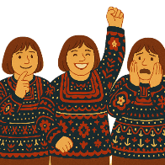 | Attitudes are what people  - Think  - Feel  - Believe.
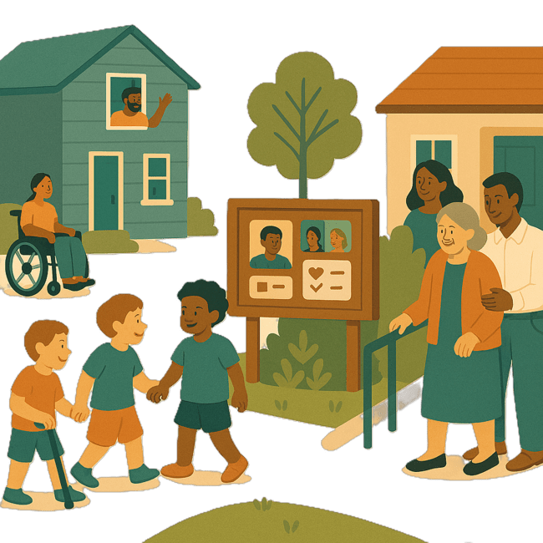 | - Inclusive Homes and Communities
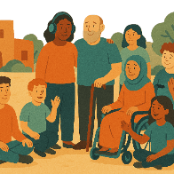 | Inclusive is when everyone  - Can take part  - Feel like they belong.
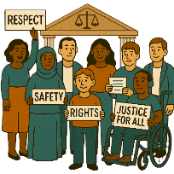 | - Safety Rights and Justice
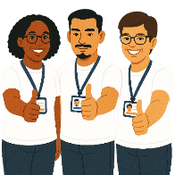 | Rights are rules about treating everyone  - Fair  - Equal.
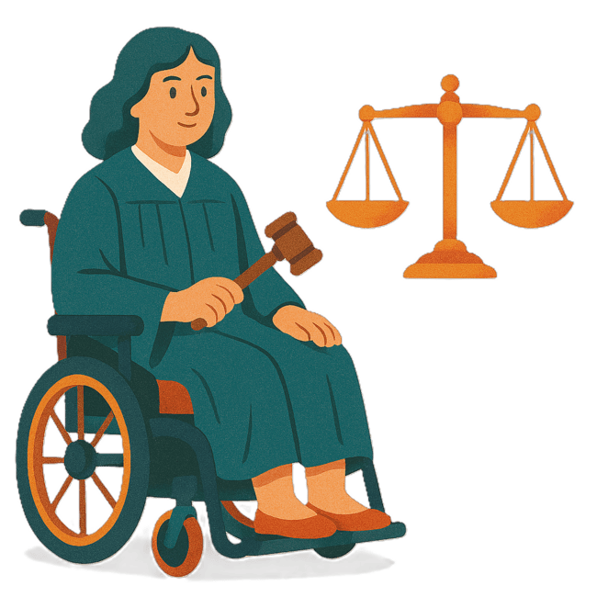 | Justice is  - The law  - Police  - The courts  - Prisons.  Laws are rules for how we live.

What this TAP is trying to do

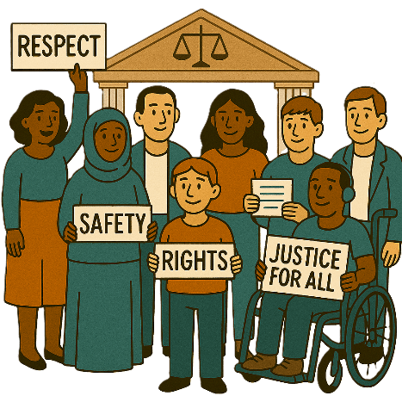 | This TAP is about Safety Rights and Justice
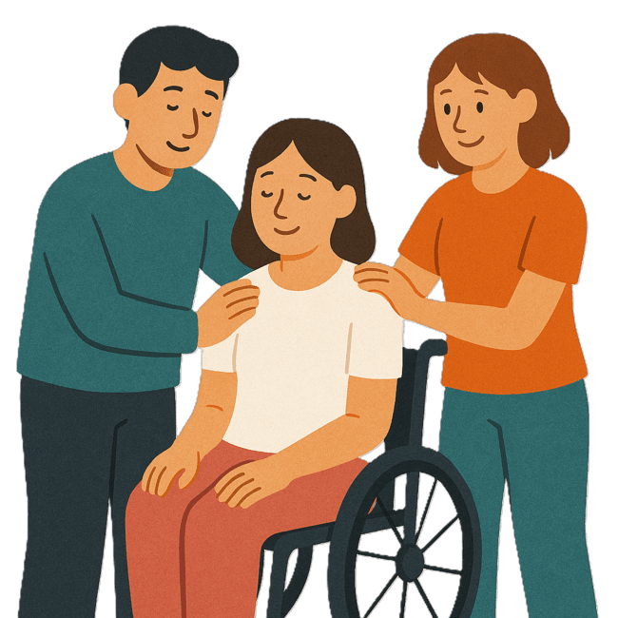 | This TAP wants to make sure people with disability  - Feel safe
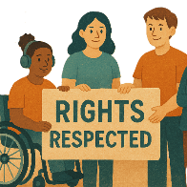 | - Have their rights respected
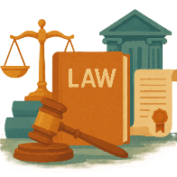 | - Are treated fairly with the law.
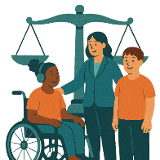 | This TAP wants  - The justice system to support people with disability better  This could be by  - Understanding them  - Meeting their needs.
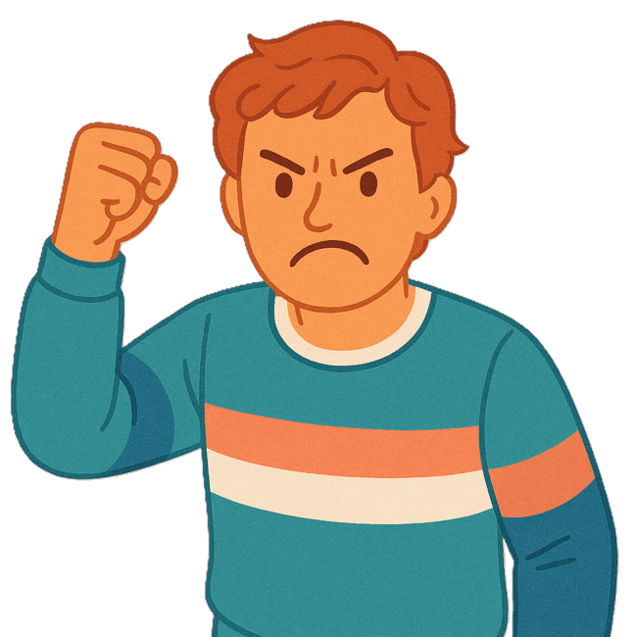 | - Helping to stop violence by making  - Policies  - Programs.  Violence is when someone hurts your body.
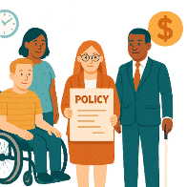 | Policies are plans for how to do things.
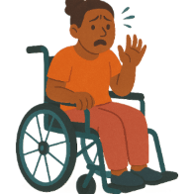 | - Having better support for people with disability who have experienced trauma  Trauma is when something happens that makes a person feel  - Upset  - Scared  - Unsafe.

Thinking about experiences

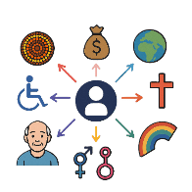 | This TAP will look at how to  - Support people with disability and the different parts of who they are.  This might change what their experience is like.  This is called intersectionality.
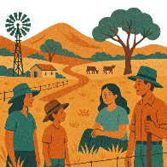 | This could be  - People with disability who live in rural or remote areas
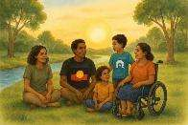 | - First Nations people with disability
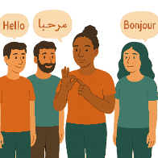 | - People who speak different languages
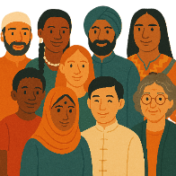 | - People from different cultures
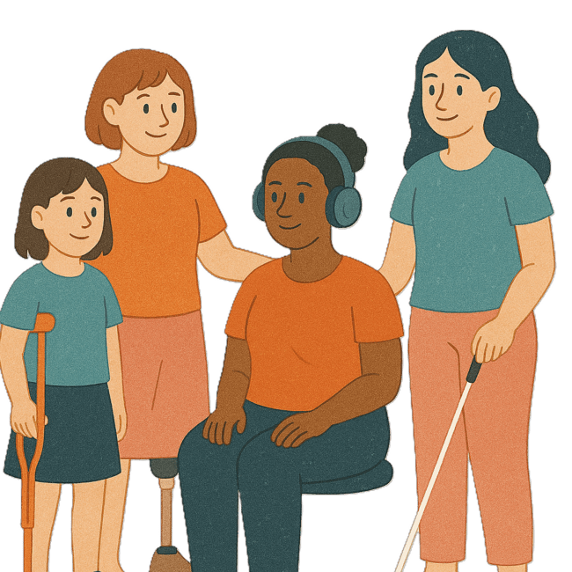 | - Women and girls with disability
 | - People with disability who are LGBTQIA+
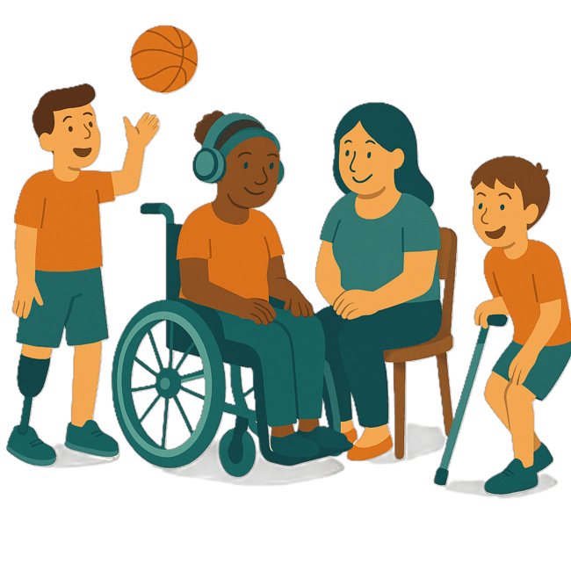 | - Children and young people with disability.
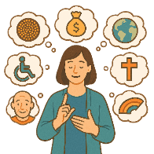 | Some people fit into more than 1 of these groups.

National Actions

The Australian Government will work with people with disability on this TAP.

All governments will put the plan into action.
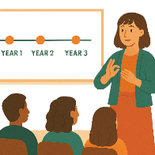 | All governments will work on the actions over the next 3 years.
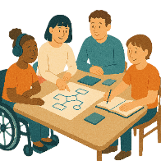 | Governments will do this by  - Sharing plans
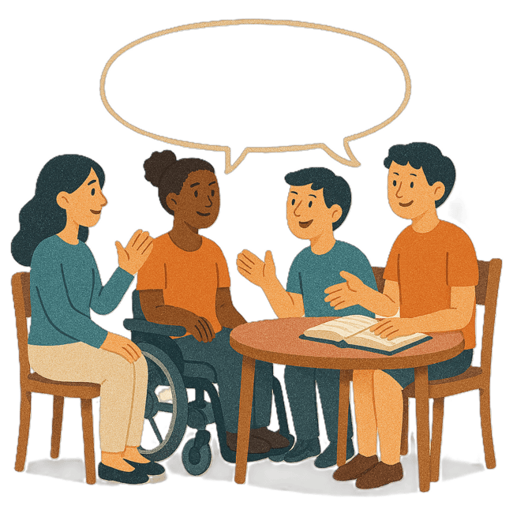 | - Sharing ideas
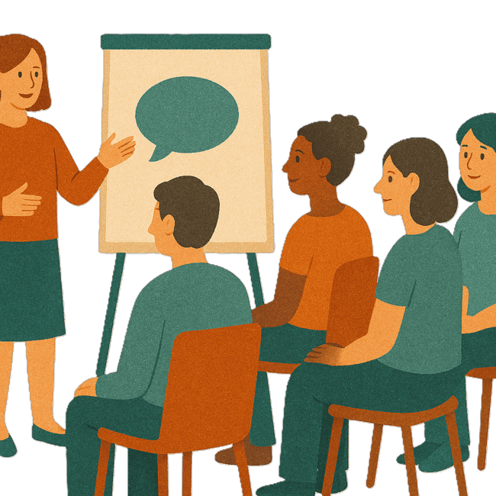 | - Doing workshops together  A workshop is when a group of people meet to talk about something.
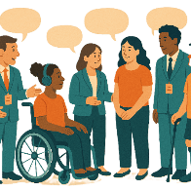 | - Working with people with disability.
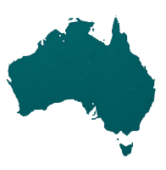 | Each state and territory will have their own ways of working with people with disability.
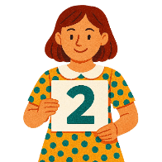 | The Australian Government is working on 2 main activities to work on the actions
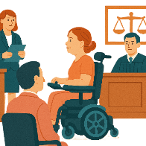 | - Having better support in court  A court is where someone goes to help solve problems or if someone broke the law.  In a court  - A judge listens to what happened  - People say what happened  - A judge decides what is fair and should happen.
 | - Support for women and children with disability.

Better support in court

 | New laws started in December 2024.  These laws support people with disability who need to tell their story in a court.
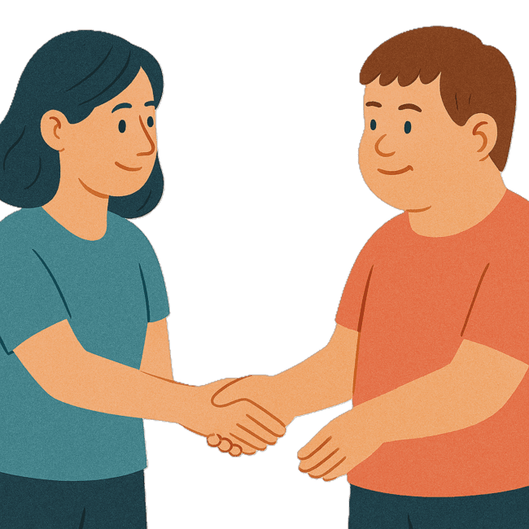 | The new laws will make it  - Safe  - Fair  For people with disability to take part in court.
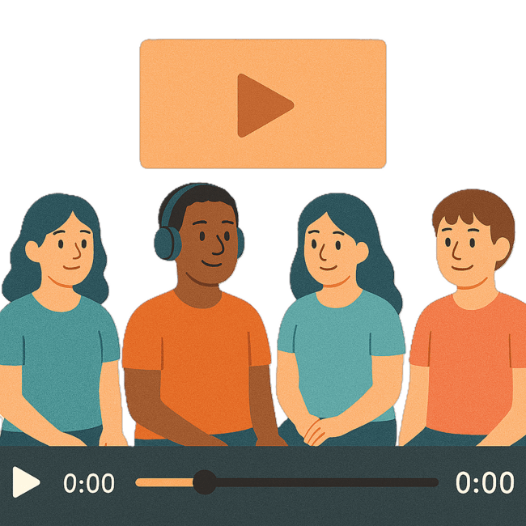 | The new laws let vulnerable people  - Record what they will say in court before they go
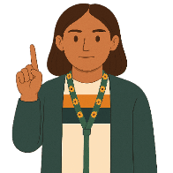 | - Only have to have a say in court 1 time  The court can decide if they need to have a say again.
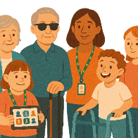 | Vulnerable people need extra help to stay safe and healthy.  They can be  - People with disability  - Older people  - Children.
The courts also need to have interpreters for people.

Interpreters are people who change what someone is saying into the words of another language
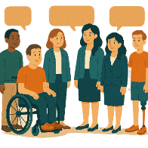 | Lots of people worked together on making these laws.

Support for women and children with disability

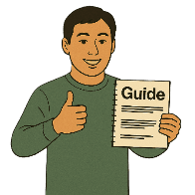 | The Department of Social Services has made a new guide to keep women and children safe.  We call them DSS for short.  The guide says  - How things should be done  - Step by step what to do  - Can give recommendations.  Recommendations are ideas to do things better.
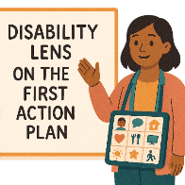 | The guide is called Disability Lens on the First Action Plan.  We called it DL1AP for short.
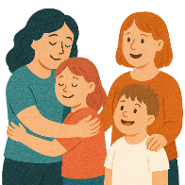 | DL1AP will help  - Women  - Children  Understand the National Plan to End Violence Against Women and Children.
DSS spoke with

- Women with disability
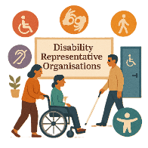 | - Disability Representative Organisations  We call them DROs for short.
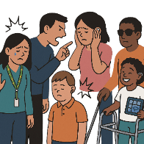 | - Family violence providers  Family violence is when someone in your family  - Hurts you  - Makes you feel scared.  It can happen between  - Partners  - Parents and children  - Brothers and sisters  - Carers and the people they care for.  It can also be called domestic violence.
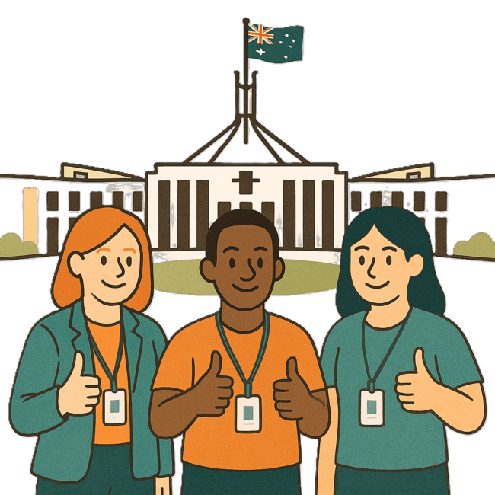 | - People who work for the government.

Images in this Easy Read must not be used or copied without permission

