Australia’s Disability Strategy 2021 to 2031

Targeted Action Plans Report

2025

Tasmania update
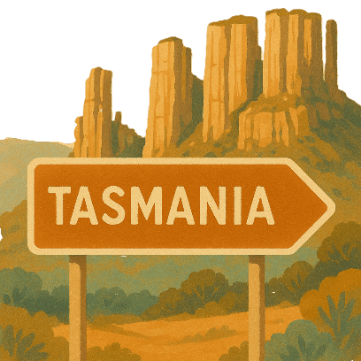
 | The Australian Government Department of Health Disability and Ageing wrote this.  We say DHDA for short.  When you see the word we it means DHDA.
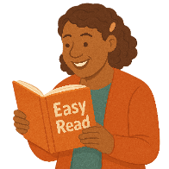 | We wrote this in an easy to read way.  We use pictures to explain some ideas.
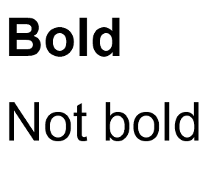 | We have some words in bold.  This means the letters are thicker and darker.  These are important words.
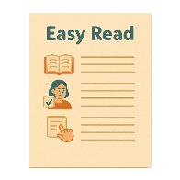 | This is an Easy Read summary of another document.  This means it has the most important ideas.
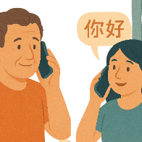 | If you speak a language other than English  - Call Translating and Interpreting Services.  1800 131 450
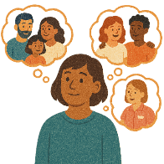 | You can ask for help to read this document.  You can ask  - A friend  - Family members  - A support person.
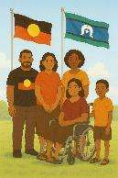 | We recognise Aboriginal and Torres Strait Islander people as the Traditional Owners of the land we live on.
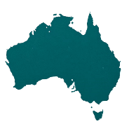 | They were the first people to live on and use the  - Land  - Waters.

Contents

About this document | 5
Australia’s Disability Strategy | 8
What are Targeted Action Plans | 9
Tasmania Update | 11
Community Attitude TAP | 13
Inclusive Homes and Communities TAP | 18
Safety Rights and Justice TAP | 21

About this document

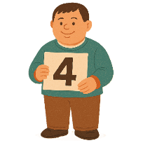 | This document has 4 parts
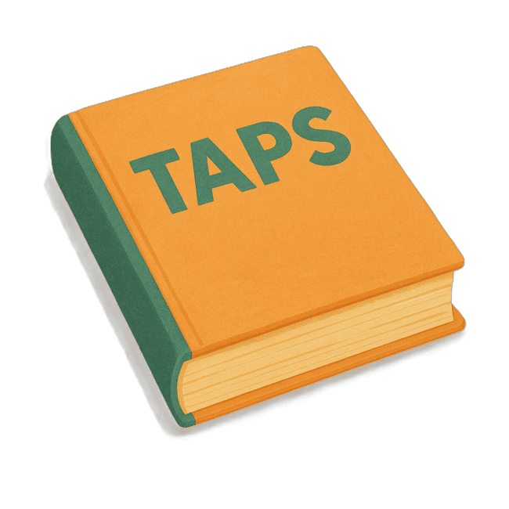 | Part 1 talks about  - What are Targeted Action Plans  We call them TAPs for short.
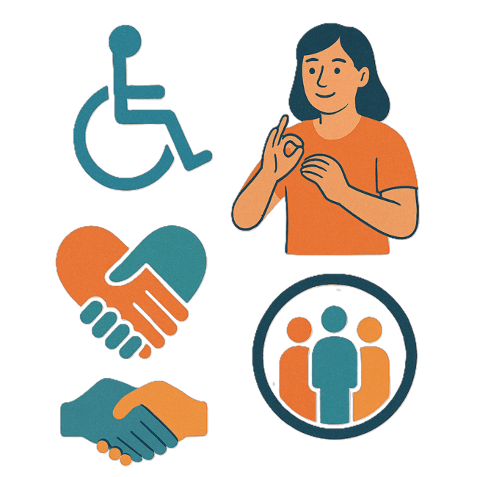 | Part 2 talks about  - Community Attitudes TAP
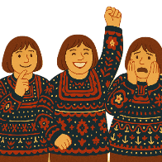 | Attitudes are what people  - Think  - Feel  - Believe.
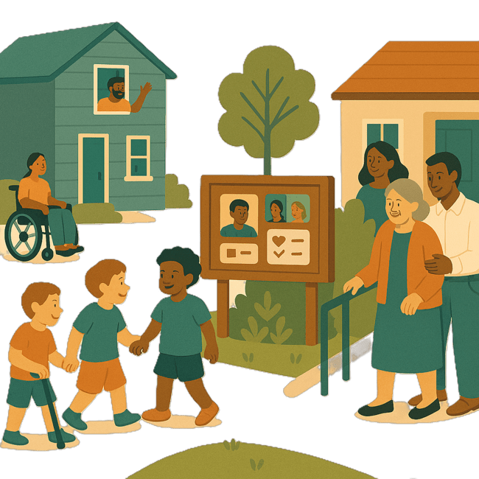 | Part 3 talks about  - Inclusive Homes and Communities TAP
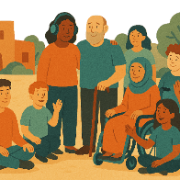 | Inclusive is when everyone  - Can take part  - Feel like they belong.
Part 4 talks about

- Safety Rights and Justice TAP

 | Rights are rules about treating everyone  - Fair  - Equal.
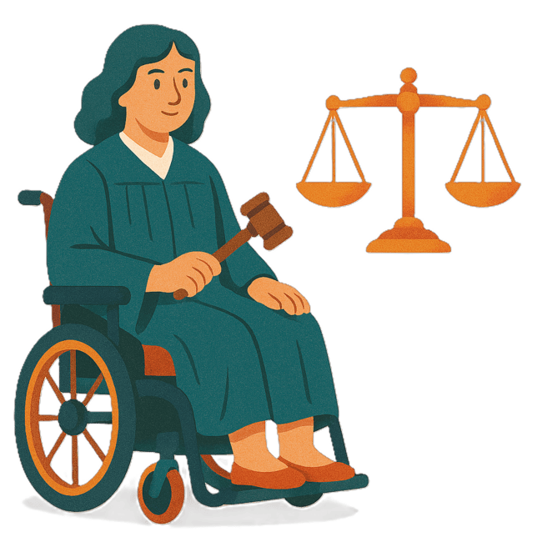 | Justice is  - The law  - Police  - The courts  - Prisons.  Laws are rules for how we live.
 | You can go to our website to read the updates from other states and territories.  www.disabilitygateway.gov.au/ads/easy-read-strategy  It is in Easy Read.

Australia’s Disability Strategy

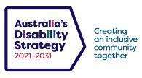 | The government set up Australia’s Disability Strategy.  We call it the Strategy for short.  It was also called ADS.
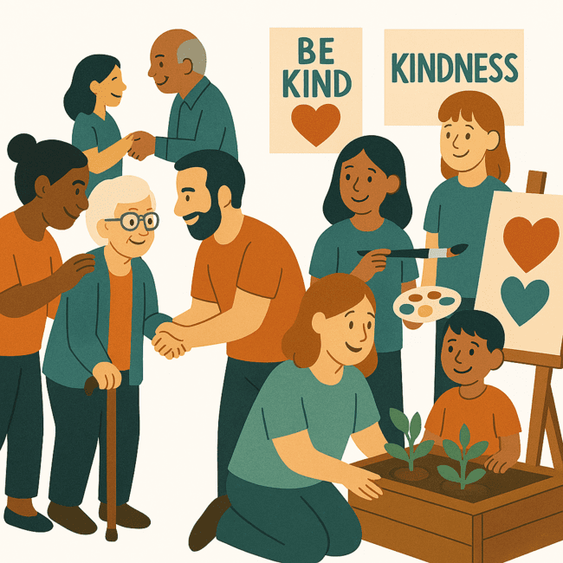 | The Strategy is the governments way of working together to support people with disability to live good lives.  They do this by working with  - People with disability  - The community.  This makes the community a more welcoming place for everyone.

What are Targeted Action Plans

We made small plans to help us work on the Strategy.

The small plans are called TAPs.
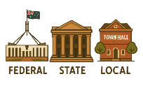 | TAPs are made by all governments in Australia.  All governments include  - Australian Government  - State and territory governments  - Local governments.
There are 3 TAPs.

- Community Attitudes
 | - Inclusive Homes and Communities
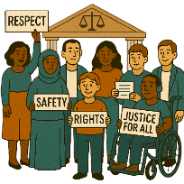 | - Safety Rights and Justice

Tasmania update

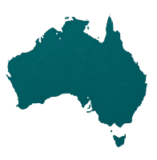 | Each state and territory government have made their own actions.  This makes sure that they meet the needs of their communities.  Actions are the things that we will do.
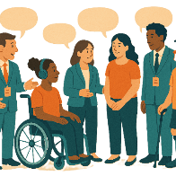 | Each government says how the actions will include  - People with disability
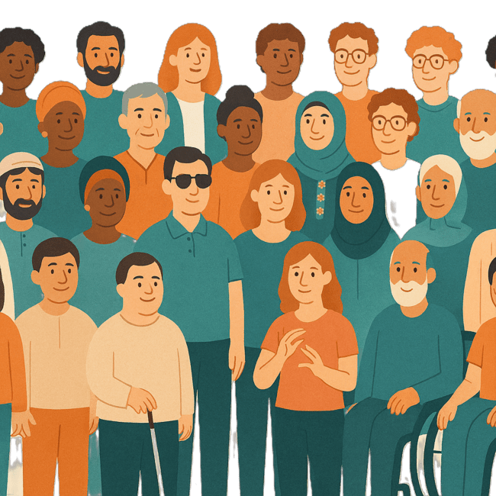 | - The disability community.
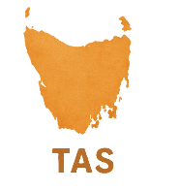 | This document talks about some actions the Tasmanian government is doing in the 3 TAPs.  We call them TAS for short.

Community Attitudes TAP

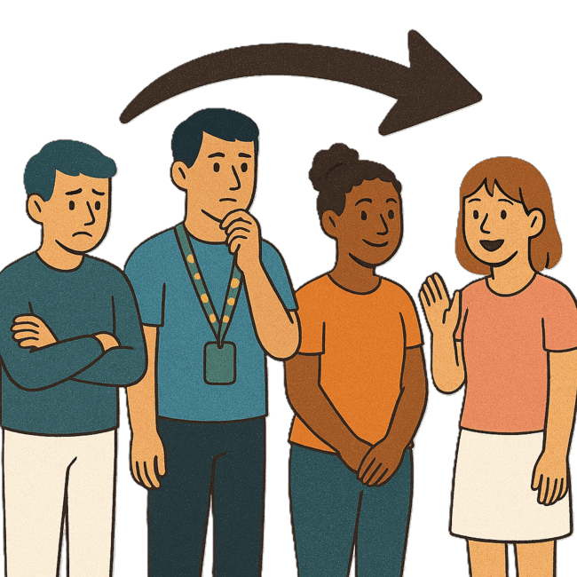 | This TAP wants to change  - How people behave  Behave means  - How you act  - What you do.
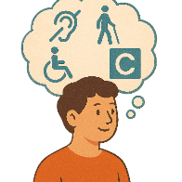 | - What people think about disability.
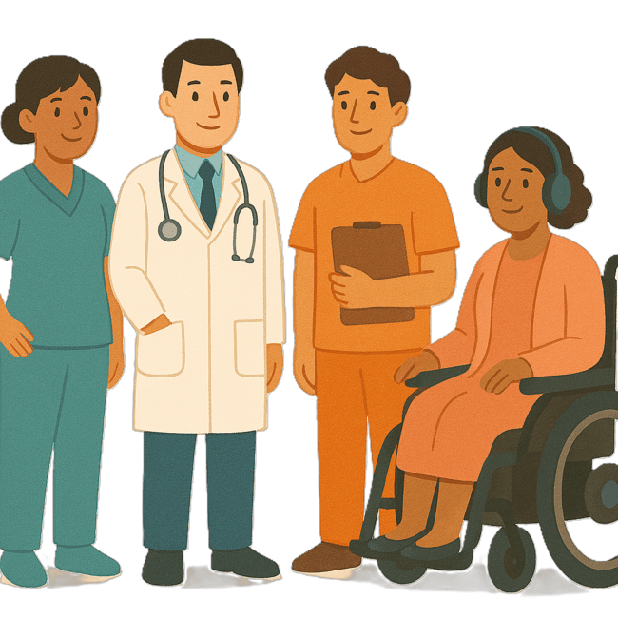 | The TAS Department of Health are working to make health services better.  We call them DoH for short.
 | In February 2025 they made a  - Disability Health Strategy  - Action Plan.
 | They were made with ideas from the disability community.
 | The Disability Health Strategy wants to  - Make health services better for people with disability living in Tasmania.
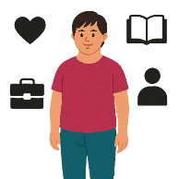 | The Action Plans have activities to do in priority areas.  Priority areas are the most important areas to work on.
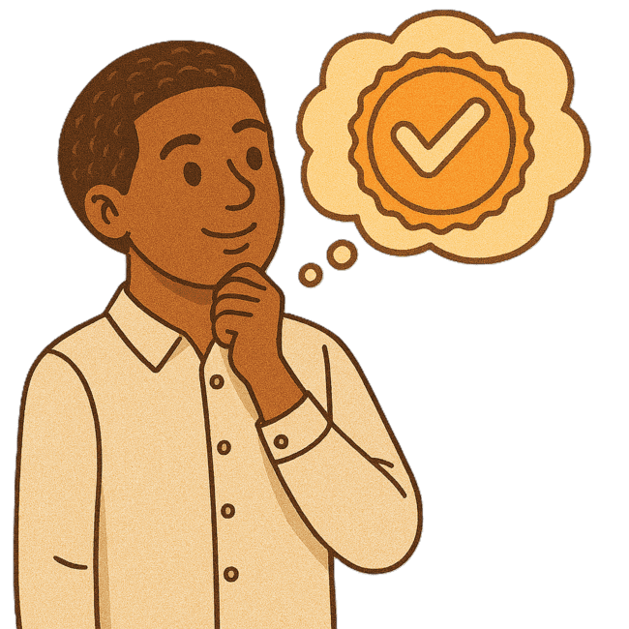 | The priority areas are  - Quality  Quality means  - People get what they need  - People are happy with the service  - Services do everything they are supposed to.
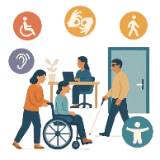 | - Accessibility  Accessibility means everyone can use it.
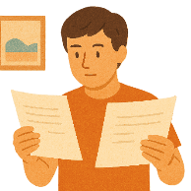 | - Making decisions
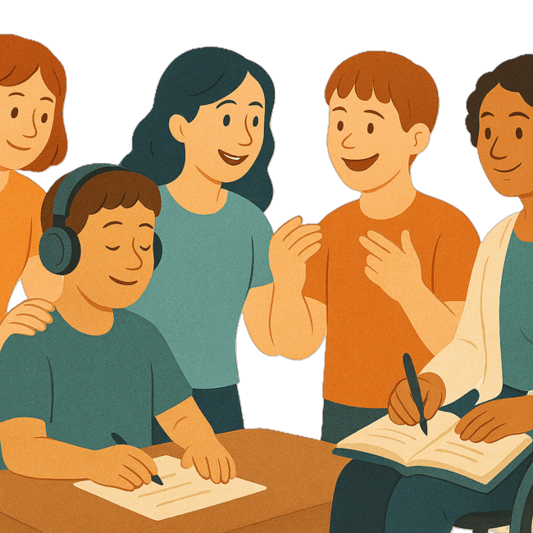 | - Workers
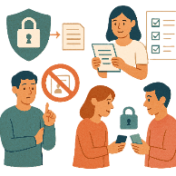 | - Information systems.  Information systems are the ways information is  - Collected  - Kept safe  - Shared.
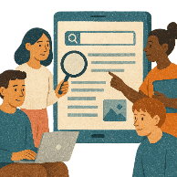 | There is a group being set up to watch over this work.  This is called to monitor.
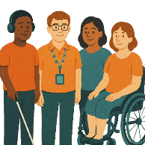 | The group will include  - People with disability
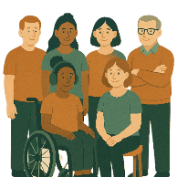 | - Their families
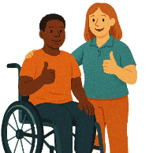 | - Carers.
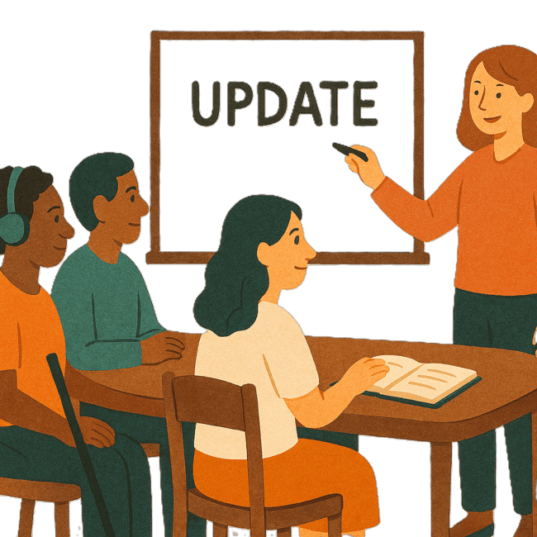 | DoH will tell the community how the Disability Health Strategy is going every year.

Inclusive Homes and Communities TAP

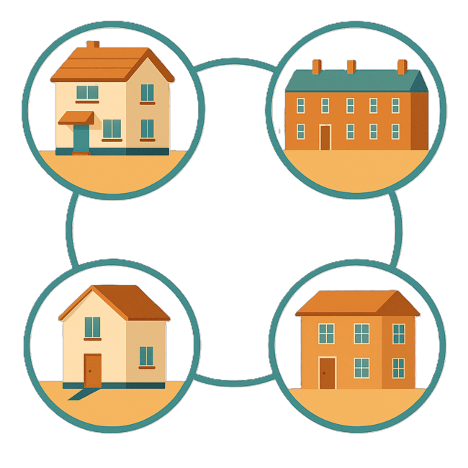 | This TAP wants to make  - Homes
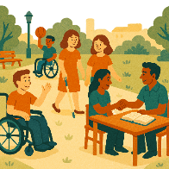 | - The community  Easier to access.
 | We also want them to be more welcoming.
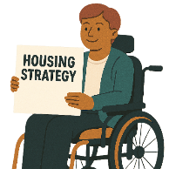 | Homes Tasmania is working on the Tasmanian Housing Strategy Action Plan.
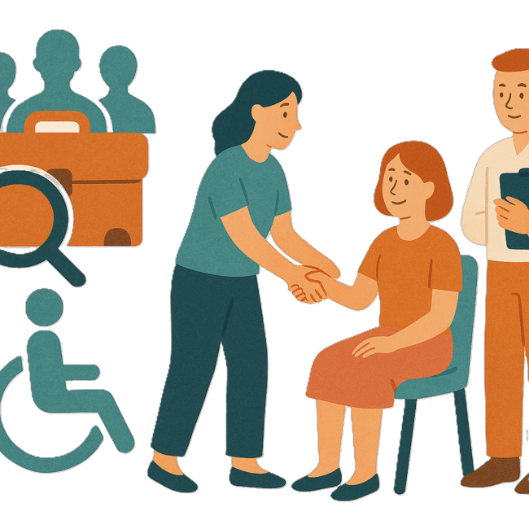 | Homes Tasmania is working with  - Disability service providers
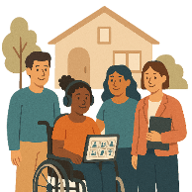 | - Housing providers  Housing providers are people or organisations that help people find homes to live in.
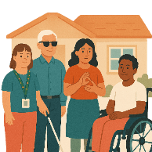 | They are looking at Specialist Disability Accommodation.  We call it SDA for short.
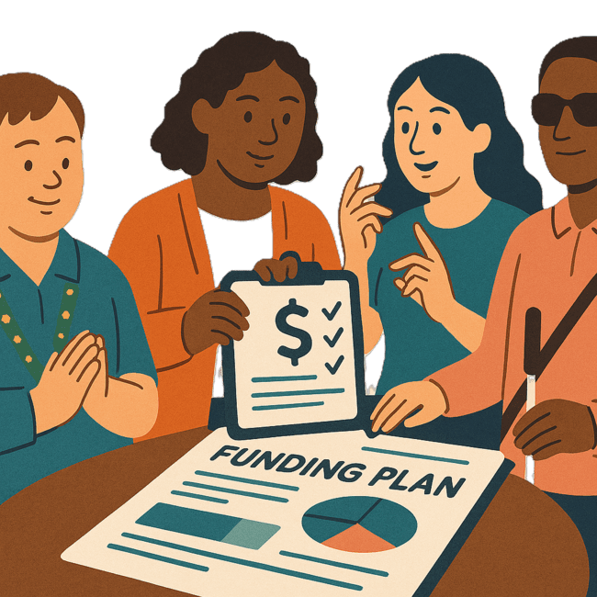 | They are looking for ways for SDA to have NDIS funding.  Funding is money from the government to take part.  This means more people with disability will have access good housing.  Access means being able to get something.

Safety Rights and Justice TAP

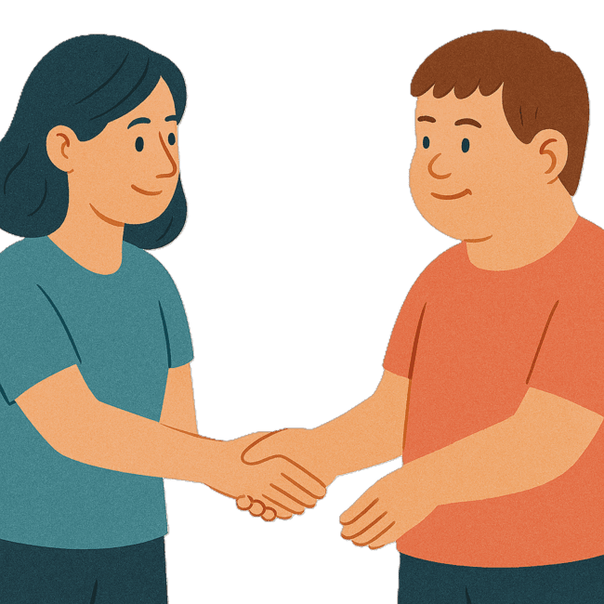 | This TAP wants to make sure people with disability are  - Safe  - Treated fairly.
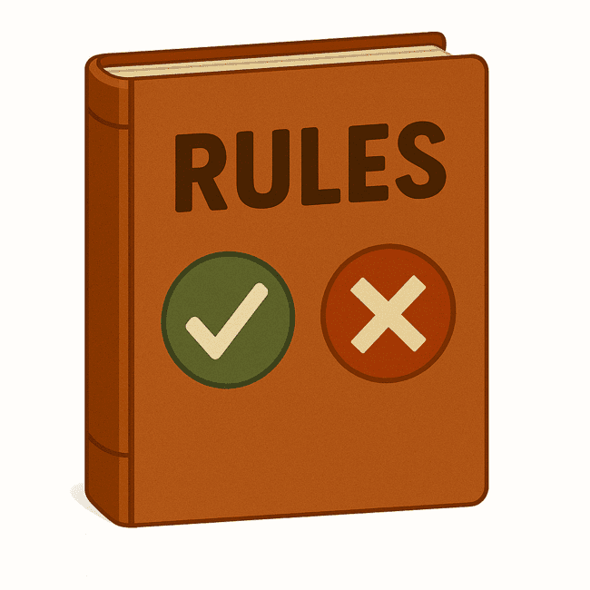 | The TAS government is working on  - A new law
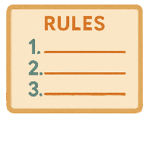 | - New planning rules
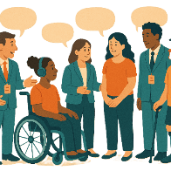 | - Working with people with disability to change laws.
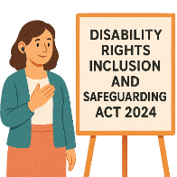 | The new law started on 1 July 2025.  It is called  - Disability Rights Inclusion and Safeguarding Act 2024.
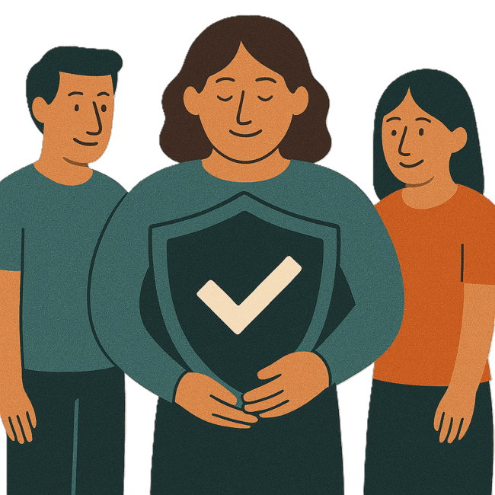 | Safeguarding means protecting people with disability from harm.
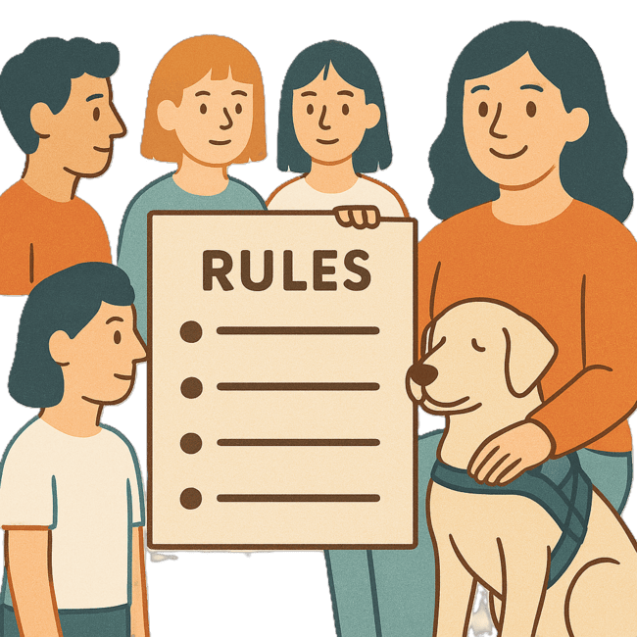 | The law has rules to help people with disability.
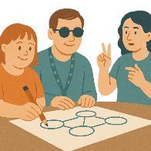 | The law says TAS government and other organisations need to  - Make plans to include people with disability
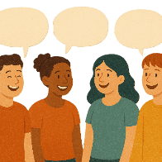 | - Talk to people with disability when making decisions
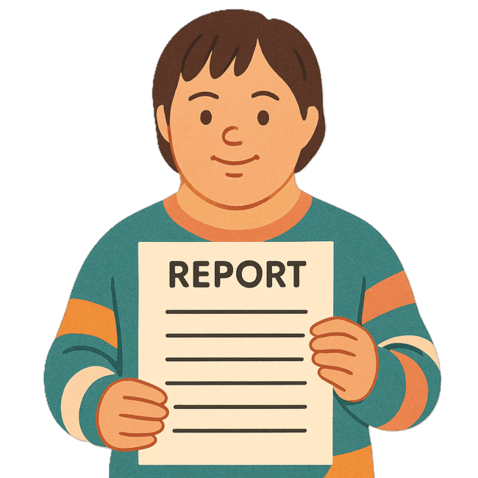 | - Write reports saying how they are making things better.
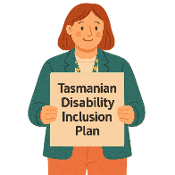 | These plans are part of the Tasmanian Disability Inclusion Plan.
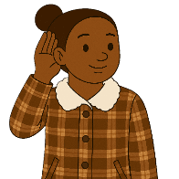 | The new law was made by listening to  - People with disability  - The community  In many consultations.
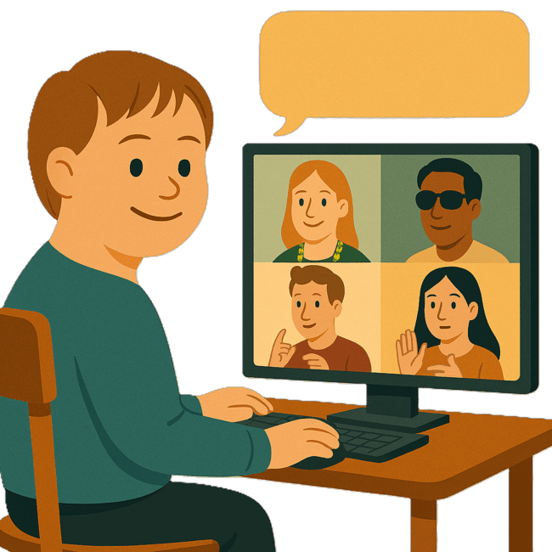 | Consultation is the governments way of working with the disability community.  It makes sure that the government is listening to communities.  This helps the government make better plans to support people with disability.
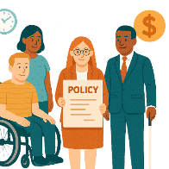 | The new law says the government must talk with people with disability when making or changing  - Policies  Policies are plans for how to do things.
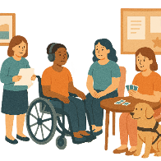 | - Programs
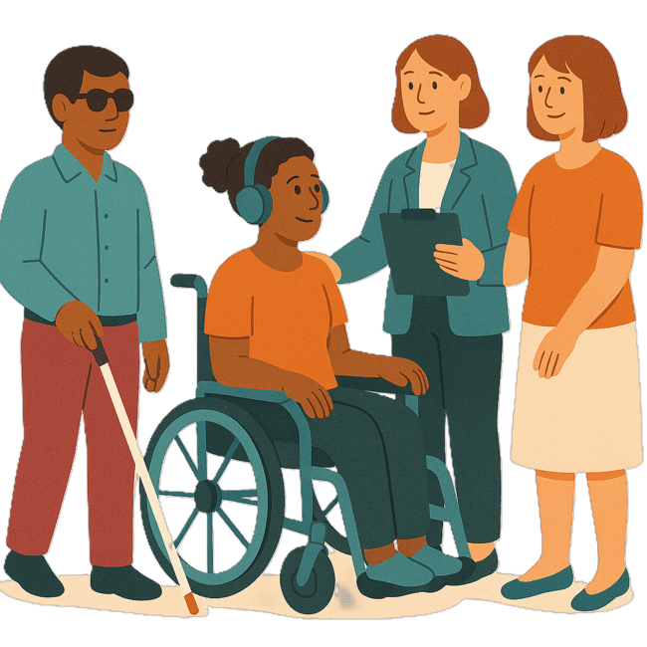 | - Services.
The talks must be

- Fair
- Flexible

Flexible means something that can change easily for different people.
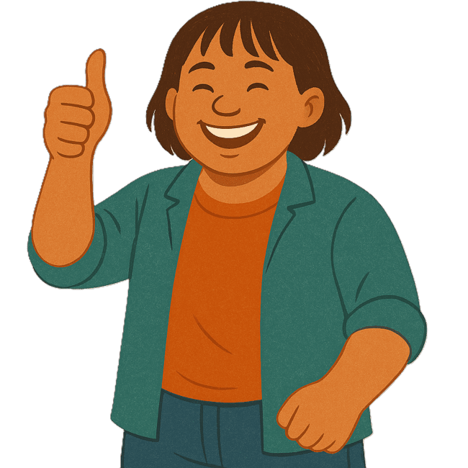 | This will make sure that people with disability have the same chance to share their ideas.

Images in this Easy Read must not be used or copied without permission

