Australia’s Disability Strategy 2021 to 2031

Targeted Action Plans Report

2025

Victoria update
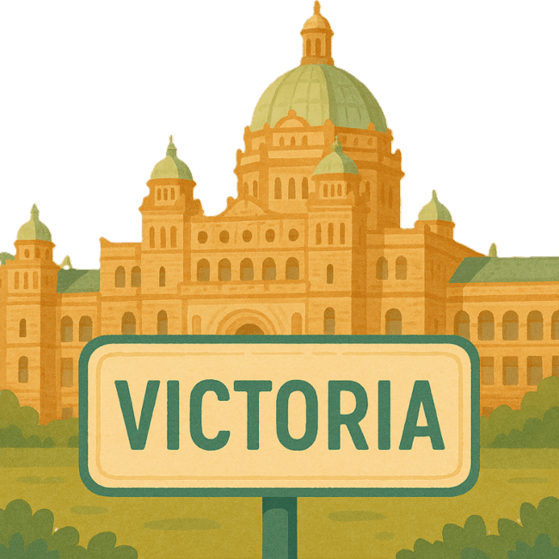
 | The Australian Government Department of Health Disability and Ageing wrote this.  We say DHDA for short.  When you see the word we it means DHDA.
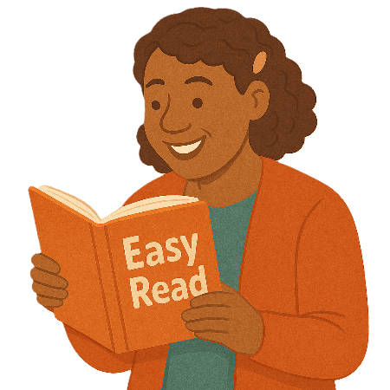 | We wrote this in an easy to read way.  We use pictures to explain some ideas.
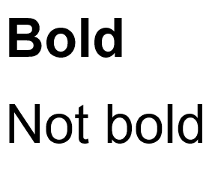 | We have some words in bold.  This means the letters are thicker and darker.  These are important words.
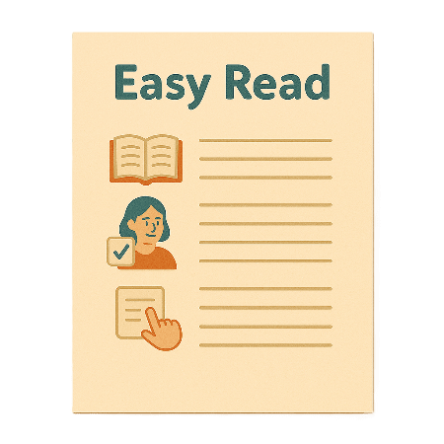 | This is an Easy Read summary of another document.  This means it has the most important ideas.
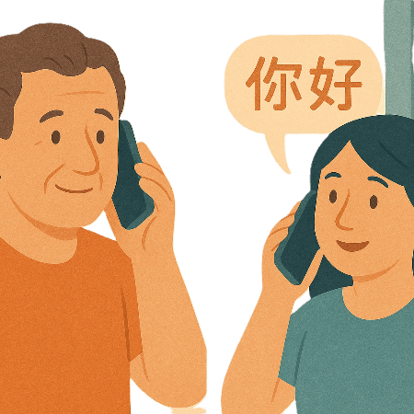 | If you speak a language other than English  - Call Translating and Interpreting Services.  1800 131 450
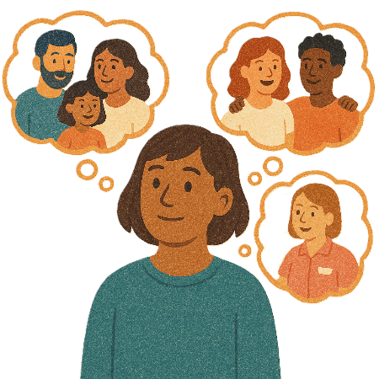 | You can ask for help to read this document.  You can ask  - A friend  - Family members  - A support person.
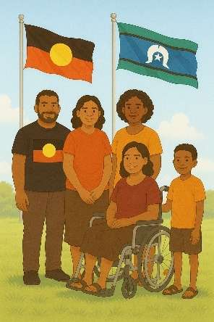 | We recognise Aboriginal and Torres Strait Islander people as the Traditional Owners of the land we live on.
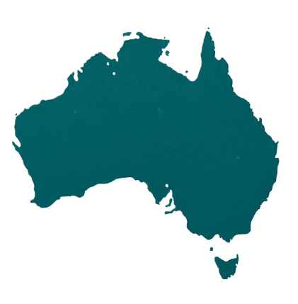 | They were the first people to live on and use the  - Land  - Waters.

Contents

About this document | 5
Australia’s Disability Strategy | 8
What are Targeted Action Plans | 9
Victoria Update | 11
Inclusive Homes and Communities TAP | 13
Safety Rights and Justice TAP | 15

About this document

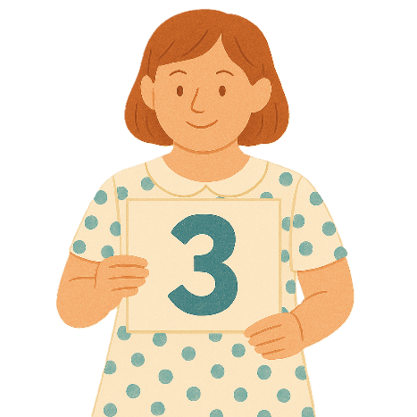 | This document has 3 parts
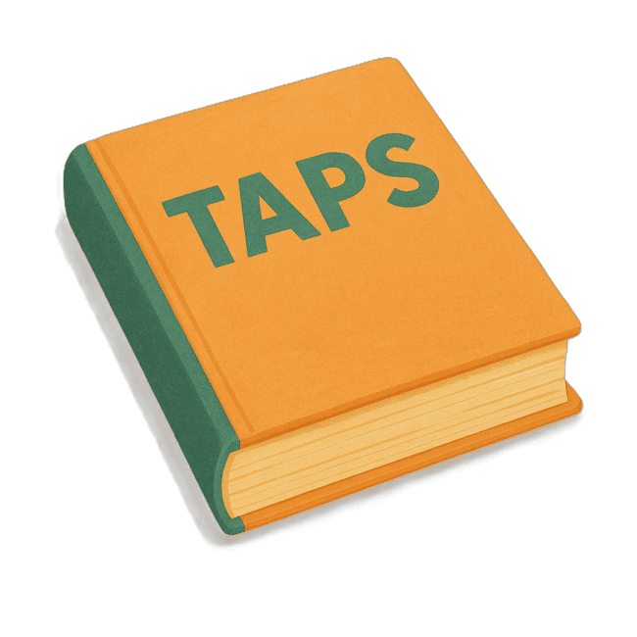 | Part 1 talks about  - What are Targeted Action Plans  We call them TAPs for short.
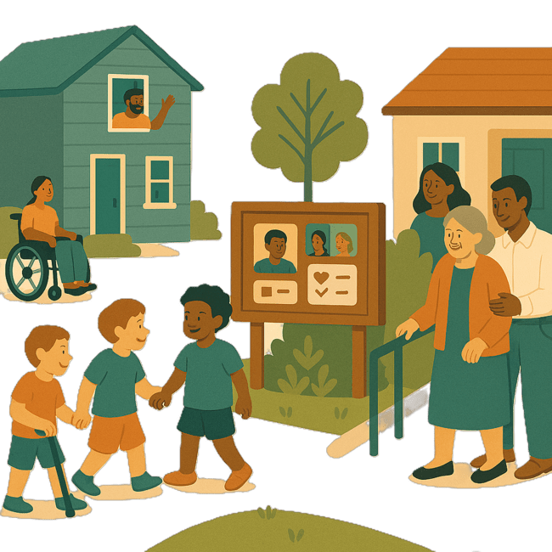 | Part 2 talks about  - Inclusive Homes and Communities TAP
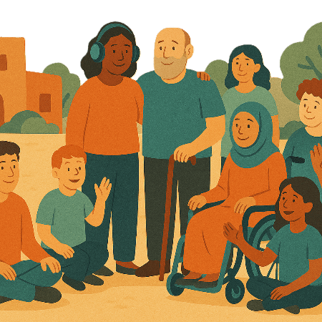 | Inclusive is when everyone  - Can take part  - Feel like they belong.
Part 3 talks about

- Safety Rights and Justice TAP

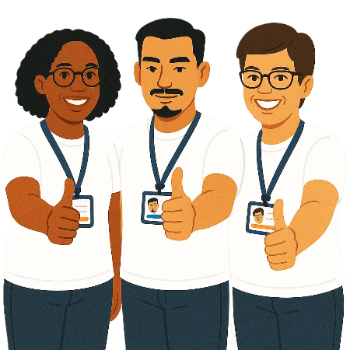 | Rights are rules about treating everyone  - Fair  - Equal.
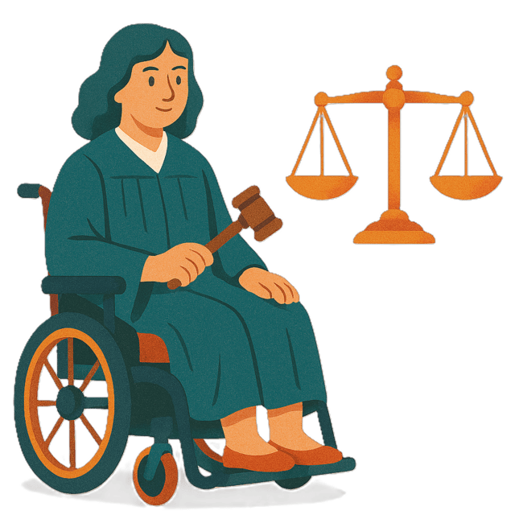 | Justice is  - The law  - Police  - The courts  - Prisons.  Laws are rules for how we live.
 | You can go to our website to read the updates from other states and territories.  www.disabilitygateway.gov.au/ads/easy-read-strategy  It is in Easy Read.

Australia’s Disability Strategy

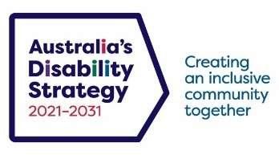 | The government set up Australia’s Disability Strategy.  We call it the Strategy for short.  It was also called ADS.
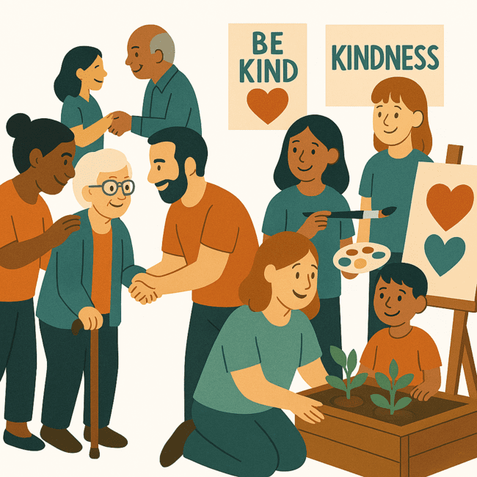 | The Strategy is the governments way of working together to support people with disability to live good lives.  They do this by working with  - People with disability  - The community.  This makes the community a more welcoming place for everyone.

What are Targeted Action Plans

We made small plans to help us work on the Strategy.

The small plans are called TAPs.
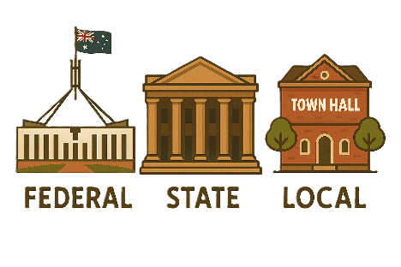 | TAPs are made by all governments in Australia.  All governments include  - Australian Government  - State and territory governments  - Local governments.
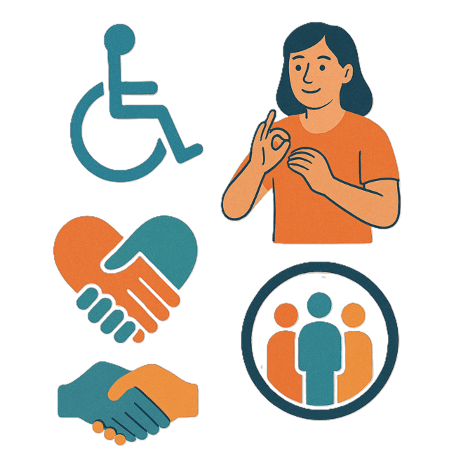 | There are 3 TAPs.  - Community Attitudes
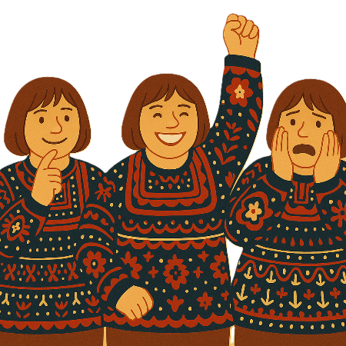 | Attitudes are what people  - Think  - Feel  - Believe.
 | - Inclusive Homes and Communities
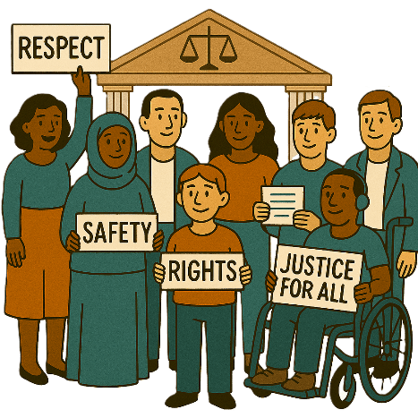 | - Safety Rights and Justice
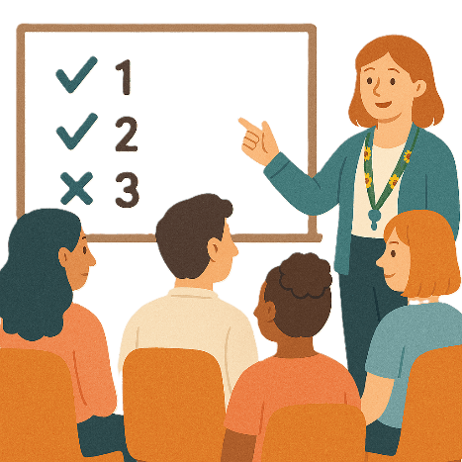 | Some governments do not have actions in all 3 TAPs.  They might have actions in only some of TAPs.

Victoria update

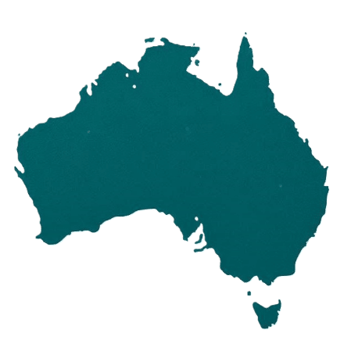 | Each state and territory government have made their own actions.  This makes sure that they meet the needs of their communities.  Actions are the things that we will do.
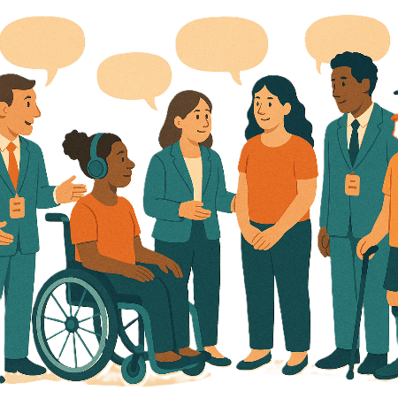 | Each government says how the actions will include  - People with disability
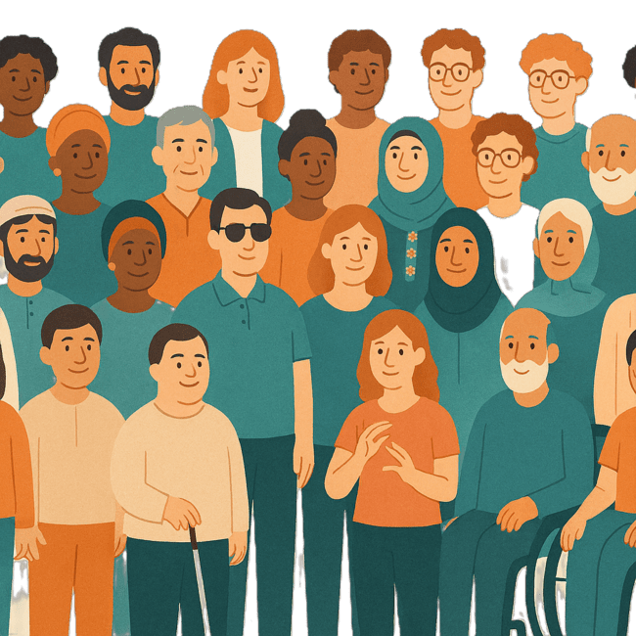 | - The disability community.
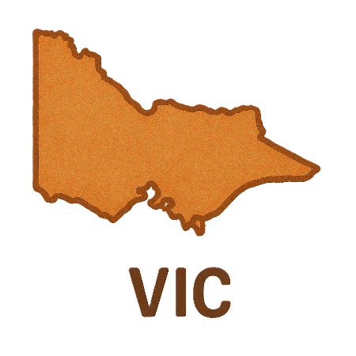 | This document talks about some actions the Victorian government is doing in their 2 TAPs.  We call them VIC for short.

Inclusive Homes and Communities

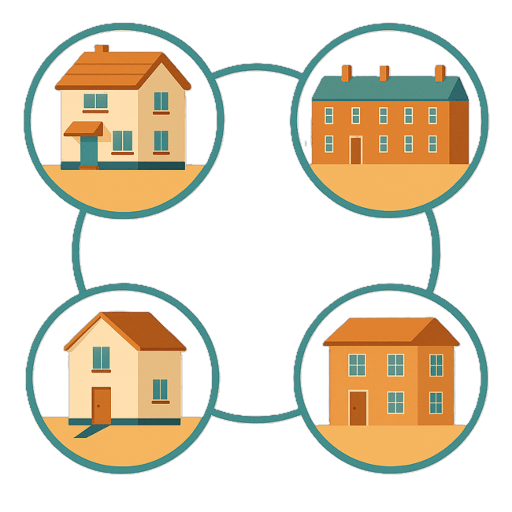 | This TAP wants to make  - Homes
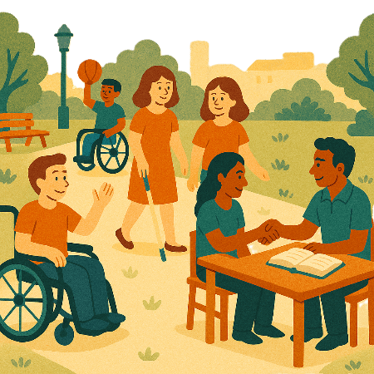 | - The community  Easier to access.
 | We also want them to be more welcoming.
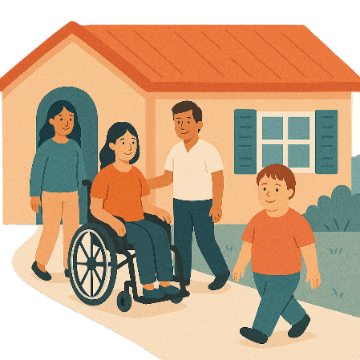 | The VIC government is working to make sure new social housing is accessible.  They need to follow standards to make sure the houses are accessible.
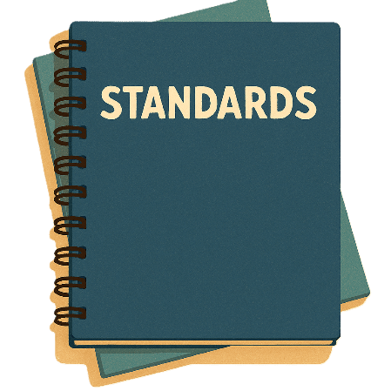 | Standards are rules that people need to follow for something.  It makes sure that everyone is doing the same good work.
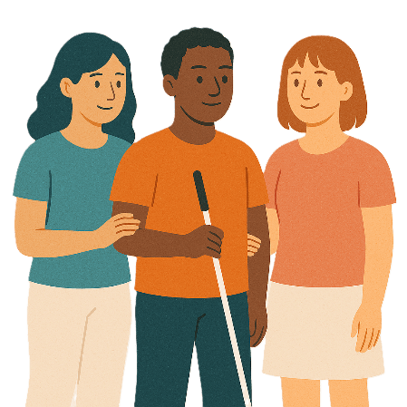 | The standards were made with the help from Disability Representative Organisations like  - Blind Citizens Australia
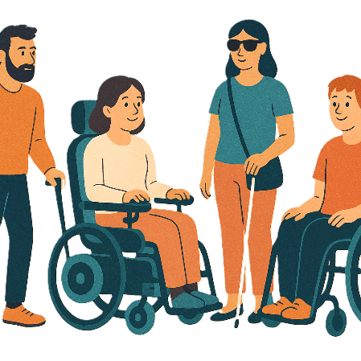 | - Physical Disability Australia.

Safety Rights and Justice TAP

 | This TAP wants to make sure people with disability are  - Safe  - Treated fairly.
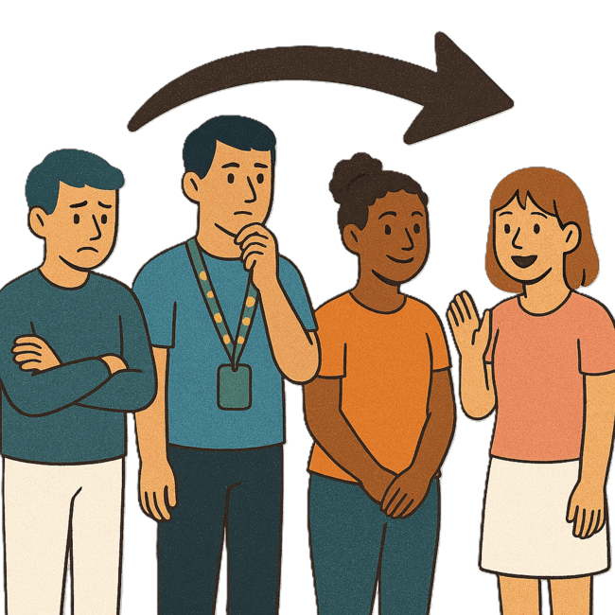 | The VIC government is working on  - Changes to disability services
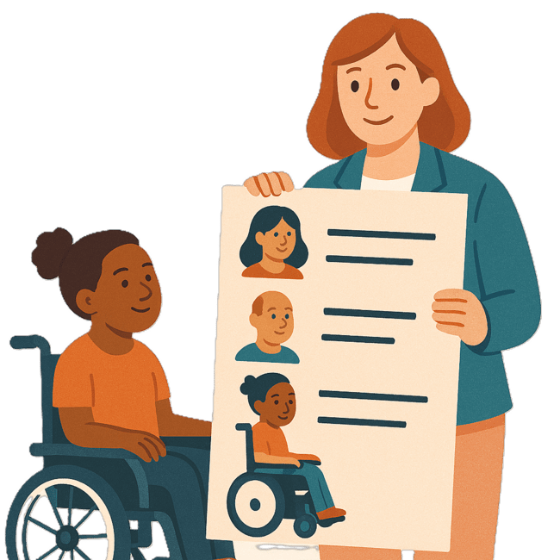 | - Registering service providers  Registering means they are on the list of service providers.
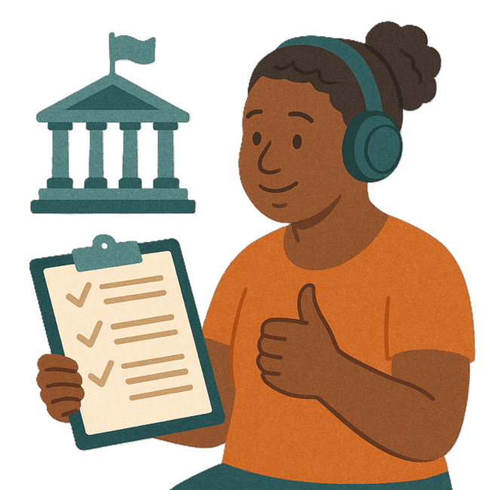 | - Disability Worker Regulation Scheme  Regulations are rules made by the government or organisation.  It says what you can  - Do  - Not do.
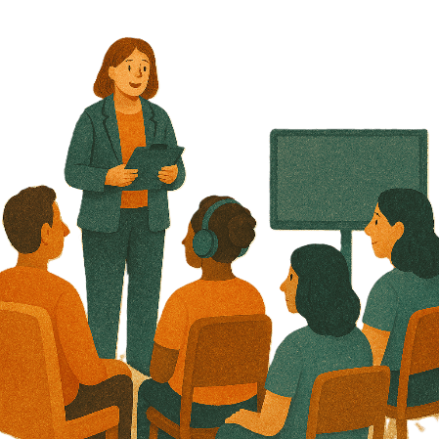 | Schemes are plans or programs.  They are usually run by the government.
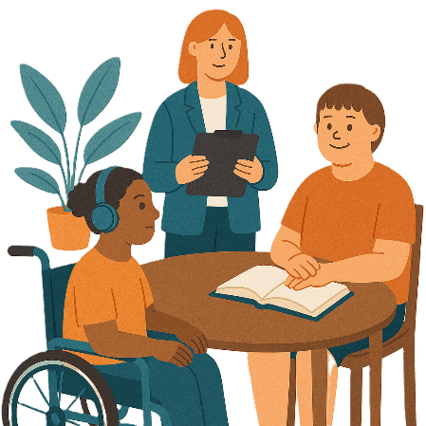 | In February 2024 the VIC government said they would change how disability services are managed.  Managed means looked after.  It can be done by a  - Person  - Group.
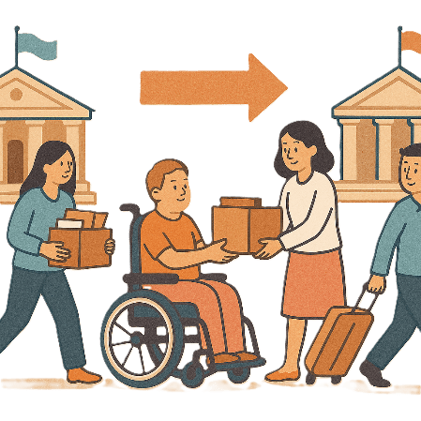 | They plan to move the work from  - Victorian Disability Worker Commission  - Disability Service Commissioner  To a new organisation.
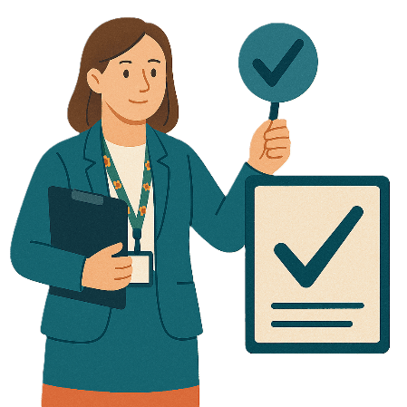 | The new organisation is called Social Services Regulator.  We call it the Regulator for short.  A regulator is an organisation that make sures the rules are followed.
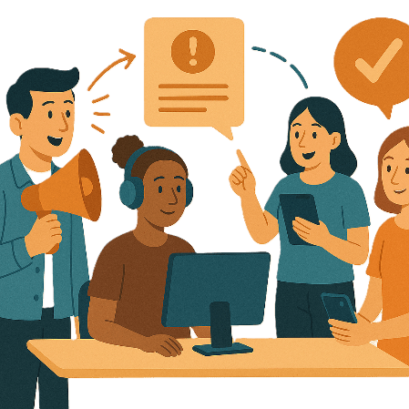 | There will be new ways for people to make complaints to the Regulator.
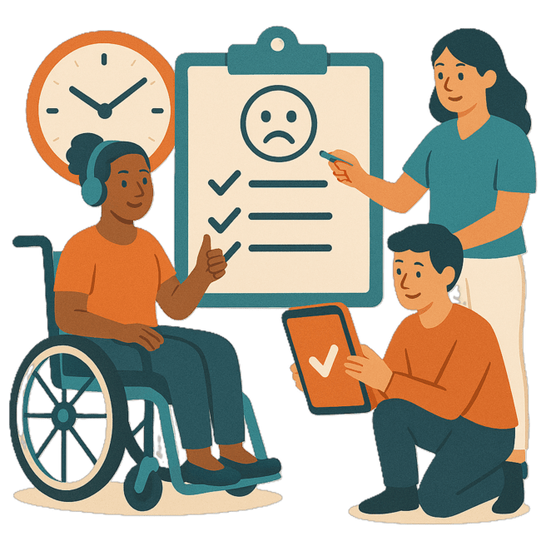 | Complaints are when you tell someone they have not done a good job.  Everyone has the right to make a complaint.
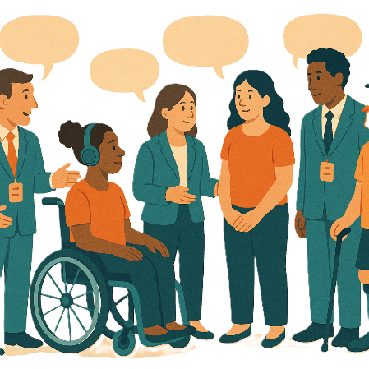 | The government is talking with  - People with disability  - Organisations.
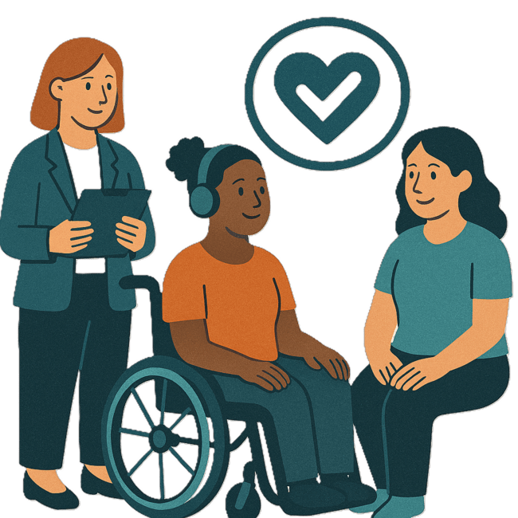 | This will make sure the changes keep  - Things safe
 | - The same rights  For people with disability.

Images in this Easy Read must not be used or copied without permission

