Australia’s Disability Strategy 2021 to 2031

Targeted Action Plans Report

2025
Western Australia update
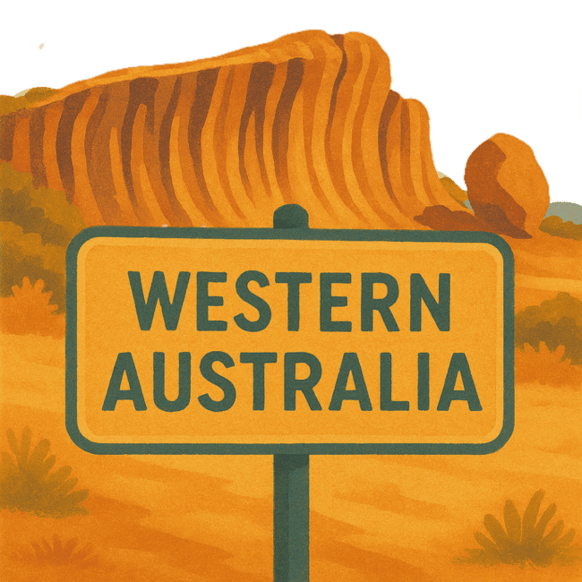
 | The Australian Government Department of Health Disability and Ageing wrote this.  We say DHDA for short.  When you see the word we it means DHDA.
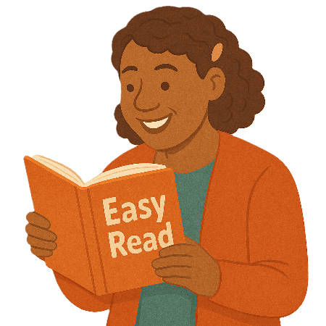 | We wrote this in an easy to read way.  We use pictures to explain some ideas.
 | We have some words in bold.  This means the letters are thicker and darker.  These are important words.
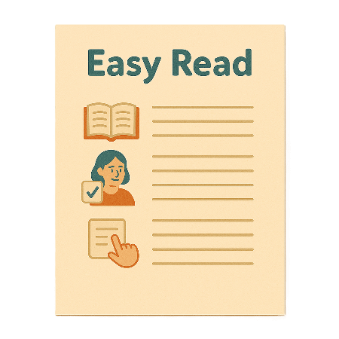 | This is an Easy Read summary of another document.  This means it has the most important ideas.
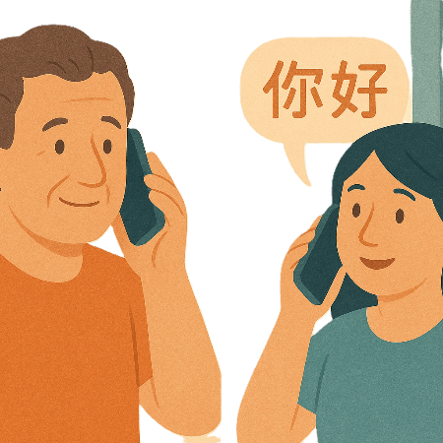 | If you speak a language other than English  - Call Translating and Interpreting Services.  1800 131 450
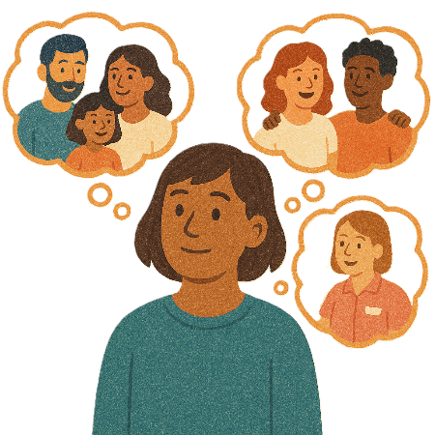 | You can ask for help to read this document.  You can ask  - A friend  - Family members  - A support person.
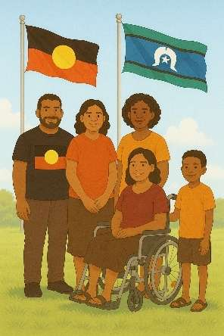 | We recognise Aboriginal and Torres Strait Islander people as the Traditional Owners of the land we live on.
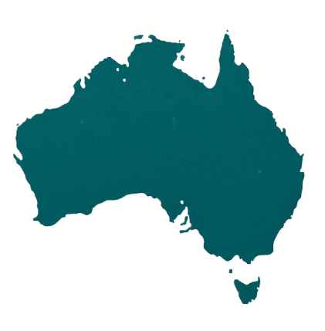 | They were the first people to live on and use the  - Land  - Waters.

Contents

About this document | 5
Australia’s Disability Strategy | 8
What are Targeted Action Plans | 9
Western Australia Update | 11
Community Attitude TAP | 13
Inclusive Homes and Communities TAP | 16
Safety Rights and Justice TAP | 19

About this document

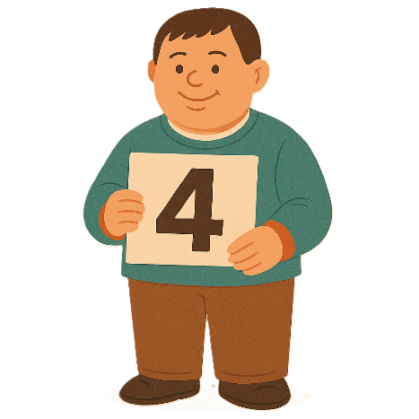 | This document has 4 parts
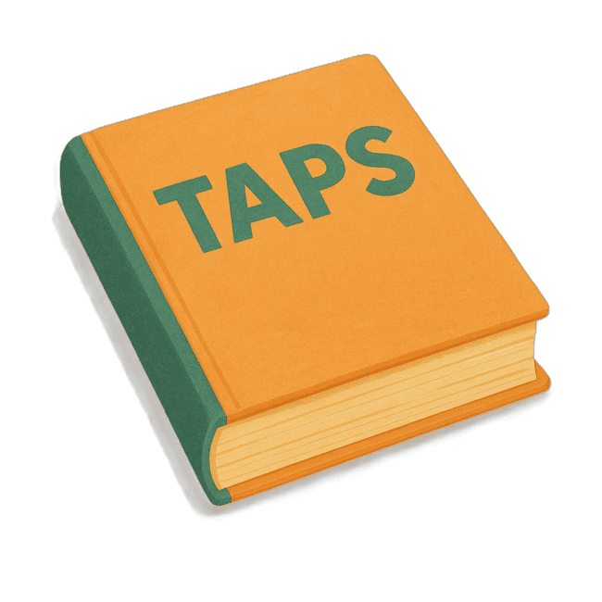 | Part 1 talks about  - What are Targeted Action Plans  We call them TAPs for short.
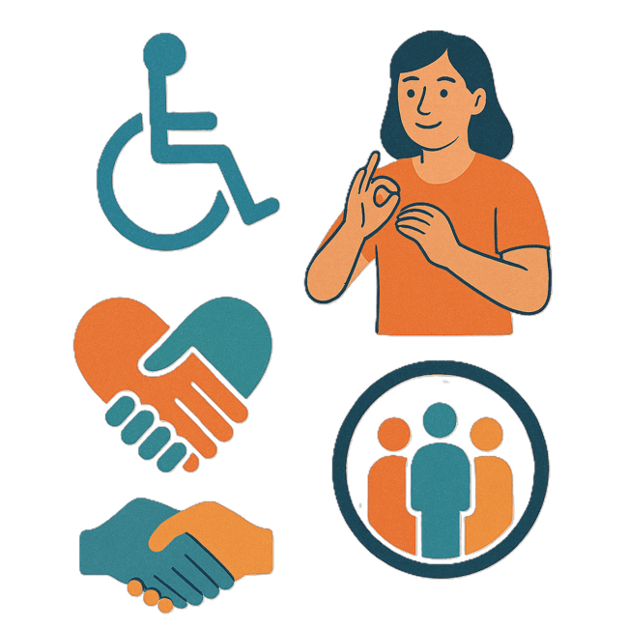 | Part 2 talks about  - Community Attitudes TAP
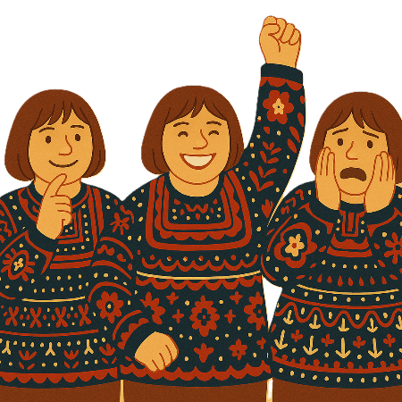 | Attitudes are what people  - Think  - Feel  - Believe.
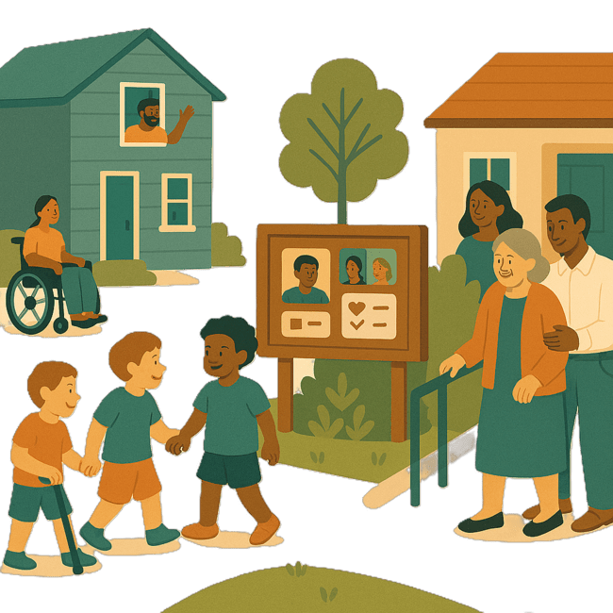 | Part 3 talks about  - Inclusive Homes and Communities TAP
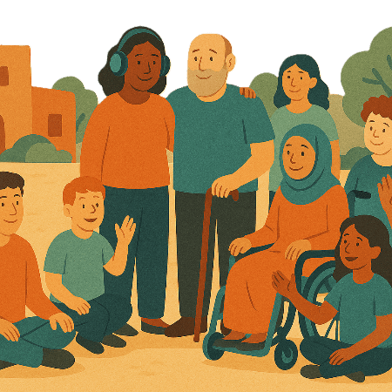 | Inclusive is when everyone  - Can take part  - Feel like they belong.
Part 4 talks about

- Safety Rights and Justice TAP

 | Rights are rules about treating everyone  - Fair  - Equal.
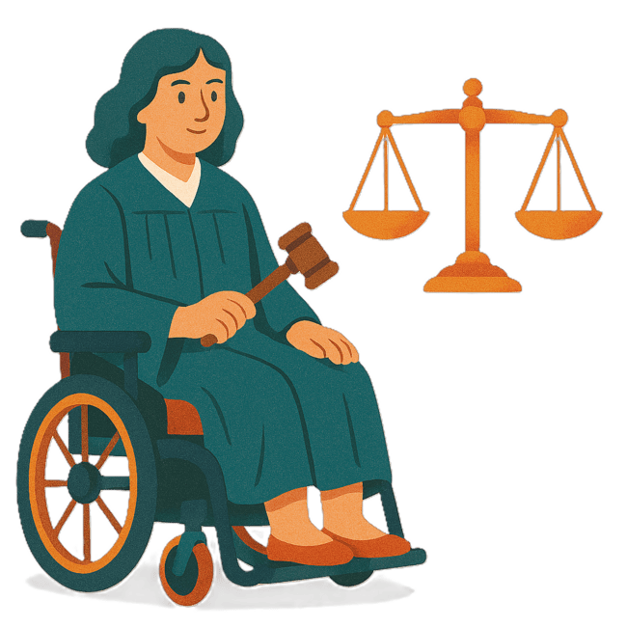 | Justice is  - The law  - Police  - The courts  - Prisons.  Laws are rules for how we live.
 | You can go to our website to read the updates from other states and territories.  www.disabilitygateway.gov.au/ads/easy-read-strategy  It is in Easy Read.

Australia’s Disability Strategy

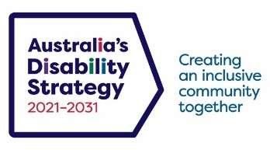 | The government set up Australia’s Disability Strategy.  We call it the Strategy for short.  It was also called ADS.
 | The Strategy is the governments way of working together to support people with disability to live good lives.  They do this by working with  - People with disability  - The community.  This makes the community a more welcoming place for everyone.

What are Targeted Action Plans

We made small plans to help us work on ADS.

The small plans are called TAPs.
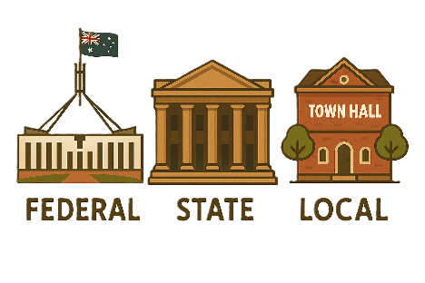 | TAPs are made by all governments in Australia.  All governments include  - Australian Government  - State and territory governments  - Local governments.
There are 3 TAPs.

- Community Attitudes
 | - Inclusive Homes and Communities
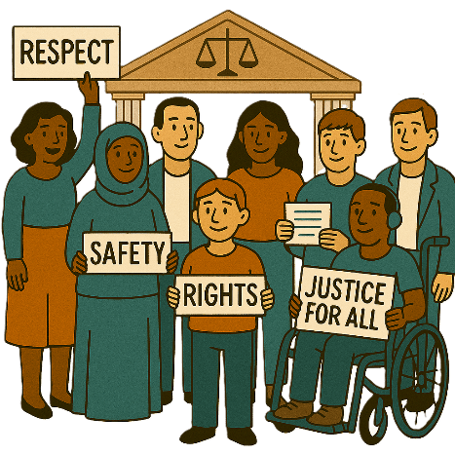 | - Safety Rights and Justice

Western Australia update

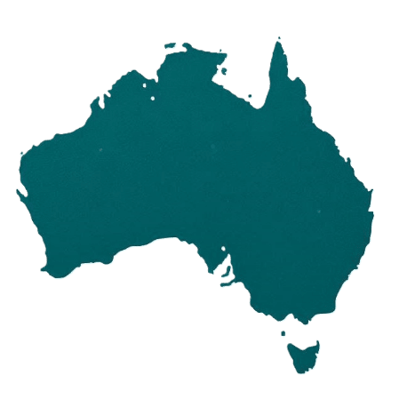 | Each state and territory government have made their own actions.  This makes sure that they meet the needs of their communities.  Actions are the things that we will do.
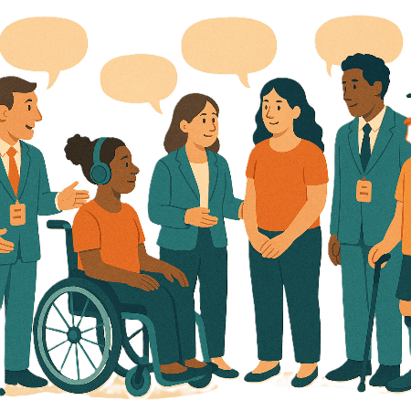 | Each government says how the actions will include  - People with disability
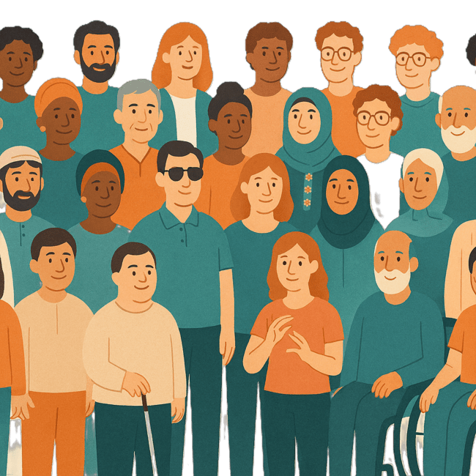 | - The disability community.
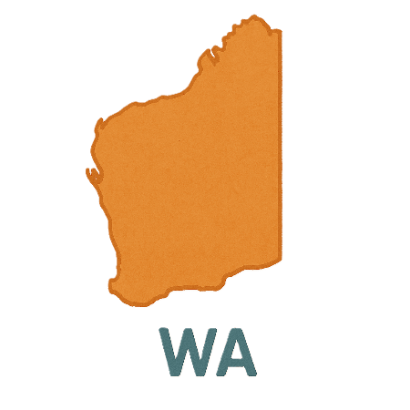 | This document talks about some actions the Western Australian government is doing in the 3 TAPs.  We call them WA for short.

Community Attitudes TAP

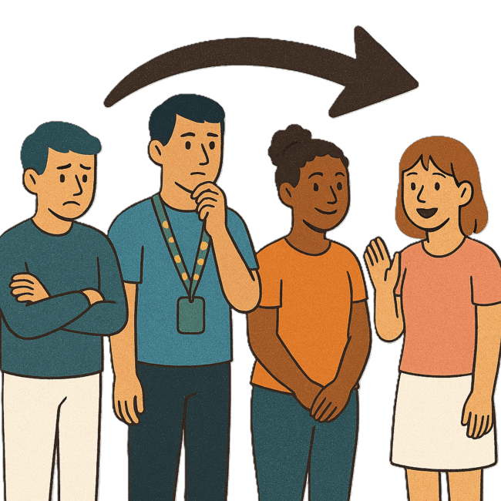 | This TAP wants to change  - How people behave  Behave means  - How you act  - What you do.
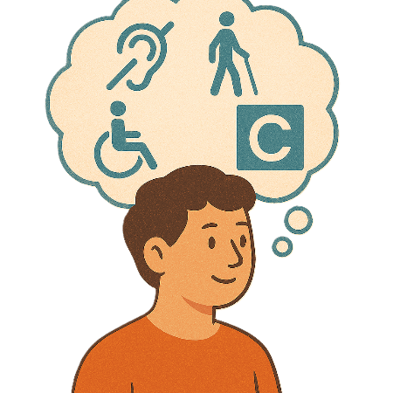 | - What people think about disability.
 | The WA government is working on  - People with disability being in leadership roles
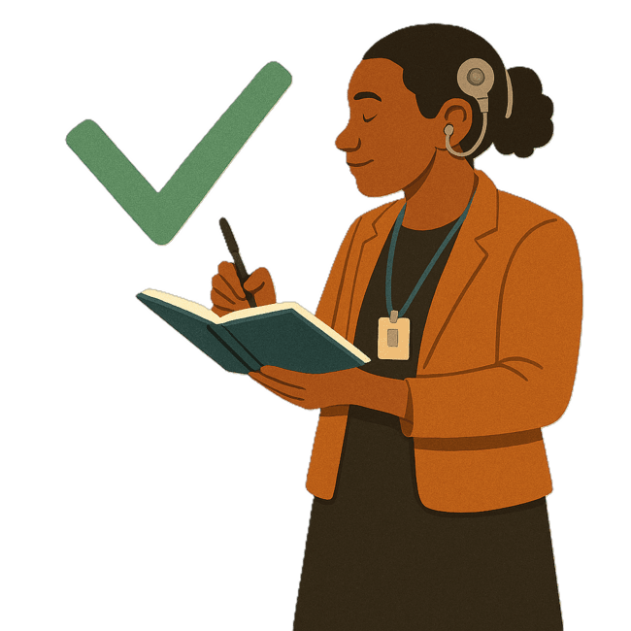 | The WA Disability Strategy says it is important for people with disability to be leaders.
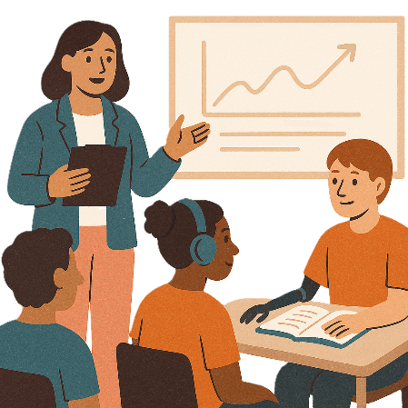 | WA government is working with Leadership WA.  They run 2 LeadAbility courses every year.  Courses are when you learn how to do something.
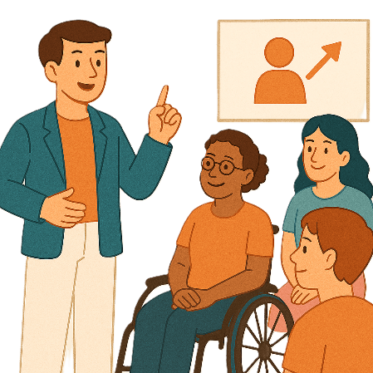 | The courses help people to learn leadership skills.  Leadership skills are the things you need to know to be a good leader.
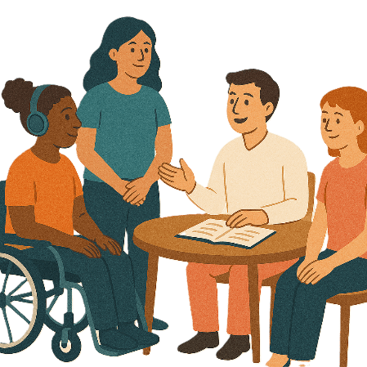 | People who finish the course can join the community of practice.  Community of practice is a group of people who talk about a topic.  They  - Share ideas  - Learn from each other.

Inclusive Homes and Communities

 | This TAP wants to make  - Homes
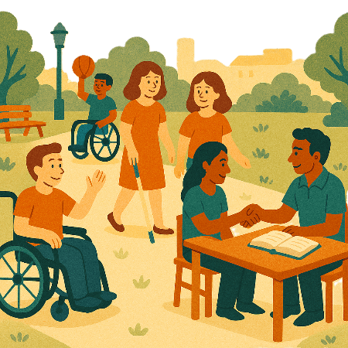 | - The community  Easier to access.
 | We also want them to be more welcoming.
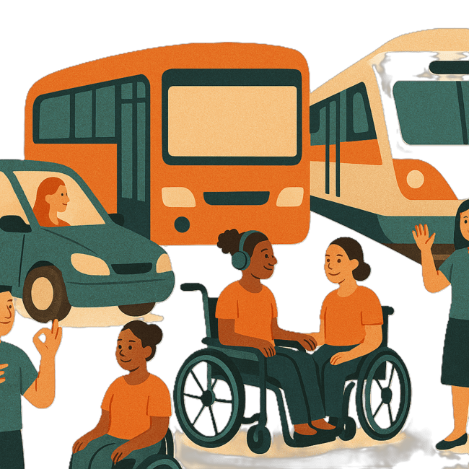 | The WA government is working on a  - Passenger Transport Subsidy Scheme  Subsidy means the cost of services for people is lower.  The government will give you a card to use for transport.
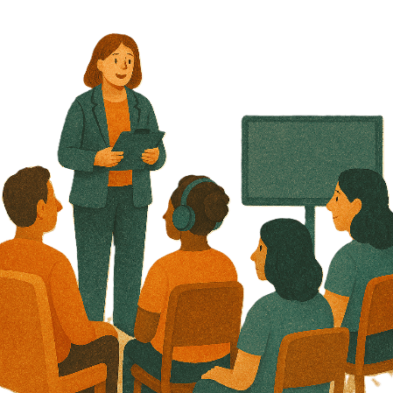 | Schemes are plans or programs.  They are usually run by the government.
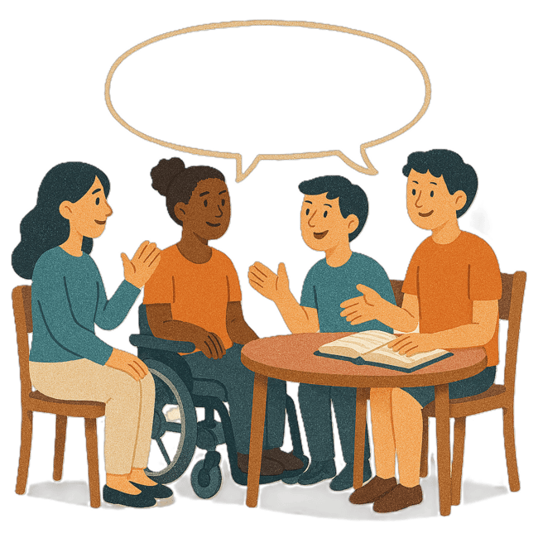 | People with disability helped say how the card should be made.  They made sure it was easy to  - Read  - Understand.
 | WA government has programs to help people use public transport safely.  Public transport is  - Buses  - Trains  - Taxis.

Safety Rights and Justice TAP

 | This TAP wants to make sure people with disability are  - Safe  - Treated fairly.
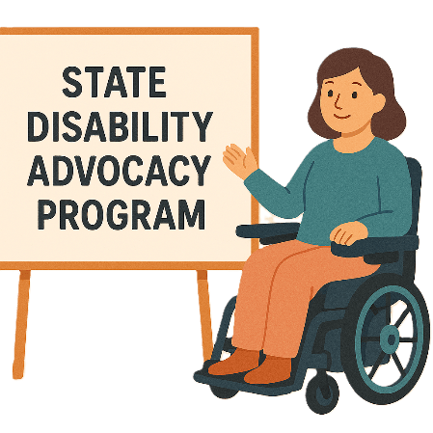 | The WA government is working on  - State Disability Advocacy Program  We call it SDAP for short.
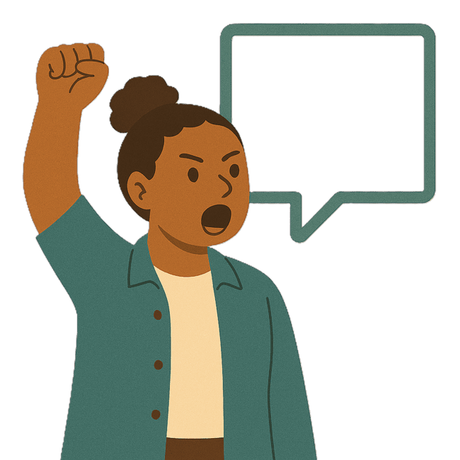 | Advocacy is when someone supports you to speak up for your rights.
 | SDAP has given lots of funding every year to advocacy services in WA.  Funding is money from the government to take part.
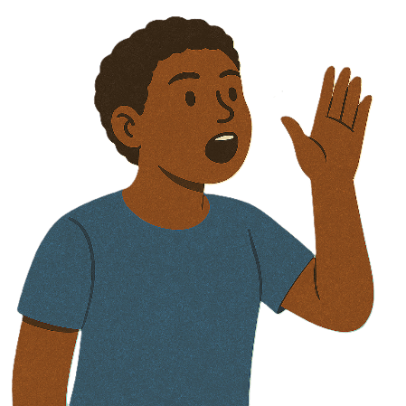 | The advocacy services support people with disability to  - Speak up
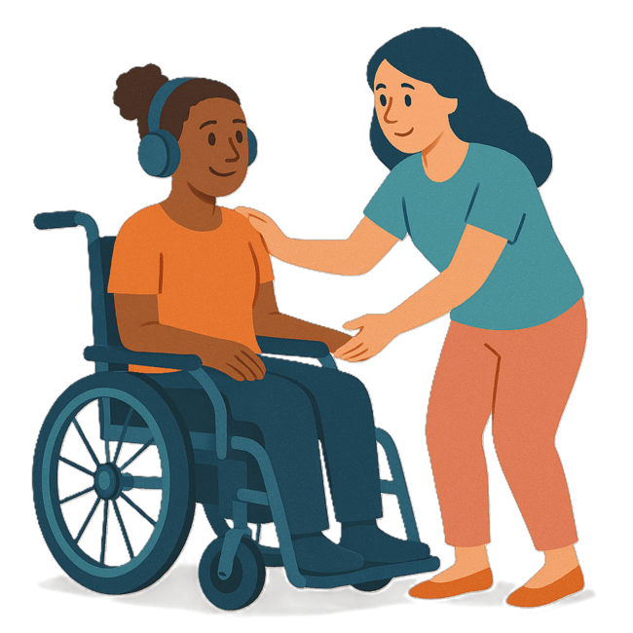 | - Get support.  This also includes supporting people with disability in the justice system.
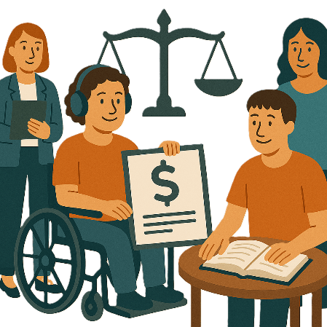 | Organisations that support people with disability in the justice system are  - Midland Information Debt and Legal Advocacy Service  Debt means you owe someone money.
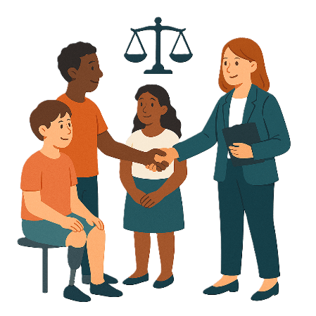 | Legal means something about the law.
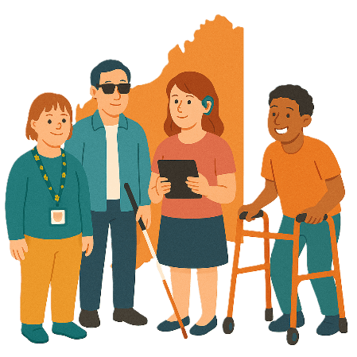 | - People with Disability Western Australia
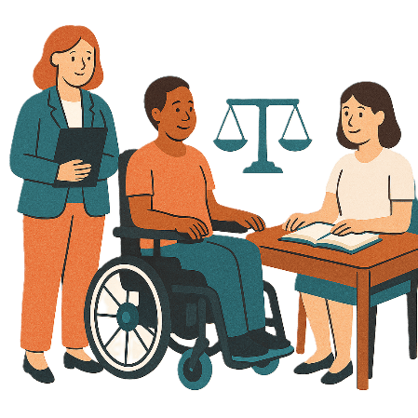 | - Sussex Street Community Law Service
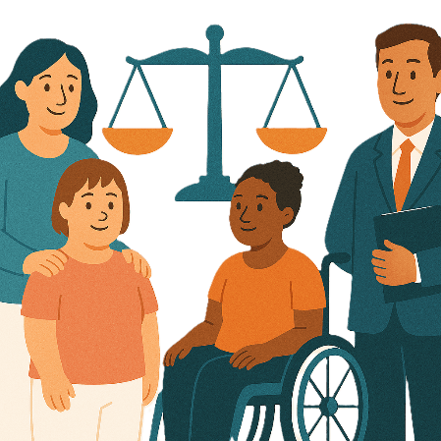 | - Great Southern Community Legal Services.

Images in this Easy Read must not be used or copied without permission

