The Advisory Council

November 2025
Update
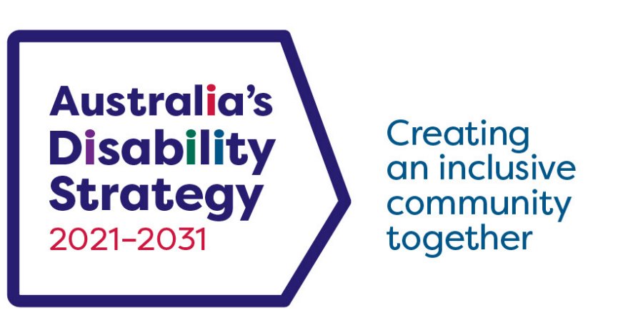
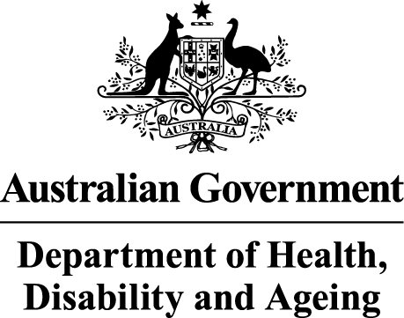 | The Australian Government Department of Health Disability and Ageing wrote this.  We say DHDA for short.  When you see the word we it means DHDA.
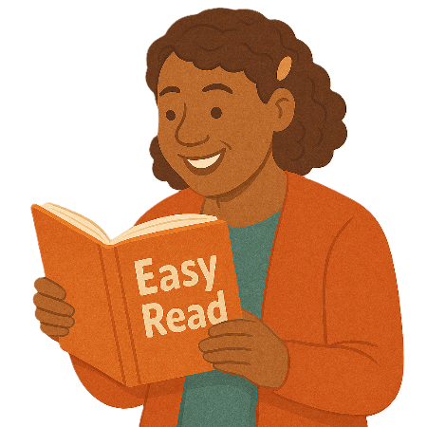 | We wrote this in an easy to read way.  We use pictures to explain some ideas.
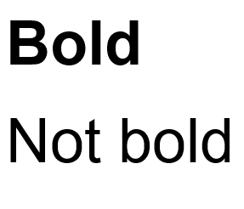 | We have some words in bold.  This means the letters are thicker and darker.  These are important words.
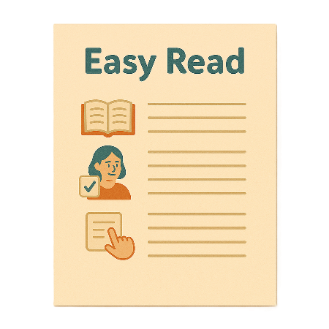 | This is an Easy Read summary of another document.  This means it has the most important ideas.
 | We can answer any questions by email.  Email us ADSAdvisoryCouncil@health.gov.au
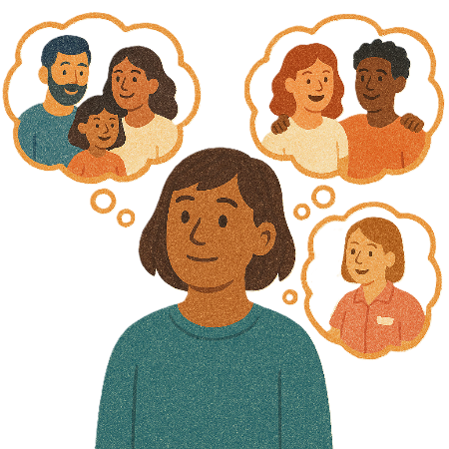 | You can ask for help to read this document.  You can ask  - A friend  - Family members  - A support person.
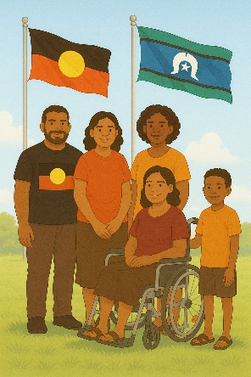 | We recognise Aboriginal and Torres Strait Islander people as the Traditional Owners of the land we live on.
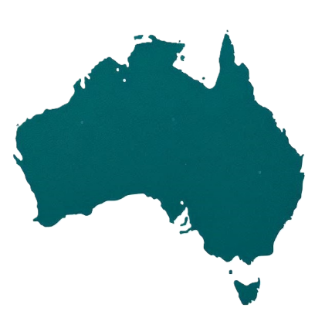 | They were the first people to live on and use the  - Land  - Waters.

Contents

Australia’s Disability Strategy | 5
The Advisory Council | 6
Documents to endorse | 10
Updates | 15
The next meeting | 21

Australia’s Disability Strategy

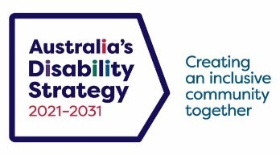 | Australia’s Disability Strategy is a plan to make life better for people with disability.  We call it the Strategy for short.  It is also called ADS.
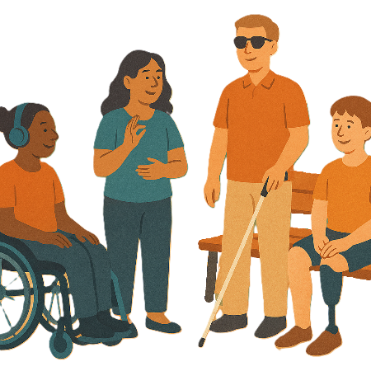 | The Strategy is important for Australia to be more inclusive.  Inclusive means everyone can take part.
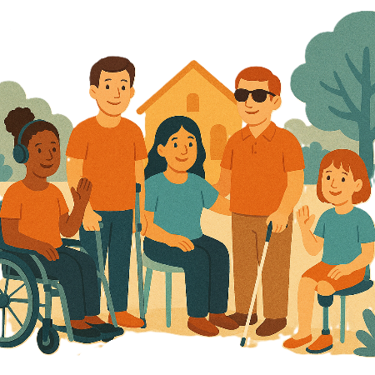 | This makes everyone in our community feel welcome.

The Advisory Council

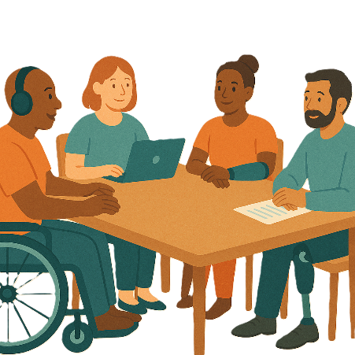 | The Advisory Council gives advice about the Strategy to  - The Australian Government  - State and territory governments  - Local governments.  We call it the Council.
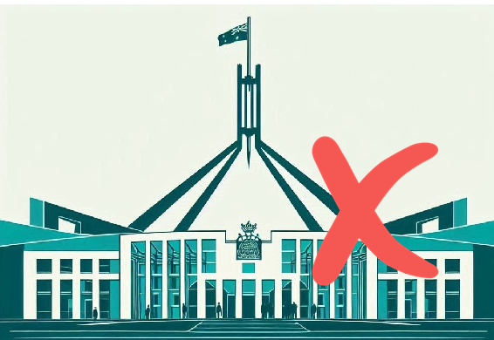 | The Council is not part of the government.
The Council helps governments understand how to

- Use the Strategy
- Share reports about the Strategy
- Work towards the goals of the Strategy.

Goals are things you want to do.
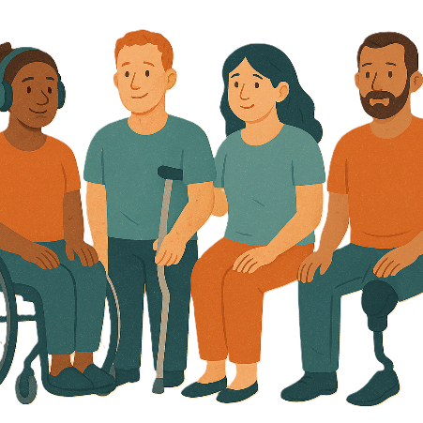 | The Council includes people  - With disability  - Who understand barriers for people with disability.
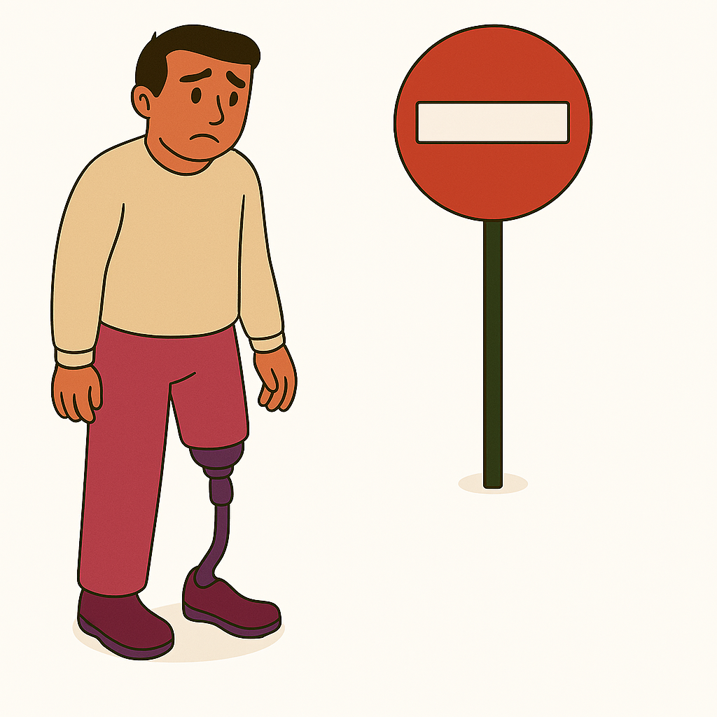 | A barrier is something that stops you from doing what you  - Want  - Need.
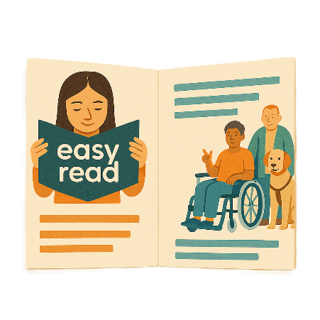 | The Council writes information about what they talked about in their meetings.  We share important information with the community.
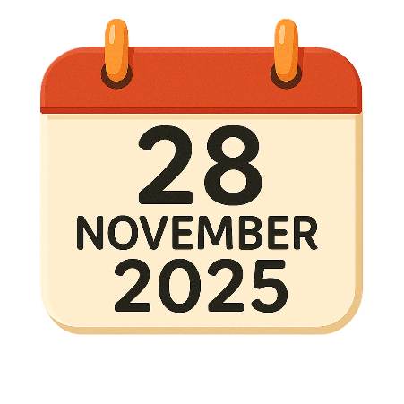 | This information is about the Council meeting on 28 November 2025.
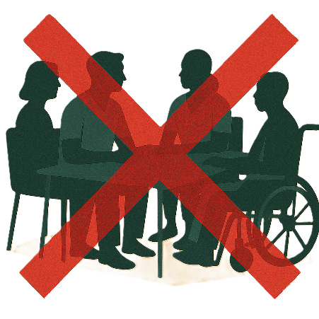 | The meeting did not happen.
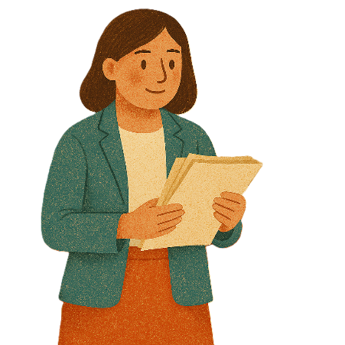 | We sent the information written down instead.
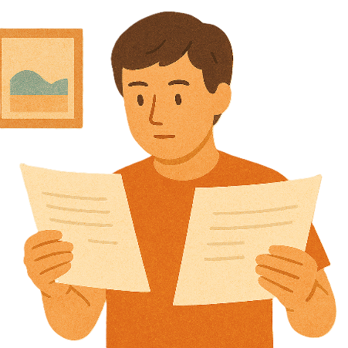 | Members needed to  - Read the information
 | - Endorse some documents  Endorse means telling the group that you agree with what is written.
 | The documents were sent by email.
 | They needed to send an email to the secretariat to say you endorse them.  The secretariat is the team responsible for all the paperwork in meetings.
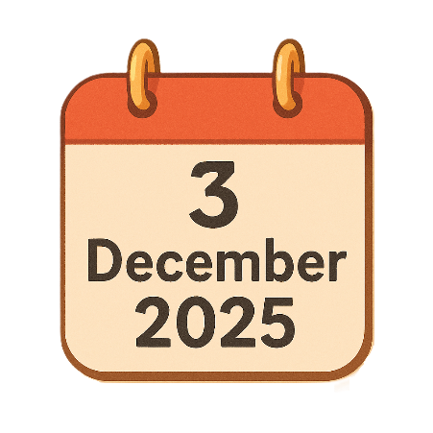 | They needed to do this by 3 December 2025.

Documents to endorse

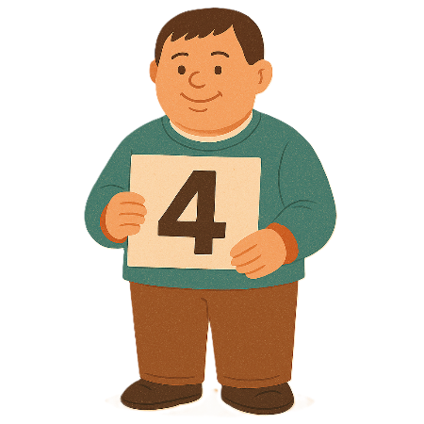 | There were 4 documents to endorse.
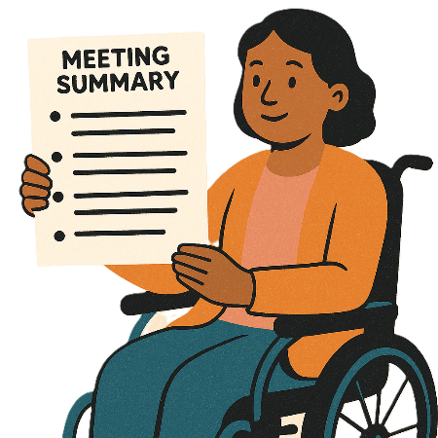 | - The August 2025 meeting action items and outcomes
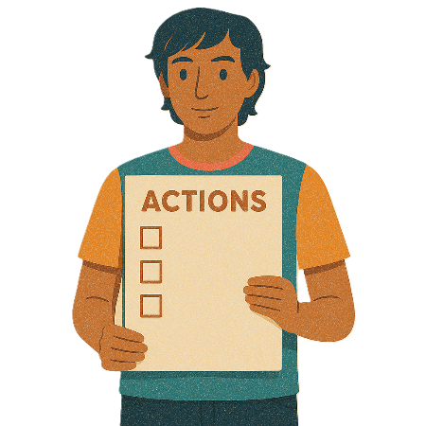 | Action items are the things that need to be done after a meeting.  They also say who needs to do them.
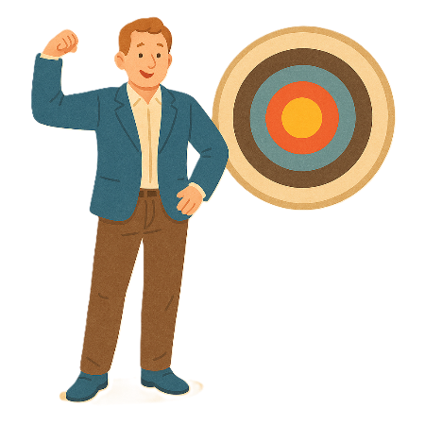 | Outcomes are the things we see when our plans are working.
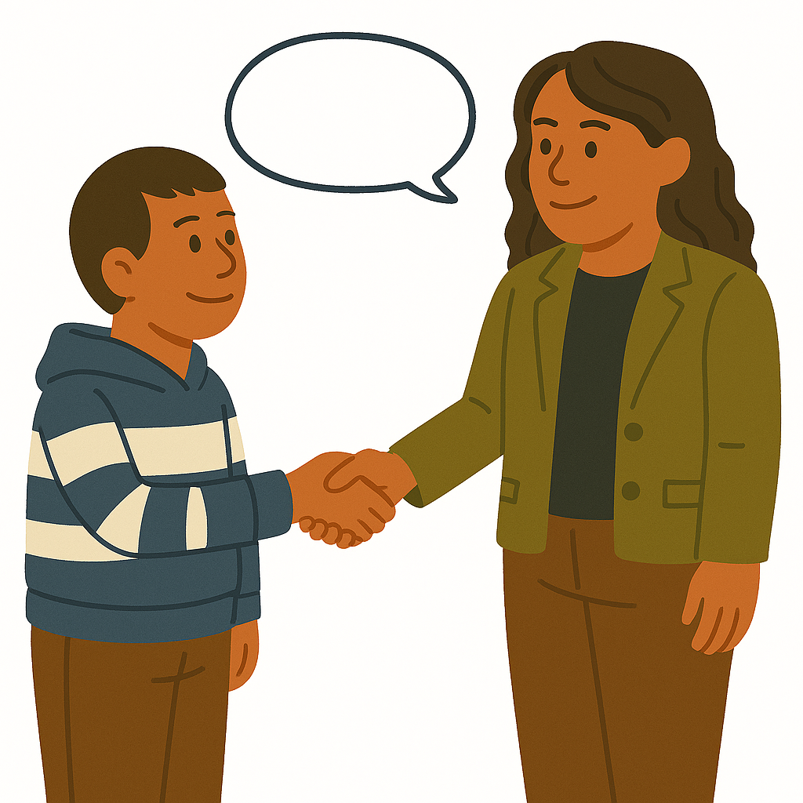 | - Informal advice about housing  Informal advice is when experts give their ideas.  There is no agreement that anything else will happen.
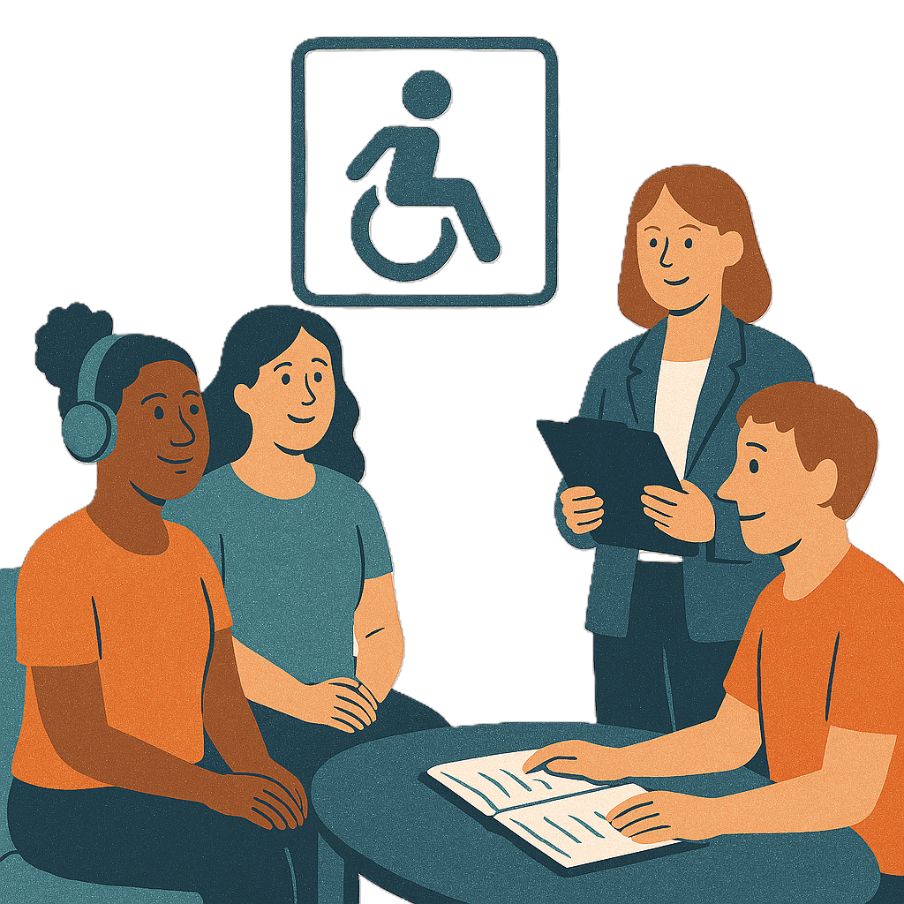 | Experts are people who know a lot about something.
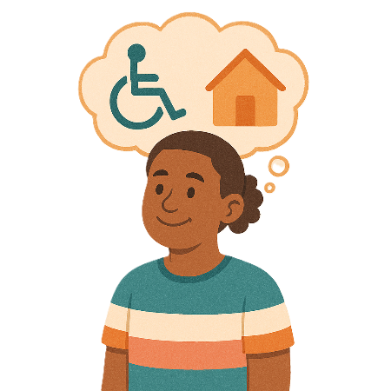 | The informal advice talks about  - Making housing better for people with disability  - Accessibility standards for houses
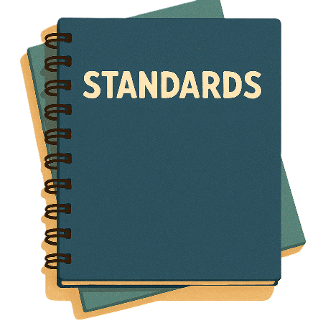 | Accessibility standards are rules that people need to follow for making homes easy to use for people with disability.
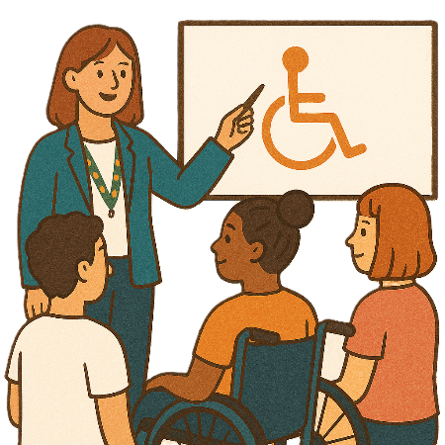 | - Disability awareness training  Disability awareness training helps people know more about  - People with disability  - How to treat people with disability.
 | - Having better ways to collect data on housing  Data is  - Facts  - Information  - Records.
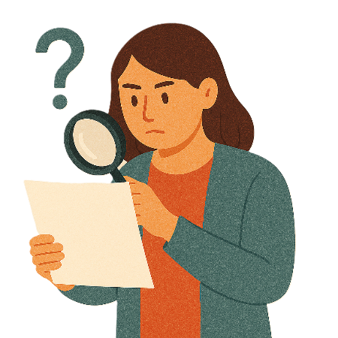 | - Better ways to do evaluation of housing for people with disability  Evaluation means you look at what  - Went well  - Could be done better.  You can do an evaluation of a  - Service  - Program  - Plan.
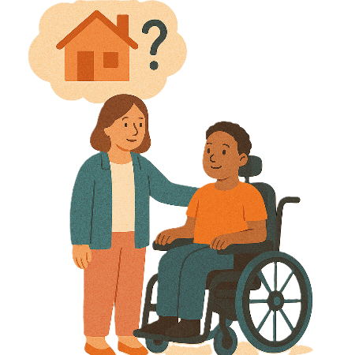 | - Ways to fix barriers to housing for people with disability
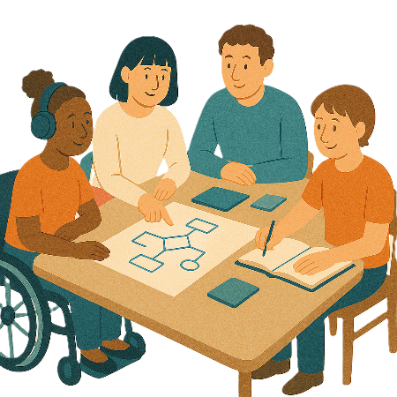 | - The Council 2026 Work Plan
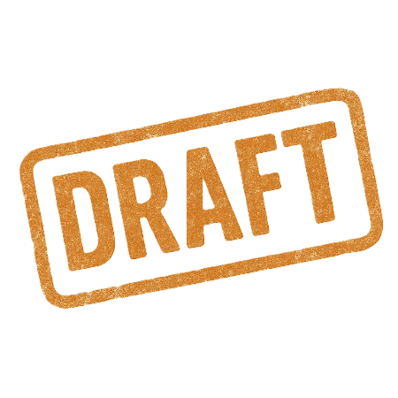 | - The Council 2025 draft annual report  Draft means the first copy you write.  A draft will not be put on the website for everyone to see.
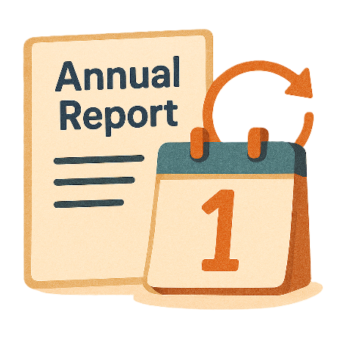 | Annual means something that happens 1 time every year.

Updates

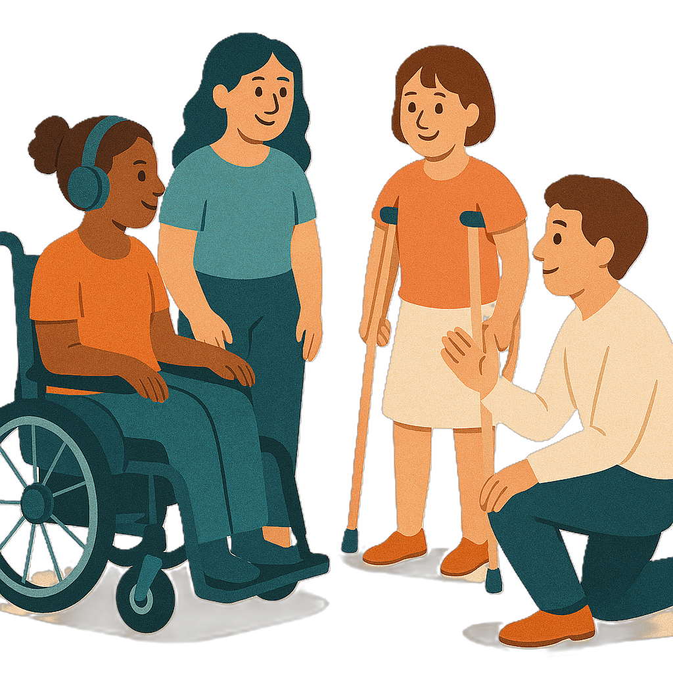 | The Council has been given updates about  - Work being done on the Inclusion and Accessibility Fund  Accessibility means everyone can use it.
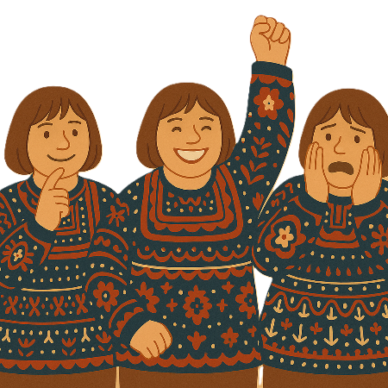 | The Inclusion and Accessibility Fund is trying to  - Change attitudes  Attitudes are what people  - Think  - Feel  - Believe.
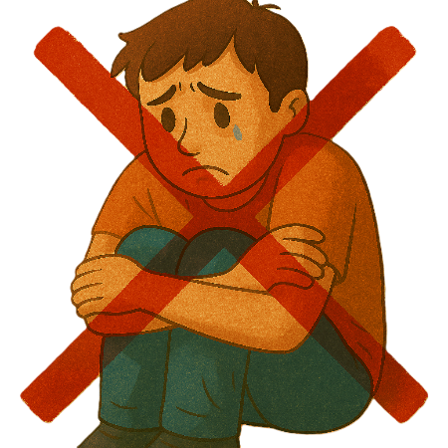 | - Have less harm  Harm means that something bad might happen to you.
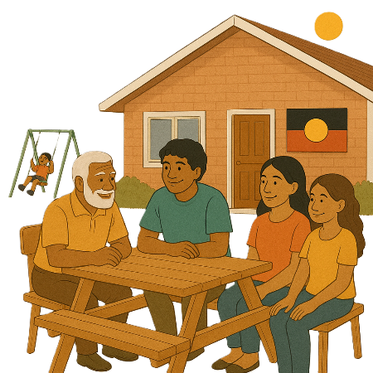 | - Reforms to have good outcomes for First Nations people with disability  Reform means making changes to make something better.
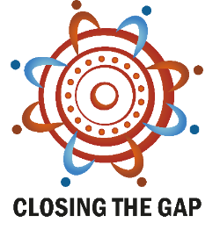 | This needs to fit in with work being done with  - Closing the Gap  Closing the Gap is a plan to make life better for First Nations people in Australia.
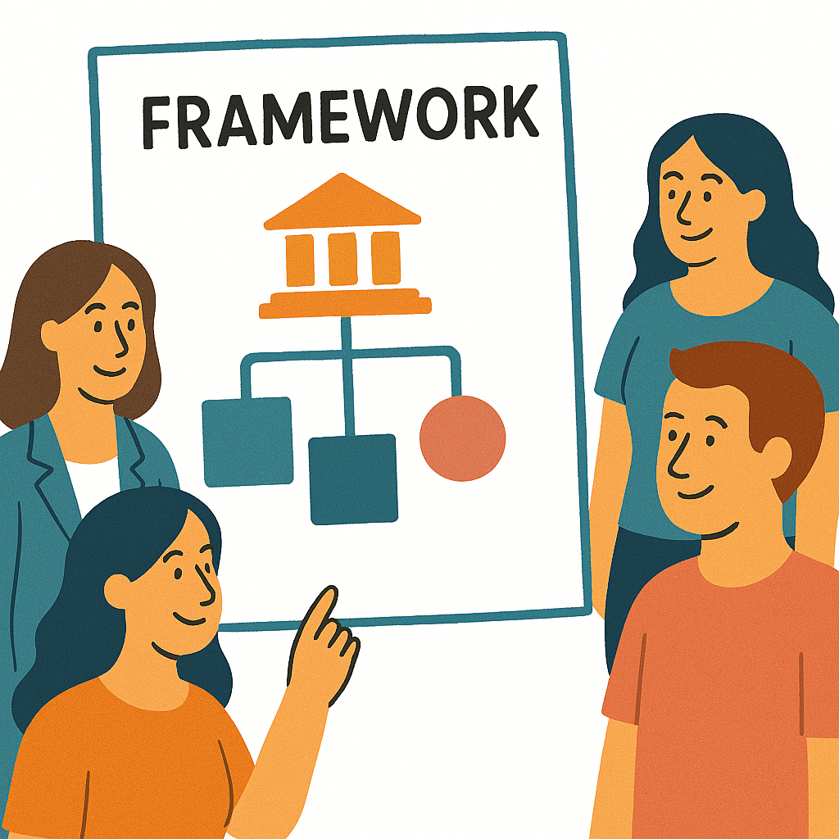 | - Other frameworks  A framework is how we will do something.
 | - How the Disability Discrimination Act review consultation is going
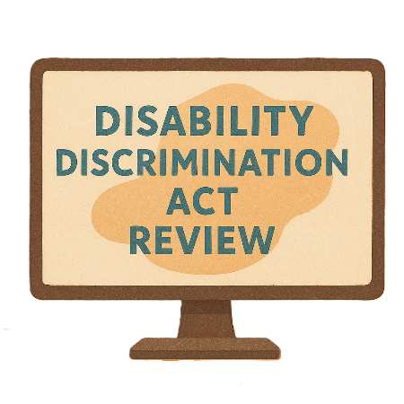 | The Disability Discrimination Act is the law that says people with disability must have their rights met.
 | Rights are rules about treating everyone  - Fair  - Equal.
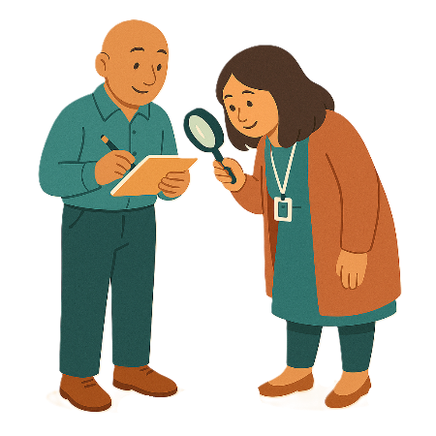 | A review is when you check what  - Works  - Needs to change.
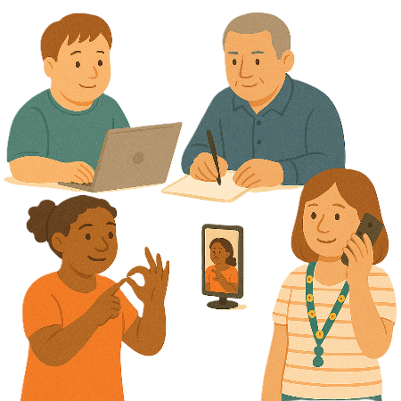 | Consultation is the governments way of working with the disability community.  It makes sure that the government is listening to communities.  This helps the government make better plans to support people with disability.
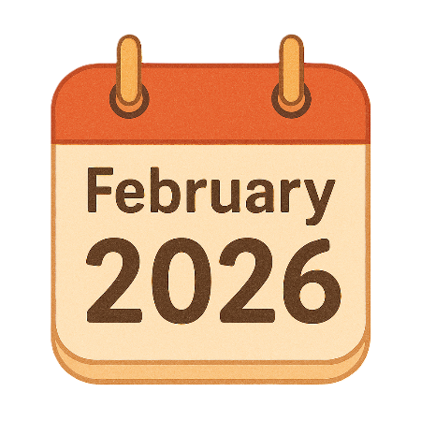 | - Making plans for the Strategy National Forum  It will be in February 2026.
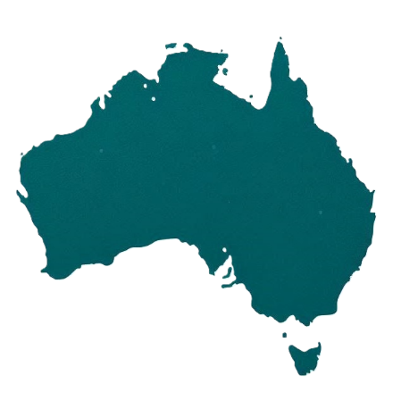 | National means people from across Australia.
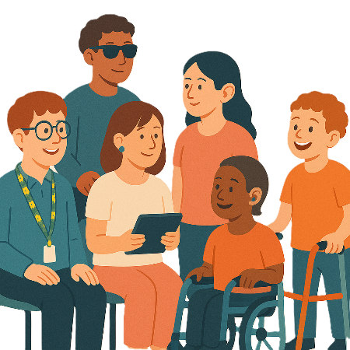 | A forum is a meeting to talk about a problem.
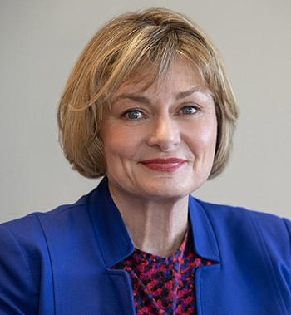 | - Since the last meeting Jane Spring
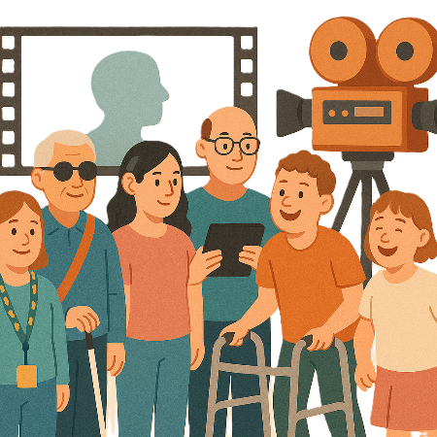 | - Went to the Sydney Focus on Ability Film Festival
 | You can go to the website to see more about it.  focusonability.com.au/
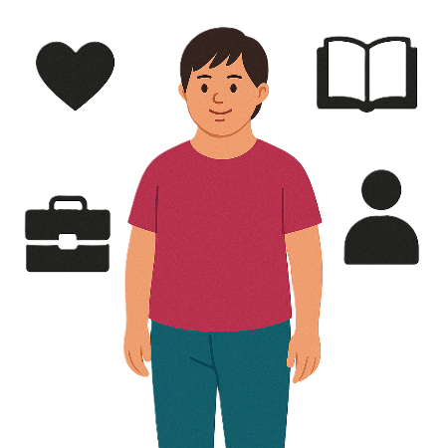 | - Shared ideas on ways to work on changing community attitudes  This is called a Strategy priority.

The next meeting

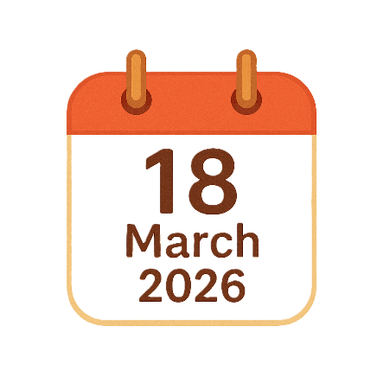 | The next Council meeting will be on  18 March 2026.
 | You can go to the website if you need more information.  www.disabilitygateway.gov.au/ads/advisory-council
 | You can email us.  ADSAdvisoryCouncil@health.gov.au

Images in this Easy Read must not be used or copied without permission

