
Australia’s
Disability
Strategy
2021–2031

Implementation Report

1 July 2023 – 30 June 2025

Summary

Copyright notice
© Commonwealth of Australia (Department of Health, Disability and Ageing) 2026
This document, Australia’s Disability Strategy 2021–2031 Implementation Report 1 July 2023–30 June 2025: Summary, is copyright and published with the permission from the third parties who have contributed third party material.
Creative Commons Licence - Attribution-NonCommercial-NoDerivatives CC BY-NC-ND

This document, Australia’s Disability Strategy 2021–2031 Implementation Report 1 July 2023–30 June 2025: Summary, is licensed under a Creative Commons Attribution-Non-Commercial-NoDerivatives 4.0 International Licence (the Licence). You must read and understand the Licence before using or relying on any material from this Report.
More information on this CC BY-NC-ND 4.0 license is set out at the Creative Commons website: https://creativecommons.org/licenses/by-nc-nd/4.0/legalcode

Restrictions
The Licence may not give you all the permissions necessary for your intended use. For example, other rights (such as publicity, privacy and moral rights) may limit how you use the material found in this publication.
The Licence allows you to download and share the publication with others for free but does not allow you to use it for any commercial purpose or allow you to alter or modify this Report for the purpose of you sharing that altered or modified Report publicly.

Enquiries
Enquiries regarding any other use of this publication should be addressed to:
Branch Manager, Corporate Communication Branch
Department of Health, Disability and Ageing
GPO Box 9848, Canberra ACT 2601
Or via e-mail to copyright@health.gov.au

Accessibility
Access Hub provides information about communication options (including the National Relay Service) for people who are d/Deaf, hard of hearing and/or have speech communication difficulty. For further information, go to https://www.accesshub.gov.au/
This Report is available online in multiple accessible formats. For further information go to Disability Gateway, https://www.disabilitygateway.gov.au/ads
Web links, telephone numbers and titles correct at the time of publication. They may have changed after publication.

Summary

This document is a summary of Australia’s Disability Strategy 2021–2031 Implementation Report 1 July 2023 – 30 June 2025. The full Implementation Report is available on Disability Gateway.
Australia’s Disability Strategy 2021–2031 (the Strategy) is our national plan to make Australia more inclusive for people with disability. It sets out how we can work together to remove barriers and create opportunities for people with disability.
Over the past 2 years we have seen landmark reforms that have reshaped the disability landscape across Australia. The Disability Royal Commission and the NDIS Review final reports, and the 2024 Review of the Strategy gave us important insights.
The Review of the Strategy gave people the opportunity to share their ideas and experiences, and to tell us what matters to them. Throughout the Review, people told us they wanted to see better collaboration between governments, more accessible information and communication, and more opportunities to participate in and engage with the Strategy.
In early 2025, we updated the Strategy to make it clearer and stronger. We also launched 3 new Targeted Action Plans. The updated Strategy reaffirmed all governments’ commitment to the Strategy.
Looking forward, there will be an independent review of the Strategy in 2026. It will look at what is working well, what needs to be improved, and how we can make the Strategy even stronger. It will use the Toolkit for Engaging People with Disability in Evaluation to make sure the process is inclusive, respectful, and shaped by people’s lived experiences.
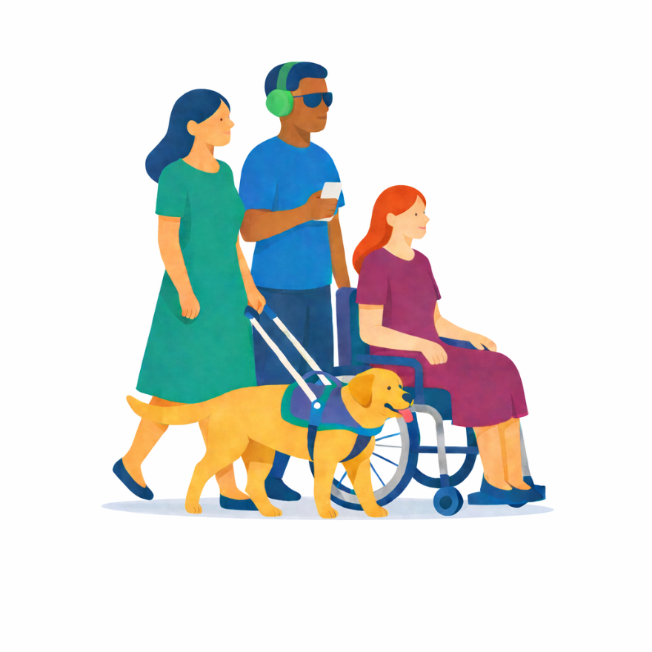
Nothing About Us, Without Us must be more than a slogan; it must shape budgets, laws and data systems.
— Disability Representative Organisation
The strengths of the Strategy are that it is agreed to by all levels of government and it spans multiple areas of government responsibility.
— Australian Human Rights Commission
Funding needs to be better tracked, and actions need to be driven by appropriate and unbiased data and evidence.
— Australia’s Disability Strategy Advisory Council

Our Progress
Australia's Disability Strategy Roadmap reflects how and what we are doing to implement the Strategy. All milestones scheduled for 1 July 2023 to 30 June 2025 have been completed or are in development.
2025

September 2025
Toolkit for Engaging People with Disability in Evaluation released
In development
1st Strategy Major Independent Evaluation
2nd National Public Forum
The Strategy’s Community Engagement Plan
Accessible Information and Communications Associated Plan
2025 Review of the Disability Standards for Education
April 2025
Intellectual Disability Health Capability Framework and associated education resources released
February 2025
National Roadmap to Improve the Health and Mental Health of Autistic People 2025–2035 released
January 2025
Australia's Disability Strategy 2024 Update released
2nd Targeted Action Plans started
National Autism Strategy 2025–2031 released
2024
December 2024
Guide to Applying the Strategy released
Data Improvement Plan 2024 released
Review of the Strategy Report released
First release of National Disability Data Asset data
3rd Targeted Action Plans Report released
National Carer Strategy 2024–2034 released
November 2024
Equity: the Arts and Disability Associated Plan released
2022 Review of the Transport Standards report and Australian Government response released
August 2024
Public consultation for the Review of Australia's Disability Strategy
2nd Strategy State Forum held in Hobart, Tasmania
July 2024
ABS Survey of Disability, Ageing and Carers (2022) results released
June 2024
1st Targeted Action Plans end
January 2024
Disability Services and Inclusion Act 2023 (Cth) commenced
2nd Targeted Action Plans Report released
2023
October 2023
Good Practice Guidelines for Engaging with People with Disability released
National Centre of Excellence in Intellectual Disability Health opened
September 2023
Royal Commission into Violence, Abuse, Neglect and Exploitation of People with Disability Final Report released
December 2023
The Strategy’s 1st Implementation Report tabled in the Australian Parliament
NDIS Review Final Report released
Timeline of Australia's Disability Strategy activities, 2023–2025

Australia's Disability Strategy Outcome Areas
The Strategy has 7 Outcome Areas that focus on building an inclusive society. The following are highlights of progress under the Outcome Areas during July 2023 to June 2025.

Employment and Financial Security
The Inclusive Employment Australia started, and a new program Centre for Inclusive Employment has been set up. Most governments worked towards hiring more people with disability in their public sectors. The ACT Disability Strategy First Action Plan and the Victorian Neurodiversity Employment Toolkit promoted inclusive hiring practices and workplace adjustments.

Inclusive Homes and Communities
Reforms in transport, tourism, communications, public spaces and services are making communities more inclusive. Local councils, like City of Newcastle and City of Ryde, promoted inclusive sport and volunteering. Governments are supporting more accessible housing. The updated Strategy now includes a new focus on homelessness.

Safety, Rights and Justice
States and territories started new justice strategies and programs to support people with disability in the legal system and to stop domestic and family violence. Legal protections were made stronger with the new Disability Services and Inclusion Act , and there is a plan to update the Disability Discrimination Act 1992 (Cth).

Personal and Community Support
New plans were released, like the National Autism Strategy and National Carer Strategy. The NDIS now supports over 739,000 Australians, and a new NDIS First Nations Strategy was launched to better support First Nations people with disability. Governments are working on extra supports outside the NDIS, including Foundational Supports and Thriving Kids.

Education and Learning
States and territories are working to make schools more inclusive. NSW and WA have programs to train educators. NT and SA have transition programs to help young people with disability move into further study or work. The Australian Government released new resources to help First Nations students and families understand their rights, and training providers are better equipped to support students with disability.

Health and Wellbeing
A new national centre and health framework were created to make health care more inclusive for people with intellectual disability. States and territories are making it easier for people with disability to get health and mental health services. For example, Tasmania’s disability health strategy or Queensland’s Centre of Excellence in Intellectual and Developmental Disability Mental Health. In 2024, the Australian Government released an Emergency Management Toolkit that was co-designed with people with disability.

Community Attitudes
Governments’ grants programs support projects that improve community attitudes, inclusion, and accessibility. For example, the Australian Government’s Inclusion and Accessibility Fund will support local projects to improve community attitudes. Initiatives like Bus Stop Films and Queenslanders with Disability Network’s Emerging Leaders Program help promote inclusion and challenge stereotypes.

Implementation Mechanisms
The Strategy is carried out through a set of linked actions. They guide how we act and help us stay responsible for what we do. The following are highlights of these actions.
Governments are working together to implement the Strategy, delivering more effective and consistent disability policies and programs across Australia. The Strategy’s Guiding Principles are helping us build more inclusive communities. The new Guide to Applying Australia’s Disability Strategy is helping governments, businesses, and communities use the Guiding Principles in their work and disability plans.
Genuine engagement with people with disability is at the heart of the Strategy. The updated Strategy commits to making a new Community Engagement Plan. The 2024 Tasmania State Forum brought together people with disability, and government to share ideas on how to make engagement better. There is also a new Toolkit for Engaging People with Disability in Evaluation. This toolkit helps make sure evaluations are inclusive.
The Strategy’s Targeted Action Plans help governments focus on short term priorities. In 2025, we released 3 new plans focused on Inclusive Home and Communities; Safety, Rights and Justice; and Community Attitudes.
The Strategy’s Associated Plans take a longer-term focus on key priorities. In 2024, we launched a new Associated Plan, Equity, focused on arts and disability. The updated Strategy commits to developing a new Associated Plan to improve the accessibility of information and communications.
We check how the Strategy is working by using the Outcomes Framework and a national Survey. These tools measure changes in important parts of life, like jobs and health. By July 2025, we had data for 56 measures in the Outcomes Framework. The Strategy’s Survey collects information about people’s attitudes on disability. The results are shared in reports and studies to help us understand what is improving and what needs more work.
We are working to improve disability data so we can better measure progress. The Strategy’s revised Data Improvement Plan sets out practical ways to strengthen disability data and reporting over 2025–2026.
Good governance helps us work together and be responsible for our actions. The Disability Reform Ministerial Council brings together disability ministers to lead national change. Australia’s Disability Strategy Advisory Council, provides independent advice to governments on the implementation of the Strategy.
Evaluations provide evidence about what is working and where improvements are needed. In 2026, there will be an independent evaluation of the Strategy.

State and Territory Governments
State and territory governments are key partners in delivering the Strategy. They also have their own disability plans that reflect the priorities of their communities.
Jurisdiction | Disability Strategy or Plan
Australian Capital Territory Government | Australian Capital Territory Disability Strategy 2024–2033
New South Wales Government | New South Wales Disability Inclusion Plan 2021–2025
Northern Territory Government | Northern Territory Disability Strategy 2022–2032
Queensland Government | Queensland's Disability Plan 2022–2027: Together, a better Queensland
South Australia Government | South Australian Disability Inclusion Plan 2025–2029
Tasmania Government | Tasmania's Disability Strategy 2025–2027
Victoria Government | Inclusive Victoria: state disability plan 2022–2026
Western Australia Government | A Western Australia for Everyone: State Disability Strategy 2020–2030
Further information about the Strategy is available at Australia’s Disability Strategy Hub on Disability Gateway.

