Australia’s Disability Strategy

Implementation Report

1 July 2023 to 30 June 2025

Part 2

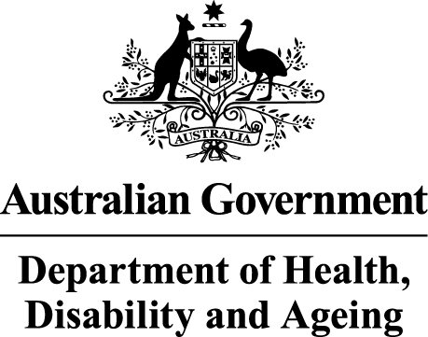 | The Australian Government Department of Health Disability and Ageing wrote this.  We say DHDA for short.  When you see the word we it means DHDA.
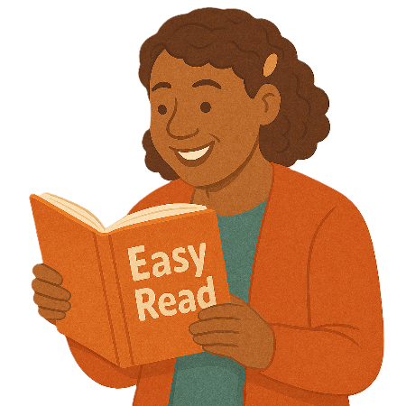 | We wrote this in an easy to read way.  We use pictures to explain some ideas.
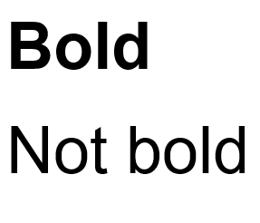 | We have some words in bold.  This means the letters are thicker and darker.  These are important words.
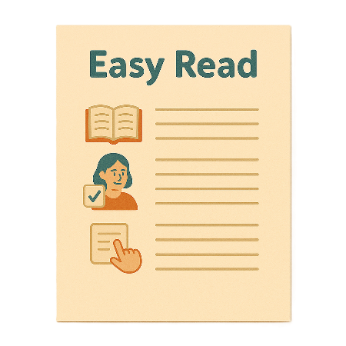 | This is an Easy Read summary of another document.  This means it has the most important ideas.
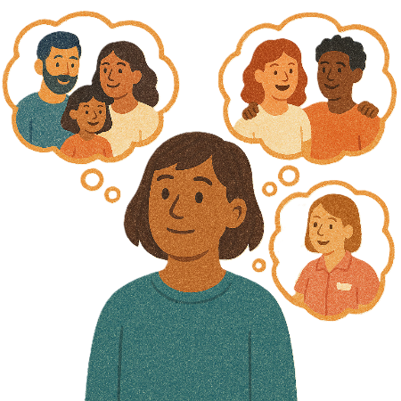 | You can ask for help to read this document.  You can ask  - A friend  - Family members  - A support person.
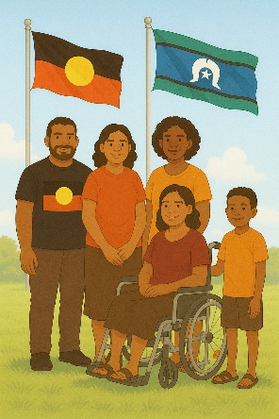 | We recognise Aboriginal and Torres Strait Islander people as the Traditional Owners of the land we live on.
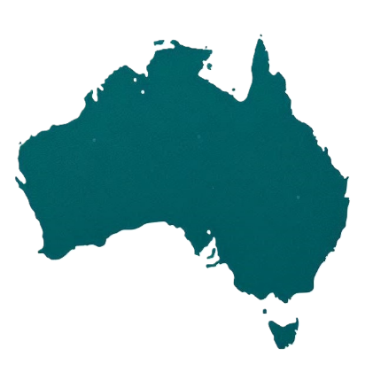 | They were the first people to live on and use the  - Land  - Waters.

Contents

Australia’s Disability Strategy | 5
About this document | 6
What we have done so far | 7
Guiding Principles | 10
Work with people with disability | 12
Targeted Action Plans | 15
Associated Plans | 20
Data | 24
Governance | 29
Evaluations | 32
State and Territory Governments | 34
Contact us | 36

Australia’s Disability Strategy

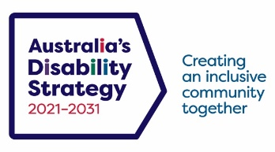 | Australia’s Disability Strategy is a plan to make life better for people with disability.  We call it the Strategy for short.  It is also called ADS.
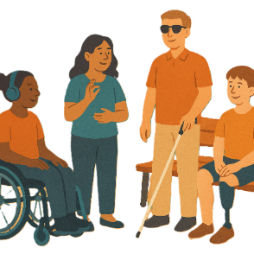 | The Strategy is important for Australia to be more inclusive.  Inclusive means everyone can take part.
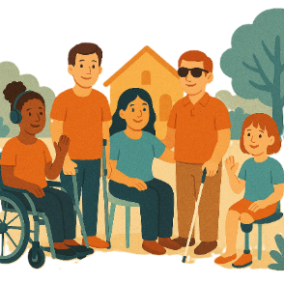 | This makes everyone in our community feel welcome.

About this document

 | This document has 2 parts.
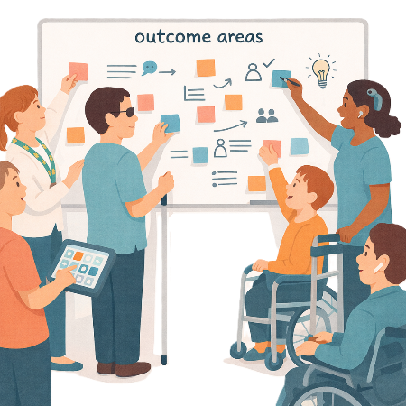 | Part 1 talks about  - 7 Outcome Areas.  Outcome Areas are the parts of the Strategy.  The work is split into smaller parts.  This makes it easier to work on.
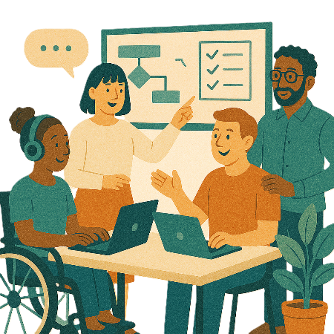 | Part 2 talks about  - Other work that has been done to support the Strategy.

What we have done so far

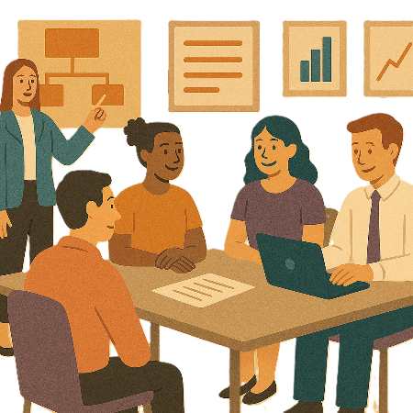 | We have done lots of work to make life better for people with disability.
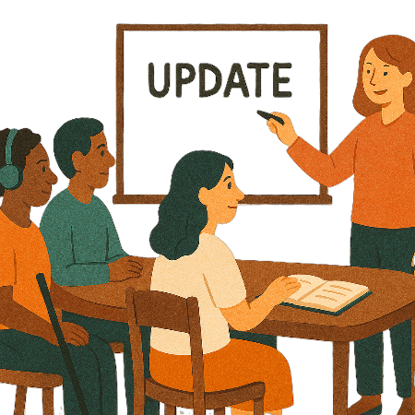 | This update talks about some of the work that has been done between  - 1 July 2023  - 30 June 2025
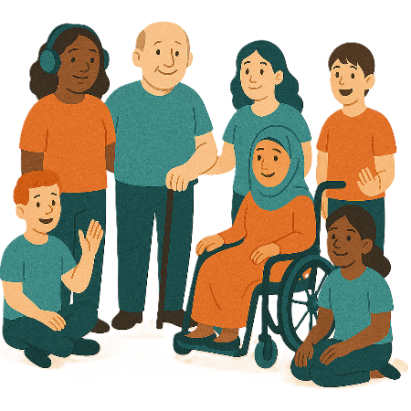 | - Work with people with disability
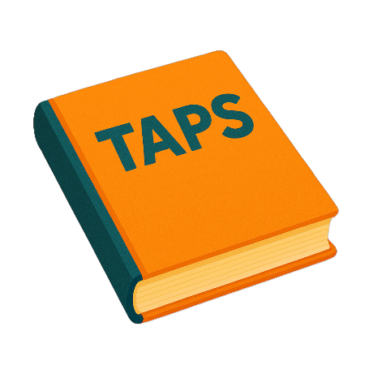 | - Making Targeted Action Plans work  We call them TAPs for short.
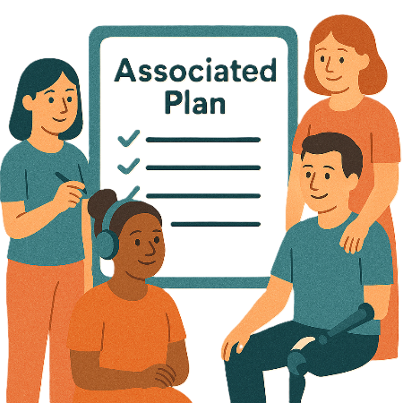 | - Made new Associated Plans  Associated plans help to work on big plans.  It helps us work on the most important parts.
 | - Collected new data  Data is  - Facts  - Information  - Records.
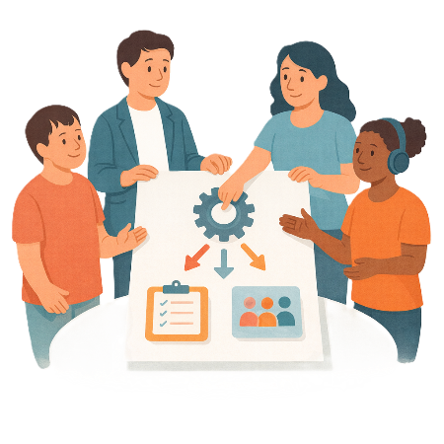 | - Worked with groups who helped us do our work  These groups are call governance groups.  Governance says how something will work.  They make sure the work is done the right way.
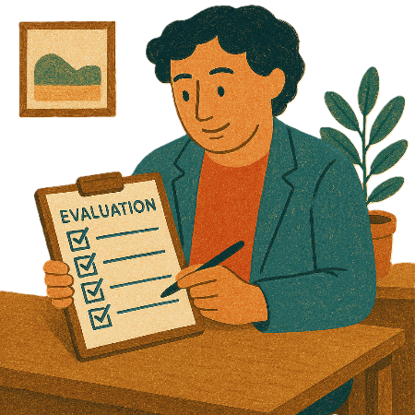 | - Evaluated our work.  Evaluated means you look at what  - Went well  - Could be done better.  You can do an evaluation of a  - Service  - Program  - Plan.

Guiding Principles

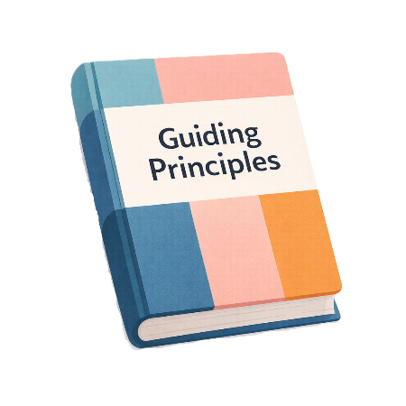 | We have Guiding Principles.  Principles say how the Strategy should work.  They say how to make the community more inclusive for people with disability.
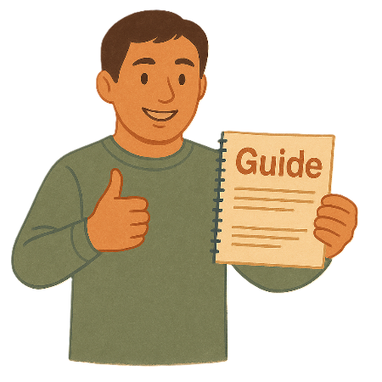 | There is a new Guide to Applying Australia’s Disability Strategy.
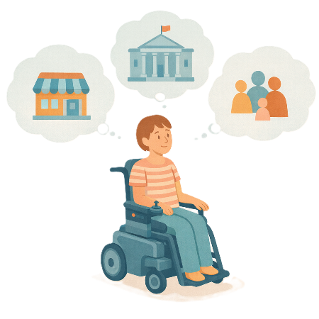 | It is for  - Governments  - Businesses  - Communities.
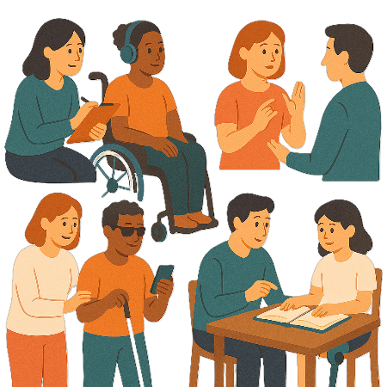 | It tells them how to use the Guiding Principles in their work.
 | You can go to the website to read more about the Guide to Applying Australia’s Disability Strategy.  www.disabilitygateway.gov.au/document/11221  It is in Easy Read.
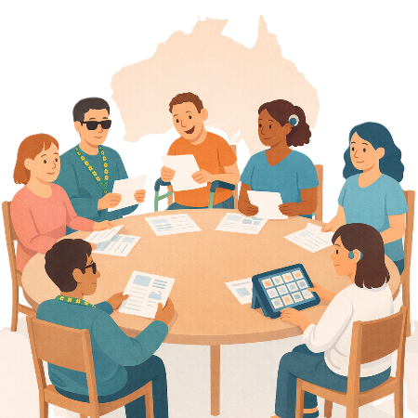 | State and territory governments are  - Making the Guiding Principles part of their disability plans or strategies.  These strategies are different from Australia’s Disability Strategy.

Work with people with disability

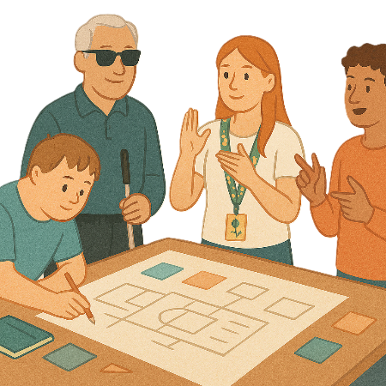 | It is important for people with disability to work on the Strategy.
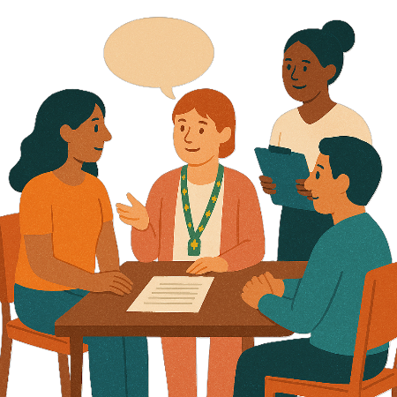 | We want to make a new Strategy Community Engagement Plan.  Engagement means the community can share their ideas with the government.
 | The Tasmania State Forum in 2024 helped share ideas about engagement.  A forum is a meeting to talk about a problem.
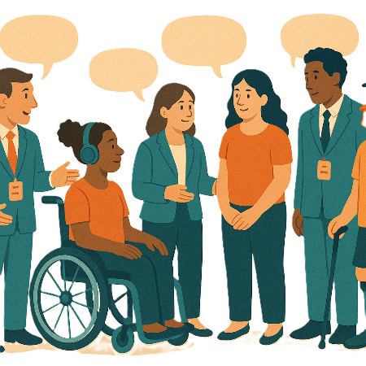 | It helped to bring together  - People with disability  - Government.
You can go to the website to read about the Tasmania State Forum.

www.disabilitygateway.gov.au/ads-tas-state-forum

It is in Easy Read.
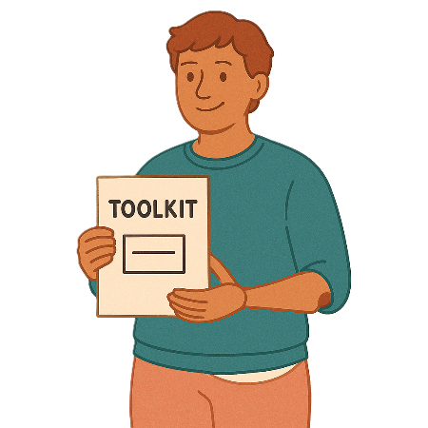 | There is a new toolkit called  - Toolkit for engaging people with disability in evaluation.
Evaluation means you look at what

- Went well
- Could be done better.

You can do an evaluation of a

- Service
- Program
- Plan.
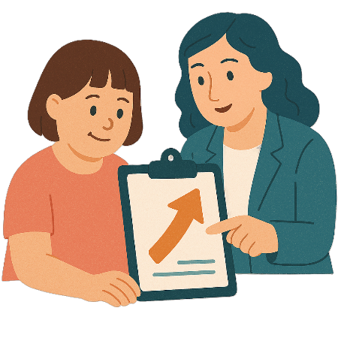 | It will help more people with disability to help make changes.
You can go to the website to read more about the toolkit.

www.disabilitygateway.gov.au/document/13591

It is in Easy Read.

Targeted Action Plans

Targeted Action Plans are the small plans to help us work on the Strategy.

We call them TAPs for short.
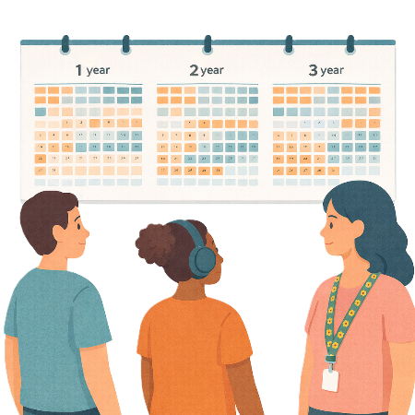 | We work on TAPs for 1 to 3 years.
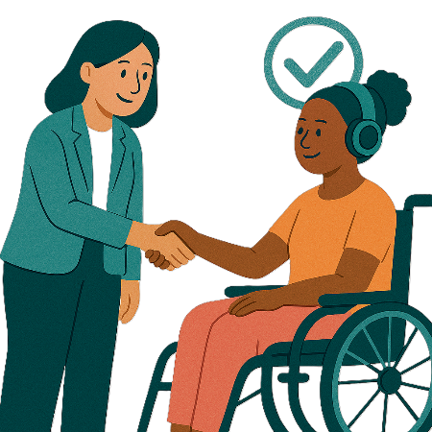 | There are 3 new TAPs.  They are working to make important policies better.
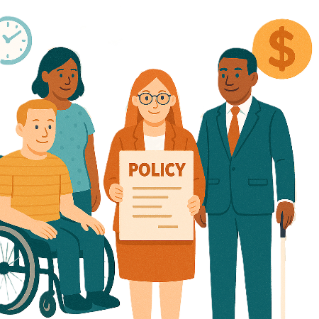 | Policies are plans for how to do things.
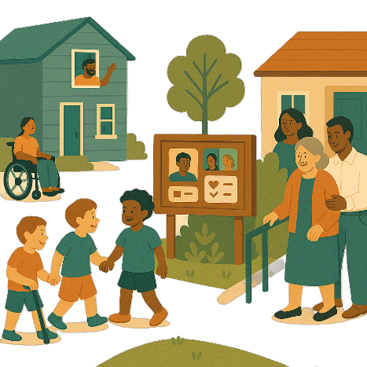 | The new TAPs are  - Inclusive Homes and Communities
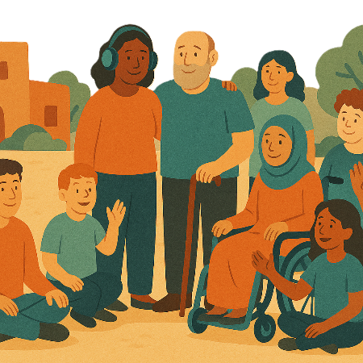 | Inclusive is when everyone  - Can take part  - Feel like they belong.
You can go to the website to read about this TAP.

https://www.disabilitygateway.gov.au/document/13867

It is in Easy Read.

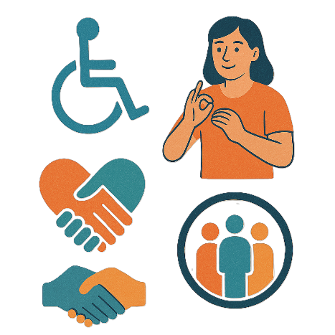 | - Community Attitudes
 | Attitudes are what people  - Think  - Feel  - Believe.
You can go to the website to read about this TAP.

https://www.disabilitygateway.gov.au/document/13865

It is in Easy Read.

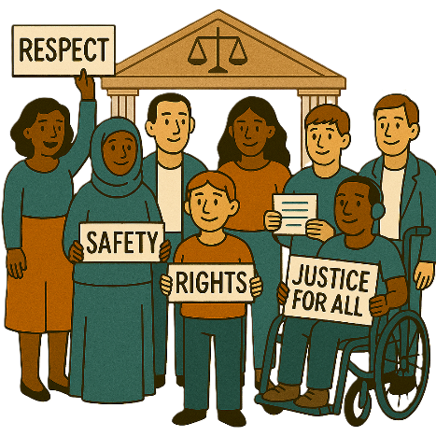 | - Safety Rights and Justice.
 | Rights are rules about treating everyone  - Fair  - Equal.
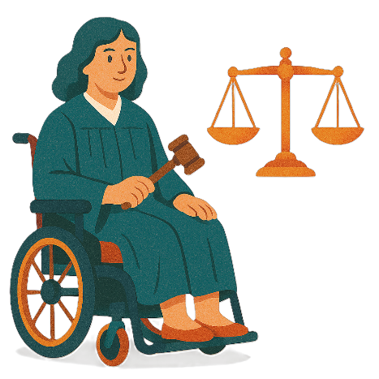 | Justice is  - The law  - Police  - The courts  - Prisons.  Laws are rules for how we live.
You can go to the website to read about this TAP.

https://www.disabilitygateway.gov.au/document/13866

It is in Easy Read.

Associated Plans

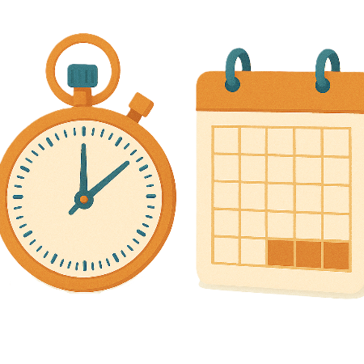 | Associated Plans are big plans that help make life better for people with disability.  The plans focus on 1 area like the arts.
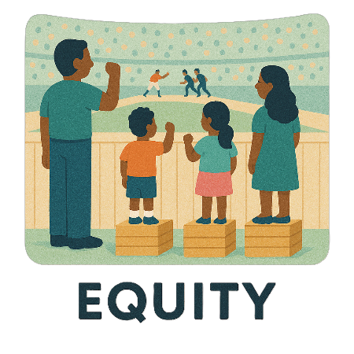 | In 2024 the Australian Government shared a new Associated Plan.  The plan is called Equity.  It looks at art and disability.  Equity means it is fair for everyone.  Sometimes people will need different things to take part.  This makes it fair.
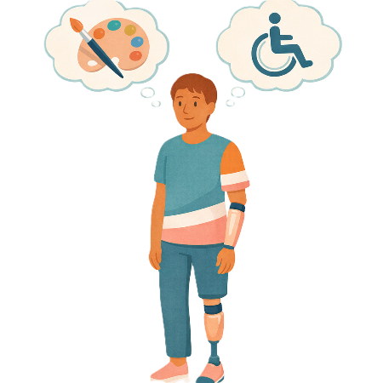 | Equity helps make arts and culture  - Fair  - Accessible  - Inclusive.
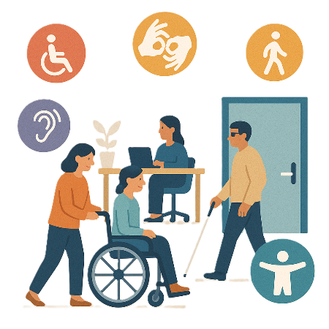 | Accessible means everyone can use it.
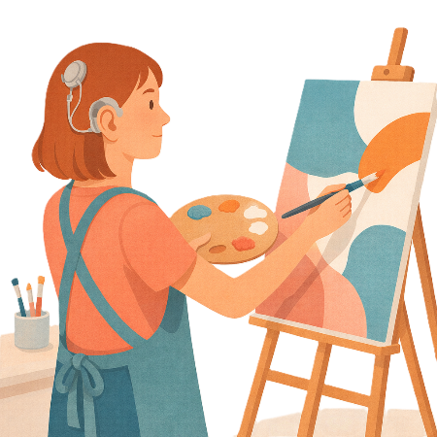 | Equity supports  - Deaf artists
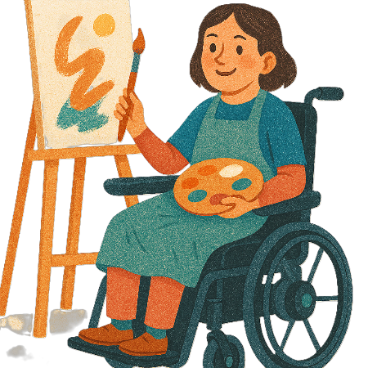 | - Disabled artists
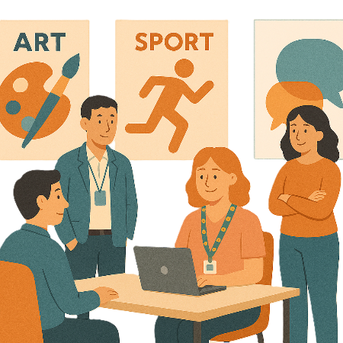 | - Arts workers
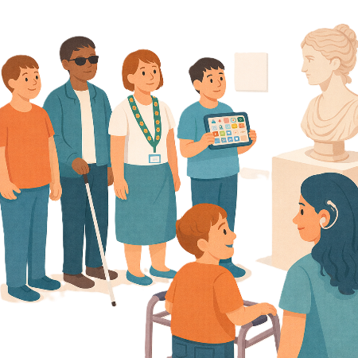 | - People with disability who like to look at art.
You can go to the website to read more about the Equity plan.

www.arts.gov.au/what-we-do/arts-and-disability/equity-arts-and-disability-associated-plan

It is in Easy Read.
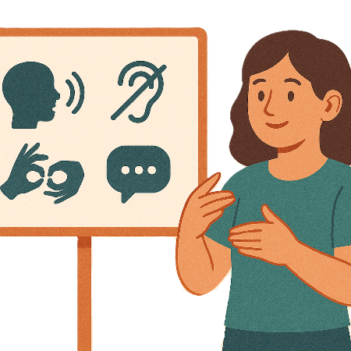 | We will make a new Associated Plan for accessible communication.  Accessible communication is information that everyone can use.  Like Easy Read.

Data

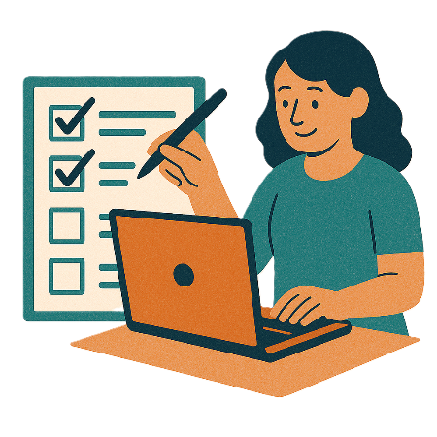 | It is important for us to check how we are going on the Strategy.
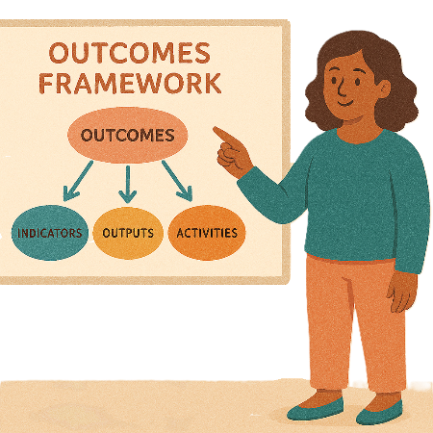 | We will check how we are going using the  - Outcomes Framework  Outcomes Framework is a plan that shows  - What we want to do  - How we will know if things are getting better.
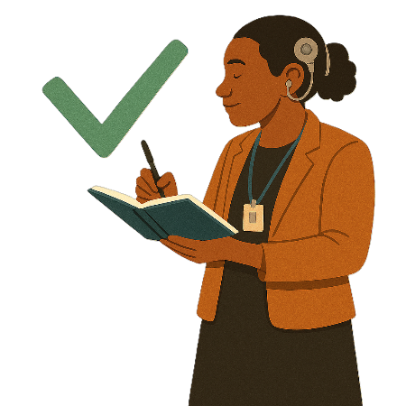 | It helps us check if the Strategy is working for people with disability.
We use it to

- Check how we are going progress
- Make sure we are on the right track.
You can go to the website to read more about the Outcome Framework.

www.disabilitygateway.gov.au/document/3166
It is in Easy Read.

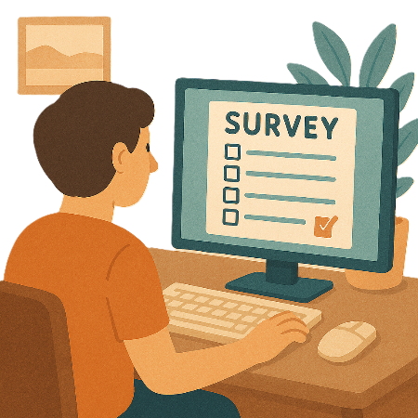 | - Survey  Surveys have questions about your ideas.
You can go to the website to read more about the survey.

www.disabilitygateway.gov.au/document/13761

It is in Easy Read.
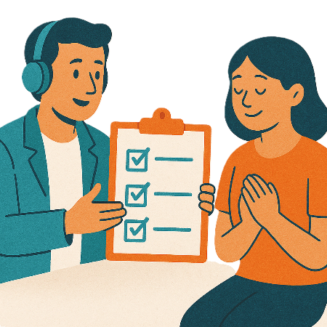 | The  - Outcome Framework  - Survey  Can help show areas that have improved.  They do this by collecting data.
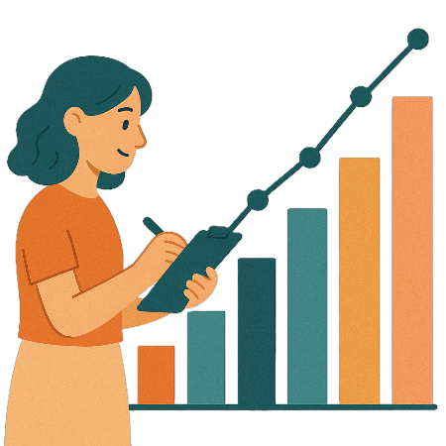 | The government is improving the way they  - Collect data
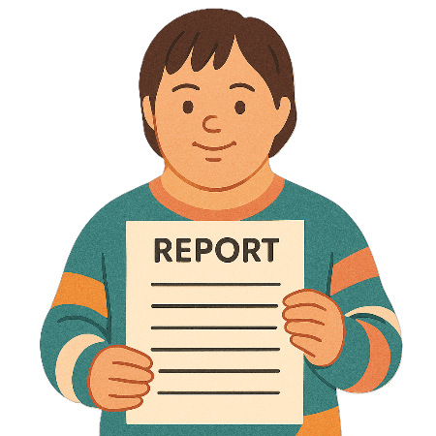 | - Write reports about the data.  The reports help to  - Make good policies  - Find gaps.
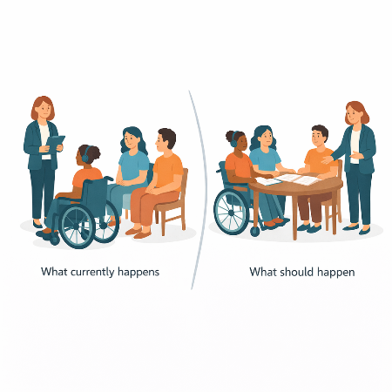 | Gaps are the difference between  - What currently happens  - What should happen.
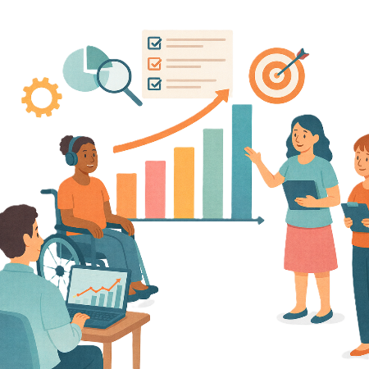 | The Data Improvement Plan will help  - Collect better data  - Do better reporting.
You can go to the website to read the Data Improvement Plan.

www.disabilitygateway.gov.au/document/10981

It is in Easy Read.

Governance

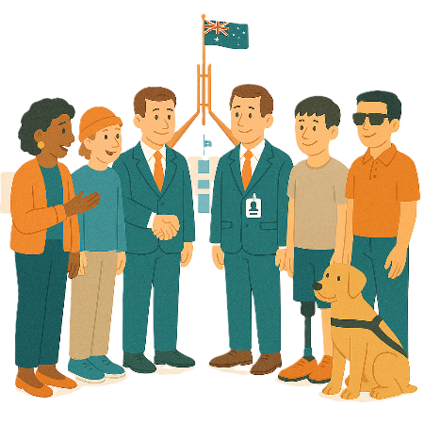 | Governance helps governments work together.
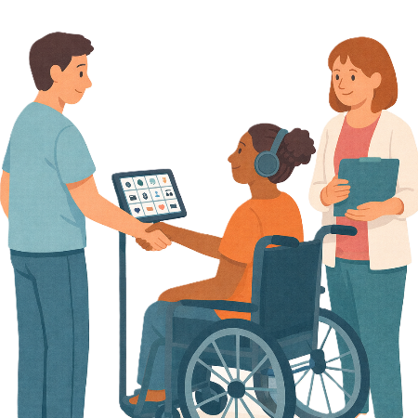 | It keeps them responsible for what they have said they would do.  Responsible means the things you need to do.
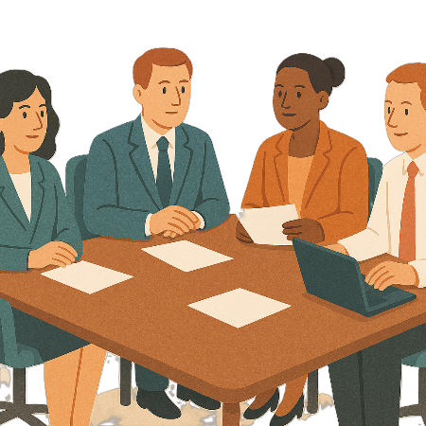 | The Disability Reform Ministerial Council is a group of Disability Ministers from  - The Australian Government  - State and territory governments.  We call it the DRMC.  Ministers are leaders in an area of the government.
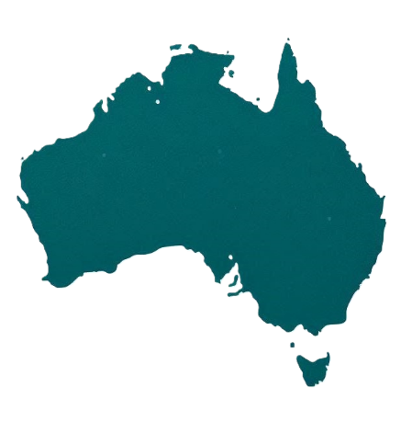 | DRMC help work on changes for disability across all of Australia.
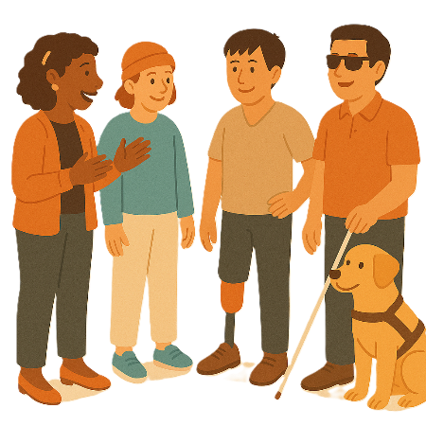 | The Australia’s Disability Strategy Advisory Council gives advice about the Strategy to  - The Australian Government  - State and territory governments  - Local governments.
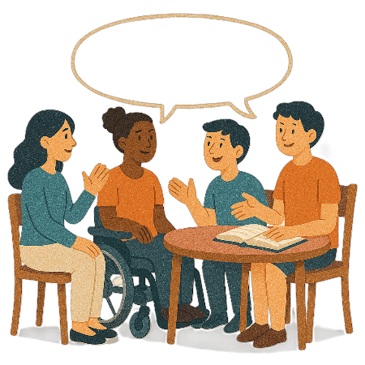 | An advisory council is a group of people who know a lot about something.
You can go to the website to read more about the Advisory Council.

www.disabilitygateway.gov.au/communiques

It is in Easy Read.

Evaluations

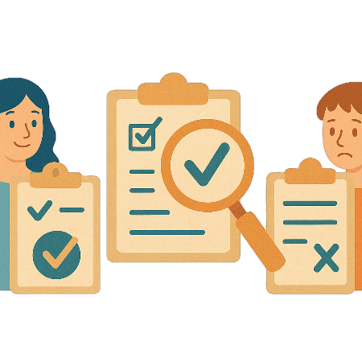 | Evaluation helps gives good evidence.  Evidence is proof that something is true.
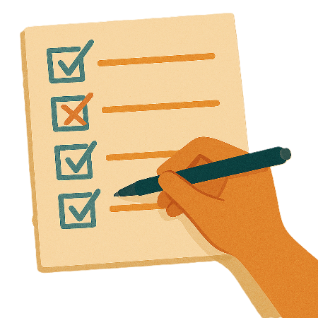 | It says  - What is working  - Where things need to change.
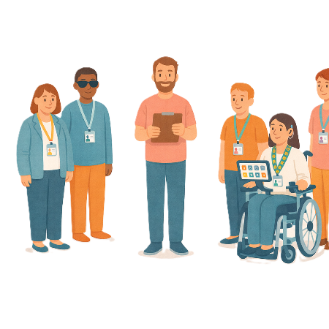 | In 2025 an independent evaluator will be picked.  Independent means separate to the government.
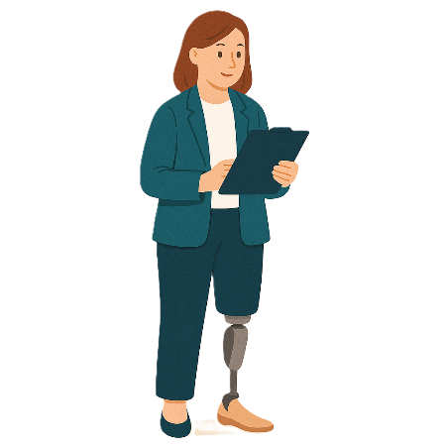 | The people who do evaluation are called evaluators.
 | They will check to see how well the Strategy is working.
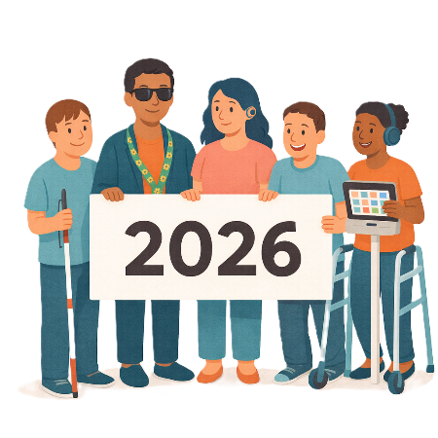 | They will write a report in 2026.

State and Territory Governments

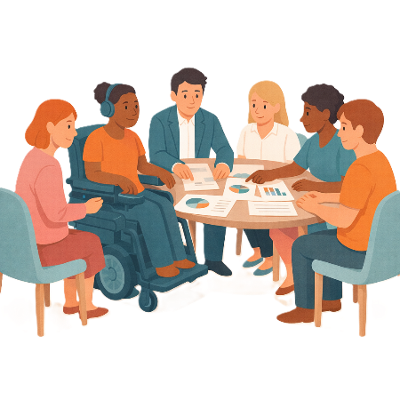 | State and territory governments help work on the Strategy.
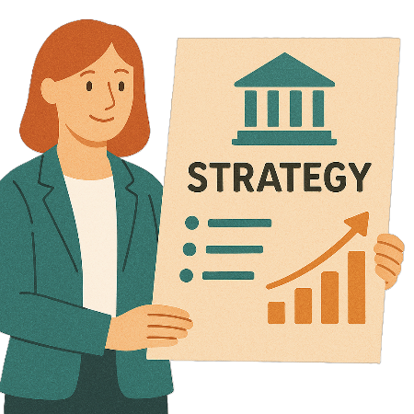 | They have their own disability plans or strategies too.  This helps them work on things that are important for their communities.
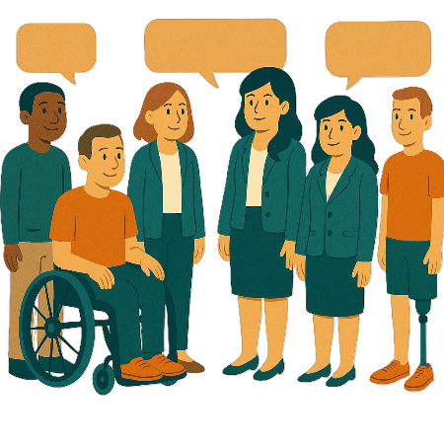 | The state and territory disability plans or strategies work with the Strategy.
You can go to the website to read the state and territory disability plans or strategies.

www.disabilitygateway.gov.au/ads/key-actions-strategy#state

It is in Easy Read.
You can go to the website to read the Implementation Report.

www.disabilitygateway.gov.au/ads/reporting-ads#the-implementation-reports

Contact us

 | You can contact us if you need more information.
 | You can look at our website.  www.disabilitygateway.gov.au/ads/strategy

Some images in this Easy Read were made using AI.
You must not share or copy any of the images without permission.
January 2026.

